Cover Page

Contents
Introduction 1
Task 1. e-Commerce Website builders/software solutions 1
1.1 Wix 1
1.2 Shopify 1
Task 2. Mind-map of contemporary software applications 1
2.1 Describe mind mapping and explain the benefits of using mind mapping 1
2.2 Create a mind map of contemporary software applications 2
Task 3. Office Applications 2
3.1 Four office software solutions for business operations 2
Ms Word 2
Ms Excel 2
Ms PowerPoint 2
Ms Access 2
3.2 Test any two features 2
Mail Merge 2
IF Statement 3
Task 4. Communication and Collaboration applications 3
4.1 One contemporary Communication and one Online Collaboration 3
Gmail 3
Zoom 3
4.2 Test one feature of a freely available Communication (1) and one feature of a Collaboration (1) application 3
Gmail 3
Zoom 3
Conclusion 4
References 4

Introduction
In the digital business world software systems are crucial for the success and normal functioning of a company. This report considers the various forms of present day software that companies use to establish an online operate their businesses and facilitate ways for employees to communicate which help them a lot.
The analysis begins with e-commerce plat forums, including and Wix two of the easiest to use for setting up and maintaining an online store appropriately. we then explore the concept of mind mapping and how this tool could be used in business. That is a demonstration of how visual thinking can assist in planning and decision making the report then spend a lot of time on the core Microsoft Office program Word, Excel, Power Point and Access. Which are broken down based on their standout features as well as an evaluation of their most significant pros and cons for business use Mail merge and as IF statement is just the beginning, as real world examples demonstrate just how powerful these tools are. Finally, the report examines modern communication and collaboration tools like Microsoft Outlook and Teams that allow people to work together and stay connected in the modern workplace. Through extensive research the report reveals how integrated software solution enhanced productivity efficiency and collaboration today’s workplaces.

Task 1. e-Commerce Website builders/software solutions

1.1 Wix

Wix is a most popular and easiest website building platform it allows people to create their own websites without needing advanced coding like java , html or any technical knowledge. It make life so easy even beginners can make web site very easy without any experience with web development.
One of the main advantages of Wix is easy to use drag and drop editor function which make very easy . Users can choose different elements, such as text, images videos, buttons, contact forms and menus change colours background , add animation , and place them wherever they want on a webpage. Wix also provides a large selection of professionally designed ready made templates for different types of websites, including business websites online shopping web site, shops portfolios blogs restaurants and, booking website, personal websites.
Wix can be useful for small businesses it provides many tools in one platform. Businesses can create an online presence, display their products or services, provide contact information and communicate with customers. For businesses that want to sell products online, Wix also offers e-commerce features that allow them to manage products, orders, payments and customers.
Wix also give you tools like search engine optimisation SEO , helping bring your web site to bring on top of the page. When peoples search for web site you website will show on top of the link. It help to get customer which is very helpful as customer always look for first two or three link which show on google. understand website visitors and add different applications to increase the website’s functionality.
Overall, Wix is a convenient option for individuals, entrepreneurs and small businesses that want to create a professional looking website without having to hire a web developer.

1.2 Shopify


Shopify is e-commerce platform specifically designed for creating and managing online stores. Where you can sell your products online. Liste the item with photos and setup the price as you want. Its very good tool where you can make all you shop online for example if you have physical store and you want to sell same item online shopify is best platform where you can list all you shop items and sell online , peoples cross the glob can buy your item. Shopify give you integration option where you can link your shop with other platform like ebay , amazon, etc . Unlike Wix, which serves many different website types, Shopify focuses on helping businesses sell products online. It provides everything needed to run an online business,
The biggest strengths is its ability to support businesses of all sizes. Whether a company sells a few handmade products or thousands of items worldwide, Shopify offers tools that can handle growing sales and customer demand. Store owners can organize products into categories, manage stock levels, set discounts, process refunds, and monitor sales performance from a single dashboard.
Shopify supports multiple payment gateways where customers can pay using their credit cards, voucher, gift cards. Shopify also provides secure checkout processes and fraud protection, helping build customer trust and protect sensitive financial information.
Another major benefit of Shopify is its extensive App Store, which contains thousands of applications for marketing, accounting, customer service, shipping, inventory management, and product reviews. These integrations allow businesses to customize their stores and automate many daily tasks, saving time and improving efficiency.

Conclusion
Both Wix and Shopify are excellent platforms, but they serve different purposes. Wix is best for users who need an easy-to-use website builder for blogs, portfolios, company websites, or small online stores. It offers great design flexibility and is ideal for beginners with little technical experience. Shopify, on the other hand, is the better choice for businesses whose main goal is selling products online. Its advanced e-commerce features, inventory management, secure payment options, and scalability make it one of the leading platforms for online retail.

Task 2. Mind-map of contemporary software applications

2.1 Describe mind mapping and explain the benefits of using mind mapping
Mind Mapping and the Benefits of Using Mind Mapping


Mind mapping is a visual thinking and learning technique that helps individuals organize information, give user ideas, and understand relationships between concepts. It start with diagram central idea or topic placed in middle of the page. From this central idea, branches extend outward to represent related topics, with further sub branches adding supporting details. Mind maps often include keywords, colours, symbols, images, and arrows to make information more engaging and easier to remember.
The concept of mind mapping became widely known through educational consultant Tony Buzan, who promoted it as a method for improving memory, creativity, and learning. Today world mind maps are used by students, teachers, business professionals, researchers, and project managers for tasks such as planning projects, ideas, solving problems, and making good decisions.
The greatest benefits of mind mapping is it improves memory and information retention. By gathering keywords, photos, colours, and logical connections, mind maps stimulate both the analytical and creative sides of the brain. This makes it easier to remember information compared to reading long paragraphs of text.
Mind mapping is also an excellent tool for organizing information. Large amounts of information can become overwhelming when presented in lists or lengthy documents. A mind map breaks complex topics into smaller, manageable sections that are connected logically. This enables users to identify the main ideas, supporting details, and overall structure of a subject at a glance. As a result, studying and reviewing information becomes more efficient.
Another important advantage is that mind mapping encourages creativity. Because ideas can be added freely without following a strict sequence, users are more likely to explore different possibilities and think creatively. During brainstorming sessions, mind maps allow individuals or teams to record ideas quickly without worrying about order or presentation.
Mind mapping also improves problem solving and decision making. By visually displaying all aspects of a problem, users can identify patterns, relationships, and possible solutions more easily. They can compare different options, analyse advantages and disadvantages, and understand how different factors influence each other. This makes mind maps useful for strategic planning, business decisions, and academic research.
Another benefit is increased productivity and better planning. Mind maps can be used to organise tasks, set goals, and plan projects. For example, a project manager can create a mind map showing project objectives, deadlines, resources, responsibilities, and risks. This provides a clear overview of the project and helps ensure that important tasks are not overlooked.
Mind mapping supports effective communication and collaboration. In group discussions or meetings, participants can contribute ideas that are immediately added to the mind map.
The mind mapping enhances concentration by encouraging active engagement with the material. Instead of passively copying notes, users actively select keywords, identify connections, and arrange information meaningfully. This process improves understanding and critical thinking while reducing boredom during learning.
In conclusion, mind mapping is a powerful visual tool that supports learning, planning, creativity, and problem-solving. By presenting information in an organised and connected format, it improves memory, enhances understanding, and increases productivity. Whether used by students for revision, professionals for project management, or teams for brainstorming, mind mapping provides a flexible and effective way to organise ideas and achieve better outcomes.

2.2 Create a mind map of contemporary software applications

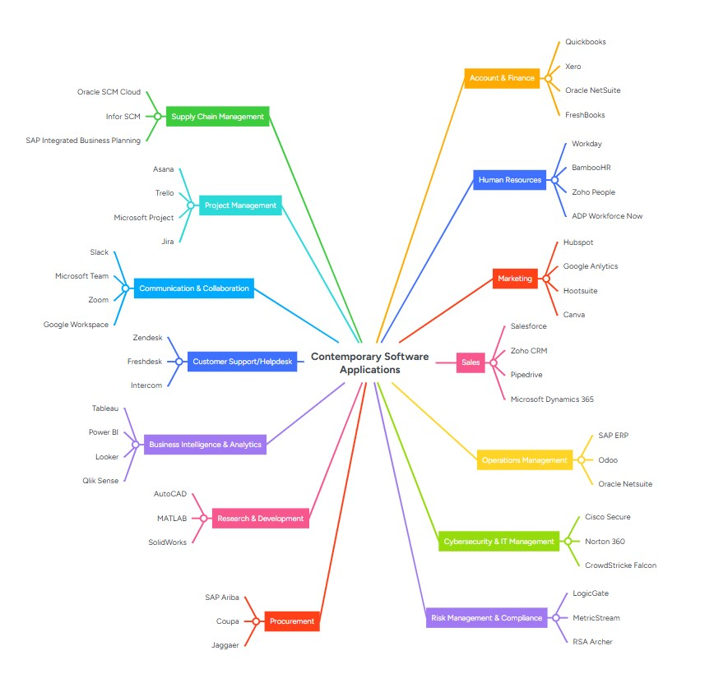

Task 3. Office Applications

3.1 Four office software solutions for business operations

Ms Word
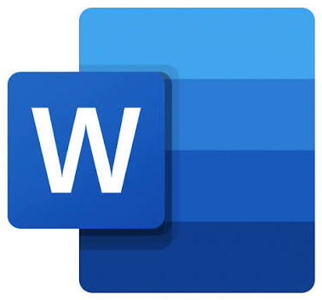
Microsoft Word is a popular word processing application developed by Microsoft. It is one of the most widely used software programs in the world for creating, editing, formatting, writing letters , make life very easy, you can also printing documents. Microsoft word is part of Microsoft 365 and now copilot of applications, you can buy from Microsoft website yearly or monthly subscription . used to be life time licence but not any more. It is used by students, teachers, professionals, businesses, and individuals for a variety of tasks, including writing letters, reports, assignments, resumes, newsletters, books, and business documents.
Microsoft Word is its user friendly interface. The program uses a ribbon menu that organizes commands into tabs such as Home, Insert, Design, Layout, References, Review, and View. This layout makes it easy for users to find the tools they need..
Microsoft Word includes many powerful editing features that improve the quality of written work. The spell checker and grammar checker help users identify and correct mistakes, while the thesaurus suggests alternative words to improve vocabulary. Users can also use the Find and Replace tool to quickly locate and change words or phrases throughout a document.
Microsoft word is the most useful software for typing letter , assignment , even you can do you school work or office work. It give you other features like create table , you can insert photos , mail merge option. There are many option which you can use in Microsoft word. Student , business and individual use this Microsoft word for their type of work they want to do. When you save files in Microsoft word it give you different option with different format you can save the files , doc, html, pdf , jpeg . you can import pdf file in Microsoft word. There are many options in Microsoft word.

Microsoft Word is its ability to insert different types of content into documents. Users can add tables, pictures, shapes, icons, charts, SmartArt graphics, hyperlinks, headers, footers, page numbers, and equations. These features make documents more informative, organized, and visually appealing. Word also supports templates that help users quickly create professional documents without starting from scratch.
Microsoft Word makes collaboration simple by allowing multiple users to review and edit documents. Features such as comments, Track Changes, and real time co-authoring make it easier for teams to work together on shared files. Documents can be saved locally or stored in cloud services, making them accessible from different devices. Users can also save documents in multiple formats, including DOCX, PDF, and RTF, making it easy to share files with others.
In conclusion, Microsoft Word is a versatile and reliable word processing application that meets the needs of users in education, business, and personal settings. Its wide range of formatting, editing, collaboration, and document management features makes it an essential tool for creating high quality documents efficiently. Because of its ease of use and powerful capabilities, Microsoft Word remains one of the most trusted and widely used word processing programs in the world.

Ms Excel
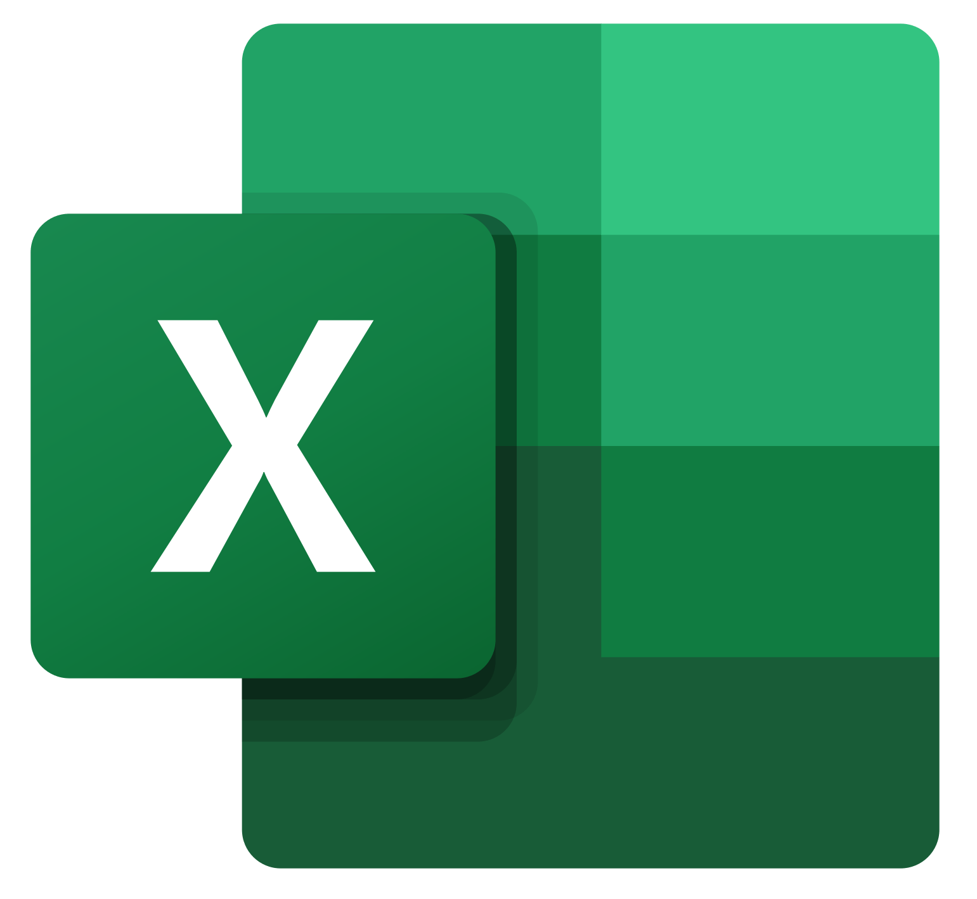
Microsoft Word and Microsoft Excel Description
Microsoft Excel is good for accounts, as many business platform using Microsoft excel for their accounts , accountancy filed Microsoft excel play big roll with the Microsoft excel it make their work very easy. Microsoft Word and Microsoft Excel are two of the most widely used applications in the Microsoft Office (Microsoft 365) suite. They are designed to help users create documents, organize data, perform calculations, and improve productivity in schools, businesses, and personal work. Both programs are easy to use and provide a wide range of features that make everyday tasks faster and more efficient.
Microsoft Word is a word processing application used to create, edit, format, and print text documents. It is commonly used for writing letters, reports, assignments, resumes, meeting agendas, newsletters, and business documents. Word offers a user-friendly interface with tools for changing fonts, text size, colors, alignment, and page layout. You can also make graph table , if you are preparing conference where you have to demonstrate you presentation regarding your account Microsoft excel can use for account. It also includes features such as spell check, grammar check, AutoCorrect, and a thesaurus to improve the quality of written content. Users can insert tables, pictures, charts, shapes, SmartArt, headers, footers, page numbers, and hyperlinks to create professional-looking documents. Word also supports templates that help users quickly create documents with attractive designs. Documents can be saved in different formats, including DOCX and PDF, making them easy to share and print.
Microsoft Excel is a spreadsheet application used to organize, calculate, applying formulas to make data analyse , and present data. It is widely used in businesses, educational institutions, and financial organizations for managing records, budgets, inventories, payroll, sales reports, and other numerical information. Excel stores data in rows and columns, creating worksheets that make information easy to organize and understand. One of its greatest strengths is the ability to perform automatic calculations using formulas and functions such as SUM, AVERAGE, COUNT, MAX, and MIN. Excel also allows users to create charts, graphs, and tables that help visualize data and identify trends. Features such as sorting, filtering, conditional formatting, and PivotTables make it easier to analyse large amounts of information accurately and efficiently.
Both Microsoft Word and Microsoft Excel support collaboration by allowing users to share files, add comments, and work on documents simultaneously through cloud storage services. They also integrate with other Microsoft applications, making it easier to manage projects and share information across different platforms
Microsoft excel is the most advance software in account field. Cross the glob Microsoft excel use specially for making account , spread sheet , create account data base. You can also export this file to Microsoft word. Microsoft excel can be merge with other software. Which can be useful for other platform.
In conclusion, Microsoft Word and Microsoft Excel are essential productivity tools that serve different but complementary purposes. Word is ideal for creating professional documents, while Excel is best for managing and analysing data. Together, they improve efficiency, accuracy, and communication, making them valuable applications for students, teachers, professionals, and organizations around the world.

Ms PowerPoint
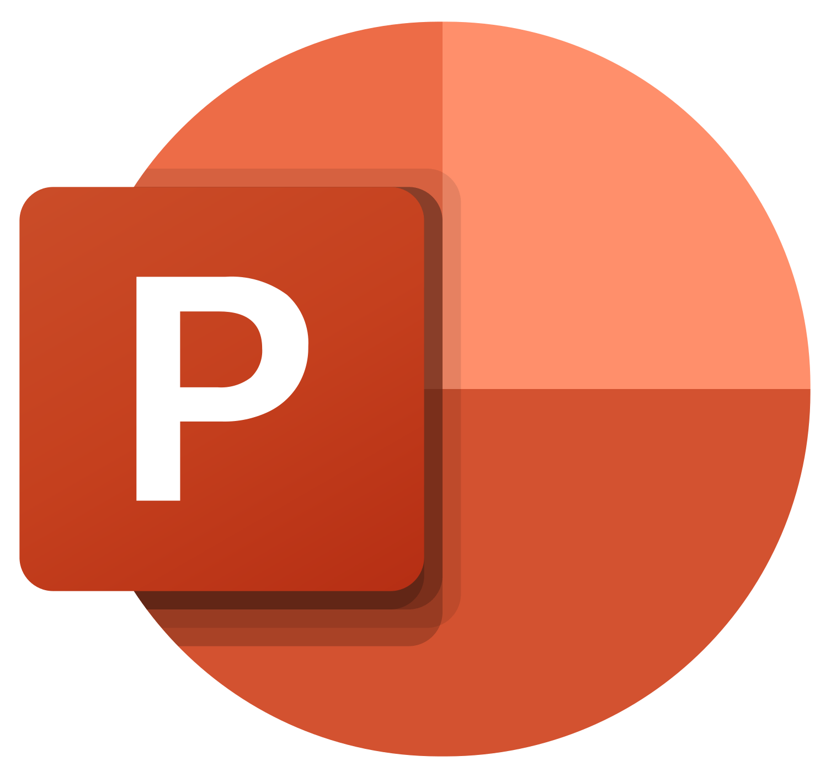

Microsoft PowerPoint Description
Microsoft PowerPoint is a presentation software developed by Microsoft and included in the Microsoft Office (Microsoft 365) suite. It is widely used by students, teachers, business professionals, trainers, and organizations to create attractive and informative presentations. PowerPoint allows users to present information in a clear, organized, and visually appealing way using slides that can contain text, images, charts, tables, audio, video, animations, and other multimedia elements.
One of the main features of Microsoft PowerPoint is its slide-based format. Each presentation consists of a series of slides that can be customized with different layouts, themes, colors, and fonts. Users can easily add titles, bullet points, pictures, diagrams, icons, and SmartArt graphics to make presentations more engaging and easier to understand. Built-in design templates help users create professional-looking presentations without requiring advanced design skills.
Microsoft PowerPoint provides many tools to improve the quality of presentations. Users can add animations to text and objects to highlight important points and use slide transitions to create smooth movement between slides. Audio recordings, videos, and narration can also be inserted to make presentations more interactive and interesting. Charts and graphs created in Microsoft Excel can be added to display numerical data in a simple and effective way.
Another important feature of PowerPoint is Presenter View, which allows presenters to view speaker notes, slide previews, and a timer while the audience sees only the presentation. This helps speakers stay organized and deliver presentations with confidence. PowerPoint also includes collaboration features that allow multiple users to edit the same presentation, leave comments, and share files through cloud storage services such as OneDrive.
PowerPoint presentations can be saved in different formats, including PPTX, PDF, and video files. Users can also print handouts and speaker notes for meetings, classrooms, and conferences. The software supports presentations on computers, tablets, and smartphones, making it convenient to access and present information from almost anywhere.
Microsoft PowerPoint is used in many fields, including education, business, healthcare, marketing, and government. Teachers use it to explain lessons, students use it for class projects, and businesses use it for meetings, training sessions, sales presentations, and project proposals. Its ability to combine text, graphics, and multimedia makes communication more effective and engaging.
Microsoft PowerPoint make easy to create slide, which can be use in different way. Student can make there assignment and business make the slide for their presentation . Microsoft PowerPoint is great tool which make your presentation look great , you can ad photos , animation , change the background colour. You can create the URL link for website.
In conclusion, Microsoft PowerPoint is a powerful and versatile presentation application that helps users create professional, attractive, and informative slide presentations. Its easy-to-use interface, multimedia features, collaboration tools, and flexible presentation options make it one of the most popular presentation programs in the world.

Ms Access



Microsoft Access Description
Microsoft Access is a database management system (DBMS) developed by Microsoft and included in selected editions of the Microsoft Office (Microsoft 365) suite. It is designed to help users create, store, organize, manage, and retrieve large amounts of data efficiently. All the big industry use Microsoft access data base as its make the work very easy, Microsoft access data base tool is great you can use in different platform , even when you make the website you can use Microsoft access for data base. Where customer data can be save and you can access whenever you need it . Microsoft Access is widely used by businesses, schools, government offices, and small organizations to manage information such as customer records, employee details, inventory, student data, sales reports, and financial records.
Microsoft Access combines the features of a relational database with an easy-to-use graphical interface. It stores information in tables, where data is organized into rows and columns. Each table contains records and fields that represent specific types of information. By creating relationships between tables, users can avoid duplicate data and maintain accurate, organized records. This makes data management more efficient and reliable.
One of the most important features of Microsoft Access is its ability to create queries. Queries allow users to search for specific information, filter records, sort data, and perform calculations quickly. Instead of searching through large amounts of data manually, users can retrieve the exact information they need in just a few seconds. Access also supports forms, which provide a user-friendly way to enter, edit, and view data without directly working in database tables.
Microsoft Access includes powerful reporting tools that help users create professional reports based on stored data. Reports can be customized with headings, charts, totals, and formatting options, making them useful for business analysis and decision-making. Users can print reports or export them to formats such as PDF or Excel for sharing with others.
Another useful feature of Microsoft Access is automation through macros and Visual Basic for Applications (VBA). Macros help automate repetitive tasks, while VBA allows advanced users to create custom database applications with additional functionality. These features increase productivity and reduce manual work.
Microsoft access make the work much easier with data base programme. It used cross the glob for data base purpose. Where all the data store and you can access anytime . and it can be share whenever you need it.
Microsoft Access can also import and export data from various sources, including Microsoft Excel, Microsoft Word, SQL Server, and text files. It integrates well with other Microsoft Office applications, allowing users to share information and create complete business solutions. The software includes templates that help users quickly build databases for common tasks such as contact management, inventory tracking, and project management.
In conclusion, Microsoft Access is a powerful and flexible database management application that helps users organize, store, and analyze data effectively. Its features, including tables, queries, forms, reports, relationships, and automation tools, make it an excellent solution for managing information. Because of its ease of use and strong database capabilities, Microsoft Access remains a valuable tool for students, professionals, and organizations that need efficient data management.

3.2 Test any two features

Mail Merge
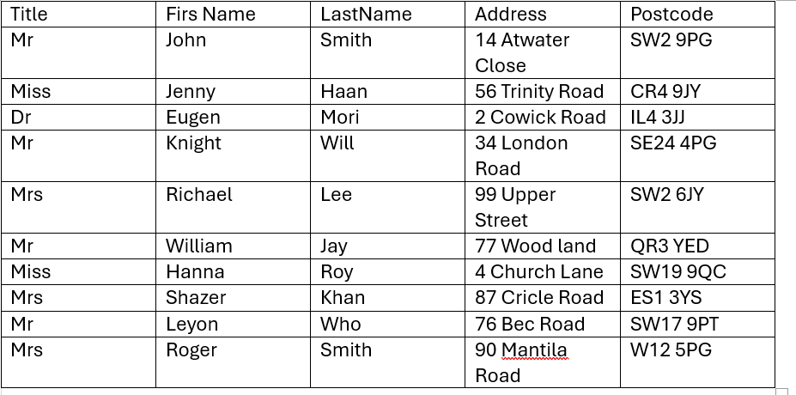

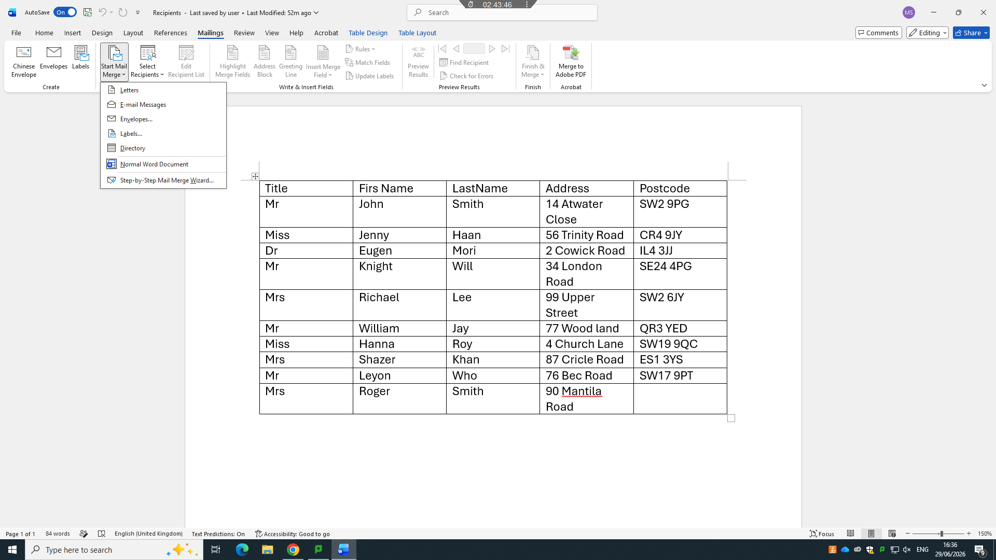

IF Statement
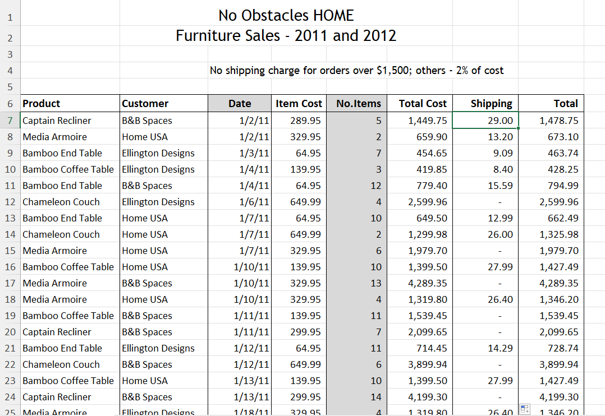
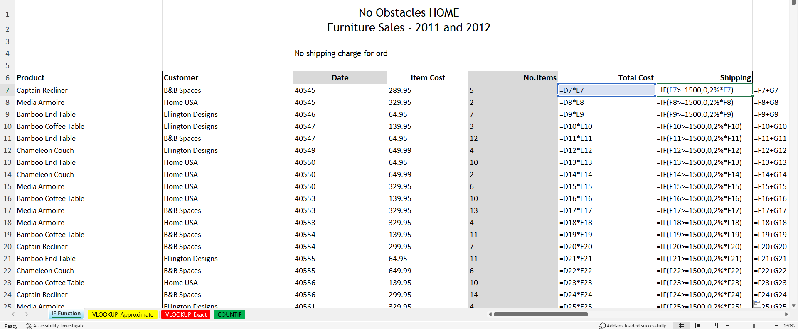

Task 4. Communication and Collaboration applications

Communication and Collaboration Applications
Communication and collaboration applications are software tools that enable individuals and teams to interact, share information, coordinate tasks, and work together effectively regardless of their physical location. These applications have become an essential part of modern organizations, educational institutions, healthcare services, and personal communication. With the increasing adoption of remote work, hybrid workplaces, and digital learning, communication and collaboration applications play a vital role in improving productivity, enhancing teamwork, and ensuring efficient information sharing.
Communication applications primarily focus on exchanging information between users through text, voice, video, or multimedia. Examples include email platforms, instant messaging applications, video conferencing software, and Voice over Internet Protocol (VoIP) services. Collaboration applications, on the other hand, provide tools that allow multiple users to work together on projects, documents, schedules, and tasks in real time. Many modern platforms combine both communication and collaboration features into a single integrated solution.
One of the most important features of communication applications is instant messaging. Instant messaging allows users to send text messages instantly to individuals or groups. Unlike traditional email, which may involve delays, instant messaging provides real-time communication that enables quick decision-making and problem-solving. Many applications also support file sharing, voice notes, emojis, and reactions to improve communication and engagement among users.
Video conferencing has become one of the most widely used communication technologies. Applications such as Microsoft Teams, Zoom, and Google Meet allow users to conduct virtual meetings, webinars, online classes, and interviews from anywhere with an internet connection. These platforms support features such as screen sharing, meeting recording, virtual backgrounds, breakout rooms, live captions, and chat functions.
Email remains one of the most reliable communication applications in professional environments. It provides a formal method of exchanging information, documents, and official announcements. Email applications support attachments, mailing lists, scheduling, automated responses, and integration with calendars and task management systems. Although newer communication tools have become popular, email continues to be essential for business correspondence and record keeping.
Cloud-based document editing platforms allow several people to edit the same document at the same time while tracking changes and maintaining version history. This eliminates the need to send multiple document versions through email and reduces confusion caused by outdated files. Team members can comment, suggest edits, and review content collaboratively, improving efficiency and teamwork.
Project management is another important aspect of collaboration applications. These tools help teams organize projects, assign tasks, monitor deadlines, and track progress. Features such as task lists, calendars, Kanban boards, Gantt charts, reminders, and progress reports enable managers and employees to stay informed about project status. By providing transparency and accountability, project management applications improve workflow and reduce the risk of missed deadlines.
File sharing and cloud storage are essential components of collaboration software. Users can securely upload, store, organize, and share files through cloud services, allowing team members to access documents from different devices and locations. Cloud storage ensures that files remain available even if a user's computer is lost or damaged. Permissions and access controls also allow administrators to determine who can view, edit, or download specific files.
Communication and collaboration applications offer numerous benefits to organizations. They improve productivity by enabling faster communication and reducing delays in decision-making. Employees can collaborate on projects without being physically present in the same office, supporting remote and hybrid work environments. Educational institutions have also benefited significantly from communication and collaboration technologies.
Healthcare organizations use communication applications to improve patient care and coordination among medical professionals. Doctors can conduct virtual consultations through telemedicine platforms, reducing the need for patients to travel for routine appointments. Healthcare teams can securely share medical information, coordinate treatment plans, and communicate quickly during emergencies.
Modern communication and collaboration applications often include artificial intelligence (AI) features that enhance productivity. AI powered assistants can schedule meetings, transcribe conversations, summarize discussions, translate languages, generate meeting notes, and automate repetitive tasks. Chatbots can answer common questions, provide technical support, and guide users through various processes. These intelligent features reduce manual work and help users focus on more valuable activities.
Security is a major consideration when using communication and collaboration applications. Since these platforms often store sensitive business and personal information, developers implement various security measures such as encryption, multi-factor authentication, secure login procedures, user access controls, and regular security updates. Organizations should also establish policies regarding password management, data sharing, and acceptable use to minimize cybersecurity risks.
Despite their many advantages, communication and collaboration applications also present some challenges. Technical problems such as poor internet connectivity, software bugs, and compatibility issues can disrupt meetings and collaboration. Excessive notifications and constant communication may reduce employee concentration and contribute to digital fatigue. Remote communication may also lead to misunderstandings because participants cannot always interpret facial expressions, tone of voice, or body language accurately. Organizations should establish clear communication guidelines and encourage balanced use of digital tools to address these challenges.
Organizations should evaluate their communication needs, choose appropriate software, provide employee training, and ensure compatibility with existing systems. User-friendly interfaces, reliable technical support, regular software updates, and strong security measures contribute to successful adoption. Integration with other business applications such as customer relationship management (CRM), enterprise resource planning (ERP), and document management systems further improves organizational efficiency.
The future of communication and collaboration applications is expected to include greater use of artificial intelligence, virtual reality (VR), augmented reality (AR), and advanced automation. Virtual workspaces may allow employees to collaborate in immersive three-dimensional environments, creating experiences similar to physical offices. AI will continue to improve language translation, meeting summarization, workflow automation, and personalized productivity recommendations.
In conclusion, communication and collaboration applications are essential tools that support effective interaction, teamwork, and information sharing in today's digital world. They enable organizations, educational institutions, healthcare providers, and individuals to communicate efficiently, collaborate on shared tasks, and manage projects regardless of geographical location. By combining messaging, video conferencing, document sharing, project management, cloud storage, and intelligent automation, these applications significantly improve productivity and organizational performance. Although challenges such as security concerns and digital fatigue must be managed carefully, the benefits of communication and collaboration technologies far outweigh their limitations, making them indispensable in modern society.

4.1 One contemporary Communication and one Online Collaboration

Gmail


Contemporary Communication Gmail:
Gmail is an email service used to send and receive messages quickly and professionally.
Online Collaboration Gmail:
Gmail supports online collaboration by allowing users to share files and communicate with colleagues through email and Google Workspace tools.

Zoom

Contemporary Communication Zoom:
Zoom allows people to communicate through video calls, voice calls and instant messaging.
Online Collaboration Zoom:
Zoom helps teams collaborate online through meetings, screen sharing and group discussions.

4.2 Test one feature of a freely available Communication (1) and one feature of a Collaboration (1) application

Microsoft Outlook
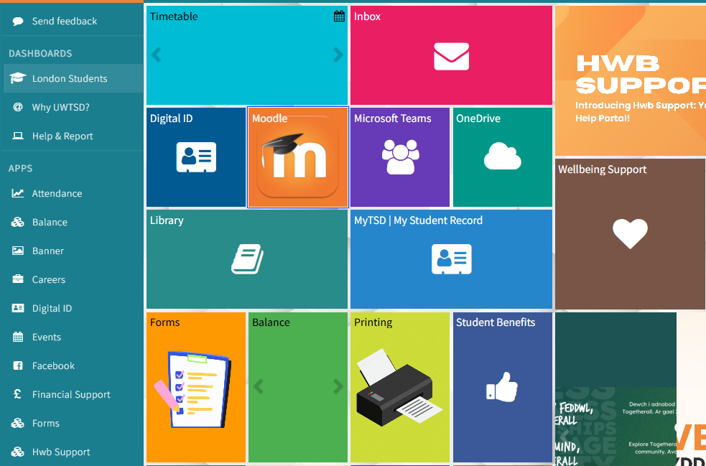

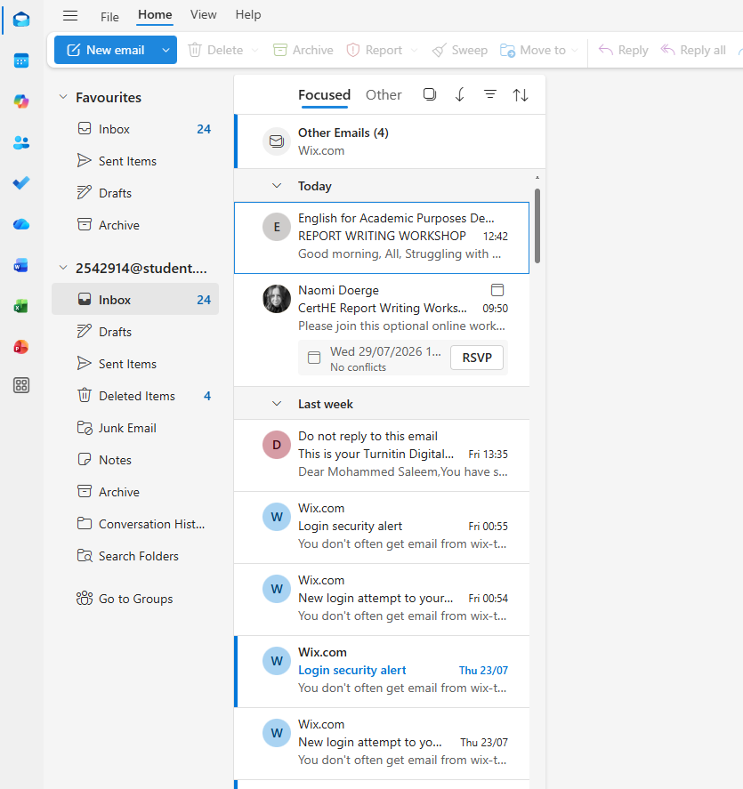

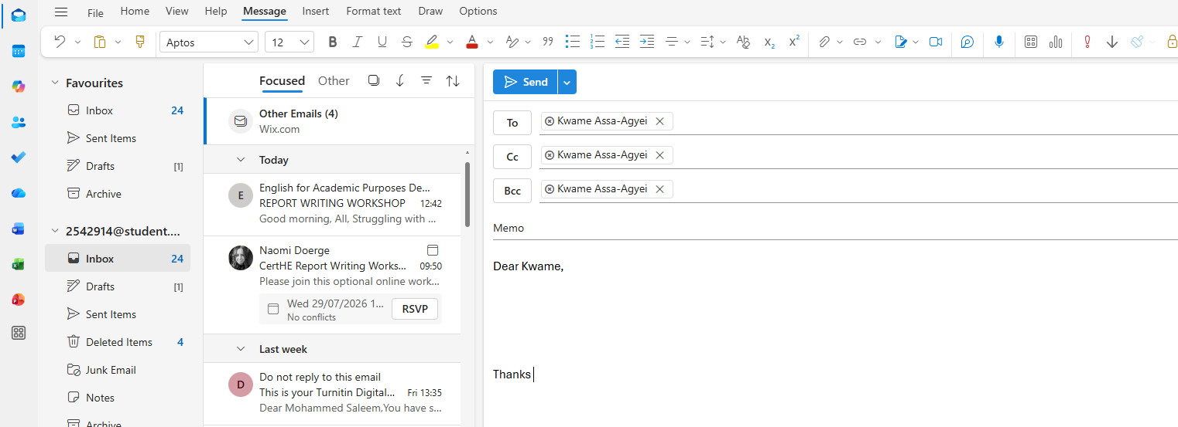
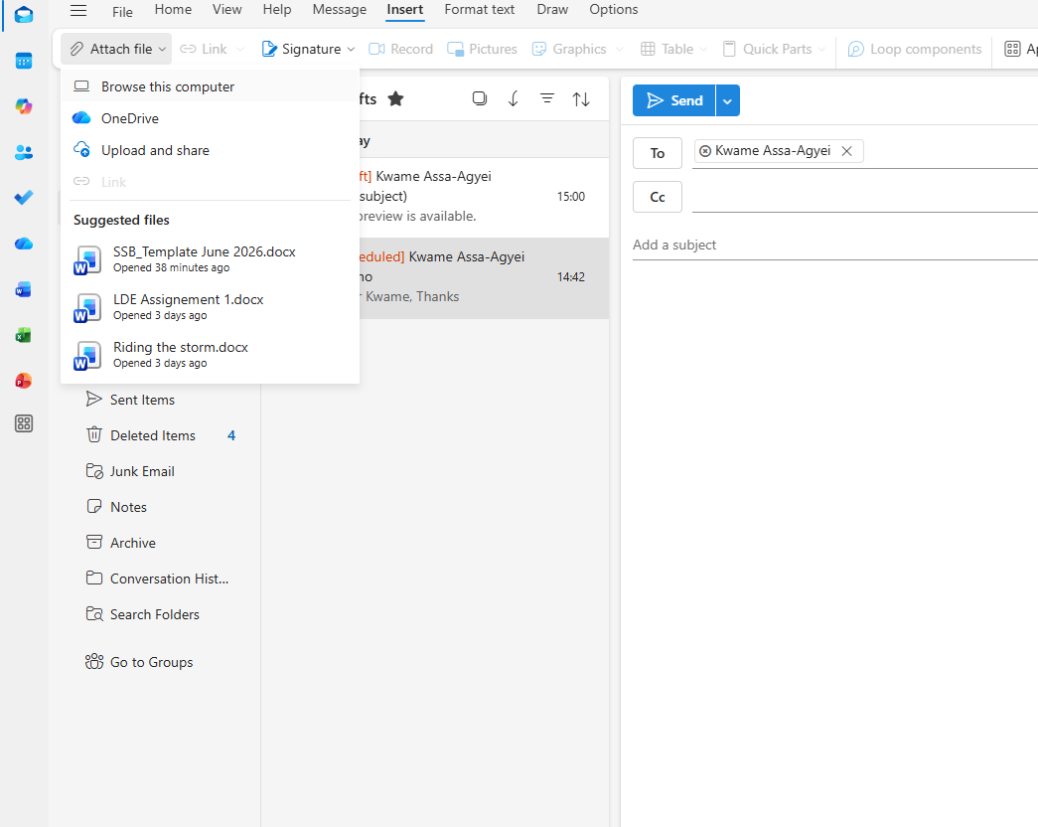
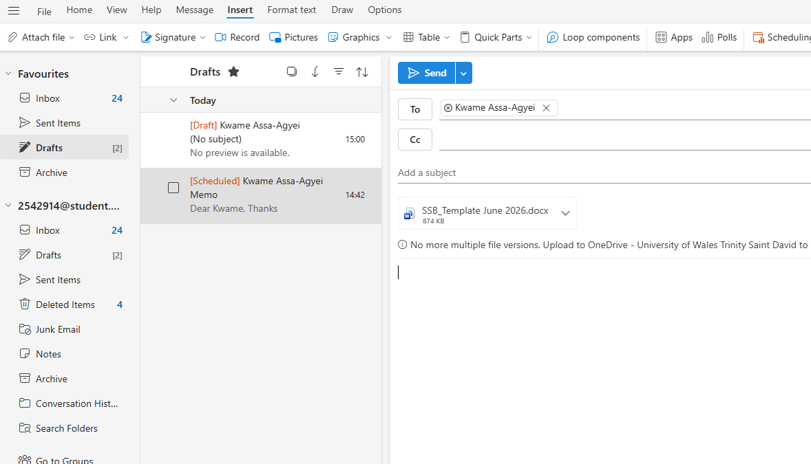
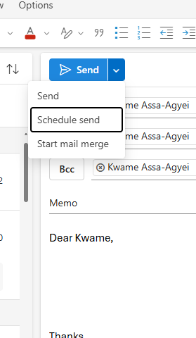
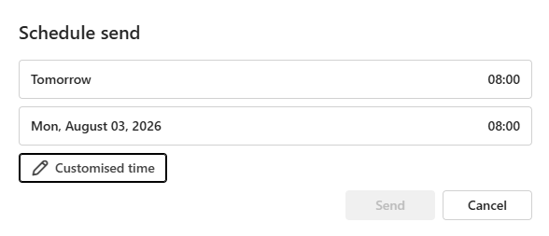
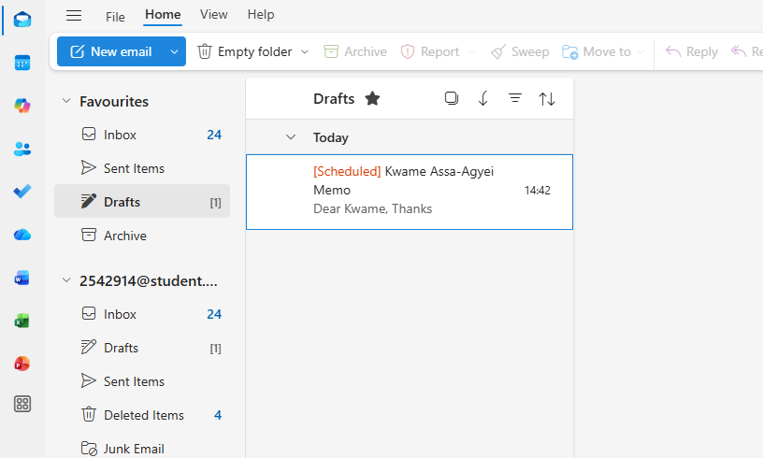

Microsoft Teams

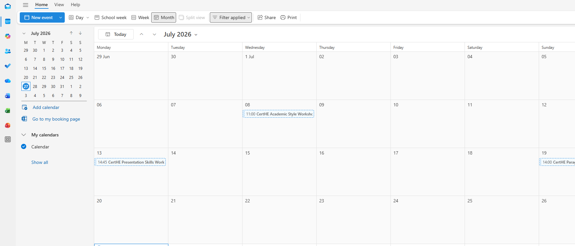
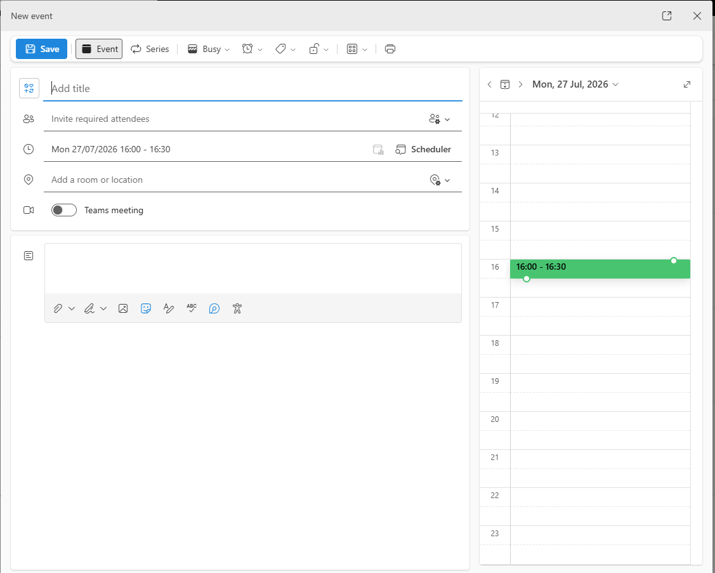
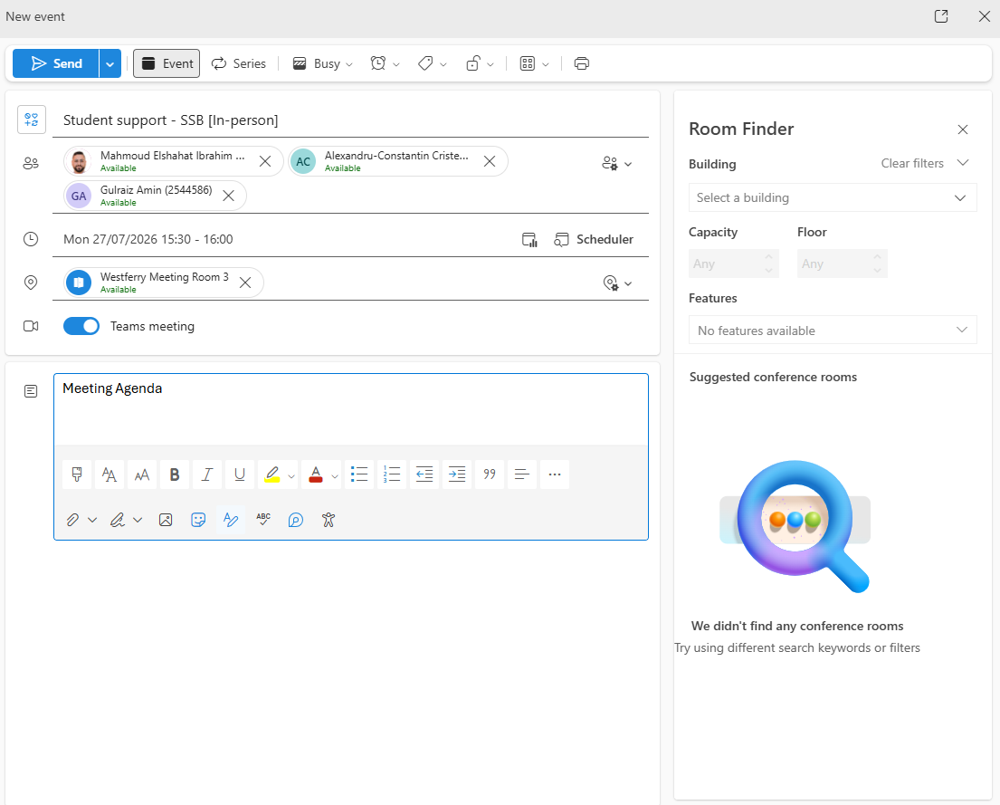
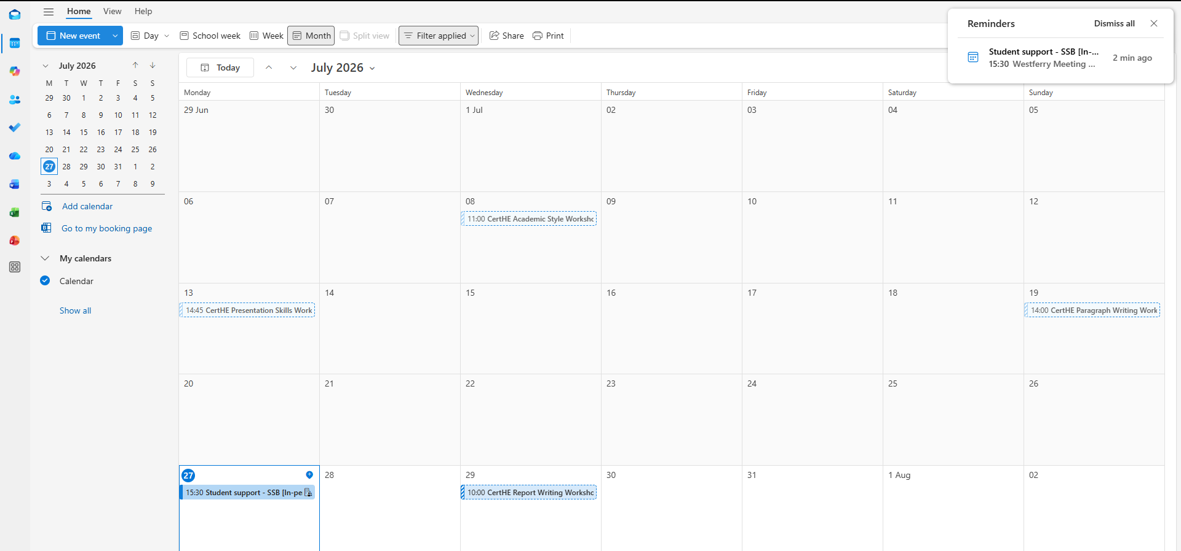
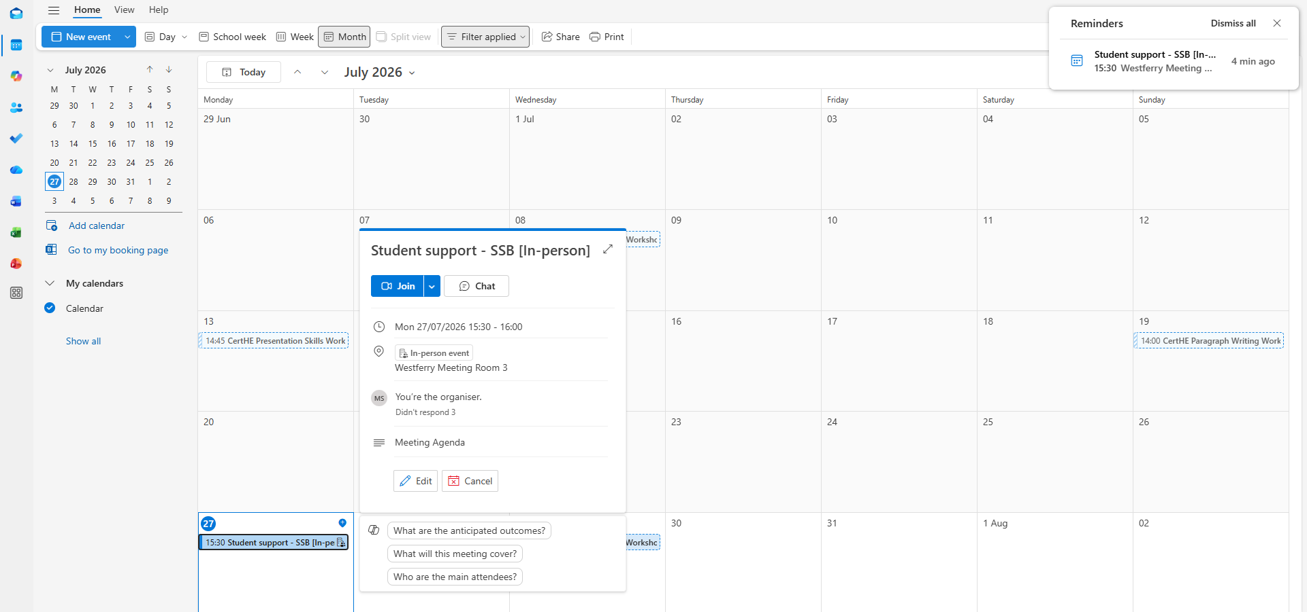
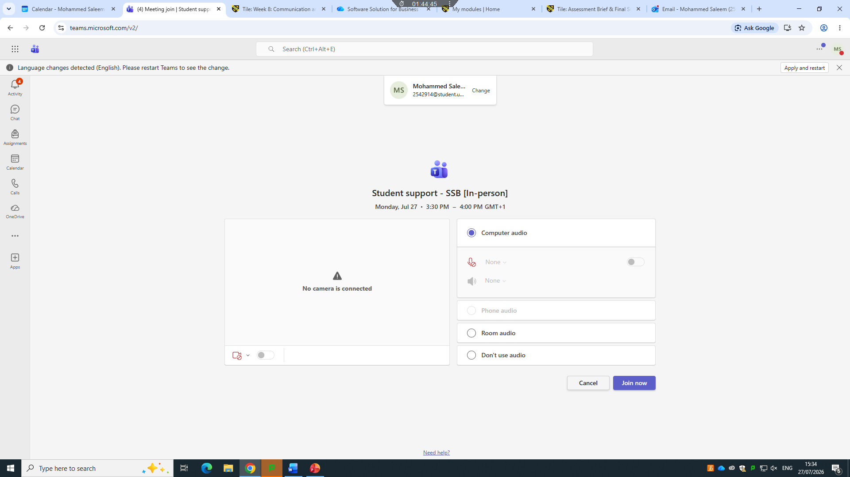
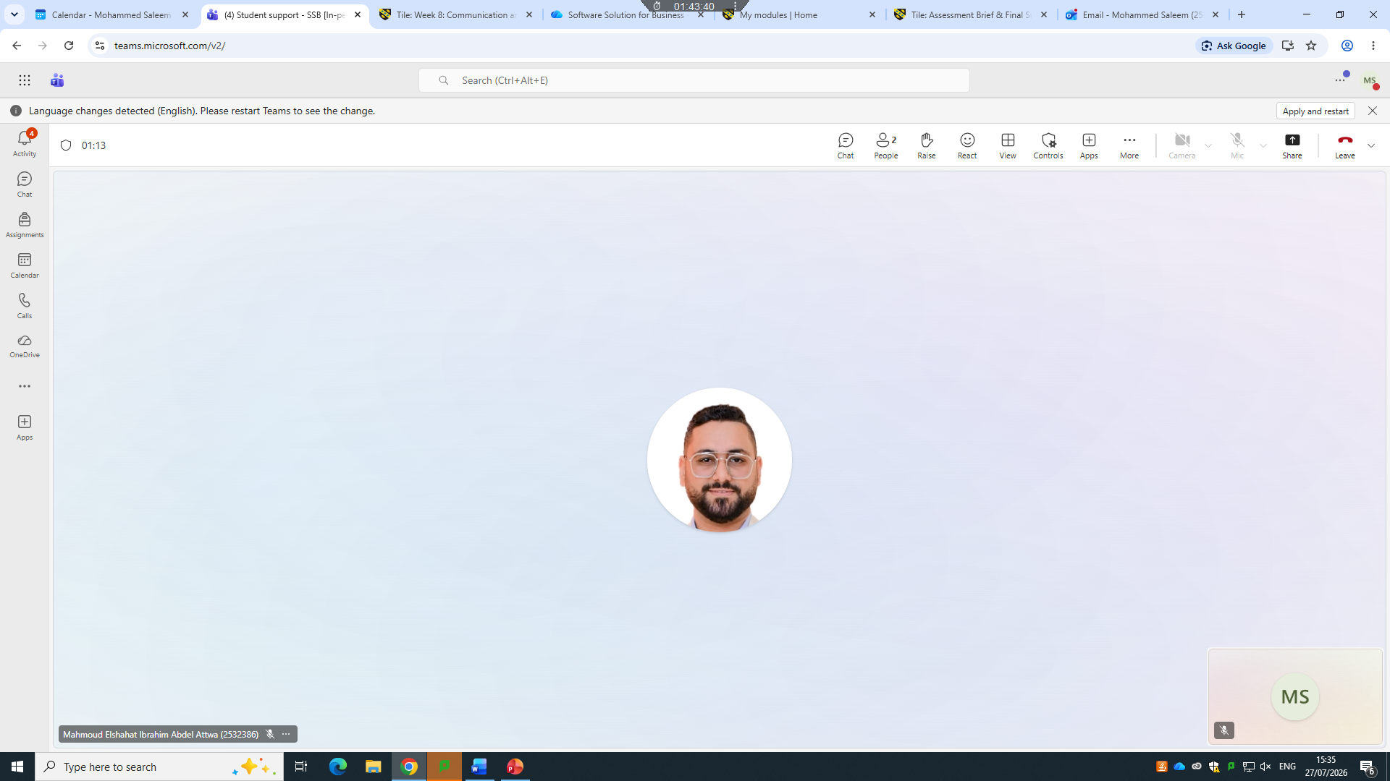

References

[1] | S. Marchant, “https://www.alumio.com/,” 9 feb 2024. [Online]. Available: https://www.alumio.com/blog/e-commerce-software-solutions-explained. [Accessed 11 08 2026].
[2] | Dipak Bhattacharya, Ramakanta Mohalik, “https://www.researchgate.net/,” october 2020. [Online]. Available: https://www.researchgate.net/publication/344465685_Digital_Mind_Mapping_Software_A_New_Horizon_in_the_Modern_Teaching-Learning_Strategy. [Accessed 11 08 2026].
[3] | Grafiati, “https://www.grafiati.com/,” 4 june 2021. [Online]. Available: https://www.grafiati.com/en/literature-selections/microsoft-office-computer-software/journal/. [Accessed 11 08 2026].
[4] | Gina Solano , Jennifer Miller, “https://www.researchgate.net/,” 09 2025. [Online]. Available: https://www.researchgate.net/publication/395635261_Improving_Communication_and_Collaboration_How_Using_a_Communication_App_Improves_the_Online_Student_Learning_Experience. [Accessed 11 08 2026].

