

COMMUNITY ENGAGEMENT
Module code: LCBB4002

Student name: Valentina Simona Duroiu
Student’s ID: 2021942
Executive Summary
Community issues are very common in every country which requires proper inspection and provision of justice to the survivors. This essay highlights one such program named the Justice- UK which is conducted by a UK-based organisation that goes by the name Redress to help torture survivors. Various factors related to the program are discussed in detail to provide a proper understanding of the project. An analysis of the best practices undertaken by the organisation is elaborately discussed highlighting the stakeholders' participation. The internal and external factors are examined giving importance to social integration and multiculturalism. Lastly, recommendations are provided for the betterment of the programs.

Table of Contents

1. Introduction 4
2. Discussion 5
2.1 Description of the program 5
2.3 Analysis of the best practices 6
2.4 Strategies suitable for engaging the stakeholders 7
2.5 Utilization of the social media platforms 8
2.6 Socio-cultural integration and multi- culturalism 10
2.7 Internal and external factors that influence community development 10
2.8 Why does community engagement practitioner need to educate community members? 11
2.9 Recommendation 11
3. Conclusion 12
References 13

Introduction
Many companies overlook the community issues that cause difficulties and disrupt the overall environment. Although there are many organisations with only focus on community issues and engage themselves in doing charity and conduct programs accordingly to help the victims overcome the difficult situation. Every day people come across innumerable social issues such as crime, social stratification, abuse of public health, child labour, social inequality, negligence to human rights, etc. In this study, an elaborate discussion about a UK-based organisation is done to understand their charitable programs in detail.
The name of the organisation chosen for this paper is The Redress Trust which is an organisation based on human rights located in London, England. Redress was founded by Keith Carmichael, who was a British torture survivor, in 1992. This organisation deals with helping the survivors of torture for obtaining justice in the form of rehabilitation, compensation, formal apologies, and official acknowledgment of the wrong deed. It also looks after the individuals who are the victims of torture. This organisation provides legal support for promoting the rights of the survivors. In this essay, a specific program termed Justice which is organised by the company for promoting justice to the torture survivors is discussed in detail.

Figure 1: Logo of Redress
(Source: Redress.org. 2021)

2. Discussion

2.1 Description of the program
The Justice program focuses on promoting justice to the torture survivors and deals with their recovery. This program helps in bringing civil cases, human rights cases, and criminal cases under jurisdiction to provide justice to the victims (Redress.org. 2021). Through the Justice program, the people associated with Redress demonstrate their commitment towards the survivors and accompany them throughout the justice process. The helps the citizens of the UK who are victims of torture to get psychosocial support and thus improve their condition (torturecare.org.uk. 2021). The program also initiates policy changes for improving the situation of the individuals who are the victims of torture while encouraging police inspection.
This program covers two sectors for doing charity. One is Justice UK and the other is Justice International. Justice- UK deals with charity programs in the UK for both citizens and refugees. Justice- International focuses on the jurisdictions in Africa, Asia, America, etc (Redress.org. 2021). Various projects fall under this program for securing justice for the survivors and allowing them to lead healthy lives. The different cases comprising the program Justice are described below:
1. Justice for torture survivors- It is observed that the program Justice worked with partners in Sudan for addressing obstacles for accountability for violation of human rights (torturecare.org.uk. 2021). The program helped in introducing anti-torture reforms in the vicinity for encouraging universal jurisdiction.
2. Working on perceptions of Justice- These deals with doing research and producing reports about the attitude behind the survival against torture and improving support for legal assistance.
3. International platform for accountability- This program also collaborates with other projects for encouraging justice and preserving the documents as evidence (Linkedin.com. 2021). This evidence helps to fight against violations of human rights.

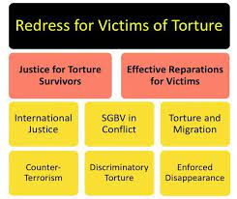
Figure 2: Concepts and theme of their program
(Source: Redress.org. 2021)

Analysis of the best practices
Community engagement principles and standards
The organization engages itself in building skills and mentoring the community so that they support and become mentally strong for fighting against the violation of human rights and tortures. The Redress through its Justice program develops litigation workshops for providing advice to several cases and support by hiring lawyers (Redress.org. 2021). It also provides effective training for evaluating and identifying the importance of learning for improving the jurisdiction to provide justice to the victims.
Benefits of stakeholders' participation
It is evident that every program is related to various stakeholders and their participation is highly essential for the success of the overall process. Engagement of stakeholders deals with providing opportunities for sharing different views and knowledge about the processes related to charity. A proper consensus can be built by taking the views of a diverse range of stakeholders (Atsdr.cdc.gov. 2021). These individuals or groups help in providing the resources as well as manpower required for achieving the mission efficiently. These individuals directly influence the programs and deal with the success of the organisation for providing relevant outcomes.

2.4 Strategies suitable for engaging the stakeholders
Stakeholders are essential for the financial sustainability of any non-profit organisation. Organisations such as Redress require predictable funds from various sources and donations by the private sectors and various Government grants to support their operations (Jones et al., 2020, p. 1341-1342). For this reason, it is essential to engage the stakeholders for helping the organisation to achieve the desired outcomes. It is essential to influence the stakeholders while concentrating on their interests and perspectives for improving financial sustainability. Various strategies are designed for the engagement of potential stakeholders for the benefit of the organisation and thus improving the condition of the victims (Redress.org. 2021). The different strategies are discussed below:
Surveying the stakeholders: Among various strategies that are used for engaging stakeholders the most important is surveying the stakeholders to understand their importance.
Prioritising the stakeholders: Prioritising the stakeholders by checking their interest level and the extent of their influence.
Stakeholder communication: It is necessary to communicate the ongoing processes of the organisation regularly to the stakeholders so that they are aware of the current activities and plans.
Stakeholder mapping: Mapping of stakeholders is essential for measuring the return on investment of the stakeholder engagement (Redress.org. 2021). This is essential to understand the value of every stakeholder and their importance in achieving success by conducting the program effectively.
Arranging regular meetings: Meetings must be arranged between the organisation and the stakeholders for providing and maintaining the institutional knowledge and making them aware of the current processes (Bang the Table. 2021). This not only helps to engage the stakeholders effectively but also effectively initiates the management processes.
Influencing the stakeholders: It is also necessary to influence the stakeholders so that they can help in solving the problems and conducting the programs successfully to help the victims. Opportunities should be looked upon to engage the stakeholders effectively and seek their contribution for justice and jurisdiction (Redress.org. 2021).

2.5 Utilization of the social media platforms
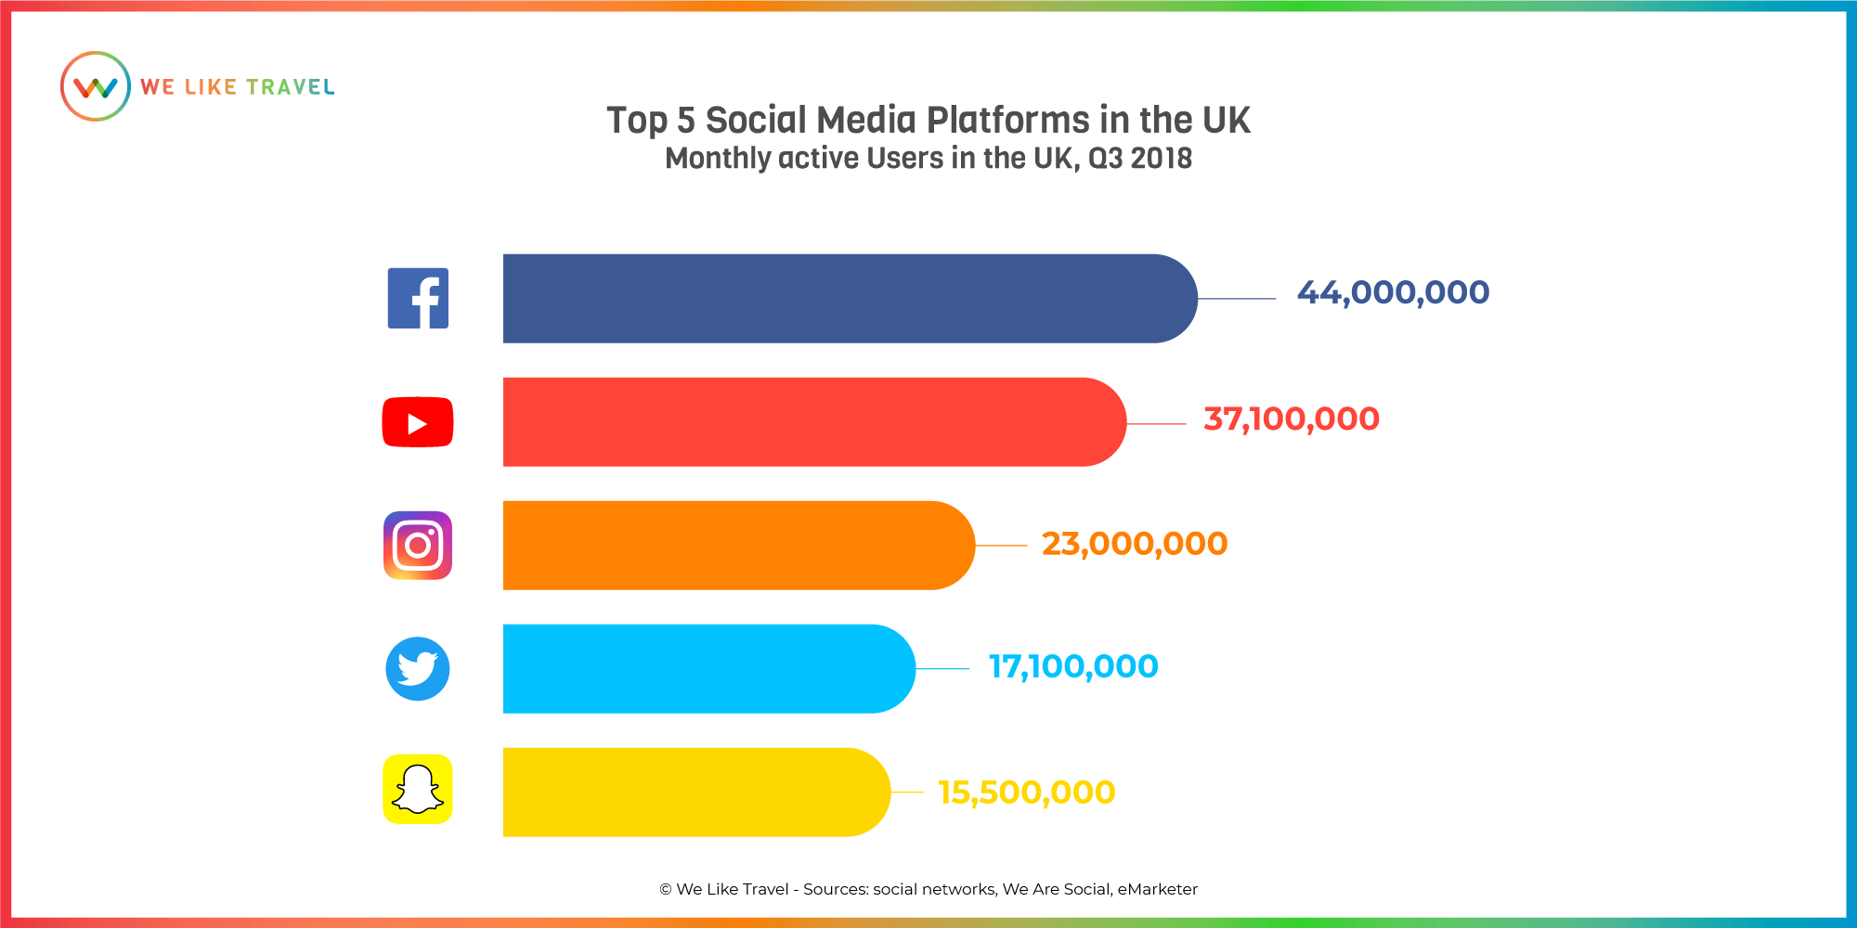
Figure 3: Social media platforms used by the organization
(Source: We-like-travel.com. 2021)
In recent times the social media platforms are used to a huge extent for circulating various programs and raising funds for doing charity. It is said to be the most effective tool for marketing for various non-profit organisations. Various social media platforms such as Facebook, YouTube, Instagram, Twitter, etc. are used for various types of advertisements (Horton et al., 2018, p. 191-197). There are innumerable benefits of using social media marketing for various charity programs. The Redress also takes the help of social media to make the people aware of the program Justice run by them for helping the torture survivors to seek legal help and get justice. There are numerous advantages of using social media effectively and raising funds as well as making common people aware of the deeds of the organisation (Smith-Carrier, 2020, p. 157-163). Few benefits of utilization of social media are described below:
Connectivity: Using the social media platform helps an organization to reach billions of people in a significant manner.
Cost-effective promotion: Moreover, the social media postings are free of cost and thus the company does not engage any money for the advertisement (Haoussou, 2017).
Circulating specific objectives: It helps in circulating the specific objectives of an organisation and details of a program organised by them for the benefit of common people.
Attracting donors and sponsors: It helps in attracting new donors and at the same time engages the existing stakeholders.Since a link is provided with the advertisement, people can easily check the details of the organization by using this platform (Pérez-Sales, 2018, p. 1-4).
Growth of network: The social media platform helps in the growth of the network and thus encourages many new members to come forward and help. It also helps the victims to know about the organisation and seek help accordingly.

2.6 Socio-cultural integration and multi- culturalism
Socio-cultural integration deals with an understanding of the factor of whether an ethnic minority class is a part of the society or it remains distinct from the country in which an organisation operates (Bhatia and Burnett, 2019). This focuses on the combination of different cultures in a unified society so that every group gains acceptance in the operating area or country. It enables an individual regardless of their community to enjoy equal opportunities, services, and rights provided by the legal bodies of an area or country as a whole.
Multiculturalism is a public policy that is adopted by various governments due to the advancement of International Trade and the effect of globalisation (Dehghan, 2018, p. 77-91). This helps to provide a better understanding of different cultures and respect them. It helps in increasing creativity by encouraging diverse cultures and valuing every belief. It also helps to align various processes in a global workforce. Multiculturalism deals with providing better service to the victims of all criminal offenses and providing them justice by building a productive relationship (Abu Suhaiban et al., 2019, p. 2309). It helps in strengthening the cultural bondings and provides importance to every individual coming from different backgrounds.

2.7 Internal and external factors that influence community development
It is known that various factors play an essential role in the development of any community or conduction of a program (Gardner, 2018, p. 163-185). The Justice program is also influenced by various internal and external factors that affect the various processes undertaken.
Internal factors:
Organisational policies: The internal factors that affect the program related to the development of the community and survival of the torture victims are the policies of the organisation.
Relationship among social workers: The relationship between the social workers related to the organisation named Redress highly affects the overall working procedures (Metcalf, 2018).
Infrastructure: The structure of the company plays an essential role in maintaining the institutional programs for seeking justice for the torture survivors.
External factors:
Government regulations and grants: Various external factors such as Government regulations and grants, play a pivotal role in the conduction of any charitable program (Mantouvalou, 2018).
External stakeholders: The external stakeholders play an essential role in the process of raising funds for the proper use of resources and services.

2.8 Why does community engagement practitioner need to educate community members?
Engagement of the community is essential for any organisation to work in a certain area. The process of community engagement helps to ensure the community members have access to the valued activities and social settings so that they can feel that they can contribute effectively to the various activities that are undertaken by the company (Latham-Sprinkle et al., 2019). Hence, it is essential to make the members aware of the different processes that are undertaken by the company for the benefit of the common people. Effective community participation helps to increase the advocacy of work and helps in raising funds (Cruyff et al., 2017, p. 41-49). Moreover, by educating the members' Involvement and active participation can be encouraged.

2.9 Recommendation
Recommendation 1: It is suggested to do public campaigns to make common people aware of the various aspects of the program justice.
Recommendation 2: Although the company is UK-based, it should focus more on the multiculturalism aspect and involve volunteers from different cultural backgrounds. This will help in attracting more people.
Recommendation 3: Volunteers from different backgrounds can speak native languages which help in the growth of belief within the victims and they feel comfortable in sharing their experiences and problems.

3. Conclusion
This study highlights the charity programs conducted by non-profit organisations for the benefit of various torture victims. In this essay, a UK based charitable organisation named Redress is chosen for conducting the study. This organisation deals with various charitable programs to help common people overcome difficult situations. This essay emphasises one such program named The Justice which helps torture survivors to get justice. This program is divided into two sectors one which operates in the UK and the other which deals with international problems in various other countries. There are various essential features related to the program where the emphasis is given to community engagement and relationships with the stakeholders. Various social media platforms like Facebook, Twitter, Instagram, YouTube are used for circulating the details of the program. This organisation believes in working in a multicultural environment that encourages social integration.

References
Books and journals
Abu Suhaiban, H., Grasser, L.R. and Javanbakht, A., 2019. Mental health of refugees and torture survivors: a critical review of prevalence, predictors, and integrated care. International journal of environmental research and public health, 16(13), p.2309.https://www.mdpi.com/488210
Bhatia, M. and Burnett, J., 2019. Torture and the UK’s “war on asylum”: medical power and the culture of disbelief. http://eprints.bbk.ac.uk/id/eprint/29399/
Cruyff, M., van Dijk, J. and van der Heijden, P.G., 2017. The challenge of counting victims of human trafficking: Not on the record: A multiple systems estimation of the numbers of human trafficking victims in the Netherlands in 2010–2015 by year, age, gender, and type of exploitation. Chance, 30(3), pp.41-49. https://www.tandfonline.com/doi/abs/10.1080/09332480.2017.1383113?journalCode=ucha20
Dehghan, R., 2018. The health impact of (sexual) torture amongst Afghan, Iranian and Kurdish refugees: A literature review. Torture Journal, 28(3), pp.77-91. https://tidsskrift.dk/torture-journal/article/view/111194
Gardner, K., 2018. ‘Our Own Poor’: Transnational charity, development gifts, and the politics of suffering in Sylhet and the UK. Modern Asian Studies, 52(1), pp.163-185. https://www.cambridge.org/core/journals/modern-asian-studies/article/our-own-poor-transnational-charity-development-gifts-and-the-politics-of-suffering-in-sylhet-and-the-uk/55DD3B5B0F3A271F27A479AFB906E399
Haoussou, K., 2017. Perspective–The long journey to rehabilitation for torture survivors. Torture Journal, 27(1). https://tidsskrift.dk/torture-journal/article/view/26537
Horton, T.J., Illingworth, J.H. and Warburton, W.H., 2018. Overcoming challenges in codifying and replicating complex health care interventions. Health Affairs, 37(2), pp.191-197. https://www.healthaffairs.org/doi/abs/10.1377/hlthaff.2017.1161
Jones, B.A., Munir, F., Harris, P.S., Bhatnagar, P. and Stevinson, C., 2020. Intervention development for exercise promotion at active charity events in the UK. Health promotion international, 35(6), pp.1341-1352. https://academic.oup.com/heapro/article-abstract/35/6/1341/5740026
Latham-Sprinkle, J., David, F., Bryant, K. and Larsen, J., 2019. Migrants and their vulnerability to human trafficking, modern slavery and forced labour.https://biblio.ugent.be/publication/8636089/file/8636091
Mantouvalou, V., 2018. The UK modern slavery act 2015 three years on. https://onlinelibrary.wiley.com/doi/abs/10.1111/1468-2230.12377
Metcalf, L., 2018. Book review The Logic of Charity: Great Expectations in Hard Times. https://ukok.pw/lik-wel-topaz.pdf
Pérez-Sales, P., 2018. Migration and torture: Building a map of knowledge. Torture, 28, pp.1-4. https://edizionicafoscari.unive.it/media/pdf/books/978-88-6969-359-5/978-88-6969-359-5-ch-18.pdf
Smith-Carrier, T., 2020. Charity Isn’t Just, or Always Charitable: Exploring Charitable and Justice Models of Social Support. Journal of Human Rights and Social Work, 5(3), pp.157-163. https://link.springer.com/article/10.1007/s41134-020-00124-2

Websites
Atsdr.cdc.gov. 2021. Chapter 1: What Is Community Engagement? | Principles of Community Engagement | ATSDR. [online] Available at: <https://www.atsdr.cdc.gov/communityengagement/pce_what.html> [Accessed 7 July 2021].
Bang the Table. 2021. What is Community Engagement? - Bang The Table. [online] Available at: <https://www.bangthetable.com/what-is-community-engagement/> [Accessed 7 July 2021].
Linkedin.com. 2021. [online] Available at: <https://www.linkedin.com/company/redress> [Accessed 7 July 2021].
Redress.org. 2021. [online] Available at: <https://redress.org/wp-content/uploads/2019/05/REDRESS-Strategy-2018-2020-1.3-Sept-2018.pdf> [Accessed 7 July 2021].
Redress.org. 2021. Homepage. [online] Available at: <https://redress.org/> [Accessed 7 July 2021].
torturecare.org.uk. 2021. REDRESS (UK) - torturecare.org.uk. [online] Available at: <http://www.torturecare.org.uk/redress-uk/> [Accessed 7 July 2021].
We-like-travel.com. 2021. The state of Social Media in the UK | We Like Travel. [online] Available at: <https://we-like-travel.com/en/the-state-of-social-media-in-the-uk-top-5-social-media-platforms-1-5/> [Accessed 7 July 2021].

