Student Name: Gabriel Neagu
Module: Sustainable Hospitality & Tourism Management
Module code: BMIH5006
Lecturer’s Name: Kathryn Roberts
Assignment Title: Report: Destination Management: Destination of choice

Executive Summary
With an emphasis on the financial benefits of implementing environmentally friendly practices, this paper explores the future of the hospitality sector. It challenges the conventional profit-centric methodology, investigates the significance of financial resilience, and evaluates the effects of consumer-driven environmentally friendly actions. It is easier to comprehend the significance of striking a balance between growth and environmental sustainability when models like Butler's Life Cycle and Doxey's Irridex are applied. The real-world application of sustainability measures is demonstrated by industry examples. With a focus on community involvement, technological adoption, sustainability, and crisis preparedness, the research makes recommendations for navigating the ever-changing landscape of the sector.

Table of Contents
Introduction 4
Relevance of hospitality industry and relevance of going green 4
Importance of finance for hospitality businesses in contrast to going green 4
Are businesses responsible for being environmentally sound or is it consumer driven? 5
Scope of hospitality industry to be truly green ever 5
Importance of financial resiliency as a key to sustainability 6
Application of Elkington’s Triple Bottom Line 6
Doxey’s Irridex model and its importance in environmental sustainability 7
Application of Butler’s life cycle model 9
Future recommendations 10
Conclusion 11
References 12

Introduction
In a rapidly evolving world, the hospitality industry finds itself at the intersection of profit, sustainability, and social responsibility. This report delves into the future of hospitality and explores the profitability of adopting environmentally sustainable practices (Merli et al., 2019). The question arises as to whether Milton Friedman's traditional profit-centric approach remains relevant and whether the industry's future success hinges on its ability to go green. The interplay between financial resiliency and sustainability, the role of consumer demand in shaping eco-friendly practices, and the industry's potential to become truly green are examined. Through the lenses of various models and industry examples, insights into the future landscape of the hospitality sector are provided.

Relevance of hospitality industry and relevance of going green
The hospitality industry plays a vital role in the global economy, offering travel and leisure experiences to millions. Going green is increasingly relevant in this industry as environmental concerns rise (Merli et al., 2019). Consumers now prioritize eco-friendly options, forcing businesses to adapt. Implementing green practices not only aligns with societal values but also reduces operational costs and attracts a growing market segment. Sustainability is no longer a choice but a strategic necessity for the hospitality industry to remain competitive, socially responsible, and ecologically sound.

Importance of finance for hospitality businesses in contrast to going green
Finance is undeniably critical for the success of hospitality businesses. It serves as the lifeblood of operations, ensuring solvency, investment capability, and the ability to provide high-quality services (Pham et al., 2019). In the short term, financial stability is often prioritized, especially in a highly competitive industry. It allows businesses to invest in infrastructure, staff training, and customer experience improvements.
However, the importance of finance does not negate the significance of going green. In today's world, environmental sustainability is not just a trend but a fundamental expectation of consumers. Neglecting green practices can result in reputational damage and lost business opportunities (García et al., 2021). Many hospitality businesses recognize that eco-friendly initiatives can yield long-term cost savings through energy efficiency, waste reduction, and sustainable sourcing. Hence, while finance is essential, businesses increasingly understand that a proactive approach to environmental responsibility is an investment in their future profitability and reputation (Wang and Mirehie, 2022). Balancing both financial prudence and eco-consciousness is the key to success in the modern hospitality industry.

Are businesses responsible for being environmentally sound or is it consumer driven?
Environmental responsibility is a shared commitment between businesses and consumers. While consumer demand plays a pivotal role in encouraging businesses to adopt environmentally sound practices, the ultimate responsibility lies with the businesses themselves (Khaghaany et al., 2019). Consumers express their preferences through choices in the marketplace, rewarding businesses that embrace sustainability. However, businesses are the primary actors who can initiate, implement, and maintain eco-friendly initiatives. They have the resources and influence to drive systemic change, reducing environmental impacts across the industry.
Businesses must recognize that addressing environmental concerns is not just about meeting consumer expectations but also fulfilling a broader societal obligation. By integrating sustainability into their operations, businesses can demonstrate leadership, inspire positive change, and contribute to a more environmentally conscious world (Wang and Mirehie, 2022).

Scope of hospitality industry to be truly green ever
The scope for the hospitality industry to become truly green is substantial, but it is a complex and ongoing journey.
- Innovation: Advances in technology and sustainable practices are continually expanding the possibilities for eco-friendly operations, such as energy-efficient buildings, renewable energy sources, and waste reduction strategies (García et al., 2021).
- Consumer Demand: Growing awareness and demand for sustainable travel options create a strong incentive for businesses to invest in greener practices, including eco-certifications and responsible sourcing.
- Industry Collaboration: Collaboration within the sector allows sharing of best practices and standards, enabling the development of comprehensive sustainability guidelines (Wang and Mirehie, 2022).
- Government Regulations: Increasingly stringent environmental regulations are pushing the industry toward sustainability compliance.

Importance of financial resiliency as a key to sustainability
In the context of businesses and industries, financial resilience is especially important for attaining sustainability (Pham et al., 2019).
- Investment Capacity: Organizations that are financially stable has the means to allocate funds towards the adoption of sustainable practices, technology, and infrastructure. Despite their initial expenditures, these investments save money in the long run and have a less negative effect on the environment.
- Risk Mitigation: Companies that are financially secure are better able to control and reduce the risks connected to sustainability projects (Wang and Mirehie, 2022). Their ability to withstand unforeseen costs and fluctuations in the market doesn't compromise their dedication to environmentally conscious operations.
- Long-term Planning: Achieving sustainability frequently entails establishing long-term objectives and plans. Organizations can plan and carry out these projects over time with financial resilience, demonstrating their continued commitment to lowering their environmental footprint.
- Competitive Advantage: Using sustainable methods can save money and set apart from the competition (Khaghaany et al., 2019). Businesses with good financial health are better able to use their green activities to obtain a competitive edge.

Application of Elkington’s Triple Bottom Line
A paradigm known as John Elkington's Triple Bottom Line (TBL) assesses an organization's performance based on its effects on three main dimensions: profit, people, and the planet.
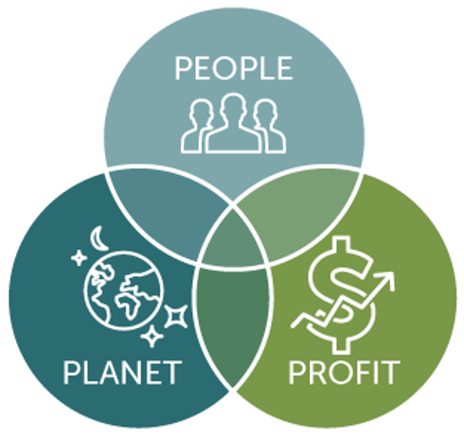
Figure: Triple Bottom Line
Source: (Abidemi and Ogujiuba, 2020)
- People: TBL's "people" component emphasizes social responsibility, which includes respecting human rights, the welfare of employees, and community involvement (Martínez et al., 2019). This is translated into the hospitality sector as paying equitable salaries, guaranteeing secure working conditions, and participating in neighborhood projects. For instance, the goal of Marriott International's "Serve 360: Doing Good in Every Direction" program, which emphasizes community involvement, is to train one million young people for employment by 2025 (Abidemi and Ogujiuba, 2020). This is a prime example of their dedication to the "people" aspect of TBL.
- Planet: The "planet" dimension focuses on environmental sustainability, covering topics such as responsible sourcing, waste minimization, and energy saving. This includes waste reduction, sustainable food and beverage options, and energy-efficient building designs in the hospitality sector. For instance, the Planet 21 program from AccorHotels is devoted to sustainability and covers topics like cutting back on waste, using less water and energy, and sourcing products ethically. It shows that they are dedicated to the "planet" component of TBL (Benner, 2020).
- Profit: The "profit" factor is concerned with long-term economic viability and financial performance (Martínez et al., 2019). TBL promotes firms to pursue profitability without sacrificing social and environmental goals, even though it is imperative that they do so. As an illustration, Hilton Hotels & Resorts' LightStay program monitors and assesses social and environmental effects with the goal of minimizing them and enhancing effectiveness. Hilton connects profitability with the "profit" part of TBL through resource conservation.

Doxey’s Irridex model and its importance in environmental sustainability
Doxey's Irridex model provides valuable insights into the relationship between tourists, residents, and their impact on a destination's environmental sustainability (Benner, 2020).
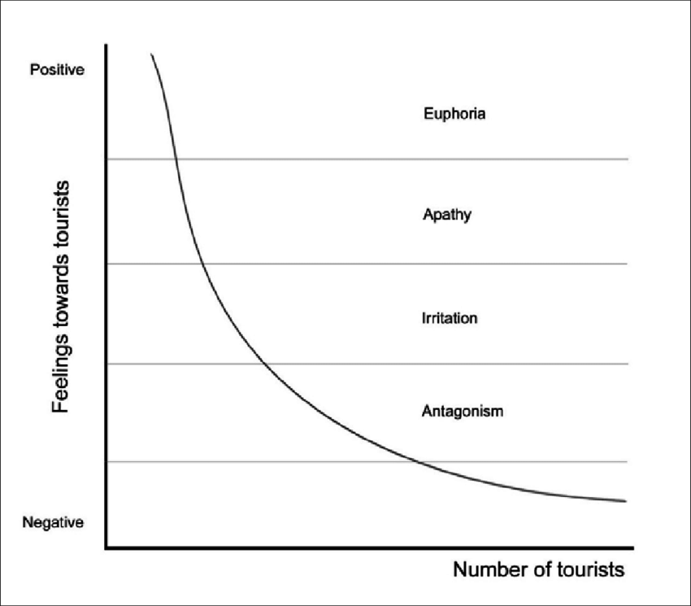
Figure: Doxey's Irridex model
Source: (Martínez et al., 2019)
- Elation Stage: This is the initial phase when a destination is discovered by a limited number of tourists (Rhou and Singal, 2020). Environmental impact is low, and residents are generally not irritated. It's crucial to preserve the destination's natural and cultural integrity during this phase, focusing on responsible tourism and environmental protection.
- Irritation Stage: As tourism grows, the destination enters the Irritation stage. Increased visitors and infrastructure development can lead to environmental impacts. Sustainable practices focus on maintaining environmental quality through responsible waste management, efficient resource use, and eco-friendly transportation. Example: Bali, Indonesia, went through the Irritation stage with a surge in tourists, resulting in environmental issues, including waste problems (Abidemi and Ogujiuba, 2020). Bali now implements sustainable waste management practices, promotes eco-friendly accommodations, and offers eco-tourism experiences for growth and sustainability.
- Tolerance Stage: Here, the destination has matured, and stakeholders collaborate to manage environmental impacts. Sustainability involves community and business cooperation to ensure long-term sustainability.
- Apathy Stage: In the Apathy stage, the destination may face declining visitor interest (Rhou and Singal, 2020). This phase provides an opportunity to focus on maintaining and conserving the environment, preserving cultural and natural heritage, and diversifying tourism offerings to keep the destination attractive. Example: Venice, Italy, is a destination in the Apathy stage, dealing with issues like overtourism and the preservation of historic architecture. Initiatives include crowd management, restoring historic sites, and promoting responsible tourism to protect its unique heritage.

Application of Butler’s life cycle model
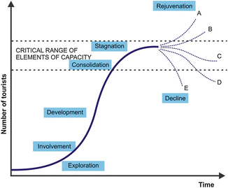
Figure: Butler’s life cycle model
Source: (Rhou and Singal, 2020)
Butler's Tourism Area Life Cycle (TALC) model is a framework that describes the typical development stages of a tourist destination (Benner, 2020). It is a valuable tool for understanding the evolution of tourist destinations and guiding sustainable development strategies within the hospitality industry.
- Exploration Stage: This is the initial phase when a destination is discovered by a limited number of adventurous tourists. Hospitality businesses in this stage should focus on preserving the natural and cultural integrity of the destination. Sustainable practices at this point may involve responsible tourism and minimal infrastructure development to prevent over-tourism (Pereira and Martins, 2021). Example: The early days of tourism in the Galápagos Islands, with Charles Darwin's exploration, reflect the Elation stage. Stringent regulations now protect the islands' unique biodiversity, limiting tourist numbers and promoting responsible wildlife viewing.
- Involvement Stage: As a destination gains popularity, more tourists visit, and businesses start to grow. Sustainability efforts should concentrate on infrastructure development and the efficient use of resources (Benner, 2020). Sustainable transportation and waste management are essential considerations during this stage.
- Development Stage: At this stage, tourism to the destination is growing quickly, frequently accompanied by the development and extension of amenities. Businesses should place a high priority on eco-friendly procedures including waste reduction, energy-efficient construction, and ethical sourcing in order to preserve sustainability. It becomes imperative to collaborate with local communities.
- Consolidation Stage: As the destination reaches its highest point in popularity, sustainability initiatives should concentrate on enhancing the quality of the visitor experience, conserving the environment, and maintaining and protecting the culture (Pereira and Martins, 2021). Long-term sustainability becomes contingent upon conservation efforts, cultural preservation, and sustainable certifications.
- Stagnation Stage: At this moment, tourism at the location might reach a high point. Businesses should now review their approaches, broaden the range of products they provide, and make investments to restore the destination's attractiveness. Enhancing visitor experiences and repurposing aging infrastructure are examples of sustainable methods.
- Decline Stage: There is a chance that tourism to some places will eventually fall for a variety of reasons (Abidemi and Ogujiuba, 2020). In order to keep the destination viable and appealing, sustainable tactics may include rebranding and adjusting to changing market trends.
- Rejuvenation or Decline Revival Stage: In some cases, destinations can revitalize themselves through strategic sustainable efforts. For instance, they may focus on ecotourism, cultural festivals, or niche markets to regain their appeal and grow sustainably.

Future recommendations
To secure a sustainable and profitable future in the hospitality industry, several key recommendations should be considered:
- Invest in Sustainable Practices: Prioritize environmental sustainability by reducing energy and water consumption, minimizing waste, and sourcing responsibly. Sustainable initiatives not only reduce costs but also attract eco-conscious consumers (Pereira and Martins, 2021).
- Leverage Technology: Embrace technology to enhance guest experiences and operational efficiency. Implement smart systems, contactless services, and data analytics to personalize offerings and improve service quality.
- Community Engagement: Collaborate with local communities, support small businesses, and engage in projects that contribute to the well-being and preservation of the destination (Benner, 2020). This fosters positive relationships and shared benefits.
- Crisis Preparedness: Develop and regularly update comprehensive crisis management plans to address unforeseen challenges, including natural disasters and health crises (Abidemi and Ogujiuba, 2020). Preparedness is crucial for ensuring business continuity and guest safety.

Conclusion
In conclusion, the future of the hospitality industry hinges on striking a delicate balance between profitability and environmental and social responsibility. While financial success remains essential, businesses must prioritize sustainability through eco-friendly practices, community engagement, and technological innovation. By investing in sustainable initiatives, embracing technology, collaborating with local communities, and maintaining crisis preparedness, the industry can ensure its long-term viability and appeal to a diverse and conscientious consumer base. The path forward is one that recognizes the evolving landscape of hospitality, where green practices and a commitment to people and the planet are integral to continued growth and resilience.

References
Benner, M. (2020). The decline of tourist destinations: An evolutionary perspective on overtourism. Sustainability, 12(9), p.3653.
Kappo-Abidemi, C. and Ogujiuba, K.K. (2020). Higher education institutions and corporate social responsibility: triple bottomline as a conceptual framework for community development. Entrepreneurship and Sustainability Issues.
Khaghaany, M., Kbelah, S. and Almagtome, A. (2019). Value relevance of sustainability reporting under an accounting information system: Evidence from the tourism industry. African Journal of Hospitality, Tourism and Leisure, 8, pp.1-12.
Martínez-Martínez, A., Cegarra-Navarro, J.G., Garcia-Perez, A. and Wensley, A. (2019). Knowledge agents as drivers of environmental sustainability and business performance in the hospitality sector. Tourism management, 70, pp.381-389.
Merli, R., Preziosi, M., Acampora, A. and Ali, F. (2019). Why should hotels go green? Insights from guests experience in green hotels. International Journal of Hospitality Management, 81, pp.169-179.
Pereira, T.H.M. and Martins, H.C. (2021). People, planet, and profit: A bibliometric analysis of triple bottom line theory. J. Mgmt. & Sustainability, 11, p.64.
Pham, N.T., Tučková, Z. and Jabbour, C.J.C. (2019). Greening the hospitality industry: How do green human resource management practices influence organizational citizenship behavior in hotels? A mixed-methods study. Tourism management, 72, pp.386-399.
Rhou, Y. and Singal, M. (2020). A review of the business case for CSR in the hospitality industry. International Journal of Hospitality Management, 84, p.102330.
Úbeda-García, M., Claver-Cortés, E., Marco-Lajara, B. and Zaragoza-Sáez, P. (2021). Corporate social responsibility and firm performance in the hotel industry. The mediating role of green human resource management and environmental outcomes. Journal of Business Research, 123, pp.57-69.
Wang, S. and Mirehie, M. (2022). Community perceptions of tourism impacts. Handbook of Tourism Impacts, pp.60-74.

