Learning In The Digital Era BMPL4007
09/11/2022
Student No: 2203699
Lewis Jackson-Peck
E-Portfolio Report

Table of Contents
Preparing for Higher Education 2
Mind Map 3
Video Presentation 4
Reflection 5
References 6

Preparing for Higher Education
Preparing for Higher Education can be daunting for some; for others they try and skip preparation entirely and try to jump straight in. It starts in the classroom with note taking. Save The Student (2022) produced a web page giving readers “10 ways to take better lecture notes”. They recommend underlining or using capital letters to aid identification of key points. The use of different colours and highlighters can also be used to help identify points and make notes more exciting. You should customise notes and tailor them to you through experimenting with colours, postcards, diagrams, or any methods you find help you learn (NHS, 2020). Forming a study relationship with contacts can also boost your learning as you can rely on such networks when you need help and support or just some simple motivation to help complete your course successfully (Skills You Need, No Date).
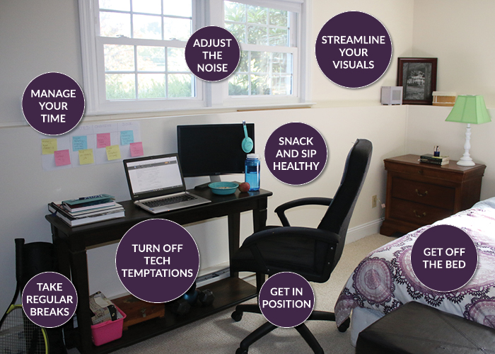
It is recommended that a suitable place should be found to make studying effective. These should have easy access to all the tools and resources needed for the study. Light sources, considering possible distractions and limited clutter are some factors that should be considered (Skills You Need, No Date). Skills You Need also state that you should “vary your locations” of study. They claim that research has concluded that a variety of locations “can help to improve memory retention”. They give the examples of, your room, the library, a quiet café, or someone else’s house (Skills You Need, No Date). UCAS (2022) have listed some top tips for studying. These include, checking resources on the Uni website, ask the Uni about study skills sessions and workshops, and check if there’s a pre-module reading list.

Figure 1: Some tips from a typical study environment (CampusWell, 2019).

Mind Map
Some Sources:
Documentary, Interviews, News Articles
Reports, Web sites, and Physical Libraries

Information
Format & structure is crucial to any public role. In police this could be in the form a witness statement or a report, for example.

Format & Structure
Ensure the information is valid and reliable.

Consider what format you should be using.
Formal? Informal?
Consider who you’re talking to.

CRAAP Test:
Currency: Ensure the information is not out of date and new.
Relevance: Is it relevant for your
purpose?
Authority: Who created the
source? Are they reliable?
Accuracy: Is the information
backed up by evidence? Is it opinion or fact?
Purpose: Why has the source been
created? Is it biased?

(University of The West of Scotland, 2022)


Becoming a Digital Learner

Microsoft Word
Word is a professional multi-tool document creator that creates a variety of professional structured documents

Microsoft Excel
Software

Microsoft Publisher
Publisher is a professional suite of software used to aid people in presentations
Police Software & Databases
The police use MDTs in replacement of their old pocket notebooks. Facial recognition, body worn cameras and trackers are also regularly used. Database systems such as Niche, used by South Wales Police, are commonly used (NicheRMS, No Date).

Investigating crime will require a variety of sources and so ensuring information is trustworthy, valid, and reliable is vital to policing.

Video Presentation
Please follow the link below to view my presentation on Becoming a Team Player:

https://youtu.be/-aasQfkXJPs

Reflection
Starting University has been a very pleasant experience and the degree has been everything I hoped it would be. Personally, one of the most useful tools has been the UWTSD Hwb app on my phone as it has everything Uni related that I could possibly need at my fingertips with seamless access from anywhere. I’ve found most digital aspects a breeze with the exception of the printers. Initially my phone wouldn’t connect to the Wi-Fi, but I eventually resolved this. As for the printers, they wouldn’t view my sent documents to print, and I cannot print from my own device at present. Note taking from lectures has been good and I have used a variety of colours to keep my work engaging and highlight specific pieces of information. There have been times where I’ve missed crucial pieces of information during the lecture and had to fill in gaps after the presentations are uploaded to Moodle later on. The first assignments have been fine but tough to meet the word counts; I always overwrite. Sourcing information from the library and internet has been easy and my citations have hopefully been correct. Diversity of my sources, however, could do with attention as most of my information comes from online websites alone.
Going forward in terms of next modules assignments I would benefit from diversifying my reading and gathering source information from physical books or online databases. A planned trip to the library could help this. Before starting any assignments, I would like to try and make a sophisticated plan of what I would like to include in the essay to try and avoid my overwriting. In a bid to avoid gaps in my notes and ensure I have all the information I need; I’m hoping to try and keep my notes more concise in the future and writing only what is important.

References
CampusWell, 2019. Get more done: How to create a productive study space. [Online]
Available at: https://www.campuswell.com/organize-your-study-space/
[Accessed 29 October 2022].
NHS, 2020. Tips on preparing for exams. [Online]
Available at: https://www.nhs.uk/mental-health/children-and-young-adults/help-for-teenagers-young-adults-and-students/tips-on-preparing-for-exams/
[Accessed 23 October 2022].
NicheRMS, No Date. South Wales Police Drives Crime Down, Clearance Rates Up. [Online]
Available at: https://nicherms.com/casestudy/south-wales-police-drives-crime-down-clearance-rates-up/
[Accessed 05 November 2022].
Save The Student, 2022. 10 ways to take better lecture notes. [Online]
Available at: https://www.savethestudent.org/extra-guides/take-better-lecture-notes-8-easy-steps.html
[Accessed 24 October 2022].
Skills You Need, No Date. Getting Organised for Study. [Online]
Available at: https://www.skillsyouneed.com/learn/organise-study.html
[Accessed 25 October 2022].
Skills You Need, No Date. Top Exam Preperation Tips. [Online]
Available at: https://www.skillsyouneed.com/learn/exam-tips.html
[Accessed 25 October 2022].
UCAS, 2022. GETTING READY FOR EDUCATION. [Online]
Available at: https://www.ucas.com/undergraduate/results-confirmation-and-clearing/getting-ready-higher-education#studying
[Accessed 25 October 2022].
University of The West of Scotland, 2022. Evaluating Sources: CRAAP Test. [Online]
Available at: https://uws-uk.libguides.com/evaluating_sources/craap_test
[Accessed 7 November 2022].

