TASK 1

Research in data security and compliance
Victoria Price
Student University of Wales Trinity St David, Swansea, Wales
2315903@student.uwtsd.ac.uk

Abstract – This research paper consists of an analysation and critical evaluation into why modern organisations need to create a secure and safeguarded environment to protect all sensitive data. The objective of this study is to understand what can be improved and adapted within the current implemented levels of security and the responses to security threats. A myriad of research methods were used within this paper. The focus of this paper lies within the employee training and knowledge to ensure that the proper security methods are being followed. In conclusion, this paper shows that there are always areas that need review and improvement to keep up to date with new methods of threat to sensitive data.
Keywords – Data, Organization, Threats, Security, Employees
- Criteria for Evaluation
The main aspects of Security and Compliance that I will be reviewing, critiquing and mentioning alternative methods for will be employee training and ensuring that colleagues have sufficient knowledge of how to identify and report a possible danger, leakage and costs possibly attached to security breaches, the risk management process within certain organisations and how they may need to be altered and, finally, compliance with legal and regulatory standards. All topics mentioned must be implemented into an organisation that is serious about their security and protection procedures.
- Information Security Maintenance
There are a myriad of ways that a modern organisation can implement security measures into every working day. This may include employee risk assessments and training measures, regularly updating security procedures and protocols to ensure the company is sticking to regulatory requirements and having secure communication and protection procedures between colleagues. Knowledge and understanding of processes between colleagues is most vital to a company being able to notice and understand any threats to the secure data and ‘sharing information and knowledge among employees is an important part of knowledge management’[1]. Security Maintenance within an organisation has been developing since the 1960’s and is still developing today. Especially with all of the new methods of attacking an organisation to obtain sensitive data, employees need to be updated continually with the best way to combat or report these attacks.
- Employee Training
As briefly mentioned in the previous section, employee training is one of the most important procedures that a company should implement to their organization and to ensure that it is consistent as a recent study found that employees tend to lose ‘50% of information in an hour, 70% in 24 and 90% of the information within a week.’ [2]. There are many reasons as to why employee training is vital to the security and structure of the organisation. Effective training programmes will increase compliance and identification skills of security breaches and minimise human error. As the employees are facing and working directly with the data, they are the critical component of security identification, reaction and protection.
- Regulations
In the UK, security is outlined and controlled by a multitude of different authorities and institutions, and this may include ISO/IEC 27001 and GDPR regulations. Organisations and employees must comply to nation and world-wide regulations to ensure that security is something the company strives for and constantly adapts to protecting. Customer sensitive data should always be at the forefront of a company’s daily procedures and training measures.
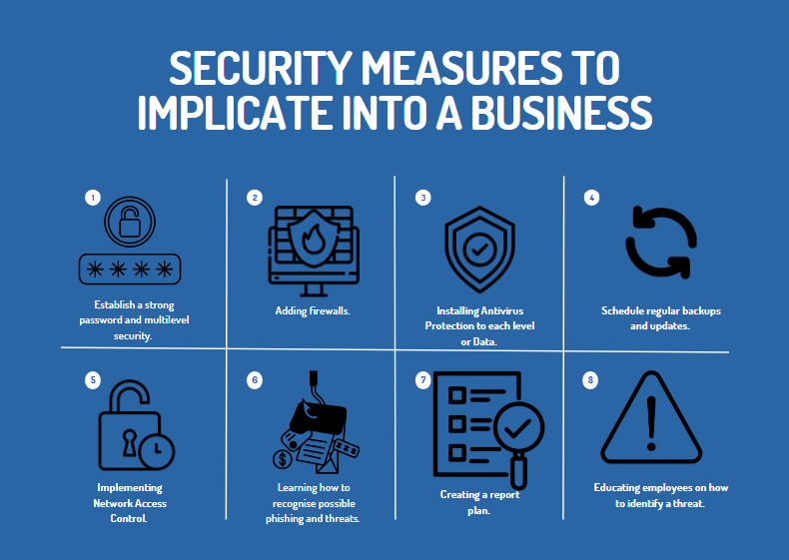
- Training Procedures
Minimising human errors will make a stark difference to the possibility of security breaches. Without the proper training, employees may just allow a multitude of phishing attempts to be successful if not identified and reported efficiently. Employees should be updated with new phishing identification procedures as soon as new attempt methods are identified and reviewed. Additionally, the employees should be notified of the implications to customers and to themselves if they mishandle sensitive data. Personell should be aware of what the risks are and the consequences of not sticking to the implemented security measures. Usually, the most effective way of educating employees is by creating short, simple, and informative infographics or PowerPoints that list exactly what they need to know.
- Reviewing Knowledge
Once employees are informed of the methods of identification and ways to report the threat, they should be tested on their knowledge and ensure that they know exactly who to contact if there are any further questions. By ensuring that the workers know how to report the issue, they should be advised that it is better to be safe than sorry especially when it comes to a possible security issue. As mentioned above, if the employee is aware of the effects to the company and the possible consequences, they should be more likely to report and to refer if there are any further issues.
- Security Measures
Hackers and phishing threats are constantly evolving, as is technology. Ensuring that a company and employees are keeping up to date to additional possible threats and referral procedures will help to minimise threat and maximise security within the organisation. Keeping up to date with new regulations will contribute to mitigating risks effectively and minimise negative implications for the company. In order to do this, an organisation should; keep systems and software regularly updated, keep employees updated of new kinds of threats and keep up to date on employee training opportunities.
- Updating Systems
Organisations must stay compliant to updated regulations to fight off phishing attacks accurately and efficiently. Updates usually include new methods of defence or patching which add more security to vulnerabilities that have been recognised. Companies should be hoping to minimise any zero-day vulnerabilities and without updates, this wouldn’t be viable. Along with this, updated systems will fight against a majority of security breaches, but if a security breach were to occur, it would have a huge effect on the company’s reputation of security and reliability. Employees must be keeping on top of the updates that are provided to them by the company. There are a myriad of examples of when companies have had a large cost attached to security breaches. For example, in 2019, a company called Capital One had a very large cybersecurity attack. Capital One is an American Banking Company and have lots of sensitive data that needs to be protected. A hacker, that goes by the name of Paige Thompson, hacked into their systems and obtained the data of over 100 million customers including bank accounts, social security numbers and accessed records dated back to 2005. This was a very large attack and therefore had a significant cost attached. It is estimated that the company had to pay over $150 million in costs including fines and regulatory fees, customer complaints and compensation, legal fees and counteractive security fees. [3]
- Rules and Regulations
Compliance to regulations is vital within the data security landscape. The European Union introduced new regulatory framework to the UK in 2016 and it became effective in May of 2018. This new framework is called The General Data Protection Regulation (GDPR) and it, essentially, enforces strict rules and guidelines on how organisations are allowed to collect, store and share personal data provided by their customers. The key factors that this regulation enforces onto an organisation include consent to be provided by customers to have their personal data stored or used in any way, data subject rights and that the company must have lawful basis for any kind of processing or use of the data. Another example of a regulation that organisations must implement into their security processes is the Data Protection Act 2018 and this act works well alongside GDPR regulations. Essentially, it is more specific to the UK and also includes more information on how the law enforcement are included within the process and has more specific information on protecting data relating to a child.
- Risk Management
Mitigating risks should be at the forefront of a company’s security process and internal policy. There are a multitude of risk management methods which will be discussed in this section. Risk management is vital to an organisation to ensure that threats are tackled as soon as they are identified, ensuring that the company is being proactive towards fighting against potential attacks and maintaining continuity with how employees can work. By implementing risk management into a company’s security process, there should be less disruptions to how a day flows. Additionally, there are different methods of risk management that should be implemented into protecting security and data within an organisation depending on the type of company that needs protection.
The following examples are not specific to the organisation.
- A Financial Organisation
A financial organisations risk management processes and procedures are likely to focus on protecting any possible vulnerabilities within the IT infrastructure already implemented. They are very likely to experience common cybersecurity attacks and threats as they store a lot of private data that a hacker could use against customers and against the company itself for personal or financial gain. Following a framework like or similar to NIST SP 800-30 is going to internally identify and evaluate possible risks that may need to be reviewed.
- A Retail Organisation
Sometimes, an organisation may want to outsource for additional protection in their security procedures. For example, even though a retail company is likely to conduct consistent security checks, it may be worth outsourcing to another company that specialise in security methods to see if there are other defence procedures that may be useful. That applies to any type of organisation. Any organisation would benefit from learning from other methods of defence against a multitude of attacks.

- A Pharmaceutical Company
A Pharmaceutical Company will store a lot of sensitive data specific to individual customers. When an organisation holds such sensitive information, they are more likely to face cyberattacks as hackers have something to gain from obtaining data. An example of implementing risk management may include up-to-date training on ways to defend against attacks or to notify the relevant person. Testing employees by creating false phishing attacks that they can report can show which employees are applying their knowledge and defending against possible attacks, and which employees may require further training.
- Compliance to Regulatory Standards
There are a multitude of regulatory standards that a company must meet to ensure that the organisation is making its best efforts to safeguard all information stored. Some examples which are not regulatory may include; data encryption and backup procedures, regular auditing and assessment procedures and internal policy editing and development. Specific legal requirements and standards that must be met are listed below.
- GDPR
Establishing internal procedures which can state records of what data what accessed, when and what data protection was passed in order to obtain the information would be beneficial if tracking back to a specific access time was necessary. Developing a response plan if an attack was ever successful would also benefit the organisation to ensure that the relevant authorities were notified if the situation occurs.
- Sarbanes-Oxley Act (SOX)
Having multilayer protection within an organisation with clear trails of data being accessed and shared would provide clear transparency and would improve efficiency when searching for specific access dates and times. Conducting annual assessments of procedures and outsourcing for reviews and criticism would improve security procedures.

- Conclusion
To summarise, there are a multitude of ways that an organisation can easily fall short on the security aspect without even realising. Although, there are also a multitude of ways to rectify those shortcomings. Protecting an organisation from cybersecurity attacks will never stay the same annum to annum. As technology is constantly developing, so do phishing and hacking attempts. Ensuring that a company is keeping up-to-date with recommended procedures and regulatory standards is vital to continuing a positive reputation and a positive reputation is vital to the growth and success of a business. Initiating and continuing risk management procedures ensures that legal standards are being maintained and that risks are being mitigated. Being proactive in this are as crucial for the safeguarding of sensitive data and protecting assets. Continuous and updated employee training is likely to be one of the main indicators of if an organisation is keeping on top of their protection and defence methods and training. If employees are not identifying risks and are taking the correct actions when one is spotted, then how will an organisation be able to see what needs to be developed and protected against? They wouldn’t. All levels of employment need to have the basic knowledge of identification, notification and reaction to potential attacks. Resources and support goes along with employee training. If a worker has any further questions or needs any support, they must understand exactly who to go to for further assistance.
Protection and defence procedures are constantly going to require updating and reviewing. Attacks adapt along with technology, so security protection procedures must also adapt. By creating a supportive environment and adapting to current threats and protection methods, it will ensure a safer and more secure environment and a positive reputation for the organisation.

Citations
[1] V. Burlov, “System Integration of Security Maintenance Processes in Knowledge Management - ProQuest.” https://www.proquest.com/openview/258dbd8cf10988de68f93c289a61ea1f/1?pq-origsite=gscholar&cbl=1796412
[2] Kohn Art (2014) Brain science: the forgetting curve–the dirty secret of corporate training. http://www.learningsolutionsmag.com/articles/1379/brain-science-the-forgetting-curvethe-dirty-secret-of-corporate-training. Accessed 20 July 2024
[3]
E. Flitter and K. Weise, “Capital One Data Breach Compromises Data of Over 100 Million,” The New York Times, Jul. 30, 2019. Available: https://www.nytimes.com/2019/07/29/business/capital-one-data-breach-hacked.html
‌

TASK 2 - Security Standards
2315903  Information Security Unit | Victoria Price  Data Security and Compliance

Table of Contents
- Overview
- Introduction
- Objectives
- Department Structure
- Department Composition
- Roles and Responsibilites
- Training and Awareness
- Methods of Training
- Referral Points
- Budget
- General Approach
- Risk Assessment
- Standards and Outline
- Technology
- Software and Tools
- Suggested Timeline
- Conclusion

Overview

The following report is a detailed report of the outlines and approach for a new department within the company that focus on implementing, controlling and reviewing security measures. The new ‘Information Security Unit’s’ sole responsibility would be to ensure that the companies sensitive data is secure to possible phishing and hacking attempts. In order to do this, they would; ensure that employees within the organisation are aware of possible attack methods and being able to recognise them, knowing how to properly report the possible attack, updating the sofware and systems used daily to ensure they have the proper defense and identification sofware installed and how the department would be structured and would work.

The reason for this report is to outline what the department would be and how they work, more information and a deeper look into the regulations that would be followed along with the benefits that would come with this team. None of the suggestions or plans in this report are set in stone and are open for review or further reccomendations. Additionally, this ‘New Information Security Unit’ (name can be reviewed) will be constantly developing and changing their methods for their security processes and suggestions to employees. Methods to defend against attatcks may not be incredibly specific as definitive procedures will be clarified once the team is confirmed to go forward.

 | Introduction
 | Security procedures are vital to any company wishing to have any level of protection to their customers sensitive data. In accordance with a multitude of regulatory bodies including; General Data Protection Regulation (GDPR), Information Security Management System (ISO 27001) and Information Commissioner’s Office (ICO) to name a few, there must be a department within this company that ensure that all employees are following enforced regulation. This is for the safety of your customers, your employees and also to ensure that the organisation is mitigating any possible risks or attacks to sensitive stored data. A specific department that is tailored towards protecting the intergrity of security procedures within the company will be incredibly benificial to the reputation of the company to potential investors, collaborators and customers. A company that has had any breaches of security and data protection seem a lot less reputable in comparison to other potential brands. Therefore, having a team within the company that are able to monitor the compliance of employees and procedures will benefit towards the growth of the company in future as well as the reputation currently.  Threats to data security only get more sophisticated as time goes on. At a certain point, if there is no team to regulate the protection to those threats within an organisation, the entire company will have little to no control over the data security defense procedures. Not having a department like suggested is only opening up the company to further possible threats. | There are a multitude of possible threats to an organisations sensitive data including data proliferation, insider threats and hacking and advanced persistent threats to employees and members of the company. Methods of defense against these possible attacks will be explained in this report. First of all, an explanation of exactly what the objectives are of this proposed team seems the most beneficial to fully understanding the purpose of the department.

Objectives

Similar to any other department within an organisation, the team has a specific goal for what they want to achieve. The Information Security Unit (ISU) will be focussing on threat detection and the correct response and reporting methods, awareness and notification training for all employees within the organisation, regulatory compliance checks and data protection and privacy.

Response and Reporting Methods

All data facing employees must be able to detect a possible threat and be able to report it in the most efficient way depending on the type of threat that they face. They must be able to respond to threats in real-time so that the relevant actions can be taken by the ISU.

Awareness and Notification Training

In order for the department to be effective to employees, the training must be interactive and interesting to learners. They have to be able to retain the information given to them as it is vital for the integrity and reputation of their employers. A common understanding of defense against security threats is needed.

Regulatory Compliance Checks

In order to ensure that the training has been effective, regular testing and drop in meetings will be scheduled to ensure employees have a common understanding of the enforced procedures and can ask any questions that may need to be answered.

Department Structure
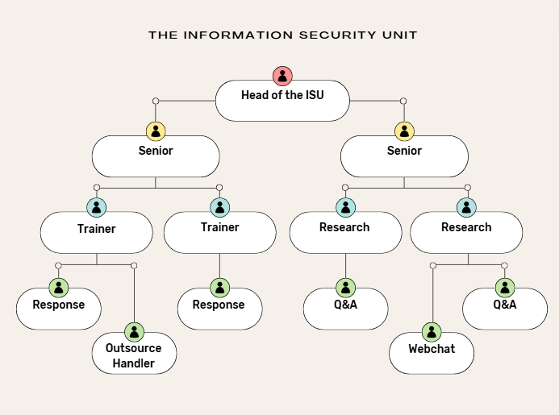
Please find above an example of what the departments structure would be.
This is able to be reviewed and is open to change and adaptation.

Roles and Responsibilities

Head of the ISU – This employee would be in charge of overseeing the
whole department and ensuring that all handlers understand the proper
procedures. This manager would also be responsible for overseeing all
proposed training methods and guides.

Seniors – There would be two halves of this department. One half of the seniors would be responsible for over seeing the trainers and would be the first point of referral. The other half would oversee the research team who would keep up with updated methods of attack and review methods of response.

All seniors would overlook all other handlers. This includes the Response Team, Q&A Team, Outsource and Webchat.

Response – These handlers would be accepting all reported threats and ensuring that they take the correct next steps to review the potential threats.

Q&A – This team would be responsible for answering all questions that any other managers, seniors and employees may have about their systems, cyber attacks and general queries. They would be the first point of referral.

Webchat – They would also be a part of the Q&A team, but would be accessed via internal webchat.

Outsource – This member of the team would be responsible for outsourcing additional training and discussing with other organisations their methods of defense to strengthen our own organisations methods of defence.

Training and Awareness
Methods of Training

There are a myriad of methods that would be implemented to train up existing employees, new hires and managers. This would include optional sit-in sessions that would be held by a Trainer within the team. They would explain any updates of procedures to any attendees that wanted further support with defence methods. Anything discussed in these sit-in sessions would be sent out to all employees in flyer format to refer to. There would also be mandatory training
sessions over Teams/Zoom in which the
Trainer would have a PowerPoint to
follow along with. Finally, the Q&A
handlers will be available for the full working
day to answer any questions that any
other employees may have.
This team is here for support to anyone that may need them.
Referral Points
Please find below the order of referral points.
- Webchat
- Q&A
- Trainer
- Senior
- If at any time the senior is unable to provide the correct answer, they will refer to the head of the team for the best response to the query. Please be rest assured that one the members of the team will have the answer to the query.
Budget
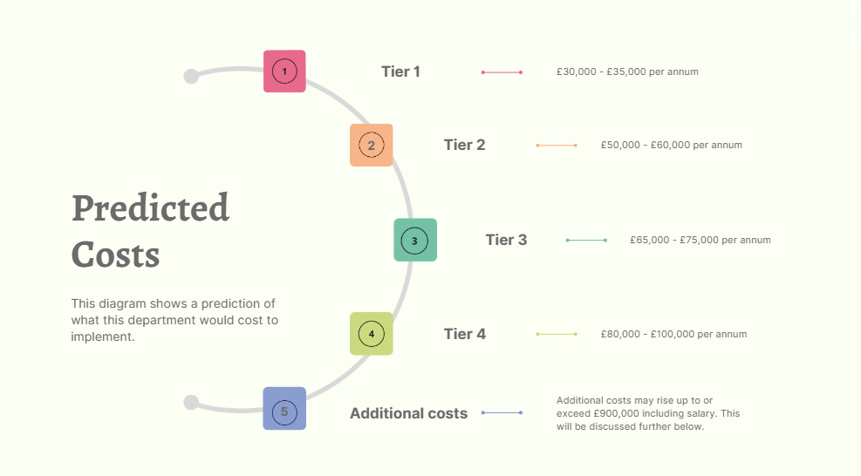
Additional Costs Breakdown
Potential Benefits and Taxes – Approx £150,000

Outsource Training – Approx £30,000

Employee Tools – Approx £100,000

Operational Costs – Approx £20,000

Micellanious – Up to Approx £80,000

General Approach

In the next section of the report, it seems useful to explain the departments proposed Risk Assessment procedures and standards that the training would conform to. It is important to be reminded that none of the outlines, policies or procedures are final. This also includes salary, budget and training methods. There are all open to review and suggestions if this team is implemented.

Outline of the Proposed Risk Assessment Process

- One of the first things that the department would look to do is to outline what the order of importance would be when it comes to threats and referrals. The response team would be the first department created so that they can begin setting out the processes for reporting threats and methods of defence.
- Once the full team is created, they need to discuss exactly what needs to be protected within the organisation and have an understanding of the methods of possible attacks. This is where the first step links up so the team understands current methods of attack, the order of importance of what to protect and the methods of defence that will be followed.
- The Outsource member of the team would be set into action as they will need to discuss with other organisations ways that they have been attacked and the ways that they protected the sensitive data. At this stage, the whole department should have a vast understanding of current threats and would be brainstorming methods of defence that would be most effective and efficient.
- Next, the team must identify possible weaknesses to the procedures they have planned and make the final revisions to procedures. The next stage would be testing and finalisation of defence.
- Lastly, they would create the final order of risk prioritisation, have definitive methods of defence and finalize the risk assessment.

Obviously, the risk assessment would constantly be up for review and monitored by the Head of the ISU to find ways that it needs to be edited to keep up to date with prominent methods of attack at the time.

Standards and Outline

Please find below the suggested frameworks and guidelines that the department would follow and implement into the methods of keeping the organisations sensitive data protected.

- The General Data Protection Regulation (GDPR) ensures that all sensitive data is well protected and would be advised to all employees with methods to follow the procedures. The employees should already have some form of understanding of this type of regulation.
- ISO/IEC 27001 is an international regulator of information security management systems. The department would be followeing their general regulations of company information and risk assessment requirement.
- NIST SP 800-30 is a regulatory body of worldwide organizations and their risk assessment procedures. The department would be following their rules and regulations to ensure that the team is doing what is best for the company.

Technology

An organisation needs to implement the relevant technology, protection tools and software to ensure the best level of protection. As there are many areas of a company that need to be protected, there are many diferent tools that may be inplemented.

Software and Tools

- Network Security
- Firewalls are a standard level of protection implemented into internet access. Examples of Firewalls include – Cisco ASA, Fortinet and Sophos.
- Antivirus
- Symantec Endpoint Protection (includes antivirus, firewall and antispyware. A kind of software like this is incredibly helpful for an organisation as to not confuse employees with understanding the kinds of protection in their software)
- McAfee Total Protection
- Data Security
- Microsoft BitLocker (ensuring that only the people who are previously authorised are able to acess company sensitive data and information)
- Symantec and Forcepoint DLP
- Backup
- Veeam Backup software
- Cloud Security
- Microsoft Cloud Security (visibility and further control of microsoft applications used within the company e.g. Teams)
- Prisma Cloud.

To confirm, these applications and forms of software are just examples of what could be used and some of the areas that would need to be protected.
Predicted Timeline

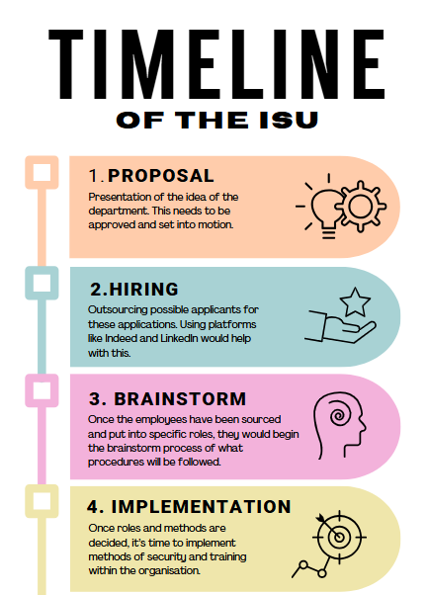

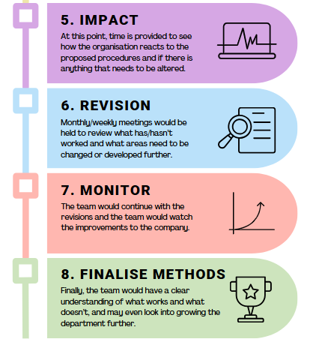

Conclusion

In conclusion of this report, the proposed department would be incredibly beneficial to the organisation. If there is a fostered culture of understanding data protection and security, the organisation will work more efficiently as there is less of a threat to sensitive data. The employees within the organisation would always feel secure and know exactly who to go to if they needed anything answered. Additionally, the employees would feel positive knowing that they have been a part of protecting the company from a potential threat.

Some of the potential benefits of having this department, to name a few, include the company having a bigger name in the data security spectrum (this may lead to more investor opportunities, other companies wanting to collaborate and discuss security procedures, possible awards for the level of protection that the company has implemented and a positive reputation to potential employees and customers. Essentially, mitigating the risks of the company’s data being attacked leads to growth in many aspects.

This department can be altered and reviewed in any way deemed necessary to ensure that it is suitable to the company’s additional rules and regulations. Additionally, the team would never be the same month to month considering that threats and attacks are constantly adapting and changing.

Please refer to the suggested timeline to discuss the next steps on how to progress on the suggested plans for this department and how to start the procedure of implementing this team into the company.

This team, if implemented, will benefit the company in every possible way. Create this department, set in motion their procedures and you will see the improvement that it will make.

