Student name: Ana Corcan
Student id: 2133068
Lecturer name: Hamdi Hassan
Module code: BMHP5005_BIRM
Module name: Introduction to Research

Effect of sex abuse on child mental health development
Abstract
The research aimed to understand the effect of sex abuse on child mental health development. A secondary data collection method was adopted to understand the effect of sex abuse on the mental health of children based on empirical evidence. The result of the research reveals that CSA or Childhood sexual abuse has long-term and age-related impacts on the mental health of a child. The main purpose of this literature review is to investigate the effect of child sexual abuse on the mental health development of children. Following this purpose, different themes that represent the consequences of the sexual abuse of children and its impact on mental health have been described in this section. The use of the methodological flow helps to determine the importance and effectiveness of this research to achieve its aim with the help of secondary sources.

Table of Contents
Introduction 5
Contextual Information of Research Topic 6
Background of research 6
The rationale of the Topic selection 8
Methodology 10
Ethical Practices 13
Result 14
Theme 1: Long-term impact of “sex abuse” on the “mental health development” of Children 14
Theme 2: Age-specific impact of “sex abuse” on child “mental health development” 14
Theme 3: Connection Between Child Sexual Abuse and Mental Disorder 15
Theme 4: Way to Remove Sexual Abuse and Its Impact on Child “mental health” 15
Findings and Discussion 16
Discussion of Theme One 16
Discussion on Theme Two 18
Finding and Discussion on Theme 3 19
Finding and Discussion on Theme 4 20
Conclusion and Recommendations with Future Practices 22
Conclusion 22
Recommendation 22
Future Scope 22
References 24

Introduction
The purpose of this report is to understand the effect of sex abuse on the mental health development of a child. Children who have been sexually abused suffer from a range of mental and emotional breakdowns. Several types of trauma children can experience include increased nightmares, sleep difficulties, anxiety, depression, and PTSD (Post Traumatic Stress Disorder). Many children with an experience of “Childhood Sexual Abuse or CSA” show emotional changes. The objective of this report is to determine factors, which can impact on mental and health development of children due to CSA. Another objective of this report is to find a solution for coping with CSA-associated mental disorders among children. Effective counselling, therapies and cognitive behaviour development practices have been suggested to cope with CSA. This research aims to understand the effect of sexual abuse on the mental health development of children.
As per existing studies, lack of trust, low self-esteem, mental isolation, increased anger, inability to cope with stressful situations and self-harm are some common reactions of children to CSA (Papalia et.al., 2021). In most cases, the experience of childhood sexual abuse directly leads to the development of mental illness. Risk factors associated with Childhood Sexual Abuse include experiences of “anxiety, depression, personality disorder, post-traumatic stress disorder and sleep disorders” (Martinello, 2020). A secondary data analysis has been conducted to understand the effect of sexual abuse on the mental health development of children.

Contextual Information of Research Topic

Background of research
As a part of the child mental health issue child sex abuse harms the mental well-being of children and damages their mental growth. Sexual abuse of children leaves a big scar on the mental development of children which has a long-lasting effect. Child sexual abuse refers to the sexual contact between a child and an adult. Child sexual abuse is also associated with those crimes that use a child for sexual purposes. In most of the cases, it has been identified that the “child abuse” has been committed by someone that the child knew from previous. Sexual exploitation is another form of child sexual abuse. Sexual exploitation is committed when a child is forced into sex acts in exchange for food or money.
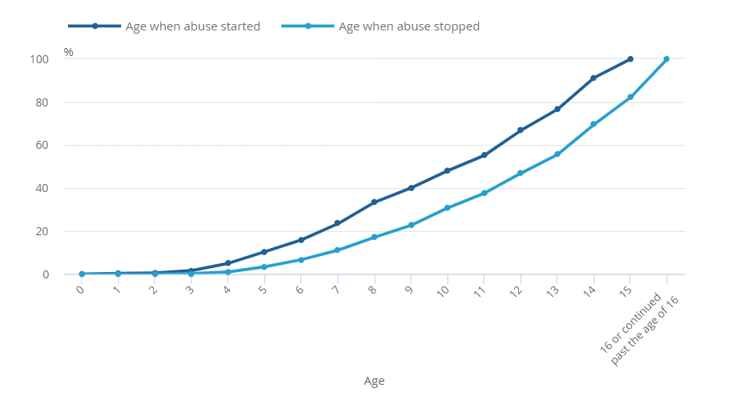
Figure 1: Child Sexual Abuse in the UK
(Source: Ons.gov.uk, 2023)
In most of the cases, it has been found that the parents of the children who became the victims of the sexual abuse feel embarrassed guilty or ashamed. Due to this, they are scared to file police reports on the crime. As a result, due to a lack of family support and required treatment majority of the child who deals with sexual abuse suffer from trauma and depression or anxiety. As per the statement of the “National Society for the Prevention of Cruelty to Children (NSPCC),” 1 in 20 children in the UK have been sexually abused. There are 2,800 children already suffering from sexual abuse in the UK (Nspcc.org.uk, 2023). Most of these reports are not taken seriously by the police and the family members. Due to these, it has a negative impact on the child's mental development process. According to the NHS (National Health Services), Child sexual abuse covers a range of illegal sexual activities (Nhs.uk, 2023). These activities involved images of the sexual abuse, engagement of the child in the sexual activity, protecting the child from becoming a witness to the abuse and inappropriate sexual touching.
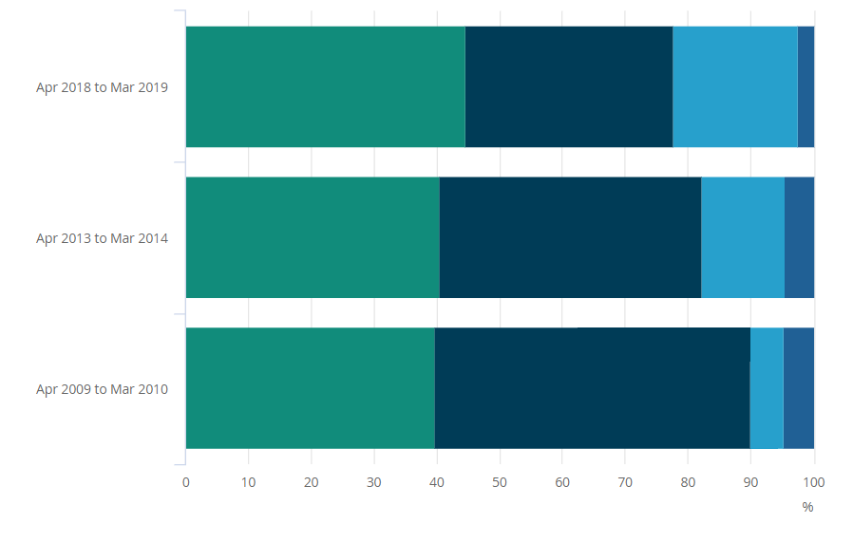
Figure 2: Reported Childhood “sex abuse” in the UK
(Source: Ons.gov.uk, 2023)
The long-term effect of child sexual abuse has created several types of mental issues post-traumatic stress disorder (PTSD), eating disorders, depression, and anxiety. These types of serious mental issues become the cause of the lack of effective mental health development. Child mental health refers to the stage of mental strength development. In this critical stage of life mental strength development, and rapid development take place in the brain. In this way, the brain shapes the emotional skills and future mental health of the children by assuming their importance in future in society. In this stage, if children suffer from sexual harassment and abuse types of issues the mental growth and development process of the child can be stopped or harmed. Following these issues, this literature review helps to understand the potential effect of child sexual abuse on the mental health development process of children.

The rationale of the Topic selection
The main aim of this research topic is to figure out the potential impact of child sex abuse in the aspect of mental health development. Following this aim this research has selected its topic from the scope of health and social care to the relations to the children. Childhood Sexual Abuse becomes the cause of several types of “mental health” issues that break down the potential bridges of the mental and physical growth and development of children (Snow et. al., 2022). Following this particular concern, this peculiar research topic selection becomes justified in understanding how child sexual abuse can affect their “mental health development.” Following the case study of North America, it has been found that 50% of women and 25% of men have experienced childhood sexual abuse which leads them to commit distinct types of crimes in future such as drug consumption, murders, and kidnapping (Ons.gov.uk, 2023). Suddenly in the UK, the child sexual abuse rate has increased, as a result, most of the children are living with diverse types of mental illness that damage their mental growth and lead to post-traumatic stress. Following these issues, this research helps to provide effective solutions to reduce “mental health “problems due to child sexual abuse. Thus, the selection of this research topic has been justified and helps to take a step towards effective child “mental health development.”

Methodology
Research Outline
“Research Onion” (is an illustrated method that describes the stages) has been followed to select appropriate research methods in order to execute the research. Based on Research Onion, the research philosophy, approach, design, and data collection method were selected.
- Research Philosophy | “Interpretivism Philosophy”
- Research Design | “Exploratory Research Design”
- Research Approach | “Inductive Approach”
- Data collection method | “Secondary Qualitative Data Collection Method”
- Data analysis Method | “Thematic Analysis”
Table 1: Research Outline
(Source: Self-developed)
“Interpretivism Philosophy” was selected for sourcing secondary data. This philosophy supports the analysis of qualitative data. Researchers can interpret the result depending on existing theories, concepts, and hypotheses. However, these results are valid under certain circumstances.
Research Approach
An “Inductive Research approach” was followed to gather empirical data to answer research questions. This approach supports gathering data from existing literature and helps to conduct a thematic analysis based on secondary findings (Newman and Gough, 2020). This research approach supports gathering data from peer-reviewed journals and articles to understand the effect of sex abuse on the mental health development of children.
Data Collection
In order to gather empirical evidence, a secondary data collection method was adopted. For sourcing relevant data, Keywords were used. Keywords such as “Childhood Sexual Abuse or CSA,” and “mental health development” were used for searching relevant and authentic data. “Google Scholar” “PubMed” and other Search databases were used for searching relevant and authentic data from existing researchers (Pandey. and Pandey, 2021). Sourcing secondary data is a less complex process compared to primary data sourcing. Inclusion and exclusion criteria were used for selecting relevant and authentic journals for conducting secondary data analysis (Mukherjee, 2019). 10 peer-reviewed journals and articles related to the effect of sex abuse on the mental health development of children have been critically analysed for developing themes.
Exclusion and Inclusion Criteria
Exclusion and inclusion criteria have been used for setting selection criteria for relevant journals and articles related to the effects of “sex abuse” on children's “mental health development.”
Exclusion Criteria | Inclusion Criteria
Non-Peer reviewed articles before 2018 | Peer-reviewed articles from 2019 to 2023
Other languages | English Language
Only abstract | Full text including abstract, introduction, findings, results, and conclusion
Quantitative methodology  (Because this essay is about the effect of sex abuse on child mental health development, the quantitative data is not useful because is number based) | Qualitative methodology  (This methodology is based on feelings, can help us to understand why, how, or what happened behind certain behaviours)
Information about adults | Information about children
Articles on another topic | The article linked on the topic “Effect of “sex abuse” on “mental health development of children”
Table 2: Inclusion and Exclusion Criteria
(Source: Self-developed)
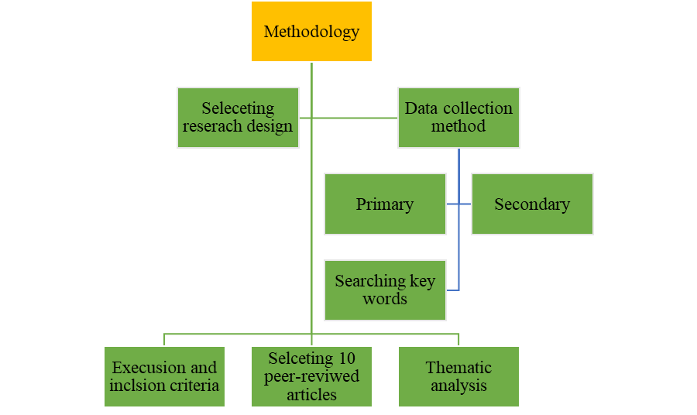
Figure 2: Methodology Flow-chart
(Source: Self-developed)
Data Analysis
In order to analyse secondary data, “Thematic analysis” was conducted. Researchers get familiarised with existing data for generating codes. After getting familiarised with existing data, themes have been identified (Mishra and Alok, 2022). Based on the research aim, four themes have been developed. Thematic analysis is an effective method for analysing qualitative data (Zhou et.al., 2022). This qualitative data analysis method helps to analyse patterns of themes in data. Each of the developed themes addresses each objective and question of the research.

Ethical Practices
Following research ethics and guidelines is important for eliminating the risk associated with legal risk. For maintaining ethics, the “Secondary qualitative data collection and analysis” guidelines were followed. “Harvard referencing guideline’ was followed throughout the research to avoid the risk of plagiarism. The “Copy Right Act” was followed by researchers, which prevented them from direct copy-pasting other work (Säfsten and Gustavsson, 2020). Only ideas and information from existing research were added. Confidentiality of the research was followed throughout the research. “Data Protection Act 2018” was followed by researchers to protect data from leakage. Researchers do not manipulate any data from existing journals and articles. After completion of the research, all the selected articles and journals were deleted. Proper referencing and acknowledgement have been provided by the researchers to avoid the risk of plagiarism and other legal issues (Greening, 2019). “General Data Protection and Regulation or GDPR” was followed throughout the research to maintain research confidentiality. After completion of the research, all the documents and files were saved on the University computer with a strong password.

Result

Theme 1: Long-term impact of sex abuse on the mental health development of Children
As per the empirical research, child sexual abuse can lead to long-term mental impacts for an individual. Children with experience of sexual abuse can engage in high-risk behaviour and find difficulties while developing relationships (Hailes et.al., 2019). Lack of trust and self-esteem can lead to negative body image, which prevents them from making intimate relationships with their partners. Furthermore, increased stress and anxiety are two common long-term effects of CSA. As per existing research, children who experience sexual abuse have altered brain structure. As per MRI images, children without any childhood trauma have a healthy development of the brain, and MRI images of healthy children depict bright colour waves (Noll, 2021). On the other hand, a child who experiences CSA shows dimmer images of brain activity. Thus, CSA can be related to poor academic performance, low concentration power, low self-esteem, and willpower.

Theme 2: Age-specific impact of sex abuse on child mental health development
With increased age, a child with experience of CSA can develop withdrawn behaviour. During teenage, they can engage in inappropriate sexual behaviour. A child with experience of CSA has a higher chance of getting addicted to drugs during their teenage life (Dye, 2020). During adulthood, they might find difficulties in making intimate relationships with their partners due to a lack of trust and low self-esteem. Children experiencing childhood trauma can face difficulties while making good relationships with their friends and family members (Kenny et.al., 2020). Other “mental health “issues including depression, anxiety, inappropriate sexual behaviour, and post-traumatic stress disorders can become prominent in their later life.

Theme 3: Connection Between Child Sexual Abuse and Mental Disorder
Childhood mental disorders are the common consequence of child sexual abuse. Recently, child sexual abuse become higher in the male gender rather than the female gender worldwide. In the UK, 73,260 sexual offences with child sexual abuse were recorded in 2019 (Schnarrs et. al., 2022). The increased rate of sexual abuse among children has increased the rate of mental disorders. Among the majority of victims, several types of behavioural and emotional disorders involving depression, social withdrawal, and anxiety have been found (Freier et. al., 2022). The present findings regarding this topic have determined that most of the time child sexual abuse becomes the cause of the personality disorder.

Theme 4: Way to Reduce Sexual Abuse and Its Impact on Child “mental health”
Preventing and Treating Child Maltreatment has the potential to reduce the level of child sexual abuse (McCabe et. al., 2022). By protecting children with the help of the Children Act 1989, this particular management can effectively implement “mental health “treatment strategies and reduce the negative impact of sexual abuse on the “mental health development” of children (Pacella et. al., 2023). On the other hand, the mental care local agency can create an interlink with the local private care provider organisations so that after the information about the sexual abuse among children the local police and the care providers can take effective steps to protect children.

Findings and Discussion
This section of the research discusses the above results. A broad discussion on developed themes has helped to interpret the real meaning of the findings and link the result with the aim and objectives of the research.

Discussion of Theme One
This theme helped to interpret the long-term impact of sex abuse on the mental health of children, Existing research shows that children who experience trauma such as CSA have a higher chance of getting engaged in inappropriate sexual activities. As per empirical evidence, there is a strong correlation between CSA and dependency on drugs and alcohol. Existing research reveals that 81% of addicted women and 69% of addicted men reported experiences of childhood sexual abuse. From the existing research, it is prominent that there is a strong correlation between child sexual abuse and alcohol or drug addiction (Hailes et.al., 2019). As per the theory of Child Sexual Abuse, drinking alcohol helps to cope with negative thoughts and stress. Thus, CSA can lead to negative health consequences by developing addiction to drugs and alcohol. It can negatively impact on the earning ability, ability to develop relationships and educational performances as a long-term impact.
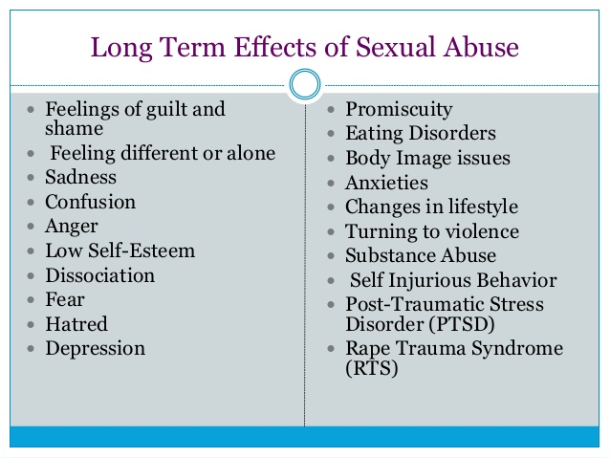
Figure 3: Long-term effects of Sexual Abuse
(Source: Noll, 2021)
Empirical evidence found that there is a strong relationship between eating disorders and CSA. A child with an experience of CSA can develop Anorexia nervosa, eating disorders, negative body image and rumination disorder in their later life. As per existing research, eating disorder helps to cope with negative feelings and anxiety (Noll, 2021). Thus, eating disorders can lead to the issue of obesity or malnutrition among the victims of CSA. Existing studies reveal that victims of childhood abuse have a higher risk of getting engaged in inappropriate sexual behaviour. Sexual risk behaviour can have negative consequences on the physical and “mental health” of individuals (Guha et.al., 2020). The risk of HIV, teenage pregnancy and further “sex abuse” can be increased among the victims of CSA. Unprotected sex, sex of multiple partners and risk of sexual activity at an early age are some vital long-term risks associated with CSA.

Discussion on Theme Two
These themes reveal the age-specific impact of “sex abuse” on the “mental health development” of a child. Low self-esteem and loss of confidence are two major mental disorders associated with CSA. The existing research reveals that 57% of young people who have experienced CSE during their childhood are suffering from depression. Among the victims of CSA, 37% have the risk of developing anxiety disorder (Dye, 2020). The rate of self-harm and suicidal thoughts increased among the victims of CSA. More than 73% of CSA victims have a risk of developing “PTSD or Post-Traumatic Stress Disorder.” The risk of suicide among the victims of CSA is six times higher than among people without any experience of CSA.
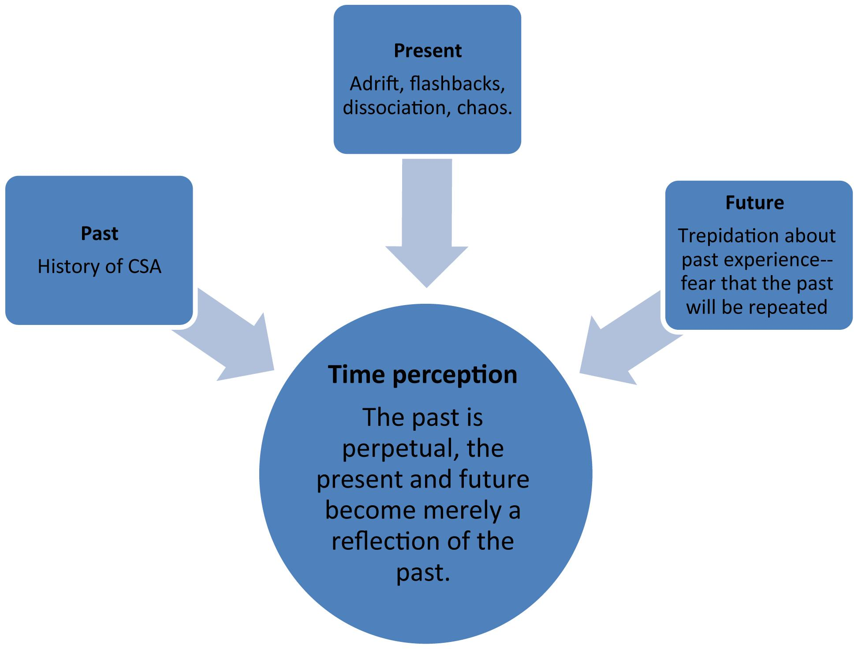
Figure 4: Age-related Impact of CSA
(Source: MacIntosh. and Ménard, 2021)
Difficulty in developing interpersonal relationships is due to the age-specific impact of CSA on the “mental health” of children. Victims of CSA are unable to develop relationships during adulthood. CSA have a profound impact on the ability to maintain a positive relationship. Only 17% of CSA victims can develop strong emotional connections. One of the most prominent impacts of CSA is an increased risk of interpersonal violence, sexual dysfunction, and poor relationship stability (MacIntosh and Ménard, 2021). Victims of CSA failed to develop intimate relationships with their partners. CSA victims develop a less active brain, which leads to poor academic performance. Victims of CSA developed less educational engagement, which directly impacts on the socioeconomic status of the victims. Many of the victims of CSA engaged in alcohol and drug addictions during their adulthood.

Finding and Discussion on Theme 3
Public mental health services have been generated that 12.04% of the cases reflect child mental disorders due to child sexual abuse. The interlink between child sexual abuse and mental disorders becomes the major cause of the lack of mental growth and development among children (Schnarrs et. al., 2022). However, the present case studies on mental health have generated that the children's sexual abuse rate among the male gender has increased in the UK rather than the female gender. However, the major findings of the past research clarified that the inseparable relationship between mental disorders and child sexual abuse has a significant negative impact on the mental health development process of children.
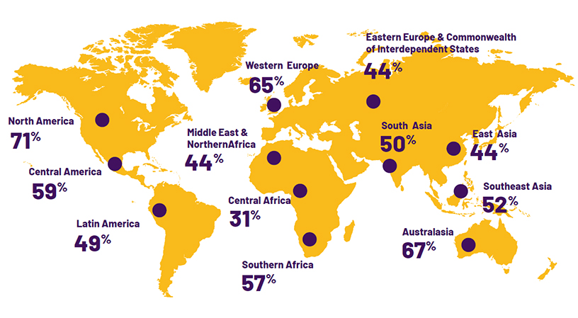
Figure 5: Child “sex abuse” rate in different countries
(Source: Dimitropoulos et. al., 2022)
It becomes the cause of major affective disorders that are also associated with a high range of possibility of personality disorders and the highest relative risks (Dimitropoulos et. al., 2022). Childhood disorders among children have increased due to child sexual abuse. In most cases, it has been found that child sexual abuse leads to schizophrenic disorders or drug-related disorders that significantly have less control over the “mental health “condition of children (Freier et. al., 2022). Childhood mental disorders that have been associated with sexual abuse cause children isolation from society. This type of lack of connection with society becomes the cause of a lack of mental development which causes various mental disorders.

Finding and Discussion on Theme 4
For the reduction of childhood mental trauma that has been generated from, sexual abuse first of all the development of the child sexual abuse awareness programme is essential. During this programme in support of the Children, Act 1989 awareness regarding the diverse types of child sexual abuse has been represented. With the awareness programme, the fear and shame of child sexual abuse among children have been removed (McCabe et. al., 2022). In this way, the child victim can get proper mental support from their parents. Support from family members and society can reduce the possibility of mental health disorders among children. On the other hand, the government support and support from the local agencies to mitigate the child sexual abuse that becomes one of the main causes of children's mental disorders helps to provide proper protection for children. On the contrary, the government supports the availability of the childcare helpline numbers of NSPCC, “The National Association for People Abused in Childhood (NAPAC)” can help to provide proper mental care to child victims. However, it also identified the majority of the carse that are recorder to police without proper action failed to provide proper treatment for the “mental health “condition of children (Pacella et. al., 2023). Following this concern, it is essential for the police to thoroughly investigate and help to provide proper punishment to the criminals. On the other hand, the support from society is to take an effectual part in reducing the level of child abuse crime. The participation of society in the prevention of child sexual abuse can become helpful to reduce the negative impact on the mental health of children.

Conclusion and Recommendations with Future Practices

Conclusion
From the above study, it has been concluded that childhood sexual abuse has both long-term and age-specific consequences on the mental health development of children. The negative impact of child sexual abuse harms mental health condition and cause diverse types of mental health disorders. The inseparable relationship between child sexual abuse and mental disorder damages the mental growth of children and leads them towards distinct types of criminology acts. It has been concluded that child sexual abuse is associated with childhood disorders that damage human psychological development factors and increase the rate of mental disability.

Recommendation
From the above study, it has been recommended that with the help of the local government and local agency, proper support of mental health services can reduce mental health disorders among the victims. The effective adoption of the Child Protection Act helps to reduce the level of child sexual abuse. The awareness of the family members and the government regarding the protection of the children and the reduction of the rate of child sexual abuse is also recommended. Proper family support and effective treatment from the psychiatrist help to reduce the traumatic problem that has been generated from the sexual abuse.

Future Scope
In the aspect of future practices, this research helps to understand the potential relationship between mental disorders and childhood sexual abuse. This will also help in further research to generate effective mental health practices that can help to reduce the mental trauma and other types of issues from the mental health care of children, especially for the victims. This research also become effective for mental service providers or public care providers to protect children from mental disorders and sexual abuse.

References
Dimitropoulos, G., Lindenbach, D., Devoe, D.J., Gunn, E., Cullen, O., Bhattarai, A., Kuntz, J., Binford, W., Patten, S.B. and Arnold, P.D., 2022. Experiences of Canadian “mental health" providers in identifying and responding to online and in-person sexual abuse and exploitation of their child and adolescent clients.” child abuse” & Neglect, 124, p.105448.
Dye, H.L., 2020. Is emotional abuse as harmful as physical and/or sexual abuse? Journal of Child & Adolescent Trauma, 13(4), pp.399-407.
Freier, A., Kruse, J., Schmalbach, B., Zara, S., Werner, S., Brähler, E., Fegert, J.M. and Kampling, H., 2022. The mediation effect of personality functioning between different types of child maltreatment and the development of depression/anxiety symptoms–a German representative study. Journal of affective disorders, 299, pp.408-415.
Greening, N., 2019. Phenomenological research methodology. Scientific Research Journal, 7(5), pp.88-92.
Guha, A., Luebbers, S., Papalia, N. and Ogloff, J.R., 2020. Long-term healthcare utilisation following child sex abuse: A follow-up study utilising five years of medical data.” child abuse” & neglect, 106, p.104538.
Hailes, H.P., Yu, R., Danese, A. and Fazel, S., 2019. Long-term outcomes of childhood sexual abuse: an umbrella review. The Lancet Psychiatry, 6(10), pp.830-839.
Kenny, M.C., Helpingstine, C. and Long, H., 2020. College students’ recollections of childhood sexual abuse prevention programs and their potential impact on reduction of sexual victimization.” child abuse” & Neglect, 104, p.104486.
MacIntosh, H.B. and Ménard, A.D., 2021. Where are we now? A consolidation of the research on long-term impact of child sexual abuse. Journal of child sexual abuse, 30(3), pp.253-257.
Martinello, E., 2020. Applying the ecological systems theory to better understand and prevent child sexual abuse. Sexuality & Culture, 24(1), pp.326-344.
McCabe, S.E., Hughes, T.L., Beal, S., Evans-Polce, R.J., Kcomt, L., Engstrom, C., West, B.T., Veliz, P., Leary, K., McCabe, V.V., and Boyd, C.J., 2022. Sexual orientation differences in childhood sexual abuse, suicide attempts, and DSM-5 alcohol, tobacco, other drug use, and “mental health” disorders in the US.” child abuse” & neglect, 123, p.105377.
Mishra, S.B. and Alok, S., 2022. Handbook of research methodology.
Mukherjee, S.P., 2019. A guide to research methodology: An overview of research problems, tasks, and methods.
Newman, M. and Gough, D., 2020. Systematic reviews in educational research: Methodology, perspectives, and application. Systematic reviews in educational research: Methodology, perspectives and application, pp.3-22.
Nhs.uk, 2023 Child Sexual Abuse [Online] Available At: https://www.nhs.uk/live-well/spotting-signs-of-child-sexual-abuse/ [Accessed On: 04.10.2023]
Noll, J.G., 2021. Child sexual abuse as a unique risk factor for the development of psychopathology: The compounded convergence of mechanisms. Annual review of clinical psychology, 17, pp.439-464.
Nspcc.org.uk, 2023 Child Sexual Abuse [Online] Available At: https://learning.nspcc.org.uk/research-resources/statistics-briefings/child-sexual-abuse [Accessed On: 04.10.2023]
Ons.gov.uk, 2023 Child Sexual Abuse [Online] Available At: https://www.ons.gov.uk/peoplepopulationandcommunity/crimeandjustice/articles/childsexualabuseinenglandandwales/yearendingmarch2019 [Accessed On: 04.10.2023]
Pacella, R., Nation, A., Mathews, B., Scott, J.G., Higgins, D.J., Haslam, D.M., Dunne, M.P., Finkelhor, D., Meinck, F., Erskine, H.E. and Thomas, H.J., 2023. Child maltreatment and health service use: findings of the Australian Child Maltreatment Study. Medical journal of Australia, 218, pp. S40-S46.
Pandey, P. and Pandey, M.M., 2021. Research methodology tools and techniques. Bridge Center.
Papalia, N., Mann, E. and Ogloff, J.R., 2021. Child sexual abuse and risk of revictimization: Impact of child demographics, sexual abuse characteristics, and psychiatric disorders. Child maltreatment, 26(1), pp.74-86.
Säfsten, K. and Gustavsson, M., 2020. Research methodology: for engineers and other problem-solvers.
Schnarrs, P.W., Stone, A.L., Bond, M.A., Salcido Jr, R., Dorri, A.A. and Nemeroff, C.B., 2022. Development and psychometric properties of the sexual and gender minority adverse childhood experiences (SGM-ACEs): Effect on sexual and gender minority adult mental health.” child abuse” & Neglect, 127, p.105570.
Snow, J., Moorman, J. and Romano, E., 2022. Emotion regulation and “mental health”among men with childhood sexual abuse histories. Journal of child sexual abuse, 31(4), pp.412-430.
Zhou, Y., Li, H. and Sun, H., 2022. Metalloproteomics for biomedical research: methodology and applications. Annual Review of Biochemistry, 91, pp.449-473.

