Lidl’s Competitive Strategy



May 1st 2020

MODULE NAME: Strategic Management and Sustainability
Name: Cameron Carlson (1701627)
Student Number: (1701627)

Table of Contents
1.0 Executive Summary 3
2.0 Introduction 3
2.1 Report Remit 4
2.2 Background of Organisation 4
2.3 Definition of concepts 4
3.0 Main Body 10
3.1 Implementation of strategy 11
3.2 Advantages & Disadvantages 12
4.0 Conclusion 13
4.1 Recommendations 14
5.0 Bibliography 15

Executive Summary

This report will be identifying which of the Porters generic strategies will apply to Lidl the best. Within the report there will be background information on Lidl and how they have become the supermarket we see today. Lidl was founded in 1994 in a town called Lutterworth, selling only 800 products in the store. 25 years later and they have over 800 stores in 13 countries. Cost Leadership is the best suited strategy for Lidl, the reason for this is because they can market products at a lower price making all the supermarkets around them lower their prices too. Within the conclusion it is made clear that Lidl have managed to successfully dominate the supermarket industry. Lidl have been recommended to not branch out and purchase some of the other branded items, this is so that Lidl doesn’t get into any price wars with bigger branded supermarkets.

Introduction
Many companies have developed and created various different business strategies, that have helped them to succeed in the business world.
“In today’s environment, a business plan is an entrepreneur’s most crucial business document. No company can expect to articulate its goals or to secure financing without a well-conceived and well-presented business plan” (Abrams, 2010).
Having these plans in place can help the companies to compete with their competitors, in some cases the business plans can be used as a way of forecasting and preparing the companies for what may come in the future. Lidl is a global discount supermarket chain, that has had many years of success. That is all down to their competitive strategy that they’ve utilised to develop their current competitive position.

Report Remit
The objective of this report is to identify what strategy Lidl apply to the business that helps them gain an advantage against other popular supermarkets. Included in the report will be how Lidl have gained their competitive position through varies examples. There will be a section explaining what the advantages and disadvantages of what Lidl’s business plan.

Background of Organisation
“We opened our first ever Regional Distribution Centre in Lutterworth and our first ten British stores in 1994, selling only 800 products in our stores” (Lild, 2020). Lidl started off as a very small supermarket and within 25 years of the store being opened, they have gained the competitive position in the market that they hold today. “25 years later, we now have more than 800 stores and 13 regional distribution centres across Britain, employing over 23,000 people” (Lild, 2020). Between 1989 and 1994 Lidl were able to open their first store in France and then they went on to open 10 brand new stores across Britain (Corporate Lidl, 2020). Over the years Lidl have gradually expanded currently they have 10,500 stores globally and continue to grow. Lidl are a part of the Schwarz Group. Between 2018/2019 the Schwarz group achieved a turnover of €104.3 billion. In 2019 the schwarz group released its financial year 2018/2019 showing that Lidl were the schwarz groups biggest asset increasing their profits by 8.8% to €81.2bn (Delacour, 2019).

Definition of concepts
Organisations use various different concepts to help their objectives and goals, Lidl has managed to understand what concepts work for them, they have then utilised these to progress them to the level of success they have today. Utilising the business plans Lidl have been able to identify any advantages or disadvantages they may have against their competitors. When defining a business strategy, the main form it’ll take will be a linear strategy:

“Spender, 1979; Steiner, 1979). Hambrick (1983) suggested that this diversity is due to two factors. First, he pointed out, strategy is multidimensional. Second, strategy must be situational and, accordingly, it will vary by industry” (Chaffee, 1985). This was outlining that when creating a strategy, it needs to be assessed thoroughly, to fully understand what the outcome of the strategy is, the second section says that strategies will vary from business to business.
Business level strategy:
“Business-level strategy focuses on how to attain and satisfy customers, offer goods and services that meet their needs, and increase operating profits” (Bizfluent, 2018).
This strategy focuses on the customers and aiming to keep them coming back and making Lidl their regular supermarket. Lidl offer various goods in their store, all at a much lower price than their competitors, these then appeals to the masses because shoppers are more drawn to discounted prices. Increasing profits will ensure that the customers need will be met with the products and services they are looking for.

Competitive advantage: An effective strategy will provide sustainable competitive advantage to an organisation resulting in superior performance; however, this can be achieved only if the strategy matches properly with the organisation’s external environment and internal conditions (Megicks, 2007). “Having an effective strategy can result in superior performance”, Lidl have an effective strategy hence why they are such a big competitor to other supermarkets. Having this advantage puts them at the tip, Lidl are able to balance the external and internal environment which is why they are resulting in the superior performance.

The model that will be applied to Lidl is Porters generic strategy, these have been the leading strategies in the incorporate competitivity:
“Porter’s generic strategy matrix, which highlights cost leadership, differentiation and focus as the three basic choices for firms, has dominated corporate competitive strategy for the last 30 years” (Pretorius, 2008).
Michael Porter says that there are four main strategies which are: Cost Leadership, Differentiation, focus cost leadership, focus/ focus Differentiation. The last strategies are a combination of two of the already existing.
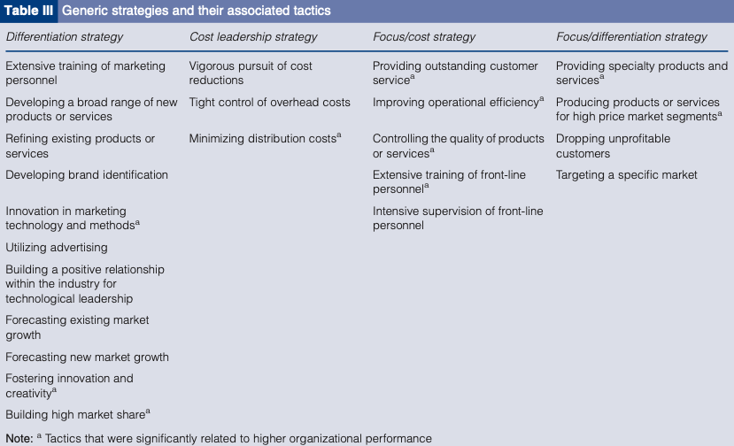
Figure 1: Generic strategies and their associated tactics (Akan, et al., 2006)

The graph above is a breakdown of a higher performing organisations tactics, every section is broken down and then the tactics are assigned to the correct columns. Each section has some crucial tactics that any business need in order to become the top competitor.

Cost leadership: “Cost leadership strategy seeks to achieve above-average returns over competitors through low prices by driving all components of activities towards reducing costs. To attain such a relative cost advantage, firms will put considerable effort in controlling and production costs, increasing their capacity utilization, controlling materials supply or product distribution” (Prajogo, 2007). Lidl have managed to capitalise on the cost leadership strategy by having some of the lowest prices for the everyday items that customers need. In January of 2020 Lidl were named as Britain’s cheapest supermarket by the Daily Mail, “Lidl is named Britain's cheapest supermarket: A basket of 33 everyday groceries costs just £44.53 in the discount chain - compared to £62.34 at Waitrose” (DailyMail, 2020). Lidl are dominating in their market; they’re rivalling some of the more expensive brands.

Differentiation: “This strategy allows organizations to charge a premium price to capture market share. The differentiation strategy is effectively implemented when the business provides unique or superior value to the customer through product quality, features, or after-sale support and service” (Allen, et al., 2007). This strategy provides the customers with products that are regarded as unique and other services that are unique to the store, items that are labelled unique tend to be a higher price than other products that are more commonly purchased.
Focus: “In the focus strategy, a firm targets a specific segment of the market, the firm can choose to focus on a select customer group, product range, geographical area, or service line. But, focus strategies are most effective when consumers have distinct preferences and when the niche has not been pursued by rival firms” (Allen & Helms, 2006). When using this strategy, the organisation needs to put a lot of planning into it, they need to look at different entries into the market by using niche products. Doing this then fills the customers need for that product, which then builds a relationship with the customer. Having relationships with customers is crucial because this generates regular purchases and builds up a form of loyalty, meaning the customers will prefer Lidl over other stores, customers would register Lidl as their local store.
Some companies can tend to use two strategies at once, “An organization may also choose a combination strategy by mixing of the aforementioned generic strategies” (Allen & Helms, 2006). Therefore, companies have mixed focus with cost and focus with differentiation. For example, if a company was to mix focus with differentiation it would mean they would have a unique product with a target audience to market it to. But, if they were to mix focus and cost then they would create a leadership strategy that would segment the targeted market. Lush, T-Mobile and Whole foods were all successful companies that managed to successfully use the focus differentiation strategy.
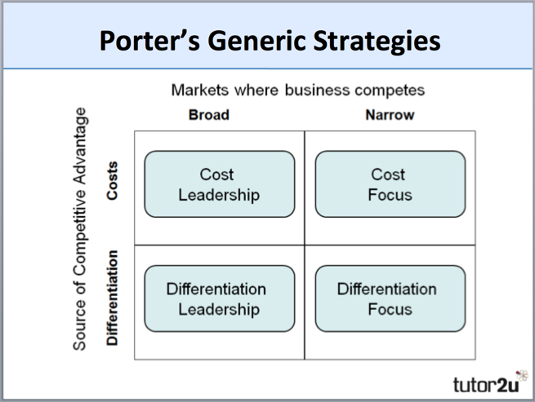
Below is an image of what the Porters generic strategy looks like. This is what’s used to help give companies more of a competitive strategy.

Main Body
As stated, the model that’s being used is the Porters generic strategies, after reviewing all the strategies, it seems that Lidl would fit into the Cost Leadership strategy. The reason for this is that Lidl pride themselves in being the best value for money, having a lost cost strategy means that this strategy seeks to achieve above-average returns over competitors through low prices. Lidl sell their products for as low as possible whilst still making a profit on the items themselves, this then has a knock-on effect on other businesses. The competitors need to fight back by trying to bring their prices as low as Lidl, but other companies haven’t perfected the Cost leadership strategy like Lidl.
“One of the reasons why Lidl became such a success against other leading supermarket chains was that it sells a smaller selection of products with extremely limited branded lines, which of course were a more expensive option than own-brand products. Items that didn’t sell were taken off the shelves to reduce costs” (Inspiringinterns, 2018). Lidl are very smart in the way they market themselves and perform the cost leadership strategy.

Implementation of strategy

A study was undertaken on various Lidl stores spread over three cities in Finland, 20 items were price matched against two other competitors over the space of three years. The reason for the length of time was so any seasonal items were eliminated.
“Lidl’s pricing was consistent across all three locations, which seemed to have the effect on the other stores in lessening the differential pricing policies, meaning that a more consistent price was available across the competitors” (Emerald insight, 2007).
This is a prime example of Cost leadership in affect, Lidl kept their pricing consistent through the varies other stores which then, made the stores around them to alter their prices to try and regain some of the customers they may have lost to Lidl. Lidl’s price was consistent for all of the three years, whereas the competitors altered their prices. This was an attempt by the competitors to try and take control of the market but where Lidl kept their prices the same, they have developed loyalty with the customers. Lidl globally have perfected the cost leadership strategy; they have become one of the lead competitors in supermarket industry. This will have had a massive impact on the business, increasing profits, publicity and customer loyalty.
Lidl have become the leading competitor due to their success by using the cost leadership strategy, in the august of 2019 Lidl attained their biggest share of the UK’s grocery market at 5.9% (The Guardian, 2019). This then aids their cost leadership strategy because for the strategy to work a company needs a large share in the chosen market they’re trying to dominate, therefore with the increase of market share for Lidl means that they’ll have more control over certain prices on products. Having an increase of market share means that it will increase their profits.

Advantages & Disadvantages
Porters generic strategies have varies advantages and disadvantages, by Lidl Using the cost leadership strategy means that they will have come against many disadvantages that could crush the business, with disadvantages there will also be some advantages for Lidl, below is some examples of advantages and disadvantages of using the cost leadership strategy.

Advantages: - Maintain profits
- Expand Market Share

Disadvantages – Price wars
Less focus on customer needs
Companies can quickly copy any techniques and lower their prices

For Lidl to keep on being successful they need to evaluate what their weaknesses or any other disadvantages, a price war can be very dangerous for certain supermarkets because some of the bigger competitors can risk putting their prices lower than everyone else because they have financial backing. “A price war is a competitive exchange among rival companies who lower the price points on their products, in a strategic attempt to undercut one another and capture greater market share” (Investopedia, 2019). This can be a big disadvantage to Lidl because if they get into a price war with another low-cost leadership strategy it could end up costing them more money to keep the prices low, this then could result in loss of profit. Being the top competitor for Lidl means that they have the advantage of being the best in the industry, this is an advantage to them because it maintains profits for them and helps to expand Market share. Expanding market shares helps to expand to new customers and help to dominate the industry, having new customers bring new profit and new ideas. Therefore, having a steady income of new customers means profits will increase.

Conclusion
Therefore, to conclude this report, Lidl have successfully managed to perform and perfect the cost leadership strategy. They have done this through utilising low prices and limited brands in their stores. This then has led the customers to develop some form of relationship with the store, meaning Lidl will have increased their customers loyalty by keeping prices the same and rotating various different products on a weekly timescale. Lidl need to be aware of any price wars that are going on, this gives them the chance to analysis how other competitors handle price wars. Therefore, Lidl are the leading competitors in the supermarket industry today.

Recommendations
Lidl have managed to ensure their position in the industry of today. Lidl are already a well-established industry therefore recommendations may be harder; Lidl should stay with the cheaper variants of products rather than the big brands, the reason is that bigger brands means more money spent on buying the new products, means less money they could making. If they were to start selling more branded items, they would start trying to compete with other high-end supermarkets, this could end up costing Lidl more money to buy the branded products and could result in losing loyal customers. Another recommendation could be that Lidl try to avoid using any other strategies, they have succeeded with using the cost leadership strategy but if they were to try and adapt another strategy they could find themselves in a difficult situation, Porter refers to companies trying to use two strategies at once he calls it “Stuck in middle”, these can be very effective in some cases but other companies have be known to fail at trying to balance the two strategies.

5.0 Bibliography
Abrams, R., 2010. The Successful Business Plan. 4th Edition ed. Palo Alto, Calif.: ThePlanningshop.
Akan, O., Allen, R. S., Helms, M. M. & Spralls, S. A., 2006. Critical tactics for implementing Porter's generic strategies. Journal of Business Strategy, 27(1), pp. 43-53.
Allen, R. S. et al., 2007. Porters Business Straegies in Japan. Business Strategy Series, 9(1), pp. 37-44.
Allen, R. S. & Helms, M. M., 2006. Linking strategic practices and organizational performance to Porter's generic strategies. Business Process Management Journal, 12(4), pp. 433-454.
Bizfluent, 2018. Bizfluent. [Online]
Available at: https://bizfluent.com/info-7900064-business-vs-corporate-level-strategy.html
[Accessed 30th April 2020].
Chaffee, E. E., 1985. Academy of Management. Three Models of Strategy, 10(1), pp. 7-11.
Corporate Lidl, 2020. Lidl. [Online]
Available at: https://corporate.lidl.co.uk/?_ga=2.11409972.1458189553.1588176189-1316845966.1588176189
[Accessed 29th April 2020].
DailyMail, 2020. DailyMail. [Online]
Available at: https://www.dailymail.co.uk/news/article-7911077/Lidl-Britains-cheapest-supermarket-basket-33-everyday-groceries-costing-44-53.html
[Accessed 30th April 2020].
Delacour, M., 2019. IGD Retail Analysis. [Online]
Available at: https://ra.igd.com/retailers/kaufland/news-article/t/schwarz-group-201819-results-74-to-104bn/i/21604
[Accessed 29th April 2020].
Emerald insight, 2007. Lidl invades Finland: Pricing and the art of Marketing. Strtegic Direction, 23(10), pp. 9-11.
Inspiringinterns, 2018. What can we learn from the rise of Lidl?. [Online]
Available at: http://www.inspiringinterns.com/blog/2018/08/the-rise-of-lidl-what-we-can-learn-from-the-shift-toward-cheap-supermarkets/
[Accessed 30th April 2020].
Investopedia, 2019. Price War. [Online]
Available at: https://www.investopedia.com/terms/p/price-war.asp
[Accessed 08 August 2020].
Lild, 2020. Lidl. [Online]
Available at: https://careers.lidl.co.uk/life-at-lidl/our-history
[Accessed 29th April 2020].
Megicks, P., 2007. Business-level strategy and performance. The moderating effects of environment and structure, 45(3), pp. 484-502.
Prajogo, D. I., 2007. The relationship between competitive strategies and product quality. Industrial Management & Data Systems, 107(1), pp. 69-83.
Pretorius, M., 2008. When Porter's generic strategies are not enough: complementary strategies for turnaround situations. Journal of Buisness, 29(6), pp. 19-28.

