

Material Evaluation

Student Name: Alex Maloney
ID Number: 2003580
Programme: BEng/HND Automotive, Motorcycle & Motorsport Engineering
Module: Engineering Design and Materials
Module Code: ACHA4001
Lecturer: Greg Owen

Submission Deadline: 30/04/2021

Table of Contents
Question 1....................................................................................2
Question 1a.............................................................................................2
Question 1b..........................................................................................2,3
Question 1c.............................................................................................3
Question 1d.............................................................................................3
Question 1e.............................................................................................3
Question 2 ................................................................................4,5
Question 3....................................................................................6
Alloy A......................................................................................................6
Alloy B......................................................................................................6
Alloy C......................................................................................................7
Question 4....................................................................................8
Vector A...................................................................................................8 Vector B...................................................................................................8 Vector C...................................................................................................8 Vector D...................................................................................................9
Question 5..................................................................................10
Vector A.................................................................................................10 Vector B.................................................................................................10 Vector C.................................................................................................10
Question 6..................................................................................11
A...........................................................................................................11
B...........................................................................................................11
C...........................................................................................................11
D...........................................................................................................11
E...........................................................................................................11
F...........................................................................................................11

Question 1
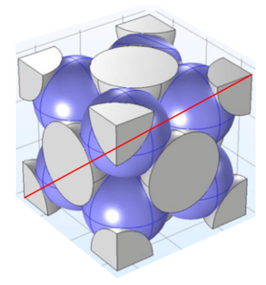
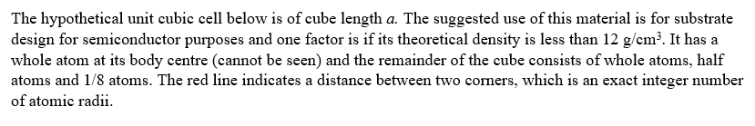

Question 1a
Write down the number of atoms within this unit cell.
$$Contribution of 1 corner atom=\frac{1}{8}$$
$$Contribution of 8 corner atoms=\frac{1}{8}×8=1$$
$$Contribution of 1 face atom=\frac{1}{2}$$
$$Contribution of 6 face atoms=\frac{1}{2}×6=3$$
$$Contribution of 1 central atom=1$$
$$Contribution of 8 central atoms=1×8=8$$
$$Contribution of 1 body centre atom=1$$
$$Total number of atoms within this unit cell=1+3+8+1=13$$
Question 1b
Show that the atomic packing fraction for this unit cell is 0.55.
$$APF= \frac{Volume of atoms in unit cell*}{Volume of unit cell}$$
$r=radius of atom$ $a=unit cell dimension$
$$Volume of sphere= \frac{4}{3}×π×r^{3}$$
$$Va=13(\frac{4}{3}×π×r^{3})$$
$$Body diagonal=r+2r+2r+2r+r=8r$$
$${8r}^{2}=a^{2}+a^{2}$$
$$8r^{2}=a^{2}+2a^{2}$$
$$a=\frac{8}{√3}×r$$
$$Volume of unit cell=\frac{8}{√3}×r^{3}$$
$$APF= \frac{13(\frac{4}{3}×π×r^{3})}{({\frac{8}{√3})}^{3}×r^{3}}=0.552=0.55$$
Question 1c
In an example of this cube, the radius of a single atom is 0.142mm. Calculate the volume of the cube.
$$Volume of cube=\frac{8}{√3}×r^{3}$$
$r=radius of single atom$
$$Volume of cube=(\frac{8}{\sqrt{3}}×{{0.142×10}^{-9})}^{3}$$
$$Volume of cube={2.821×10}^{-28}m^{3}$$
Question 1d
Given the hypothetical material above has an atomic weight 53.5g/mol. Calculate its theoretical density.
$$Atomic weight=53.5g/mol$$
$$ρ=\frac{n×A}{V_{C}×N_{A}}$$
$$ρ=\frac{13×53.5}{{2.821×}^{-28}×{6.02×10}^{23}}$$
$$ρ=5.06{g/cm}^{3}$$
Question 1e
Comment on its suitability for its intended purpose.
The material used is suitable for its intended purpose as the density used is less 12g/cm³.
Question 2
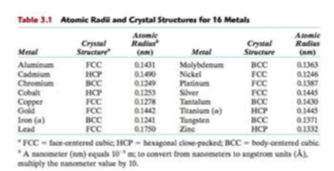
$$Molybdenum-BCC-r=0.1363×{10}^{-7}$$
$a= \frac{4}{√3}×r$ $n=2$
$$APF= \frac{2(\frac{4}{3}×π×r^{3})}{({\frac{4}{√3})}^{3}×r^{3}}=0.68$$
$$Vc=(\frac{4}{\sqrt{3}}\left(0.1363×{10}^{-7}\right))^{3}=3.12×{10}^{-23}{cm}^{3}$$
$ρ= \frac{m}{Vc}$
$$Weight=10.3g/{cm}^{3}$$
$$10.3=m×g$$
$$m=\frac{10.3}{9.81}=1.05$$
$$ρ= \frac{1.05}{3.12×{10}^{-23}}=3.37 ×{10}^{22}$$

$Nickel-FCC-r=0.1246×{10}^{-7}$
$a=2√2×r$ $n=4$
$$APF=\frac{4(\frac{4}{\sqrt{3}}×π×r^{3})}{(2√2×r^{3})}=0.74$$
$$Vc=(2×√2×0.1246×{10}^{-7})^{3}=4.38×{10}^{-23}{cm}^{3}$$
$ρ= \frac{m}{Vc}$
$$Weight=8.9g/{cm}^{3}$$
$$8.9=m×g$$
$$m=\frac{8.9}{9.81}=0.91$$
$$ρ= \frac{0.91}{4.38×{10}^{-23}}=2.078×{10}^{22}$$
The atomic packing fracture of molybdenum is slightly higher than that of nickel, as well as this molybdenum has a slightly higher density than nickel. Nickel however has a higher unit of volume than molybdenum.

Question 3
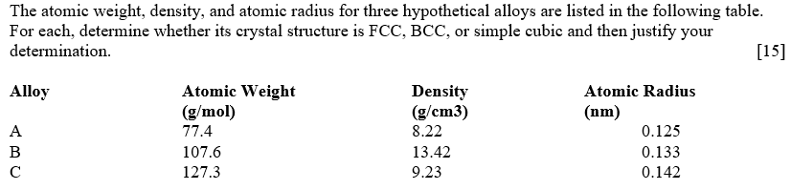

Alloy A
$A=77.4$ g/mol
$$ρ=8.22 g/{cm}^{3}$$
$$r=0.125×{10}^{-7}cm$$
$$ρ=\frac{n×A}{V_{C}×N_{A}}$$
$FCC: n=4$ $Vc=16r^{3}√3$
$$ρ=\frac{4×77.4}{(16r^{3}√3)×(6.022×{10}^{23})}=11.63g/{cm}^{3}$$
$$Not FCC$$
$Simple Cubic: n=1$ $Vc=8r^{3}$
$$ρ=\frac{1×77.4}{(8r^{3})×(6.022×{10}^{23})}=8.22g/{cm}^{3}$$
$$Alloy A corresponds to simple cubic therefore Alloy A is simple cubic.$$
Alloy B
$A=107.6$ g/mol
$$ρ=13.42 g/{cm}^{3}$$
$$r=0.133×{10}^{-7}cm$$
$$ρ=\frac{n×A}{V_{C}×N_{A}}$$
$FCC: n=4$ $Vc=16r^{3}√3$
$$ρ=\frac{4×107.6}{(16r^{3}√3)×(6.022×{10}^{23})}=13.43g/{cm}^{3}$$
$$Alloy B is therefore FCC.$$
Alloy C
$A=127.3$ g/mol
$$ρ=9.23 g/{cm}^{3}$$
$$r=0.142×{10}^{-7}cm$$
$$ρ=\frac{n×A}{V_{C}×N_{A}}$$
$FCC: n=4$ $Vc=16r^{3}√3$
$$ρ=\frac{4×127.3}{(16r^{3}√3)×(6.022×{10}^{23})}=10.66g/{cm}^{3}$$
$Simple Cubic: n=1$ $Vc=8r^{3}$
$$ρ=\frac{1×127.3}{(8r^{3})×(6.022×{10}^{23})}=9.23g/{cm}^{3}$$
$$Alloy C is therefore simple cubic.$$

Question 4
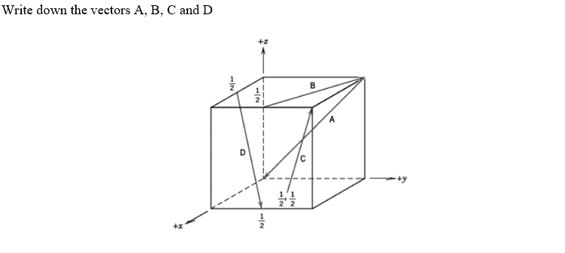
Vector A
$$Head=\left(0,0,0\right)$$
$$Tail=(0,1,1)$$
$$Head-Tail=(0,-1,-1)$$
$$→A=(0,\overline{2}, \overline{2})$$
Vector B
$$Head=\left(0,1,1\right)$$
$$Tail=(1,\frac{1}{2},1)$$
$$Head-Tail=(-1,\frac{1}{2},0)$$
$$→B=(\overline{2},1,0)$$
Vector C
$$Head=\left(1,1,1\right)$$
$$Tail=(\frac{1}{2},\frac{1}{2},0)$$
$$Head-Tail=(\frac{1}{2},\frac{1}{2},1)$$
$$→C=(1,1,2)$$

Vector D
$$Head=\left(1,\frac{1}{2},0\right)$$
$$Tail=(\frac{1}{2},0,1)$$
$$Head-Tail=(\frac{1}{2},\frac{1}{2},-1)$$
$$→D=(1,1,\overline{2})$$

Question 5
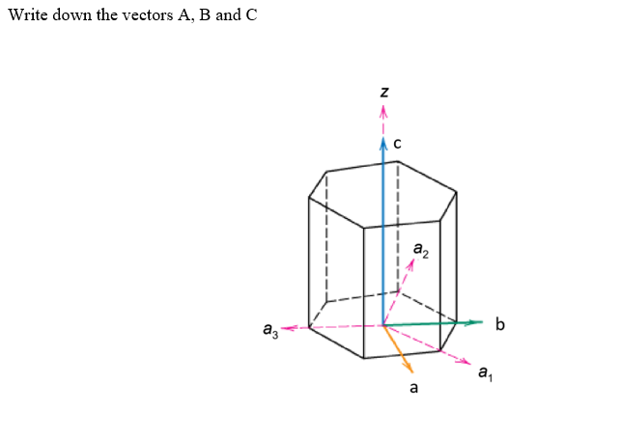
Vector A
$$→A=(1,0, 0)$$
Vector b
$$→B=(0,1,0)$$
Vector c
$$→C=(0,0,1)$$

Question 6
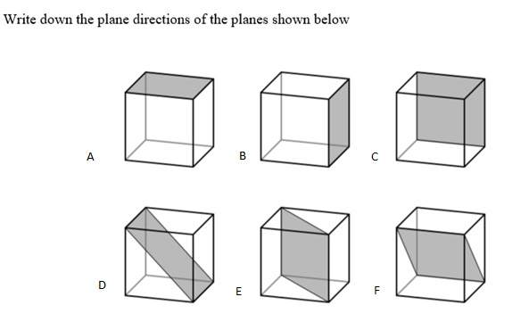

$A= \left(0,0,1\right)$ $D=\left(1,0,1\right)$
$B=\left(1,0,0\right)$ $E=(1,1,0)$
$C=(0,1,0)$ $F=(0,1,1)$

