PRISMA Process
01-03-24
Meta analysis
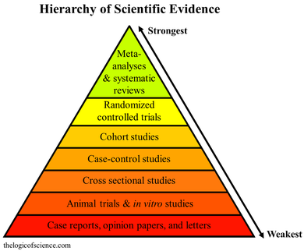
QUOROM

In 1996, an international group of 30 clinical epidemiologists, clinicians, statisticians, editors, and researchers convened The Quality of Reporting of Meta-analyses (QUOROM) conference to address standards for improving the quality of reporting of meta-analyses of clinical randomized controlled trials (RCTs).^{[6]} This conference resulted in the QUOROM checklist and a flow diagram that described the preferred way to present the abstract, introduction, methods, results, and discussion sections of a report of a systematic review or a meta-analysis.^{[6]}

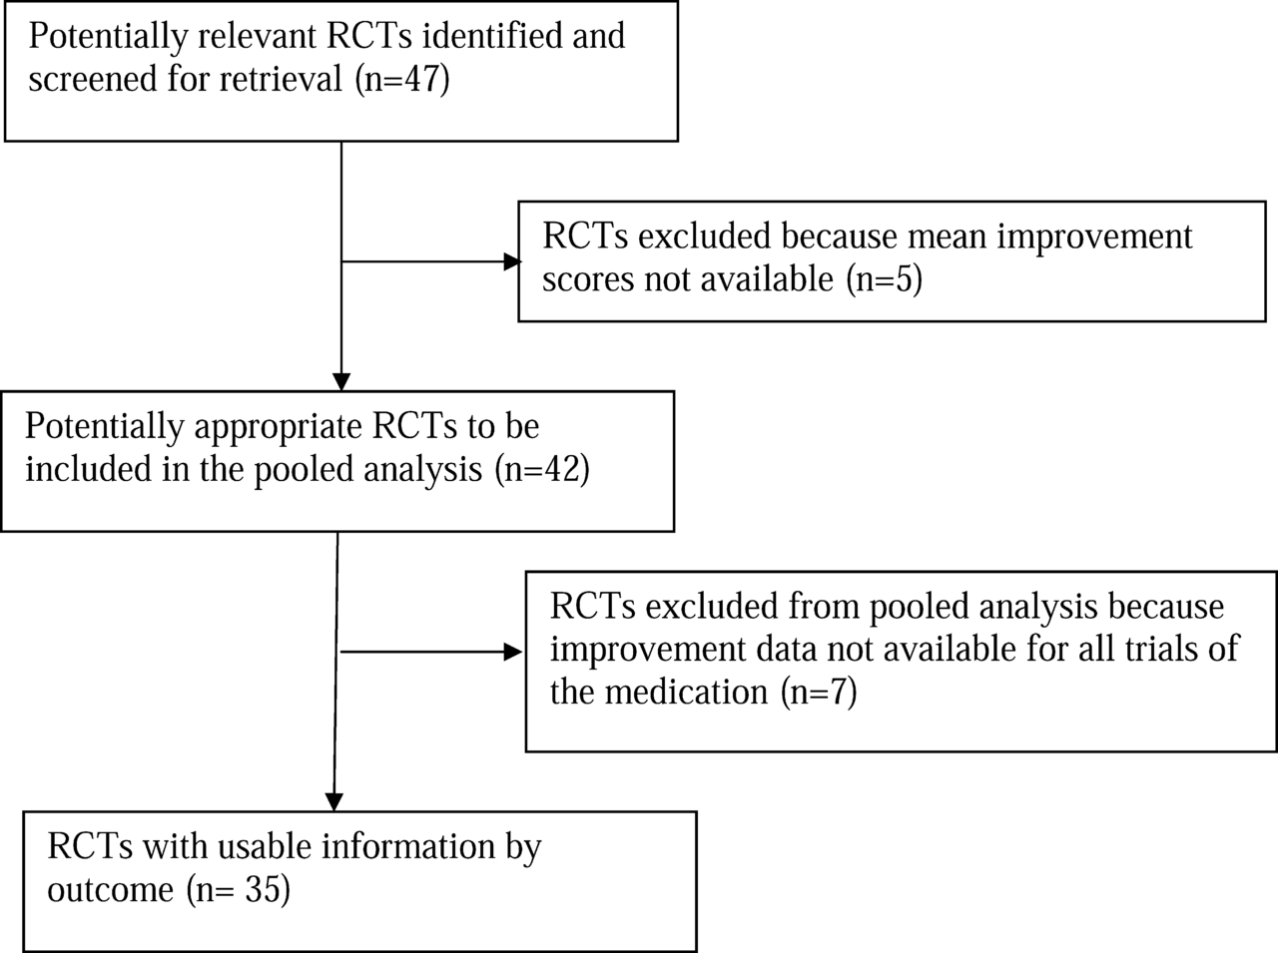

PRISMA
https://www.youtube.com/watch?v=fr-mMDJib4Y
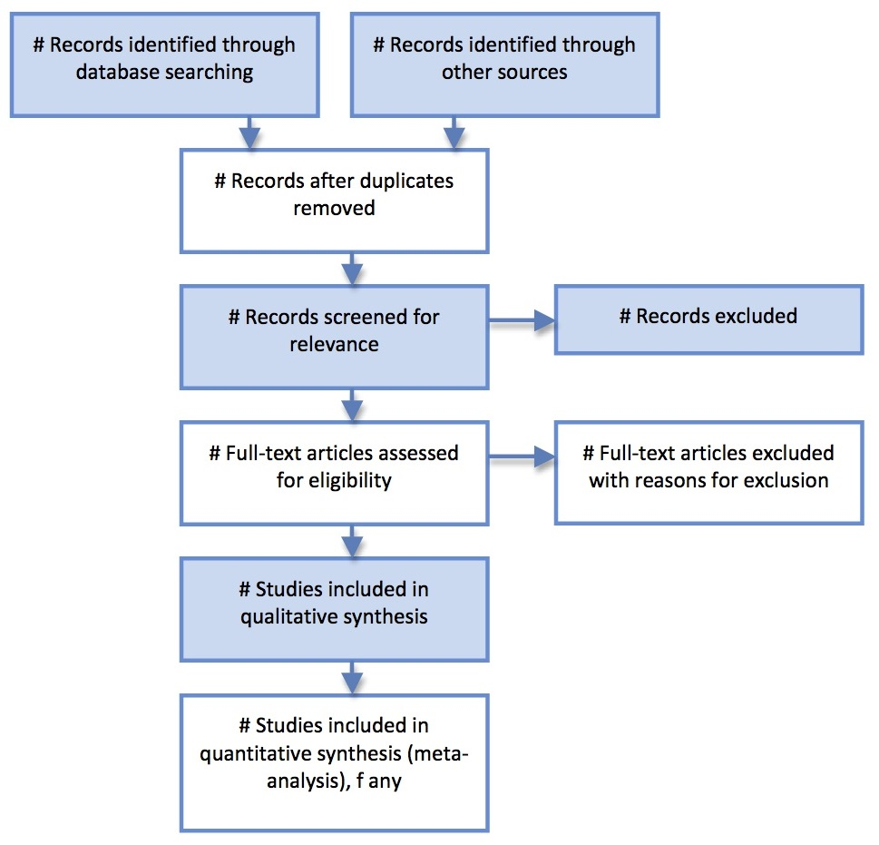

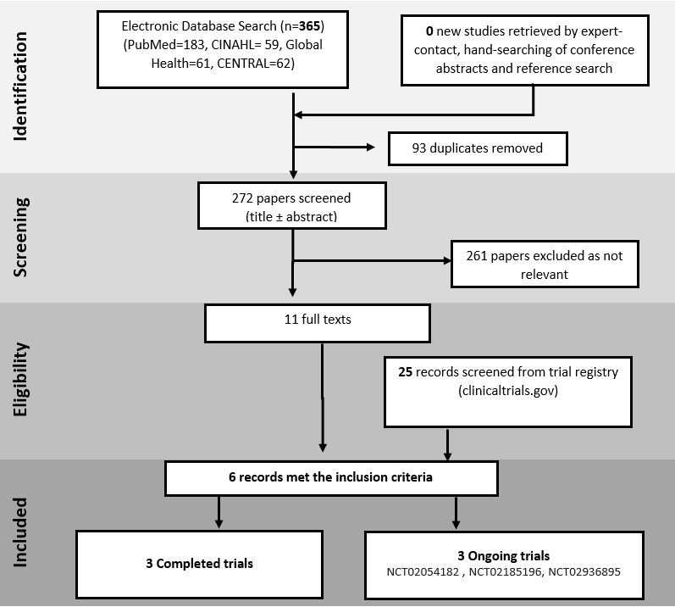
https://libguides.derby.ac.uk/literature-reviews/prisma-lr
- What is the PRISMA Flow Diagram?
- How should I use it?
- When should I use it?
- PRISMA Links
The PRISMA Flow Diagram is a tool that can be used to record different stages of the literature search process--across multiple resources--and clearly show how a researcher went from, 'These are the databases I searched for my terms', to, 'These are the papers I'm going to talk about'.
PRISMA is not inflexible; it can be modified to suit the research needs of different people and, indeed, if you did a Google images search for the flow diagram you would see many different versions of the diagram being used. It's a good idea to have a look at a couple of those examples, and also to have a look at a couple of the articles on the PRISMA website to see how it has--and can--be used.
The PRISMA 2020 Statement was published in 2021. It consists of a checklist and a flow diagram, and is intended to be accompanied by the PRISMA 2020 Explanation and Elaboration document.
In order to encourage dissemination of the PRISMA 2020 Statement, it has been published in several journals.
- How to use the PRISMA Flow Diagram for literature reviews
A PDF [3.81MB] of the PowerPoint used to create the video. Each slide that has notes has a callout icon on the top right of the page which can be toggled on or off to make the notes visible.
There is also a PowerPoint version of the document but the file size is too large to upload here.
If you would like a copy, please email the Academic Librarians' mailbox from your university account to ask for it to be sent to you.
Thank you.

https://libguides.derby.ac.uk/c.php?g=689379&p=5101625

Page MJ, Moher D, Bossuyt PM, Boutron I, Hoffmann TC, Mulrow CD, Shamseer L, Tetzlaff JM, Akl EA, Brennan SE, Chou R, Glanville J, Grimshaw JM, Hróbjartsson A, Lalu MM, Li T, Loder EW, Mayo-Wilson E, McDonald S, McGuinness LA, Stewart LA, Thomas J, Tricco AC, Welch VA, Whiting P, McKenzie JE. PRISMA 2020 explanation and elaboration: updated guidance and exemplars for reporting systematic reviews. BMJ. 2021 Mar 29;372:n160. doi: 10.1136/bmj.n160. PMID: 33781993; PMCID: PMC8005925.
https://www.ncbi.nlm.nih.gov/pmc/articles/PMC8005925/
Summary points
The PRISMA 2020 statement includes a checklist of 27 items to guide reporting of systematic reviews
In this article we explain why reporting of each item is recommended, present bullet points that detail the reporting recommendations, and present examples from published reviews
We hope that uptake of the PRISMA 2020 statement will lead to more transparent, complete, and accurate reporting of systematic reviews, thus facilitating evidence based decision making

Box 1

Glossary of terms
- Systematic review—A review that uses explicit, systematic methods to collate and synthesize findings of studies that address a clearly formulated question²⁷
- Statistical synthesis—The combination of quantitative results of two or more studies. This encompasses meta-analysis of effect estimates (described below) and other methods, such as combining P values, calculating the range and distribution of observed effects, and vote counting based on the direction of effect (see McKenzie and Brennan²⁸ for a description of each method)
- Meta-analysis of effect estimates—A statistical technique used to synthesize results when study effect estimates and their variances are available, yielding a quantitative summary of results²⁸
- Outcome—An event or measurement collected for participants in a study (such as quality of life, mortality)
- Result—The combination of a point estimate (such as a mean difference, risk ratio or proportion) and a measure of its precision (such as a confidence/credible interval) for a particular outcome
- Report—A document (paper or electronic) supplying information about a particular study. It could be a journal article, preprint, conference abstract, study register entry, clinical study report, dissertation, unpublished manuscript, government report, or any other document providing relevant information
- Record—The title or abstract (or both) of a report indexed in a database or website (such as a title or abstract for an article indexed in Medline). Records that refer to the same report (such as the same journal article) are “duplicates”; however, records that refer to reports that are merely similar (such as a similar abstract submitted to two different conferences) should be considered unique.
- Study—An investigation, such as a clinical trial, that includes a defined group of participants and one or more interventions and outcomes. A “study” might have multiple reports. For example, reports could include the protocol, statistical analysis plan, baseline characteristics, results for the primary outcome, results for harms, results for secondary outcomes, and results for additional mediator and moderator analyses

https://guides.lib.unc.edu/systematic-reviews/write#:~:text=The%20Preferred%20Reporting%20Items%20for,results%2C%20discussion%2C%20and%20funding.

Critical Reviews in Oncology/Hematology
Volume 103, July 2016, Pages 10-21
Critical Reviews in Oncology/Hematology
Updates in preserving reproductive potential of prepubertal girls with cancer: Systematic review
Author links open overlay panelMahmoud Salama a b, Vladimir Isachenko a, Evgenia Isachenko a, Gohar Rahimi a, Peter Mallmann a

http://www.prisma-statement.org/

News Feed

PRISMA Statement update
Friday March 16, 2018
An official update of the 2009 PRISMA Statement for systematic reviews and meta-analyses is currently under development. An update is needed to incorporate new items and guidance arising from various methodological developments that have occurred in the last 9 years. An updating process provides a good opportunity to discuss how to rearrange the layout and rephrase the existing checklist items to increase clarity, and to discuss strategies to facilitate journals’ endorsement and implementation of the updated checklist.
Read the protocol for the update of this guideline (February 2018): https://osf.io/2v7mk/

REWARD/EQUATOR Conference Video
April 13, 2016
A video summary of the REWARD/EQUATOR conference in Edinburgh, in September 2015, is now available.
The REWARD/EQUATOR conference brought together health research scientists, clinicians, journal editors and peer reviewers, publishers, regulators, research funders, and other professionals involved in research education, research governance and the publication of medical research, to discuss and learn about Waste in Research.
Watch below:

EQUATOR Publication School
April 13, 2016
The EQUATOR Network are holding a 1-week summer school in Oxford, aimed at helping authors plan, write publish, and disseminate their research. Spots are limited, sign up here.

PRISMA Website re-design
October 19, 2015
The PRISMA website underwent a badly-needed update in September 2015 to update the content of the website. We have updated the look of the site and added the PRISMA extensions, translations, and information about review protocols.

PRISMA Extensions!
October 19, 2015
Several PRISMA extensions have been published in 2015 so far.
- PRISMA-P for developing review protocols was published in January 2015 in Systematic Reviews and the BMJ.
- PRISMA-IPD (individual patient data) was published in JAMA in April
- PRISMA-NMA (Network Meta-Analyses) was published in Annals of Internal Medicine in June
These are in addition to the PRISMA Abstract and Equity extensions, all found on the PRISMA website, here.

Standards for the reporting of new Cochrane Intervention Reviews
As part of their Methodological Expectations of Cochrane Intervention Reviews (MECIR) project, the Cochrane Collaboration has finalized reporting standards for authors of new Intervention Reviews. The standards provide authors with a list of attributes that are either mandatory or highly desirable to include in reports of Cochrane Intervention reviews. The Collaboration intends that standards should help authors meet compliance with the PRISMA Statement, which the Collaboration has endorsed since it was released in 2009.
Further details of the MECIR project can be found on the Cochrane Editorial Unit website at: www.editorial-unit.cochrane.org/mecir
Dear colleagues,
The EQUATOR Network and the German Cochrane Centre are organising their first scientific symposium focusing on how to achieve high standards in publication of health research studies.
The theme of the meeting is "ACT now: Accuracy, Completeness, and Transparency in health research reporting" and it will be held in Freiburg, Germany, 11-12 October 2012.
Speakers include:
Douglas Altman  Gerd Antes  Virginia Barbour  Amanda Burls  Iain Chalmers  An-Wen Chan  Luis Gabriel Cuervo  Erik von Elm  Paul Glasziou  Steven Goodman | John Ioannidis  Ana Marusic  Joerg Meerpohl  David Moher  Marcus Muellner  Mark Pitman  Iveta Simera  Elizabeth Wager  Paula Williamson
More at:
Please come and share your experiences and take part in discussions on how to improve health research reporting.
Please contact Iveta Simera, Head of Programme Development for the EQUATOR Network, for more information.
email: iveta.simera@csm.ox.ac.uk
tel: + 44 (0) 1865 284413; fax: + 44 (0) 1865 284424
English: http://www.equator-network.org/
Spanish: http://www.espanol.equator-network.org/

"In memoriam: Alessandro Liberati".
It is with great sadness that the PRISMA group acknowledges the passing of a dear friend and colleague, Professor Alessandro Liberati. Alessandro passed away on January 1st, 2012 at the age of 57 in Modena, Italy after a long battle with multiple myeloma. In his 25 years working to improve evidence-based healthcare, he made a number of important scientific contributions. In addition to being instrumental to the development of PRISMA and leading the development of the Explanatory document, Alessandro was the founding director of the Italian Cochrane Centre and his research helped make quality of life assessment a standard part of clinical trials in Italy. In a recent published contribution, Alessandro called for a new governance strategy which would enable stakeholders and researchers to make decisions about which treatments to study and outcomes to evaluate based on their relevance to patients. Alessandro eagerly contributed to an upcoming PRISMA extension for protocols until at least one month before his passing; his passion for high standards in scientific research and determination to push forward patient-centred research, will be deeply missed.

Systematic review register - PROSPERO - launched!
March 22, 2011
We are pleased to announce that PROSPERO, the first online facility to prospectively register systematic reviews, was launched in February 2011. PROSPERO is a global initiative led by the Centre for Reviews and Dissemination, University of York. To find out more, click on the following link: www.crd.york.ac.uk/prospero/
Please forward this message and link to your colleagues!

Instructions for Authors of UK NIHR Health Technology Assessment programme (HTA) reports
January 6, 2011
The UK HTA program has released a guidance and resources for authors. It provides very specific requirements on reporting and refer very clearly to the use of appropriate guidelines, including PRISMA. PRISMA is highlighted as the guideline to use when preparing HTA reports and a PRISMA checklist is required with submission of the final HTA report.
The guidance aims to help authors with the preparation of HTA reports commissioned by the HTA program, which are subsequently published in the journal Health Technology Assessment and available on the HTA website.
Link to the guidance: http://www.hta.ac.uk/investigators/rfa.pdf

PRISMA webinar available on YouTube
Sept 15, 2010
Listen to David Moher's webinar for the Cochrane Canada spring series, entitled Crystal clear reporting: importance of using PRISMA for systematic reviews. The video run 57 minutes long and gives a run through of why transparent reporting is important, how checklists can help, how to develop a reporting guideline, what different organizations are doing towards improve reporting, PRISMA Statement and other resources. http://www.youtube.com/user/pahopin#p/c/453DD53E93169678/3/TVFYenon1Jo

Five top medical journals publish research guidelines developed in Ottawa
An international group led by Dr. David Moher of the Ottawa Hospital Research Institute (OHRI) and the University of Ottawa has today released guidelines to improve how highly influential reviews of medical and health research are reported. The guidelines address systematic reviews and meta-analyses, which are considered the ‘gold standard' of medical evidence because they systematically combine and summarize all research from around the world on a given topic.
"Systematic reviews and meta-analyses frequently form the basis for clinical decisions, but evidence suggests that in many cases these reviews are conducted and reported poorly," said Dr. Moher, a Senior Scientist at OHRI and Associate Professor of Medicine at the University of Ottawa. "Our guideline will help ensure that all relevant information is included in these reviews, so that better and more informed health decisions can be made."
The guideline is called the PRISMA Statement (Preferred Reporting Items for Systematic Reviews and Meta-Analyses) and it is published in Annals of Internal Medicine, PLoS Medicine, Open Medicine, the British Medical Journal and the Journal of Clinical Epidemiology. Among other things, it includes a 27-item checklist and flow chart to follow when reporting a systematic review or meta-analysis.
The PRISMA Statement will promote more complete and transparent presentation of syntheses of research findings," said Dr. Ian Graham, Vice President, Knowledge Translation at the Canadian Institutes of Health Research (CIHR). "The Group's work in developing these guidelines is an important international contribution to improving the quality of health research."
By improving the reporting and hopefully the conduct of synthesis and meta-analysis research, this work will also improve decision making by clinicians, policy makers and the public by providing them with important information on which to judge the quality and potential usefulness of the health information they are considering," Dr. Graham added.
Dr. Moher and his colleagues are encouraging medical journals and editorial groups to endorse the PRISMA Statement and include it in their publishing instructions for authors. More than 2,500 systematic reviews are published in English every year.
Development of the PRISMA Statement was funded by CIHR; Universita di Modena e Reggio Emilia, Italy; Cancer Research UK; Clinical Evidence BMJ Knowledge; the Cochrane Collaboration; and GlaxoSmithKline, Canada. For more information, see www.prisma-statement.org
This OHRI Newsroom release appeared on July 21, 2009.

