

Stakeholder influence on the decision making of Police Officers
on whether to carry Nyxoid Spray.

Christina Fraser BA (Hons)
Student Number: 2011990
Degree: MSc Policing (Operational & Strategic Leadership)
Submitted: 16th July 2023
Word Count: 15391

Acknowledgements
I offer thanks to my supervisor, Alison Cooke, who with endless patience guided me through my final year at Trinity Saint David. Thanks to the Police Officers who gave their time and generously shared their thoughts and experiences of policing on the front line. To my family and friends, who allowed me the space and time to commit to further studies, to complete my dissertation; I am as always, incredibly grateful.

Declaration/Statements
Declaration: This work has not previously been accepted in substance for any degree and is not being concurrently submitted in candidature for any degree.
Signed CFraser (candidate)
Date 16th July 2023

STATEMENT 1: This dissertation is being submitted in partial fulfilment of the requirements for the degree of MSc Policing (Operational & Strategic Leadership).

Signed CFraser (candidate)
Date 16th July 2023.

STATEMENT 2: This dissertation is the result of my own independent work / investigation, except where otherwise stated. Other sources are acknowledged by footnotes giving explicit references. A bibliography / reference list is appended.

Signed CFraser (candidate)
Date 16th July 2023
STATEMENT 3: I hereby give consent for my dissertation, if accepted, to be available for photocopying and for interlibrary loan, and for the title and summary to be made available to outside organisations.
Signed CFraser (candidate)
Date 16th July 2023

STATEMENT 4: I hereby give consent for my dissertation, if accepted, to be available on the University’s IT system to those who have consent to use the system.

Signed CFraser (candidate)
Date 16th July 2023

Abstract
The aim of this research focuses on the decision of Police Officers within Dyfed-Powys Police about whether they will carry Nyxoid, a nasal spray variant of naloxone. The study also explores the influence that stakeholders in Policing had on those decisions.
The rationale for the research is the startling rise in deaths associated with fatal opioid overdoses. Illicit drugs such as heroin and fentanyl are at the centre of this health crisis and decades of traditional drugs policing has failed to stem the rise. There have been many advocates of a problem-orientated, health-based approach and several Police Forces have in recent years, undertaken trials of Police carriage of Nyxoid, a single use medication for counter acting the effects of opioids.
The aim of the research was to understand the position taken by the major stakeholders in Dyfed-Powys Police in relation to Nyxoid. The objectives include establishing the decisions made by Police Officers and the influence that the stakeholders had on their decision making with the intention of understanding how Police Officers come to a decision in such a new and innovative procedure.
The research consists of a comprehensive literature review of the Policing strategies of controlling illicit drugs, the introduction of naloxone and Nyxoid as a remedial activity, the stakeholders in policing and the decision-making process. This underpins the empirical research conducted with Police Officers of Dyfed-Powys Police using structured questions distributed via Microsoft Forms.
The key findings were that stakeholders held little influence over Police Officer’s decision-making. Police Officers were far more likely to rely on their own judgement based on their previous policing experience. Environmental factors, such as ambulance waiting times, were also an influencing factor on their decisions.
The implications of these findings is that a central and coordinated rollout of new procedures such as the carriage of Nyxoid is recommended for policing to ensure comprehension of the procedure, uniform compliance across Forces and a good take-up rate.

Table of Contents

Acknowledgements 2
Declaration/Statements 2
Abstract 4
Table of Contents 5
Table of Acronyms 6
1. Introduction 7
1.1 Background of the study 7
1.2 Research rationale 7
1.3 Aims & Objective 8
1.4 Research Design 8
2.Literature Review 9
2.1 Introduction 9
2.2 History of Drug abuse and Police response in the UK 9
2.3 UK Government strategy and Policy 10
2.4 Introduction of Naloxone as a remedial action 12
2.5 Stakeholders in UK Policing 14
2.6 Decision-Making by Officers 15
2.7 Research undertaken in the UK 18
2.8 The ‘War on Drugs’ or a problem orientated approach to policing drugs? 19
2.9 Conclusion 20
3. Methodology 21
3.1 what is research? 21
3.2 What is research philosophy? 22
3.3 Research Methodology 23
3.4 Research methods 23
3.5 Methods 25
3.6 Limitations 27
4. Data Analysis 29
4.1 Introduction 29
4.2 Aim and objectives 29
4.3 Data analysis 29
4.4 Results 30
4.5 Summary 43
5. Conclusion and Recommendations 44
5.1 Introduction 44
5.2 Research Objectives: Findings & Results 44
6. Appendices 49
6.1 Appendix A 49
6.2 Appendix B 49
7. References 50

Table of Acronyms

CC | Chief Constable
CPR | Cardiopulmonary resuscitation
DCC | Deputy Chief Constable
HMICFRS | His Majesty’s Inspectorate of Constabulary and Fire and Rescue Service
IOPC | Independent Office of Police Conduct
MP | Member of Parliament
NPCC | National Police Chiefs Council
OCG | Organised Crime Gang
OPCC | Office of the Police and Crime Commissioner
PCC | Police and Crime Commissioner
PFEW | Police Federation of England and Wales
UK | United Kingdom
US | United States
USA | United States of America

1. Introduction
People overdosing on opioids such as heroin and fentanyl has become an everyday feature reported in our media and frequently observed on our streets. While most people would categorise it as a serious medical condition requiring emergency care, the reality is that drug overdoses have historically been more readily associated with a lack of law enforcement, both in the United Kingdom (UK) and the United States of America (USA) (Bacon 2022). The approach taken by Police Departments in the USA and the Police Service in the UK, have been broadly similar, involving a collaboration with health services to provide medication to counteract the effects of opioids (Conservative Drug Policy Reform Group 2022) (Dahlem, King, Anderson, Marr, Waddell, & Scalera. 2017). The medication used is known as Naloxone in the UK, and as Narcan in the US, both are administered by injection. A nasal spray version, referred to as Nyxoid in the UK, has been made widely available in the last five years negating the requirement to use a needle and syringe.
1.1 Background of the study
In the USA, the prospect of litigation can prevent members of the public and law enforcement Officers providing first aid to those in need of medical attention. This is generally not the case in the UK where Police Officers are under no commitment to legally provide first aid but are trained to do so and expected to provide a duty of care to the public (Dyfed-Powys Police 2022).
Since early 2010 Law Enforcement Officers in the USA have been issued with Narcan to effectively deal with opioid overdoses. It has taken a further decade before such measures have been considered in UK Policing. In the UK there has been no central decision to roll out this measure across UK Policing, but an ad hoc approach taken by individual Forces on a voluntary basis. Therefore, British Police Officers have had the individual choice whether to carry Nyxoid.
This study focuses on the decision of Police Officers’ within Dyfed-Powys Police about whether they will carry Nyxoid. It also explores the influencing factors on that decision.

1.2 Research rationale

The approach of the British Police Service has been to take up the use of Naloxone and Nyxoid on a Force-by-Force basis and therefore it has been voluntary for Police Officers in each force to decide whether to carry and administer Nyxoid, with no repercussion for choosing not to do so. This is a unique position for British Police Officers to find themselves in, as nearly all other training such as First Aid and investigations are mandatory and developed centrally within the College of Policing (College of Policing 2023). This research focuses on the factors that have influenced the decisions made by Police Officers and establishes a basis on which to help Forces make their own decisions in the future.
Between December 2021 and May 2022, Dyfed-Powys Police undertook a pilot rollout of Nyxoid in 4 stations across the Force area, including Llanelli, Pembroke Dock, Aberystwyth, and Llandrindod Wells. 45 Police Officers agreed to be trained and consequently, 27 Police Officers from across these 4 stations received training in the use of Nyxoid and were issued with the product to carry on their person during their day-to-day response policing duties.
1.3 Aims & Objective
To explore the influence of stakeholder views on the decision of Dyfed-Powys Police Officers to carry and administer Nyxoid to those experiencing an opioid overdose.
The aims of this research is to explore the influence of stakeholder views on the decision of Dyfed-Powys Police Officers to carry and administer Nyxoid to those experiencing an opioid overdose.
- To identify the major stakeholders within UK policing and evidence their views on the use and administration of Nyxoid by Police Officers.
- Establish and evaluate Police Officers’ decision-making relating to the carriage of Nyxoid.
- To evidence and analyse the influence of the stakeholder views on Police Officers’ decisions as whether to carry Nyxoid.
- Express the reasons stakeholders have influence over the Police Officer’s decision-making on Nyxoid
1.4 Research Design
The research methodology will take a pragmatic approach using quantitative collection of primary data via Likert scale questionnaire with a qualitative aspect whereby views expressed in text statements are also collected as part of the questionnaire. This will be undertaken by questionnaires put to the research participants.

2.Literature Review

2.1 Introduction
Chapter One explained the background to this research and presented the four research aims. This literature review assists in addressing the first aim and works towards understanding the fourth aim, the answer to which will be gained through empirical research conducted by the author combined with the literature review. Aims two and three will also be answered solely by empirical research:
The aim of this research is to identify the major stakeholders within UK policing and evidence their views on the use and administration of Nyxoid by Police Officers and the impact this has on Police Officers’ decision to carry Nyxoid.
- Establish and evaluate Police Officers’ decision-making relating to the carriage of Nyxoid.
- To evidence and analyse the influence of the stakeholder views on Police Officers’ decisions as whether to carry Nyxoid.
- Express the reasons stakeholders have influence over the Police Officer’s decision-making on Nyxoid
This review will identify and discuss the major stakeholders for policing and establish and review their statements and perspectives relating to the use of Nyxoid. This will assist in establishing a baseline against which to analyse the research undertaken by the author.
To provide additional context, the author will examine some of the key issues surrounding illicit drug use and the different approaches taken by Police during recent history. This enables the reader to understand the backdrop to the introduction of Naloxone as a policing tool to tackle overdoses and a theoretical review of how Police Officers may make the decision around the use of Naloxone products.
2.2 History of Drug abuse and Police response in the UK
Shapiro (2020) argues that drugs are just a small fraction of the globally traded stimulants available in the UK, where products such as coffee, sugar, alcohol and opiate painkillers have been traded on British shores for hundreds of years.
The policing of illicit drugs within the UK, has occurred across a number of distinct phases. Commencing in the early 1900s with no control measures at all, measures were put in place due to the rise in pharmaceutical production during and post-World War I; the Dangerous Drugs Act 1920 dealt with the unlicenced import of heroin, cocaine and opium. (Transform drug policy foundation 2021)
The rise of recreational drugs during the 1950’s and 60’s led to the creation of a new Dangerous Drugs Act 1961, this time banning cannabis which had seen a rise in recreational use. (Transform drug policy foundation 2021)
Following a Government review by Lady Wootton, the Misuse of Drugs Act 1971 was eventually enacted and has remained in place to this day. This was followed by the rise of Ecstasy and other psychoactive drugs requiring further legislation through the Psychoactive Substances Act 2016 (Shapiro 2020).
For many decades, British drug policy has been focused entirely on the criminalisation of drug users, suppliers and dealers. This was driven by a global regime and was deemed to be a ‘war on drugs’ (Shapiro 2020). Shapiro’s research and experience led to the view that this was a convenient smokescreen for Governments who generally promote and benefit from the international trade of the other stimulants, such as alcohol and tobacco.
The UK Government disagreed with this view, stating that organised crime gangs (OCGs) drive the consumption of illicit drugs which in turn, fuels violent and acquisitive crime. The undeniable fact regardless of viewpoint is that drug related deaths in England and Wales have increased by 72% in the nine years from 2011 to 2020, which saw 4,562 deaths (UK Government 2019) (UK Government 2022)
The significant increase in the rate of drug related deaths has had a major influence on many other nations’ views over the last 10 years. The impact on those directly affected by drug related deaths, the cost to the public purse, alongside an increasingly evidence-led debate on the effectiveness of the ‘war on drugs’ has seen repeated calls for a new approach to drug policy. (Black 2020) (Shapiro 2020).

2.3 UK Government strategy and Policy

In 2012, the UK Government legislated for Local Authorities to assume responsibility for the health of their communities, this included the reduction of drug and alcohol misuse. In the period 2009/10 to 2019/20 funding to local authorities was cut by 37% in real terms from £41million to £26million. A price cap was applied to council tax rises meaning the Local Authorities, whilst being allocated additional responsibilities, had fewer resources to manage them (Institute for Government 2020). Policing faced decreases to the central Government grant with the expectation of raising council tax precepts; whilst these maintained budgets not to an extent that kept pace with increased spending (Black, C. 2020).
This resulted in Police Forces across the UK applying tighter prioritisation to their use of resources and the national focus on reducing crime and violent crime was reflected in those priorities. Force level drug strategies were no longer resourced, and this, coupled with Local Authorities being unable to support activity in this area produced a notable increase in drug related deaths.
In 2021, with the Misuse of Drugs Act 1971 having been in existence for 50 years, UK Government consulted their own Members of Parliament (MP) on what the national drugs policy was trying to achieve. This consultation found that 75% of UK MPs were unable to articulate or debate what drug policy in the UK should include. During 2019, the Government had already commissioned a series of reports from Professor Dame Carol Black. These reports were intended to identify how drugs were fuelling violent crime and provide an understanding of what drugs were being used and by whom. It was also designed to support the understanding of how to tackle the misuse of drugs.
The Government review was published in September 2021 and exposed a hugely underfunded health sector, unable to assist those needing support to intervene in their drug use, at a time when demand was at record levels. It also found that the total cost of the illicit drug trade was over £19 Billion with 2917 drug related deaths in 2018 alone, and primarily Heroin overdoses. (Black, C. 2020) The report conceded that Police pursuing a course of criminalisation was not the solution.
‘From Harm to Hope’ the Government’s ten-year Drug Strategy concluded that ”it’s clear that the old way of doing things isn’t working,” signalling a move away from drugs as a law enforcement issue, to a whole system approach (UK Government report 2021). This resulted in the reduction of drug-related deaths as a key performance indicator for the Strategy.
‘From Harm to Hope’ was published in December 2021 in response to the review by Professor Dame Carol Black. However, whilst the devolved governments of Scotland, Wales and Northern Ireland were mentioned, the Strategy did not specifically cover those countries. The Scottish Government had already set out its own national mission to improve and save lives from the impact of illicit drugs in January 2021. Likewise, The Welsh Government had revised their Substance Misuse Delivery Plan in January 2021 and Northern Ireland had launched a similar strategic framework in September 2021. This resulted in a slightly disparate and disjointed approach across the UK.
Whilst there are many parallels between the various national strategies, plans and frameworks there are differing timeframes, ambitions, funding and resources. Police do feature in the ambitions for ‘From Harm to Hope’ but under the enforcement element of dismantling OCGs and County Lines. There is no mention of the use of Naloxone or early intervention.
In August 2022, the UK Government released a consultation on a tiered approach to punitive measures for those found in possession of recreational drugs, culminating in the confiscation of driving licenses and passports. As a mechanism for reducing demand for illicit drugs, the consultation seems at odds to the evidence presented by Professor Dame Carol Black and the Government’s own statement in its ‘From Harm to Hope’ strategy, that existing methods of dealing with drug offending were ineffective.
Effectively, the UK’s overarching Drug Strategy remains disparate in its aims, and with a tension between its own views on intervention and diversionary schemes versus punitive measures that are being exercised. There has been a multi-agency shift towards those who use and have become dependent on illicit drugs which has seen a push to move from penalise, to harm reduction (Black 2020) and strategy appears to be lagging.

2.4 Introduction of Naloxone as a remedial action

The use of Naloxone and Nyxoid has been used by medical professionals for around 40 years to combat the effect of opioid overdoses. (Rando et al 2015). The rate of such overdoses has increased dramatically over the last decade, resulting in a significant rise in fatal opioid overdoses across the UK (Rando et al 2015).
Initial strategies centred on medical administration, followed more recently by ‘take home naloxone’ provision. These schemes focus on drug users, their friends and families and encompass training and provision of Naloxone kits.
The USA, faced with a significant fatal overdose rate much earlier in the 2010’s than the UK, identified the carrying of Narcan by law enforcement Officers as a solution as early as 2011. UK Police Services took rather longer to come to the same position and as such, the use of Nyxoid by policing is in its infancy.
The Police have for some time been seen as a vital stakeholder in stemming this rising death rate given their position of regularly being the first at the scene of an overdose (Murphy & Russell 2020). However, research by Townsend et al (2020) found that whilst distribution to emergency service personnel was more cost-effective and an option that should be pursued, a higher reduction in drug-related deaths was achievable through the distribution of take-home Naloxone to lay people, i.e., those living and associating with those using the drugs.
In 2019, the use of nasal spray Naloxone as a preventative measure in UK Policing was commenced by West Midlands Police. Commissioned by the OPCC for West Midlands following their drugs policy summit in 2017, which highlighted the high death rate linked to opioid overdoses and the subsequent cost to the public purse. North Wales Police followed in 2020 and Police Scotland in 2021. There is no evidence that these decisions were driven by central Government policy outside of the Government paper permitting Naloxone to be issued by non-scribers such as the public and Police (UK Government 2015). This marked the start of a local multi-agency approach to harm reduction methods, to stem the rising tide of drug-related deaths.
Given the geographical location of the research undertaken in this study, the observations of Davis et al (2015) are relevant as they found that Police Officers working in remote or rural locations, outnumber Paramedics ten to one. Therefore, having an Police Officer arrive on scene with the ability to provide first aid may result in the overdose victim receiving a life-saving intervention several minutes sooner than would have previously been possible. Townsend et al (2020) clarified this point further, identifying that some American emergency response crews only had basic live saving responsibilities, citing Faul et al (2017) that this was mostly in rural areas, who were banned by some states from administering Naloxone. Madah-Amiri, Gjersing and Clausen (2019) noted from their research that the majority of overdoses occur in private homes and that more than a third of Ambulance call outs for nonfatal overdoses were in private homes therefore giving credence to the observations of Davis et al (2015) and also Townsend (2020) that Naloxone being available in the home was the best option.
Stephens (2019) and Bacon (2022) both found that Law Enforcement Agencies were the change drivers for a move away from criminalisation in the USA, where the Government recognised the reluctance of the public to step in a provide first aid or call for medical assistance due to the threat of being prosecuted; this triggered therefore the ‘Good Samaritan’ law to remove this barrier, that said the medical assistance cover varies by state and it is still accepted that as long as there is no care-giver responsibility, you can do nothing, if that is your preference.
There is no similar protective measure in the UK and no legal precedent has been set for anyone being subject to a criminal or civil action, albeit guidance stipulates that if first aid is provided in an acceptable format, aligned with current practice and to the level of training provided to the individual, that it is difficult for that person to be taken to court. (Resuscitation Council UK, 2018) The premise under UK law is that when applying first aid or medical provision, you do not leave the person in a worse state than they otherwise would have been. When considering the provision of Naloxone, the medication has no negative effects if given erroneously i.e., the individual was not in an overdosed state, or the overdose is from a substance other than opioids.
Police Officers also have an additional legislative burden of having a ‘duty of care’ towards any members of the public they came across that required first aid, the options outside of Naloxone for someone in an overdosed state would potentially be cardiopulmonary resuscitation (CPR), an action more physically intrusive, demanding and likely to cause physical damage, than administering Nyxoid.
2.5 Stakeholders in UK Policing
Policing in the UK is structured within Force areas, each with a unified structure aligned to the Home Office. The Home Office view of Police Officers carrying/administering Naloxone was captured within the Government’s Advisory Council on the misuse of drugs report (ACMD 2022) on UK Naloxone implementation. The report made several recommendations, including ‘national support and training for Police in the holding and administration of … naloxone.’ The following paragraphs set out the major stakeholders in UK Policing and their position on the use of Nyxoid by Police Officers.
Across the UK, a broader framework of scrutiny has been established including Police and Crime Commissioners (PCCs) and the Independent Office of Police Conduct (IOPC), both of which are independent organisations; this framework had been made accessible to the public. In addition, Forces are inspected by the Government-appointed inspectorate, His Majesty's Inspectorate of Constabularies, Fire and Rescue Services (HMICFRS), who independently consider the efficiency and effectiveness of Forces and produce a public report of their findings.
To improve the professionalism of UK Policing, the College of Policing was created in 2012, with the ambition of ‘developing the knowledge, standards of contact, leadership and professionalism’ of those involved in Policing across the UK. (UK Government 2016). The College of Policing has yet to express any view on the use of Naloxone or Nyxoid by Police Officers, despite championing a problem-orientated approach to policing. (College of Policing Website 2022). This suggests an unwillingness to be a ‘change-driver’ as found by Stephen (2019), Bacon(2022). It would appear they are waiting for a wider determination to be made which they can follow.
Police Officers in the UK, up to and including the rank of Chief Inspector, also have access to the staff association, the Police Federation of England and Wales (PFEW), who aim to represent and support rank and file Police Officers and influence decision-makers (PFEW 2023). PFEW have not issued a public written statement but local Federation Boards are on record providing their views on Naloxone, stating those administered the medication could pose a risk to Police Officers and that ambulances not Police Officers are best placed to deal with such a situation (Police Federation West Midlands 2021). The views of individual Force Federation Boards however do deviate, with some saying Police Officers would not be represented, that Police Officers could be investigated by the IOPC (Bryon 2022) should a death follow the use of Nyxoid and others that they would continue to work with Police Officers (Black, R. 2021) despite the objection to pilot schemes.
The PFEW appear unclear about their aims and objective in objection to the use of Nyxoid within Policing with no clear, evidence-led argument as to why the product would not be adopted for operation use. Again, this obfuscating the findings of Stephen (2019) and Bacon (2022) of Police driving change in this field of work.
Finally, Chief Constables in the UK, whilst answerable to their PCCs, have a long-established joint council, the National Police Chief’s Council (NPCC) which, as one of its multiple ambitions, aims to work “in partnership as part of the whole policing system and beyond to improve public safety” (NPCC 2023) and strive to set an agreed national position for all Forces to progress towards.
The view of the NPCC was summarised in a paper to a Governmental Home Affairs Committee in February 2021 (Home Affairs Committee 2021), which stated that seven forces (from the 24 respondents) supported the carriage of Nyxoid by frontline Police Officers, with just one force cited as having concerns about the potential of health and safety risks to staff and the cost of the product and the same force noted Nyxoid was a ‘divisive issue’ amongst staff. The NPCC Lead for Drugs, DCC Harwin, stated council support for the use of Nyxoid and Naloxone for all front-line Police Officers and staff. (NPCC 2022).
The views of stakeholders are therefore mixed, whilst many support, some have abstained from expressing their opinion and others cite concerns of cost, sustainability and liability as a consequence of providing treatment. When considering the aims of this research, these views will play an important factor in the decisions made by Police Officers. None of the stakeholders openly consider the view or decision-making considerations of the Police Officers themselves, or the evidence of benefit to the public.

2.6 Decision-Making by Officers

When considering the theory relating to decision-making, the work of Simon Herbert on ‘bounded rationality’, Cristofaro (2017) suggests that humans are not perfectly rational beings who are able to seek out all available information prior to making decisions. Herbert deducted however that humans are generally faced with limitations such as being unable to anticipate the consequences of a future decision, or working with incomplete information; therefore, people make decisions based on the best available information at that time. Applying this theoretical approach within this study suggests that Police Officers, in the absence of written confirmation from key stakeholders or the knowledge of their stated views, are unlikely to spend time seeking those views but make a ‘best guess’, with what they know at that time to make their decision (Kilantri 2010)
Contrast this then with the work of Tversky and Kahnemen's ‘Prospect theory’ (1979) which puts forward the view that where risk is involved, individuals will be influenced more by avoiding risk than of gaining any benefit, that they will use heuristics (I.e. mental shortcuts) to assist them in making decisions, which can by the nature of the ‘shortcut’, lead to mistakes or errors being made. Therefore, when presented with the only stakeholder view being that of the Police Federation, the Police Officer’s likely reference point may be previous complaints or concerns being raised to professional standards against them and they will therefore use evasive decision making to avoid the potential risk.
The research of Banta-Green et al (2013) investigated the views of Law Enforcement Officers and established that most had never prioritised law enforcement at an overdose incident, instead believed their attendance was to protect medical personnel, perhaps confiscating any illicit drugs and paraphernalia left accessible. Promoting the health of the overdosed individual was not a primary concern but neither was the prosecution of the alleged offender.
Beletsky (2005) discusses the difference between ‘law on the streets’ versus ‘law in the books, i.e., legislators can create any policy or regulation they like however law enforcers may or may not comply with it or use the legislation in the way it was designed. Their research found that law enforcers were often misinformed about changes in needle/syringe legislation, anxious about the risk to themselves of communicable diseases. The research suggested changes to training for Officers to address the concerns and misconceptions.
This research suggests that Law Enforcement Officers are influenced by the circumstances and their experience in acknowledging that illicit drug use was a health issue. Almost 50% of respondents felt that Naloxone should have been administered by a health professional to prevent it being used as an aid to continue misuse of drugs.
This appears to support the research evaluation of Hillen, P., Speakman, E., Dougall, N., Heyman, I., Murray, J., Jamieson, M., Aston, E., McAuley, A., (2022) whose research in Police Scotland found that having medically trained professionals within the training session provided far more authenticity and reassurance to Police Officers trying to decide whether to carry Nyxoid.
Thaler and Suntein (2008) found that where individuals had enough information, some experience and quick feedback, they were able to make good decisions. They also found the opposite true; meaning poor information, limited experience and slow feedback led to poor decision-making.
A 2016 study by Wagner et al (as cited by Murphy & Russell 2020) posed questions to American Law Enforcement Officers following a Naloxone training session; the agree / disagree question was that “it should not be the job of Law Enforcement Officers to treat drug overdoses”, most law enforcement Officers did not agree with the statement and felt it was part of their role. The research paper went on to describe some Officer's satisfaction at being recognised by members of the community or family members for their live–saving action at the scene of an overdose.
The observation that feedback and accessible information was relevant to the decision-making process is interesting and appears to be reflected in the findings of Speakman et al (2022) when discussing their recommendations, specifically that supervisors and senior managers should be kept out of the training sessions due to the ‘political debate’ and medical experts brought in to provide the reassurance Officers were looking for, which overall would improve the take up rate of Officers carrying Nyxoid.
The day-to-day work of response Police Officers, their training and experience which enables them to dynamically risk assess every call and incident that they attend, suggests they are skilled at taking minimal information, using heuristics learned in the routine of their work, and resulting in them making defensible decisions on a regular basis. These theories appear relevant and plausible explanations as to how and why Police Officers have come to a decision to either carry or bypass the option of Nyxoid.
When considering such a change, Chan (1996) made the case for ‘Culture eats strategy for breakfast’ in her research into culture as a barrier to Police reform. Similar effects could play out during the training of Police Officers to carry Nyxoid, in that Police Officers could remain static in their position, determined that the current situation (no Nyxoid) is fine and there is no requirement to change. The research of Speakman and evaluation by West Midlands OPCC determined the effect of mandatory training improved the knowledge of Police Officers, the theories identified would support that the information would influence this decision. Shearing & Ericson (1991) describe Police Officers as not just being guided by the Force culture, but of constructing it, specifically to create order in an uncertain world, therefore minimising the risk to themselves and giving legitimacy to their actions.

2.7 Research undertaken in the UK

Much of the research available on the use of Naloxone in policing has been undertaken in America, solely due to the length of time that the medication, and its nasal spray alternative, Narcan, have been widely available to emergency service workers, since 2011 (Wermeling 2013). There is however a growing body of research focused on European countries such as Norway, Scotland and England, along with Canada, where the spike in drug-related deaths has occurred far more recently and therefore consequently the use of Naloxone.
The introduction of Naloxone and Nyxoid (the UK intranasal variant) within UK Policing in 2019 means there is less documented research of UK Police Officers’ views on carrying and administering such products.
Following the introduction of Naloxone to Police Scotland during a trial in 2021, research in a UK Police setting has started to take place. Speakman et al (2023) noted the significant change of approach to tackling drugs deaths by Police and observed that the use of Naloxone was an ‘acceptable and potentially valuable harm-reduction tool’ but balanced this with the need to interact more effectively with health care providers. An informal evaluation of the West Midlands pilot was also published by the OPCC (West Midlands OPCC 2019) with the conclusion that funding should be secured, and the pilot rolled out more widely in terms of geography of the force but also additional departments (i.e., to include Police Firearms Officers and response teams).
Research into American Police Chief’s views on the use of Naloxone (Smyser & Lubin 2018) found Police Chiefs understood the scale of the problem of opioid deaths and saw Naloxone as a viable option for countering this and reducing deaths, there was little concern raised about long-term implications for the organisation or the Officer, other than legal liability for not recognising an overdose and therefore withholding Naloxone. Davis, C. et al (2015) also noted concerns by some US Police Departments with regard to legal liability in relation to rolling out the use of Naloxone to their frontline staff. However, interrogation of the references indicates this finding is based on local newspaper reports, therefore not a reliable source of information to support the views of Smyser & Lubin (2018).
Within the UK, several Chief Constables spoke out about the use of Nyxoid, predominantly those in Police Scotland who undertook the first Nyxoid trial in the UK, with Chief Constable Ian Livingstone stating,
“I’m grateful to all the Officers who stepped forward during the trial to carry Naloxone and help their fellow citizens when they needed it.” (Police Scotland 2022) and Assistant Chief Constable Gary Ritchie claiming Police Officers had been misinformed by their Federation (Police Oracle 2021)
This conflicted picture across UK Policing creates an interesting dynamic relating to the use of Nyxoid. The research findings of Hillen et al (2022) recommended that internal ‘political debate’ was de-escalated with Police training on Nyxoid being run by medical practitioners.
The recommendations also called for written statements from all stakeholders to remove ambiguity for those being asked to carry and administer Nyxoid. This is a pertinent point and one that explains much of the discord identified within the review of the literature, given most Police training would be determined and mandated centrally within the College of Policing and ‘rolled out’ to Forces, at the time of this study, this has not been put in place. Could the College of Policing have led on trialling the solution to prevent harm from drugs?
As it stands, Forces have identified the issues and given their funding of the associated costs, found their own solution through collaboration with partner agencies resulting in an organic move from a centrally directed ‘war on drugs’ to a problem orientated approach to dealing with the issues locally.
2.8 The ‘War on Drugs’ or a problem orientated approach to policing drugs?
Problem-orientated policing is described as a structured partnership approach to tackling a problem which involves environmental scanning, analysis of the problem, developing a response and assessment of the outcomes (College of Policing 2022) (Mazerolle et al 2006).
Mazerolle et al (2006) suggests problem-orientated policing is an effective method of reducing drug-related offences, as well as calls for demand and crimes against the person or property.
Goldstein (1990) noted the move in the 1990s towards problem-orientated policing i.e., the propensity to resolve issues at source rather than the traditional reactive style of previous generations of Police Officers. The use of Nyxoid is an example, providing a pre-emptive solution to a potentially fatal drugs overdose which enables Police Officers to devote their time and attention to a short-lived health emergency rather than a sudden death with the associated investigation and necessary paperwork.
Wagner et al (2016) discussed the American policy of training Law Enforcement Officers to deliver Naloxone to those experiencing overdoses as a policy decision in the battle to reduce deaths; in an additional measure, the lifesaving qualities of the measure were seen as beneficial to Police community-relations. Green et al (2013) noted the lack of research into Police Officer attitudes towards the prevention of and treatment of overdoses. The research of Banta-Green et al (2013) was effective in addressing the question of Officers’ views, as they found that 58% of their respondents were either supportive or neutral about drug users or their families having possession of Naloxone, with the general consensus being that whilst drug use was not supported, it was recognised as an illness rather than criminal activity and thus having access to medication to deal with it was a positive.
This then prompts the question of how Police Officers manage the conflicted position of having pursued and prosecuted for many decades under various Governments and force level strategies, versus a new problem-orientated approach with no change in legislation.
Green et al (2013) noted that as a society we have transitioned from a zero-tolerance attitude to that of a problem-orientated approach with all parties involved required to take a far wider, community and partnership view.

2.9 Conclusion

To summarise the literature review, the author has identified all major stakeholders involved in the discussion around the use of Naloxone by frontline Officers. The author has also been able to identify divergent stakeholder views, or where they have expressed no view at all. Decision-making theorists have given credence to the research findings of studies into Police Officers’ views and wishes on using Naloxone.
The emerging issues appear to be the potential conflict for individual Police Officers of the ‘poacher turned game keeper’ position, where Forces are moving from a catch and prosecute stance towards a harm prevention and problem-orientated approach. The Government strategy itself becomes fragmented across the devolved Governments in the UK and aspects of the UK Strategy currently being consulted on directly contradict earlier agreed aspects of their plans.
It appears that those stakeholders within the nearest proximity and with the greatest leverage over Police Officer’s employment opportunities, i.e., the IOPC, Chief Officers the Police Federation were those most likely to be involved in Police Officers' consideration and thought processes. The empirical research set out in this paper will seek to establish what decision has been made by Police Officers placed in this position, identifying the level of influence exerted by each of the identified stakeholders.

3. Methodology

3.1 what is research?

Research is the systematic approach to interrogating varying sources of data such as written, verbal or observational sources to collate facts and ascertain a position (Gray 2009). This is followed by an in-depth analytical phase whereby the researcher uses methods, such as a thematic analysis to analyse the information, identifying trends or patterns, enabling a conclusion and / or recommendations to be established. Consideration is given throughout to the ethical requirements of the area of study to ensure no harm is done to those involved or affected by the research. Crotty (1998) talks about the need for researchers to build a framework upon which to develop and structure their research.
Saunders, Lewis and Thornhill (2019) defined their model of research development, naming it the ‘Research Onion’ comprising of 6 layers, each covering the separate and distinct stages of planning and conducting the research into a question or problem.
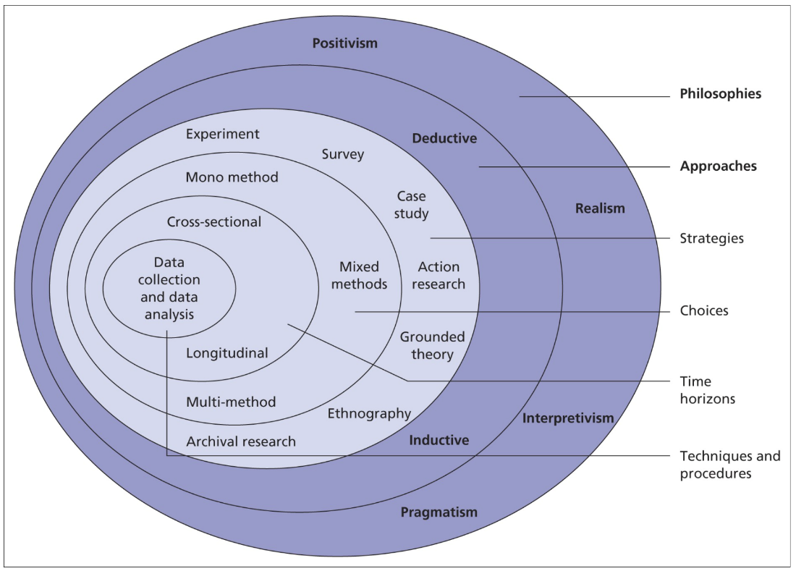
Title: The Research Onion. Source: Saunders, Lewis and Thornhill (2019)
This chapter works through the layers of the ‘research onion’ and how the theory is applied in the context of the research question posed, and the methods employed to collect and analyse data to arrive at a conclusion. It is worth noting here the 2 approaches to undertaking research, namely Inductive and Deductive. This research commences with the collection of primary research and progresses to test the outcomes of the analysis against existing theories therefore is classed as inductive research.
The reasoning for this approach is based on the complexity of decision-making, there are many theories based in the differing social sciences. The research question is also focused on decisions already made by Police Officers, therefore making it challenging to build a theory that can be tested against those past decisions, already made. The alternative is a deductive approach which commences with a theory which is tested during the research.

3.2 What is research philosophy?

The word philosophy comes from the Greek for ‘love of Wisdom’ (World History Encyclopaedia 2020) therefore prior to delving into the research onion, Saunders, Lewis and Thornhill (2019) state that it is helpful to understand the belief system upon which the theoretical perspective is reliant, before deciding on a research methodology and research methods, each feeding into the other. Providing a rationale to the reader on these matters, assists in understanding the view through which the author has come to their conclusions and aids the credibility of the work.
There are two considerations; Ontological and Epistemology. An ontological system refers to the understanding of what exists, what we believe to be true and how we came to believe that information i.e., what our reality is. When considering the research question in this paper, it could be assumed that Police Officers, based on the author's experience, will always choose to undertake first aid, when in fact the data collection may show that it makes many feel uncomfortable and they will try to avoid the situation. Alternatively, the author could over-generalise the findings from a small and limited data collection, making claims for the whole of Policing UK. In both examples the ontology considers what is the real situation, the relationships between individuals and their beliefs and how it is known or perceived to the author, the respondent and others.
Epistemology on the other hand, considers how individuals obtain information and knowledge, how they then process this by their own set of reasoning, experience and values. When considering the research question posed in this paper, the epistemic study could be whether the Police Federation are justified in their position of opposition to Nyxoid and how this influences Police Officers decision to carrying the medication.
The first and outer layer of the ‘research onion’ (Saunders, Lewis and Thornhill 2019) relates to research philosophy; the beliefs and assumptions that an individual holds about the creation or development of knowledge. By answering this research question, new knowledge is being created therefore having determined the ontological approach of the author, the appropriate philosophy can be applied.
There are many research philosophies, however the predominant philosophies are Positivism, Interpretivism and Pragmatism, and are described briefly as follows:
A positivist philosophy or paradigm is concerned with the systematic observation of reality, using data to establish replicable outcomes. This philosophy is rigid and discards or rejects any information that cannot be measured and quantified, potentially overlooking significant research findings.
Interpretivism on the other hand would not reject such information, interpretists believe that the world is subjective and would seek to interpret and understand the findings based on the reality of those involved with providing the information. This can however lead to concerns about the validity of the findings, which can be subjective and difficult to replicate.
Finally, pragmatism looks at the research philosophy as being on a sliding scale incorporating aspects of more than one philosophy, allowing the researcher to use mixed methods of data collection to find the best way to answer the research question.
This piece of research is based on the collection of primary data using questionnaires which will produce mostly quantitative data, with some aspects of qualitative data gained via open ended questions. Therefore, the pragmatic philosophy which allows the use of both paradigms and enables subjective assessment of the findings to best answer the research question and support the findings from the quantitative data sets.
3.3 Research Methodology
Based on the approaches to the epistemology, theory development and research philosophy, it is possible to scope out potential methodologies or strategies that align with the researcher\s viewpoint and assumptions whilst also answering the research question. Examples of strategies are case studies, archival research and surveys, each presenting strengths and weakness as a methodology such as the outcomes being easily replicable or the research phase needing a considerable span of time to complete. During this piece of research, the survey strategy was taken due to the inductive approach, positivist philosophy aligning with the quantitative methods of data collection and analysis via a questionnaire.

3.4 Research methods

The research is focused on the collection of primary data, however there is some use of secondary data throughout. Primary data is original information derived from research methods, such as interview notes and recordings, samples and completed questionnaires. Secondary data is often created as a consequence of primary data such as a data analysis or graphs, it can also refer to existing research or documentation which has been made available more widely.
There are benefits and costs to both options including the cost of obtaining the data with primary being significantly higher than secondary data, the reliability however of primary data can be far superior especially when considering the epistemology and philosophy of the researcher in secondary data and how this information could be interpreted differently. Secondary data is also often far quicker to access and obtain as it is already in existence and in an available format.
This leads to the method of researching with quantitative research and qualitative research being the two distinct methods of research used. The main difference between these two types of research is the type of data they gather and analyse (Dawson and Dawson (2009)).
Quantitative research uses statistical, mathematical, and computational techniques to measure and analyse numerical data. It typically involves large samples of participants and aims to generalise findings to a broader population. The research design is usually structured, objective, and focused on testing hypotheses. Examples of quantitative research include surveys, experiments, and observational studies.
Qualitative research focuses on non-numerical data, such as words, images, and observations, to understand and interpret social phenomena. It typically involves a smaller sample size, with data being collected through methods such as interviews, focus groups, and ethnography. The research design is often flexible and less structured, allowing for a deeper exploration of a topic. The results of qualitative research are descriptive and aim to provide insights into the complexity of human behaviour and experience.
There is also the potential of using mixed methods, which, as the name suggests, uses a mixture of both quantitative and qualitative research methods within a single study, with the intention of a more thorough and comprehensive understanding of the research question. The methods can be used concurrently or sequentially to follow up on the initial method with the additional benefit of counteracting the possible weaknesses in each approach and triangulating data collected using the alternative approach.
This study has taken a mixed method approach, using a quantitative approach via a questionnaire with some open-ended questions allowing the collection of qualitative data to assist in better understanding the decision making of the respondents. A thematic approach will be used to analyse the data collected, enabling the author to identify patterns and meanings before developing themes within the responses.
3.5 Methods
The initial method was to undertake a literature review of the available information pertaining to the research question. Shulman (1999) as cited by Grey (2009) found that a comprehensive literature review allowed for ‘generativity’, meaning the research undertaken was informed by, and built upon, the research that has already come before. As a method, it allows the researcher to understand the main themes and issues within the field of study, also helping to identify gaps in the knowledge (Grey 2009). Saunders, Lewis & Thornhill (2019) remind researchers to consider the period of publication and to ensure the material being reviewed is relevant and to consider the source of the literature, with peer-reviewed documents being preferable to other sources of information with the research topic being very narrow, it was vital to plan the literature review process to ensure an efficient process. The parameters of the research had been set during the research proposal process, therefore the terms of the literature review were drawn down from this.
The available and appropriate sources of information were reviewed and found to be online databases including BrowZine and Google Scholar, along with the University's online and physical libraries, reviewing the literature also assisted in identifying further references which could be used as additional sources of information. A list of search terms, (Police Officers, Law Enforcement Officers, naloxone, intra-nasal, nasal spray, decision-making, influence, views, stakeholders) was generated by the author and used to compile the texts to be reviewed that aligned with the search parameters.
A further quantitative questionnaire was designed to establish the decision-making of Police Officers within Dyfed-Powys Police. There are several benefits to using questionnaires in research, including: allowing researchers to collect standardised data, which ensures that all participants receive the same questions in the same format. This reduces the potential for bias in the data and ensures that responses are comparable across participants. Participants can remain anonymous when completing questionnaires, which can lead to more honest and accurate responses. They are also highly versatile and efficient, available to large samples of participants relatively quickly and easily, making them a cost-effective method of data collection with data collected usually numerical and easily analysed using statistical software. Questionnaires can also be replicated in future research, allowing for comparisons to be made across different studies and time periods. This can help to build a cumulative body of knowledge on a particular topic.
In summary, questionnaires are a versatile and efficient research tool that can provide standardized, quantifiable data on a wide range of topics. They can be administered to large samples of participants, provide anonymity, and be easily replicated, making them an important method of data collection in many fields of research.
While questionnaires have several benefits as a research tool, there are also some potential drawbacks to using them in research, including bias in several areas:
- Response bias: Participants may not answer questions truthfully, accurately, or fully, leading to response bias. This can be due to social desirability bias, where participants provide socially acceptable answers, or acquiescence bias, where participants tend to agree with statements regardless of their accuracy.
- Limited depth: Questionnaires may not allow participants to provide detailed or nuanced responses, particularly when compared to methods such as interviews or focus groups. This can limit the richness and depth of the data collected.
- Limited context: Questionnaires may not capture the context in which the behaviour or attitudes being studied occur. This can lead to a lack of understanding of the complex factors that influence the behaviour or attitudes being studied.
- Incomplete data: Participants may skip questions or provide incomplete answers, which can reduce the quality and completeness of the data collected.
- Sampling bias: The sample of participants who complete questionnaires may not be representative of the target population, leading to sampling bias. This can occur if certain groups of people are more likely to respond to the questionnaire than others.
- Interpretation bias: The way questions are worded, structured, or ordered can influence how participants respond and can lead to interpretation bias. This can occur if questions are ambiguous, leading, or assume certain values or beliefs.
In summary, while questionnaires can provide standardized, quantifiable data on a wide range of topics, they may also suffer from various biases, with the researchers needing to carefully consider the limitations of questionnaires and design them in a way that minimizes these potential drawbacks.
The questionnaire will be designed and shared utilising Microsoft Forms, shared via email and the internal Force intranet system.
The target audience of the questionnaire will be Police Officers working in the 4 pilot areas, Llandrindod Wells, Aberystwyth, Llanelli and Pembroke Dock. These Police Officers were likely to have been faced with the offer of being trained to use Nyxoid and therefore have had the real-life experience of having decided whether to take the training and utilise the product operationally.
3.6 Limitations
There is an inevitable limitation to interpretation when the primary data comes from the Police Officers of one Force. It could have been helpful to widen the scope of the research for example to all four Welsh Forces or made a comparison with another forces outside Wales.
The research method has limitations; being potentially incomplete data, due to its voluntary nature and the time demands placed on front line response Police Officers making completion of the questionnaire a challenge. Due to taking a quantitative approach, the resulting data could lack depth, therefore limiting its interpretation and understanding of the results.
The researcher noted potential bias due to their senior role within the target organisation influencing the respondent’s answers. Steps were taken within the joining instructions to overcome this potential bias, advising of the researcher's position as a student at the University, that all participation was anonymous and finally, that the participant's answers would in no way influence or impact on their future decisions to carry Nyxoid.
3.7 Ethics
The requirement to undertake research in an ethical manner has become increasingly prominent, (Sunders, Lewis and Thornhill 2019) who states research should be conducted in a morally defensible manner. Following the unethical actions of Hitler’s scientists during World War II, international guidelines were universally adopted with the overarching requirement that research should always be with consent and never cause the human participant harm. (Grey 2009).
Harm has been increasingly defined during the intervening period (Grey 2009) to include not just physical harm but also emotional harm such as stress and anxiety, with some going even further to suggest that researchers should leave participants in a better position where possible, for example by sharing their own health data back to them or the wider survey outcomes.
There are two predominant theories relating to ethics in research, these are deontological and Teleological; with the pair having opposing positions on whether the outcome justifies the means used to obtain the result. Deontological followers believe the ends will never justify the means suggesting that the research aims cannot, regardless of their worthiness, outstrip the concerns or welfare of the research participants. Teleological theorists however believe that the ethical considerations should permit pushing boundaries if the outcome is of greater benefit for humankind, for example.
During this piece of research, consideration was given to the potential of causing emotional harm or distress to participants by causing them to recall incidents of medical overdoses or potentially, the sudden death of an overdose patient. Due to this, advance warning was provided in the participant information, they were also advised of the voluntary nature of not just the survey but of individual questions and requested to provide their informed consent before proceeding to the questions.
The Occupational Health Department for Dyfed-Powys Police were also approached, advised of the study and they granted permission to direct participants to their service should any distress be caused or experienced during or after completing the study.

4. Data Analysis

4.1 Introduction

Data analysis is a systematic way of breaking down the data to investigate trends and patterns with reference to the literature review. This chapter will present the findings of the empirical research undertaken, setting out the results of the questionnaire followed by qualitative thematic analysis to assist in understanding the findings against the original research question. After the closure of the questionnaire, the data was compiled and coded to enable a thematical analysis. The online questionnaire was predominantly quantitative. Having been designed and answered within Microsoft Forms, the analysis was also undertaken using Microsoft Forms software.

4.2 Aim and objectives

The aims of this research were to establish the following:
- To identify the major stakeholders within UK policing and evidence their views on the use and administration of Nyxoid by Police Officers.
- Establish and evaluate Police Officers’ decision-making relating to the carriage of Nyxoid.
- To evidence and analyse the influence of the stakeholder views on Police Officers’ decisions as whether to carry Nyxoid.
- Express the reasons stakeholders have influence over the Police Officer’s decision-making on Nyxoid
This section will aim to answer objectives 2, 3 and 4.

4.3 Data analysis

The questionnaire was open for six weeks from mid-February to end of March 2023, 33 responses were received with the number of responses desired in the research proposal being 40, aligned to the original pilot. The questionnaire (Appendix A) posed 13 questions which covered the following areas of questioning:
Demographics of the respondent
Awareness of Naloxone & Nyxoid products
Experiences of the Officer in dealing with overdoses / use of Naloxone or Nyxoid
Training to carry Nyxoid
Stakeholders’ views on Nyxoid
Factors that influence Officers’ decision-making

Of those 33 responses, 32 (97%) were Police Officers (question one), just one was a member of Police Staff. Due to there being a single response from a member of Police staff, no statistical meaning can be given to the comparison of the answers between Police Officers and Staff. The original pilot held between December 2021 and May 2022 was only open to Police Officers, as such Police staff had not received the training. During the literature review many sources of information were researched and there was no evidence of Police staff being involved in the provision of Naloxone. For these reasons, the responses recorded for the Police staff member have been discounted throughout the entire analysis of the data set, although are available in Appendix B.
The response to question two confirms there were a mix of respondents, some from the original Nyxoid pilot , and other supplying further information and enriching the response. Question two also assisted with understanding the demographic of the respondents with 36% (n=12) of the responses came from Ceredigion, 27% (n=9) from Carmarthenshire, Powys 21% (n=7) and Pembrokeshire 15% (n=5). No staff based in Headquarters responded to the questionnaire.
It is beneficial that responses were obtained from all 4 divisions given pilot studies were undertaken in each, however these proportions do not reflect the general staffing volumes of those divisions. The fact no responses were derived from headquarters is unsurprising given the pilot activity and questionnaire was aimed at frontline response Police Officers.
There were respondents from each of the four divisions within the Force however Ceredigion, being the smaller of the divisions returned more respondents. This suggests some evidence of bias within the dataset, demonstrated in answer two as proportionately, Ceredigion is the least resourced of the 4 divisional bases, however, has the highest response rate. The author is a senior member of staff within this division, and it is evident here and from the written responses in question 12 that one of those responding may have done so due to expectations of a ‘line manager to staff member’ relationship rather than a ‘student invite to respondent’ approach.

4.4 Results

Analysis of the questions are dealt with independently; describing the responses, analysing the findings and synthesising these with the findings of the literature review.
In Questions three and four, 94% (n=30) of the 32 Police Officers who responded to the questionnaire, had heard of naloxone; with one Police Officer in Powys and one in Pembrokeshire never having heard of the product. When asked about their awareness of Nyxoid, 78% of the 32 (n=25) were aware of the product.
A single Police Officer (from Pembrokeshire) had not heard of either Naloxone or Nyxoid. Overall, 6 Police Officers had no awareness of Nyxoid, 2 each in Pembrokeshire and Powys, with a single Police Officer in each division of Ceredigion and Carmarthenshire being unaware of the product.
The numbers involved are small but may indicate a lack of awareness of the Nyxoid product outside the pilot study held in the Force. Powys and Pembrokeshire feature as areas of non-awareness for both Nyxoid and Naloxone, which could indicate a wider lack of understanding of harm prevention tools available to Officers in those areas.
The awareness of Naloxone was expected; it has been available within custody suites for many years. Standard Operating Procedures promote the use of Naloxone by health care professionals based within the custody suites and there have been successful uses of Naloxone within custody suites, which response Officers were likely to be aware of.
When considered against the findings of the literature review, very few stakeholders had openly held views or opinions on Nyxoid. With so little discussion from those in a position to influence Police Officers, it is understandable that Police Officers were unaware of the product. Police Officers lacking awareness of Nyxoid are unlikely to possess a full awareness of the uses for the medication, nor the pros and cons of its use.
The theory suggests that, in this context, Police Officers will use their prior experience to decide and are therefore unlikely to seek out further information (Kalantri 2010). When considering the 78% of Police Officers that were aware of Nyxoid, if these experiences are used as a basis for their decision-making, then understanding the type of experience would be important. What were the circumstances and outcomes of that use of Nyxoid, what does that Police Officer understand and believe that Nyxoid can do, or indeed, not do? This question was unable to clarify that level of comprehension, although it is revisited in question 12.
Question five addressed respondent’s experiences of opioid overdoses with 23 having previously dealt with an opioid overdose. Seven stated they had not been required to do so and two said they were not sure whether they had or not. This suggests that one third (34%) of the respondents have either never dealt with or were unsure if they had dealt with an opioid overdose.
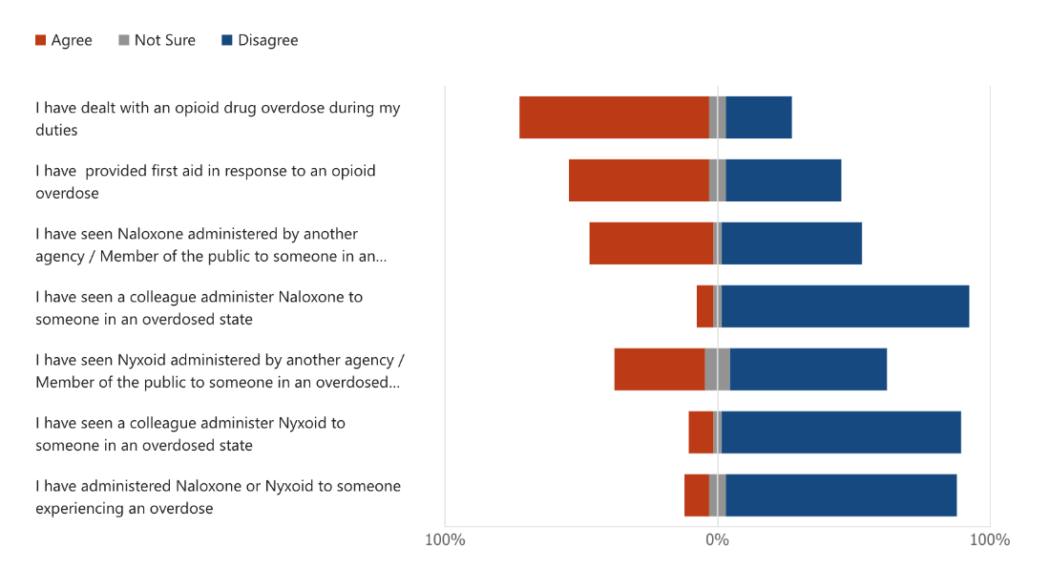
Title: Question five, MS Forms.
The ambiguity could be linked to the uncertainty of whether someone has indeed overdosed or instead suffered an unrelated medical episode. It is also difficult without external cues such as witnesses or drug paraphernalia, to confirm on initial Police attendance whether an overdose is opioid related or linked to other illicit substances, therefore leaving Police Officers unsure of whether they dealt with an opioid overdose.
A third of the respondents having no experience of overdoses is interesting in the context of the research of Cristofaro (2017), given the limited information available from stakeholders. With such limited evidence on which to base their decisions, Police Officers are left to make a ‘best guess’. Later questions will delve into what has informed and influenced the decision-making of the respondents.
100% of Carmarthenshire based Police Officers had provided first aid, 80% in Pembrokeshire and 58% each in Ceredigion and Powys. Notably, whilst 23 had dealt with an overdose, only 17 had provided first to an individual in an overdosed state. 16 had seen Naloxone given by another agency, seven had seen Nyxoid given and only two had seen Police Officers administer Nyxoid.
These percentages align with the rate of fatal opioid overdoses noted by the local health boards within these Counties (Public Health Wales 2022).
The data also evidenced Police Officers’ experience of providing first aid to persons in overdose, and the role of paramedics in undertaking this role. Officers were willing to provide first aid to those in an overdosed state. Many had witnessed the administration of Naloxone or Nyxoid and would likely have witnessed the effect the drug had on a patient.
The research found that in 17 of the 23 cases, (nearly three quarters of the cases) Police Officers provided first aid, however only 2 of those cases involved the administration of Nyxoid by a Police Officer. Therefore 15 patients would have been provided with traditional first aid and an additional 6 were not provided with first aid by the Police at all.
During the review of literature, the author discussed the views of Murphy & Russell (2020) and Townsend et al (2020) who cited the benefits of Law Enforcement Officers being equipped with Narcan products, particularly in rural locations versus Naloxone being provided in the homes of opioid users, respectively. The data collected supports the findings that Police Officers in rural locations are required to assist with first aid and many had seen either Naloxone or Nyxoid provided to a patient, suggesting that had Officers been in possession of the medication, this would have been the correct course of action for them to have taken.
Question six referenced the Police Officers’ observations and experiences of dealing with an opioid overdose from question five and asked about the influence of that experience on their decision to carry or administer Nyxoid. Whilst over half of the respondents said there had been an influence as a consequence of their prior experiences (n=13), there was a nearly even split however between yes / no and the remainder (n=8) stated it ‘maybe’ influenced their decision. Considering the 40% that stated their prior experiences of overdoses had no influence on their decision, coupled with the limited information available from stakeholders on the topic of Nyxoid, this does leave an unanswered question of what information these Officers are able to use in order to make an informed decision.
Tversky and Kahnemen’s ‘prospect theory’ (1979) suggests that individuals faced with a decision will seek to avoid risk and therefore base their decision on the outcome most likely to limit risk to them. Based on the outcome of the research at this stage, this theory seems an acceptable explanation for the position the Police Officers have chosen.
The respondents were asked in question seven, to provide their status in terms of existing carriage of Nyxoid i.e., had they received training or carried Nyxoid prior to undertaking the survey. This data indicated whether the respondents had been part of the original trial.
Twelve of the 31 respondents stated that they had received Nyxoid training and had therefore already made the decision central to the topic of this research. All twelve, having received the training decided to carry Nyxoid. Of the remaining 20 respondents, five Police however stated that had not been offered the training but would decline to carry Nyxoid in the future in any case. None of the respondents stated that they had been offered / received training and then declined to carry Nyxoid.

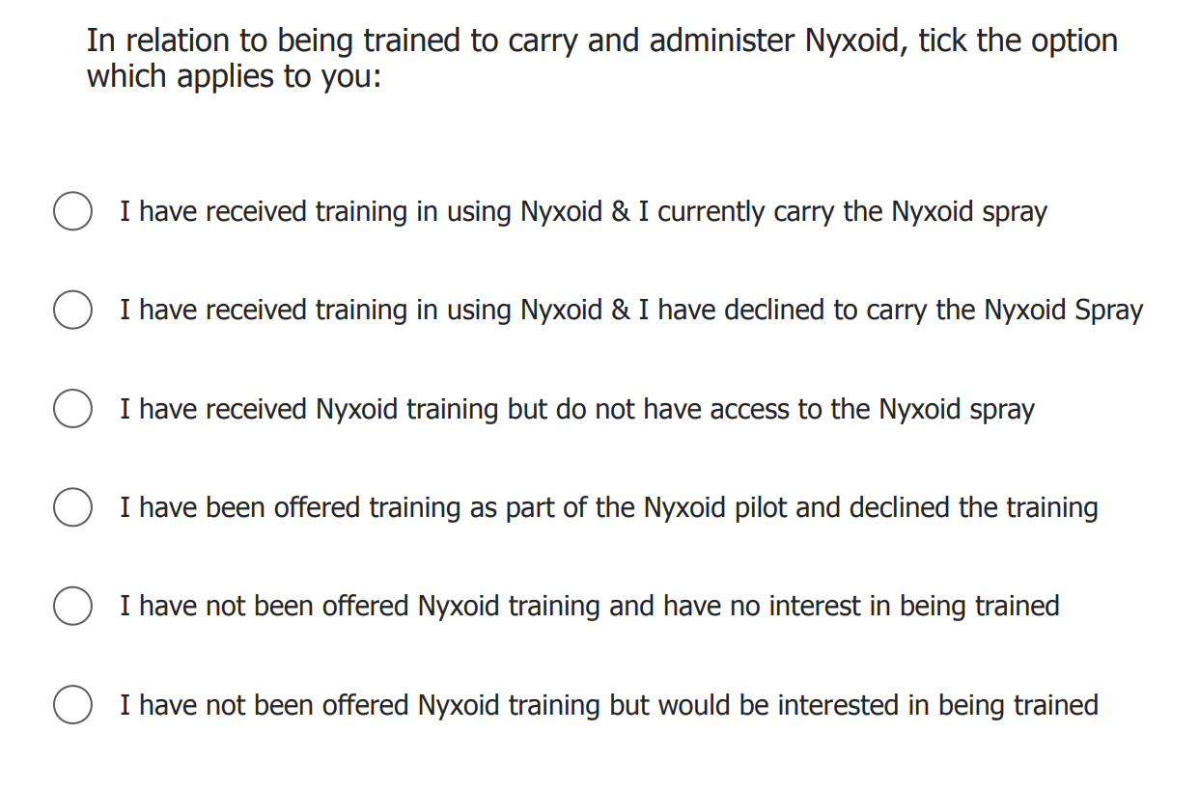
Title: Q7 questions, MS Forms.

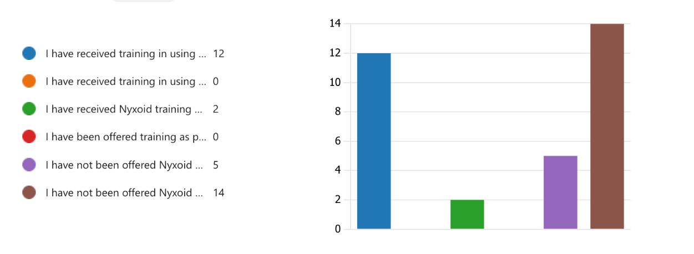
Title: Q7 Responses, MS Forms.
75% (n=25) of the Police Officer respondents were either already carrying Nyxoid, or willing to carry the product if they were offered the training to do so. 2 individuals had received the training but were unable to access the product to carry it, taking the figure to 84% being willing to carry Nyxoid. This figure appears positive in terms of the ambition of the original pilot, although the data from later questions suggests that the information the respondents were basing their decisions on was not always related to the pilot but more so work-placed conversations with colleagues, or their wider observations on the topic.
The five Police Officers that stated their preference to neither carry nor be trained in Nyxoid is worthy of further exploration. It is quite a determined stance to take when considering the Peelian principles of policing and perhaps reflects the views of Beletsky (2005) that regardless of the ‘law in books’, it is the ‘law on the streets’ that will dictate the day-to-day practices of Police Officers. These Police Officers were more likely to overlook changes in legislation and policy etc and simply do what worked best for them. In this case, new ways of working have perhaps been tarred with the possibility of complaints and disciplinary action and it was therefore to be avoided.
These overall figures however align with the findings of (Hillen et al 2022) research which had a similar take up rate for their Naloxone project; once participants were provided with the right information and reassurances.
Question eight targeted the 14 respondents to question seven who stated they have received the training for Nyxoid. They were asked about any disadvantages experienced due to carrying or using Nyxoid. 12 respondents answered question eight out of a possible 14, only 2 respondents reported that they had experienced a disadvantage or negative experience as a consequence of carrying Nyxoid. Both stated the carriage of Nyxoid had brought additional work responsibilities. There were no reports of repeated calls to the same patient, refusal of ambulance to attend or the patient refusing to attend hospital. There was an option for respondents to cite any other reasons under the option of 'other', here the respondents had the opportunity to raise any addition and unforeseen drawbacks to the attention of the author however none were noted.
Despite the finding in the literary review that concerns were raised from several sources of possible IOPC or potential civil action against Police Officers, it was noted that this was not the experience of the respondents, the majority had not experienced any negative aspects of carrying or using the product. It is also worth noting that the research into Law Enforcement Officers’ experiences in the US referenced the use of Narcan as an enabler for long term drug use. Whilst this was a small and limited piece of research there was no evidence of Police Officers visiting patients repeatedly.
Question nine presented the respondents with a summary of potential influencing factors about their decision-making. 31 Officers provided a response with 64% (n=20) respondents stating that their own research did not play a part in their decision-making and 74% (n=23) were not influenced by information from TV, news or social media relating to Nyxoid.
What was notable was that 78% (n=24) were either ‘somewhat’ or ‘greatly influenced’ by their previous policing experiences. Just 13% (n=4) stated that they had been ‘greatly influenced’ by stakeholders, with an additional 45% (n=14) being ‘somewhat influenced’ by stakeholders' views, making 58% overall of Police Officers who were somewhat or greatly influenced by stakeholders. When given the opportunity in question 11, a similar proportion of Police Officers (63%) identified that stakeholder views had influenced them.
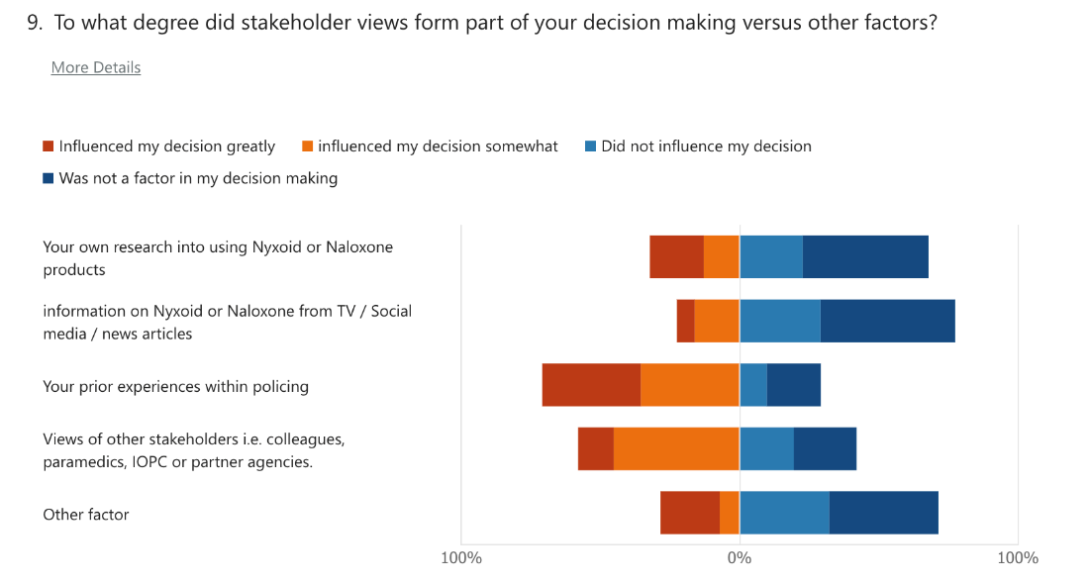
Title: Question nine, MS Forms.
26% (n=8) of the 31 Police Officers stated there were other factors not listed that influenced their decision making. Whilst there was no option to expand on the ‘other’ option in this response, respondents were able to expand on their views in question 12.
It would appear from the data that the two largest influential factors were the Officer's prior experiences within Policing followed by the views of stakeholders such as colleagues, paramedics, IOPC etc. The question set could have been extended to clarify what the additional influencing factors were, albeit these may have needed to have been explored in a different study.
The literature review highlights existing US studies discussing at length, the influence of Police Officer's experiences as influencing factors; namely the investigation of previous overdoses, having family members go through similar, being thanked by family or community members for assisting. When considering the primary decision-making tools for Police Officers, Information and research are far from their first choice, with experiences closely followed by the views of others as front runners.
The data also reflects the Bounded Rationality theoretical model put forward by Herbert in that Police Officers are making their decisions based on the best available information at that time (Cristofaro 2017). Whilst all Police Officers were free and capable of undertaking their own investigations into Nyxoid and its uses or benefits, 64% declined to do so instead appearing to take the views of colleagues and stakeholders into consideration when making their decisions.
Given the earlier findings that there are potential gaps in Police Officers' knowledge about Naloxone & Nyxoid, reliance on colleagues' views as a decision-making tool should be concerning as the possibility for misinformation to be shared is amplified.
Question ten focused on the understanding and perception of the views held by stakeholders. One Police Officer failed to complete the question set therefore the dataset is based on 31 responses. The predominant answer for nearly every stakeholder listed was that the Police was not aware of the views held by that stakeholder. The only category that fell outside that was ‘Colleagues from within Dyfed-Powys Police’ whereby 58% (n=18) of the 31 respondents knew the views of their colleagues. 81% (n=25) were unaware of the position of the IOPC and interestingly, Police Officers seemed confused over the position of the Dyfed-Powys Police Federation, with most stating they did not know their position but with 42% stating they believed they held a neutral or were supportive to varying degrees. Only one respondent was aware that the Dyfed-Powys Police Federation did not support the use of Nyxoid by front-line Police Officers. This was a significant outcome given the PFEW stance and position being stated in several publications online and in print. That said, the response to this question resonates with the findings of question nine where respondents openly stated that they did not research the matter, but they did consider the views of stakeholders – here they have clarified the specific stakeholders being colleagues.
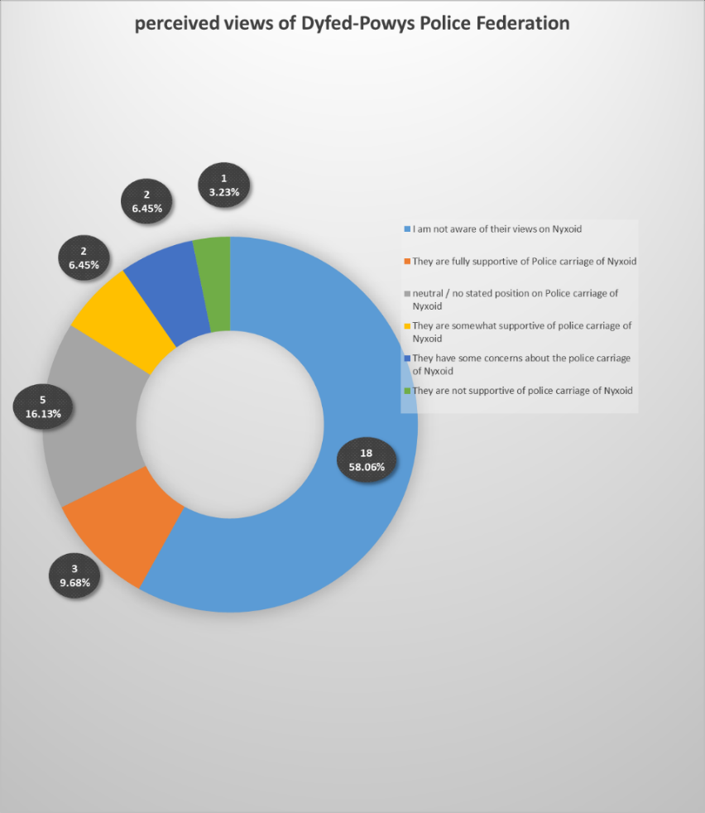
Title: Question nine – Dyfed-Powys Police Federation analysis.
When considered against the findings of the literature review, very few stakeholders had openly held views or opinions on Nyxoid. With so few opinions expressed by those in a position to influence Police Officers, it is perhaps understandable that Police Officers were unaware of their views.
The data does suggest that staff appear to either discuss Nyxoid or overhear the views of others hence being aware of the views of colleagues. There is void of awareness of the views of nearly every other stakeholder available to staff. This outcome suggests that having key influencers available within a cohort of staff can overcome negative influencing factors – the saying ‘culture eats strategy for breakfast’ (Conmy 2023) comes to mind.
These responses align with the ‘Bounded Rationality’ theoretical model put forward by Herbert (Kilantri 2010) who stated that humans are imperfect, not always particularly good at considering the consequences of their decisions but will make the best of the information available to them at the time. Alternatively, it could be argued that Police Officers are simply ill informed, audacious in their belief that ‘they know best’ and have failed to seek out or take the offered opinions of strategic stakeholders to inform their decisions.
Having gained the Police Officers’ perspectives on stakeholder views, question 11 offered the respondent the option to expand on their previous response by identifying specifically which, of any stakeholder views had influenced them. There was a low response rate to this question however the omission of a 'none apply' option would have been beneficial, given the generally good response rate to all previous questions. Three respondents did record such a response under the 'other' category where there was a choice to free type.
Despite being the most known position, only five Police Officers said the views of colleagues influenced their decision. Outside of these responses and using the ‘other’ category, respondents reporting the following influences: colleagues from Dyfed-Powys Police, one colleague from South Wales Police provided some influence, and members of the public feature.
The answer to this question suggests that whilst Police Officers were more likely to be aware of the views of their colleagues (as evidenced in question nine), they did not necessarily act on that information. Overall, there is a lack of demonstrable influence from any identified stakeholder which suggests Police Officers prefer to 'make up their own minds'. The overarching response to these questions suggests, much as the response to questions five and six, that Police Officers prioritised their experiences over external sources of information. Although this conflicts somewhat with the outcomes of question nine where Police Officers listed ‘other stakeholders’ (including colleagues) as decision influencers
There are a small number of responses that mention members of the public as an influencing factor, this correlates with the US study where Police Officers felt a sense of pride having been thanked by members of the public or family members for administering naloxone and saving the life of a potentially fatal overdose.
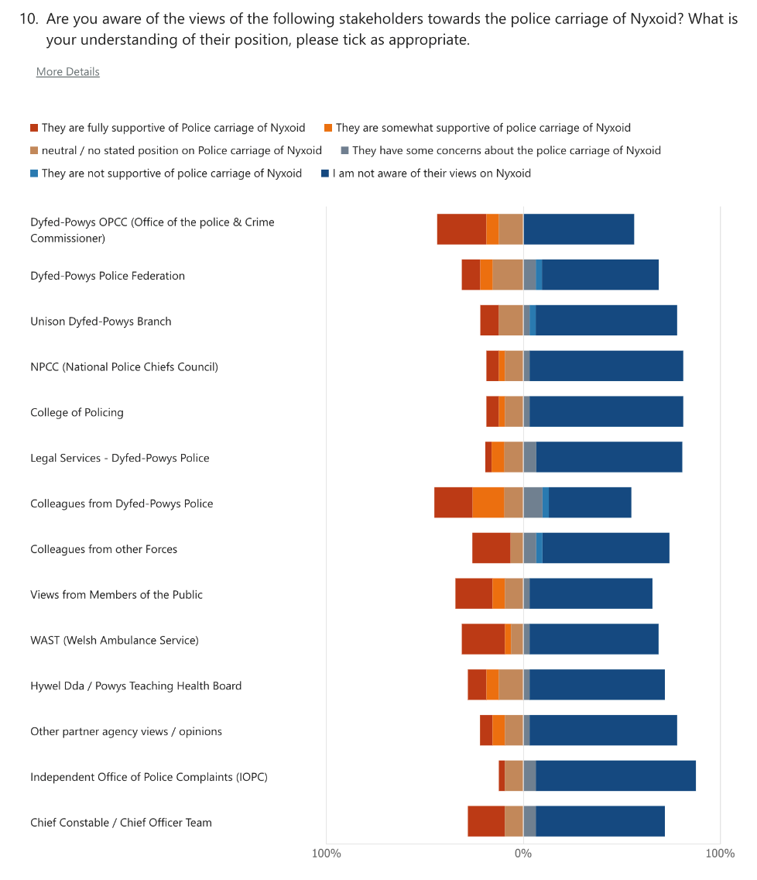
Title: Question Ten, MS Forms.
When considering 'Prospect Theory', Police Officers have indeed opted for heuristics by relying on prior policing experiences and the views of their colleagues. The conflicting position could be that Police Officers feel they have made their own decision which has been validated or reinforced by the views of their colleagues. Albeit the position of the Police Federation does not appear to have been a major influencer in any Police Officer's decision-making since the view was mostly either unknown or mistakenly believed to be positive. The position taken by these respondents could alternatively be seen, as overly confident in their own knowledge or expertise on the subject.
From the data in question six; that 18 Police Officers had not received the training to carry Nyxoid, and the data from question nine confirming that many Police Officers did not undertake their own research suggests that there is little evidenced-based decision-making being taken.
Respondents were invited to express their views of the stakeholder's position and how they had influenced their decision, 22 Police Officers responded, and their respondent number was allocated (1-33) in the order in which they completed the questionnaire.
Seven of the 22 responses referenced poor ambulance response times and mostly identified reassurance at having a product such as Nyxoid within their first aid provision ‘if it can save somebodies life […] I’d happily have access’(respondent 26), however two answers were more pessimistic about ambulance deployment stating that Police would be ‘intentionally deployed due to lack of ambulance’ (respondent 13) and the other stating ‘if we are attending they would delay or not attend’ (respondent 23).
Six responses referred to their prior experience as a Police Officer dealing with Organised Crime Gang (OCG) activity or previous overdoses as an influencing factor in their decision to carry Nyxoid,
‘We are regularly sent to drugs OD with little training or equipment to deal’ (respondent 28), and ‘I have personally carried out CPR on a teenager who has suffered an accidental drug overdose’(31).
A different respondent expressed disagreement with the overall strategy, seeing addiction and overdose as a choice and preferring the resources were utilised on other medical conditions;
‘It is my experience that these persons will require numerous Nyxoid administrations over the course of their lives, at a horrendous cost. They are more likely to overdose repeatedly knowing their mates have Nyxoid, and will revive them. It is an enormous expense, and it concerns me how much money is being spent on this, when there are those who need funding for other illnesses and mental health, which is totally beyond their control.’ (Respondent 19),
Four responses highlighted concerns around personal responsibility or culpability should there be an adverse incident
‘I would not carry it due to the fact if it is used and something goes wrong I'd be hung out to dry’ (respondent 6), and ‘if something were to go wrong or be ineffective its another thing which the Police (or me) be blamed for’ (respondent 18).

Another cited the voluntary status of carrying Nyxoid;
‘I am also concerned that individual choice would be removed from this’ (respondent 19).
One respondent however quoted concern for their colleagues as a reason to carry Nyxoid, stating the risk of highly potent products such as Fentanyl are ever present during Police work
‘Although we as Officers try our best to identify hazards there are times where this isn't possible and knowing I have Nyxoid at hand if any of my colleagues found themselves in a life or death situation if they were exposed to these drugs in any way.’ (Respondent 29).
Only one response mentioned members of the public stating their view would be a positive influencing factor. Similarly, there were individual responses for information observed on social media posts and from partner agencies.
The split in Police Officers’ positions on Nyxoid comes to the fore in question 12, with those not in favour listing views akin to that seen in the NPCC response (2021) citing potential health & safety concerns along with the view of the PFEW that Police Officers may find themselves subject to complaints about their actions. What was clear as an additional and previously unidentified influencing factor was not so much the position of a stakeholder but the performance of the Welsh Ambulance Service. Officers repeatedly reference the inability or uncertainty of emergency medical provision being available with Nyxoid providing them with an additional tool with which to save lives – very much in line with the Peelian principle to which Police Officers sign up.
The responses confirmed many of the research findings from Faul et al (2017) with Police Officer’s experiences playing a strong role in their decision making. There is evidence of significant differences, this is understandable given the differing stakeholders in the UK such as the perceived unreliability of ambulance attendance which does not feature in American studies as well as the personal concerns of liability. Whilst civil action appeared as an organisational concern, mostly at Chief Officer level in American studies, it was not cited by individual Law Enforcement Officers. This poses a question about where the perception of responsibility for the carriage of Nyxoid lies, given Police Officers did not add much value to the views of the Chief Constable as a stakeholder in the project yet felt they would be held personally responsible. This certainly leaves space for reassurance to be inserted to fill an information void.
Question 13 provided respondents the opportunity to identify which stakeholders would be able to provide them with reassurance in their decision about carrying Nyxoid.
Half of the respondents stated that information from the Federation would be beneficial to aid their decision, this was followed by a middle band, all scoring in a similar nine to thirteen range with 13 respondents (42%) wanting information from the OPCC, 12 asking for information from the College of Policing, 11 for local Health Boards, ten for the Welsh Ambulance Service and the IOPC - all of which came before information or reassurance from the Chief Constable. The views of colleagues, Unison, NPCC and partner agencies scored much lower at the bottom of the scale.
Given the strong stance of the Police Federation on the subject and the press coverage they have secured in relation to their views, it was surprising that Police Officers were not already aware of the views they have shared. The role of the Police & Crime Commissioner (OPCC) was also highlighted and surprisingly came ahead of the Chief Constable in term of providing advice and reassurance to staff in their decision to carry Nyxoid. When reflecting against the research findings of the Police Scotland trial (Hillen 2021), the recommendations advised to minimise internal disruptive political debate which could be achieved by allowing healthcare professionals to run the training sessions.
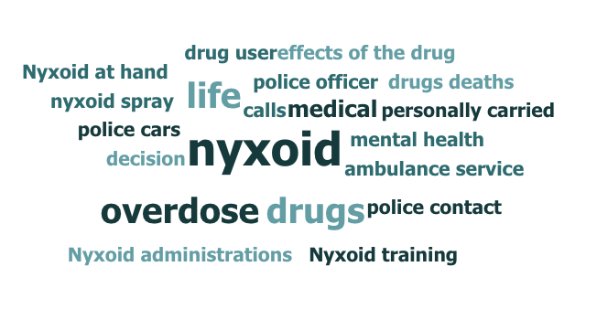
Title: Question Twelve, word coding analysis MS Forms.
From the initial research for this study, PCC's do feature in British pilots and early research, in some cases (West Midlands) they have been the instigators and long-term supporters for the use of harm reduction products such as Naloxone, none however have appeared as influencers for Police Officers decision-making. Without the option to explain the reasoning for this, it is not possible to reach further conclusions on the reasoning.
Colleagues being placed at the low end of responses continues to create an interesting picture of how colleagues’ views influence decision-making with question nine confirming that whilst staff share their views, and question eleven which suggests that whilst colleagues' views are well understood, they are not using this information to feed their decision-making process. Question 13 supports the earlier answers as that views of colleagues are already known, and that further information from them is not beneficial
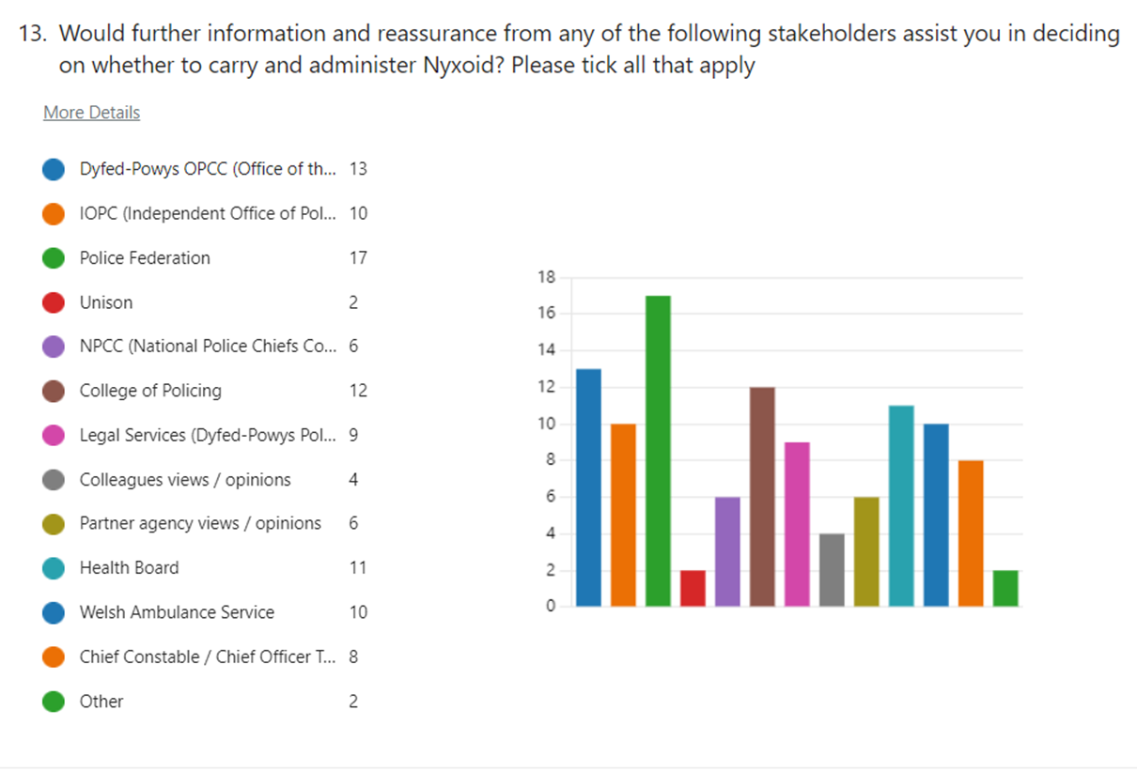
Title: Question Thirteen, MS Forms.

4.5 Summary

In Summary, Police Officers confirmed that they were generally not familiar with the views of most stakeholders, except for their colleagues whose views were known and understood. Even where some knowledge was known about stakeholder positions, Police Officers stated they were not influenced in their decision by those views.
Many of the respondents did not undertake any research into the matter prior to concluding whether to carry Nyxoid, Police Officers predominantly made their decisions based on their previous experiences of dealing with overdoses as emergency service workers. Aside from stakeholder views on Nyxoid, other influencing factors crept into the Police Officer’s mindsets, specifically the response times and deployment criteria of the ambulance service and the ability to save the life of a colleague if they encountered a highly toxic substance, such as Fentanyl.
Where reassurance could be sought, it was not always from expected sources. For example, the respondents suggested reassurance from the Police and Crime Commission, Police Federation, College of Policing, and the Health Board would be more beneficial than the Chief Constable, Force Legal Services, or partner agencies.

Conclusion and Recommendations

5.1 Introduction

The objective of this research was to explore the influence of stakeholder views on the decision of Dyfed-Powys Police Officers to carry and administer Nyxoid to those experiencing an opioid overdose.
- To identify the major stakeholders within UK policing and evidence their views on the use and administration of Nyxoid by Police Officers.
- Establish and evaluate Police Officers’ decision-making relating to the carriage of Nyxoid.
- To evidence and analyse the influence of the stakeholder views on Police Officers’ decisions as whether to carry Nyxoid.
- Express the reasons stakeholders have influence over the Police Officer’s decision-making on Nyxoid
This chapter will review the research aims and objectives, summarise the findings and establish how the findings answered the research questions. The contribution to Police decision making will be defined. The author concludes this dissertation with a self-reflection on the dissertation process bringing the research journey to a cyclical closure.

5.2 Research Objectives: Findings & Results

Research Aim 1: To identify the major stakeholders within UK policing and evidence their views on the use and administration of Nyxoid by Police Officers.
Summary of findings: The literature review identified 13 stakeholders that staff within Dyfed-Powys Police would interact with at every level during their day-to-day duties. All stakeholders have the potential to be impacted by the use of Nyxoid in a Policing context.
The position taken by each stakeholder was identified within the literature review with many taking a neutral stance; expressing no views on the matter. Others had taken a cautious but balanced approach, highlighting the pros and cons of implementing such a course of action by Police. Only one stakeholder, the Dyfed-Powys Police Federation took a position of total disagreement with the use of Nyxoid, whilst not committing a formal organisational statement on the matter, the PFEW did outline their position during Force meetings and in social media and news sources.
The research demonstrated that Police Officers were not familiar with the views of 12 of the 13 stakeholders, the exception being their colleagues whose views were known and understood by the majority of respondents. Even where Police Officers believed they were aware of the stakeholder's views; they incorrectly reported these views on many occasions, for example, believing the Dyfed-Powys Police Federation were supportive and vice versa, the IOPC unsupportive.
Conclusion
There are various strands of information available from some stakeholders on the topic of Nyxoid, others remained silent on the matter. When asked about which stakeholders could provide the most reassurance about using the product, Dyfed-Powys Police Federation, IOPC, and College of Policing were the three most likely to have been chosen by Police Officers. This suggests a high-level, strategic rollout of Nyxoid would have satisfied Police Officers' expectations.
Recommendation
The lack of demonstrable research, information, and intelligence led to the appearance of misinformation, misunderstanding, and undue concern about personal liability for using Nyxoid. This research, whilst limited, evidences the need to coordinate large-scale changes to the way Police Officers undertake their duties. The College of Policing would be well-placed to take forward and lead on such activities in the future with a co-ordinated approach supported by PFEW and IOPC, which would eschew many of the concerns that were raised by respondents as part of the research.
Research Objective 2: Establish and evaluate Police Officers’ decision-making relating to the carriage of Nyxoid.
Summary of findings; 14 of the respondents had been part of the original trial and had therefore already made a real-life decision around whether to carry Nyxoid. The remainder were providing a hypothetical analysis of the factors they would consider making that decision.
27 of the 32 respondents had either received, or were willing to receive, training to carry and use Nyxoid.
The remaining 5 respondents were not willing, nor were they interested in being trained or receiving Nyxoid.
These decisions were all made and reported independently, however showed some similar traits. Two thirds of the respondents did not undertake any personal research into Nyxoid prior to concluding whether to carry or not to carry the medication, whereas two thirds of Police Officers indicated that their prior experiences either ‘somewhat’ or ‘greatly’ influenced their decision.
Conclusion
Officers were confident in making a decision about whether to carry Nyxoid, many were able to articulate their reasoning for doing so and the factors that influenced that decision. Police Officers were heavily reliant on their experience as a reference point and were not overly aware of the stakeholders views on Nyxoid use within Policing. Police Officers did not demonstrate interest in sourcing further information or checking their understanding or the implications of using Nyxoid which suggests a lack of evidence-led decision-making.
Recommendation
Factors outside the control of any stakeholder can influence the decisions made by Police Officers in the course of their duties. These environmental factors should be identified and accounted for when designing staff training or implementing new procedures to ensure new processes are adhered to.
Research Objective 3: To evidence and analyse the influence of the stakeholder views on Police Officers’ decisions as whether to carry Nyxoid.
Summary of findings: There was surprisingly little influence from stakeholders on Police Officers’ decision-making, with respondents dispelling any notion that they had been positively influenced in their decision-making by any of the 13 identified stakeholders. They did this by openly stating the fact but also by demonstrating their lack of awareness of any stated positions on how the stakeholders felt about Nyxoid.
For some stakeholders this was understandable; Unison for example – who represent Police staff, are not likely to feature highly for Police Officers as their advice is aimed at Police Staff. The Chief Constable and National Police Chiefs Council alternatively can exert direct pressure via policy decisions and statements, therefore would be expected to influence Police Officers thought processes. On this occasion however, they are not actively engaged with Police Officers on the topic of Nyxoid. Whilst possibly not a conscious decision to abdicate from the discussion, the move aligns with earlier research findings by (Hillen et al 2022) in that training was more successful without the input from senior Police Officers. The research also noted the limited positions expressed by stakeholders, with many holding a neutral position, neither advocating for or against its use, which left a vacuum of information on the subject.

Conclusion
Police Officers made their decisions based predominantly on their previous experience as emergency service workers. Given limited information being fed in from stakeholders; station discussions and individual experiences drove the respondents thought processes leading to the decision outcomes.
Recommendation
Collating and assessing the understanding of staff views prior to launching new policies or procedures could assist senior leaders to deliver change programmes. Whilst these factors may not be the drivers for creating the change, they could be the cultural drivers (I.e. what is important to the Police Officer) that help deliver the change.
Research Objective 4: Express the reasons stakeholders have influence over the Police Officer’s decision-making on Nyxoid
Summary of findings: Stakeholders did not feature within the decision-making process for most respondents. Two thirds of Officers stated that their previous experiences were a factor in their decision-making along with views of other stakeholders such as colleagues, IOPC or paramedics; when drilling down into this data, it was colleagues’ views that featured. The level to which they were able to influence the respondents’ decision was not conclusive enough to say they had influenced, however the high level of awareness of the views of others suggests that Nyxoid and its use by Police Officers had been openly discussed and debated amongst staff.
Conclusion
Aside from stakeholder views on Nyxoid, further environmental factors appeared in the mindset of the respondents; some respondents identified poor ambulance response times as a driving factor in their decision-making, suggesting that being in possession of Nyxoid provided them with an additional level of first aid in a situation where they may find themselves providing first aid whilst waiting for ambulance arrival. A further factor that had not been considered but was highlighted by a respondent was the ability to save the life of a colleague should they encounter a highly toxic substance, such as Fentanyl, during their duties. This demonstrates that whilst these were not the reasons for which Nyxoid was implemented, they are cultural driving factors that are important for the Police Officers making the decision to carry Nyxoid.

Learning
Investigating a lack of influence was not an objective that was considered as part of the research, however the absence of stated views by stakeholders on the use of Nyxoid appears to have led to a void of direction for Police Officers, along with environmental factors that appear to have influenced Police Officers towards adopting Nyxoid in their day to day duties suggests that the decision-making around Police Officers’ carriage of Nyxoid could be quite different dependent on which part of the UK they are Policing in. This suggests a lack of control, direction, and overall strategy in the rollout of Nyxoid to frontline Police Officers.

6. Appendices

6.1 Appendix A
Questionnaire shared with respondents

6.2 Appendix B
Question responses.

7. References

Advisory Council on the Misuse of Drugs (2022). Drug Misuse Prevention Review. Available at: ACMD review of the UK naloxone implementation (accessible) - GOV.UK (www.gov.uk) [Accessed 24th March 2023]
Archbold. (2021). ‘Police Accountability in the USA: Gaining Traction or Spinning Wheels?’. Policing : a Journal of Policy and Practice, 15(3), 1665–1683. Available at: https://doi.org/10.1093/Police/paab033 [Accessed 24th March 2023]
Arredondo J., Strathdee S. A., Cepeda J., Abramovitz D., Artamonova I., Clairgue E., Olivarria H. O. (2017). ‘Measuring improvement in knowledge of drug policy reforms following a Police education program in Tijuana, Mexico’. Harm Reduction Journal, 14(1), 72. Available at: Google Scholar [Accessed on 19th February2023]
Bacon, M.(2022). ‘Desistance from criminalisation: Police culture and new directions in drugs policing’. Policing & Society, 32(4), 522–539. Available at: https://doi.org/10.1080/10439463.2021.1920587 [Accessed 2nd May 2023]
Banta-Green C. J., Beletsky L., Schoeppe J. A., Coffin P. O., Kuszler P. C. (2013). ‘Police Officers’ and paramedics’ experiences with overdose and their knowledge and opinions of Washington State’s drug overdose-naloxone-Good Samaritan law’. Journal of Urban Health, 90(6), 1102–1111. Available at: Google Scholar [Accessed 19th February 2023]
Beletsky, Macalino, G. E., & Burris, S. (2005). ‘Attitudes of Police Officers towards syringe access, occupational needle-sticks, and drug use: A qualitative study of one city Police department in the United States’. The International Journal of Drug Policy, 16(4), 267–274. Available at: https://doi.org/10.1016/j.drugpo.2005.01.009 [Accessed 11th March 2023]
Biggam. (2021). Succeeding with your master’s dissertation : a step-by-step handbook (Fifth edition.). Open University Press, McGraw Hill.
Black, Carol (2020) Review of Drugs Phase one report. Available at: https://www.gov.uk/government/publications/review-of-drugs-phase-one-report/review-of-drugs-summary#summary-of-key-findings [Accessed 12th March 2023]
Black, R. (2021). ‘Police federation raises concerns over Naloxone pilot scheme.’, The Independent, 3rd December. Available at: Police federation raises concerns over Naloxone pilot scheme | The Independent [Accessed 18th February 2023]
Brown, & Daus, C. S. (2015). ‘The influence of Police Officers’ decision-making style and anger control on responses to work scenarios’. Journal of Applied Research in Memory and Cognition, 4(3), 294–302. https://doi.org/10.1016/j.jarmac.2015.04.001[Accessed 7th February 2023]
Bryon, G. (2022) Will British Cops Be Allowed to Carry Naloxone?. Available at: Will British Cops Be Allowed to Carry Naloxone? - The Crime Report [Accessed 13th March 2023]
Carroll, & Payne, J. W. (1977). ‘Crime seriousness, recidivism risk, and causal attributions in judgments of prison term by students and experts’. Journal of Applied Psychology, 62(5), 595–602. Available at: https://doi.org/10.1037/0021-9010.62.5.595 [Accessed on 15th March 2023]
Carter, Mohler, G., & Ray, B. (2019). ‘Spatial Concentration of Opioid Overdose Deaths in Indianapolis: An Application of the Law of Crime Concentration at Place to a Public Health Epidemic’. Journal of Contemporary Criminal Justice, 35(2), 161–185. Available at : https://doi.org/10.1177/1043986218803527 [Accessed 23rd March 2023]
Chan. (1996). ‘Changing Police Culture’. British Journal of Criminology, 36(1), 109–134. Available at: https://doi.org/10.1093/oxfordjournals.bjc.a014061 [Accessed 15th March 2023]
Chappell, MacDonald, J. M., & Manz, P. W. (2006). ‘The Organizational Determinants of Police Arrest Decisions’. Crime and Delinquency, 52(2), 287–306. https://doi.org/10.1177/0011128705278329
Coates, S., Kautt, P., & Mueller-Johnson, K. (2009). ‘Penalty notices for disorder: influences on Police decision making’. Journal of Experimental Criminology, 5(4), 399–428. Available at: https://doi.org/10.1007/s11292-009-9084-6 [Accessed 11th March 2023]
College of Policing Website (2022) ‘Problem-Solving Policing’ available at: https://www.college.Police.uk/guidance/problem-solving-policing [Accessed 14th May 2023]
College of Policing Website (2023) Learning. Available at : https://www.college.Police.uk/career-learning/learning [Accessed March 14th 2023]
Conservative Drug Policy Reform Group (2022) Evidence submitted by the Conservative Drug Policy Reform Group. Available at: https://committees.parliament.uk/writtenevidence/107429/html/ [Accessed 13th May 2023]
Conmy, S. (2023). What does Culture eats strategy for breakfast mean? Corporate Governance Institute. Available at; https://www.thecorporategovernanceinstitute.com/insights/lexicon/what-does-culture-eats-strategy-for-breakfast-mean/ [Accessed 10th April 2023]
Cristofaro. (2017). ‘Herbert Simon’s bounded rationality’. Journal of Management History, 23(2), 170–190. Available at: https://doi.org/10.1108/JMH-11-2016-0060 [Accessed 5th May 2023]
Crotty. (1998). The foundations of social research : meaning and perspective in the research process. SAGE.
Dahlem, King, L., Anderson, G., Marr, A., Waddell, J. E., & Scalera, M. (2017). ‘Beyond rescue: Implementation and evaluation of revised naloxone training for law enforcement Officers’. Public Health Nursing (Boston, Mass.), 34(6), 516–521.Available At: https://doi.org/10.1111/phn.12365 [Accessed 11th March 2023]
Davis, C., Carr, D., Southwell, J. K., & Beletsky, L. (2015). ‘Engaging Law Enforcement in Overdose Reversal Initiatives: Authorization and Liability for Naloxone Administration’. American Journal of Public Health (1971), 105(8), 1530–1537. Available at: https://doi.org/10.2105/AJPH.2015.302638 [Accessed 13th March 2023]
Davis, Ruiz, S., Glynn, P., Picariello, G., & Walley, A. Y. (2014). ‘Expanded access to naloxone among firefighters, Police Officers, and emergency medical technicians in Massachusetts’. American Journal of Public Health, 104(8), e7–e9. Available at: https://doi.org/10.2105/AJPH.2014.302062 [Accessed 25th November 2022]
Dhami. (2003). ‘Psychological Models of Professional Decision Making’. Psychological Science, 14(2), 175–180. Available at: https://doi.org/10.1111/1467-9280.01438 [Accessed 23rd March 2023]
Dawson, & Dawson, C. (2009). Introduction to research methods : a practical guide for anyone undertaking a research project (4th edition). How To Books. Available at: https://r3.vlereader.com/Reader?ean=9781848033429 [Accessed 15th February 2023]
Dyfed-Powys Police, 2022. First Aid Policy. Available at https://www.dyfed-powys.Police.uk/foi-ai/dyfed-powys-Police/publication-scheme/our-policies-and-procedures/Policies/health-and-safety/first-aid-policy/ [Accessed 14th March 2023]
Engel, R. S., Sobol, J. J., & Worden, R. E. (2000). ‘Further exploration of the demeanor hypothesis: The interaction effects of suspects’ characteristics and demeanor on Police behavior’. Justice Quarterly, 17(2), 235–258. Available at: https://doi.org/10.1080/07418820000096311 [Accessed on 15th March 2023]
Faul, M., Lurie, P., Kinsman, J.M., Dailey, M.W, Crabaugh, C. & Sasser, S.M. (2017) ‘Multiple Naloxone Administrations Among Emergency Medical Service Providers is Increasing’, Prehospital Emergency Care, 21:4, 411-419, Available at: DOI: 10.1080/10903127.2017.1315203 [Accessed 11th March 2023]
Fisher, R., O'Donnell, D., Ray, B., & Rusyniak, D. (2016). ‘Police Officers can safely and effectively administer intranasal naloxone’. Prehosp. Emergency Care. 20:6, 675-680, Available at: DOI: 10.1080/10903127.2016.1182605 [Accessed 18th February 2023]
Goldstein, H. (1990).Problem-oriented policing. New York: McGraw-Hill
Green T., Zaller N., Palacios W. R., Bowman S. E., Ray M., Heimer R., Case P. (2013). ‘Law enforcement attitudes toward overdose prevention and response’. Drug and Alcohol Dependence, 133(2), 677–684. Available at: Google Scholar [Accessed 18th February2023]
Gray, D.E. (2009). Doing research in the real world (5th edition.). SAGE.
Gray, J.P. (2012). Why our drug laws have failed and what we can do about it a judicial indictment of the war on drugs (2nd ed.). Temple University Press.
Hesse-Biber, & Johnson, B. (2016). The Oxford handbook of multimethod and mixed methods research inquiry (Hesse-Biber & B. Johnson, Eds.). Oxford University Press.
Hillen, P., Speakman, E., Dougall, N., Heyman, I., Murray, J., Jamieson, M., Aston, E., McAuley, A., (2022). Naloxone in Police Scotland: Pilot Evaluation. Available at: https://www.sipr.ac.uk/wp-content/uploads/2022/04/Naloxone-in-Police-Scotland_Final_9.2.22.pdf [Accessed 11th May 2023]
Home Affairs committee (2021). Home Affairs Committee Drugs Inquiry – Call for Evidence – Submission by National Police Chiefs’ Council (NPCC). Available at: https://committees.parliament.uk/writtenevidence/107533/pdf/ [Accessed 1st May 2023]
House of Commons Research Briefing Paper (2014). Local Authorities’ Public Health Responsibilities. Available at: https://commonslibrary.parliament.uk/research-briefings/sn06844/ [Accessed 13th May 2023]
House of Commons, Home Affairs committee.(2016) College of Policing: three years on. Available at: https://publications.parliament.uk/pa/cm201617/cmselect/cmhaff/23/23.pdf [Accessed 1st May 2023]

Institute for Government (2020) Local Government Funding in England. Available at: https://www.instituteforgovernment.org.uk/explainer/local-government-funding-england [Accessed 13th May 2023]
Insure First Aid, legislative summary (2018). Available at: http://www.streetangels.org.uk/uploads/4/9/5/4/4954631/the_legal_status_of_those_who_provide_first_aid.pdf [Accessed 13th May]
Kahnemen, D. and Tversky, A. (1979). ‘Prospect Theory: An Analysis of Decision under Risk.’ Econometrica, vol. 47, no. 2, 1979, pp. 263–91. JSTOR, Available at: https://doi.org/10.2307/1914185[Accessed 12th March 2023]
Kalantari. (2010). ‘Herbert A. Simon on making decisions: enduring insights and bounded rationality’. Journal of Management History (2006), 16(4), 509–520. Available at: https://doi.org/10.1108/17511341011073988 [Accessed 13th March 2023]
Kedia, P. R. (1985).Assessing the effect of college education on Police performance. Ann Arbor, MI: University Microfilms International.
Khorasheh, Naraine, R., Watson, T. M., Wright, A., Kallio, N., & Strike, C. (2019). ‘A scoping review of harm reduction training for Police Officers’. Drug and Alcohol Review, 38(2), 131–150. Available at: https://doi.org/10.1111/dar.12904 [Accessed 11th March 2023].
Klinger. (1994). ‘Demeanor or Crime? Why “hostile” citizens are more likely to be arrested.’ Criminology (Beverly Hills), 32(3), 475–493. Available at: https://doi.org/10.1111/j.1745-9125.1994.tb01162.x [Accessed on 15th March 2023]
Krishan, Bakeman, R., Broussard, B., Cristofaro, S. L., Hankerson-Dyson, D., Husbands, L., Watson, A. C., & Compton, M. T. (2014). ‘The influence of neighborhood characteristics on Police Officers’ encounters with persons suspected to have a serious mental illness’. International Journal of Law and Psychiatry, 37(4), 359–369. Available at: https://doi.org/10.1016/j.ijlp.2014.02.006 [Accessed 11th March 2023]
Madah‐Amiri, Gjersing, L., & Clausen, T. (2019). ‘Naloxone distribution and possession following a large‐scale naloxone programme’. Addiction (Abingdon, England), 114(1), 92–100. Available at: https://doi.org/10.1111/add.14425 [Accessed 15th February 2023]
Magness. (2008). ‘Who Are the Stakeholders Now? An Empirical Examination of the Mitchell, Agle, and Wood Theory of Stakeholder Salience’., 83(2), 177–192. https://doi.org/10.1007/s10551-007-9610-2 [Accessed 6th February 2023]
Maguire, E. R., & Uchida, C. (2000).’Measurement and explanation in the comparative study of Amican Police Organizations’. Measurement and analysis of crime and justice(Vol. 4).Washington, DC: Department of Justice, National Institute of Justice
Mastrofski, S. D., Ritti, R. R., & Hoffmaster, D. (1987). ‘Organizational determinants of Police discretion: The case of drinking and driving’. Journal of Criminal Justice,15, 387-402
Mazerolle, Soole, D. W., & Rombouts, S. (2006). ‘Street-level drug law enforcement: A meta-analytical review’. Journal of Experimental Criminology, 2(4), 409–435. Available at: https://doi.org/10.1007/s11292-006-9017-6 [Accessed 15th May 2023]
Murphy, & Russell, B. (2020). ‘Police Officers’ Views of Naloxone and Drug Treatment: Does Greater Overdose Response Lead to More Negativity?’ Journal of Drug Issues, 50(4), 455–471. Available at: https://doi.org/10.1177/0022042620921363 [Accessed on 25th November 2022]
Novak, K. J., Frank, J., & Smith, B. W. (2002). ‘Revisiting the decision to arrest: Comparing beat and community Officers’. Crime & Delinquency, Vol 48, (pages 70-98) Available at: https://doi.org/10.1177/0011128702048001003 [Accessed 23rd February 2023]
National Police Chiefs Council website (2023). About Us. https://www.npcc.Police.uk/About-Us/about-us/ [Accessed 1st May 2023]
Police Federation of England and Wales website (2023). About Us. Available at: https://www.polfed.org/about-us/aims-objectives [Accessed 1st May 2023]
Police Federation West Midlands (2021). Federation Chair Discusses naloxone on newsnight. Available at: https://www.polfed.org/westmids/latest-news/2021/fed-chair-discusses-naloxone-on-newsnight/ [Accessed on 14th March 2023]
Police Oracle Website (2021). Naloxone Officers not at risk of prosecution says drugs lead ACC. Available at: https://touch.Policeoracle.com/news/article.cfm?id=106936 [Accessed on 14th March 2023]
Pourtaher, Payne, E. R., Fera, N., Rowe, K., Leung, S.-Y. J., Stancliff, S., Hammer, M., Vinehout, J., & Dailey, M. W. (2022). ‘Naloxone administration by law enforcement Officers in New York State’. Harm Reduction Journal, 19(1), 1–102. Available at: https://doi.org/10.1186/s12954-022-00682-w [Accessed on 26th November 2022]
Public Health Wales (2022). Harm reduction database Wales; Drug related mortality. Annual report 2021-2022. Available at: PowerPoint Presentation (nhs.wales) [Access 15th May 2023]
Rando, Broering, D., Olson, J. E., Marco, C., & Evans, S. B. (2015). ‘Intranasal naloxone administration by Police first responders is associated with decreased opioid overdose deaths’. The American Journal of Emergency Medicine, 33(9), 1201–1204.Available at: https://doi.org/10.1016/j.ajem.2015.05.022 [Accessed on 26th November 2022]
Ray, B., O’Donnell, D. & Kahre, K. (2014). ‘Police Officer attitudes towards intranasal naloxone training’. Drug and Alcohol Dependence, 146, 107–110. Available at: https://doi.org/10.1016/j.drugalcdep.2014.10.026 [Accessed on 26th November 2022]
Real First Aid (2018) Duty of care advice. Available at: https://www.realfirstaid.co.uk/dutyofcare [Accessed 13th May 2023]
Resuscitation Council UK (2023) Guidance document. Available at: https://www.resus.org.uk/sites/default/files/2020-05/CPR%20AEDs%20and%20the%20law%20%285%29.pdf [Accessed 13th May2023]
Saunders, Lewis, P., & Thornhill, A. (2019). Research methods for business students (Eighth Edition.). Pearson.
Shearing, & Ericson, R. V. (1991).’Culture as Figurative Action’. The British Journal of Sociology, 42(4), 481–506. Available at: https://doi.org/10.2307/591444 {accessed 15th March 2023]
Smyser, & Lubin, J. S. (2018). ‘Surveying the opinions of Pennsylvania Chiefs of Police toward Officers carrying and administering naloxone’. The American Journal of Drug and Alcohol Abuse, 44(2), 244–251. Available at: https://doi.org/10.1080/00952990.2017.1339053 [Accessed on 27th November2022]
Speakman, Hillen, P., Heyman, I., Murray, J., Dougall, N., Aston, E. V., & McAuley, A. (2023). ‘I”m not going to leave someone to die’: carriage of naloxone by Police in Scotland within a public health framework: a qualitative study of acceptability and experiences’. Harm Reduction Journal, 20(1), 20–20. Available at: https://doi.org/10.1186/s12954-023-00750-9 [Accessed 12th May 2023]
Thaler, Richard H. and Sunstein, Cass R. (2008). ‘Nudge; Improving decisions about health, wealth and happiness’. The Journal of the National Association for Business Economics. Vol43, Pp. 304, Available at: https://www.ncpathinktank.org/pdfs/businessEcono072008.pdf [Accessed 14th May 2023]
Townsend, Blostein, F., Doan, T., Madson-Olson, S., Galecki, P., & Hutton, D. W. (2020). ‘Cost-effectiveness analysis of alternative naloxone distribution strategies: First responder and lay distribution in the United States’. The International Journal of Drug Policy, 75, 102536–. Available at: https://doi.org/10.1016/j.drugpo.2019.07.031 [Accessed 12th May 2023]
Transform drug policy foundation (2021). A short history of the misuse of drugs act. Available at: A Short History of the Misuse of Drugs Act | Transform (transformdrugs.org) [Accessed 19th May 2023]
UK Government report (2021). From Harm to Hope. Available at: https://assets.publishing.service.gov.uk/government/uploads/system/uploads/attachment_data/file/1079147/From_harm_to_hope_PDF.pdf [Accessed 13th May 2023]
UK Government consultation paper (2022). Swift, Certain, Tough: New Consequences for Drug Possession. Available at: https://www.gov.uk/government/consultations/swift-certain-tough-new-consequences-for-drug-possession-white-paper/swift-certain-tough-new-consequences-for-drug-possession-accessible-version [Accessed 13th May 2023]
UK Government(2019) Professor Dame Carol Black announced as independent reviewer of drugs
https://www.gov.uk/government/news/professor-dame-carol-black-announced-as-independent-reviewer-of-drugs [Accessed 13th May 2023]
UK Government Guidance (2015). Widening the availability of naloxone. Available at: Widening the availability of naloxone - GOV.UK (www.gov.uk) [Accessed 11th March 2023]
Wagner, Bovet, L. J., Haynes, B., Joshua, A., & Davidson, P. J. (2016). ‘Training law enforcement to respond to opioid overdose with naloxone: Impact on knowledge, attitudes, and interactions with community members’. Drug and Alcohol Dependence, 165, 22–28. Available at: https://doi.org/10.1016/j.drugalcdep.2016.05.008 [Accessed 13th March 2023]
West Midlands Office for Police and Crime Commissioner (2019). West Midlands Nasal Naloxone Pilot Evaluation. Available at: https://www.westmidlands-pcc.gov.uk/wp-content/uploads/2020/11/Naloxone-Evaluation-2020-01006.pdf?x35436 [Accessed 13th May 2023]
Wermeling, D. (2013) ‘A response to the opioid overdose epidemic: naloxone nasal spray’. Drug Delivery and Transitional Research, 3 (1), pp. 63-74 Available at: A response to the opioid overdose epidemic: naloxone nasal spray | SpringerLink [Accessed on 27th November 2022]
Worden, R. E. (1989). ‘Situational and attitudinal explanations of Police behavior: A theoretical reappraisal and empirical assessment’. Law and Society Review,23, 667-710. Available at https://doi.org/10.2307/3053852 [Accessed 15th February 2023]
World History Encyclopedia. 2021. Philosophy. Available at: https://www.worldhistory.org/philosophy/ [Accessed 14th May 2023]

