
University of Wales Trinity Saint David
School of Engineering

Failure Modes and Effect Analysis – Technical Report

Engineering Applications & Study Skills
ACMA4007

Nathan Purnell
2315457
12/02/2024
Contents

1 Introduction iii
1.1 Aims iii
1.2 Objectives iii
2 Literature Review iv
3 Methodology v
4 Discussion vi
5 Conclusions vii
6 References viii

Introduction
The frequent use of metal products in domestic and industrial industries requires ways of testing and sampling these products to ensure their soundness. This could be beneficial in such trades as the automotive industry; for example, if a metal material were to be used in a new project, the ability to assess such things as the materials microstructure would be essential.
The process of assessing a materials microstructure and grain structure through chemical etching is a crucial process in material science but is importantly very hazardous. If the metallurgical sample in question were a cobalt-chromium alloy, then the use of Murakami’s etchant would be required.
The primary scope of this investigation is to produce an FMEA (Failure Mode Effect Analysis) for this etching process and consider its effectiveness in reducing risk. Second to this is to develop an efficient and sound method for producing and using this etchant, with respect to the safety of the technicians and engineers performing the task.

Aims
The aim of this research is to improve upon the already in use practice of preparing and etching metallurgical samples using Murakami’s reagent, whilst paying close consideration to the health and safety of those carrying out the process. We will do this through the production of FMEA, in which we will focus on minimizing and reducing the potential risks.

Objectives
One primary objective of this report is to facilitate the safest etching process possible of chromium samples using Murakami’s reagent, whilst understanding the sound engineering practices set out by the IMechE code of conduct and Health and Safety legislation. This reagent contains potassium ferrocyanide, which is a compound that is unstable at elevated temperatures and is reactive with various metals and acids. Potassium ferrocyanide will decompose to form toxic hydrogen cyanide gas, so there is a huge importance to pay respect to safety.

Literature Review
Through my knowledge and research into this topic, it can be found that.
risk management is integral part of the engineering sector due to the large array of
potential hazards associated with various processes. Engineers and technicians both
play a part and have responsibility for identifying, assessing, and reducing these risks to ensure the safety of the personnel and the assets of the industry.
The main responsibility of staff safety falls to the employers, as stated in the Health and Safety at Work Act (1974). This act lays down wide ranging duties on employers to protect the “health, safety and welfare” of all their employees as well as others on their premises such clients, visitors and the public. It is therefore in a company’s favor to adhere to these guidelines. You will find that most companies will use a lot of their time and resources to work towards the guidelines set out by the HSE (Health and Safety Executive) to maintain that all their work is done safely to comply with the law, standards and procedures expected for a company to follow.
The IMechE Code of Conduct emphasizes the ethical obligation of engineers to prioritize the safety of themselves and others in the workplace, stating “We should act with integrity and in a reliable and trustworthy manner. Do not knowingly mislead nor allow others to be misled. Should respect confidentiality obligations express or implied.”
A Process Failure Mode and Effects Analysis (PFMEA) is a systematic tool used in various industries, including manufacturing, engineering, and healthcare, to identify potential failure modes in a system, product, or process. This is done by assessing their potential failure modes effect and prioritizing corrective actions to reduce or eliminate these failures. FMEA is a proactive approach aimed at preventing failures, improving reliability, safety, and quality.
Metallurgists in the engineering industry often use tools such as FMEA’s to observe potential risks when performing tests and experiments, as well as following set standards and practices set out by organizations such as ISO (International Organization for Standardization). In the case of metallurgical etching, FMEA can help identify potential risks such as over-etching,
under-etching, or harm to technicians. By analyzing the severity, occurrence probability, and detection capability of these failure modes, engineers can develop strategies to minimize risks and improve process reliability. Examples of this could be where a potential risk has been observed and a new measure or control is brought in to minimize that risk as much as possible.
Another importance to remember here is that when metallurgically etching a sample it is essential to adhere to COSHH (Control of Substance Hazardous to Health) regulations to ensure safe handling and disposal or the Murakami’s etchant.

Methodology - FMEA
I focused my PFMEA (shown fig. 1) on the process of chemically etching chromium-cobalt samples with Murakami’s reagent. Within my role at R-Tech Materials this is a commonly performed practice, so the use of FMEA is a very necessary tool. The technicians conducted this test have identified some failure modes and potential recommended actions that would help to streamline the process and reduce certain risks.
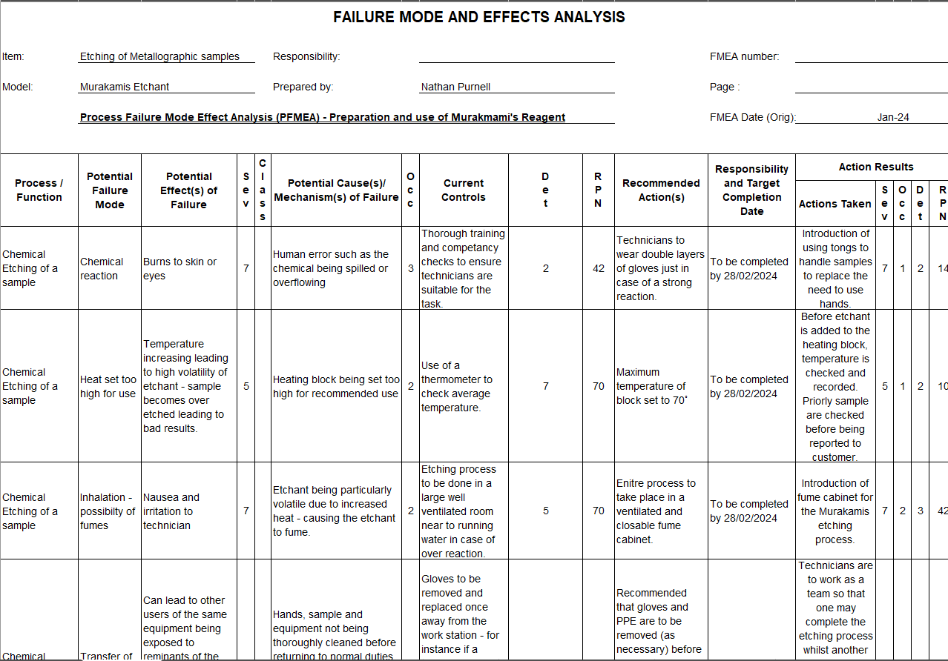
Fig 1. FMEA
Out of the numerous potential failure modes shown in the above table, the team of technicians tasked with this production assigned each failure mode a score to rank their severity, rate of occurrence, and detectability. For example, of each identified failure mode, the severity of its potential effects is considered. This is usually scored from 1 to 10, with 10 being catastrophic consequences such as loss of life or significant financial impact, and 1 being a minor inconvenience.
As seen in this table, the original RPN (Risk Priority Number) for each failure mode was quite high as certain practices had not been considered or adhered to.
Through the production of this FMEA it was evident that the process of metallurgically etching needed to be changed and modified. A case of this would be where the possibility of inhaling fumes was evident when being done in a large room.
Due to the high risk uncovered in producing the document – technicians had the introduction of a fume cupboard. This reduced the RPN score from 70 to 42, a significant drop that has streamlined the process for the better. Such an action would also satisfy phase 3 of APQP (Advanced product quality planning).
A further RPN reduction was seen when technicians were instructed to use tongs instead of double layers of gloves for handling samples, significantly dropping from 42 to 14.
Examples of a FMEA like such shows that it has advantages in detecting and understanding the risks associated with the given task, however it must also be remembered that they do have their limitations and figures such as the RPN score cannot always be accurate.
As can be seen when calculating the score, if a severity rating were to be 10 out of 10 – as high as it could possibly be – but then rate of occurrence is very low scored at around 1 or 2, the RPN would be relatively low. However, this type of failure mode could be something such as an engine issue on an aircraft; where it is unlikely to occur and can be detected quite well. But nonetheless be a hugely catastrophic failure if it were to occur.
Due to this we can only use FMEA data as a guideline for implementing real world changes to design and processes. The risk management approach facilitated by FMEA helps industrial engineers to optimize resource allocation and minimize costs associated with design and production.

Discussion
So as can be seen from the results of the experiment and run of the FMEA we were able to produce a method of etching the metallurgical samples efficiently and effectively, and in doing so created a better understanding of the risks associated. This simultaneously creates a better working environment overall for all parties in volved in the process, the technicians are reassured knowing they are performing with minimized risk whilst the organization can be pleased that all protocols, procedures and guidelines are being followed.
As well as considering safety, projects like this can also look to reducing costs for their companies – which is essential when creating innovative and useful technologies that help to advance the population. By optimizing a company’s processes through observation of the potential failure modes and the associated costs, engineers can focus on implementing methods that maximize cost effectiveness and safety, whilst minimizing expenses and risks.
This can be seen in this experiment where the amount of etchant used for testing was reduced, hence saving costs and minimizing risk to the technician as less volume of Murakami’s was being used.

Conclusions
In conclusion employees of metallurgical labs and other areas of the engineering sector expect to be relatively safe in their job roles. Equally customers and clients expect that thorough and standardized testing has been performed on the samples in question, and the use of FMEA can be a very useful tool in meeting their needs and implementing these conditions.
While FMEA is an effective tool, it requires ongoing vigilance and continuous improvement to address emerging risks previously undiscovered and ensure the long-term sustainability of manufacturing and testing operations. Consequently, by improving process designs the FMEA adds to the creation of higher quality, more streamlined engineering processes.
The valuable information it identifies helps companies and processes to align well with quality and safety standards such as Six Sigma (JM, 2015), which is a set of methodologies and tools used to improve business processes by attempting to achieve quality which is near perfect.
These advantages solidify the use of FMEA and the other mentioned tools in the strive for quality in the engineering industry.

References
JM, 2015. Six Sigma Daily. [Online]
https://www.sixsigmadaily.com/failure-modes-and-effects-analysis-fmea-and-six-
Health and Safety at Work Act (1974)
https://www.hse.gov.uk/legislation/hswa.htm
Health and Safety Executive (2023)
https://www.hse.gov.uk/
Control of Substance Hazardous to Health
https://www.hse.gov.uk/coshh/

