
Computational Methods ACMA6001
Arnaud Marotin

January 26, 2024
University of Wales Trinity Saint David

Adam Evans 2005959

Table of Contents
Adam Evans 2005959 0
Tabel of Figure 1
Introduction 3
Assignment 3
Heat equation 4
Explicit finite difference form of the constitutive equation 5
MATLAB Code 8
Sensitive analysis of the code 15
Grid Spacing h 16
Time Step 17
Tolerance change 18
Limitations 19
Suggestion for improvement 20
Conclusion 20
Works Cited 21
Appendix – Code 22

Tabel of Figure
Figure 1 - Aluminium Plate properties 3
Figure 2 - Analytical solution of the temperature at thermal equilibrium 4
Figure 3 - second-degree heat equation for 2D steady state heat generation 4
Figure 4 - non heat source 5
Figure 5 - Taylors series 5
Figure 6- compressed format 6
Figure 7 - Graph 1 6
Figure 8- Forward Difference 7
Figure 9 - Backwards Difference 7
Figure 10 - Central Difference 7
Figure 11 - Spatial discretisation 7
Figure 12 - Fourier’s equation 7
Figure 13 - MATLAB 1 8
Figure 14 - MATLAB 2 8
Figure 15 - MATLAB 3 9
Figure 16 - MATLAB 4 9
Figure 17 - MATLAB 5 9
Figure 18 - MATLAB 6 9
Figure 19 - MATLAB 7 10
Figure 20 - MATLAB 8 10
Figure 21 - MATLAB 9 10
Figure 22 - MATLAB 10 10
Figure 23 -MATLAB 11 10
Figure 24 - MATLAB 12 11
Figure 25 - MATLAB 13 11
Figure 26 - MATLAB 14 12
Figure 27 - Analytical equation 12
Figure 28 - MATLAB 15 12
Figure 29 - MATLAB 16 13
Figure 30 - MATLAB 17 13
Figure 31 - MATLAB 18 13
Figure 32 - h = 1 time step 3600 14
Figure 33 - h = 0.5 time step = 750 14
Figure 34 - 0.8 difference. 15
Figure 35 - MATLAB 19 15
Figure 36 - MATLAB 20 15
Figure 37 - Grid spacing h 16
Figure 38 - graph for Grid spacing h 16
Figure 39 - Change in Time step 17
Figure 40 - Time step Graph 17
Figure 41 -Tolerance Value changed 18
Figure 42 - Tolerance Graph 18
Figure 43 - Old version 20
Figure 44 - New version 20

Introduction

Assignment

The assignment brief requires the study of heat being transferred through a plate of aluminium against a given time against the aluminium plate properties. Figure 1 - Aluminium Plate properties
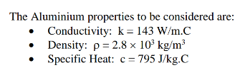
Figure 1 - Aluminium Plate properties

To be able to do this a program will need to be written using the computer software MATLAB and using the methodology used in the Explicit Finite Difference Method or EFDM in short hand.
The program which will be written will also be interactive, allowing the user to in put their own desired grid reference although restricted against a set of rules, and also allowing the user to input a desired time to which they would like to study the heat transfer.
The Explicit Finite Difference Method will be looked and researched to prove this is the correct equation which should be used within this study.
To provide confirmation that the program works within the assignment brief the analytical solution of the temperature at thermal equilibrium (Figure 2 - Analytical solution of the temperature at thermal equilibrium) has been provided, this will be written within the program to provide the comparison proving the method is correct.
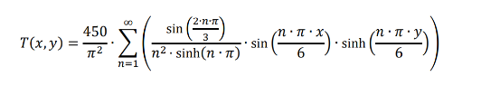
Figure 2 - Analytical solution of the temperature at thermal equilibrium

Heat equation

When looking at studying and determining the heat transfer through an object the boundary conditions which are provided / obtained must be as accurate as possible to provide the most accurate answer. As when calculating the heat transfer the answers which will be provided will be an approximation.
The finite difference method is one way to solve the governing partial differential equations into numerical solutions in a heat transfer system. This is done through approximation, which replaces the partial derivatives with finite differences. This provides the value at each grid point in the domain. (Cadence CFD, 2024)

When using the finite difference method, it will require the aluminium plate to be split in to grid where at each intersection of the grid a temperature reading will be calculated, the finer the grid the more accurate the approximated answer which will be provided. As the aluminium plate has been split into a grid the second- degree heat equation for 2D steady-state heat generation can be applied which is shown below in Figure 3 - second-degree heat equation for 2D steady state heat generation.

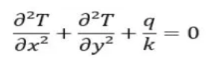
Figure 3 - second-degree heat equation for 2D steady state heat generation

When applying this equation to an object with no heat source the equation looks like Figure 4 - non heat source
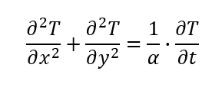
Figure 4 - non heat source

The reason why we use Explicit Finite Difference Method is that is a numerical problem-solving methodology which systematically uses equations like the ones shown above to approximate values of the unknowns, so in this case the heat being transferred through the aluminium plate. (Harish, 2023)

Explicit finite difference form of the constitutive equation

A good starting point is to look at the Tayor Series and under how it is used to generate different approximations from the first to the second derivatives.
A key would in the above information is approximations as the answer which is provided is only an approximation to what the correct answer will be, but how the Taylor Series works is the more terms you add to the equation the more accurate the approximation will become.
In mathematics, the Taylor series of a function is an infinite sum of terms that are expressed in terms of the function’s derivatives at a single point. For most common functions, the function and the sum of its Taylor series are equal near this point. Taylor’s series are named after Brook Taylor who introduced them in 1715. (yasin capar, 2020)
When looking at the first and second derivatives
While a Taylor series of the first or second order is usually sufficient for a wide range of combustion responses, there exist situations in which the response is of higher order within the model parameter space. (Bayen, 2021)
The equation for Taylors series looks like Figure 5 - Taylors series
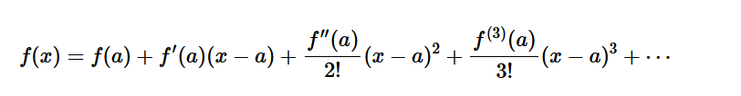
Figure 5 - Taylors series
And this can be written into a compress format show below Figure 6- compressed format
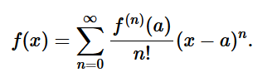
Figure 6- compressed format

Looked at direction derivatives as in forward, backwards, and central this is best explained firstly by plotting a graph (Figure 7 - Graph 1) with a straight line on it, the slope on the line is the approximation generated by the Tayor series equation.
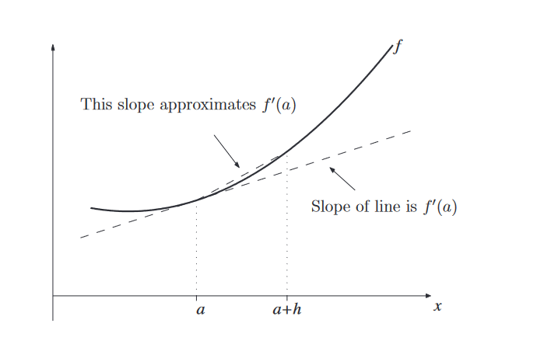
Figure 7 - Graph 1

Selecting a point on the line will give you what is called one sided difference or better known as the forward difference this equation is show below. Figure 8- Forward Difference
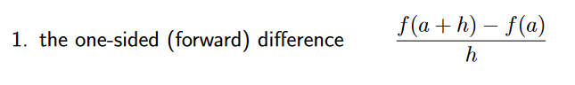
Figure 8- Forward Difference
Working backward from this point would be the backwards difference shown below Figure 9 - Backwards Difference
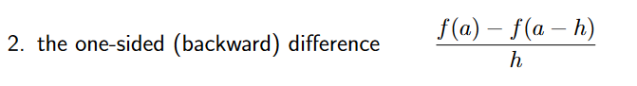
Figure 9 - Backwards Difference
And focusing on that point would be the central difference which is the most accurate. Figure 10 - Central Difference
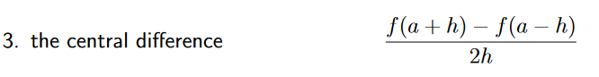
Figure 10 - Central Difference
When applying these in relation to a grid which will be generated you can work out the direction of travel using the forward, back and central equations. But the as the direction will be looking at rows and columns its easy to refer to these as North and South instead of forwards and backs columns and east to west for the rows.

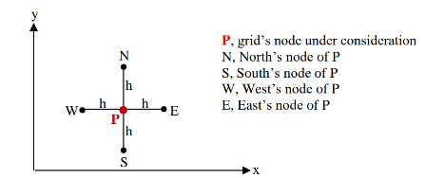
Figure 11 - Spatial discretisation

As the heat equation is uses Fourier’s number needs to be calculated through the equation Figure 11 - Fourier’s equation
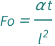
Figure 12 - Fourier’s equation
The answer to this is equation is represented by Fo, this number is the dimensionless number that characterizes transient heat conduction. Which will provide the ratio to which the heat diffuses through the matter or thermal energy. (resources.wolframcloud.com, 2024)

When all the equations and working out are complete the subject which the heat is being applied to will at some point reach a state of Stability criterion, this is reached when the subjected no longer exchanges heat due to reaching a state of equilibrium resulting in a uniformed temperature.

MATLAB Code

When writing a code, a MATLAB it is always good practice to open the code with the following Figure 13 - MATLAB 1

Figure 13 - MATLAB 1
This will clear all the windows which will prevent confusion as they could contain information from previous run codes.
The next part to enter is what we already know from the assignment brief which has been handed to us. Figure 14 - MATLAB 2
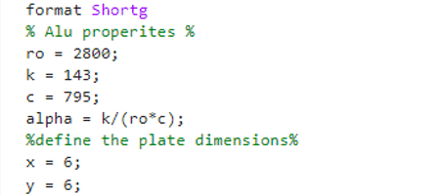
Figure 14 - MATLAB 2
On row 5 I have used the code “format shortg” this will reduce the decimal place which number are shown, so that the program is easier to read and decipher.
As the code will require user inputs to determine the grid spacing and a time step these need to be written into the program.
Figure 15 - MATLAB 3
In the above image the user is asked to enter a grid spacing Figure 15 - MATLAB 3, however the number which is being entered must be larger than 0 and also disable by 6. If an incorrect number is entered this will be displayed on the screen and the user must renter a number. The program will not continue until the correct number is entered. This code is shown in Figure 16 - MATLAB 4
Figure 16 - MATLAB 4

The next user input is the time step in seconds and again this need to be within a set limit which is determined by Fourier’s number, but as the user won’t know what this number is the prompt if the number is entered in incorrect the first time will display the maximum number which can be entered. This is shown in Figure 17 - MATLAB 5
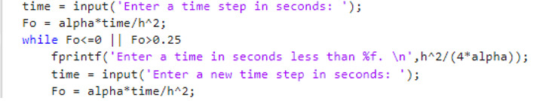
Figure 17 - MATLAB 5
With all the user inputs, inputted correctly the program will utilise these and start the calculation process.
Firstly, the matrix with the initial temperature will be made.
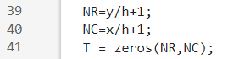
Figure 18 - MATLAB 6
The reason for the added 1 to the h value is that the grid spacing will start on 0 shown in Figure 18 - MATLAB 6
Now the boundary condition needs to be set shown in Figure 19 - MATLAB 7
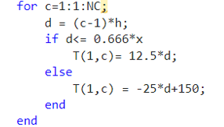
Figure 19 - MATLAB 7
Now a matrix needs to be generated for the updated temperature what are passing through the aluminium block. These will continue to calculate until thermal equilibrium is reached.
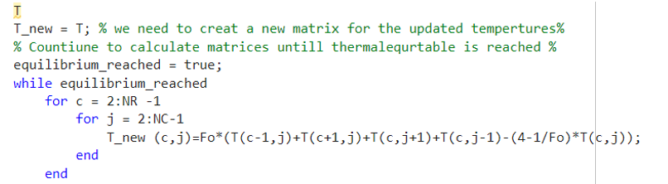
Figure 20 - MATLAB 8
Within this you can see that each direction is being considered North, South, East and West when calculating each nod.
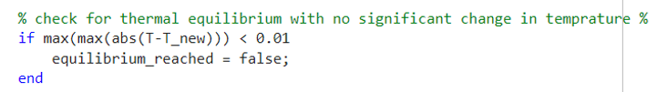
Figure 21 - MATLAB 9
The While loop will continue to calculate until equilibrium is reached.
With this the original temperature will be replaced with the new temperature
Figure 22 - MATLAB 10
This can now be plotted into a graph to show what is happening pictorially.
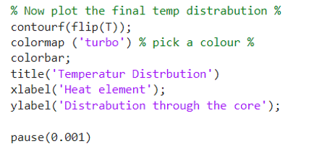
Figure 23 -MATLAB 11
The pause is added so that when the user is running the program, they can see the heat transferring through the core step by step.
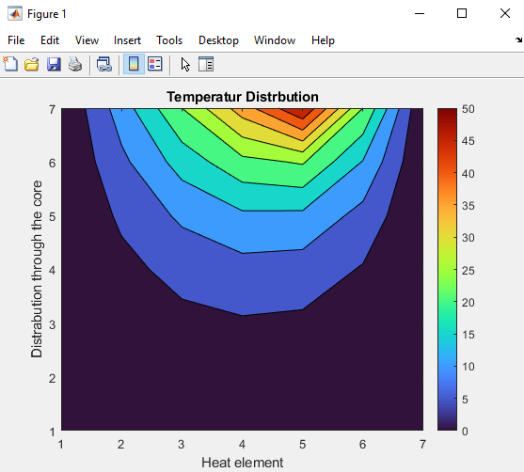
Figure 24 - MATLAB 12

A calculation and a loop counter will tell us how long it has taken this will be referred to further in the program.
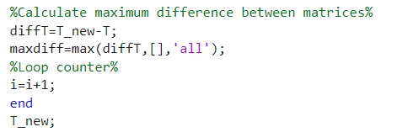
Figure 25 - MATLAB 13
To see if the program has worked using a numerical calculation, an analytical equation can be written into the program to generate a separate graph, this can then be interrogated to see how much difference there is between two temperature graphs being generated.

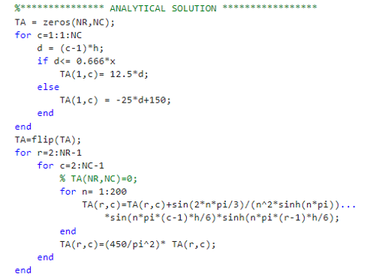
Figure 26 - MATLAB 14

This Analytical equation is provided in the assignment brief.
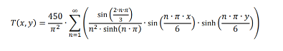
Figure 27 - Analytical equation
However instead of using an infinite number this has been replaced with 200.

Again, the result of this is put into a graph and to ensure it is displayed it is called figure(2) within the code .
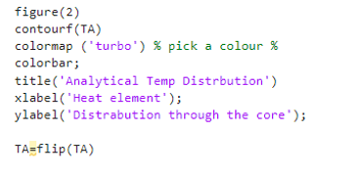
Figure 28 - MATLAB 15
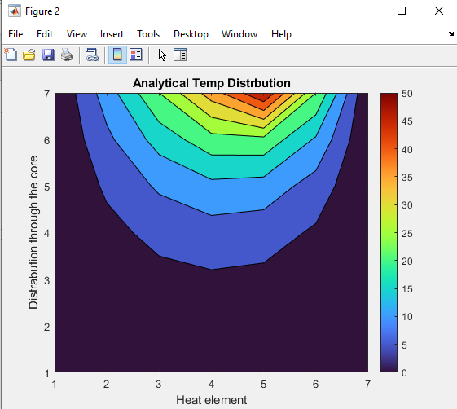
Figure 29 - MATLAB 16
To compare the graphs against each other another code was write and again this was plotted.
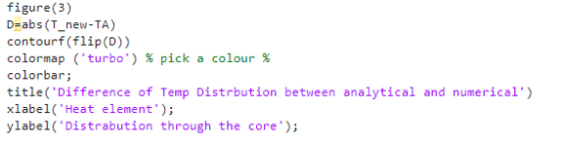
Figure 30 - MATLAB 17
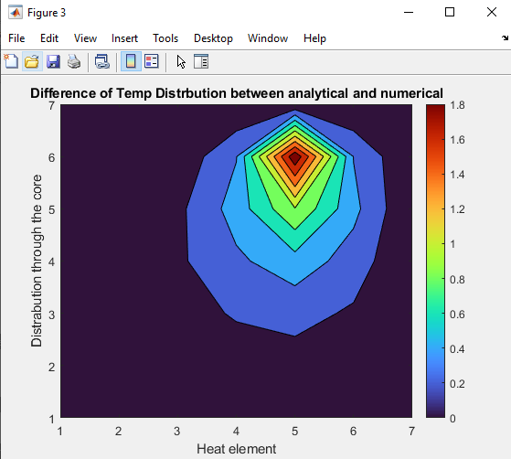
Figure 31 - MATLAB 18

From this the graphs are pretty much identical with a max difference of about 2 degrees.
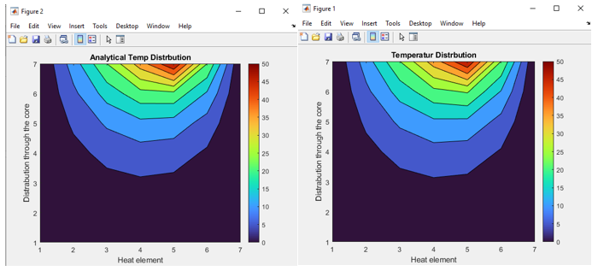
Figure 32 - h = 1 time step 3600
This program was run with the user inputs being h = 1 and time step being 3600

If the user inputs are more refined with h = 0.5 and the time step being 750 the graphs look a lot smoother.
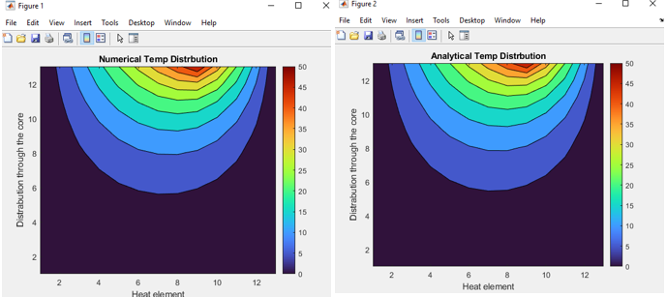
Figure 33 - h = 0.5 time step = 750

The difference between the numerical and the analytical is only 0.8 degrees.
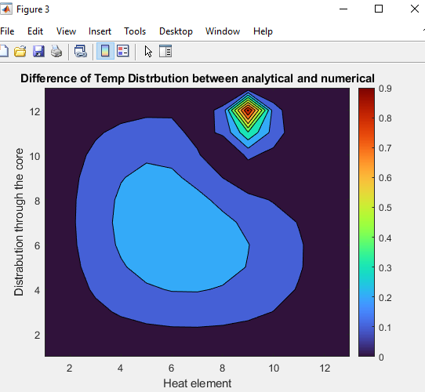
Figure 34 - 0.8 difference.

Knowing that the program which has been written is correct the final stage is establish how long thermal equilibrium takes.
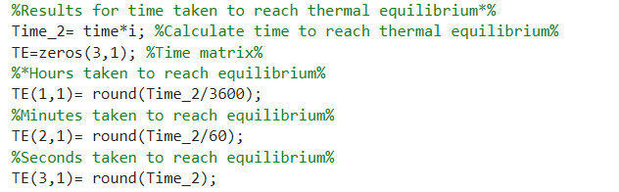
Figure 35 - MATLAB 19
With this worked out it needs to be displayed for the user to see.
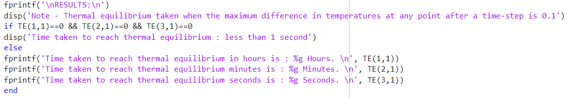
Figure 36 - MATLAB 20

Sensitive analysis of the code

In this section of the report altering different values of the program will be looked at to see how these effects the time taken to reach thermal equilibrium. The values which will be altered are.
- Grid Spacing h
- Time step
- Tolerance
Only one area will be altered leaving the other values the same during each exercise.

Grid Spacing h

For this the grip spacing will be the value which is altered leaving the time step fixed at 150 and the tolerance fixed at 0.001, this is shown in Figure 37 - Grid spacing h
Figure 37 - Grid spacing h
When these number are plotted onto a graph it can be seen that the tighter the grid spacing is the more consistent the values are and the last four grid spacing results are similar with the last two being the same.( Figure 38 - graph for Grid spacing h)

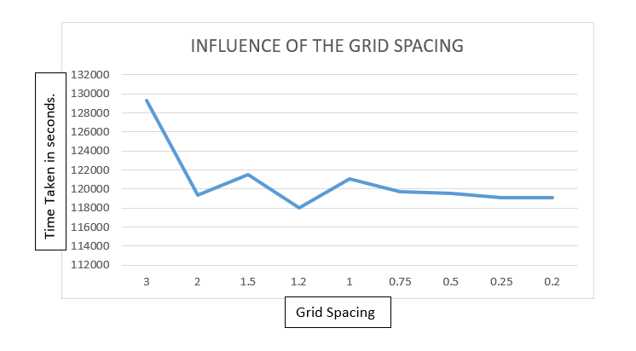
Figure 38 - graph for Grid spacing h

Time Step

Again, the same method is going to be applied where only the time step changes with the other two factors staying the same. Figure 39 - Change in Time step

Figure 39 - Change in Time step

When plotting these values, the smaller the time step the more the line changes where with the larger time step the graph increase isn’t as dramatic. Figure 40 - Time step Graph
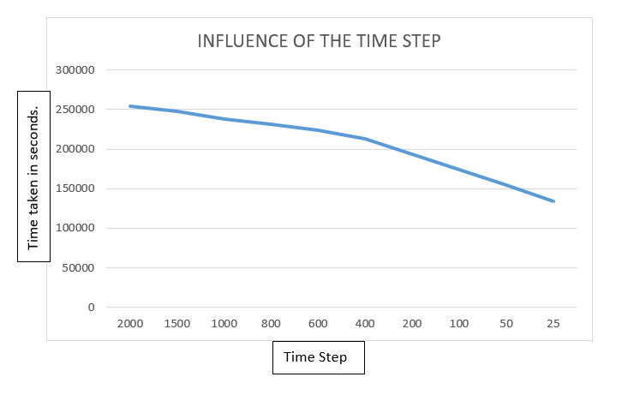
Figure 40 - Time step Graph

Tolerance change

The same method was applied when looking at the effect of the tolerance change, with only the tolerance value being altered. Figure 41 -Tolerance Value changed

Figure 41 -Tolerance Value changed

When these values are plotted the line which is given off is straight, which means the tighter tolerance will take much longer reach the thermal equilibrium time. Figure 42 - Tolerance Graph
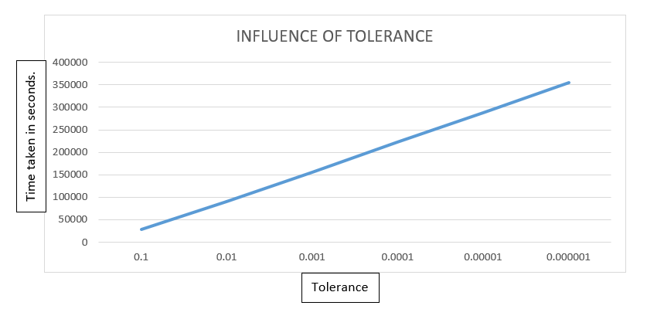
Figure 42 - Tolerance Graph

Limitations

When looking at the limitations both numerical method and the coding method have them.
numerical method can provide round off errors as computers represent numbers in binary form, which means numbers can be represented infinite binary form fractions, example 1/3 is 0.010101010101010……. therefore any normal computer which sees a finite number of bits in each storage location will not represent the number exactly. (Smith, 2021)
A truncation error can be given, this means that there is an difference between an actual and a truncated, of a cut off value. The truncated quantity is represented by a number with a number of allowed digits with an excess digits chopped off. (Awati, 2024)
Example of truncation error
e^{x} = 1 + (x / 1!) + (x² / 2!) + (x³ / 3!) + ⋯ + (x^{n} / n!) + ⋯ ∞
e^{x} = 1 + x + (x² / 2) + (x³ / 6) + ⋯ + (x^{n} / n!) + ⋯ ∞
Thus, e^{x} has an infinitely long series that can be expressed in a truncated (approximated) format:
e^{x} = p₂x +∑∞ (x^{n} / n!)
n = 3
(Awati, 2024)

Suggestion for improvement

When writing this about the program I have realised that the use of the letter c to represent rows and the letter j to represent columns was a confusing situation, so in the program which I have submitted I have corrected these. This is shown below in Figure 43 - Old version and Figure 44 - New version. Going forward I will use letters which represent the item which I am referring too and not just a random letter.

Figure 43 - Old version

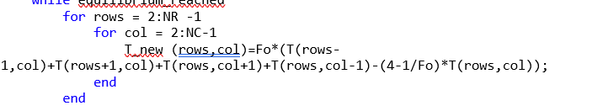
Figure 44 - New version

The use of comments as I am writing the program, will benefit me so when I need to come back to the program after a long period of time I can understand more clearly when I am coding.

Conclusion

The code which has been written gives off a theoretical value and this must always be taken into consideration when applying the results to a real word situation, in this incident there was an analytical equation which we could compare the results to showing that they were very similar. However, having an analytical solution is not always the case as this is one of the only few which are written. But what this code does is provide the end user with data which can be used and which will give the best possible idea to how something is going to react under the situation it has been subjected too.

Works Cited
Bayen, A. M., 2021. https://www.sciencedirect.com. [Online]
Available at: https://www.sciencedirect.com/topics/engineering/taylor-series
[Accessed 20 january 2024].
Cadence CFD, 2024. resources.system-analysis.cadence.com. [Online]
Available at: https://resources.system-analysis.cadence.com/blog/msa2022-explaining-the-finite-difference-method-and-heat-transfer
[Accessed 2 January 2024].
Harish, A., 2023. https://www.simscale.com. [Online]
Available at: https://www.simscale.com/blog/implicit-vs-explicit-fem/
[Accessed 2 january 2024].
resources.wolframcloud.com, 2024. https://resources.wolframcloud.com. [Online]
Available at: https://resources.wolframcloud.com/FormulaRepository/resources/Fourier-Number-Using-Thermal-Diffusivity
[Accessed 20 January 2024].
Terry, K., 2022. https://www.isixsigma.com/new-to-six-sigma/dmaic/what-dmaic/. [Online]
Available at: https://www.isixsigma.com/new-to-six-sigma/dmaic/what-dmaic/
yasin capar, 2020. yasincapar.com. [Online]
Available at: https://yasincapar.com/taylor-expansion/
[Accessed 20 January 2024].

Appendix – Code
% first clear the workspace and command window%
clc
clear all
close all
format Shortg
% Alu properites %
ro = 2800;
k = 143;
rows = 795;
alpha = k/(ro*rows);
%define the plate dimensions%
x = 6;
y = 6;
% asking the user to define the grid referance %
h = input('Enter the grid perameters for h: ');

% Check if the entered value is greater than 0 and entirely
% divisible by 6

while rem(6,h)~=0 || h>=6 || h<=0
fprintf('The entered value must be greaterthan 0 and also entirely divisible by 6.\n');
h = input('Enter the grid perameters for h: ');
end
% now that we have the grip spacing we need them to enter a time %
time = input('Enter a time step in seconds: ');
Fo = alpha*time/h^2;
while Fo<=0 || Fo>0.25
fprintf('Enter a time in seconds less than %f. \n',h^2/(4*alpha));
time = input('Enter a new time step in seconds: ');
Fo = alpha*time/h^2;
end
%start to generate the matrix with intial temps when h=1 %
NR=y/h+1;
NC=x/h+1;
T = zeros(NR,NC);
for rows=1:1:NC
d = (rows-1)*h;
if d<= (2/3)*x
T(1,rows)= 12.5*d;
else
T(1,rows) = -25*d+150;
end
end
T;
T_new = T; % we need to creat a new matrix for the updated tempertures%
% Countiune to calculate matrices untill thermalequrtable is reached %
i=0; %Set Loop Counter%
equilibrium_reached = true;
while equilibrium_reached
for rows = 2:NR -1
for col = 2:NC-1
T_new (rows,col)=Fo*(T(rows-1,col)+T(rows+1,col)+T(rows,col+1)+T(rows,col-1)-(4-1/Fo)*T(rows,col));
end
end

% check for thermal equilibrium with no significant change in temprature %
if max(max(abs(T-T_new))) < 0.01
equilibrium_reached = false;
end

% Now i need to update the matrix with the new temperatures%
T = T_new;

% Now plot the final temp distrabution %
contourf(flip(T));
colormap ('turbo') % pick a colour %
colorbar;
title('Numerical Temp Distrbution')
xlabel('Heat element');
ylabel('Distrabution through the core');

pause(0.001)
i=i+1; %Loop counter%
end
T_new;

%*************** ANALYTICAL SOLUTION *****************
TA = zeros(NR,NC);
for rows=1:1:NC
d = (rows-1)*h;
if d<= 0.666*x
TA(1,rows)= 12.5*d;
else
TA(1,rows) = -25*d+150;
end
end
TA=flip(TA);
for r=2:NR-1
for rows=2:NC-1
% TA(NR,NC)=0;
for n= 1:200
TA(r,rows)=TA(r,rows)+sin(2*n*pi/3)/(n^2*sinh(n*pi))...
*sin(n*pi*(rows-1)*h/6)*sinh(n*pi*(r-1)*h/6);
end
TA(r,rows)=(450/pi^2)* TA(r,rows);
end
end
figure(2)
contourf(TA)
colormap ('turbo') % pick a colour %
colorbar;
title('Analytical Temp Distrbution')
xlabel('Heat element');
ylabel('Distrabution through the core');

TA=flip(TA)

figure(3)
D=abs(T_new-TA)
contourf(flip(D))
colormap ('turbo') % pick a colour %
colorbar;
title('Difference of Temp Distrbution between analytical and numerical')
xlabel('Heat element');
ylabel('Distrabution through the core');

% Results for time taken to reach thermal equilibrium%
%Calculate time to reach thermal equilibrium%
Time_2= time*i;
%Time matrix%
TE=zeros(3,1);
TE(1,1)= round(Time_2/3600); %Hours taken to reach equilibrium%
TE(2,1)= round(Time_2/60); %Minutes taken to reach equilibrium%
TE(3,1)= round(Time_2); %Seconds taken to reach equilibrium%
%Displaying results%
fprintf('\nRESULTS:\n')
disp('Note - Thermal equilibrium taken when the maximum difference in temperatures at any point after a time-step is 0.1')
if TE(1,1)==0 && TE(2,1)==0 && TE(3,1)==0
disp('Time taken to reach thermal equilibrium : less than 1 second')
else
fprintf('Time taken to reach thermal equilibrium in hours is : %g Hours. \n', TE(1,1))
fprintf('Time taken to reach thermal equilibrium in minutes is : %g Minutes. \n', TE(2,1))
fprintf('Time taken to reach thermal equilibrium in seconds is : %g Seconds. \n', TE(3,1))
end

