

Component 1- Website Redesign for Online Business Presence

Module: Business and Web Management (ACCA5019)
Course: BSc Applied Computing
Student Name: Sonya Vakarelova
Student ID: 2426532
Lecturer: Dr Mobolanle Bello
Submission Date: 23 October 2026

Contents
1.0 INTRODUCTION 3
2.0 WELLCARE CONNECT WEBSITE REDESIGN 3
3.0 RESPONSIVE DESIGN IMPLEMENTATION 6
4.0 IMPLEMENTATION 7
4.1 MOODBOARD AND WIREFRAME DESIGN 13
5.0 CONCLUSION 14
REFERENCES 15

INTRODUCTION
Today, websites play a vital role in enabling people to access services, obtain information and manage everyday tasks. This is particularly important within the healthcare sector, where patients rely on online platforms to book appointments, communicate with healthcare professionals and access essential health information efficiently[1].
This project focuses on the redesign of the WellCare Connect website to improve its usability, visual appeal and overall user experience. The existing website has several identified issues, including confusing navigation, an outdated interface and poor mobile responsiveness. These shortcomings can make it more difficult for patients to access services and may negatively impact user satisfaction.
The primary aim of the redesign is to create a modern, accessible and user-friendly website that meets the needs of patients while strengthening the organisation's online presence. Attention has been given to improving access to key services, such as appointment booking, virtual consultations and personal health information, ensuring that users can complete common tasks quickly and easily.
This report analyses the key problems identified within the current website and explains how the proposed redesign addresses these issues. It also examines the importance of responsive web design for organisations operating online and outlines the design process undertaken. This process includes the development of a mood board using Canva, wireframes created in PowerPoint and a five-page interactive prototype designed in Inkscape.

2.0 WELLCARE CONNECT WEBSITE REDESIGN
The existing WellCare Connect website has several issues that may affect how people access healthcare services online. These include confusing navigation, an outdated layout, unclear appointment booking options and difficulties finding personal health information. Such problems may cause frustration, particularly for individuals who are less confident using digital services. The proposed redesign focuses on creating a clearer structure, improving the visual appearance and making essential features more accessible.
Navigation is one of the main areas requiring improvement. When menus are unclear or inconsistent, users may struggle to locate the services they need. Hägglund and Scandurra [2] discuss structure and navigation as usability challenges in an online patient health record system. To address this issue, I designed a consistent navigation bar with five sections: Home, Appointments, Consultations, My Health and Membership. This menu appears across all five pages, creating a familiar structure. I also included a search option and clearly labelled buttons on the homepage. These features are intended to simplify navigation, but testing with different users would help determine whether the menu is easy to understand.
The appointment booking process is another area that needs attention. Unclear booking options may discourage people from arranging appointments online. To address this, I created a dedicated Appointments page where users can choose between a GP appointment, a nurse appointment or a video consultation. The layout also includes date and time selections followed by a Continue button. Presenting these choices in a logical order is intended to make the process more straightforward. The prototype only demonstrates the proposed interface, so its effectiveness would need to be evaluated once a functioning booking system is developed.
Access to virtual consultations is also an issue identified in the original website. When consultation options are difficult to locate, users may be unsure how to access remote healthcare. My proposed Consultations page clearly presents telephone and video appointments, allowing visitors to identify the available options. Separating consultations from general appointment booking also helps organise the information. The relationship between these two pages would need to be clear to avoid confusion about where users should begin.
Finding personal health information can also be challenging when details are spread across different sections. To address this, I designed a My Health dashboard that brings together medical records, prescriptions and appointment information. The page also includes an appointment reminder and wellbeing tips, providing a more personalised experience. Organising these features in one location may reduce unnecessary searching and help individuals manage their healthcare needs. A working version would also require secure access and appropriate protection of sensitive medical information, which are beyond the scope of this design prototype.
The site's outdated appearance and inconsistent branding may also affect how professional and trustworthy the organisation appears. For the new interface, I selected teal, navy blue and white to create a clean and welcoming visual style. Arial was chosen for readability, while consistent headings, buttons and navigation elements were used across the five pages. The homepage includes a healthcare-related image, a clear heading and a Book Appointment button to highlight a key service. These choices establish a recognisable visual identity, but the colours and layout alone cannot guarantee that visitors will trust the platform.
Accessibility is another key consideration. People have different levels of digital experience, and some may experience difficulties reading text or navigating online services. I therefore used clear headings, readable fonts, simple layouts and descriptive button labels. These features are intended to reduce confusion and make the interface more approachable. Jonsson et al. [3] highlight the importance of accessibility in eHealth services. This goes beyond visual appearance, as further evaluation would be needed to assess keyboard navigation, screen-reader compatibility and how well the design meets the needs of users with different accessibility requirements.
Building trust is particularly relevant when providing healthcare services online. Visitors need to feel confident when accessing medical information or using digital consultations. Son and Nahm [4] identified privacy and security as important concerns for people using online patient portals. In my redesign, consistent branding and clearly organised content aim to create a professional appearance. The Membership page also presents three options: Essential, Plus and Complete, allowing users to compare the available plans more easily. A fully developed website would also need clear information about pricing, privacy and service limitations.
Overall, the proposed redesign addresses several problems identified in the WellCare Connect scenario through clearer navigation, organised healthcare features and consistent visual design. These changes are intended to support a better user experience and strengthen the organisation's online presence. Usability testing, accessibility evaluation and further development would be necessary to confirm whether the proposed improvements meet users' needs in practice.

3.0 RESPONSIVE DESIGN IMPLEMENTATION
Responsive web design is an approach that allows a website's layout and content to adjust to different screen sizes, including desktop computers, tablets and smartphones. Rather than creating a separate version for each device, this method uses flexible layouts and images to make information easier to view and navigate [5]. This is particularly relevant for online businesses, as many people now access services through smartphones and tablets. An adaptable interface can provide a more consistent experience, regardless of the device being used.
A well-structured interface can improve user experience by making online services more accessible and straightforward to navigate. On smaller screens, menus, images and text should adjust appropriately so that visitors can read information and select options without constantly zooming or scrolling sideways. For e-commerce businesses, these improvements can simplify browsing, comparing products and completing purchases [6]. Clear navigation and readable content may also reduce frustration, encouraging visitors to spend more time exploring the platform.
Adapting online stores for smartphones can also support increased sales by making shopping more convenient. When product details, payment methods and checkout buttons are clearly presented, buyers may feel more confident completing transactions. Complicated menus or lengthy forms could discourage purchases and contribute to abandoned shopping baskets. Businesses can address these difficulties through straightforward checkout processes and accessible payment options. Such improvements may encourage repeat purchases and strengthen customer satisfaction [7]. While these features offer potential advantages, higher sales are not guaranteed, as pricing, product quality and trust also influence purchasing decisions.
For WellCare Connect, an adaptable interface could improve access to healthcare services on smartphones and tablets. The navigation menu, booking options and consultation details would need to fit smaller displays without affecting readability. For example, the five main sections could appear within a collapsible menu, while larger buttons would make appointment selection more convenient. This could help individuals manage their healthcare needs when away from a computer. Since my Inkscape prototype was created for desktop viewing, these features have not yet been implemented or evaluated. Future development should therefore include layouts for different devices, followed by usability testing to assess their effectiveness.

4.0 IMPLEMENTATION

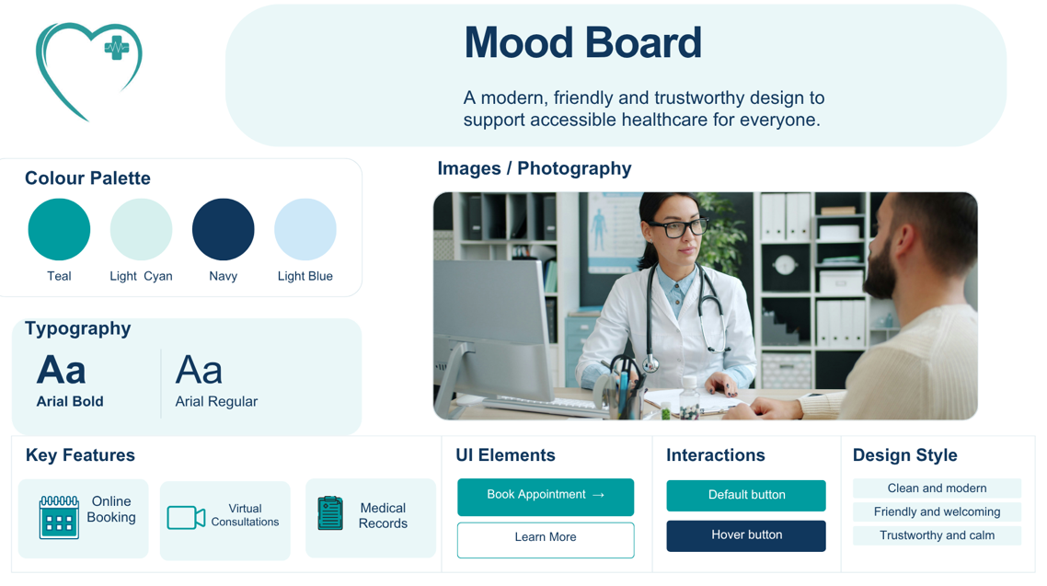
Figure 1: Mood Board Screenshot

Wireframe Screenshots
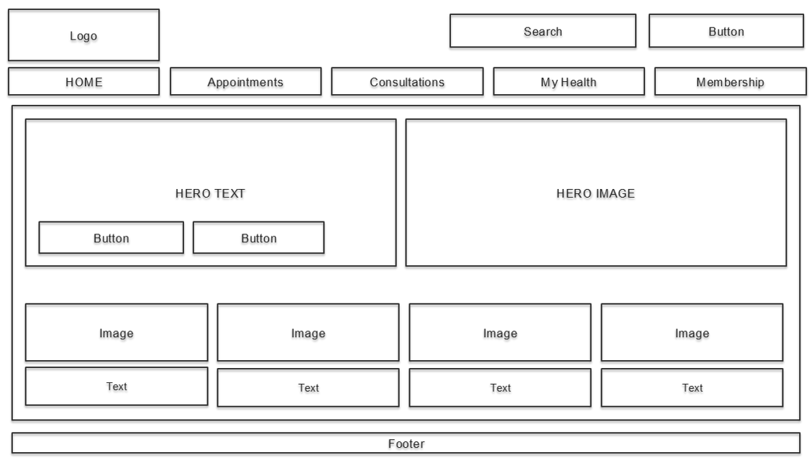
Figure 2: Home Page Wireframe Screenshot

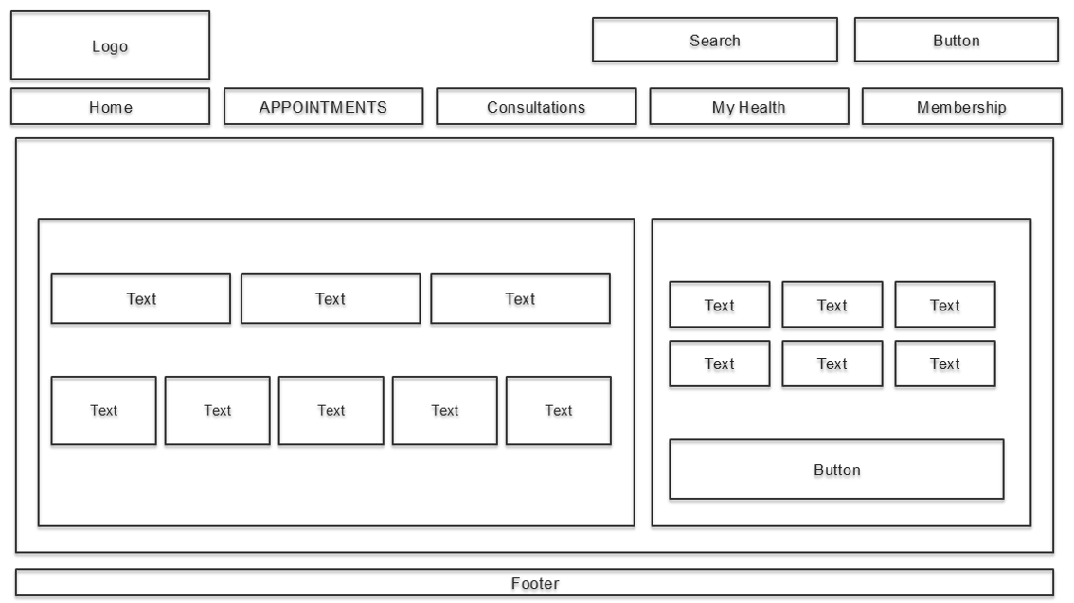
Figure 3: Appointments Page Wireframe Screenshot

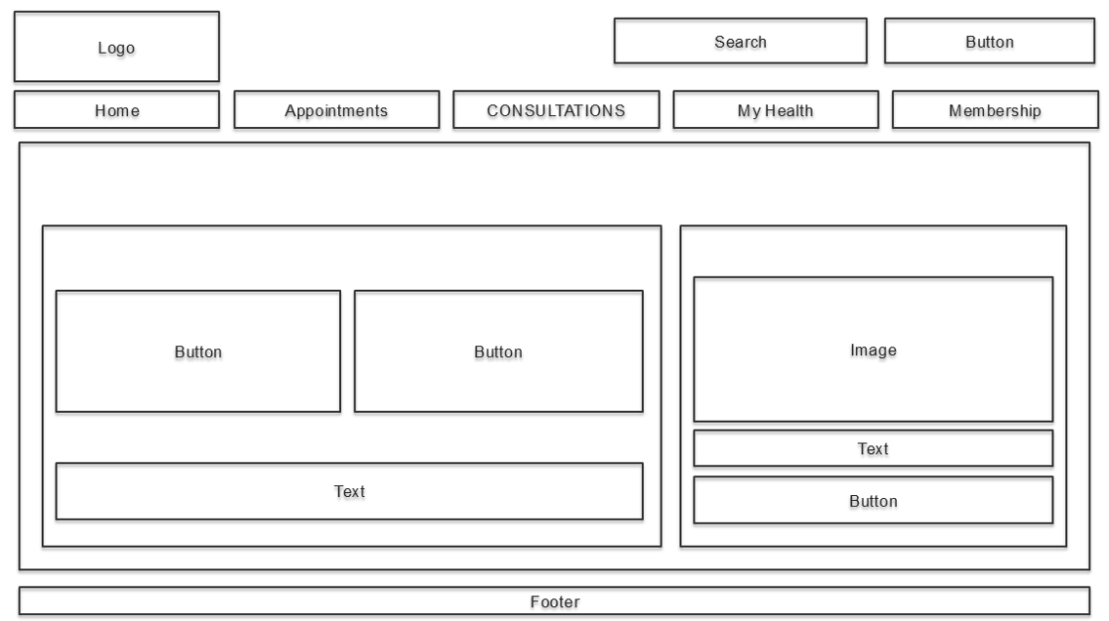
Figure 4: Consultations Page Wireframe Screenshot

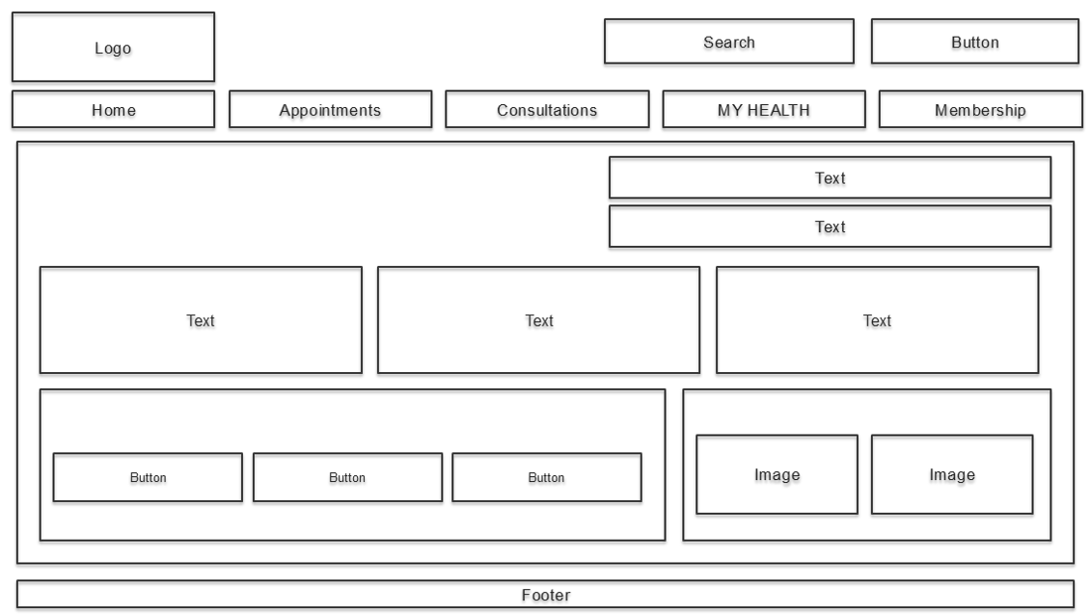
Figure 5: My Health Page Wireframe Screenshot

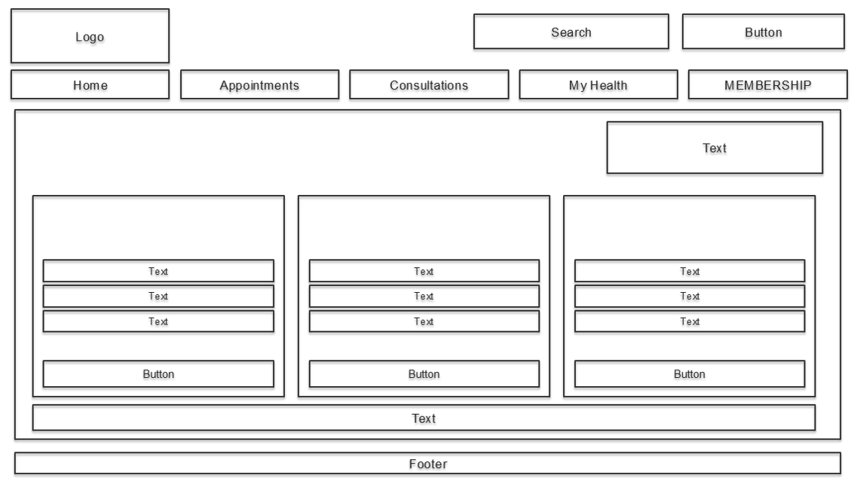
Figure 6: Membership Page Wireframe Screenshot

Web Design Screenshots

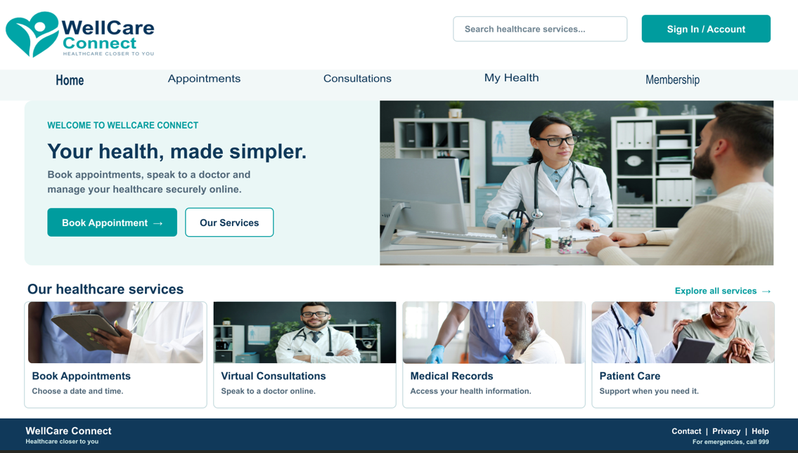
Figure 7: Home Page Web Design Screenshot

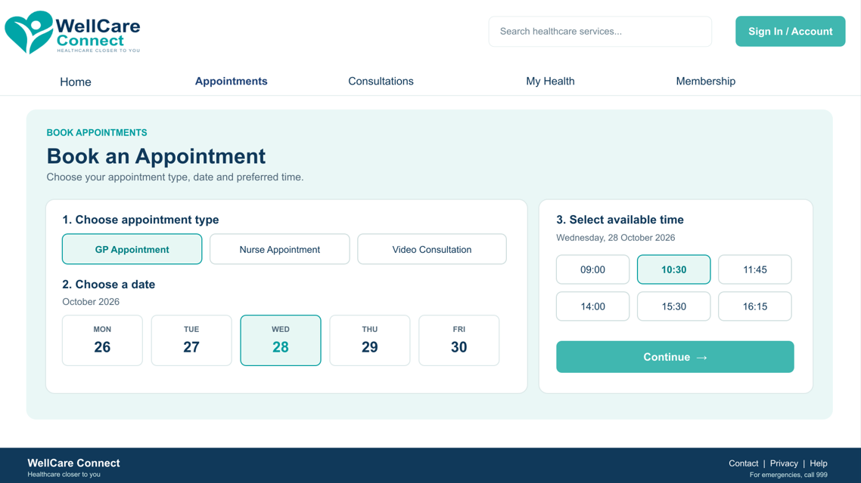
Figure 8: Appointments Page Web Design Screenshot

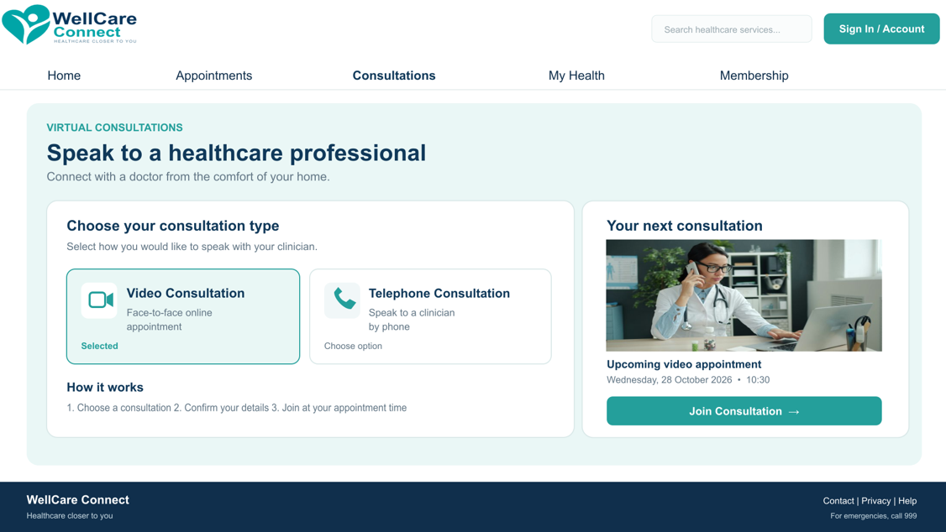
Figure 9: Consultations Page Web Design Screenshot

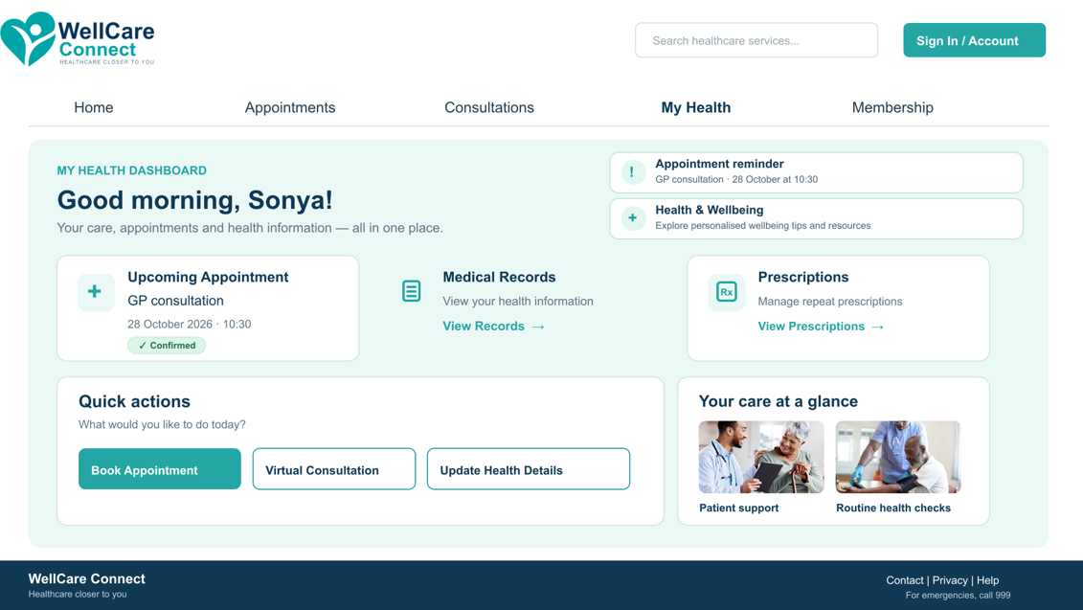
Figure 10: My Health Page Web Design Screenshot

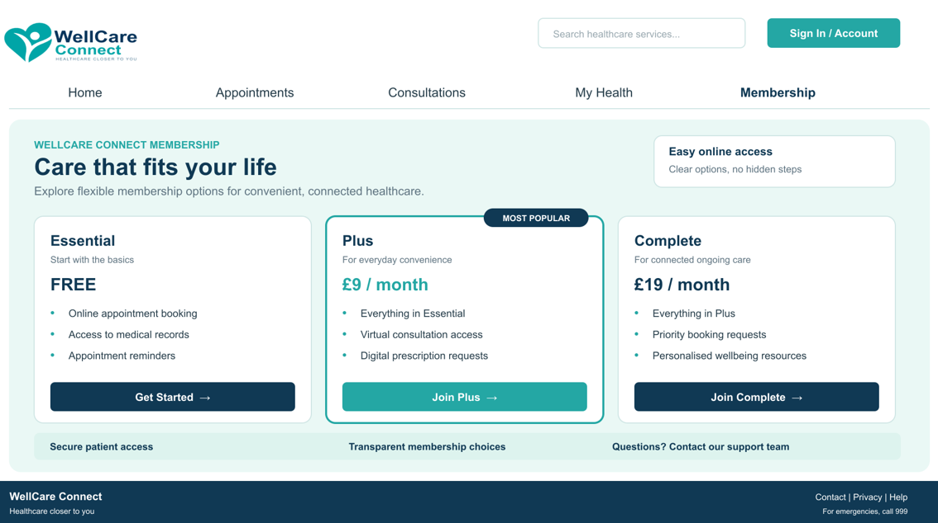
Figure 11: Membership Page Web Design Screenshot

4.1 MOODBOARD AND WIREFRAME DESIGN
A mood board is a visual collection of images, colours, typography and other elements used to explore the overall style of a design project. It helps organise creative ideas before developing a detailed interface [8]. For WellCare Connect, I created a mood board in Canva to establish a suitable appearance for a healthcare platform. This allowed me to explore different visual elements and consider how they could work together to create a professional and welcoming impression.
The mood board influenced several decisions in my final prototype. I selected teal, navy blue and white to create a clean and consistent colour scheme. Teal was chosen to give the interface a calm appearance, while navy helped distinguish headings and navigation elements. White backgrounds provided contrast and prevented the pages from appearing overcrowded. I also included healthcare-related imagery and selected Arial for its clear and readable appearance. These choices helped establish a recognisable identity across the five pages. However, feedback from potential users would be needed to determine whether the visual style meets their expectations.
A wireframe is a simplified representation of a digital interface that shows the position of key elements before detailed colours, images and styling are introduced [9]. It helps designers plan the structure, navigation and arrangement of information at an early stage. For this project, I created five wireframes in PowerPoint, representing Home, Appointments, Consultations, My Health and Membership. These initial layouts allowed me to organise the content of each page and consider how visitors would move between different services.
The wireframes provided a starting point for developing my Inkscape prototype. For example, the Home page places the main navigation at the top and highlights the appointment booking option. The Appointments page presents different consultation choices, alongside date and time selections. Meanwhile, My Health groups personal information into a dashboard, making the content easier to locate. Following the initial sketches helped me maintain consistency when adding colours, images and interactive elements.
Both stages contributed to the development process in different ways. The mood board guided the visual identity, whereas the wireframes focused on structure and organisation. Together, they helped transform my initial ideas into a five-page prototype. Although this process supported planning and consistency, further usability testing would be necessary to identify potential difficulties and evaluate whether the interface meets users' needs.

5.0 CONCLUSION
This project focused on redesigning the WellCare Connect website to improve its visual appearance, navigation and overall user experience. The proposed changes addressed difficulties in accessing healthcare services, including appointment booking, virtual consultations and personal health information. By organising these features into five clearly structured pages, the prototype aimed to provide a more straightforward and efficient user experience.
Throughout the project, I developed a greater understanding of how planning and user-centred design contribute to effective digital solutions. Creating the mood board in Canva helped establish a consistent visual identity, while the wireframes developed in PowerPoint supported content organisation before the final prototype was created in Inkscape. These stages demonstrated how a structured design process can help balance user needs with organisational objectives.
A key limitation of the project is that the prototype represents a visual concept rather than a fully functioning system. Features such as appointment booking and virtual consultations were not implemented, and the interface was designed primarily for desktop viewing. In addition, no formal usability testing was conducted, meaning the effectiveness of the design could not be evaluated with real users. Simola et al. [10] highlight how patient feedback can provide valuable insights into improving the usability of digital healthcare platforms.
Future development should focus on creating mobile-responsive layouts, implementing functional features and conducting usability testing with potential users. Overall, this project demonstrated how thoughtful interface design can support accessibility, improve communication and contribute to the delivery of more effective online healthcare services.

REFERENCES
[1] B. Scheckel, K. Schmidt, S. Stock, and M. Redaèlli, “Patient Portals as Facilitators of Engagement in Patients With Diabetes and Chronic Heart Disease: Scoping Review of Usage and Usability,” Journal of Medical Internet Research, vol. 25, Art. no. e38447, 2023, doi: 10.2196/38447.
[2] M. Hägglund and I. Scandurra, “Usability of the Swedish Accessible Electronic Health Record: Qualitative Survey Study,” JMIR Human Factors, vol. 9, no. 2, Art. no. e37192, 2022, doi: 10.2196/37192.
[3] M. Jonsson, S. Johansson, D. Hussain, J. Gulliksen, and C. Gustavsson, “Development and Evaluation of eHealth Services Regarding Accessibility: Scoping Literature Review,” Journal of Medical Internet Research, vol. 25, Art. no. e45118, 2023, doi: 10.2196/45118.
[4] E. H. Son and E.-S. Nahm, “Adult Patients’ Experiences of Using a Patient Portal With a Focus on Perceived Benefits and Difficulties, and Perceptions on Privacy and Security: Qualitative Descriptive Study,” JMIR Human Factors, vol. 10, Art. no. e46044, 2023, doi: 10.2196/46044.
[5] B. Frain, Responsive Web Design with HTML5 and CSS, 4th ed. Birmingham, UK: Packt Publishing, 2022.
[6] B. A. Kumar, “Mobile-First Usability Guideline for Responsive E-Commerce Websites,” International Journal of Web Portals, vol. 14, no. 1, pp. 1–12, 2022, doi: 10.4018/IJWP.310060.
[7] J.-É. Pelet and B. Taieb, “Context-aware optimization of mobile commerce website interfaces from the consumers’ perspective: Effects on behavioral intentions,” Computers in Human Behavior Reports, vol. 7, Art. no. 100225, 2022, doi: 10.1016/j.chbr.2022.100225.
[8] F. Staiano, Designing and Prototyping Interfaces with Figma: Learn Essential UX/UI Design Principles by Creating Interactive Prototypes for Mobile, Tablet, and Desktop. Birmingham, UK: Packt Publishing, 2022.
[9] T. Green and J. Labrecque, A Guide to UX Design and Development: Developer’s Journey Through the UX Process. Berkeley, CA, USA: Apress, 2023, doi: 10.1007/978-1-4842-9576-2.
[10] S. Simola et al., “Patients’ Experiences of a National Patient Portal and Its Usability: Cross-Sectional Survey Study,” Journal of Medical Internet Research, vol. 25, Art. no. e45974, 2023, doi: 10.2196/45974.

