Student Name: Kira Roberts
Student Number: 1804203
Programme of Study: Creative Advertising (BA)
Module: ADAD5004

Research in Practice Lecturer’s Name: Donna Williams
Total word count: 2536
Words Chosen: Advertising, Influencer and Colour

Table of Contents
Introduction: Page 2
Advertising: Pages 2-5
Influencer: Pages 5-9
Colour: Pages 9-14
Conclusion: Pages 14-15
Reference List: Pages 16-20

This essay will assess three key words; ‘Advertising’, ‘influencer’ and ‘colour’. These words were chosen due to an interest in how these factors play a part in convincing a consumer to buy into a product. These words will be assessed on their role within the advertising world and the theories behind their effectiveness. These theories include integrated advertising strategy, social learning theory and colour theory.

Advertising
Exposure to advertisements is more common than most people realise, there are many indirect advertisements influencing consumers daily.
“Digital marketing experts estimate that most Americans are exposed to around 4,000 to 10,000 ads each day” (Simpson, 2017). These advertisements could be anywhere, for example, social media, posters that you drive past on your way to work, or even just in conversation, where people discuss brands and businesses. Most advertising strategies are designed to gradually influence the consumer over time, and do not need to necessarily be informative, so long as the advertising enhances the perceivers preference towards the brand and products.
(Vakratsas and Ambler, 1999). Therefore, not every advertisement needs a ‘call to action’ (CTA). Sutherland and Sylvester explain this by explaining that,
“The effect of advertising is not to make us ‘run out and buy’. This is especially true with low-involvement products and especially true with image advertising”. (Sutherland and Sylvester, 2000). This indicates that advertisements can be subtle with their goals, which is to gradually influence the consumer to purchase their products. This leads to the question of what must be on an advertisement to make it effective. It can be argued that CTA’s are vital in a good advertisement, as Business Matters estimated,
“..that 90 percent of people who look at your website will read your CTAs and if they are embedded in your text then your conversion rate will increase by over 120 percent.” (Business Matters, 2017). Both of these points of view indicate that it is important to develop a brand image which is not solely focused on making sales. However, it is equally important that the advertisement is clear and enables the consumer to understand how they could benefit from the product.

Dan Wieden is a co-founder of Wieden and Kennedy, an independent advertising company that has been in the industry for over forty years. Wieden and Kennedy have worked with many big brands, such as Coca Cola, Disney, Ford, Ikea and many more. (Wieden and Kennedy, n.d.). In an interview conducted by Design Indaba with Dan Wieden, Wieden explained that they do not follow traditional approaches when creating their campaigns and would rather find unusual ways to portray a message (Design Indaba, 2015). Although Wieden stated that they did not follow the traditional strategies, one feature that many of their projects have had in common is that they were developed as integrated campaigns.(Widen and Kennedy, n.d.)

Advertisements can be used in unison to create an integrated campaign which will include some to have clear CTA’s. Allen explains in an article for Smart Insights that,
“Integrated Marketing is a strategic approach to integrating communications and interactive experiences targeting defined audiences and individuals which coordinates all aspects of marketing of a brand, including: Paid media, Earned media and Owned media. In order to achieve consistent messaging customised where possible by channel which presents a unified and seamless experience to consumers across the customer lifecycle or path to purchase". (Allen, 2022).
To summarise, within this strategy, advertisements would use both communication and experiences from a multitude of advertisements from a singular campaign in order to sell the product.

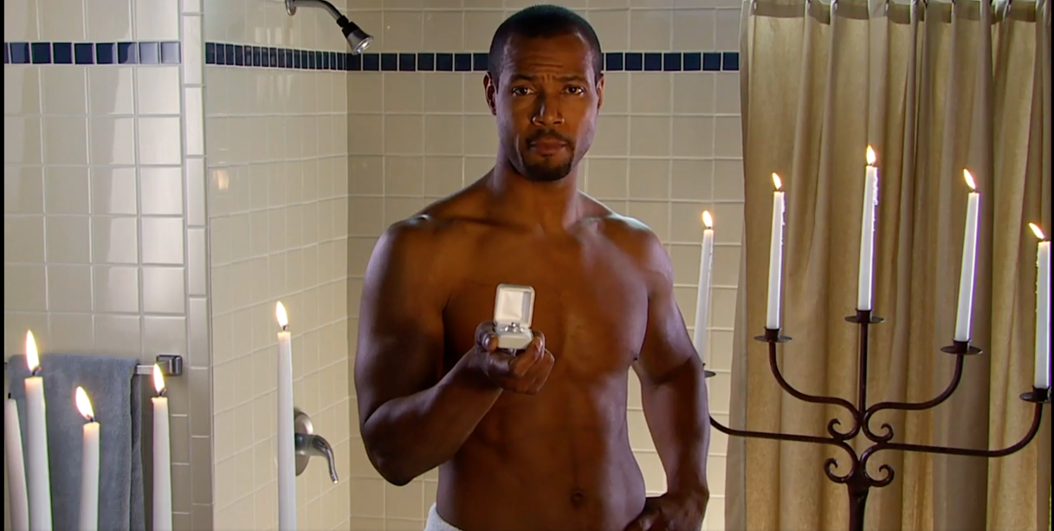

Figure 1 Screenshot of the Old Spice 'Smell like a man' campaign. This is a screenshot of one of the twitter responses, where a customer asked if he could propose for him.
A strong example of an integrated advertising campaign is the ‘Old Spice’ campaign; ‘Smell like a man’ by Wieden and Kennedy in 2010. They designed the campaign around the concept of wanting to encourage a conversation between couples since over half of their sales were from women. They initially created a TV commercial for the Superbowl, then with the excitement generated they used multiple social media platforms to respond to their developed fanbase. This created a live dialogue which resulted in over 186 live interactive video replies from the main actor to the potential consumers (Wieden and Kennedy, 2010). The success of this campaign was measured by the increase of sales.
“The goal was to increase body wash sales by 15%, but by May 2010, sales of Old Spice Red Zone Body Wash had increased 60% from the previous year. By July 2010, sales had doubled.” (Wieden and Kennedy, 2010). It evident that this advertising strategy is effective and Wieden and Kennedy have since replicated this method when developing ideas for other brands.

Influencer
According to the Cambridge Dictionary an influencer is someone who “affects or changes the way that other people behave”, or “a person who is paid by a company to show and describe its products and services on social media, encouraging other people to buy them” (Cambridge Dictionary, n.d.) Companies use influencers as a part of influencer marketing, which is supported by the social learning theory created by Banduara and Walters in 1963. Falk, R and Kim, S (2019) explain that this theory is how, “Patterns of behaviour can be acquired through direct experience or by observing the behaviour of others” (Falk, R and Kim, S, 2019).

Brands can associate their products with an influencer who has a high following on social media. This brand association is intended to encourage the influencers followers to be persuaded to buy into the brand. Sammis et al explains that
“influencer marketing is an established trend in marketing that identifies and targets individuals with influence over potential buyers. Although this has usually meant focusing on popular celebrities and Internet personalities, there is a new wave of 'everyday consumers' that can have a large impact.”. (Sammis et al, 2015)

Many brands use everyday consumers to share their merchandise through their personal social media accounts, giving them the title of ‘influencer’, ‘affiliates’ or ‘brand ambassador’, typically giving them discounts or payments for advertising for their brand. This strategy has many benefits, such as giving the brand a personal feeling through having a social presence and makes the brand appear more genuine in the eyes of the consumer. (Firstbird, n.d.)

Although influencer marketing has many positive effects on brands, the brands need to trust that these influencers reflect their brands values. Brands need to be cautious as they may sign on a contract with an influencer who may represent them in a negative light. Elle Darby was an online influencer for fitness, fashion, beauty and lifestyle after one of her videos went viral in 2015 (Howells, 2022). She was sponsored by GleamFutures, who then secured her contracts with ‘Step in Style’ and ‘Beauty works’. (Leyfield, 2022)

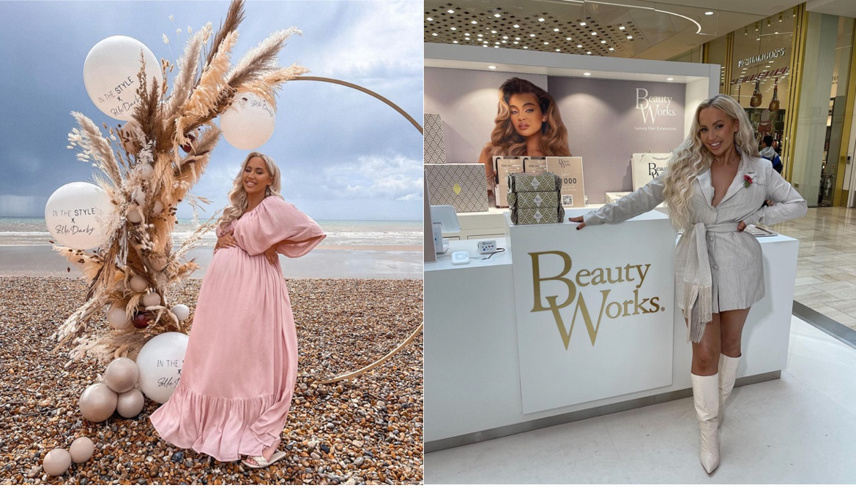
Figure 2 both images from The Sun, demonstrating Elle Darby’s collaboration with Step in Style and Beauty Works.
However, this came to a swift end and many brands stopped endorsing her due to tweets she made in 2011. The Daily Mail captured the tweets in the screenshot shown below before her twitter page was deleted.

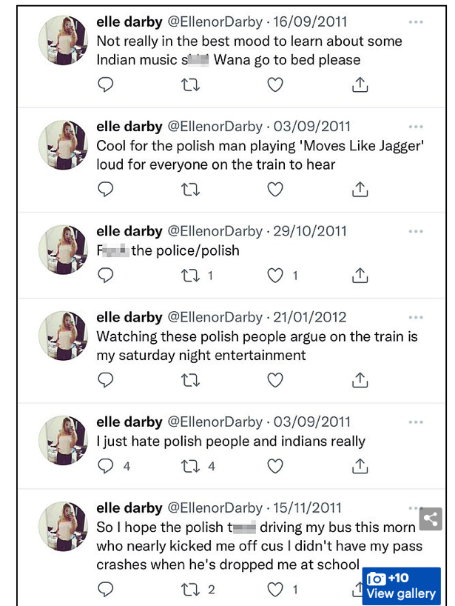
Figure 3 Elle Darby's tweets from 2011 which lead to the termination of her influencer contracts, screenshot from The Daily Mail (2022).
Darby lost thousands of followers and subscribers from this reveal.
“Darby enjoyed more than 785,000 Instagram followers but the social media star now has 716,000. On YouTube, a subscriber count of 611,000 has now dropped to 585,000.” (Pearson-Jones, 2022). These tweets resulted in the crash of Darby’s career as an influencer and in the last video she posted to youtube she expressed her distress regarding the situation. (Darby, 2022).

This sort of publicity also affects the brand’s that signed the influencer. The talent agency, Gleam Futures, explained that
“At Gleam Futures, our mission is to be a driving force for a culturally progressive and diverse industry, offering leading-edge representation for talent that align with our values.. In light of recent events, we have therefore made the decision to no longer represent Elle Darby and Connor Swift.” (Pearson-Jones, 2022). In The Style and Beauty Works have released similar statements to The Sun disclosing the termination of contracts with Darby. Though In The Style had to remove their Elle Darby collection, it is unclear as to the exact impact on their sales from this publicity. Similarly for the other brands that Darby collaborated with, none of which have posted any statements on the damage. Although most of the research on this instance is from news paper articles, it shows how badly the media can respond to negative press on influencers, how impactful it is on the influencer and how the brands can be demonised with the influencer. This demonstrates just one of the risks of influencer marketing.

Colour
The final word selected for this essay is ‘colour’. Colour selection is crucial in advertising due to the connotations implicated where it is used. Theorist Ferdinand de Saussure explains this in his theory of Semiotics. Lagopoloulos and Boklund-Lagopoulou explain in their book ‘Theory and Methodology of Semiotics – The Tradition of Ferdinand de Saussure’ that,
“Semiotics studies the processes of semiosis. This means that it studies meaning, and the specific perspective that defines and constitutes its domain is meaning..” (Lagopoulos and Boklund-Lagopoulou, 2016). This means that the features within an advertisements use symbolism for hidden meaning within an advertisement, with use of implications rather than stating everything in a written form. Some studies even argue that colour can have a huge impact on a advertisement with
“Up to 90% of a person’s assessment on products or services is based on colors alone as long as we perceive the brand color as one that fits a brand’s personality” (ConceptDrop, 2018).
How someone perceives the brand is dependent on many factors. In a course by the Interaction Design Foundation, they explain that,
“The vibrancy you choose for your design is likewise crucial to provoking desired emotional responses from users. How they react to colour choices depends on factors such as gender, experience, age and culture.” (Interaction Design Foundation, n.d.). Aslam explains the impact of cultural differences in their book ‘Are you Selling the Right Colour? A Cross-cultural Review of Colour as a Marketing Cue.’. Aslam explains that
“Colour forms an integral part of semiotics, non-verbal communication, and spatial orientation. It carries important symbolic and associative messages and acts as a potent cue for conferring meaning, contrast and novelty to the product and brand.” (Aslam, 2005) He further explains that culture can have an impact on the meaning of each colour, going into depth with blue, red, yellow, green, purple, black and white, and comparing different cultural connotations with them, which can be seen in the table below.
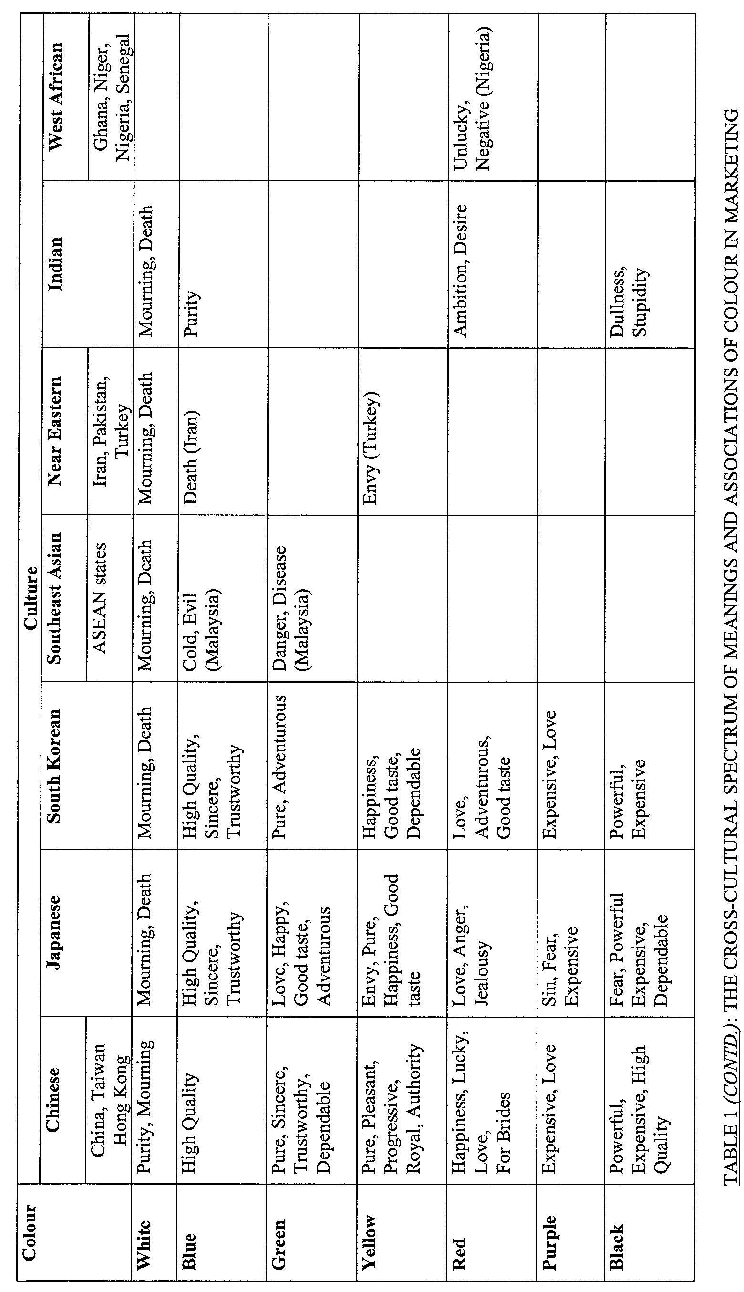
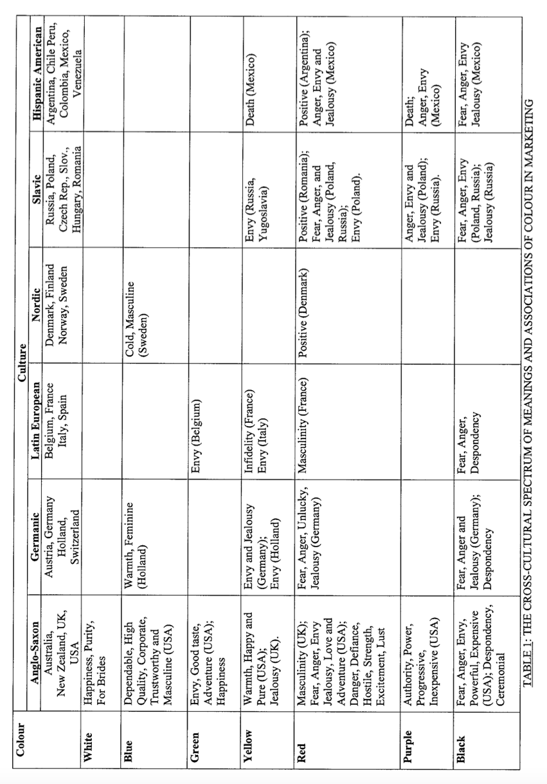
Figure 4 Table explaining cultural implications of colour, extracted from online book by Aslam, 2005)
This theory can be applied when analysing current logos and brandings to assess what they are trying to evoke from in costumers when they see their brand. In a 2007 study by Thomas et. Al on the effects of fast-food branding on your taste preferences, they concluded that,
“By the early age of 3 to 5 years, low-income pre-school children preferred the tastes of foods and drinks if they thought they were from McDonald’s, demonstrating that brand identity can influence young children's taste perceptions. This was true even for carrots, a food that was not marketed by or available from McDonald’s.” (Thomas et. Al, 2007)

To investigate McDonald’s branding closer, Harahap explains in their Youtube video analysis the development of being a barbecue restaurant founded in 1940 to the iconic golden arches that are used today.

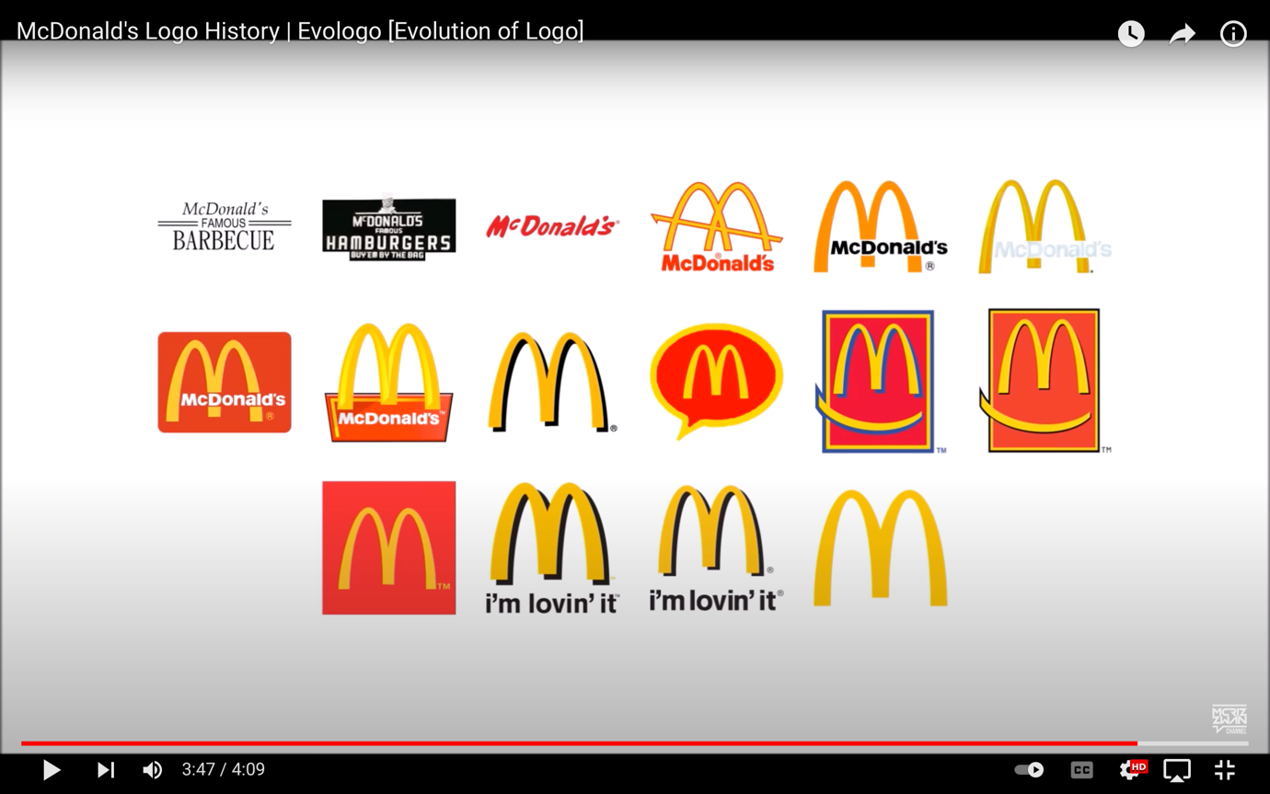
Figure 5 Video Screenshot from; Harahap, R (2017) McDonald's Logo History | Evologo [Evolution of Logo] Showing the development of the McDonald's logo since 1940.
According to the table above by Aslam, the use of McDonalds’ two primary colours of yellow and red symbolise feelings such as happiness, good taste, and other positive feelings across most cultures. Hallier confirms in her article on branding by stating,
“red & yellow in relation to the fast food industry, red triggers stimulation, appetite, hunger, it attracts attention. Yellow triggers the feelings of happiness and friendliness” (Aslam, 2005). This matches the Mcdonalds feelings of happiness and love.

Although Mcdonalds would appear to be the preferred food for children, Sylvia Guo, who refers to Mcdonalds as ‘MCD’, found in her university paper that there seemed to be,
“The perception of MCD as an unhealthy, irresponsible, cheap fast-food chain seemed ingrained in many people. In 2014, MCD experienced its largest sales descend, triggering investor anxiety and media speculations” (Guo, n.d.). Mcdonald’s tried to tackle this perception by altering their brand image. Mcdonald’s reported that in 2020 they opened their,
“first net zero-designed restaurant at Walt Disney World Resort, which creates enough renewable energy on-site to cover 100% of its energy needs on a net annual basis.”. (McDonalds, n.d.) In addition, they also rebranded many of their restaurants interior design feature green furniture and to have more greenery as demonstrated in the photographs I have taken of a local Mcdonalds below. This rebranding would contradict the notion that their fast food is unhealthy and irresponsible by connotating that they are eco-friendly and healthy for consumers.

Figure 6 Photographs I have taken of the artificial greenery that is used as decoration in Morriston McDonalds’ Swansea [taken on 04.05.22]

Three effective techniques evident in successful advertising campaigns have been addressed in this essay. Learning about these techniques made me realise that we are being subtly influenced all the time by what we encounter from brands. It makes me wonder how else advertisers use psychology to influence consumers, and if consumers are aware of the way they have been manipulated into buying their product. Would consumers be happy to continue their purchase if they had found out about the ways they had been convinced without realising? This leads to many moral implications, especially when researching into different ways brands can track across different apps with cookies, or how some brands sell on a persons personal data.

I have had a few ideas as to how this research could be visualised in a practical project next year. My initial idea was to create the ‘perfect brand’, following the strategies learnt in this essay. However, I have also had the idea of researching into these techniques into more detail, finding ways to show consumers these techniques and finding out how they feel about them. I could then build a project based on an emotional response from consumers for advertisers. I am still uncertain on this, but think I would be able to conclude this with more research.

In conclusion, this essay has looked at integrated advertising, influencer marketing, and how influential colour is on consumer’s perceptions. This leads to many questions, such as ‘how else do advertisers use psychology to influence consumers’, ‘Is design strategy important within design and consumer influence’ and ‘is it wrong to use psychological manipulation in advertising’. I am uncertain how this will be visualised within a practice based project, but hope that I will learn more about these techniques over this summer when researching for my dissertation.
Bibliography
Allen, R (2022) What is integrated marketing? Smart Insights. [Accessed 18.04.22] Available at: https://www.smartinsights.com/traffic-building-strategy/integrated-marketing-communications/what-is-integrated-marketing/

Aslam, M. (2006). Are you Selling the Right Colour? A Cross-cultural Review of Colour as a Marketing Cue. Journal of Marketing Communications, 12(3): 7-28. [Accessed 20.03.22] Available at:
https://ro.uow.edu.au/cgi/viewcontent.cgi?referer=&httpsredir=1&article=2092&context=commpapers

BusinessMatters (2017) How important is a Call to Action?. BusinessMatters. [Accessed 17.04.22] Available at: https://bmmagazine.co.uk/marketing/important-call-action/

Cambridge Dictionary (n.d.) Influencer. Cambridge Dictionary. [Accessed 03.05.22] Available at: https://dictionary.cambridge.org/dictionary/english/influencer

ConceptDrop (2018). Color Theory: Marketing, Branding, and the Psychology of Color. Concept Drop. [Accessed 20.03.22] Available at: https://conceptdrop.com/blog/60-color-theory-the-psychology-of-color-marketing-and-branding/

Falk, R and Kim, S (2019) The War System: An Interdisciplinary Approach. Routledge. London. Page 145.

Firstbird (n.d.) Brand Ambassadors: Who Are They and What Do They Do?. Firstbird. [Accessed 20.04.22] Available at: https://www.firstbird.com/en/hr-glossary/brand-ambassador/

Guo, S (n.d.) Reviving the Corporate Brand: McDonald’s Turnaround and Implications for Public Relations/Organizational Communication. Institude for PR. [Accessed 30.04.22] Available at: https://instituteforpr.org/wp-content/uploads/MCD-Final-Paper_IPR_PRIME_Deliverable.pdf

Haller, K (n.d.) branding – why red & yellow is used by the fast food industry. Karen Haller Behavioural Design Consultancy. [Accessed 17.04.22] Available at: https://karenhaller.com/journal/branding-why-red-yellow-is-used-by-the-fast-food-industry/

Harahap, R (2017) McDonald's Logo History | Evologo [Evolution of Logo]. Youtube. [Accessed 17.04.22] Available at: https://www.youtube.com/watch?v=nI1Hus0b1DQ

Howells, S (2022) Who is Elle Darby and how many followers does the Wiltshire influencer have on Instagram?. Wiltshirelive. [Accessed 17.04.22] Available at: https://www.wiltshirelive.co.uk/news/wiltshire-news/who-elle-darby-how-many-6504924

Interaction Design Foundation (n.d.) Colour Theory. Interaction Design Foundation. [Accessed 20.03.22] Available at: https://www.interaction-design.org/literature/topics/color-theory

Lagopoulos, A and Boklund-Lagopoulou, K (2016) Theory and Methodology of Semiotics – The Tradition of Ferdinand de Saussure. De Gruyter Mouton. Greece. [Accessed 20.03.22] Available at: https://books.google.co.uk/books?hl=en&lr=&id=0BMrEAAAQBAJ&oi=fnd&pg=PR5&dq=semiotics+Ferdinand+de+Saussure&ots=cEaeRO4BQY&sig=cMXZROdz_M_NF0M1etXxfR-d3c8#v=onepage&q=semiotics%20Ferdinand%20de%20Saussure&f=false

Leyfield, F (2022) CUT OFF Elle Darby dropped by Beauty Works and In The Style and is set to lose thousands as top brands drop her amid race row. The Sun. [Accessed 17.04.22] Available at: https://www.thesun.co.uk/tvandshowbiz/17252907/elle-darby-dropped-brands-row/

Nicolson, S (2007) The impact of the colour red on product price perceptions in retail, print advertising. Graduate School of Business Leadership University of South Africa. Pp. 27. [Accessed 20.03.22] Available at: https://uir.unisa.ac.za/bitstream/handle/10500/63/2007%20MBL%203%20Research%20Report%20SM%20Nicolson%20Full%20Report.pdf?sequence=1&isAllowed=y

Maclnnis, D.J, Chandy, R.K, Thavivanich, P, Tellis, G.J. (2001) What to Say When: Advertising Appeals in Evolving Markets. Journal of Marketing Research, Vol. 38, pp. 399-414. [Accessed 20.03.22] Available at: https://papers.ssrn.com/sol3/papers.cfm?abstract_id=905128

Mcdonalds, (n.d.) McDonald’s History. McDonalds. [Accessed 17.04.2022] Available at: https://corporate.mcdonalds.com/corpmcd/our-company/who-we-are/our-history.html

Sammis, K, Lincoln, C, Pomponi, S, Ng, J, Rodriguez, E, Zhou, J (2015) Influencer Marketing For Dummies. [Accessed 05.04.22] Available at: https://www.wiley.com/en-us/Influencer+Marketing+For+Dummies-p-9781119114093#description-section

Simpson, J (2017) Finding Brand Success In The Digital World. Forbes. [Accessed 20.03.22] Available at: https://www.forbes.com/sites/forbesagencycouncil/2017/08/25/finding-brand-success-in-the-digital-world/?sh=4177e219626e

Sutherland, M and Sylvester, A (2000) Advertising and the mind of the consumer. Kogan Page. London. Pp. 12. [Accessed 17.04.22] Available at: https://books.google.td/books?id=kNacoUEPwB8C&hl=fr&source=gbs_navlinks_s

Thomas N. Robinson, MD, MPH; Dina L. G. Borzekowski, EdD; Donna M. Matheson, PhD; et al (2007) Effects of Fast Food Branding on Young Children's Taste Preferences. JamaNetwork. [Accessed 17.04.22] Available at: https://jamanetwork.com/journals/jamapediatrics/article-abstract/570933

Vakratsas, D and Ambler, T (1999). How Advertising Works: What Do We Really Know?. American Marketing Association. London. Pp 29. [Accessed 20.03.22] Available at: https://pdfslide.net/download/link/how-advertising-works-what-do-we-really-know

Wieden + Kennedy (n.d.) About. Widen + Kennedy. [Accessed 20.04.22] Available at:
https://www.wk.com/about/
Wieden + Kennedy (n.d.) Work. Widen + Kennedy. [Accessed 20.04.22] Available at: https://www.wk.com/work/

