Student Name: Gemma Yeomans
P Number: 1901204
Programme of Study: Surface Pattern
Module: M4X01560

Tasks in the order I received them:
Task One: Manifesto (Julia Task) = 548 words
Task Two: Reflective Writing (Jon Task) = 524 words
Task Three: Semiotic Analysis (Ryan task) = 513 words

Task One: Manifesto (Julia’s Task).
Manifesto.
- The use of art therapy is an effective method of helping a person express their thoughts and feelings.
- Companies which offer takeaway drinks need to find a more appealing reusable cup design to encourage people to use them more.
- Installing art into towns and cities can brighten culture and improve tourism.
- Bamboo is a versatile and ecofriendly material which should be used more as an alternative to plastic.
- There is too much textile waste and this issue needs to be more emphasised in today’s society.
- Fast fashion is harming the survival of smaller and more economical businesses.
- Strain of consumers fashion demands has resulted in sweatshops and exploitation of labour.
- There needs to be more opportunities for younger artists to improve their skills and showcase their art.

Keywords and Images.
“Art therapy.”
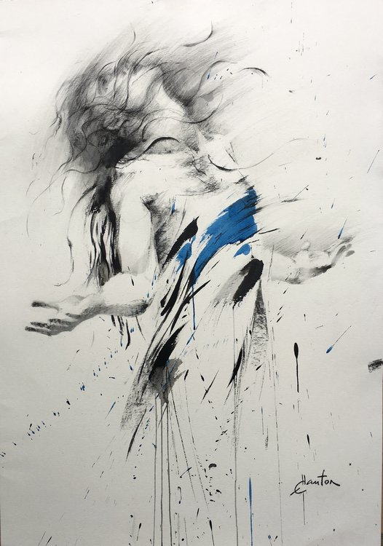
Hauton, E (2018).

Art therapy can be defined in many ways but it is best defined as “the purposeful use of visual arts materials and media in intervention, counseling, psychotherapy, and rehabilitation” (Malchiodi, 2014). Art is widely accepted as a form of expressionism. Graffiti is often used to express political statement, statues are created to pay tribute and express admiration, and fine art is made to record moments and the feelings attached to those moments. Art therapy is a very effective way to able a person, especially children, to express their thoughts and feelings by physically letting their suppressed feelings be unleashed onto a page. Creating art and being able to physically put one's feelings onto a page can help a person to express their suppressed feelings. Proof of this can be found within a study conducted in Pakistan. After the 2005 earthquake which caused devastation to Pakistan, the Pakistan Association for Mental Health decided to use art therapy as a means of helping children recover from the trauma they had experienced as a result of the earthquake. The therapist leading the drawing activity observed that at first the children “were very guarded” and “afraid to interact.” However as the activity progresses “the children began to talk to each other and also to the volunteers and staff” (Ahmed and Siddiqi, 2006, p. 28 - 30).

“Textile waste.”
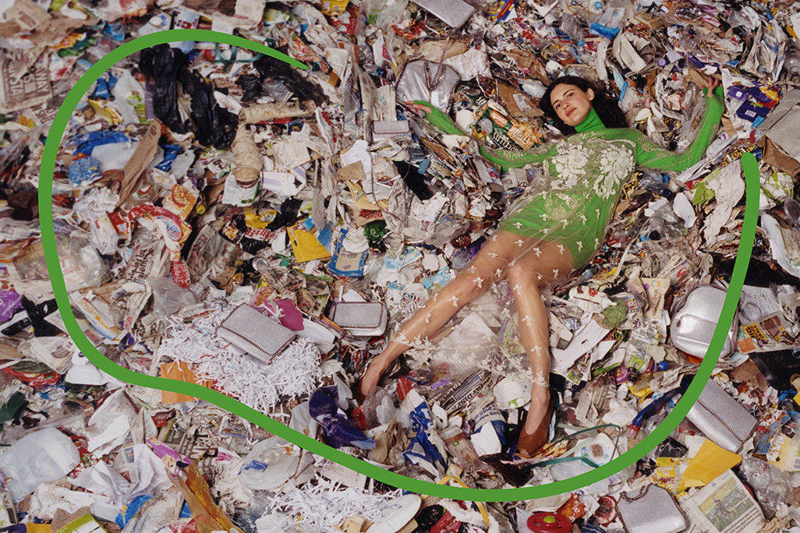
The Fashion Spot, 2018
As the population grows, so does the population’s consumption which leads to an increase in waste and this does not exclude fashion which is why textile waste is increasing becoming a problem. Textile waste is defined as “fashion and textile industry waste, created during fibre, textile and clothing production, and consumer waste, created during consumer use and disposal” (Ecochic, 2014). There are two types of textile waste, firstly the estimated £140 million of clothes which go to the landfill each year (Wrap, 2000) and secondly, the pollution waste that is created during the production, shipping and disposal of the clothing. In 2015, around 1714 million of Co2 emissions were produced in the making of fabric and this is estimated to increase to 3030 million by 2025 (Muthu, 2018). It is vital that people are aware of the environment effects that the production of fashion is causing and try environmentally friendly alternative options like second hand clothing, so that this issue can be reduced.
“Sweatshops.”
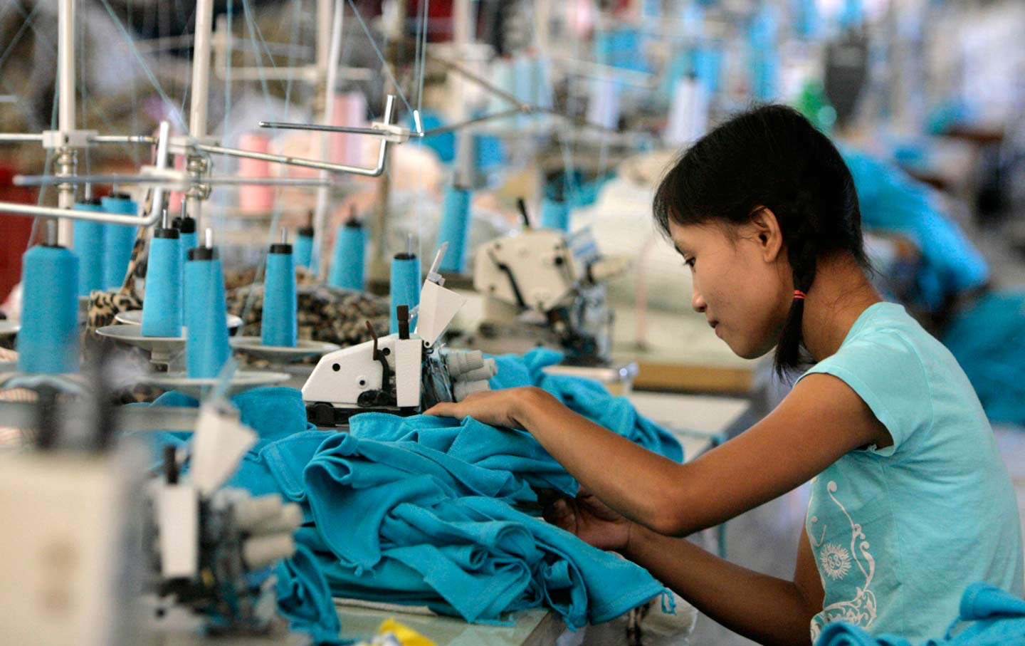
The Nation, 2016

A sweatshops can be defined as “a shop or factory in which employees work long hours at low wages and under unhealthy conditions” (Mariam Webster, ND). Multinational companies or MNCs often set up their production factories in lower developing countries to achieve lowest labour costs and highest profit possible. This exploitation of labour is particularly common in China and Bangladesh where “wages may be no more than the bare local minimum” (Black, 2008, p.182-185) which as of 2020 will be 2,200 yuan per month in China (China Daily, 2019) and 1000.00 BDT per month in Bangladesh (Marjorie, 2018). Not only do the companies exploit their workers’ pay but also their working facilities. A report produced by War on Want investigated the sweatshops of Primark, Asda and Tesco. Interviews with sixty workers in six different Bangladesh sweatshops revealed “criticised working conditions and actual wages paid as below minimums” (Black, 2008, p.182-185).
Bibliography.
Ahmed, S.H. and Siddiqi, M.N. (2006) Healing Through Art Therapy in Disaster Settings. Vol 368. London : Elsevier Limited.

Black,S. (2008) Eco-Chic The Fashion Paradox. London: Black Dog Publishing.

EcoChic. (2014) The Ecochic Design Award Sourcing Textile Waste. Available at: https://static1.squarespace.com/static/582d0d16440243165eb756db/t/585a15a9bebafba69927c172/1482298805626/LEARN2014_Sourcing_ENG-07.pdf (Accessed: 2019).

Hauton, E. (2018) Danse, Bleu. [ink, charcoal] Available at: https://www.singulart.com/en/artworks/ewa-hauton-danse-bleu-5757 (Accessed: 2019).

Malchiodi, C. (2014) Creative Arts Therapy and Expressive Arts Therapy. Available at: https://www.psychologytoday.com/gb/blog/arts-and-health/201406/creative-arts-therapy-and-expressive-arts-therapy (Accessed: 2019).

Mariam Webster. (ND) Sweatshop. Available at: https://www.merriam-webster.com/dictionary/sweatshop?src=search-dict-hed
(Accessed: 2019).

Marjorie, V, E. (2018) Bangladesh raises minimum wage for garment workers. Available at: https://fashionunited.uk/news/business/bangladesh-raises-minimum-wage-for-garment-workers/2018091438912 (Accessed: 2019).

Muthu, S, S. (2018) Sustainable Innovations in Recycled Textiles. Singapore: Springer.

The Fashion Spot. (2017) Stella McCartney’s Fall 2017 Campaign Was Shot In a Pile of Garbage. Available at: https://www.thefashionspot.com/runway-news/757197-stella-mccartney-fall-2017-campaign/ (Accessed: 2019).

The Nation. (2016) A Myanmar migrant works in a Taiwanese-owned sweatshop. Available at: https://www.thenation.com/article/colleges-arent-enforcing-their-own-anti-sweatshop-policies/ (Accessed: 2019).

Wrap (2000) Clothing. Available at: http://www.wrap.org.uk/content/clothing-waste-prevention (Accessed: 2019).

Yang, Y. (2019) Minimum wage increases to improve welfare in China. Available at: http://www.chinadaily.com.cn/a/201905/10/WS5cd4eda0a3104842260baf7a.html (Accessed: 2019).

Task Two: Reflective Writing (Jon’s task).
I have chosen Olafur Eliasson’s installation ‘Ice Watch’ as the subject of my reflective writing. The act of reflective writing involves thinking about a situation and considering the benefits, the disadvantages, and the outcomes. The purpose of reflection is to learn from the experience which evoked the need to reflect. Kolb’s Experiential Learning Theory emphasises the central role which experience has upon a person's learning process. To better explain his theory, Kolb created the Experiential Learning Cycle which has four sections and these sections include Concrete Experience, Reflective Observation, Abstract Conceptualisation and Active Experimentation (Kolb, 2014, p.88-89). Kolb’s theory introduces the idea that a person, when faced with an experience, will firstly grasp and observe the experience and then will show what they have learnt from the experience through their ideas and actions. Naturalism, although mostly associated with religion and ethics, is a similar theory to Kolb’s Experiential Learning Theory as it states that empirical testing (such as an experience) will lead to a learnt conclusion (Bowie, 2004, p.12). I will consider these reflective processes when writing my reflection of Eliasson’s ‘Ice Watch’ installation.

The installation ‘Ice Watch’ is a collection of glacial ice, harvested from the seas around Greenland and Iceland, which have been placed into public spaces, and left to melt. In some countries which the ‘Ice Watch’ has been installed, the ice blocks are arranged in the shape of a clock which is possibly a metaphor that our time to reverse climate change is ‘melting’ away. Ice Watch “seeks to communicate the urgency of climate change and to raise awareness of the need for concerted global action” (Tate, 2019, p.173). Although I did not view the exhibition in person, the images of people hugging and touching the ice are very visually stimulating and evoke feelings of shock, worry and sadness. It is especially moving when comparing the images from when the glacial ice was first installed to its last days in existence. Actually seeing the ice melt into nothingness as if it never existed, it physically articulates the dire nature of our environmental situation.
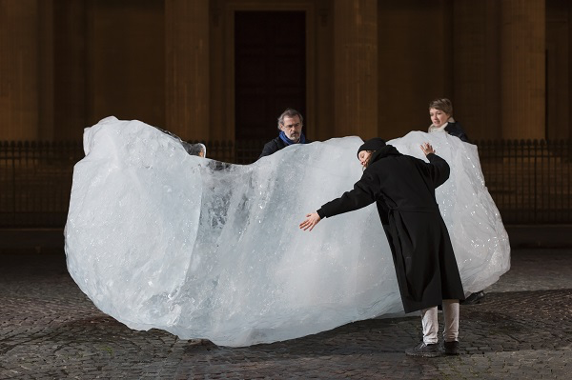
Argyroglo, 2015
The crisis of climate change is a recurring theme within Eliasson’s work and he has expressed his concerns through multiple of his projects including ‘Ice Watch’. Eliasson’s ‘Ice Watch’ installation first debuted in the Danish city of Copenhagen in 2014 as a response to the publication of the UN’s climate change report (Tate, 2019, p.173). This report contains shocking facts, figures, graphs and statements about rising sea levels and the increasing amount of CO2 emissions (IPCC, 2014). Ice Watch has been installed into many different cities including Paris, London and Copenhagen and the sight of melting ice had a prominent effect on its observers. A review from Go London says that the exhibit “evokes not just the speed with which the ice sheet is disappearing, and causing alarming sea-level rises but also the diminishing time in which we can make a difference” (Luke, 2018) and The Guardian stated that the purpose of the installation “is to bring the effects of climate change closer to home, putting people in direct contact with its effects” (Jonze, 2018).

Bibliography.
Argyroglo, M. (2015) Olafur Eliasson Responds to Paris Summit with a Doomsday Clock Made of Glacial Ice. Available at: https://news.artnet.com/art-world/ice-watch-olafur-eliasson-climate-summit-384704 (Accessed: 2019).

Bowie, B. (2004) Ethical Studies. 2nd edn. Oxford: Oxford University Press.

Eliasson, O. (2019) In Real Life. London: Tate Publishing.

Ipcc.ch. (2019) AR5 Synthesis Report: Climate Change 2014 Available at: https://www.ipcc.ch/report/ar5/syr/ (Accessed 2019).

Jonze, T.(2018) Icebergs ahead! Olafur Eliasson brings the frozen fjord to Britain. Available at :https://www.theguardian.com/artanddesign/2018/dec/11/icebergs-ahead-olafur-eliasson-brings-the-frozen-fjord-to-britain-ice-watch-london-climate-change (Accessed: 2019).

Kolb, D. (2014) Experiential Learning: Experience As the Source of Learning and Development. Chicago: PH Professional Business.

Luke, B. (2018) Olafur Eliasson and Minik Rosing's Ice Watch review: Big freeze comes early with an urgent warning of climate crisis. Available at: https://www.standard.co.uk/go/london/arts/olafur-eliasson-minik-rosing-ice-watch-review-tate-modern-a4015216.html (Accessed: 2019).

Task Three: Semiotic Analysis.
According to Eco, semiotics is apparent in our everyday lives from a person’s appearance to the presentation of a person’s house. For example, if a person does not wear a tie or tuck in their shirt, in a professional setting, one might view these as signs that the person is unprofessional and incompetent. Whereas if you saw a person with their shirt tucked in and a tie, you would see these as signs that the person was professional and driven. We can see semiotics in our everyday lives but the signs and symbols are especially important within art and other creative mediums. Eco is a writer who, like artists, uses semiotics as metaphors in telling a story. Eco explains that the reason for using semiotics is to “use signs and symbols to communicate, with meaning supplied by the author, yet interpreted by the reader” (Eco, 1976, p.48). When conducting a semiotic analysis, it is important to consider signs and symbols and consider how they influence the meaning of the object. Saussure defined a sign as “being composed of a signifier and a signified.” The ‘signifier’ is the word, quote or object being observed by the viewer and the ‘signified’ is the concept or meaning derived, by the viewer, from the ‘signifier’ text or object (Chandler, 2002, p.14-15). If the ‘signifier’ was a present, for example, then the ‘signified’ could be that presents are delivered by Santa at Christmas. Whilst considering both Eco and Saussure’s ideologies on semiotics, I will now conduct a semiotic analysis on the image below.
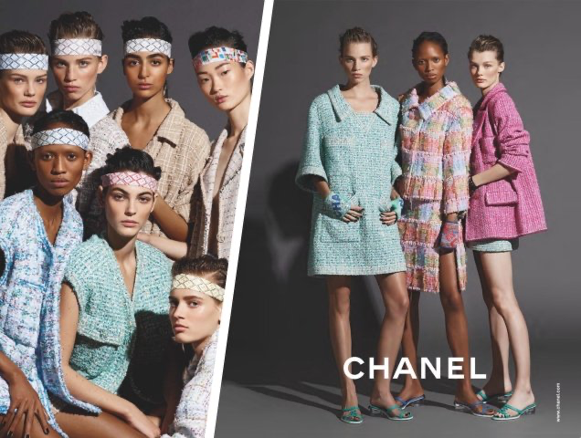
(The Fashion Spot, 2019)

This is an advertisement for Chanel’s Spring 2019 collection. To analyse this image I will focus on the three key aspects of lighting, text and colours. The colours of the clothes being advertised are bright and fresh which is contrasting to the dark grey backdrop and this makes the garments become more prominent as the advert campaign’s focus object. Another aspect of the colours to consider is the connotations of pink and blue. Due to Western cultural constructed ideals, we naturally associate pink with girls and blue with boys but this image breaks those cultural norms by dressing the woman models in both pink and blue. This could be accidental or this could be a subtle nod to the ever growing feminism movement. In regards to lighting, it is very dramatic and intense. This emphasises the thin faces and bodies of the models which can we further analyse as adhering to the old fashioned cultural normalities and the idea that all women need to be thin. The text ‘Chanel’ is depicted in white and all capital letters which although seems like a minimalistic touch, compared to the intense lighting and depth of colours, is actually a recognisable symbol “utilised to efficiently increase image as well as awareness level” (Park and Andrew, 2011, p.12). The Chanel logo is often depicted, whether in adverts of on their products, in the basic colours of black or white because this is what their brand is known for and therefore is easily recognisable to the observer.

Bibliography.
Chandler, D. (2002) Semiotics The Basics. 2nd edn. Routledge: Oxon.

Eco, U. (1976) A Theory of Semiotics. Bloomington: Indiana.

Park, S.R. and Andrew, C.J. (2011)
Visual Signs/Logo-Identity in the Major League Baseball Facility: Case Study of Tropicana Field. Vol 23. Plum Print: USA.

The Fashion Spot. (2019) Chanel’s New Ad Campaign Is Missing All the Fun of the Spring 2019 Collection. Available at: https://www.thefashionspot.com/buzz-news/forum-buzz/821101-chanel-spring-2019-ad-campaign-karl-lagerfeld/ (Accessed: 2019).

