Case Study Report.

Student Name: Soabia Rafiq
Student ID: 2015530
Module Code: BMSW-4003_BIRM
Lecturer’s Name: Rebecca Kavanagh

TABLE OF CONTENTS

Introduction 2

Social Identity Theory 3

Attribution Theory 5

Frustration Aggression Theory 7

Emery-Dreifuss Muscular Dystrophy 8

Suicidal Rates 9

Benefits of Counselling 10

Conclusion 11

References 12

Introduction

The basis of this report is to identify the problems provided and ensuring that the illness of Emery-Dreifuss Muscular Dystrophy is fully understood. In this report there will be statistical rates of suicide to ensure that this information gets recognised and how counselling can help lower this. This report will outline 3 key theories of Social Identity Theory (SIT), Attribution Theory and Frustration Aggression Hypothesis (FAH) to ensure this relates back to the case study. This should help break things down slowly where it can be identified from any perception of how this should be understood. In this report there will be a brief description voicing the concerns and opinions on the staff member employed as a receptionist to see if she should be supported or discharged from the job on a non-biased point of view.

Social Identity Theory

Trepte and Loy (2017) stated that the Social Identity Theory know as ‘SIT’ was found by Henri Tajfel in 1978. This was then developed further using the help of John Turner in 1979. This is where they categorized themselves and others into a variety of groups (in-groups and out-groups). They evaluated each group by initiating an evaluation on each and compared the value on each. This helped determine the hypothesis of each person’s social identity. Tajfel and Turner came up with a reward system i.e., positive, and negative. This meant that the positive reward was their self-esteem where the negative was on-going behaviours, competitions, and cognitive strategies to enable positivity. This can implicate certain behaviours by the interaction of both as the groups succeed of having a superior social significance (Trepte S. & Loy L. S., 2017). Islam (2014), also suggested that Tajfel and Turner states in their theory that every individual characterizes their own personal characteristics based on what group category they are in. The individuals use this as a booster to help ensure and determine that they are viewed as a positive bias vis-à-vis to outrun the out-group (Islam., Gazi, 2014). APA PsycNet (2020), suggested on their website that Tajfel and Turner also summarized the theory of intergroup conflict. When Tajfel and Turner evaluated all groups, they kept on eye to RCT which is Realist Group Conflict Theory which contributed at them looking into certain behaviours modelled by a group of individuals. They learned that when they saw neglect in the upkeep of the group, they found a lot of hidden problems which caused a lot of conflict within the in-groups and intergroups. They came to the conclusion of realizing the mental attributes of a change cannot be passive without the social analysis of social conflict towards self-esteem and also belonging (APA PychNet, 2020).

This relates to the 15-year-old and 58-year-old as the age range separates between them. The 15-year-old is at the age where he is at the rebellious stage which can attribute in his behaviour towards the 58-year-old. This is where intergroup can be seen as its conflicting. The 58-year-old is at the maturity stage of life. She has seen a lot of behaviours and hasn’t justified by responding aggressively to him, which can be seen in the same intergroup. This differs between the behavioural traits and personality traits of the two.

Figure 1. A Diagram of the Social Identity Theory
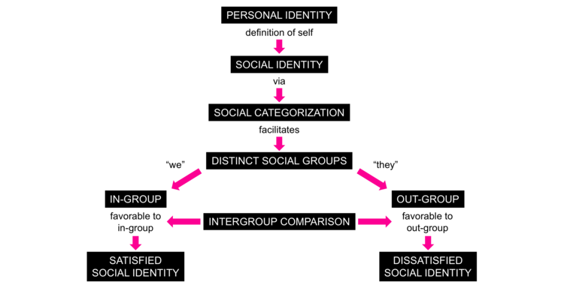

(YStudios, 2020)

Attribution Theory

Baumeister and Vohs (2007), stated that the Attribution Theory was founded by Fritz Heider in 1958. This theory was based towards the behaviourism and how this caused by an individual or by a certain situation/event. Heider figured that these two factors related as deliberate behaviours which are more then what an individual behaviour is about in relations to a situation. He said that this attributes towards predicting how this can influence how a person behaves. (Roy F. Baumeister & Kathleen D. Vohs, 2007).
Manusov and Spitzberg (2008) have stated that the Attribution Theorists have explained that the theories gravitate towards the practical understanding of humanity. Theorists mainly believed that the fundamental procedure in effort to understand the logical views of humanity and to be able to understand the conceptual side of the Attribution Theories is to understand the internal and external sides by thinking of the ‘How’ and ‘What’ in order to understand an event and also to be able to judge this accurately and liable to influence behaviour. They also stated that the originator of the Attribution Theory Fritz Heider signified this logic where Heider looked at this as a whole. Heider also did not care about what other people thought of his stability of the casual locus through his work. This shows how Heider was in control of his own theory and put this into practice where other researchers leaned on his work. (Valerie Manusov & Brian Spitzberg, 2008).

This relates to the case study by understanding the behaviours that were shown by both individuals but at different stages i.e., age. This theory relates to the behaviours that was shown by the 15-years-old where he was using foul language. This contemplates by the 58-year-old retaliating by using the Covid 19.

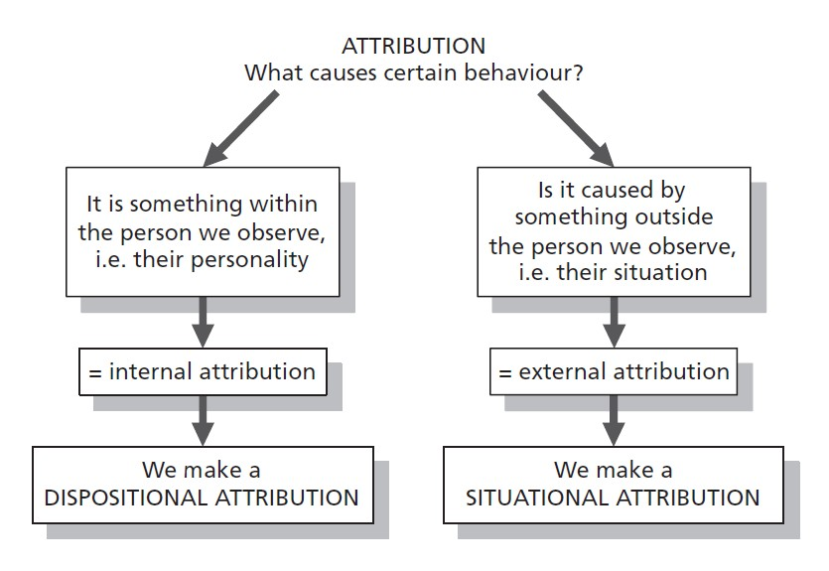
Figure 2. A Diagram of the Attribution Theory:
(Rice, K. E., 2016)

Frustration Aggression Hypothesis

Miller Et Al., (1958) stated that the Frustration Aggression Hypothesis was based on a challenge to maintain a connection which was considered to be critical in various years of study. Miller Et Al., stated that the existence of frustration started certain kinds of aggression. This proposal stated that this instigated towards many different responses made by different individuals which showed different types of aggression. (Neal E. Miller Et Al.,, 1958). Bateson (1941) stated that the basics of the Frustration-Aggression Hypothesis are revised cultural beliefs and acts. This fit the Hypothesis into it entirely whilst taking out parts of the aggression to turn it into enjoyment which failed within the rest of the other cultural beliefs as this study was found to be inconclusive. (Bateson, 1941).

This connects to the case study as they both were showing signs of aggression. The 15-year-old boy was frustrated as according to the case study he had to stop training at Aston Villa Football Academy which can help elevate the pressure of aggression and has not found another way to relieve this pressure. This shows that he has not got much understanding on how to take the pressure off safely without any harm. The 58-year-old women has shown her aggression by being extremely uncivil to the 16-year-old boy by directing the Covid-19 rules at the boy.

Figure 3. This is a Diagram of the Frustration Aggression Hypothesis.
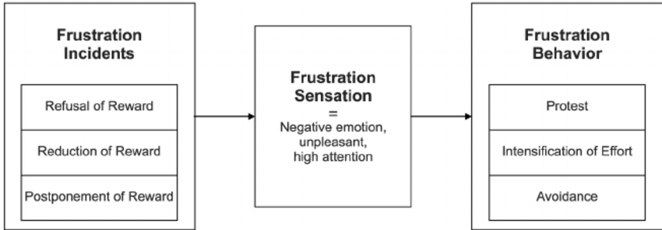
(Stauss, Schmidt, Scholer, 2005)
Emery-Dreifuss Muscular Dystrophy

Leclerc, Bonne and Schwartz (2002) stated that Emery-Dreifuss Muscular Dystrophy is an illness that affects the muscle which wastes away and can cause a lot of weakness and pain. This affects:
- Achilles Tendons
- Post Cervical Muscles (weakness of the neck flexion)
- Entire Spinal bone becomes restricted
- Affects upper and lower limbs
- Can cause heart block/ cardiac failure (most serious)
This starts from the age of 15-years-old. This causes a lot of vulnerability which can sometimes cause loads of behaviour explosions due to not being able to take the discomfort any longer or even worst-case situations can cause loss of life. Leclerc, Bonne and Schwartz have also stated that the diagnostic for Emery-Dreifuss Muscular Dystrophy is:
- Medical Examinations (MRI)
- Tissue Removal
- White blood cell
- Collagen and Fibres
- Exfoliative Cytology
(Leclerc A.H. Bonne G. Schwartz K., 2002)

Figure 4. Picture of how EDMD tests to verify the diagnosis.

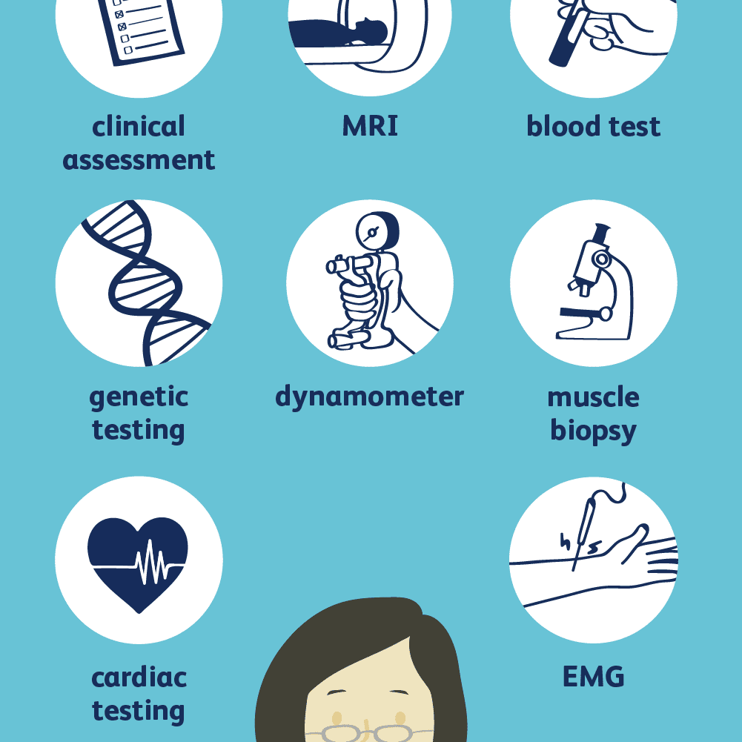

(Sears, 2021)

Suicidal Rates

Gore Et Al., (2011) have stated that 10-24-year-olds speak for the world’s residents by 27%. The main impact of these is to ensure that the physical condition and risk consideration for diseases are very low. They stated that in some places around the world the physical conditions are often overlooked as this age group are constantly identified as healthful (Fiona M Gore Et AL., 2011).

Figure 5. A Diagram of UK Statistical Suicide Rates from 1980-2020.


(Statistics, 2020)

Benefits of Counselling

Cooper Et Al., (2021) they stated that in order for the beneficial of counselling to work is for the 11–16-year-olds to come forward and accept help from professionals. This will help the emotional trigger of doing the undesirable to having a goal to accomplish later on in life. This can help them deal with mental illness/disorders and the patients would be able to understand they are not alone and can lean on a professional. Cooper Et Al., also stated that in order to provide support sessions to try and identify disorders now as this can develop further into later life. The government are struggling to ensure help is available in UK government schools ensuring this is easier to access and trying not to put connotations around certain levels of how young child may be suffering and what stages. This is costing the government billions of pounds each year (Mick Cooper Et Al., 2021).

Figure 6. A Diagram of the Counselling Process
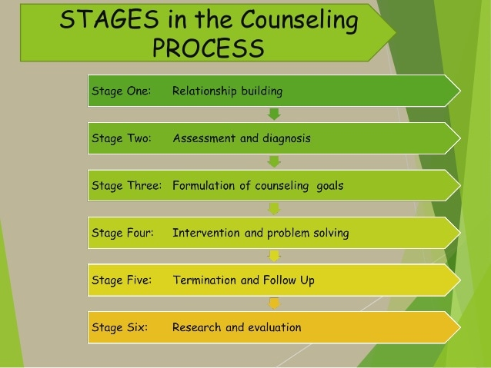

(Slideshare, 2015)

Conclusion

My Conclusion is that this should be upheld and handled through a disciplinary stage. The reason behind this is because the 58-year-old was wrong by initiating back to the 15-year-old. The Duty of Care was not supported, she dropped in Covid-19 guidelines which was correct as she may be high risk but, did she ask if the young boy was exempt or why he was pacing around the waiting room and also, she did not uphold any relevance of the establishment’s policies. As of the young boy, he should also get a warning by speaking to staff members in the establishment in a polite manner. Also, Training should be introduced to the receptionist to ensure that she would know how to control this situation if it may rise in the future.

The Theory that fits towards the case study would be the Frustration Aggression Hypothesis. The reason behind this is because you can see the frustration that the 15-year-old boy is facing by having to leave the things he loves behind due to EDMD. Also, the 58-year-old shows the signs as she just phrased it in a way of bringing in the government guidelines. This is very understandable for the boy to react as he may not understand the pandemic and also rebel at the rules. But in the case study it clearly stated due to his illness in order to stop any side effects he suffers with, walking around helps him.

References

Leclerc, A.H., Bonne, G., and Schwartz, K., (2002) Emery-Dreifuss Muscular Dystrophy [Online] Available at:
https://www.nature.com/articles/5200744 (Accessed on: 23rd November 2021)

APA PsycNet (2020) The Social Identity Theory of Intergroup Behaviour [Online] Available at: https://psycnet.apa.org/record/2004-13697-016 (Accessed on: 9th November 2021)

Stauss, B., Schmidt, M., and Scholer, A., (2005) Customer Frustration in Loyalty Programs [Online] Available at:
https://www.researchgate.net/publication/37475076_Customer_frustration_in_loyalty_programs (Accessed on: 30th November 2021)

Sears, B., (2021) How Muscular Dystrophy is Diagnosed [Online] Available on: https://www.verywellhealth.com/how-muscular-dystrophy-is-diagnosed-4161251 (Accessed on: 23rd November 2021)

Gore, F.M., Bloem, P, JN., Patton, J. C., Ferguson, J., Joseph, V., Coffey, C., Sawyer, S.M., and Mathers, C. D., (2011) Global Burden of Disease in Young People aged 10-24 Years: A Systematic Analysis [Online] Available at:
https://www.sciencedirect.com/science/article/pii/S0140673611605126 (Accessed on: 23rd November 2021)

Islam, G., (2014) Social Identity Theory [Online] Available at:
https://link.springer.com/referenceworkentry/10.1007%2F978-1-4614-5583-7_289 (Accessed on: 9th November 2021)

Bateson, G., (1941) IV. The Frustration-Aggression Hypothesis and Culture [Online] Available at: https://psycnet.apa.org/record/1941-04169-001 (Accessed on: 19th November 2021)

Rice, K. E., (2016) Attribution Theory [Online] Available at:
https://www.integratedsociopsychology.net/theory/meta-states-and-the-cognitive-triad/attribution-theory/ (Accessed on: 19th November 2021)

Cooper, M., Stafford, M.R., Saxon, D., Beecham, J., Bonin, E.M., Barkham, M., Bower, M., Cromarty, K., Duncan, C., Pearce, P., Rameswari, T., and Ryan, G., (2021) Humanistic Counselling Plus Pastoral Care as Usual For The Treatment of Psychological Distress in Adolescents in UK State Schools (ETHOS): A Randomised Controlled Trial [Online] Available on:
https://www.sciencedirect.com/science/article/pii/S2352464220303631 (Accessed on: 23rd November 2021)

National Statistics (2020) Suicides in England and Wales: 2020 Registrations [Online] Available on:
https://www.ons.gov.uk/peoplepopulationandcommunity/birthsdeathsandmarriages/deaths/bulletins/suicidesintheunitedkingdom/2020registrations
(Accessed on 30th November 2021)

Miller, N.E., Mowrer, O.H, Doob, L.O., Dollard, J., and Sears, R.R., (1958) Frustration-Aggression Hypothesis [Online] Available at:
https://psycnet.apa.org/record/2006-10220-023 (Accessed on: 19th November 2021)

Baumeister, R.F., and Vohs, K.D., (2007) Encyclopedia of Social Psychology: Attribution Theory [Online] Available at:
https://sk-sagepub-com.ezproxy.uwtsd.ac.uk/reference/socialpsychology/n43.xml (Accessed on: 15th November 2021)

Trepte, S and Joy, L.S., (2017) Social Identity Theory and Self-Categorization Theory [Online] Available at:
https://www.researchgate.net/profile/Sabine-Trepte/publication/314531246_Social_Identity_Theory_and_Self-Categorization_Theory/links/5a12b8eb458515cc5aa9ee51/Social-Identity-Theory-and-Self-Categorization-Theory.pdf (Accessed on: 9th November 2021)

SlideShare (2015) What is Peer Counseling? [Online] Available on:
https://www.slideshare.net/jrose_yuyen/what-is-peer-counseling-54935734 (Accessed on: 23rd November 2021)

Manusov, V and Spitzberg, B., (2008) Attribution Theory: Finding Good Cause in the Search for Theory [Online] Available at:
https://in.sagepub.com/sites/default/files/upm-binaries/21200_Chapter_3.pdf (Accessed on: 19th November 2021)

YStudios (2020) What Factors Really Influence Identity? [Online]
Available at: https://ystudios.com/insights-people/influence-on-identity
(Accessed on: 9th November 2021)

