

BA(Hons) Business Management Level 4: Term 1 Group 1

Marketing Fundamentals (LCBB4004)

Assessment 1
Processes and stages of marketing
Red Bull GmbH

Lecturer: Tushara Balendran
Student: Laurentiu Ghindeanu (1922159)
Email: 1922159@student.uwtsd.ac.uk

Content

Marketing definition p. 3

Marketing Process p. 3,4

Macro Environment (PESTLE) p. 5

SWOT Analysis p. 6,7

Marketing Mix (4 Ps) p. 7,8

Conclusion and Recommendation p. 9

References p. 10

Marketing
Marketing is a process within companies could obtain what they want by creating value and exchanging with other companies or individuals. Kotler and Armstrong (2018)
In business content, we can say that marketing is a process who engage both the company and the consumer; the company will create value for customers and will try to maintain a strong relation with the customers, than in return the company will get value from customers. Kotler and Armstrong (2018)
Marketing Process
Marketing process include a series of steps to identify and reach the companies goals. Through those steps the company will find out what are customer needs and will develop products to fill that needs. Weller (2017)
Diagram 1 show the steps to a successful strategic marketing process.
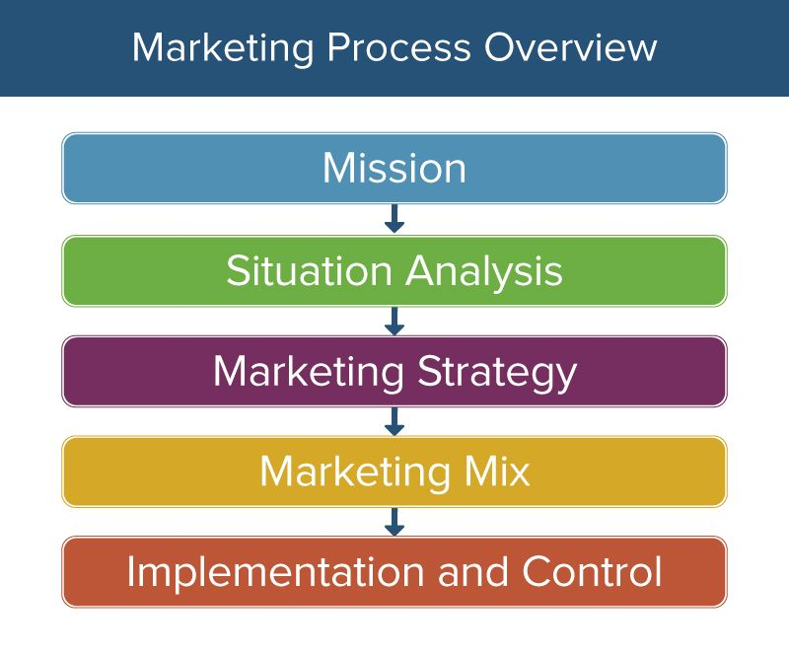
Diagram 1. Source: Weller (2017) The Definitive Guide to Strategic Marketing Planning
Mission Statement. Company mission defines what is the fundamental goal of company, why is that and what company do to achieve the goal. Bishop (2013)
Red Bull mission statement is “giving wings to people and ideas.” This slogan what the customers to easy identify and distinguish the product.
Situation Analysis. Situation analysis means to evaluate the internal factors and external factors who affect the company and the market. Situation analysis show what is the company position in the market, who are the company customers, company goals and trends on market. Weller (2017)
There are several methods to conduct the situation analysis:
- Macro environment or PEST Analysis
- Porter 5 Forces model
- SWOT Analysis.
Marketing Strategy. Marketing strategy helps companies to reach their goals and objectives. Marketing strategy is a plan who content target audience, measurable goals and a budget. Weller (2017)
Red Bull it is not selling a product, arguably the company sells a way of life. We can notice that by the events it is hosting and by his sponsorship through a large range of sports like Formula 1 racing, football, extreme sports, boxing, music festivals, video game events etc. (Red Bull Website)
Marketing Mix. Best known way to describe the marketing mix is with the 4Ps: Product, Place, Price and Promotion. Weller (2017)
Implementation and Control. Implementation means to identify the way the company will launch the plan and when the company will launch the plan, then is time to put the plan into action. At this stage the company will reach out to customers to inform about the product and try to convince the customer to buy the product or service. Weller (2017)

Macro Environment (PESTLE) of Red Bull GmbH
Macro environment consist of the societal forces that affect indirectly or directly the very existence of the company. Macro environment consist of six major components: Young and Pagoso (2008)
Political. UK will exit soon from UE, and this thing will affect import products cost, and we will see higher prices on some products including Red Bull GmbH products.
Economic. Economic forces are forces influenced by the economy of each country. On the actual premises of Covid-19 the world economy will be in recession and will impact the economy of UK, this thing will not have such a big impact on consumer`s buying power as the Energy Drinks prices are accessible prices.
Social. Red Bull presence is well known on online social media. Red Bull have accounts on mostly platforms like Facebook, You Tube Instagram, Twitter etc. This is helping Red Bull company to have a large spectrum of consumer of all ages and cultures.
Technological. Internet is the most important technological factor that affect in a good manner the Energy Drinks Industry. Nowadays is the main channel used by Red Bull to attract consumers.
Legal. Legal or regulatory forces who affect the Red Bull GmbH company in UK are unfavourable:
- UK sugar tax – this tax aim to reduce the consummation of soft drinks with high content of sugar.
- age restriction – children under 16 are banned from buying energy drinks in UK.
Environmental. Sustainability was always in Red Bull DNA:
- every can is made of 100% recyclable aluminium.
- compact and lightweight aluminium doses are a key factor in reducing CO2 emissions in transport, packaging and storage.
- company use ECO fridges. (Red Bull Website)
In conclusion PESTLE Analysis show that the external forces are favourable for Red Bull GmbH grow and expansion on the UK market. According to Statista Research Department (2019) in 2018, Red Bull was used by 3.8 million customers, this think make Red Bull the most popular energy drink brand by its number of users.
SWOT Analysis of Red Bull GmbH
Swot Analysis is a strategic analyse who highlight Strengths, Weaknesses, Opportunities and Threats related to a company. The goal of using Swot Analysis is to take advantage of the company’s strengths, to attract in company the opportunities while simultaneously try to eliminate the weaknesses and minimize the threats. Kotler and Armstrong (2018)
Strengths - internal positive factors. Strengths include company internal powers, resources, and positive factors that help the company to run the business. Kotler and Armstrong (2018)
- the company markets themselves excellent on social media; on Facebook the company have 48 mil followers, on You Tube 9 mil followers and some of the videos listed here have more then 20 mil views (some videos reach 90-100 mil views). (Red Bull You Tube) (Red Bull Facebook)
- the company logo is easy recognized (this is part of Red Bull mission statement). (Red Bull Website)
- the company has dominated the market for more than three decades, thing who allow to company to build a strong brand reputation and increase consumers loyalty.
- the market strategy through sponsorship and constant engagement in a large spectrum of sports, define the brand identity and make the brand well known to customers.
- the large amount of financial resources. In 2019, Red Bull sold 7.5 billion cans worldwide. Group sales was around 6 billion euros. (Red Bull Website)
- Red Bull products are available among 171 counties. (Red Bull Website)
Weaknesses – internal negative factors. Weaknesses include limitations of company and negative factors that could affect the company’s performance. Kotler and Armstrong (2018)
- high prices. Red Bull have higher prices than competitors.
- lack of diversity. Red Bull offer just few products, for example his main competitor Monster drinks come in 36 varieties. Fontinelle (2020)
- people who consume Red Bull are prone to many health issues. McGrane (2019)
Opportunities – external positive factors. Opportunities - positive factors or trends in the external environment who could be used by company to it advantage. Kotler and Armstrong (2018)
- product line extension; product diversity will help Red Bull to consolidate his position and defend against competitors.
- Invest more in emerging markets.
Threats – external negative factors. Threats - negative factors or trends that may affect the company performance. Kotler and Armstrong (2018)
- nowadays we can see the tendency for a healthier lifestyle.
- the competitors number has highly grow in the last decade for Energy Drinks Market. Red Bull have direct competitors like Monster, Pepsi Co, Coca Cola, Rockstar, Nestle etc.
- many blogs and health websites criticizes the effect of energy drinks on human body.
- excess intake of energy drinks has been linked to heart attacks and sudden death in rare cases. McGrane (2019)

As a comparation between PESTLE Analysis and SWOT Analysis, SWOT Analysis is giving more information about the company itself, help us understand where the company should improve and is more accurate about understanding the company needs.

Marketing Mix Elements (4Ps) of Red Bull GmbH
The major marketing mix tools are classified into four groups, called the 4 Ps of marketing: product, price, place, and promotion. Kotler and Armstrong (2018)
Product. A product is a good/object that could be offered on a market to satisfy/meet the needs of customers. Weller (2017)
- Red Bull energy drink is a carbonated drink who contain caffeine, taurine, sugar, spring water and vitamin B complex. (Red Bull Website)
- Red Bull offer energy drinks like: Original, Sugar Free, Editions and Energy Shot. The company offer as well some organics drinks made with ingredients from 100% natural origin: Cola, Lemon, Ginger, Tonic etc. (Red Bull Organics)
- products are packed in 100% aluminium cans.
- the brand is one of the most recognized brands of the world. According to Forbes, Red Bull GmbH brand worth $11.1 B and is getting #69 place on World`s Most Valuable Brands 2020.
- the quality of products is high, as Red Bull is having the top place on Energy Drinks Market for more than three decades.
Price. The price is the amount of money that target market is willing to sacrifice in order to gain a product or service. Factors who influence the price: discounts, payment periods, and much it costs the company to produce the product. Weller (2017)
- consumers could buy Red Bull in bulk, so will be cheaper than to buy a single can.
- Red Bull have the highest price on the Energy Drinks Market compared to competitors.
Promotion. The marketing communication used by the company to attract the target market. Promotion is an opportunity to expose to customers the product benefits and features, show the value of the product and how the product could satisfy customer needs and desires. Weller (2017)
- Red Bull company host and sponsor events who cover a large spectrum of sports: extreme sports, motor cross, boxing, video game events etc.
- Red Bull is supporting a large spectrum of events like Formula 1, ice hockey and football, in different countries: England, US, Austria, Germany and Italy.
- the company have a strong presence on social media: Facebook, Twitter, Instagram and You Tube.
- Red Bull endorse various sports athletes and celebrities.
- the company have Red Bull TV and Red Bull Media House, where we can see films, music festivals, shows and various videos.
Place. Refer to activities that make the product available to customers and make the buying process easy - distribution channels. Weller (2017)
- Red Bull is available at locations like supermarkets, physical stores, bars, night clubs, vending machines and casinos.
- Red Bull is available in online stores.

Conclusion and Recommendation
Red Bull GmbH is the company who has leading the Energy Drinks Market in the last three decades. The factor who keep Red Bull on top of the market was certainly the aggressive advertising and large sponsorships who make the brand strong and well know everywhere in the world. In the Energy Drinks Market is a multitude of competitors, for example Monster and Rockstar - are strong competitors and they are growing fast. Red Bull competitors offer a large variety of products and flavours, and it is possible to see some changes on top of the market. Red Bull should extend his line production and come with new variety of products, new flavours to satisfy the existing demand on market. To keep his leading position in future, Red Bull should change his formula for energy drinks and bring into organic content.
“Red Bull give you wings.”

References
Bishop,T. (2013) Principles of Marketing Management Publisher: World Technologies
Fontinelle, A. (2020). The Energy Drinks Industry. Available at //www.investopedia.com/articles/investing/022315/energy-drinks-industry.asp (Accessed: 20/08/20).
Forbes //www.forbes.com/companies/red-bull/ (Accessed: 21/08/20)
Kotler, P. T. and Armstrong, G. (2018) Principles of Marketing 17th Edition. Harlow: Pearson p.27 – p.46
McGrane, K. (2019) What Are the Side Effects of Drinking Red Bull? Available at //www.healthline.com/nutrition/red-bull-side-effects/ (Accessed: 21/08/20).
Red Bull Facebook //www.facebook.com/user/redbull (Accessed: 21/08/20).
Red Bull Organics //www.organicsbyredbull.com/ (Accessed: 19/08/20).
Red Bull You Tube //www.youtube.com/user/redbull (Accessed on 19/08/20).
Red Bull website //www.redbull.com/ (Accessed: 19/08/20).
Reference for Business (2003). Red Bull GmbH - Company Profile, Information, Business Description, History, Background Information on Red Bull GmbH. Available at //www.referenceforbusiness.com/history2/94/Red-Bull-GmbH (Accessed: 20/08/20).
Statista Research Department (2019) Brands of energy ranked by number of users in Great Britain in 2018 Available at //www.statista.com/statistics/ (Accessed: 21/08/20)
Weller, J. (2017) The Definitive Guide to Strategic Marketing Planning Available at //www.smartsheet.com/strategic-marketing-processes-and-planning/ (Accessed: 20/08/20).
Young, F. C. and Pagoso, C. M. (2008) Principles of Marketing. Philippine: Rex Book Store. p.53 – p.57

