

Student Name: HIRALBEN YUVRAJSINH DABHI

Student ID:2539211

Module Name: Marketing Management

Module Code: LCMB7024

Lecturer’s Name: Laila Maazouz

Term 1

Contents
INTRODUCTION 3
Task 1: Marketing Environment Analysis 3
1.1.Natural Environment 4
1.2.Political and Regulatory Environment 6
1.3.Conclusion 6
Task 2: Strategic Growth and Competitive Positioning 7
2.1.Recommended Strategy: Product Development and Diversification 7
INTRODUCTION 7
2.2.Product Development Strategy 7
2.3.Diversification Strategy 8
2.4.Achieving Competitive Advantage 9
2.5.Risk Considerations 9
2.6.Conclusion 10
Task 3: Critical Reflection on AI Usage 11
a. Tool Disclosure 11
b. Students analyze and evaluate the output of AI.Students examine and assess the products of AI. 11
c. Contribution Analysis 12
d. Considering the ethical and professional implications. 12
Conclusion 13
References (Harvard Style) 14

INTRODUCTION
This report critically analyses the external marketing environment as well as the strategic growth opportunities of a world's leading mining organisation, Rio Tinto, with a special reference on the company's shift towards sustainable and low carbon marketing. Marketing concepts such as the macro-environment model proposed by Kotler et al. (2024) and Ansoff Matrix are used to assess the external factors which influence the business strategies of the company. The report focuses in particular on the natural environment as the main vector of change, with political and regulatory influences determining the practices of the industry. Additionally, product development and diversification strategies capable of enabling sustainable competitive advantage to Rio Tinto are discussed. Enhanced with academic theory and industry evidence, it is a critical and informed analysis of the company's stance in an ever-changing global market.

Task 1: Marketing Environment Analysis
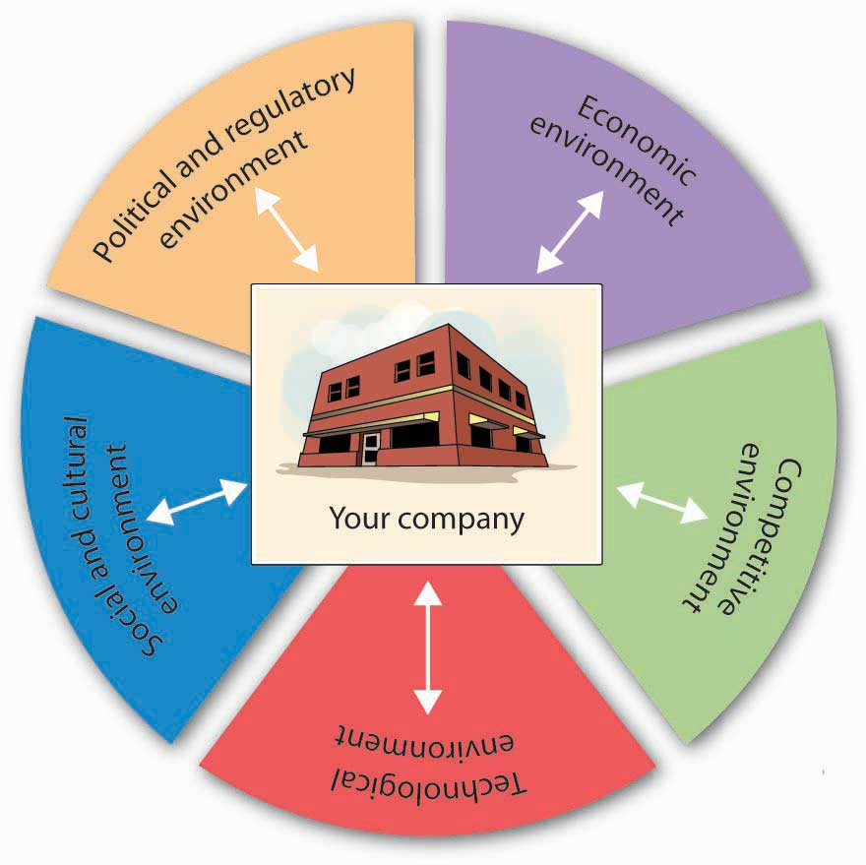
The objective of the report is to critically analyse the external marketing environment that affects one of the leading global mining organisations, Rio Tinto, in particular as it moves to the production of lower carbon products. The analysis is based on Kotler et al. (2024) macro environment framework which emphasizes the natural environment as the primary driver and political environment and regulatory environment as a supporting factor. All of these external factors heavily influence Rio Tinto's strategic choices, priorities and positioning in the market.

1.1.Natural Environment
The natural environment is the greatest external factor that affects Rio Tinto's transition to sustainability. As people become more aware of the impact the mining industry has on the environment and resources, and the threat of climate change, the industry is under the microscope. The Kotler et al. (2024) study indicates that sustainability is not a marketing trend of 2024, but a major concern of marketing and business strategies, particularly for carbon-intensive businesses such as metals and mining.
The industry in which it operates, Rio Tinto, is a very resource intensive industry, and the extraction, processing and transport activities have high greenhouse gas (GHG) emissions. Its Scope 1 and 2 emissions are around 31.5 million tonnes of CO₂ equivalent (Mt CO₂e), with its Scope 3 emissions (which are primarily from its downstream products) being much higher (Rio Tinto, 2025a). This will reflect the size of the environmental footprint of its activities and the need for decarbonisation.
To meet these challenges, Rio Tinto has set bold targets in the area of climate. The company's carbon emissions reduction targets are for a 50% reduction in scope 1 and 2 emissions by 2030, and to become 'net zero' emissions by 2050 (Rio Tinto, 2025b). To attain these targets, Rio Tinto has invested heavily, allocating between 5–6 billion dollars towards decarbonisation projects. These involve the introduction of renewable energy, the electrification of mining equipment and the use of low emission technologies throughout its value chain.
One of the most important innovations, fuelled by environmental constraints, is the ELYSIS project, a partnership between for which carbon-free aluminium is produced. The ELYSIS technology produces oxygen as a by-product of the smelting process, eliminating direct emissions, compared to traditional aluminium smelting processes that produce CO₂. (Rio Tinto, 2025c) This is a good example of how the environment can inhibit traditional practices and promote technological development and product innovation.
Moreover, market demands are also changing due to the natural environment. Some industries that are located downstream are putting more focus on low carbon materials as a way of achieving their own sustainability goals including the automotive, construction and energy sectors. This transition presents a strategic opportunity to drive Rio Tinto to become a provider of ESG compliant products. The company's “green” metals provide a competitive edge and meet changing customer demand.
There are also high risks to the natural environment. Extreme weather, rising temperatures, and reduced water supplies trigger operational disruptions, damage infrastructure, and higher operational costs that impact operations and performance. For instance, availability of water is a key concern within mining, especially in areas where Rio Tinto has operations. Water management and biodiversity are among the concerns being put to pressure on the company by stakeholders, as well as sustainability issues (Reuters, 2024).
Overall, it is a contraining and stimulating natural environment for Rio Tinto. It offers enormous opportunities for the innovation, differentiation and growth of the market, while at the same time being a great challenge. How well the company can adapt to these challenges will be the key factors in its future competitiveness in a low carbon economy.

1.2.Political and Regulatory Environment
The political and regulatory environment is also very supportive of the natural environment but it is not as dominant. The world's governments have implemented increasingly stringent environmental laws and carbon pricing schemes and set emissions caps based on international laws and accords, including the Paris Agreement (Kotler et al., 2024). The policies directly affect Rio Tinto's operations by imposing compliance obligations and stimulating investments in cleaner technologies.

1.3.Conclusion

Overall, the natural environment is the most important external factor affecting Rio Tinto's path towards lower-carbon products. It influences both risks and opportunities, including operational challenges and regulatory requirements, as well as opportunities for innovation and the expanding market for sustainable materials. This evolution is also supported by the political and regulatory landscape, with measures that encourage sustainable practices. All of this makes it imperative for Rio Tinto to change how it does business, to be innovative with its products and to solidify its market standing in a global economy that increasingly favors those who are sustainability-oriented.

Task 2: Strategic Growth and Competitive Positioning
This section aims to suggest a strategic growth plan for Rio Tinto in the Ansoff Matrix based on the environmental analysis. The goal is to find out how the organisation can gain sustainable competitive edge while moving towards low-carbon business practice. The Ansoff Matrix can be useful for product and market strategy analysis, such as market penetration, product development, market development and diversification (Ansoff, 1957). Product development and diversification is best suited to Rio Tinto's growth strategy in the face of rising environmental pressures and shifting market expectations.

2.1.Recommended Strategy: Product Development and Diversification

INTRODUCTION
A product development and diversification approach is recommended for Rio Tinto to meet decarbonisation requirements and changing customer expectations. This strategy allows them to pursue innovation in their existing markets as well as move into new markets where sustainability is driving innovation. Kotler et al. (2024) suggest that organisations are more likely to gain competitive advantage in the long term if they respond to macro-environmental changes in their growth strategies.

2.2.Product Development Strategy
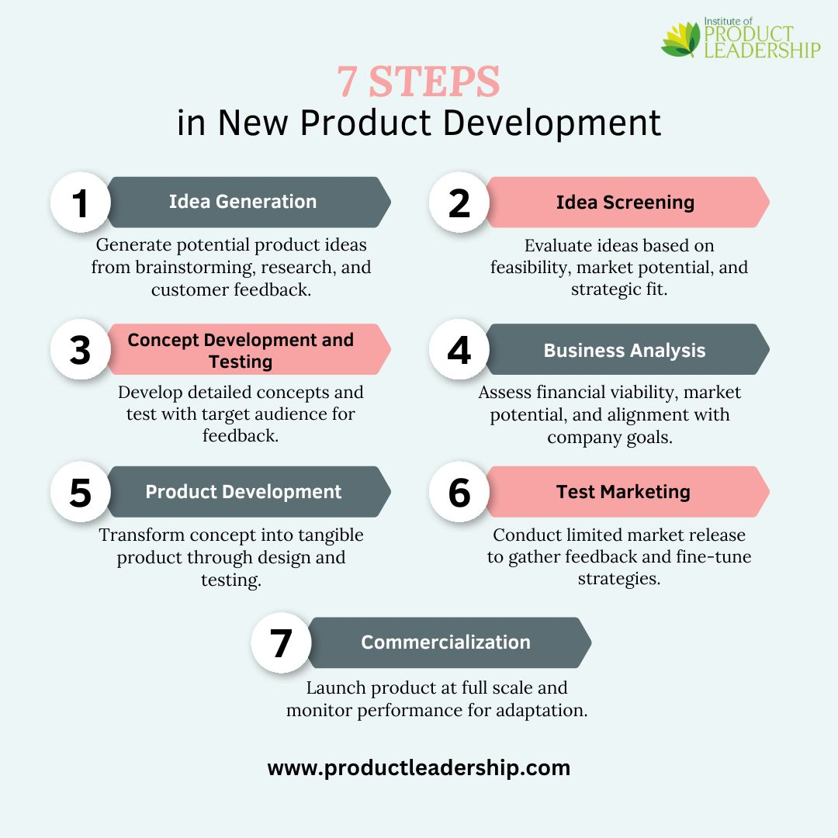
Product development is the process of putting new or improved products into a market that already has one or more products available. The development of alternative low-carbon mining products is the main concern for Rio Tinto. Raw materials with lower environmental impact are increasingly required due to the growing demand in the downstream industries, especially in the automotive, construction and energy industries.

One example is the investment of Rio Tinto in the ELYSIS technology which transforms aluminium into a carbon-free product by eliminating direct emissions of GHGs during the smelting process (Rio Tinto, 2025a). The innovation is a major step towards lowering the carbon footprint in aluminium production, making Rio Tinto a leader in the field of sustainable materials.
Likewise, with the development of BioIron technology, the company has shown its dedication to decarbonizing iron production. This can cut emissions as much as 95% from traditional blast furnace production methods (Reuters, 2024a). Given that one of the biggest emitters of industrial gases in the world is steel production, such innovations are vital.
Strategically, product development makes a product more different. With certified low-carbon products, Rio Tinto can stand out from their competitors and respond to the customers' sustainability expectations. This is especially relevant in the context of the rising pressure on companies in all sectors to lower their Scope 3 emissions. This puts a competitive edge at the forefront of the suppliers which can offer low carbon feeds.

2.3.Diversification Strategy
The diversification is the process of entering into new markets with new products, usually to lessen risk and to take advantage of new opportunities. Diversification is closely related to the global energy transition and the growing importance of critical minerals in renewable technologies for Rio Tinto.
The company has diversified its business into commodities like lithium, copper and aluminium, which are crucial for e-vehicles, battery storage and renewable energy infrastructure (Rio Tinto, 2025b). The strategic move is in line with a long-term worldwide trend, because the demand for these materials is projected to increase considerably during the transition to a low carbon economy.
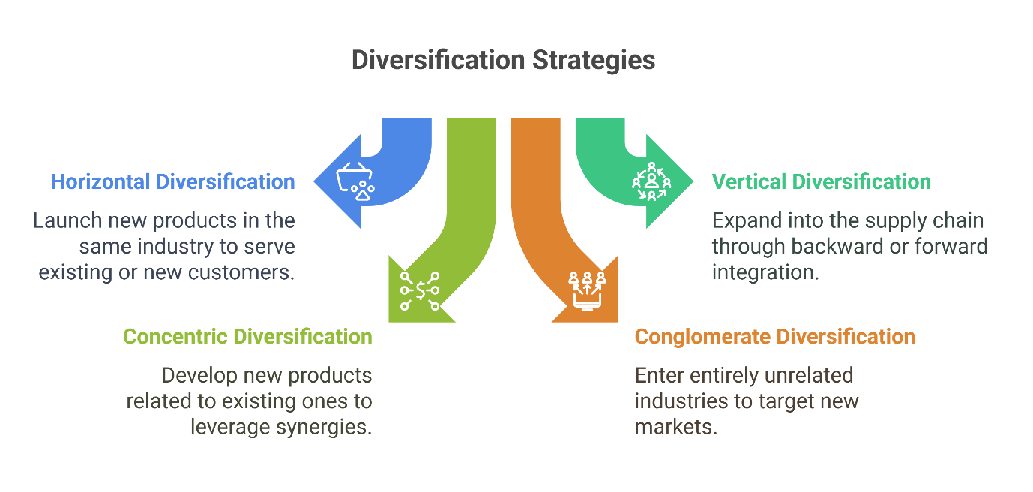
For instance, Lithium is a crucial material in the manufacturing of batteries, which are vital for the electrification of transportation systems. Investing in lithium assets and growing its footprint in battery materials markets helps cut its carbon-intensive commodity footprint, while also setting it up for future growth opportunities (Rio Tinto, 2025b; Wikipedia, 2025).
There is also a strategic partnership program that enables diversification. Partnerships with governments, technology providers and industry partners help to share risk, introduce new technologies and drive innovation at Rio Tinto. Co-operation, for example, in low-carbon steel production and renewable energies, helps the company to be competitive in new markets (Reuters, 2024b).

2.4.Achieving Competitive Advantage

In order to successfully execute its growth strategy, Rio Tinto will need to seek competitive advantage through cost leadership, differentiation and through its stakeholder engagement.
First, operational efficiency can provide a competitive advantage in the form of a cost leadership strategy. Renewable energy and electrification as well as automation investments lower operational costs in the long term and emissions. While the upfront capital cost can be significant, long-term cost savings and increased efficiency can be achieved (Kotler et al., 2024).
Second, sustainability is a key success factor in differentiation. The growing emphasis on environmental issues in the decision-making process can be an opportunity for Rio Tinto to leverage its role as a supplier of sustainable and responsible products. ESG reporting and certification of low carbon materials are transparent, increasing the credibility and giving customers and investors who care about ESG an incentive to buy from you.
Third, stakeholder engagement is a crucial component in enhancing a company's competitive position. Communicating sustainability efforts creates trust with stakeholders, such as governments, investors and local communities. Good relationships with stakeholders build brand equity and mitigate risk to the brand.

2.5.Risk Considerations

There are a number of risks associated with the proffered plan. Expansion in new technologies might influence the short-term profitability, especially if expected returns are postponed. Further, the effectiveness and/or scalability of innovations like carbon-free aluminium or low carbon ironmaking can be affected by technological uncertainty.
Regulatory uncertainties also pose a challenge. Adjustments to environmental policies, carbon pricing or trade restrictions may impact the potential viability of investments. In addition, fluctuations in commodity prices can have an effect on the financial results.
But these risks can be reduced by a gradual investment plan, diversifying portfolios and collaborating with partners. It's also crucial to monitor market trends and regulatory changes on an ongoing basis. More importantly, the long-term advantages of doing so in relation to global sustainability goals are likely to be greater than the short term risks.

2.6.Conclusion

Finally, a dual product development and diversification strategy offers good bedrock for the development of Rio Tinto in a low-carbon economy. The company can gain the sustainable competitive advantage by investing in innovative technologies and moving towards future resources. This not only helps to solve environmental problems, but also places Rio Tinto in the advantageous position of benefiting from new opportunities in the global transition towards sustainability.

Task 3: Critical Reflection on AI Usage
The report has been developed with the help of Artificial Intelligence (AI) tools throughout. The mention of AI showcases how digital technology is being increasingly adopted in academia and the professional world, especially in marketing analysis. This reflection discusses the use of AI, its limitations and the ethical issues involved in the use of AI.

- Tool Disclosure

Generative language models (GPT-3) were employed to help organize the report, draft some parts, and edit academic language. These tools were especially helpful when structuring content for the basis of the assignment, making content coherent, and developing clarity of expression. AI also facilitated the identification of the marketing frameworks that are relevant to the scenario, in line with the academic theory.AI also helped to identify marketing frameworks that are relevant, which is based on the established academic theory, such as macro-environment analysis and Ansoff Matrix.
But in the context of knowledge, AI was not the main source of knowledge. The academic resources used (Kotler et al. 2024) provided the core concepts and theoretical principles supporting the study, aligning with the accepted marketing principles. This is crucial, because AI-generated answers are not always accurate, and need to be backed up with credible sources.

- Students analyze and evaluate the output of AI.Students examine and assess the products of AI.

All content from AI was assessed with a critical approach. AI-generated information was systematically validated with authoritative sources such as academic textbooks, industry reports, official company documents including Rio Tinto's sustainability and annual reports. This process guaranteed the information presented is accurate, relevant and up-to-date.
The ability of AI to produce plausible but false or unsupported information is one of its drawbacks, commonly known as “hallucinations” (Dwivedi et al., 2023). To tackle this, all factual statements (including emissions, sustainability goals and technological efforts) have been sourced using credible information. Any inconsistencies or ambiguous comments were found and rectified by research.
Moreover, the AI-generated content was carefully reviewed for depth and academic rigor. AI is capable of creating well-structured text, but it may lack in critical analysis and understanding of the context. The content was thus streamlined to include more evaluative reflections, arguments and connections to the theory used. This helped to ensure that the final report was to the academic standard.

- Contribution Analysis

The report was drafted mainly with the assistance of AI, while its structure and organization were done in collaboration with the students. It gave the basis for communicating ideas in a logical and coherent way, which could be furthered by independent analysis. Original reasoning and critical thinking were used in the selection of the case study, identification of environmental factors and developing strategic recommendations.
Moreover, the use of marketing theories, such as the Ansoff Markets, necessitated the interpretation and contextualization of such theories, which went beyond AI-generated suggestions. The initial drafts were significantly modified, with the inclusion of critical evaluation, the incorporation of Harvard style citations and the incorporation of the requirements of the assignment.
Therefore, the final report was a collaborative effort whereby AI was used as a tool to support the substantive analytical content and academic rigor, which were developed separately. This is a very important difference to make as it is a requirement to show originality and uphold academic integrity.

- Considering the ethical and professional implications.

The application of AI in academia brings several ethical challenges, including transparency in use, originality, and accountability. Using AI tools should be recognized to prevent misrepresentation, and to maintain academic integrity (University of Leeds, 2024). Not reporting the use of AI might be a type of cheating in academic work.
The other ethical concern is that the use of AI can lead to overreliance and stifle the development of critical thinking and analytical skills. AI can be used to make things easier, but it should not take the place of thinking. To encourage students to think critically about the information they come across and analyze it so that they can interpret and rather than take it for granted the output generated by Artificial Intelligence.
Professionally, AI is increasingly being applied to the field of marketing to analyze data, create content and make decisions (Dwivedi et al., 2023). So, the skill of using AI in a responsible manner is a valuable one. This involves knowledge of its limitations, checking and ensuring its outputs, and ensuring its use is ethical.

Conclusion

To wrap up, AI proved to be a great help in the efficiency, organization and clarity of this report. But it had its drawbacks and needed to be tested and improved upon. Judgement, accuracy, originality and critical depth needed to be ensured, and this could only be achieved with human intervention. Responsible use of AI with transparency and critical thinking enriches student learning and development and improves professional practice.

References (Harvard Style)
- Kotler, P., Keller, K.L., Chernev, A. and Brady, M. (2024) Marketing Management. 17th edn. Harlow: Pearson.
- Ansoff, H.I. (1957) ‘Strategies for diversification’, Harvard Business Review, 35(5), pp. 113–124. Available at: https://hbr.org/1957/09/strategies-for-diversification (Accessed: 8 July 2026).
- Dwivedi, Y.K., Hughes, L., Baabdullah, A.M., Ribeiro-Navarrete, S., Giannakis, M., Al-Debei, M.M., Dennehy, D., Metri, B., Buhalis, D., Cheung, C.M.K. and others (2023) ‘So what if ChatGPT wrote it? Multidisciplinary perspectives on opportunities, challenges and implications of generative conversational AI’, International Journal of Information Management, 71, 102642. Available at: https://doi.org/10.1016/j.ijinfomgt.2023.102642 (Accessed: 8 July 2026).
- Rio Tinto (2025a) Annual Report 2024. Available at: https://www.riotinto.com/en/invest/reports (Accessed: 8 July 2026).
- Rio Tinto (2025b) Climate Change Report 2024. Available at: https://www.riotinto.com/en/sustainability/climate-change (Accessed: 8 July 2026).
- Rio Tinto (2025c) ELYSIS Carbon-Free Aluminium Technology. Available at: https://www.riotinto.com/en/products/aluminium/elysis (Accessed: 8 July 2026).
- Reuters (2024) ‘Rio Tinto faces environmental pressures and sustainability challenges’. Available at: https://www.reuters.com/business/energy (Accessed: 8 July 2026).
- Reuters (2024a) ‘Rio Tinto develops low-carbon ironmaking technology’. Available at: https://www.reuters.com/markets/commodities (Accessed: 8 July 2026).
- Reuters (2024b) ‘Rio Tinto expands partnerships in clean energy transition’. Available at: https://www.reuters.com/sustainability (Accessed: 8 July 2026).
- University of Leeds (2024) Guidance on the use of Artificial Intelligence in academic work. Available at: https://students.leeds.ac.uk/info/10110/academic-integrity/ai (Accessed: 8 July 2026).

