1920269
Congeita Clarke-Young
BMSW 4005
Professional and Career Development.
Olubkola Adegbite

Reflective Portfolio Report

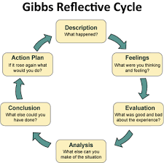
Gibbs Reflective Cycle (13 November2021). NoveNovember2021).

Contents:

1 Introduction
2 Managerial Skills and competencies
3 Where would I want to be using Swot Analysis.
4 Personal development plans
5 Discrimination when recruiting using Smart.

Introduction

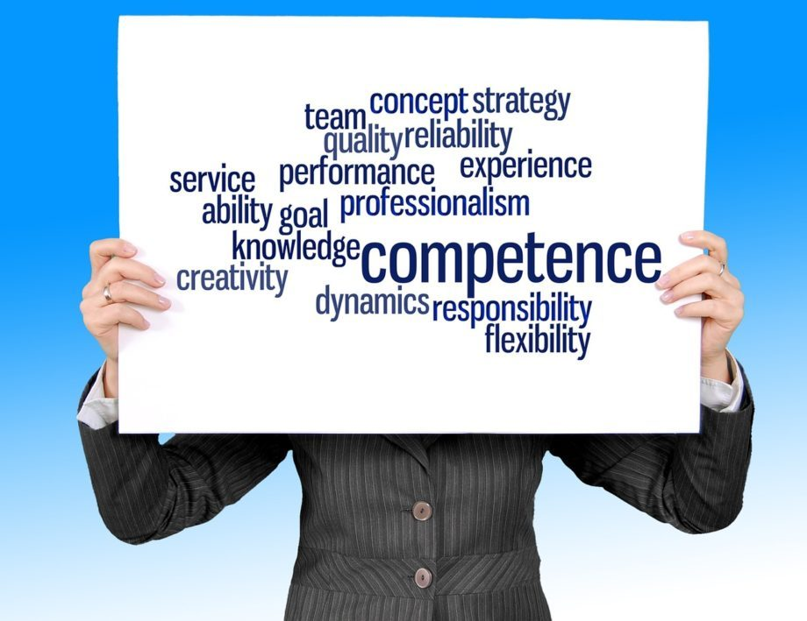
Introduction to Competencies (13 November2021).

- Managerial Skills and Competencies:
- Where I would like to be using Swot Analysis:
- Personal Development plan:
- Discrimination when recruiting using Smart.
.
Recent evidence I have established within the previous studies doing open book assignment of five hundred words in under two hours, I found it to be great challenge for me as I suffer with dyslexia and takes me a bit of time to adapt information. I have learnt now how I will plan to use them with the competencies that I have learnt over past couple of months. personal development planning in order in becoming a manager within my chosen career. what achievement will I have to look at, within my professional career development in becoming an effective Manager, thinking about the right steps in enhancing my knowledge towards this role. Managing in a position has Administration Officer is a completely different step from my last role, within Mental Health Services Analysing the different skills and Qualification that I have at this present moment. What do I require for the role of Manager position in this environment of organisation, what are the important factors how to move head towards this goal?

SWOT Analysis:

Weaknesses, Internal Factors.
- Motivation and focusing.

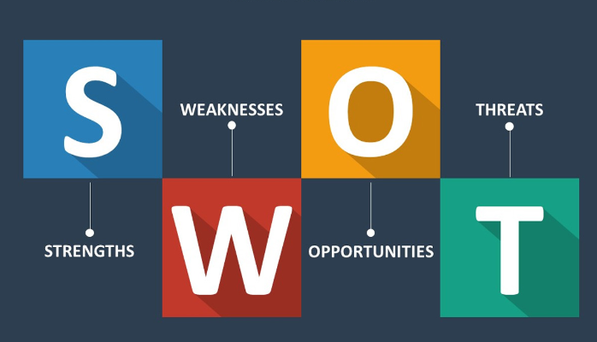
Threats-External-Factors.
- Risk when recruiting try minimising Discrimination
- Immigration workers who work in UK.

Strengths- Internal Factors.
- Qualifications Skills needed.
- Aims towards becoming an Effective Manager.
- Personal development Plan.

Opportunities-External Factors.
- Recruitment
- Discrimination Immigration compliance within Organization.
Jodie Shaw 13, January 2017).

Auditing evaluating how to become an effective manager planning towards my future goal my values how will I perform within a new organisation. looking at all the potential skills and my ambitions. Having knowledge how to mind map how to accomplish in achieving that successful goal. Processing in right direction with an opened mind looking at how to process by doing my Swot Analysis strengths, weakness, opptunities, Threats.

Career Development plan.

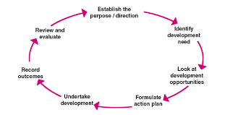
Personal Development Planning (24 November 2010.

Conclusion.

Reference List.
Ivory Research (13, November 2021). Gibbs reflective Circle. https://www.google.com/search?q=Reflective+Portfolio+report&tbm=isch&ved=2ahUKEwjvlMSX05j0AhXZ_IUKHcyRCV8Q2-cCegQIABAA&oq=Reflective+Portfolio+report&gs_lcp=CgNpbWcQAzoHCCMQ7wMQJzoFCAAQgAQ6CAgAEAgQBxAeUKoZWNh6YMuaAWgBcAB4AIABT4gBpgWSAQIxMpgBAKABAaoBC2d3cy13aXotaW1nwAEB&sclient=img&ei=yWuRYa-MFdn5lwTMo6b4BQ&bih=698&biw=802#imgrc=3NpvyLfGx2vCvM (Accessed 13 November2021).
Marlborough Training (13 November 2021). Introduction to competencies. https://www.google.com/url?sa=i&url=https%3A%2F%2Fwww.zing365.co.uk%2Fintroduction-to-competencies%2F&psig=AOvVaw18RhZbk7J-9aKdDINrfX63&ust=1637010100922000&source=images&cd=vfe&ved=0CA0Q3YkBahcKEwjY0sWl4Jj0AhUAAAAAHQAAAAAQAw (Accessed 13 November2021).
Jodie Shaw (13 January 2017). How to complete a personal Swot Analysis https://medium.com/thrive-global/how-to-complete-a-personal-swot-analysis-2f8769aebd5e (Accessed 13, November2021).
CMI Chartered Management Institute (13, November2021). Personal Development Planning.
https://www.managers.org.uk/knowledge-and-insights/research/personal-development-planning/ (Accessed 13, November 2021).

