

Programme: | MSc Public Health and Social Care in Practice
Module: | Population Health and Digital Health Promotion
Module code: | LCHS7009
Lecturer | Diola Bijlhout
Assignment Title: | Component 1, 2 Blogs
Student Name | Kamlesh Nakum
Student ID: | 2503810

Table of Contents
Blog 1: 3
Title: Impact of Digital Technologies on hypertension 3
Introduction 3
Public health problem: why hypertension is important 3
Existing digital technology 4
How the technology promotes health 5
Critical evaluation 6
Recommendation 7
Conclusion 7
References 8
Blog-2 10
Title: PulseCare: A digital application to monitor blood pressure among individuals 10
Introduction 10
Description of the proposed application 10
How it promotes health 10
Critical Evaluation 11
Recommendation 12
Conclusion 12
References 13

Blog 1:

Title: Impact of Digital Technologies on hypertension

Introduction
Hypertension, also referred to as high blood pressure, is a lifelong health condition in which blood pushes too hard against the blood vessels (Kario et al., 2024). Hypertension often develops without visible symptoms; uncontrolled blood pressure can trigger serious complications, including heart disease, stroke, kidney disease and vision impairment (Masenga and Kirabo, 2023). In 2024, approximately 1.4 billion adults aged between 30 and 79 years are affected by hypertension, and nearly 600 million of them are unaware that they have this severe condition (WHO, 2025). SmartBP application is an existing digital technology aimed to reduce hypertension related problems. In this blog, evaluation of this technology will be the prime area.

Public health problem: why hypertension is important
Hypertension is known as the silent killer because it has few symptoms and can damage vital organs (Crea, 2022), (NHS, 2026). It is an important public health concern since it leads to severe health challenges like heart attacks and strokes (NHS, 2026). Around 31% of men and 26% of women have high blood pressure, and an estimated 5 million individuals in the UK remain undiagnosed for hypertension reflecting high risk of chronic complications (British Heart Foundation, 2021).
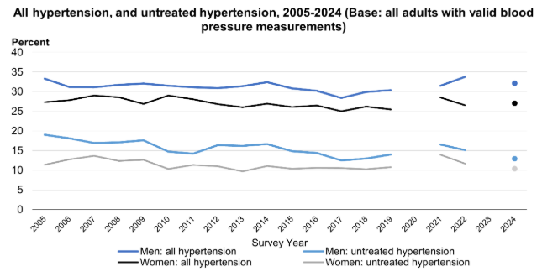
Figure: 1 Health survey for England, 2024
(Source: NHS, 2026)

Existing digital technology
The SmartBP application is a free and convenient blood pressure management platform that allows individuals to record, monitor, evaluate and share normal, low, or high blood pressure charts and other important information through mobile phones. Additionally, users can record medication dosage and other relevant information to support ongoing hypertension management. (SmartBP, 2026).
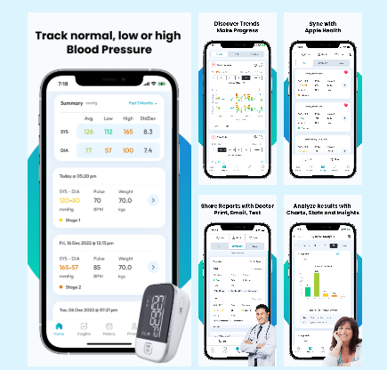
Figure: 2 A smarter way to manage your blood pressure
(Source: SmartBP App, 2026)

How the technology promotes health
The SmartBP application promotes health by helping users track and record their blood pressure regularly, enabling users to promptly identify abnormal readings. It provides clear charts and trends, helping users understand changes in their cardiovascular health over time. SmartBP suggest useful medications, provides measurement notifications for users, and encourages adherence to treatment plans. Users can conveniently share their blood pressure reports with medical experts to improve clinical decision-making (SmartBP, 2026). SmartBP helps reduce cardiovascular health risks by enabling users to self-monitor their blood pressures, and by observing their personal medical data trends and optimising communication between patients and doctors.
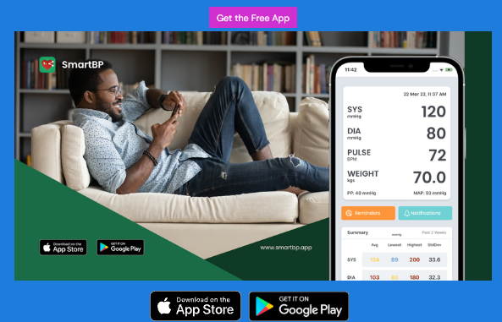
Figure: 3 SmartBP App mobile version
(Source: SmartBP, 2026)

Critical evaluation
Strengths
- It helps users monitor their blood pressure, analyse health data, improve medication adherence, and share medical records with medical practitioners.
- The SmartBP aligns with the COM-B model by enhancing capability through education, opportunity through data exchange and motivation through progress tracking (Webb et al., 2022).
- It encourages self-management and helps users take early measures to reduce risks of cardiovascular diseases (Luqman et al., 2024).
Limitation
- . Blood pressure is not directly measured by an expert, so the readings can be inaccurate.
- There are certain restrictions for device syncing.

Recommendation
- It can integrate AI-driven customised clinical guidance by connecting with the NHS to boost user engagement and support long-term blood pressure management (Goh et al., 2026).

Conclusion
Hypertension is a major health challenge faced by people across the globe. Therefore, to monitor hypertension, SmartBP serves its purpose despite its shortcomings.

References
British Heart Foundation, (2021) Our Impact on high blood pressure research, Available at: https://www.bhf.org.uk/what-we-do/our-research/research-successes/our-research-impact-reports/our-hypertension-research-report
Crea, F., (2022). Update on a silent killer: arterial hypertension. European Heart Journal, 43(38), pp.3595-3598. Available at:https://academic.oup.com/eurheartj/article/43/38/3595/6758425
Goh, H.L., Sancenon, V., Chu, B.M., Koh, G.C., Koh, L., Teo, D., Ooi, M.S., Thng, C.N., Tan, C.Z., Chua, D.W. and Ta, A.W., (2026). Personalised health plan development using agentic AI in Singapore’s national preventive care programme: a pilot study. NPJ Digital Medicine, 9(1), p.332. Available at:https://www.nature.com/articles/s41746-026-02514-8
Kario, K., Okura, A., Hoshide, S. and Mogi, M., (2024). The WHO Global report 2023 on hypertension warning the emerging hypertension burden in globe and its treatment strategy. Hypertension Research, 47(5), pp.1099-1102. Available at: https://www.nature.com/articles/s41440-024-01622-w
Luqman, Ameer, Adil Hassan, Mehtab Ullah, Sahar Naseem, Mehraj Ullah, Liyuan Zhang, Ahmad Ud Din, Kamran Ullah, Waqar Ahmad, and Guixue Wang. "Role of the intestinal microbiome and its therapeutic intervention in cardiovascular disorder." Frontiers in immunology 15 (2024): 1321395. Available at: https://www.frontiersin.org/journals/immunology/articles/10.3389/fimmu.2024.1321395/full
Masenga, S.K. and Kirabo, A., (2023). Hypertensive heart disease: risk factors, complications and mechanisms. Frontiers in cardiovascular medicine, 10, p.1205475. Available at: https://www.frontiersin.org/journals/cardiovascular-medicine/articles/10.3389/fcvm.2023.1205475/full
NHS, (2026) Health Survey for England, 2024, Available at: https://digital.nhs.uk/data-and-information/publications/statistical/health-survey-for-england/2024/adults-health
NHS, (2026) High Blood Pressure, Available at: https://www.nhs.uk/conditions/high-blood-pressure/
SmartBP, (2026) a smarter way to manage your blood pressure, Available at: https://www.smartbp.app/
Webb, J., Baker, A., Palmer, T., Hall, A., Ahlquist, A., Darlow, J., Olaniyan, V., Horlock, R. and Stewart, D., (2022). The barriers and facilitators to physical activity in people with a musculoskeletal condition: A rapid review of reviews using the COM-B model to support intervention development. Public Health in Practice, 3, p.100250. Available at: https://www.sciencedirect.com/science/article/pii/S266653522200026X
WHO, (2025) Hypertension, Available at: https://www.who.int/news-room/fact-sheets/detail/hypertension

Blog-2

Title: PulseCare: A digital application to monitor blood pressure among individuals

Introduction
Hypertension is a severe health challenge affecting 1.4 million people, and it is the reason for premature deaths across the globe (WHO, 2025). People with hypertension may not feel any symptoms, but hypertension results in headaches, abnormal heart rhythm, kidney problems and breathing troubles (Wumaier et al., 2026). The global burden of hypertension is projected to reach 1.5 billion by 2030 (Satoh et al., 2026).

Description of the proposed application
PulseCare will be specifically targeted to help individuals monitor their blood pressure and improve cardiovascular health (Kassavou et al., 2022). It will record blood pressure readings of its users. The application will generate comprehensible charts which will help users securely share their reports with medical practitioners. PulseCare will also provide medication reminders for its valuable users (Ping et al., 2022). Additionally, it will offer guidance from qualified medical practitioners supporting timely assistance and improving users’ medical decision-making to ensure sustained cardiovascular health outcomes (Haynes et al., 2022).

How it promotes health
The application will help users regularly monitor and record their blood pressure and enable users with easy-to read- hypertension screening charts that can be easily shared with physicians (Graham et al., 2025). PulseCare will provide AI-driven personalised medical guidelines for its users, which will also increase the involvement of new users in the application (Khude and Shende, 2025). Through AI, PulseCare will help in the identification of abnormal blood pressure readings.
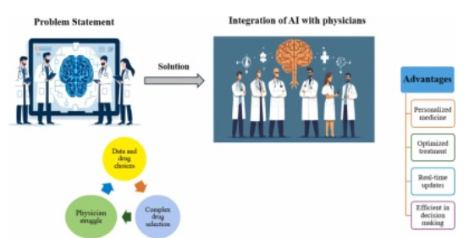
Figure. 1: AI integrates with physicians
(Source: Khude, and Shende, 2025).

Critical Evaluation
Strengths
- PulseCare will ensure customised risk prediction of cardiovascular events based on previous history of patients.
- It will notify patients if they miss a dosage of medicines based on the logged symptoms of users (ting Zhou et al., 2022).
- The application will answer basic queries and explain the reason behind blood pressure fluctuations.
- The Theory of Planned Behaviour is aligned with the PulseCare application because it describes how the user’s attitude, subjective norms, and perceived behavioural control shape their intentions to use the application to monitor their hypertension (Lee, Kim, and Roh, 2023).
Limitations
- It can generate inaccurate blood pressure readings for older people, or pregnant women because of poor generalisations of the AI tools (Lohman, et al., 2024).
- The incorrect AI output can put a patient’s life in unforeseen danger by showing inaccurate readings and ignoring the real risks associated with it, and users can feel panicked due to high blood pressure readings (Xu and Shuttleworth, 2024).

Recommendation
PulseCare must comply with strict medical laws and regulations which can prevent from providing wrong medical advice to its users. AI integration must not replace medical professionals. The application must clearly state that its outputs are informational and offer time being support and it should prompt users to seek medical guidance in case of an emergency.

Conclusion
Hypertension is a public health crisis not only in the UK but across the world. Therefore, PulseCare will track and monitor the hypertension of people residing in the UK. Similarly, in case of a medical emergency, users should seek help from medical experts.

References
Graham, C., Steckelmacher, J., Prashar, J., Ahmed, A., Capel, M., Poulter, N.R., Sever, P.S. and Gupta, A.K., (2025). Trends in hypertension prevalence, control, and antihypertensive use in England from 2003 to 2021: insights from annual, nationwide Health Surveys for England. BMJ medicine, 4(1), p.e001556. Available at: https://pmc.ncbi.nlm.nih.gov/articles/PMC12666190/
Haynes, N., Kaur, A., Swain, J., Joseph, J.J. and Brewer, L.C., (2022). Community-based participatory research to improve cardiovascular health among US racial and ethnic minority groups. Current Epidemiology Reports, 9(3), pp.212-221. https://link.springer.com/article/10.1007/s40471-022-00298-5
Kassavou, A., Wang, M., Mirzaei, V., Shpendi, S. and Hasan, R., (2022). The association between smartphone app–based self-monitoring of hypertension-related behaviors and reductions in high blood pressure: systematic review and meta-analysis. JMIR mHealth and uHealth, 10(7), p.e34767. Available at: https://mhealth.jmir.org/2022/7/e34767
Khude, H. and Shende, P., (2025). AI-driven clinical decision support systems: Revolutionizing medication selection and personalized drug therapy. Advances in Integrative Medicine, 12(4), p.100529. Available at:https://www.sciencedirect.com/science/article/abs/pii/S2212958825000886
Lee, S.S., Kim, Y. and Roh, T., (2023). Pro-environmental behavior on electric vehicle use intention: Integrating value-belief-norm theory and theory of planned behavior. Journal of Cleaner Production, 418, p.138211. Available at:https://www.sciencedirect.com/science/article/abs/pii/S0959652623023697
Lohman, T., Sible, I.J., Shenasa, F., Engstrom, A.C., Kapoor, A., Alitin, J.P.M., Gaubert, A., Thayer, J.F., Ferrer, F. and Nation, D.A., (2024). Reliability of beat-to-beat blood pressure variability in older adults. Scientific Reports, 14(1), p.20197. Available at:https://www.nature.com/articles/s41598-024-71183-y
Ping, Y., Visaria, A., Suppiah, S.D., Tan, Y.W. and Malhotra, R., (2022). Prevalence and correlates of medication reminder app ‘use and use intention’among older adults. Exploratory Research in Clinical and Social Pharmacy, 6, p.100150. Available at: https://www.sciencedirect.com/science/article/pii/S266727662200049X
Satoh, M., Nakayama, S., Nobayashi, H., Iwabe, Y., Izumi, S., Murakami, T., Hirose, T. and Metoki, H., (2026). Current hypertension epidemiology and contemporary approaches using the “Real-World Evidence Cycle” framework. Hypertension Research, pp.1-12. Available at: https://www.nature.com/articles/s41440-025-02532-1
ting Zhou, T., Wang, R., jia Gu, S., ling Xie, L., hua Zhao, Q., zhao Xiao, M. and lu Chen, Y., (2022). Effectiveness of mobile medical apps in ensuring medication safety among patients with chronic diseases: systematic review and meta-analysis. JMIR mHealth and uHealth, 10(11), p.e39819. Available at: https://mhealth.jmir.org/2022/11/e39819/
WHO, (2025) Hypertension, Available at: https://www.who.int/news-room/fact-sheets/detail/hypertension
Wumaier, G., Tuerxun, R., Hamiti, G., AN, Z. and AN, P., (2026.) Network comparative analysis of anxiety and depressive symptoms in patients with hypertension and diabetes comorbidity: A cross-sectional study. Journal of Psychosomatic Research, 207, p.112649. Available at: https://www.sciencedirect.com/science/article/abs/pii/S0022399926001339
Xu, H. and Shuttleworth, K.M.J., (2024). Medical artificial intelligence and the black box problem: a view based on the ethical principle of “do no harm”. Intelligent Medicine, 4(1), pp.52-57. Available at: https://www.sciencedirect.com/science/article/pii/S2667102623000578

