Employee Voice in Hywel Dda University Health Board
wORD cOUNT: 4746
Managing employment relations
Leanne Powell – P0551961
[Year]
Executive Summary
Employee voice is broadly defined as the mechanism in which employees communicate their views to their employer (CIPD, 2019). Creating opportunities for such is fundamental to the success of an organisation (Macleod, 2009).
According to the CIPD (2019) an effective mechanism of employee voice is attributable to increased levels of job satisfaction innovation, productivity and organisational performance.
Mega trends in the contemporary world of work (Mercer, 2018) such as alternative employment arrangements and technological advances are creating new challenges for employees to influence working practices (CIPD, 2019).
This report explores the changing nature of work and how such factors infiltrate the employment relationship and influences mechanisms of employee voice. It draws upon literature to make recommendations as to how the health board can promote an inclusive approach to employee voice to ensure the successful delivery of its healthier mid and west wales strategy.

Contents
1.0 Introduction 3
2.0 Literature Review 6
3.0 Conclusion 18
4.0 Recommendations 19
5.0 References 21
6.0 Appendices 25
Appendix 1.0 25
Appendix 2.0 26
Appendix 3.0 27

Introduction

  - 1.1 Overview
Since the founding of the NHS in 1948, population health needs and expectations have fundamentally transformed (HDUHB, 2016). A combination of increased life expectancy, (The Kings Fund, 2011) economic turbulence and advances in technology have acted as a catalyst for such and have subsequently raised specific challenges concerning how care is organised and delivered in a health care setting (HDUHB, 2018). In 2018 alone

1.2 Transforming Clinical Services (TCS)
In response to such factors Hywel Dda University Health Board has embarked upon a 20 year programme to transform the way in which health care services are delivered (HDUHB, 2018). Its ‘Healthier Mid and West Wales Strategy acts as an enabler for this and depicts a vision of a health care system that is fit for current and future generations. Commensurate of various Welsh Government legislative requirements, the strategy demonstrates a shift in focus from hospital-based care to population-based health and well-being (Fig 1.1).

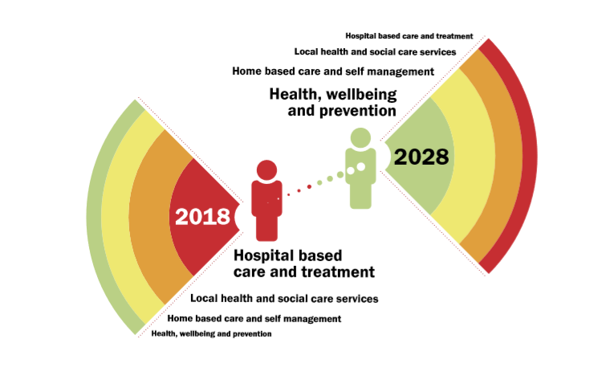
Fig 1.1. Source: HDUHB (2018)

It is recognised that the successful delivery of the strategy will require significant changes to the workforce, examples of which include: new working practices, role development and streamlining processes. Its staff are quoted as integral to this process. It is essential therefore that throughout the delivery of this transformation programme HDUHB work in partnership with staff to ensure that they remain fully informed, involved and have the ability to influence future service models (HDUHB, 2019).

1.3 Hywel Dda University Health Board

Hywel Dda University Health Board (HDUHB) constitutes one of 7 Local Health Boards throughout NHS Wales (NHS Confed, 2016). Its 13,358 members of staff provide primary, community, in-hospital, mental health and learning disabilities services for a population of approximately 384,000 (HDUHB, 2016).

1.4 Employee Voice in HDUHB

As a local Health Board in Wales, HDUHB are legally obliged to have in existence a Local Partnership Forum (NHS Wales, 2011). The LPF acts a formal mechanism in which employers trade unions and professional bodies work in collaboration to inform, debate and seek to agree local priorities on health service and employment relations issues (HDUHB, 2011).

It is therefore with some concern to note statistical evidence is indicative of a declining trajectory in Trade Union Membership (CIPD, 2018) thus their value and influence in the workplace is consistently questioned (ibid)

1.5 Aim & Objectives

The purpose of this report is to explore changes in the external environment that have impacted upon employment relations, in order to ascertain an inclusive approach to employee voice within HDUHB.

The objectives will be to

- Identify the mechanisms in which employee voice is prevalent throughout HDUHB
- Explore external environment trends pertinent to employee voice
- Make recommendations to enable an inclusive approach to employment voice in HDUHB.

It is envisioned that by focussing on those outlined objectives the organisation can identify and prioritise any potential interventions pertinent to employee voice to allow an inclusive, collaborative approach to the transformation of its health care services.

2.0 Literature Review

2.1 Employee Voice Defined

Employee voice can be defined as the mechanism in which employees communicate with their employer surrounding work matters that affect them (CIPD, 2019).

Academic research surrounding the positive connotations of a prosperous employee relations climate, namely one that encompasses high levels of employee engagement, commitment and involvement, include: enhanced organisational performance and improved employee well-being (McLeod, CIPD)

The workings of West & Dawson (2011) who focussed their research specifically on the NHS reiterate the same sentiment. Their findings conclude that employee engagement is intrinsically linked to a variety of individual and organisational outcome measures of which include staff absenteeism, staff turnover, patient satisfaction, patient infection and mortality rates.

Thus, employees who have good quality jobs and are managed well, will not only be happier, healthier and more fulfilled, but are also more likely to drive productivity, improved services, and innovation.

2.2 Actors in the Employment Relationship

According to Gennard et al it is the interaction between the three main actors of the employment relationship: employee, employer and the state that determine the type and quality of the employment relationship, the stake for each is outlined in fig 1.2


Fig 1.2 Source: Gennard et al, 2019

2.3 Employer
As a government organisation, the NHS as an employer has traditionally been affiliated with job stability, relatively good pay and conditions alongside high levels of union involvement (Gennard et al). However, seven years of austerity under a conservative government has taken its toll on employee relations, and union membership (Topping, 2017) has subsequently toppled. Yet, despite the erosion of institutional employment relations (Bach, 2011), the trade unions are still considered influential within the public sector (Gennaard Et al, 2019).

2.4 Employee & Employee Voice

The bargaining power of employees in HDUHB and their subsequent ability to influence lies very much at the hands of the trade unions, the formal mechanism for which is the Local Partnership Forum (LPF). The LPF was established as an Advisory Committee in 2009 and comprises both management and staff representatives. The forum meets on a bi-monthly basis to communicate and consult on service and operational management issues specific to HDUHB and its workforce (HDUHB, 2011).

The LPF Terms of Reference stipulate that “staff representatives must be employed by the organisation and accredited by their respective organisations for the purposes of bargaining” (ibid). Details of the recognised Trade Unions can be found at Appendix 1.

Other than the annual staff survey no formal mechanisms of employee voice exist throughout HDUHB.

At the time of writing no information was available to indicate the percentage of employees within HDUHB that are members of a Trade Union. Based on figures provided by the TUC (2017), which articulate that 51% of public sector staff belong to a trade union it is suggestive that approximately half of all staff (7500) within HDUHB have to no formal mechanism of employee voice (CIPD, 2019).

2.5 The State
While in reality the State and Government are two separate entities, both will be discussed interchangeably for the purposes of this report.

The government has an apparent interest in employment relations due to its political obligation to manage the economy via the implementation of social, economic and foreign policy (Gennard et al, 2019). Government Policy and its influence on employment relations will be discussed further in section 2.7.

2.4 Employment Relations Defined
The principle of employment relations is to develop apply and negotiate rules, agreements and processes that govern the employment relationship (Gennard et al, 2019) which according to Watson (1995).

In the context of this report and according to Gennard et al (2019) main employment relations processes comprise:
- Collective bargaining
- Unilateral employer action
- Employee involvement and participation
- Employee engagement
- Industrial sanctions

According to Watson (1995) too includes autonomy, control, satisfaction, status and power.

2.5 Employment Relations in HDUHB

In 1974 Fox conceptualised the following three frames of reference in which employment relations can be defined and understood: pluralist, unitary and radical (Gennard et al (2019).

HDUHB very much depicts a pluralist approach to employment relations due to its commitment to partnership working (Gomez & Budd, 2004) alongside 14 recognised trade unions (identified in appendix 1). It is accepted that such partnerships enables the workforce and management to collectively resolve conflict to facilitate organisational growth and sustainability (HDUHB, 2015).

2.6 Shifting Perspectives

Throughout the 1970’s and 1980’s a pluralist perspective was considered the conventional approach to employment relations (Gennard et al, 2019).

Since such time Trade Union institutions have progressively declined (ibid). Figures published in 2017 illustrate that now, less than a quarter, 23.5% (6.2m) of UK employees belong to a trade union (CIPD, 2018), a stark contrast to the 13 million member strong-hold of 1979 (Gennard et al, 2019). Significant changes in the political, economical and technological environment, of which are discussed in chapter 2, are considered a catalyst for this paradigm (Gennard et al, 2019).

Today, a pluralist approach is generally considered a post war concept to employment relations and a shift in stance toward a unitarist approach has been noted (Van Wooray, 2011). This perspective considers an organisation a harmonious entity in which employees and management share a collective goal (Gennard et al, 2019). While traditionally associated with SME’s, there is growing evidence to suggest that a unitarist approach is now infiltrating larger, sometimes unionised organisations (ibid) as in a recent WRES survey 80% of managers would rather consult directly with employees as opposed to a Trade Union (van Wooray et al, 2013)

In summary both perspectives conform on communication to consult but vary in terms of organisational structure and power distribution.

2.7 The External Environment

Since the 1980’s the context of the public sector has transformed dramatically, spanning privatisation, increased outsourcing and changes in the workforce itself (Bach, 2017). The NHS is no exception, and some theorists consider such transformational change to be attributable to the decline of the Trade Unions (reference), while the majority of theorists consider such trend consequential of changes in the external environment.

Changes in the external environment can pose dramatic implications for employment relations within an organisation. By definition, the external environment comprises political, economical, social, technological, legislative and environmental factors (CIPD, 2019).

For the purposes of this report it is not practical nor reasonable to discuss the potential implications that each environmental factor’. Instead the report will focus on those factors most pertinent to a public sector, health care setting as determined in PESTLE Analysis Appendix 2.

2.7.1 Political Factors
2.7.1.1 Government
Since the 1999 referendum the National Assembly for Wales has the legislative authority to pass laws in relation to health and health services (Welsh Government, 2015). Although Wales’ health system has maintained similar values and objectives to England and remains tax funded with universal coverage, policies have deviated considerably (Kings Fund, 2015).

Despite a decline in membership trade unions continue to demonstrate a strong presence in the public sector, predominantly via the existence of institutions of collective consultation (CIPD, 2018). Recent high profile industrial disputes over pay, contracts and pensions amongst teachers, royal mail, the fire service and junior doctors albeit with varied outcomes corroborate such claim (Newcombe, 2013).

It is said by Newcombe (2013) that what is perceived as increasing attacks on workers’ rights such as pay freezes, zero hour contracts and tribunal fees give unions a lot to fight for in today’s workplace.

Yet with the evolution of the workplace in conjunction with a lesser focus on the collective voice, combined with a declining union membership the influence of the union is consistently being questioned (CIPD, 2017).

2.7.1.2 Brexit
Due to the current delays and uncertainty surrounding the UK’s departure from the EU at the time of writing it is not possible to predict with accuracy any potential implications surrounding employment relations.

2.7.2. Legislative Factors
Government legislation considered to limit the power and influence of the Trade Union was first introduced in the 1980’s, in the form of the Trade Union Act (1984). In 2016 this legislation was updated to impose further restriction on industrial action. The implementation of the latter was described by the Trades Union Congress (2017) as “the most serious attack on the rights of trade unions in a generation”.

2.7.3 Economical Factors

2.7.3.1 Public Expenditure
Public finances are closely aligned to economic performance by “a sequence of complex, interconnected relationships”, the primary relationship being between tax revenue and public expenditure (Mulgan, 2008). Thus the financial crisis of 2008 that saw the UK plunge into the deepest recession since World War II impacted significantly on the public sector (ibid).
2019/20 marks the last year of public spending cuts (Bell, 2019) as May declared 8 years of austerity over in 2017 (Elliott, 2017). However, the ripple effects of the 2008 crisis are still being felt in public services. In 2018 the BMA announced that the NHS is buckling under the pressure of austerity, due to reductions in budgets and increasing patient demand (Kings Fund, 2017) austerity and the flexible workforce are being cited by Trade Unions as the reason for much of the decrease in membership (Kelly, 2017).
2.7.3.2 Flexible Workforce
The flexible workforce, often referred to as the ‘Gig Economy, is a ‘megatrend’ (WEF, 2018) that is causing the humble definition of a job, “a 9-5 position with stability, longevity, predictably and fringe benefits” (Kesslar, 2018) to become nuanced.
In 2017 alone 1.3 million UK workers were engaged in ‘gig work’ (Wilmott, 2017), and it is estimated that this figure will increase in excess of 50% by 2025 (WEF, 2018) as new generations are shunning the traditional career path in favour of freelance working (Deloitte, 2019).
HDUHB demonstrates a significant reliance on temporary staff. Having a flexible workforce, often with no fixed work location causes difficulties for Trade Unions to connect with members, resulting in decreased union figures (Lamb, 2019). Some argue that the concept of the gig economy was actually born as a consequence of the weakening of worker power, resulting in what some portray as low added value and low quality employment (Devlin, 2016).
2.7.4 Technological Factors
2.7.4.1 Digital Revolution
As we progress further into workplace 4.0 (Marr, 2018) it is without doubt that technological advances will continue to impact upon work practices and labour productivity which are ultimately at the fore front of employment relations (Bhargava, 2018). Technological advances are described in literature as a ‘double edged sword, due to their ability to both enable and disrupt working practices, namely via the creation of new job opportunities while simultaneously causing worker displacement (Peng et al, 2018)
Gennard et al (2019) identifies the following three perspectives from which such impact may be viewed.
1. A de-skilling agent and creator of unemployment
2. A monitoring and surveillance agent
3. A creator of new skills and eliminator of repetitive tasks
This ICT revolution and the consequential ‘new globalisation’ has resulted in fundamental changes surrounding working practices, one of the more significant changes is the upsurge of the flexible workforce and the subsequent implementation of non-standard forms of employment (Weir, 2018).
In certain instances such revolution has been beneficial for those seeking a more flexible working arrangement (CIPD, 2019) a number of studies exist that are suggest advancement has been significant factor in the decline of union membership and employee bargaining power (Weir, 2018). In 2012 when referring to technological advances, Rogoff cited mankind will be confronted with more complex economic and moral questions as technology accelerates. Reflecting over the last 5 years and the media coverage surrounding the working practices at large organisation such as sports direct, the arcadia group and google, offers an accurate representation of Rogoff’s prediction.
2.7.4.2 Social Networking
Finally, the growth of online social networks has caused the boundaries between work and social lives to become blurred (Patel, 2010) and has subsequently presented employers with a number of challenges pertaining staff’s inappropriate usage of social media. In 2018 alone more than 1200 NHS employees were disciplined for misusing social media (Lay, 2018). But akin to all technology, Social media too poses opportunities for employers and employees and has the potential to offer a new lease of life to employment relations via variation in communication channels and ‘appealing to the masses’ (Smith, 2011).
At present HDUHB uses social media solely as a means of engaging with its external population, yet an article in Forbes articulated that social media actually boosts employee engagement (BAER, 2018), thus employers are now encouraged to engage with staff via such means.

2.7.5 The transformation of the UK labour market
One of the main consequences of the changing external landscape has been a radical transformation in the UK Labour market (Mercer, 2018). Perhaps most significantly is a shift from manufacturing to the service industry (Gennard et al, 2019). Some commentators argue that it was the shift to service industry that led to an influx of part time, badly paid, low status jobs which has resulted in the consequential decline of trade union membership and influence (Gennard et al, 2019).
2.7.6 Government Policy
Finally, Government Policy poses major implications for employment relations in the UK (Gennard et al (2019) as policies surrounding enhanced expenditure performance (Vandeierendonk, 2014) tend to limit the bargaining power afforded to the employee (Gennard at el, 2019) meanwhile economic policies directed toward the creation of full employment weakens the power afforded to the employer (ibid).
2.7.7 HDUHB in Context
HDUHB, akin to the whole of the NHS operates in a highly global and competitive labour market (talent management network, 2017) thus are not adverse to external environment fluctuations.
In 2015-16 alone HDUHB had a reported deficit of £69.6m (HDUHB, 2016) as recruitment and retention continues to impose significant challenge its ability to provide care within budget as a heavy reliance on agency staff is denoted (HDUHB, 2018).
It was in direct response to these challenges and in accordance with government strategy that HDUHB embarked upon the Transformation of Clinical Services. Employee voice was represented throughout various stakeholder events and in November 2018 a way forward was prescribed. However this proposal was met with Umbridge from the Unions. Unison, the largest trade union for health care in Wales Unison (2017)reported that HDUHB have more work to do to convince staff of the merit of its plan to change hospital services (Unite, 2018) therefore a Unison action group, comprising of the four different hospital sites and communities was created to “fight to retain local hospital services” (Unison, 2018)
HDUHB must look to transform the way in which it engages with its staff to ensure staff feel safe and protected throughout the process. Failure to engage with staff could prove to de-rail the process and only seek to extenuate the organisations financial deficit. Factors of engagement are further discussed in section 2.9.

2.8 Employee Voice
According to the CIPD (2017) the capacity for employees to influence their jobs is one of the “few truly perpetual” matters in employment relations, and has consequently received sustained focus since the industrial revolution and the formation of the trade union movement (ibid). A quote taken from the Taylor review (2017) denotes that:

“A greater voice in the organisational decisions that affect your job can make people feel better about their work” . It can also add to a more collegiate environment between management and staff, boosting the feeling of fulfilment and increasing productivity.”

2.9 Employee Voice and Engagement
The term commonly describes the means in which employee communicate their views to their employer (CIPD, 2019) and comprises one of the four components of employee engagement according to McLeod & Clarke’s Engage for success (2009)

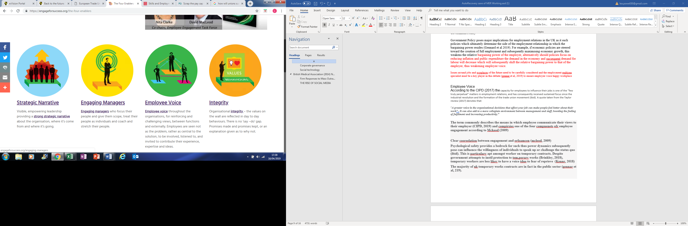
Fig 1.3 Source: McLeod & Clarke (2009)
Their workings suggest an undeniable correlation between engagement and organisational performance, increased productivity and improved staff well-being and retention. Further positive connotations of employee engagement include higher quality production, more satisfied customers and perhaps most importantly for an NHS setting improved patient care.

According to the CIPD (2019) Psychological safety provides a bedrock for employee voice (CIPD, 2019). In order to nurture psychological safety West (2017) advocates that leaders must demonstrate compassion in their leadership and is indicative of the four behaviours illustrated in fig 1.5.
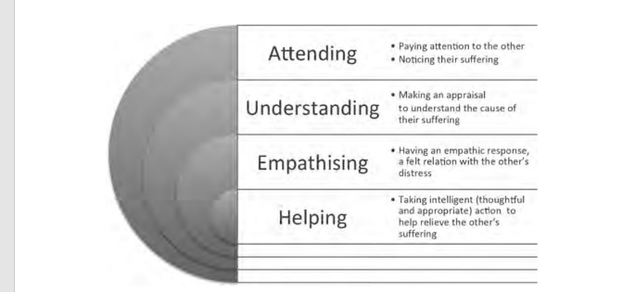
Fig 1.5 Source: Gilbert (2017)

West (2017) further articulates that the demonstration of those qualities illustrated in fig 1.5 instils a culture of inclusivity, trust and engagement within an organisation.

Employee Voice within HDUHB is entirely representative of the recognised trade unions thus not entirely representative of the workforce demographic as a whole. Below offers industry examples of platforms for employee voice.

2.10 Platforms for employee voice

2.10.1 Direct Participation
Traditionally the concept of employee voice comprised the bargaining power bestowed upon trade unions, however as previously discussed in the report, collective agreements as a vehicle to leverage influence has fallen considerably (CIPD, 2011). Findings taken from the Skills and Employment Survey (2017) illustrate that despite this decline the proportion of employees reporting high influence over workplace decisions has increased. Such findings are reflective of the NHS Wales Survey (2018) although at the time of writing this report there is no narrative to suggest what channels are used to influence decisions in the workplace.

2.10.2 Corporate Governance
In 2017 the government sets out three key proposals for reform to strengthen the voice of employees, (DBEIS, 2017) one of which requires listed companies to ensure an employee representative on the board, as is already normal practice across Europe (CIPD, 2019). However, there is no one size fits all approach and similarly there is no one single to solution to the creation of meaningful employee voice (ibid).

2.10.3 Social Technology
In recent years technology has enabled new mechanisms for employee voice (CIPD, 2019). Social networks, such as yama offer employees a platform for employees to express their views and network with colleagues. However as touched upon previously social media can also have a negative impact upon workplace relations

2.10.4 Green spaces
The degree of discretion in which employees have and the demands placed upon them is particularly salient in psychology (Wood, 2008). A range of bodies, inclusive of Government agencies, advocate the possible physical and mental health benefits of access to green space (Houses of Parliament, 2016). A study carried out in 2015 by Colley et al to determine the impact of both using and viewing green space at knowledge sector workplaces found that use of open space and views of vegetation were positively associated with well-being. According to CIPD (2019) promoting well-being can create positive working relationships

2.10.5 The union response- Strategies for Survival
Recent reforms such as minimum wage, globalisation and the rise of the flexible service sector (The Economist, 2015) has caused the dramatic changes to the world of work (Deloitte, 2017). If trade unions want to survive they must, according to Newcombe (2013) accept and adapt to these changes rather than fighting for the same employment landscape of the 1950’s. Strategies for survival therefore include a possible co-existence or combination of trade unions and other union-type organisations that exist to defend employee rights and interests (Vandele, 2017).
While Simms and Holgate (Gennard et al, 2019) consider an alternative union approach to comprise:
- The recruitment and development of new union leaders
- The encouragement of a culture of “self organisation” whereby members take responsibility for resolving issues.
- Increase membership density

2.10.6 The non-union alternative
The decline in trades union membership in recent times and the lack of alternative representation in UK employment terms is referred to as the representation gap (Gennard et al, 1997). In 2011 11% of non-union representation was found in 7% of workplaces (van Wanroy, 2011) a statistic to which Bryson and Gomez refers to as “never members: individuals who have never and are unlikely to experience unionisation.
Dundon and Gollan (2007) articulate that a renewed focus has subsequently been placed on direct consultation arrangements between employees and employers. They advocate that the following techniques constitute the employment relations agenda for todays organisation:
- non-union works councils,
- joint consultative committees,
- quality circles,
- work teams
They further advocate that employee voice in a non-unionised environment must be contextualised against a broad set of strategies and external environmental influences as illustrated in the below framework (fig 1.6)

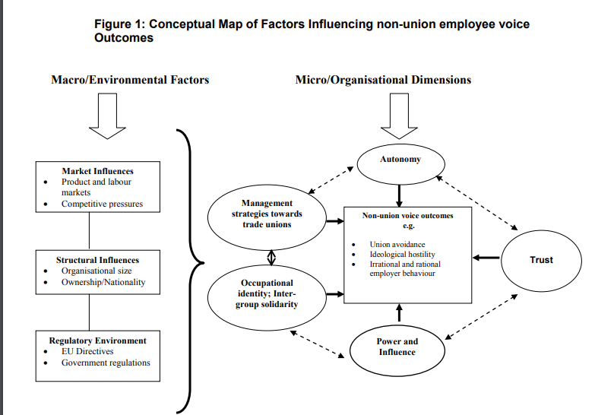
Source Dundon and Gollan (2007)
Ultimately strategies for employee voice can be quite complex due to the interplay between the macro and micro level components (Marchington et al, 2001).
Despite the prevalence of the non-union form and little prospect of a return to high levels of unionisation (Dundon & Gallon, 2007) a lack of empirical evidence exists to suggest the effectiveness of such mechanisms in the workplace (Gennard et al, 2019) and such concepts are more pertinent in the private sector. Dundon & Gallan (2007) however, consider that in the face of declining union numbers the efficacy of a non-union voice is critical to employees, organisations and the economy as whole.

3.0 Conclusion
In recent years the very nature of ‘work’ has changed as a consequence of mega trends in the contemporary workplace (Mercer, 2018), these are creating new challenges for employees to influence working practices (CIPD, 2019).
According to the CIPD (2019) an effective mechanism of employee voice is attributable to increased levels of employee engagement, job satisfaction productivity and organisational performance such workings are further corroborated in literature by Macleod (2009) and West (2017).
Additional exploration of the literature denotes a move away from the collective bargaining approach of the 1970’s toward that of an individualistic, unitarist approach (Gennard et al, 2019). However little empirical evidence exists to suggest its effectiveness (ibid) but such non-unionised concept tends to be more of a predominant feature throughout private organisations.

In 2017 union membership within the public sector constitute 51% of the workforce. As a government organisation HDUHB has a legal obligation to engage in a partnership approach to employment relations through such mechanism as the Local Partnership Forum. Yet by operating in such a manner almost half of the workforce is immediately excluded.

Given the “missing or non-included voice” (CIPD, 2017) HDUHB must seek to transform the way in which it engages with staff. Subsequently, if HDUHB is to secure the successful delivery of its Healthier Mid and West Wales Strategy, it must put mechanisms in place that enable and encourage an inclusive approach to employee voice. Failure to do so could result in kick back from staff and the de-railing of the transformation programme, proving extremely costly for HDUHB.

4.0 Recommendations
- To actively promote the local partnership forum via engagement events throughout HDUHB.
For Workforce & OD to engage with various unions to proactively promote the LPF and its purpose via various engagement events over the course of May 2019 throughout HDUHB, including induction events.
The purpose of such will be to:
- Promote union membership and its benefits, i.e. paid time off for union duties.
- To promote the purpose of the LPF and some of the positive outcomes, i.e. the recent pay rise for Agenda for change staff and how this was influenced in part by the LPF.
- To encourage employee voice
In doing so it is anticipated that staff will feel empowered to have a voice in the workplace and encourage prosperous working relationships which in turn will improve engagement and have a positive impact on organisational performance and patient care (West, 2017).
Such activity will further allow for adequate opportunity to dispel any historic myths and misconceptions surrounding either the Unions or LPF and actively encourage the membership of new staff, thus allowing for a completely different perspective and new, possibly innovative approaches to partnership working which will ultimately result in staff feeling empowered and valued and more inclined to ‘speak up’.
- Utilise Social Media Platforms
HDUHB is a large organisation that covers a quarter of the landmass of Wales. The LPF must take a proactive approach in disseminating information via the intranet within a week of convening. This will allow for the breakdown of geographical barriers and staff from all sites to feel equally informed and valued. Open and honest communication is immediately encouraged and staff groups will have the opportunity to contact their relevant union representative for discussion. Such approach is likely to instil a positive employment relations climate and reduce challenge and ‘kick back’ from the employees.
To allow for two-way correspondence a social media platform such as Yama can be introduced. It is likely that by generating awareness and allowing for discussion staff will be more inclined to get involved in partnership working and ‘raise their voice’ for the good of the organisation.

3.Green Space Well-Being Initiatives
Employee engagement and employee voice are intrinsically linked (Macleod, 2009) thus the importance of well-being in the workplace cannot be underestimated, particularly when the wellbeing of the population is within the jurisdiction of HDUHB.
HDUHB must encourage staff to have ‘walking meetings’, or to hold meetings outside without forgetting professional standards in which their contracts are governed as advocated by Public Health Wales.
Staff should further be encouraged to help maintain the grounds of the hospital on a volunteer basis to harbour a green space that promotes well-being. This will allow for a more aesthetically pleasing environment as according to the study by Colley et al (2015) even viewing plantation can have positive implications for individuals’ well-being.
Healthier staff promote better organisational outcomes which in turn promote positive outcomes for the patients.

An action plan and costings can be located at Appendix 3 respective of each recommendation.

5.0 References

Bach (2011) Future of Workplace Relations discussion paper series available at: http://www.acas.org.uk/media/pdf/m/c/Future-workplace-relations-series-public-service-accessible-version-august-2011.pdf (accessed 16.04.2019)

Baer, 2018 Social Media proves to boost employee engagement. Forbes https://www.forbes.com/sites/forbesagencycouncil/2018/02/13/social-media-proves-to-boost-employee-engagement/#6d6a7bab4db5 accessed (15.04.2019)
Bell, T (2019) Austerity may be on the way out – but its legacy will haunt us for years. The Guardian available at: https://www.theguardian.com/business/2019/apr/07/austerity-on-way-out-legacy-haunt-us-for-years (accessed 10.04.2019)
Bhargava, Vikram (2018) Firm Responses to Mass Outrage: Technology, Blame, and Employment Journal of Business Ethics, Oct 2018, pp.1-22

Brinkley (2018) In defence of Zero hours contracts. CIPD available at https://www.cipd.co.uk/news-views/cipd-voice/issue-14/defence-zero-hours-contracts (accessed 12.04.2019)

British Medical Association (2014) NHS 'buckling under pressure' of austerity, finds report available at: https://www.bma.org.uk/news/2014/july/nhs-buckling-under-pressure-of-austerity-finds-report (accessed 11.04.2019)
Cardiff University (2017) Skills and employment survey https://www.cardiff.ac.uk/research/explore/find-a-project/view/626669-skills-and-employment-survey-2017
CIPD (2019) Employee Voice Factsheet https://www.cipd.co.uk/knowledge/fundamentals/relations/communication/voice-factsheet (accessed 10.04.2019)

CIPD (2018) Employee relations an introduction available at https://www.cipd.co.uk/knowledge/fundamentals/relations/employees/factsheet (accessed 16.04.2019)

Colley, K; Brown, C; Montarzino M (2015) Workplace settings and wellbeing: Greenspace use and views contribute to employee wellbeing at pen-urban business sites Landscape and Urban Planning 138:32-40 · June 2015 with 499 Reads
David Gunnell, Jenny Donovan, Maria Barnes, Rosie Davies, Keith Hawton, Nav Kapur, Will Hollingworth, Chris Metcalfe (2015) The 2008 Global Financial Crisis: effects on mental health and suicide. University of Bristol http://www.awp.nhs.uk/media/757861/policyreport-3-suicide-recession.pdf (accessed 16.04.2019)

DBEIS (2017) Corporate Governance Reform https://assets.publishing.service.gov.uk/government/uploads/system/uploads/attachment_data/file/640470/corporate-governance-reform-government-response.pdf (accessed 13.04.2019)
Deloitte (2017) Future of Work https://www2.deloitte.com/global/en/pages/human-capital/topics/future-of-work.html

Deloitte (2017) workplace transformations in the digital age https://www2.deloitte.com/content/dam/Deloitte/ch/Documents/innovation/ch-en-workplace-of-the-future.pdf

Department for Business Innovation and Skills (DBS) (2016) Trade Union Act Becomes Law available at https://www.gov.uk/government/news/trade-union-act-becomes-law (accessed 15.04.2019)
Devlin (2016) Massive surge in London’s gig economy. New Economics Foundation https://neweconomics.org/2016/12/massive-surge-londons-gig-economy/ (accessed 09.04.2019)
Dundon and Gollan, (2007) Re-conceptualising non-union voice, International Journal of Human Resource Management, 18 (7): 1182-1198

Elliott, F (2017) Austerity is over, May tells Tories. The Times
Gilbert (2017) Compassion Concepts research and application. Routledge. Oxon
Grady, Jo. "The State, Employment, and Regulation: Making Work Not Pay." Employee Relations 39.3 (2017): 274-90.

Haldenby (2015) The BMA will ruin our doctors. The Telegraph

HDUHB (2015) partnership working available at: http://www.wales.nhs.uk/sitesplus/862/page/75786 (accessed on 15.04.2019)
HDUHB (2018) A Healthier Mid and West Wales. Our Future Generations Living Well Available at: ttp://www.wales.nhs.uk/sitesplus/documents/862/A%20Healthier%20Mid%20and%20West%20Wales%20FINAL%20amended%20-%2028.11.18.pdf (accessed 12.04.2019)

HDUHB (2018) Annual Quality Report

HDUHB (2019) A Healthier Mid and West Wales. More Information about staffing, technical document to support the strategy.

Housesofparliament(2016) green space and health. Parliamentary office of science and technology file:///C:/Users/Powell/Downloads/POST-PN-0538.pdf (accessed 10.04.2019)
Kelly, G (2017) Trade Unions – adapt to the modern world or die. Financial Times https://www.ft.com/content/f65a8510-4626-11e7-8d27-59b4dd6296b8 (accessed 07.04.2019)
Kenner, M (2018) Organisations keeping workers on agency contracts for years to undermine pay. People Management available online at: https://www.peoplemanagement.co.uk/news/articles/organisations-keeping-agency-contracts-undermine-pay (accessed 05.04.2019)

Kings Fund (2017) The impact of NHS financial pressures on patient care available at https://www.kingsfund.org.uk/projects/impact-nhs-financial-pressures-patient-care (10.04.2019)

Kingsfund (2015) Devolution: what it means for health and social care in England available at: https://www.kingsfund.org.uk/sites/default/files/field/field_publication_file/devolution-briefing-nov15.pdf (accessed 27.03.2019)

Lamb, M (2017) Trade Unions on the Decline? UK employment Hub available at http://www.ukemploymenthub.com/trade-unions-on-the-decline (accessed 06.04.2019)
Lay (2018) NHS disciplines 1200 staff for misusing social media The times https://www.thetimes.co.uk/article/nhs-disciplines-1-200-staff-for-misusing-social-media-cwtt2s6m6 (accessed 11.04.2019)
Marchington, M., Wilkinson, A., Ackers, P. and Dundon, T. (2001). Management Choice and Employee Voice, Research Report. CIPD: London.

Marr, B (2018 What is Industry 4.0? here’s a super easy explanation for anyone. Forbes .available at https://www.forbes.com/sites/bernardmarr/2018/09/02/what-is-industry-4-0-heres-a-super-easy-explanation-for-anyone/ (accessed 05.04.2019)
Mercer (2018) Delivering the Workforce for the Future: Open-Source Talent. Available at: http://www.mercer.com/our-thinking/career/delivering -the--workfoce-for-the-future-open-source-talent.html [accessed on 10.04.2019]

Mulgan, G (2008) When money is too tight The Guardian available at: https://www.theguardian.com/society/2008/oct/15/banking-crisis-public-services (accessed 16.04.2019)

Patel, Laleh (2010) "The Rise of Social Media" T + D, Jul 2010, Vol.64(7), pp.60-61,8

Peng, G; Wang Y: Han, G (2018) Information technology and employment: the impact of job taks and worker skills Journal of Industrial Relations January 8 2018 vol 60 issue 2 2018 https://doi-org.ezproxy.uwtsd.ac.uk/10.1177%2F0022185617741924

Prassl, J (2018) Humnas as a service. The promise and perils of work in the gig economy. Oxford. Oxford University press

Roper (2018) Trade union membership is growing, but there’s still work to do. TUC https://www.tuc.org.uk/blogs/trade-union-membership-growing-there%E2%80%99s-still-work-do (accessed 16.04.2019)
Srnicek (2017) Platform capitalism. Cambridge. Polity Press

The Economist (2015) Why trade unions are declining https://www.economist.com/the-economist-explains/2015/09/29/why-trade-unions-are-declining (accessed 10.04.2019)

TUC (2017) Trade Union Act 2016 - A TUC guide for union reps available online at:
TUC (2017) Trade Union Membership is growing. https://www.tuc.org.uk/blogs/trade-union-membership-growing-there%E2%80%99s-still-work-do (accessed 16.04.2019)
Unison (2018) Hywel Dda plans inadequate https://cymru-wales.unison.org.uk/news/2018/07/unison-hywel-dda-plans-inadequate/ [accessed (accessed 04.04.2019)
Unison (20185) Hywel Dda Action Group Formedhttps://cymru-wales.unison.org.uk/news/2018/06/hywel-dda-action-group-formed/ (accessed 04.04.2019)
Vandele (2018) Will unions survive in the platform economy? ETUI file:///C:/Users/Powell/Downloads/Working+Paper+2018.05+Vandaele+Trade+unions+Platform+economy+Web.pdf (accessed 04.04.2019)
West, M (2017) Collaborative and compassionate leadership. The Kings Fund https://www.kingsfund.org.uk/audio-video/michael-west-collaborative-compassionate-leadership (accessed 16.04.2019)
Wood (2008) job characteristics, employee voice and well-being in Britain. Industrial relations journal Vol. 39 Issue 2, p153-168 DOI: 10.1016/j.landurbplan.2015.02.004

6.0 Appendices

Appendix 1.0

NHS Wales Recognised Trade Unions:
British Medical Association
Royal College of Nursing
Royal College of Midwives
Unison
Unite
GMB
British Orthoptic Society
Society of Radiographers
British Dental Association
Society of Chiropodists and Podiatrists
Federation of Clinical Scientists
Chartered Society of Physiotherapy
British Dietetic Association
British Association of Occupational Therapists

Appendix 2.0

PESTLE Analysis

P | Political Party - “The organisation of the NHS in each of the four countries is driven by political and systematic considerations, there is an explicit requirement for NHS organisations to meet government legislation.  Government Policy
E | Organisation remains in financial difficulties due to inability to provide services within budget mainly due to temporary staffing (Hywel Dda Annual Plan)  Brexit – “Any Brexit which means leaving the single market could be catastrophic for the NHS and particularly devastating in Wales (BBC Wales, 2017)  Gig Economy
S | Demographics within HDUHB - Current Population within Hywel Dda service area estimated at 384,000 – Projected to rise to 425,400 by 2033, with a proportional rise in over 65’s  Recruitment and retention of staff  Control of variable pay expenditure  (Hywel Dda Integrated Medium Term Plan 2016/17)  Rurality: impact upon recruitment/flexibility of workforce across services/localities (HDUHB IMTP 2016/17)
T | Automated Intelligence  Social Media
L | Acts of Parliament: Nurse Staffing Levels (Wales) Bill 2016, Social Services and Well Being (Wales) Act 2014, Future Generations Act (Wales), Well being of Future Generations (Wales) Act 2015  Remain in compliance with Internal Information Governance Policies, i.e. data protection, patient confidentiality, Health and Safety.  Remain in compliance with any EU/UK Laws.
E | Obligation to work in accordance with Shared Services Partnership CSR Policy

Appendix 3
Recommendation | Actions | When | Who | Cost
1 | Promote union membership and its benefits, i.e. paid time off for union duties  .  To promote the purpose of the LPF and some of the positive outcomes, i.e. the recent pay rise for Agenda for change staff and how this was influenced in part by the LPF. | May 2019  May 2019 | ER Staff & TU’S  ER Staff & TU | Cost implications of staff involved in planning event  Two band 5’s invest 7.5 hours planning equates to approx. £200  Cost implications of staff attending event. Staff will be engaged at lunchtimes and breaks thus cost will only be incurred for workforce staff and promotional materials.  Financial savings of an engaged workforce will far outweigh the remedial costs of such exercise
2. | Take a proactive approach in disseminating information via the intranet within a week of LPF convening  Create media platforms | June 2019 | PA to director of WF & OD | Cost of admin staff to upload minutes on intranet  Admins staff and HR person to create media platform via Yama. Yama accounts are free to organisation. The time involved in creating maintaining the platform will be the only cost involved and will be minimal.
3 | To promote wellbeing via green spaces | Members of wf&od and Public Health |  | Hiring a gardener to clean the gardens and make them safe. £500 per site.  Promotional material to use green space approx. £100.  Sickness currently costs HDUHB £6m any attempt to reduce figure will lead to instant costs savings.

