Statistics for Logistics Assignment (M4X01277)
Todor Stoykov 1702643

Discuss the importance of statistical methods applied for supply chain decisions in the motorsport industries.

Introduction
Statistical methods are used in many different ways for helping making a research and analyzing information in motorsports. In this report I will discuss why collecting data is from great importance for motorsport industries.
Statistics
Making a research is the first step of finding the answer of questions. Moreover, when we make a research we do it to collect data. In case of collecting a certain quantity data that can be measured with numbers by a device, for example a chronometer used to measure the time a race car will do one lap on the race track, It is called quantitative data. By contrast, the other type of data does not use numbers as a way of collecting, but more linguistic methods like descriptions and explanations. It is called qualitative. (Hilton, 2004)
Collecting data in motorsports
When collecting data for research in motorsports most commonly it is quantitative. For example when comparing two different kind of racing championships quantitative data is the main tool in the research because big part of the comparison is based on numeric statistics from both racing series. However, some of the facts are based on descriptions, so qualitative date is used too. (Silva, 2010) Here is a comparison between two completely different series Formula 1 and NASCAR Table 1:
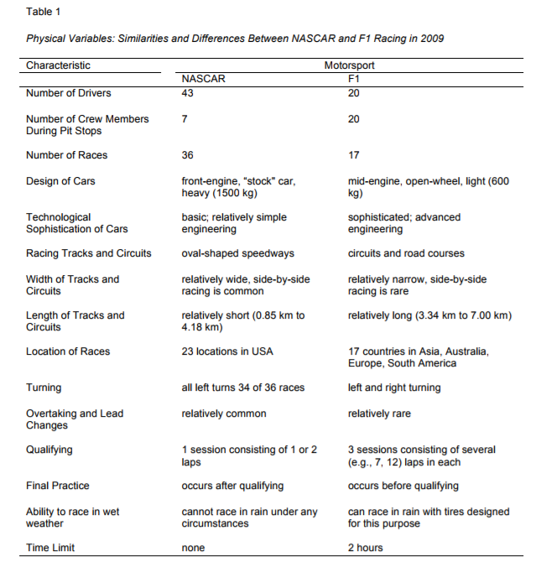

Descriptive statistics in motorsports
From a marketing point of view customers, that are the actual motorsport fans are supplied with the product that is the actual race by the suppliers – the racing championships and organizations. Furthermore, that is exactly why racing organizations always ask the fans when something is not going well in the sport by making online questionnaires. For example, the 2017 season of the World Endurance Championship was not promising and that is why the series organizers made an online survey to ask the fans what they would like to see in the new season and how does it need to be ran. (World Endurance Championship , 2018) Moreover, as it can be seen in the new 2018 season entry list the teams have a visual growth compared to last year’s one. (FIA WEC , 2018) That is a confirmation for the theory that the best way to make a research and collect data in terms of improving a product is to make a questionnaire or survey for the customers.
Economic impact of motorsports and statistical methods used to support it
Generally speaking the need of motorsport related manufacturing is no different to any other industry. That’s why manufactory brands have the tendency to knot in a certain region. Companies that do this normally have these things in common: buyer-supplier relationships; competitor and collaborator relationships; shared resources relationships. The geographical location is a key factor in relationships like these. For example, almost half of the world’s motorsport industry is located in no bigger than fifty-mile radius in England. That’s were almost all Formula 1 parts and cars are developed and made, also most of the Rally cars for the World Rally Championship. (John E. Connaughton, 2006 )
The economic impact of motorsports is measured in the total income of a certain event involving motorsport or the jobs. The best approach of the output is the annual sales and reward that is generated by the organizations that compromise motorsports. A good example for multiplier methodology used in motorsports is the one provided by the Minnesota IMPLAN Group. (John E. Connaughton, 2006 ) ‘’Once the estimates of direct output and employment are established, the multiplier concept can then capture the total effect of the economic activity on output, employment, value added, and employee compensation. For instance, a job multiplier value of 2.1 would mean that for each direct job in an industry, 1.1 additional jobs are generated in other parts of the economy (the total benefit to the economy being 2.1 jobs). Thus, an event or firm that creates 100 new jobs in a particular industry would, through the multiplier effect, translate into a subsequent employment gain of 110 jobs in other sectors, for a total employment gain of 210 jobs (100 x 2.1).’’
Table 2.1 presents the IMPLAN sectors used in this study:
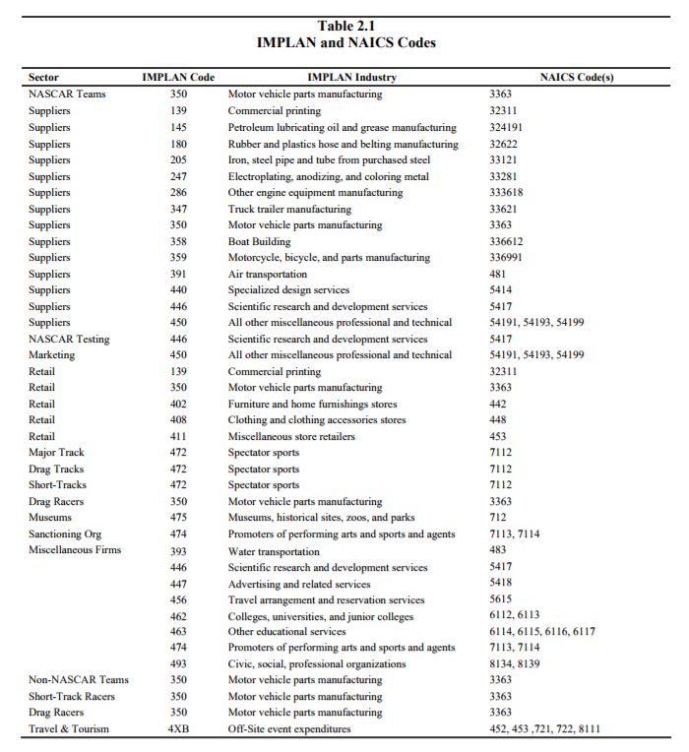
Conclusion
In conclusion, summarizing all that was mentioned above, statistical methods of collecting information and data are the most used in the motorsport industry. Moreover, not only to measure the statistics of the sport between the fans and the customers but also to support decisions in the supply chain of the motorsport industries.

Bibliography

FIA WEC . (2018). Retrieved from FIA WEC : http://www.fiawec.com/
(2004). Statistics Explained . In P. R. Hilton, Statistics Explained (pp. 1-6).
John E. Connaughton, R. A. (2006 ). The Economic Impacts and Occupational Analysis of the Motorpsort industry. The Belk College of Business Unccharlotte , 1-6.
Silva, K. M. (2010). A tale of two Motorpsorts . 1-3.
World Endurance Championship . (2018). Retrieved from Motorpsort.com: https://wecsurvey.motorsport.com/

