Contents
3. Methodology Introduction 2
3.1 Research Strategy 3
3.2 Data Collection 5
3.3 Data Analysis 7
3.4 Limitations & Ethical Considerations 8
3.5 Conclusion 10
3.6 Bibliography 11

3. Methodology Introduction

This study aims to investigate the central research question: Do Women Police Differently? An Examination of Gendered Approaches to Policing and Public Perception. The research is informed by Saunders et al.’s (2023) Research Onion, which provides a framework for considering philosophical stance, research strategy, methodological choice, and data collection techniques. The research objectives to guide this study are as follows:
- To explore how female officers approach policing comparatively to their male counterparts.
- To identify whether there are noticeable patterns in communication styles, empathy, or de-escalation.
- To examine how unconscious biases influence gendered policing and its impact on policing practice and public perception.
Given these aims, this methodology is required to capture both pattern breadth (patterns across a wider population) and depth (individual experiences and perspectives). Therefore, a mixed-methods approach incorporating surveys, semi-structured interviews and Freedom of Information (FOI) requests will be used. This combination allows for triangulation of findings and ensures the research objectives are addressed.

3.1 Research Strategy

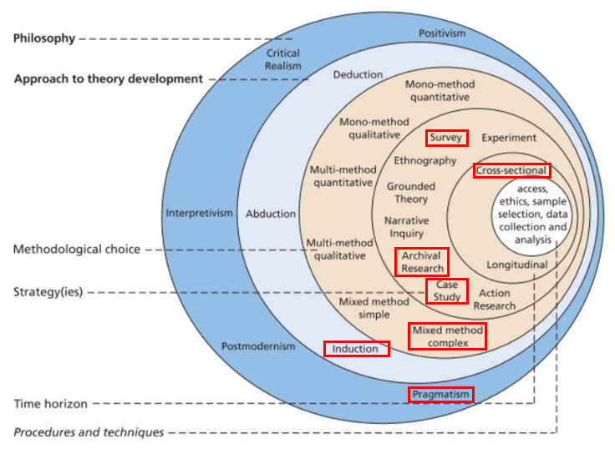
As outlined in Saunders et al’s. (2023) Research Onion, the methodological process begins with the identification of the research philosophy, which serves as a foundation for subsequent strategic and procedural decisions. The below diagram shows the Research Onion, whereby the highlighted fields indicate the researchers’ chosen approaches.

Figure 1.1: The Research Onion (Saunders et al. (2023)). Showing the researchers chosen approaches.

Guided by Saunders et al.’s (2023) Research Onion, this study adopts a pragmatic philosophy, recognising that complex social issues such as gendered policing cannot be fully understood through a single philosophical lens. Pragmatism allows for the integration of quantitative and qualitative methods, making it well suited to addressing the research objectives, which require both measurable comparisons between male and female officers and exploration of subtler dynamics such as empathy, communication, and unconscious bias. In line with this stance, a mixed-method complex design was selected, as the study integrates and triangulates survey and interview findings rather than treating them as parallel, independent strands. This provides both breadth and depth, enhancing the credibility of results.

The chosen strategies consist of an anonymous survey and semi-structured interviews. The survey, targeting 50-100 officers who are either serving or retired, offers a broad overview of gendered statistical analysis. The Semi-structured interviews both male and female officers provide robust accounts of lived experiences ranging from the mid-1980’s through to modern day policing, particularly valuable for exploring how unconscious biases shape practice and public perception. A cross-sectional time horizon was selected, reflecting the dissertations timeframe and aiming to capture a snapshot of current perspectives. Finally, the techniques and procedures include survey analysis through statistics and thematic analysis of interview transcripts. Triangulation across these methods ensures that findings are robust and that all three research objectives, exploring gendered approaches, identifying patterns in communication, and examining unconscious bias, are addressed comprehensively.

3.2 Data Collection

Interviews (Qualitative Component):
Semi-structured, in-depth interviews with 5 female and 5 male officers, across a range of ranks and backgrounds will be utilised within this research. This purposeful sampling ensures representation of diverse perspectives, aligning with the principles of maximum variation sampling (Patton, 2015). Interviews will explore the officers experiences and their perceptions of the public responses, and internal dynamics within the force.

Interviews will be conducted in person, recorded (with consent), then transcribed verbatim for analysis. Semi-structured formats enable flexibility, allowing participants to spotlight issues most salient to their experience, whilst ensuring coverage of key themes like public interactions, use of discretion, emotional labour, and perceived gender expectations.

This interview sample size is appropriate for achieving depth and thematic saturation in a qualitative phase embedded within a mixed-methods design (Guest et al., 2006).

Surveys (Quantitative Component):
An anonymous online survey will target between 50-100 respondents who are either currently serving or retired police officers and policing staff from a range of ranks and policing contexts. Closed questions will collect demographic information (e.g. gender, rank, years of service) and Likert-scale questions will assist in gauging attitudes, perceived public responses, and self-reported behaviours, as opposed to open questions which will invite brief reflections.

Anonymity encourages candid responses on potentially sensitive topics such as gender bias or perceived public responses. Online distribution through police associations ensures a wide reach while preserving privacy. Targeting 50-100 survey respondents’ balances feasibility with the need for variability and statistical breadth, a method in line with recommendations for exploratory mixed-methods studies (Saunders et al., 2023).

Freedom of Information Requests (FOI):
In addition to primary data, FOI requests will be submitted to Heddlu Gwent Police to obtain secondary data, such as:
- Use of Force forms submitted in the year 2024-2025 and the level of force used, with the data segregated by gender.
- Complaints received in the same year in relation to Use of Force, using the same criteria.
FOI data offers a valuable institutional perspective, helping to contextualise individual accounts. For example, survey and interview findings on bias can be triangulated with organisational statistics on Use of Force. This strengthens the validity of findings by integrating personal experiences with documentary evidence (Bowen, 2009).

3.3 Data Analysis

Qualitative Data:
Interview transcripts will be analysed using thematic analysis (Braun & Clarke, 2006). The process will involve familiarisation, coding, theme development, review, and definition. Themes will be mapped to the objectives listed above.

Survey Data:
Closed responses will be analysed using statistics to identify trends, and where possible, open non-parametric tests will be applied to compare male and female responses, which will then be thematically coded to capture additional insights.

Interview Data:
Interview transcripts will undergo thematic analysis (Braun & Clarke, 2006). This involves developing themes, and comparing differences in approach, empathy, and perception of bias. Reflective memo-writing will be used to reduce researcher bias.

FOI Data:
FOI responses will be treated as documentary evidence. Where the data is numerical, statistical analysis will be applied and where responses contain contextual or qualitative information, content analysis will be used.

Integration:
Findings from all three sources will be triangulated, for example, survey results showing higher self-reported empathy among women can be explored through interviews and then compared with FOI data. This integration enhances validity and provides a richer understanding of gendered policing.

3.4 Limitations & Ethical Considerations

Sample size and Representativeness:
The small number of interviews limits the transposing of responses into qualitative findings. By limiting the exposure of the initial question set, the survey results collected via non-probability sampling, may not represent the wider population.

FOI Data Quality:
Responses may vary in completeness and format, and some forces may decline requests or withhold certain information.

Time Constraints:
The cross-sectional design captures perceptions and experiences at a single point in time, meaning findings may not reflect changes over time. There are gaps in the data from the 1980’s to modern day policing as it has not been previously captured, preventing the researcher from making a direct comparison.

Sensitivity of Topic:
Discussions about bias, gender, and policing may cause discomfort. This will be mitigated through careful question framing, the right to skip questions, and signposting to support resources.

Ethical considerations:
Ethical considerations are central to this study, particularly given the sensitive nature of policing and gender. All participants will be provided information prior to their involvement ensuring informed and voluntary participation, and they will be reminded of their right to withdraw at any time.

Anonymity and confidentiality will be strictly maintained. Survey responses will be fully anonymous, and interview data will have all personal details removed. Data will be securely stored and only accessible to the researcher. Given the potential for sensitive issues such as discrimination or bias to arise, interviews will be conducted with care, allowing participants to skip questions or pause. FOI requests, as a form of secondary data collection, involve a minimal ethical risk since the information is publicly available, however, responses will still be handled responsibly and stored securely.

3.5 Conclusion

This methodology, structured using Saunders’ Research Onion, combines a quantitative officer survey with qualitative interviews, and FOI data to provide a comprehensive exploration of gendered approaches to policing. A complex mixed-methods design was chosen, combining surveys, semi-structured interviews, and FOI requests to address the three objectives: exploring gendered approaches, identifying patterns in communication and empathy, and examining unconscious bias.

Surveys provide breadth and comparability across male and female officers, interviews provide depth and nuance, and FOI requests supply official institutional data that contextualise and validate primary findings. Data analysis will combine statistics, thematic analysis, and documentary analysis, using triangulation to ensure robustness. While limitations around sample size, representativeness, and FOI responses are acknowledged, strong ethical safeguards underpin the study.

Together, this methodology provides a balanced and rigorous approach, ensuring that the research objectives are comprehensively addressed and contribute valuable insights into whether, and how, women police differently.

Word Count: 1,369

3.6 Bibliography

Bowen, G. A. (2009). Document Analysis as a Qualitative Research Method. Qualitative Research Journal, 9(2), 27–40. https://doi.org/10.3316/QRJ0902027. Accessed 18th August 2025.
Braun, V. and Clarke, V., 2006. Using thematic analysis in psychology. Qualitative Research in Psychology, 3(2), pp. 77-101. Accessed 9th August 2025.
Guest, G., Bunce, A., & Johnson, L. (2006). How Many Interviews Are Enough? An Experiment with Data Saturation and Variability. Field Methods, 18(1), 59–82. https://doi.org/10.1177/1525822X05279903. Accessed 31st August 2025.
Patton, M. Q. (2015). Qualitative research and evaluation methods (4th edition.). SAGE. Accessed 31st August 2025.
Saunders, M. N. K., Lewis, P., & Thornhill, A. (2023). Research methods for business students (Ninth edition.). Pearson Education Limited. Accessed 11th August 2025.

