‘Getting deep’: A heuristic exploration on my personal development as a practitioner and its impact on my clinical practice.

I confirm that I have not used any AI tools in the research and creation of this assignment. I confirm that I have not presented any AI generated materials as my own work. I confirm I have copies of my drafts, notes, and other resources I used, which I may be asked to provide in evidence.

Introduction

The Heuristic inquiry is an unparalleled humanistic qualitative research methodology that I will be using within this paper. It was developed by the humanistic researcher and psychotherapist Clark Moustakas (1923–2012) as a way of evaluating the human experience and its meaning while harmonising with the beliefs of humanism and its psychology, it underlines an individuals’ personal experience, making meaning of something and more importantly assisting self-actualization (Lewis-Beck et al., 2004).

The heuristic approach is different to conventional research as it will involve myself as the researcher and my own lived experience within the study, making my question the initial focus (Hiles, 2002).
Where do I start? I must be honest, I'm not so sure I’ll succeed in creating any such resemblance to a viable heuristic inquiry as I've never had to do one before, but as everything in my life, I'll give it a good go!

Self-enquiry
So, two years ago, when the excitement of beginning my master’s degree enthralled me, I didn’t know who I was, how I felt or what I was capable of. I had no idea what I was doing from one day to the next, I was still healing from trauma and still drowning in sadness from being a mother without her child........ but I was unaware of this, I was ok now, right? How I was unaware I don’t know; I suppose these feelings became the norm and I'd forgotten how to feel any other way. There is a picture that often pops up on social media that I relate too and perfectly depicts the feeling of being a child-loss mother, this was the emotional state I was stuck in. (See appendix A – Drawing of grieving mother).

My lack of self-awareness has since come to light during the last two years of my life through journaling, mindfulness exercises, skills practice, and study. These past two years I have been given the time, space and tools by my tutors to do so much soul searching, to learn how to be aware of my own body, mind, thoughts, feelings and self. It has helped me to take back control of my life, given me hope and eased the total feelings of helplessness and hopelessness that ate away at me, while also giving me a real ability to understand my trauma and assisting with letting go of the feeling of being in a constant state of fight or flight... With the help of my peers and tutors of course. Because of this, I am now aware that my self-esteem was at its lowest when I began. I guess this new-found awareness is giving me the opportunity to work on this. Although I have now found a little self-love, care and forgiveness for me and I am aware I still have a long way to go, but don’t we all?

As a woman that has known what career path I have wanted to take since I was a child, my low self-esteem causes me too often to ask myself; am I good enough? Is there more I can do? Do my clients think I'm any good? Am I really helping them? Throughout my short time training as a therapist and working on placement with my clients, I have seen such a difference in some of them over their six sessions with me. They haven't just left my sessions seemingly more relaxed compared to when they first came through the door on their initial session, they leave hopeful and happier with less anxiety, sadness and guilt. I have seen a complete turn-around in their visible personality, the way they hold themselves, even the way they walk and talk. ‘Why isn’t this enough for me to feel worthy of my position? Why do I feel like an imposter? I do wonder if it’s because it’s not so visible in others or if I feel I haven’t been able to help them as well as I have been able to help other clients. I find that a lot of my clients have attended their sessions only a few times and left before their 6 sessions came to an end, this makes me wonder if they left because of something I had done wrong or if it’s because they felt they no longer needed the sessions. I guess I’ll never know, which then makes it harder on my self-esteem and fires up the imposter-syndrome. I guess this is something I will continue to make sense of as my placement goes on, but as it stands, I walk into my therapy room and sit, eagerly awaiting my client, and sometimes, I think to myself, “What if someone thinks I shouldn’t be here?” and in that moment, that eagerness for my client turns to waiting for someone to come into the room to tell me to leave.... oh, the humiliation that would bring! Just thinking about it makes my heart race and the hair on my arms stick up on end and I can feel the anxiety beginning to simmer in my chest and throat.

I have discovered through my journaling that I always compare myself to my peers and other people in the same role as me, and so far, I have found a feeling that often bubbles up deep inside me that there is not one person I believe I could compare to. This makes me feel like I must put on a façade that I know what I’m doing to be worthy in their eyes, of my role as their therapist in skills practice (See appendix B – My journal piece).

When, on the odd occasion, I’m able to put my feelings of inadequacy to one side, I realise I do know what I’m doing, and I do a bloody good job at it too (so long as my client isn’t someone I study with). But this doesn’t happen very often…. Maybe the issue is that I feel I’m better at giving life advice due to previous experience, than I am at listening and hoping they discover their path without it. This is where my next interconnected problems come in.

I find myself at times wanting to rescue my clients, specifically within my skills practice. This is more than likely because I see them as friends rather than clients due to us building friendships over the couple of years we have studied together. I notice I feel I want to rescue at such times that I feel I can personally relate with my client due to my own personal past life experiences having similarities to theirs. I mean, no-one wants anyone to suffer, least of all your friends. I know I played a massive part in rescuing myself, so is it that subconsciously I feel I may be able to do the same for them? My problem is the strength of my empathy, I feel ‘hard’, others empathise, but I feel it in depth, deep in my body, in the depths of my soul. I don’t believe this is a bad thing, but I do think I need to work on it being ‘right time, right place’.

When I find myself pulling out my ‘friend’ hat, I know I must pull back and hold tight to my ‘therapist’ hat, and most of the time, I manage to do so before It slips, but on the odd occasion before I realised I had the tendency to try and rescue, I’d leave the room to join back into the class after trying to save them again, feeling like an idiot, an imposter, and kicking myself for putting on my ‘friend’ hat. I mean, that’s not what therapists do! Not only do I need to remember that in that room we are not friends, we are client and counsellor and that’s a different, special kind of relationship, but I also need to remind myself, that they are not me, and I am not them! We do not feel the same, think the same or perceive our problems in the exact same way, so no matter what I have been through, I cannot expect that what worked for me, will work for them just because our circumstances are similar. They are their own individual, experiencing and perceiving their problems in their own way. So, I guess the question is, ‘Why do I have low self-esteem/imposter syndrome and feel the need to rescue my clients?’

Immersion
Theres a quote that I came across and I feel is important for me to remember as a small form of motivation to continue the journey of overcoming my low self-esteem within my work, to succeed and feel worthy of my position rather than feeling like an imposter.

“To attain "success" without attaining positive self-esteem is to be condemned to feeling like an imposter anxiously awaiting exposure.” - (Branden, 2013).

While thinking about my question, it brings to my mind Karpman’s’ drama triangle. Though for me it would more than likely be a drama line. The famous drama triangle was a theory brought about in 1968 by Stephen Karpman who was a psychotherapist. Karpman believed this was the perfect example of how individuals commonly take on an unhealthy role when trying to fix some sort of dispute or conflict. The three unhealthy roles included in the drama triangle are: The victim, The rescuer and of course, the persecutor. Most of the time an individual will only take up one of these roles, but it is possible depending on the current situation, an individual might shift back and forth between these roles. (Attachment project Team, 2024). (See appendix C – Drama triangle)
I believe I tend to bounce back and forth between two of these unhealthy roles, the rescuer and the victim. I believe my low self-esteem has grown from being a victim of trauma and loss, overcome by grief and mental illness causing me to lose who I was before her death which caused my low self-esteem and creating a rescuer. I believe it’s because I can’t fathom the thought of others suffering like I did… I spend my time as the rescuer, fighting against the prosecutor which to me is the pain and anguish, the grief and fear and the psychological issues of my clients. So how do I overcome this? I don’t want to be a victim and i especially don’t want to continue to fall victim to low self-esteem and imposter syndrome. I also want to learn to control the urge to be a rescuer.
I came across a paper that depicts what a rescuer is seen to be, and while i can relate to some of it I’m not exactly agreeable with other parts, in my case at least. The paper states that rescuers tend to have an elevated need or desire to help others that they see as weak minded, emotionally and physically and have a mindset of being a saint. Now we’ve established that I feel the need to help others but i wouldn’t call myself a saint or martyr even though I do my best to be a good person and i definitely don’t see people as weak, i think those that seek help are some of the strongest people i know and some just need to feel supported, as we all do at times.. (L’Abate, 2009; Burgess, 2005; McMahon, 2005). The paper then goes on to say that a rescuers social life is all over the place because they tend to spend most of their free time excessively trying to change, control or improve other peoples’ behaviours and constantly offer unsolicited advice or help. This I do agree with, to a point, i do find myself constantly giving advice to people I care about that's gone off the rails or putting themselves and others in bad situations, you know when you can just see their actions are going to cause them issues but they don’t seem to realise it but i don’t feel I'm controlling, just very opinionated when it comes to actions that will affect their wellbeing.. But then again it may not be my business, yet I over worry, mostly because I’m then left to pick up the pieces after. It then goes on the say a rescuers emotional estate consist of feelings of self-importance and excitement which i don’t find at all. (Shmelev, 2015). I find having these feelings of needing to help people extremely draining and most of the time it feels like a chore as I'm getting taken away from my warm house and kids by people that need me to do stuff for them because they know i will, rather than a euphoric state of self-importance. (Lac & Donaldson, 2020)
I sat with my partner lee to gain an idea of someone else’s perception of why he believes I feel the need to rescue people and why my self-esteem is so low that I feel like an imposter at times. He helped me realise that the days I feel this way are also the days I’m under a lot of stress, and having PTSD, a stress-based illness that also causes anxiety, it effects my mood on a daily basis. When I am stressed, I feel low and anxious, and when I feel low and anxious, I feel bad about myself. He said he notices the change in the way I speak and the way I hold myself. He explained that when I have these low days, I am constantly self-conscious about everything I do, how I look, my weight, my parenting and the quality of human being that I am. So therefore, he believes this may be why I feel like an imposter at times, my negative mindset creates the way I feel about myself.
When I asked him about why he believes I’m a rescuer, he confirmed my thoughts about my past traumas and not wanting others to suffer. He then brought to my attention my friends, he doesn’t believe they are my friends as much as I am theirs. He told me to think about my relationship with a 2 of my friends, he did make a very good point. He reminded me that they became friends of mine only because I helped them.
Friend 1: One of them I met through a multi-level marketing side hustle I was doing, id contacted her to see if she was interested in joining my team, knowing nothing about her other than shed agreed to speak to me about it over facetime. We got talking on that call and she had quite openly told me her life story: She had lost her children because she had a drug problem, and mental health issues due to her drug taking and past traumas…. Within a month I’d helped her get clean, within two months id helped her get back into college, by month three we had made her house a home and by month four I helped her fight for her children… She won.
Friend 2: Another friend of mine I had met over covid, just as things were opening up again but caution was still in place. She had put a picture on Facebook of her 11-year-old daughter that had stopped being able to swallow and was being tube fed. It was purely psychological. She was a single mother isolating with her only child and had no support or friends and no transport. In the photo she had put on Facebook her daughter was crying because she had just had her feeding tube changed and it had hurt her. Really pulled at my heart strings. On that note, I contacted her mum and asked if I could drop off a hamper for her daughter to make her feel better and from then on I became the rescuer once again, I took her daughter out with mine to give mum a rest, I had training by her nurse to learn how to tube feed her using her machine and to this day I am still highly involved with them, helping out wherever I can.
I have never asked for anything from these people and I’m their first port of call when they need something to which I drop what I’m doing to help. I do not regret being their ‘rescuer’, but my partner did make another good point; That this rescuer mentality not only makes a rod for my own back by making them latch on to me but also takes me away from time with my family, that’s my only regret.
Incubation
I find myself talking about my life as ‘before’ and ‘after’. Before I lost my child and after I lost my child. Before I lost my child, I was someone else. I found beauty in everything, I was fun and full of life, my future excited me and I barely ever felt any form of stress or sadness. I had so many friends and so many plans and nothing would get in my way, I was content. Now, I’m someone I don’t recognise anymore. I feel like I have aged before my time, I see the threat in everything and everyone, I’m constantly stressed out and constantly fear for my children and the people I love. I have low self-esteem and never feel content. And one thing that really gets to me, I cannot sit still, I cannot relax, I constantly have to be doing something going somewhere, wanting more from life and trying to do better and be better. I can’t even sit and watch television in the evening without doing something with my hands like felting, artwork or catching up on my Uni-work, and that’s not usually until after 10pm when I finally sit down.

I could never pinpoint why I became like this after my loss. But then I was sitting down in my living room half watching tv and half felting (a great stress relief by the way) trying to take a break from thinking about my essay for a while like I’m supposed to for this part of my study, and then it came to me… It’s not about succeeding at all, it’s about constantly, unknowingly making myself busy as a coping mechanism to avoid thinking too deep for too long, because it hurts my heart… It’s a void that I can only fill by having my child back in my arms. I could never fill that void with all the crap I’ve been trying to do and get. It is always going to be there and by wasting my time making myself busy in an attempt to feel good about myself and fill a void I thought I could fill by doing all this ‘stuff’, thinking that if I succeeded, I would feel better about myself which would build my self-esteem and stop me feeling like an imposter. I thought it would help me feel like a strong, confident, successful woman instead of this mess of a shadow of who I once was. I now realise that by filling my time up with it I’ve been missing out on the small things with the children I still have. The incubation period has made me realise it’s time to up my game and start focussing on the right things. Being more present with my children and concentrating on building my self-esteem by being gentler with myself and consistently challenging the negative thoughts. This way I will not only be happier but will become a much more confident counsellor…. That’s what I feel will deeply benefit both my personal life and my professional career.

Illumination
Since starting my training as a counsellor I have evolved, I see it in everything I do. Maybe not as much as I need to but as we know, the journey to self-actualisation and building self-esteem is never fully over. But since starting my degree my self-esteem has developed and my feelings of imposter syndrome aren’t as bad as they were, although it’s still rife within me. I do still have a lot of work to do with overcoming the need to rescue, but for this reason I am so grateful ethical practice and boundaries are in place within the therapy room. I find my self-esteem has improved because of the secure, supportive and empathetic environment from which we all stroll into on a Thursday morning. I believe stepping out of my comfort zone with having to do presentations in front of an audience has improved my self-esteem as well. I’m still proud of myself for being the first student in the class to offer to guide a mindfulness relaxation exercise with, and in front of, the whole class. That shows big steps forward in my efforts to build my confidence and it did go very well to which I’m now very confident in practicing these exercises with my clients in my placement. I know I have the confidence inside me to continue to dip my toe in the ‘scary pool’, but this course has given me the confidence to really chase my passion and use my therapeutic abilities, resilience and personal experiences to truly help change someone’s life for the better.

Explication and Creative synthesis
The last two phases I’m finding hard to distinguish between and I’ve practically already done it throughout this piece of work and rationalised my thought process based on what I have learnt while thinking about why I am the way I am. I mean, my partner lee basically explained his beliefs as to why I feel the need to rescue people and why my self-esteem is so low that I feel like an imposter, and he hit the nail on the head! My PTSD causes anxiety and stress, which effects my mood and when I am stressed, I feel low and anxious, and when I feel low and anxious, I become critical of myself, and I am constantly self-conscious. Hence, the imposter syndrome. Then, when I asked him about why he believes I’m a rescuer, he confirmed my thoughts about not wanting others to suffer like I did so I feel like I should rescue them.
Of course, I know it will take more practice and experience and more self-healing from my trauma, self-awareness and consistently pushing myself out of my comfort zone but I will get to the point that imposter syndrome and self-criticism will lessen as time goes on, though maybe not dramatically, but it is a journey, and a journey I’m excited to take.
I’ve mentioned earlier within my inquiry that I lost the person I was when I lost my child and now, I’m a whole new person I don’t recognise and I feel this also has a massive impact on feeling like an imposter… I know this is a common reality for those that have lost a child, it’s the effects of trauma, losing a child in itself is traumatic without the future diagnosis of PTSD. There are still times I don’t know who I am, I feel numb, dissociate, and don’t recognise myself. I found clips from two papers which explain that these issues I experience may be because trauma of any kind seriously effects an individuals’ sense of self and who they are, leaving a cognitive and somatic stamp on their innate sense of self. Those who have experienced trauma can find themselves plagued with negative thoughts and beliefs about themselves like the belief they will never be emotionally stable again, they will feel they have lost their identity. People with PTSD will have somatically based changes in their experiences of self like dissociation, disturbances in their identity and feelings of disembodiment. This will cause them to feel like they’re having outer body experiences and like their body belongs to someone they no longer recognise. Reports such as these emphasize the helplessness of the sense of self in trauma survivors where both types of disturbances to a persons’ sense of self seemingly mirror small parts of the past trauma experiences by individuals with Post traumatic stress disorder (Lanius et al., 2020).

As we all know It’s extremely important that to enable the therapist to give effective sessions to their clients they must ethically, be emotionally and psychologically sound of mind. Its extremely important for therapists to have an awareness of how many different types of environmental and personal issues can factor in on the mental and emotional health of a therapist. A common issue that is often linked to anxiety, depression, emotional instability and burnout is imposter syndrome, a phenomenon that is characterised by feelings of being seen as a fraud, self-doubt, and not being able to accept their successes within their career. All of which are also symptoms of trauma (Clark et al., 2021).

No part of this self-inquiry has been linear, I have bounced back and forth between stages throughout so when it’s come to writing about it, I am aware that it’s a little bit all over the place as I’ve written it as it’s come to mind. And I’m ok with that… The emotional process I went through during this inquiry have been bumpy as well. At times I’ve felt mildly triggered and stressed. I then experienced anxiety, shame, denial, annoyance (at myself) and at times a little sadness, but then as my inquiry went on, I began to experience gentler emotions like empathy for myself, excitement for the future and most of all, curiosity as to what I may later discover about myself. At the end of the day, I’m grateful to have learnt so much about myself. Yes, there are still so many questions unanswered that stem from my main question but I’m looking forward to exploring these in the future. I have come to terms with my experiences and I’m on a path to healing the negative self-sabotaging parts of me that I still need to work on that I feel hold me back. It feels good to finally have an idea about why I function the way I do and how I can move forward with my personal growth as a therapist.

So, there it is laid out as the big bad bare truth, my authentic self. Since doing this inquiry I am beginning feel its ok to accept who I have become. This piece of work really opened a can of worms, but it’s also really taught me a lot! And there’s even a poem. (See appendix D – Short poem).

Word count: 4,399

References

- Branden, N. (2013) Our urgent need for self-esteem, Nathaniel Branden. Available at: https://nathanielbranden.com/our-urgent-need-for-selfesteem/ (Accessed: 13 February 2025).
- Burgess, R. C. (2005). A model for enhancing individual and organisational learning of “emotional intelligence:” The drama and winner’s triangles. Social Work Education, 24, 97–112.
- (PDF) Development and Validation of the Drama Triangle Scale: Are You a Victim, Rescuer, or Persecutor?. Available from: https://www.researchgate.net/publication/344240252_Development_and_Validation_of_the_Drama_Triangle_Scale_Are_You_a_Victim_Rescuer_or_Persecutor [accessed Feb 14 2025].
- Clark, P. et al. (2021) ‘The impostor phenomenon in mental health professionals: Relationships among compassion fatigue, Burnout, and Compassion Satisfaction’, Contemporary Family Therapy, 44(2), pp. 185–197. doi:10.1007/s10591-021-09580-y.
- Drama triangle explained: How to recognize and Escape it - ap (2024) Attachment Project. Available at: https://www.attachmentproject.com/psychology/drama-triangle/ (Accessed: 13 February 2025).
- Hiles, D. (2002) Narrative and Heuristic Approaches to Transpersonal Research and Practice, Narrative and heuristic inquiry - (C) Dave Hiles 2002. Available at: http://psy.dmu.ac.uk/drhiles/N&Hpaper.htm (Accessed: 13 February 2025).
- Lac, A. and Donaldson, C.D. (2020) ‘Development and validation of the Drama Triangle Scale: Are You a victim, rescuer, or persecutor?’, Journal of Interpersonal Violence, 37(7–8). doi:10.1177/0886260520957696.
- Lanius, R.A., Terpou, B.A. and McKinnon, M.C. (2020) ‘The sense of self in the aftermath of trauma: Lessons from the default mode network in posttraumatic stress disorder’, European Journal of Psychotraumatology, 11(1). doi:10.1080/20008198.2020.1807703.
- Lewis-Beck, M.S., Bryman, A. and Liao, J.F. (2004) ‘Heuristic inquiry’, The SAGE Encyclopedia of Social Science Research Methods [Preprint]. doi:10.4135/9781412950589.n394.
- L’Abate, L. (2009) ‘The drama triangle: An attempt to resurrect a neglected pathogenic model in family therapy theory and Practice’, The American Journal of Family Therapy, 37(1), pp. 1–11. doi:10.1080/01926180701870163.
- McMahon, D. (2005). The drama triangle. In R. M. Schwarz, A. Davidson, P. Carlson& S. McKinney (Eds.), The skilled facilitator fieldbook: Tips, tools, and tested methods for consultants, facilitators, managers, trainers, and coaches (pp. 421–431). John Wiley & Sons
- (PDF) Development and Validation of the Drama Triangle Scale: Are You a Victim, Rescuer, or Persecutor?. Available from: https://www.researchgate.net/publication/344240252_Development_and_Validation_of_the_Drama_Triangle_Scale_Are_You_a_Victim_Rescuer_or_Persecutor [accessed Feb 14 2025].
- Partnership Team, L. (2024) About the drama triangle – and how to escape it: Listening partnership, Listening Partnership | Oxford. Available at: https://www.listeningpartnership.com/insight/about-the-drama-triangle-and-how-to-escape-it/ (Accessed: 13 February 2025).
- Shellman, C. (2020) Broken heart syndrome, A Bed for My Heart. Available at: https://abedformyheart.com/broken-heart-syndrome/ (Accessed: 13 February 2025).
- Shmelev, L.M. (2015) [PDF] beyond the Drama Triangle: The overcoming self | semantic scholar, Semantic Scholar. Available at: https://www.semanticscholar.org/paper/Beyond-the-Drama-Triangle:-The-Overcoming-Self-Shmelev/ae1d15b44b488c8c98e1684e86cd3d8dbe697f75 (Accessed: 14 February 2025).

Appendices’

Appendix A
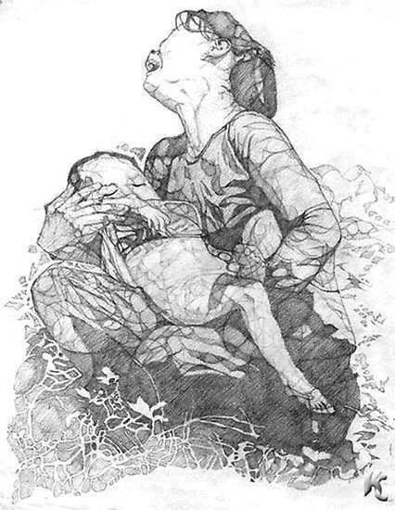
Broken Heart Syndrome by artist Angela Miller.
A drawing that depicts exactly how it feels to be a mother of child-loss. The day i lost myself and everything that made me who I was.
(Shellman, 2020)

Appendix B

Personal Journal quote: 28/09/2023
“Today was a challenging day, emotionally and mentally, I woke up not feeling great and was tired. The exercises we were given to do were good though, really helped me pull myself together a bit, but I was dreading skills practice, I always feel like an imposter and the skills of everyone I have worked with so far seemed to be so much better than mine. Also, when I’m in the skills sessions I also feel like my skills are being judged by the client and it makes me so uncomfortable I just get all stuttery and can’t think straight. Which is really irritating to me because outside of skills practice, I think I may be pretty good at what I do. Of course, I still get imposter syndrome but at least my clients don’t know me to judge me as easily as my student peers do. Plus, they’re more worried about feeling better and their own problems than they are about me….”

Appendix C
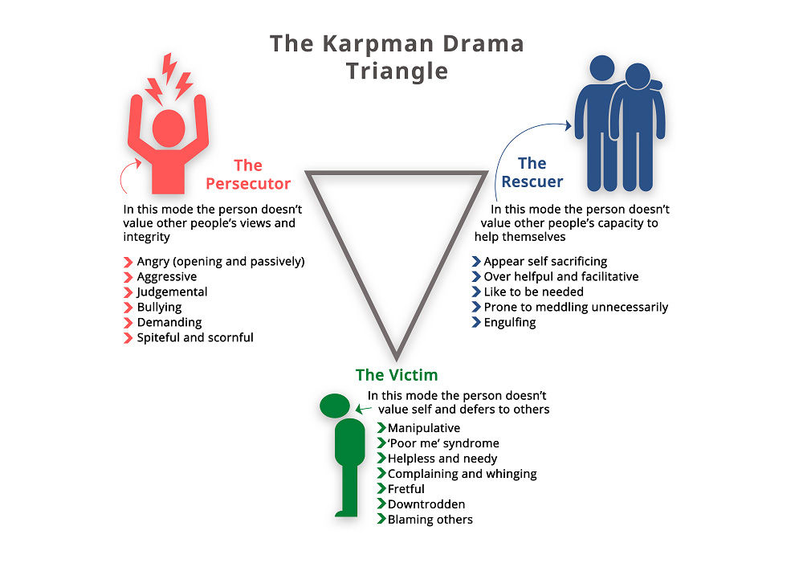
The Karpman drama triangle.
(Listening Partnership, 2024)

Appendix D

So, there we are, this is me, laid out for all to see,
My authentic self, I must be,
But what has this inquiry taught me?
Don’t hide in the shadows?
Don’t shy away?
I’m better than I was yesterday.
My futures bright,
I can help many,
Once I’ve progressed on my healing journey.

