DS 1 Template

My Screenshots/Photos
- Please add 4–6 screenshots or photos of your digital life.
- You can use your phone or laptop.
- For each screenshot, write one or two sentences explaining what it shows.

Screenshot/Photo 1
[Insert Photo/Screenshot below]
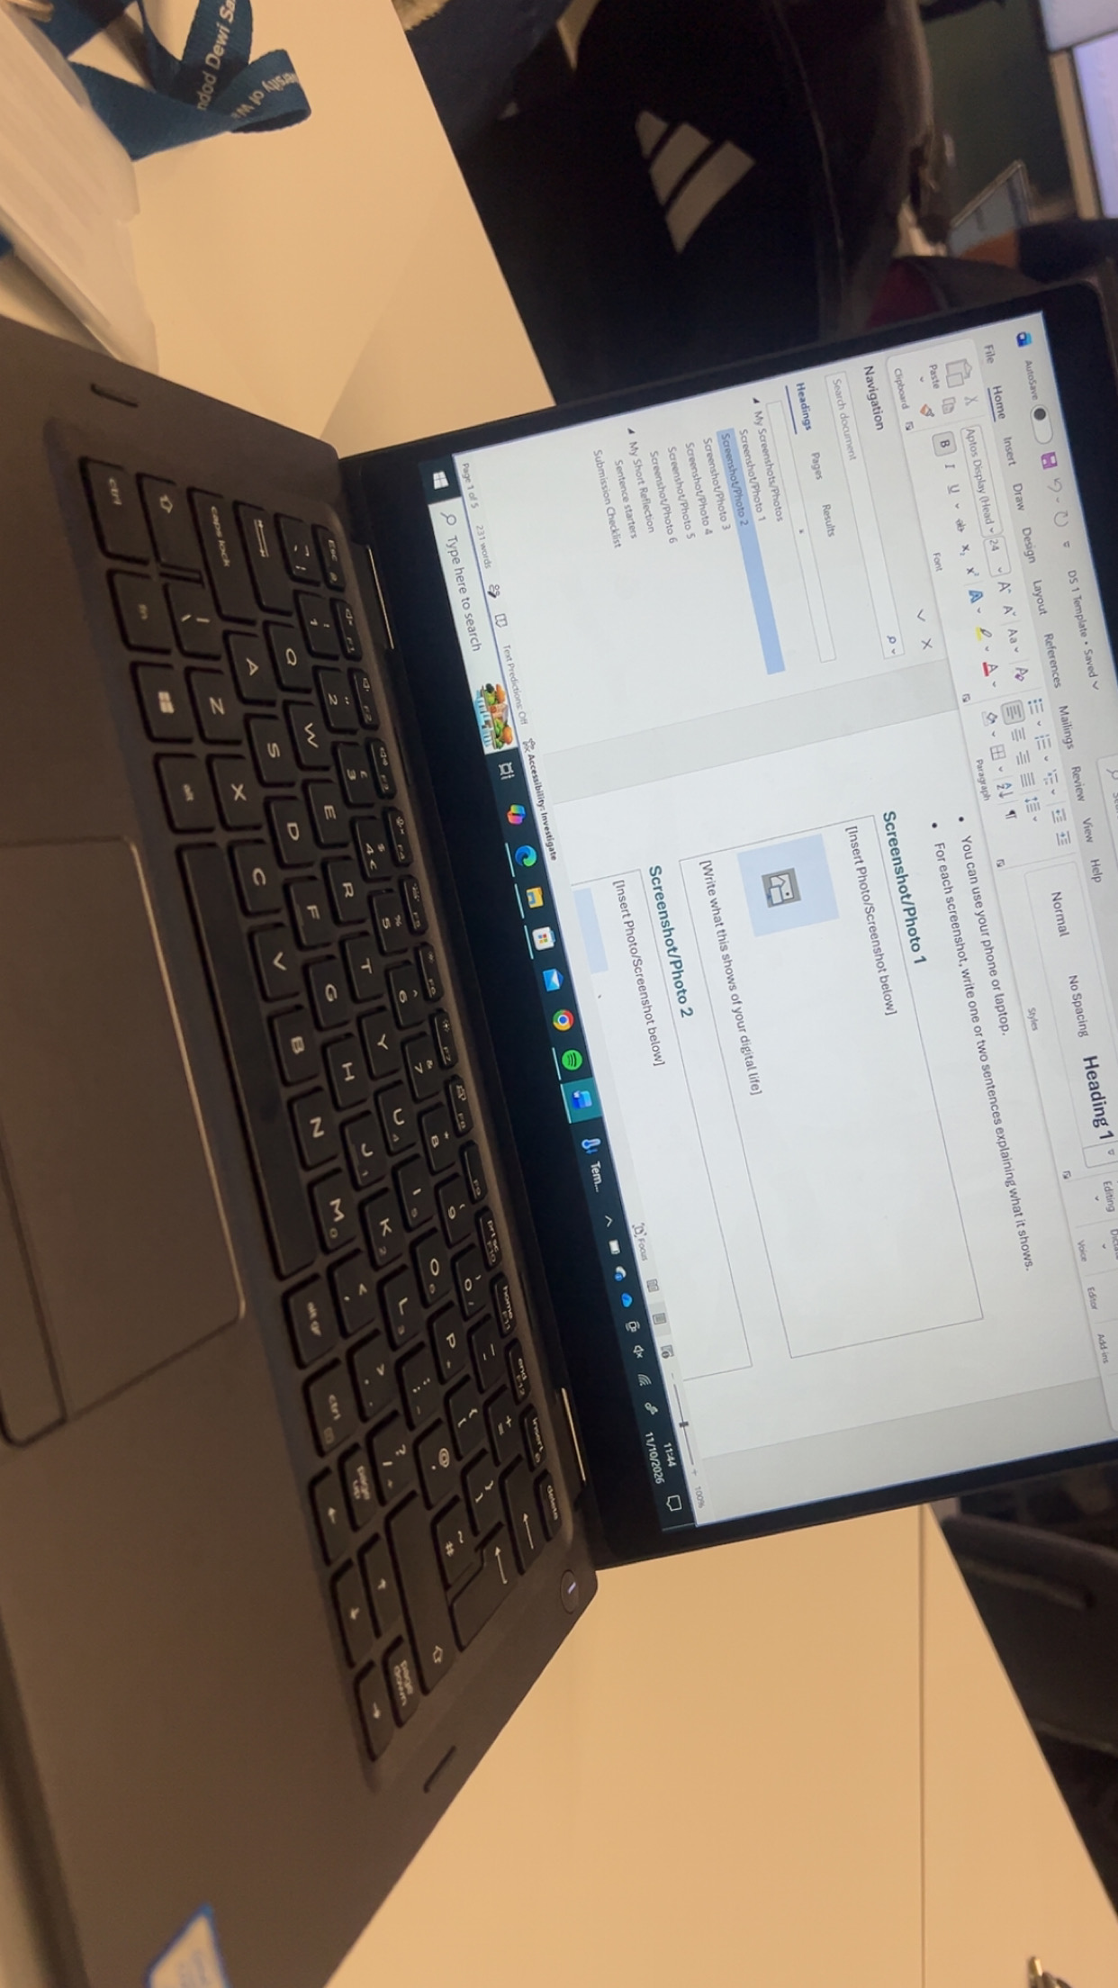
This is a picture of a laptop. A laptop can be used for multiple things such as doing coursework or applying for a job. It can also be used for many other things such as sending emails or taking pictures. This device is also used for playing videogames.

Screenshot/Photo 2
[Insert Photo/Screenshot below]
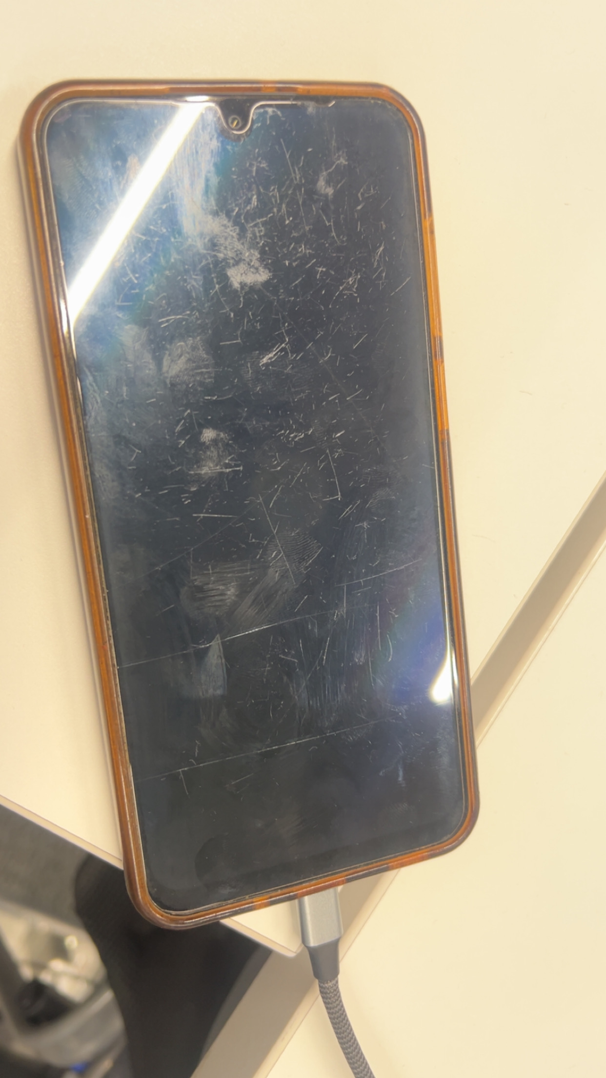
This is a picture of a mobile phone. This device is used every day for many things such as communicating with people. It can also be used to take pictures and send emails. A mobile phone has many other features such as being able to check the weather and even translate different languages.

Screenshot/Photo 3
[Insert Photo/Screenshot below]
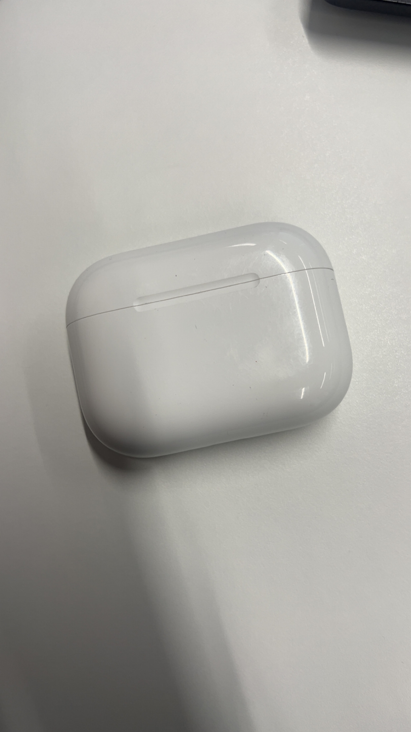
This is a picture of apple airpods/ headphones. You can use them to either listen to music/podcasts or to take calls. They are also often used to block out external sounds from the outside world.

Screenshot/Photo 4
[Insert Photo/Screenshot below]
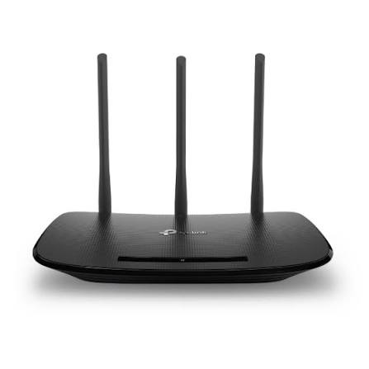
This is a picture of a router. Routers are used to connect multiple devices to the internet and to each other. This is also used to store and transmit data from one device to another.

Screenshot/Photo 5
[Insert Photo/Screenshot below]
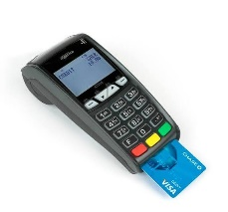
This is a picture of a card reader. This device can be used for multiple things with the first being to receive payments. this digital device is most commonly found in stores or places that sell products. Card readers can also be used to check your account balance or even to transfer money from one account to another.

Screenshot/Photo 6
[Insert Photo/Screenshot below]
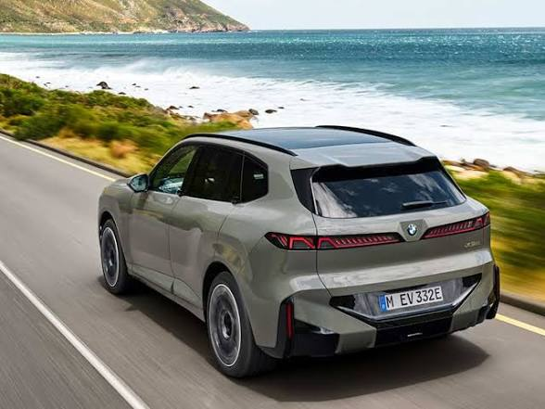
This is a picture of a car. This is used to travel from one location to another. Its also used to transport heavy items or a lot of items. Cars also have a built in navigation system to help you get to where you need to go. Many cars even have an auto drive feature that allows the car to drive itself using sensors to detect other people and vehicle.

My Short Reflection
- Write 5–8 simple sentences about your digital life.
- You can use the sentence starters below if helpful.
In my life I use a lot of digital devices throughout my day to day activities. When I wake up in the morning the first thing I do is look at the clock on my phone. After that I make something to eat that normally requires a microwave to heat it up. Throughout my time getting ready I am also using my airpods to listen to music. Most of the devices I use is connected to a router . I order to commute and travel around I get the bus or train which is another form of digital devices. Digital skills are important to me because I have become so used to using them with everything I do in life. I feel more then confident enough to use all the digital devices I have listed above. I want to improve my excel skills and I home that this module will help me with that.

Sentence starters
- I use digital tools to …
- I feel confident when I …
- I want to improve …
- I often use these tools: …
- I sometimes feel nervous about …
- I hope this module will help me …
- Digital skills are important for me because …
You can write more if you want.

Submission Checklist
Before you submit, please check:
​​​ ☐ I added 4–6 screenshots
☐ I wrote short sentences for each screenshot
☐ I wrote my short reflection
☐ My work is my own
☐ My file opens correctly
​​☐ My file opens correctly

