Business Report - Comparison of Corinthia Hotels and Ibis Hotels

Student ID: 2207646
Student Name: Alina Boestean
Module name: Financial Management for the Hotel Industry
Module code: BMIH5007
Lecturer’s Name: Tristan Hawkins
Word Count: 2124

Table of Contents
1 Introduction 3
2 Background of hotels 3
3 Total Revenue 4
4 Market position 5
5 Growth potential 8
6 Financial Commitment to CSR 8
7 Conclusion 10
8 Recommendation 10
9 References 12

Introduction
The hospitality sector is a billion-dollar industry including many services and activities. Some of the major activities in the hospitality sector are tourism services, hotel businesses, transport, and event planning. In the tourism sector hotels are considered to be the main element due to the reason that hotels are fulfilling the basic accommodation needs of tourists. Another reason is that guests use hotels not only for accommodation but also to take maximum advantage of their services (Anwar et al., 2021). The following business report aims to conduct an in-depth analysis of two major hotels in the UK that are Corinthia Hotels and Ibis Hotels. The report will compare the total revenue, market position, growth potential, and financial commitment to CSR of both hotels.

Background of hotels
Corinthia Hotel was established by the Pisani family in 1962 in Malta. The hotel represents timeless and effortless services in some great cities and locations of the world. Originally the hotel was established as a restaurant but in 1968 it was transformed into a hotel 1968 (Abdullah, 2018). Corinthia Palace has become a legendary and luxurious part of Malta as the most seen and visited destination. It is considered an unrivaled example of real magic in Malta. The first Corinthia was established to extend family values by providing good services generously. It also aimed to understand the importance of the hospitality sector by delighting all the senses. At present, there are nine Corinthia Hotels that are comprised of beauty that the hotel has gained slowly and elegantly. The hotel is the best choice for individuals who believe that traveling is a privilege that should be cherished and welcomed (Corinthia, 2024).
Ibis is a French brand of economical hotels. The hotel was established in 1974 in Bordeaux by Accor groups. In 1988, 182 hotels were operational only in France. The Ibis Hotels group continues to expand to the USA and the UK. By 1995 8 hotels were operated in the UK. In 2011, Ibis became the megabrand of Accor’s group and rebranded itself from Etap Hotel and All Seasons to Ibis Styles and Ibis Budget. Till December 2019 the Ibis brand owns 1218 hotels except Budget and Style hotels. The hotel group has 159,180 rooms in 70 countries worldwide. Ibis Hotel is committed to providing the highest level of comfort and services to its customers at the best market prices (all.accor.com. 2024).

Total Revenue
Total revenue is the concept of increasing revenue systematically within an organization. It uses systematic analytics to predict customer behavior by optimizing the availability of products to maximize revenue. Revenue is usually applied to hospitality and aviation industries that offer services. It is linked with profits, earnings, or income generation by using smart tools (Helmold and Helmold, 2020).
The annual total peak revenue generated by Corinthia Hotel is $62.0M in the year 2022. The number of employees in the Corinthia group of Hotels is 3000 and the revenue generated per employee is $20,666. While considering the revenue generated per employee at Corinthia Hotel London is $279,400. The number of employees in Corinthia Hotel London in 2022 was 216 which shows that the number of employees increased by 12% compared to last year (growjo.com.2023).
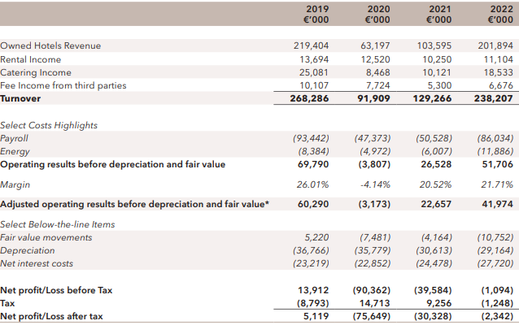
Figure 1: Total revenue of Corinthia Hotel
(source: Corinthia annual report, 2022)
The Accor group experienced a global decrease in revenue trend from 2005 to 2022. Ibis Hotel of Accor Group generated revenue of approximately 4.22 billion euros in 2022 which is 2.2 billion euros higher than 2021 revenue (Statista 2018). The Ibis Group of Hotels reported revenue of €1,725 million which makes up 97% of total revenue compared to 2021 revenue. From an activity point of view, the growth of hotels breaks down to a 119% increase in the services of hotels and 57% for hotel assets and other services. Compared to 2019 revenue generation by Ibis Hotel is 10%. Hotel services include fees from Management and Franchise and owner Services which is reported to be €1,276 million which is 119% higher than the year 2021 and 12% down compared to 2019. The increased percentage shows revenue recovery in the first half of the year 2022. In the UK the recovery strength was compared to France and it was higher than that in 2019 (Zhang, 2022).
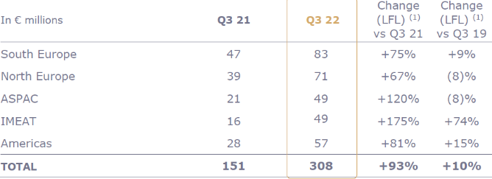
Figure 2: Total revenue of Ibis hotel
(Source: AllAccor.com, 2023)
Comparing the revenue generated in both hotels it is identified that the overall revenue generated at Corintinia Hotel is high in the year 2022. The revenue generated at Corinthia Hotel is 62 million dollars while the revenue generated by Ibis Hotel is 55.6 million dollars.

Market position
The Corthinia Hotel Group owned by Malta-based International Hotel Investments (IHI) has observed an increase in revenue of €95.8 million by the June of 2022. The market share of the Hotel group increased by €61.2 million compared to last year's total revenue. Comparing 2021 depreciation charges that decrease in the year 2022 by 1.6 million €. The expenses and interest rates of 2022 were mostly similar to 2021 rates. However, there were some additional costs of interest for some properties offset by lower interest cost rates (Tabone, 2022).
Corinthia Hotel is located at a prime location in the heart of London. The tourists and hotel guests are within walking distance of most of the top attractions like the Parliament House, the National Gallery, and the London Eye. Guests seem to be impressed with the accommodations, amenities, and services provided at Corinthia Hotel. Hotel guest rating is calculated at Corinthia Hotel total of 3797 guests reviewed and rated Corinthia Hotel 5 on a 1-5 scale (Tripadvisor. 2024).
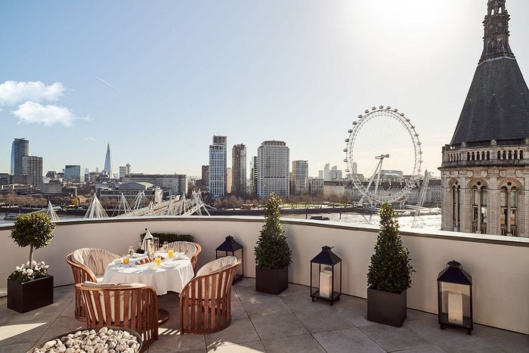
Figure 3 Brand Perception of Corinthia Hotel
(Source: Corinthia, 2024)
Ibis Hotel offers a high standard of accommodation and services at market-competitive prices. From 2019-2023 Ibis Hotel continue to expand globally at a much faster rate than before the pandemic. Until 2019 customers were confident about their financial conditions and spent more on luxuries like travel. Due to this reason, there was a significant increase in accommodation and occupancy rate of hotel rooms. These two factors are considered to be the indicators of hotel performance. The rate of tourist arrival also continued to increase till 2020 before the pandemic hit the world. After the pandemic due to immunization programs, the revenue of Ibis increased by 12.3% in 2023. Overall it is expected that revenue at Ibis Hotel will continue to increase at the rate of 1.1% making $1.5 trillion (ibisworld.com, 2023).
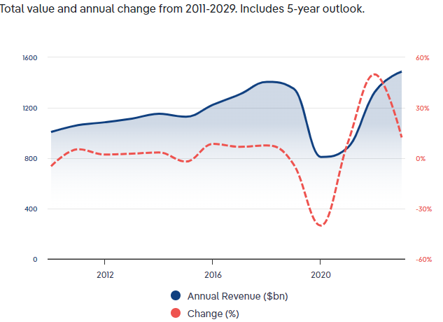
Figure 4 Annual industry market share
(Source: ibisworld.com, 2023).
A survey was conducted to analyze the brand awareness of Ibis in the UK. According to the results, 79% of participants were aware of the Ibis as a hotel brand. Among these 79% of participants 29% like Ibis. According to the results, 8% of hotel customers heard about the brand through social media or advertisements in the last three years. About 10% of participants have had little buzz over Ibis in the UK (Statista, 2022).
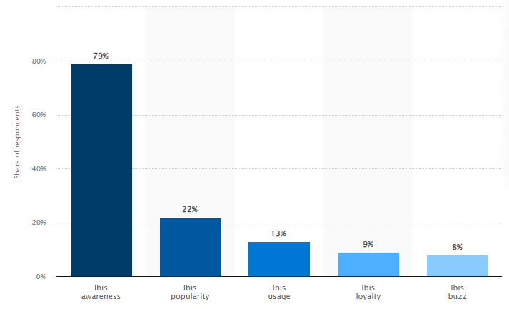
Figure 5 Brand Awareness of Ibis
(Source: Statista, 2022)

Growth potential
The commitment and heritage of Corinthia Hotel have allowed it to improve its market growth and expertise. The operational team of the hotel works hard to raise standards and generate results by supporting and guiding teams. The core objective of the hotel is to increase ROI, increase overall efficiency, and motivate colleagues. The HR at Corinthia is highly trained and professional and they make efforts to recruit individuals with the right capabilities. The hotel also provides training to employees for career progression. The ultimate goal of a hotel is to have highly qualified staff in an intense working environment. The first and foremost priority of a hotel is quality in everything experience, hotel, and relationships. The hotel has also employed a continuous appraisal policy and trained staff simultaneously. The hotel has also introduced the Loyalty program Corinthia Discovery which is applicable globally and created by the Global Hotel Alliance (GHA). The loyalty card provides recognition benefits to its customers from Corinthia and 500 other hotels in 75 countries (Corinthia, 2024).
The overall economic condition can affect the hospitality of the Ibis. Ibis should focus on expanding its business in areas with high economic stability that can enhance its operations. Ibis should focus on the customer demands and preferences keenly. Customers are attracted to those hotels that are fulfilling their needs if a hotel uses sustainability practices it can attract environmentally friendly customers. The brand reputation of Ibis is considered one of the significant strengths. Ibis should plan for areas where there is high brand recognition. By performing a survey Ibis can know its brand awareness and customer preferences in the area. Ibis is performing market research to understand the need for accommodation in the targeted market. Ibis is also making marketing strategies for its business worldwide for the growth and expansion of its business (‌Accor.com. 2019).

Financial Commitment to CSR
The policies of Corinthia are contributing to achieving UN sustainable development goals. Focusing on the jurisdictions in which the operations are done and uplifting the lives with Corinthia Spirit. The policies contribute to sustainable development that safeguards the well-being of individuals and communities. The hotel is committed to fulfilling the expectations of stakeholders and complying with international laws and norms. The hotel includes sustainability and CSR in organization and practice in building relations.
The hotel is committed to strengthening its position as a luxury hotel brand that uplifts the lives of communities through connectedness. The hotel truly understands the needs and demands of their guests and provides excellent experience according to the expectations. IHI services and employees are not only the resources company instead they are the main components that are involved in the success of the hotel. The hotel provides self-development and self-fulfillment opportunities to its employees. Corinthia is focused on environmental innovation. The hotel takes complete responsibility for its environmental impact by innovating our services, and products to have positive results. The hotel is applying a creative entrepreneurial approach to create positive environmental initiatives (Corinthia CSR, 2024).

Figure 6 CSR pillars of Corinthia
Source: (Corinthia CSR, 2024)
Accor Group is committed and inclusively focused on limiting its carbon footprint. The Ibis Hotel group is taking steps to reduce its environmental impact on the earth and the hostel is responsible for fulfilling the environmental concerns of its guests. The CSR and sustainability approach of the hotel takes the initiative to help in the continuous advancement of the community. The hotel welcomes its employees and guests in its WATCH (We Act Together for Children) program. The program aims to vanish sexual harassment of children. The CSR initiative of the hotel has many benefits as it saves the total operational cost. The hotel is selected for commercial operation and ensures that sustainability initiatives are fulfilled. By fulfilling CSR policies Ibis can develop a good brand image and reputation (group.accor.com. 2024).
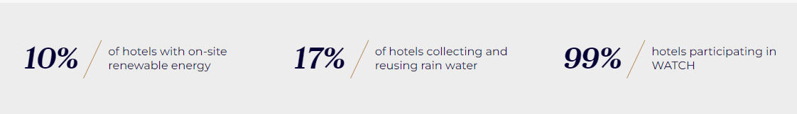
Figure 7 Ibis CSR initiative
(Source: group.accor.com. 2024)

Conclusion
The hospitality sector is a billion-dollar industry including many services and activities. Corinthia Hotel was established by the Pisani family in 1962 in Malta. Ibis is a French brand of economical hotels. The hotel was established in 1974 in Bordeaux by Accor groups. The annual total peak revenue generated by Corinthia Hotel is $62.0M in the year 2022. Ibis Hotel of Accor Group generated revenue of approximately 4.22 billion euros in 2022 which is 2.2 billion euros higher than 2021 revenue. The Corthinia Hotel Group owned by Malta-based International Hotel Investments (IHI) has observed an increase in revenue of €95.8 million by the June of 2022. The revenue of Ibis increased by 12.3% in 2023. Overall it is expected that revenue at Ibis Hotel will continue to increase at the rate of 1.1% making $1.5 trillion. The Ibis Hotel group is taking steps to reduce its environmental impact on the earth and the hostel is responsible for fulfilling the environmental concerns of its guests.

Recommendation
- Ibis and Carinthia hotels can increase their market revenue by personalized customer experience. The hotels can implement strategies for personalized services to attract more customers (Kuehnl et al., 2017). The hotels can benefit from data analytics tools for understanding customer choices and making their services accordingly. They can take feedback from guests to develop trust among customers (Lee et al., 2019).
- The Corinthia and Ibis hotels can enhance their market position by making strategies that differentiate them from competitors. The strategies could include rooms with certain trending themes, environmentally friendly activities, and better partnerships (Liu and Atuahene-Gima, 2018).
- Both hotels can increase their growth potential by exploring new segments of the market like eco-tourists, travelers, and well-being seekers. They can also make initiatives that differentiate them from the rest of the hotels (Richard, 2017).

References
‌ Accor.com. 2019. Hotel development - Accor Group. [online] Available at: https://group.accor.com/en/hotel-development.
‌ all.accor.com. 2024. Ibis Hotels - Brand New Ibis, Brand New Comfort | Accor. [online] Available at: https://all.accor.com/brands/ibis.en.shtml.
‌ Corinthia. 2024. We Operate. [online] Available at: https://www.corinthia.com/en-gb/development/we-operate/.
‌ Fabrizio Tabone. 2022. International Hotel Investments registers 176% increase in revenue in first six months of 2022. [online] Available at: https://whoswho.mt/en/international-hotel-investments-registers-176-increase-in-revenue-in-first-six-months-of-2022
‌ Lee, M., Lee, S. and Koh, Y., 2019. Multisensory experience for enhancing hotel guest experience: Empirical evidence from big data analytics. International Journal of Contemporary Hospitality Management, 31(11), pp.4313-4337.
Abdullah, N.S., 2018. Corporate governance and performance of hotel industry (IHI).
Ali, B.J., Gardi, B., Jabbar Othman, B., Ali Ahmed, S., Burhan Ismael, N., Abdalla Hamza, P., Mahmood Aziz, H., Sabir, B.Y., Sorguli, S. and Anwar, G., 2021. Hotel service quality: The impact of service quality on customer satisfaction in hospitality. International Journal of Engineering, Business and Management, 5(3), pp.14-28.
Corinthia. 2024. About Corinthia | Corinthia Hotels International | Corinthia.com. [online] Available at: https://www.corinthia.com/en-gb/our-story/.
Corinthia. 2024. SUSTAINABILITY AT CORINTHIA. [online] Available at: https://www.corinthia.com/en-gb/sustainability/.
group.accor.com. 2024. Environment & CSR. [online] Available at: https://group.accor.com/en/hotel-development/Optimise-your-costs/Environment-and-CSR.
growjo.com. 2023. Corinthia London Competitors, Revenue, Alternatives and Pricing. [online] Available at: https://growjo.com/company/Corinthia_London.
Helmold, M. and Helmold, M., 2020. Total revenue management (trm) (pp. 1-12). Springer International Publishing.
Homburg, C., Jozić, D. and Kuehnl, C., 2017. Customer experience management: toward implementing an evolving marketing concept. Journal of the Academy of Marketing Science, 45, pp.377-401.
Liu, W. and Atuahene-Gima, K., 2018. Enhancing product innovation performance in a dysfunctional competitive environment: The roles of competitive strategies and market-based assets. Industrial Marketing Management, 73, pp.7-20.
Richard, B., 2017. Hotel chains: survival strategies for a dynamic future. Journal of Tourism Futures, 3(1), pp.56-65.
Statista 2018. Accor Group: revenue 2005-2018 | Statista. [online] Statista. Available at: https://www.statista.com/statistics/266261/revenue-of-the-accor-group/.
Statista. 2022. Ibis brand profile UK 2022. [online] Available at: https://www.statista.com/forecasts/1335566/ibis-hotels-brand-profile-in-the-uk.
Tripadvisor. 2024. CORINTHIA LONDON - Updated 2024 Prices & Hotel Reviews (England). [online] Available at: https://www.tripadvisor.com/Hotel_Review-g186338-d1845678-Reviews-Corinthia_London-London_England.html
www.ibisworld.com. 2023. Global Hotels & Resorts - Market Size, Industry Analysis, Trends and Forecasts (2023-2028)| IBISWorld. [online] Available at: https://www.ibisworld.com/global/market-research-reports/global-hotels-resorts-industry/#IndustryStatisticsAndTrends.
Zhang, C. 2022. Third-quarter 2022 revenue of €1,149 million up 83% like-for-like. [online] Accor – Newsroom. Available at: https://press.accor.com/third-quarter-2022-revenue-of-e1149-millionup-83-like-for-like/?lang=en.

