
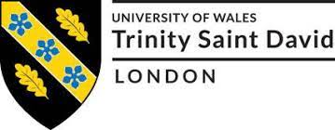

Programme: MBA – Masters of Business Administration
Module Name: Human Resource Management
Module code: LCMB700

Presented By: Professor Name:
Viralkumar Pravinbhai Panchal (2210866) Prof. DR. Gladius David Kulothungan
Prof. Mushfiqur Rahman
Table of Contents
A. Present state of labour market in the UK 3
1. Labour Market of the World 3
2. Labour Market of the Developed Country 3
3. Labour Market of Developing Country 3
4. Labour Market of the UK 4
4.2 Economic Inactivity and Unemployment 5
4.3 Earnings 6
4.4 People in the Labour Market 7
Conclusion 8
B. Emerging Transformations in HR Strategies during the Post-Covid and Post-Brexit Period 9
Introduction 9
1. Transformations in the HR Practices during the Post-Pandemic External Environment Incorporation of Human-Centric Culture: 9
2. Emerging HR Trends Induced by the Post-Brexit External Environment 10
Conclusion 11
Reference List 12

A. Present state of labour market in the UK
Introduction
In recent times, one of the key challenges encountering any industrialised nation is to ascertain that its labour market runs in such a way so that people can get reasonable pay rate (Azar, Marinescu and Steinbaum,2022). From the macro-economic perspective, the labour market of the United Kingdom has been undergoing exponential turbulence owing to Covid-19 and Brexit. As reported by the Guardian (2022), after the great financial crisis of 2007-09, the percentage of people in work amplified exponentially. The overall percentage of economically immobile decline drastically (Azar, Marine Scum and Steinbaum,2022). This section of the assessment is designed to revolve around the current state of the labour market of the UK and key challenges and opportunities existing in the market. Further, the report also succinctly outlines the labour market of the world, developed country and developing country.

Labour Market of the World
As far as global labour market is concerned, in the year 2022, total number of employment was around 3.32bn (Statista, 2022). However, a noticeable decline is discernible in global employment from 2019 to 2020. During this time-frame, the number of employment declined from 3.3bn to 3.19bn on account of economic plunder effectuated by Covid-19 pandemic. However, as reported by International Labour Organisation (2022), inequality and unemployment can amplify exponentially due to political tussle between Russia and Ukraine and its disastrous effectuations on global economy. As reported by World bank (2021), the current rate of unemployment was around 6.2%.

Labour Market of the Developed Country
One of the key facts of the labour market of developed country is that it is dominated by both large multinationals and SMEs. However, in recent times, on account of the pandemic, developed economies also suffer setbacks, including huge layoffs of while collar positions, rising rate of unemployment and amplifying rate of low-skilled workers (Aljazeera, 2022). For instance, in the US labour market, the technology sector has witnessed largest layoff in recent times (Aljazeera, 2022).

Labour Market of Developing Country
In developing nations, labour market demonstrate several crucial facts, including a considerable fraction of poor acting as entrepreneurs, prevalence of temporary migration to work and dearth of specialisation. Further, another important feature of the labour market in developing country includes dominance of SMEs. For instance, India is a developing nation were them rate of unemployment is about 5.98% (Statista, 2022).

Labour Market of the UK

4.1. Employment
As reported by the Guardian (2022), although there is an exponential growth in total pay at a growth rate of 6% slumping wages is still discernible in the labour market of the UK. It is significantly evident in the public sector where pay is amplified only 2% per year. Employers and workers have started to deal with the issues of labour market in various manners. Slumping real pay has resulted in an exponential amplification in industrial confrontations and disputes. The number of days wasted in labour strike remains highest starting from the pandemic (The Guardian, 2022). At the same time, employers groups have started to demand government intervention in terms of easing legislation pertaining to migration in order to accelerate labour supply.

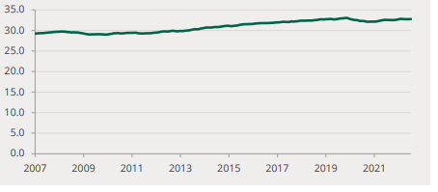
Figure 1: Millions of employed people in the UK
(Source: ONS, 2022)
Based on the aforementioned graph, it is evident that employment levels declined in the aftermath of Covid-19 induced lockdown in March of 2020 and incessantly declined throughout 2020. However, the levels of employment have started to recover starting from 2021. As reported by Parliament.UK (2022), starting from August to October 2022, the rate of employment level amplified analogising with the previous quarter. However, compared to the pre-pandemic phase, (January to March 2020) employment remains 211,000 low.

4.1.1 Kind of Employment
The amplification employment level during the past ten years has been led by full-time staff members (Daly, Sutin and Robinson, 2022). After the spread of the pandemic, the overall number of full-time employees continued to amplify. There is also a decline in overall number of self-employed people. As reported by Parliament.UK (2022), there were around 24.60mn full-time workers in the labour market of the UK compared to 8.17mn part-time employees. As avouched by Daly, Sutin and Robinson (2022), one of the major reason behind the trend is that since the overall count of full-time employees gets amplified, the overall count of part-time workers gets declined considerably.

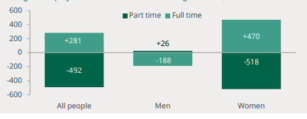
Figure 2: Change in employment (January-March 2020 to August-October 2022; in thousands)
(Source: Parliament. UK, 2022)
As demonstrated in the above-mentioned figure, a clear fall in the number of men carrying out work full-time declined significantly. On the other hand, there was a large decline in the part-time women staff (Parliament. UK, 2022).

Economic Inactivity and Unemployment

4.2.1 Unemployment
Starting from August 2022 to October 2022, the total number of unemployed people in the UK was 1.25mn. The rate of unemployment remained at around 3.6%. It is relevant to point out that before the arrival of the pandemic, the rate of unemployment reached the lowest level. As argued by Azar, Marinescu and Steinbaum (2022), one of the major reasons for the amplification of unemployment in 2020 was the pandemic. As stated by Parliament.uk. (2022), compared to Brexit, the implication of Covid-19 was exponentially adverse to the labour market of the UK.
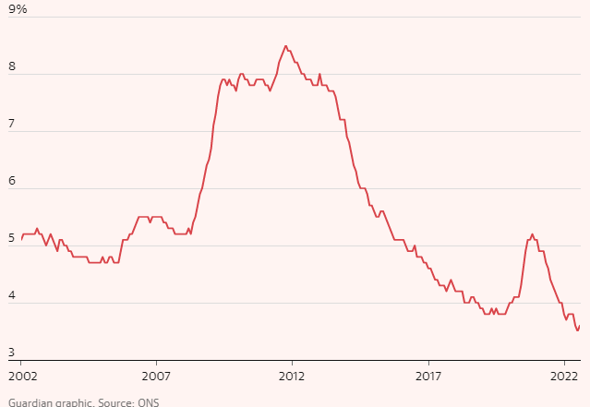
Figure 3: Unemployment rate in the UK Starting from August 2022 to October 2022
(Source: The Guardian, 2022)

4.2.2 Economic Inactivity
Starting from August to October of 2022, the number of economically inactive people in the United Kingdom was around 8.94mn (Parliament.uk, 2022). The percentage of inactivity was 21.5%. Although the level of inactivity declined in the quarter, it has witnessed an amplification compared to the past year. As argued by Parliament.uk (2022), being a student and having long-term ailment were the major reasons behind the spiral of economic inactivity. As observed by Azar, Marinescu and Steinbaum (2022), at the beginning of the epidemic, although the economists thought that unemployment would be the biggest burden in the UK, it a reality, it turned that high magnitude of economic inactivity remained the major economic legacy.

4.3 Earnings
As reported by ONS (2022), the average growth in regular pay rates in the realm of the private sector remained at 6.9% from August to October this year. This is regarded as the largest ever earning differentiation between the private and public sectors. However, the value of wages is also desired to slump exponentially throughout 2022 and subsequent years since nominal wages fall short with rising inflation (Financial Times, 2022).
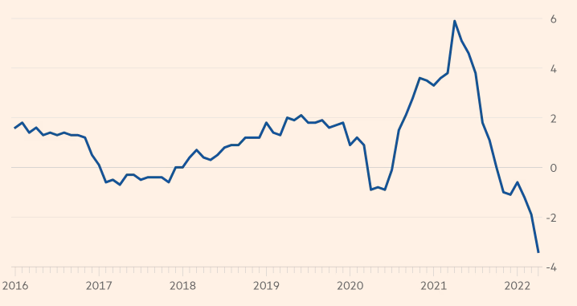
Figure 4: Annual change in average weekly earnings of the UK
(Source: Financial Times, 2022)
Based on the aforementioned graph, it is evident that in 2022, the annual change in average weekly earnings was -4% which has become a cause of concern (Financial Times, 2022).

4.4 People in the Labour Market
During the timeframe of August-October 2022, the rate of employment among males was 79.0% and among women was 72.2% (Parliament.uk, 2022).

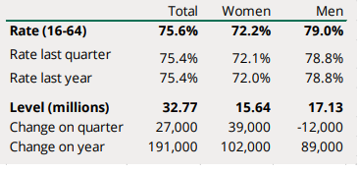
Figure 5: The rate of employment among women and men
(Source: Parliament.uk, 2022)
During the same tenure, the rate of both employment and unemployment remained high for men compared to women. However, the extent of economic inactivity was high for women.
During the same time, the rate of youth unemployment has started to dwindle. With the lifting of the government-led lockdown, an improvement is discernible in youth employment (Rees, 2022).

Conclusion
Based on the detailed elucidation of the present state of the UK labour market, it is evident that in the post-pandemic period, with the restarting of economic activities, the labour market has been witnessing a sign of recovery with rising wage rate, increased number of full-time workers and growth of average pay-rate in both private and public sector. However, some of the challenges encountered by the labour market encompass the wage gap between the public and private sectors, inflation and unemployment. Summing up, considering the eroding value of the average wage, it is important for the government to formulate effective policies to control inflation and support the employees and those who are inactive.

B. Emerging Transformations in HR Strategies during the Post-Covid and Post-Brexit Period

Introduction
As an aftermath of the Covid-19 pandemic, global businesses and economies have witnessed a standstill. Simultaneously, HR activities have also been affected by the unforeseen consequences caused by the pandemic on the external environment. As stated by Bratton et al. (2021), due to a poorly implemented referendum, Brexit has effectuated relentless uncertainties in the realm of HR practices and strategies. On account of Brexit, changes in HR practices are discernible in areas like workforce planning, incorporation of a novel approach in alluring highly skilled EU workers, alluring diverse pool of talent and alluring UK youths and so on. This part of the assessment is designed to figure out emerging transformations in HR strategies during the post-Brexit and post-pandemic external climate.

1. Transformations in the HR Practices during the Post-Pandemic External Environment Incorporation of Human-Centric Culture:

During the new normal, re-building organisational culture has emerged as a predominant priority for enterprises irrespective of all sectors. As argued by Przytuła et al. (2020), while this is considered a positive change, the repercussion of the transition may upset the existing culture of an organisation. One of the emerging changes in the domain of HR is associated with a human-centric approach incorporated by contemporary organisations to tackle the issue of high staff turnover and poor employee morale. Rather than supervising the employees, a number of reputed organisations in the UK have incorporated effective initiatives in pursuit of preserving core values and focus on establishing a workplace that can assist employees to stay at the forefront of every predominant decision made by the HR department (Przytuła et al., 2020).

- The Emergence of Employee Well-Being as the key mandate of Business:
The Covid-19 pandemic remained a key source of stress for employees (Caligiuri et al., 2020). Employees have come across multiple stressors, including unrealistic workloads, poor work-life balance and amplifying anxiety concerning job security and so on. It has led a number of organisations in the UK to emphasise developing productive association and fostering sustainable and positive implications (Przytuła et al., 2020). One of the emerging trends associated with post-pandemic HR practices is not just limited to ascertaining the physical well-being of the employees but taking care of the psychological health of the employees.

- Incorporation of Personalised and Adaptive Compensation Framework:
The unpredicted consequences caused by the pandemic have led several businesses to significant debt levels, poor balance sheets, poor revenue and so on (Bratton et al., 2021). They were left with no alternatives but to adopt cost-cutting by curtailing the benefits and costs of the employees. In order to foster economic growth and compensate loss induced by Covid-19, a section of organisations have started to involve in competition. Since a number of organisations have failed to proffer high salaries, they may consider curtailing fixed pay while amplifying variable pay that is associated directly with the productivity and performance of the employees. Based on Herzberg’s Two-Factor Theory, compensation is considered a hygiene element that facilitates employees not to get discontented (Bratton et al., 2021). Further, it has also been mentioned in the theory that the salary of the employees needs to be in accordance with the industry standard as well as competition with other enterprises within the same sector. Another key trend during the new normal is offering personalised compensation packages that enable staff members in terms of creating their own packages that are aligned with their preferences and requirements.

- Data-Centric Decision-Making:
As stated by Bratton et al. (2021), data-driven decision-making is regarded as a strategy that utilises data in pursuit of making business-related decisions. Some large-sized organisations have started to incorporate workforce analytics to get a concrete picture of employee satisfaction, engagement and experience. To ascertain success in a highly uncertain business climate, it has emerged one of the key priories for organisations operating in the UK to incorporate various tools and technologies associated with data-driven decision-making, including social media analytics, CRM software and business intelligence and so on (Bratton et al., 2021). Regular data evaluation and tracking of the performance of the employees have become crucial for organisations in terms of excelling hiring, talent development and fostering management decisions and so on.

2. Emerging HR Trends Induced by the Post-Brexit External Environment

UK's leaving the European Union has exerted considerable implications on the economies of both the UK and the EU. Although 25% of the businesses of the UK presently deploy staff members from the EU, net migration between the UK and EU declined by 95% in the year 2017 (Keukeleire and Delreux, 2022). Some of the salient sectors encountering adverse consequences of Brexit encompass the healthcare sector, aerospace, engineering and aerospace and so on. Some of the emerging trends in the domain of HR during the post-Brexit times are as follows:

Incorporation of a Differentiated approach to Allure EU Workers:
During the post-Brexit period, stringent immigration rules have created a considerable stumbling block for EU workers in terms of continuing their employment in the UK (Ridgway, 2019). Therefore, it has led the HR managers to resort to job advertisements in terms of explicating the career progression prospects of the EU workers who are interested to continue their employment in the UK. Further, Brexit has also led the HR managers of the UK to work relentlessly on improving employee relations. As argued by Keukeleire and Delreux (2022), successful workplaces are established by addressing all kinds of discrimination and biases. Therefore, during the post-Brexit period, employers are trying to allure, engage and finally retail skilled staff members of the EU.

- Working with Recruitment Agencies:
As an aftermath of Brexit, work in association with other companies via industry reanimations and trade associations become a trend in the UK. Rather than finding talent directly, recruiters are working with international agencies to recruit the right talent (Keukeleire and Delreux, 2022). One of the major reasons behind this is that irrespective of Brexit-induced outcomes, it is possible for an international recruitment agency to offer seamless hiring to business entities stationed across Europe, the UK and Globally. Further, the incorporation of virtual human resources has become a trend during the post-Brexit period.

- Admitting Salary Differences:
Apart from emphasising the aspect of paperwork, the sudden move to hybrid working due to the pandemic has now become a reality (Keukeleire and Delreux, 2022). Therefore, depending on the type of work and sector, it is possible to employ an employee from any part of the globe. Therefore, HR professionals stationed in the UK are acknowledging the fact that following the salary standard of the UK is no longer effective to retain high-performing employees if they dwell in another nation. Therefore, elucidation of the local market pay structure has become crucial for HR professionals in an aftermath of Brexit. Moreover, Brexit has also given a call to the HR department to become more transparent to employees (Ridgway, 2019). It has led the HR personnel to take care of the mental health of the employees so that stress can be reduced and productivity can be ascertained.

Conclusion
In conclusion, it can be averred that Covid-19 and Brexit have effectuated significant challenges to HR practices. Therefore, during the post-pandemic and post-Brexit periods, new trends emerged. Some of the new trends prevalent in the post-pandemic period encompass an emphasis on human-centric culture, ascertaining employee wellbeing, adaptive and personalised compensation and data-driven decision-making. Emerging HR trends in the post-Brexit period encompass a dedicated approach to attracting EU workers, working with recruitment agencies and admitting salary differences. Summing up, the digitalisation of HR and offering mental support to employees has become common in both the post-pandemic and post-Brexit periods.

Reference List
Ashton, D., Maguire, M. and Spilsbury, M., (2016). Restructuring the labour market: The implications for youth. Springer.
Azar, J., Marinescu, I. and Steinbaum, M., (2022). Labor market concentration. Journal of Human Resources, 57(S), pp.S167-S199.
Bratton, J., Gold, J., Bratton, A. and Steele, L., (2021). Human resource management. Bloomsbury Publishing.
Caligiuri, P., De Cieri, H., Minbaeva, D., Verbeke, A. and Zimmermann, A., (2020). International HRM insights for navigating the COVID-19 pandemic: Implications for future research and practice. Journal of international business studies, 51(5), pp.697-713.
Daly, M., Sutin, A.R. and Robinson, E., (2022). Longitudinal changes in mental health and the COVID-19 pandemic: Evidence from the UK Household Longitudinal Study. Psychological medicine, 52(13), pp.2549-2558.
Financial Times. (2022) UK labour market remains hot despite stalling economy, Subscribe to read | Financial Times. Available at: https://www.ft.com/content/812f3177-2d4d-47df-9c8a-919681f56946 (Accessed: December 24, 2022).
Ilo.org (2022). Global labour market to deteriorate further as Ukraine conflict and other crises continue (2022) International Labour Organization. Available at: https://www.ilo.org/global/about-the-ilo/newsroom/news/WCMS_859191/lang--en/index.htm (Accessed: January 4, 2023).
Keukeleire, S. and Delreux, T., (2022). The foreign policy of the European Union. Bloomsbury Publishing.
Meister, J. (2022) 10 hr trends for the next normal of work, Forbes. Forbes Magazine. Available at: https://www.forbes.com/sites/jeannemeister/2021/01/14/10-hr-trends-for-the-next-normal-of-work/?sh=d8e53a75fc43 (Accessed: December 24, 2022).
Mohamed, M., Pärn, E.A. and Edwards, D.J., (2017). Brexit: measuring the impact upon skilled labour in the UK construction industry. International journal of building pathology and adaptation.
ONS. (2022) Labour market overview, UK: November 2022, Labour market overview, UK - Office for National Statistics. Office for National Statistics. Available at: https://www.ons.gov.uk/employmentandlabourmarket/peopleinwork/employmentandemployeetypes/bulletins/uklabourmarket/november2022#:~:text=The%20UK%20employment%20rate%20for,December%202019%20to%20February%202020). (Accessed: December 23, 2022).
Parliament.uk. (2022). UK labour market statistics. Available at: https://researchbriefings.files.parliament.uk/documents/CBP-9366/CBP-9366.pdf (Accessed: December 24, 2022).
Przytuła, S., Strzelec, G. and Krysińska-Kościańska, K., (2020). Re-vision of future trends in human resource management (HRM) after COVID-19. Journal of Intercultural Management, 12(4), pp.70-90.
Rees, T., (2022). Women and the labour market. Taylor & Francis.
Ridgway, M., (2019). Brexit: human resourcing implications. Employee Relations: The International Journal.
Statista. (2022) Global employment figures 2022, Statista. Available at: https://www.statista.com/statistics/1258612/global-employment-figures/ (Accessed: January 4, 2023).
Statista. (2022) Topic: Employment in India, Statista. Available at: https://www.statista.com/topics/6583/employment-in-india/#topicHeader__wrapper (Accessed: January 4, 2023).
The Guardin. (2022). UK labour market is changing as inflation squeezes real pay. Guardian News and Media. Available at: https://www.theguardian.com/business/2022/nov/15/uk-labour-market-inflation-real-pay-unemployment (Accessed: December 23, 2022).
Worldbank.org. (2022). Unemployment, total (% of total labor force) (modeled ILO estimate) (no date) Data. Available at: https://data.worldbank.org/indicator/SL.UEM.TOTL.ZS (Accessed: January 4, 2023).

