Introductory
A welcome introduction for the new team member
New Members are welcome to Hotel trinity, Hotel trinity is a four-star hotel, that has grown its chain in over 5 countries across the globe. I am your manager and you are welcome. The training for the housekeeping department will put in mind the following standards, which vary from their uniform, cleaning equipment, product/cleaning chemicals, maintenance, laundry, communication, health and safety, and fire protocol among others.
The organization chart for the housekeeping department is shown in the chart below, these would describe the various units available and your duty post as a new employee. While I see you through the training, we will be working together as a team to achieve a common goal. The first task is getting the employee to familiarize themselves with the system they are working with, which is generally represented in the housekeeping department organizational chart as shown in figure 1.
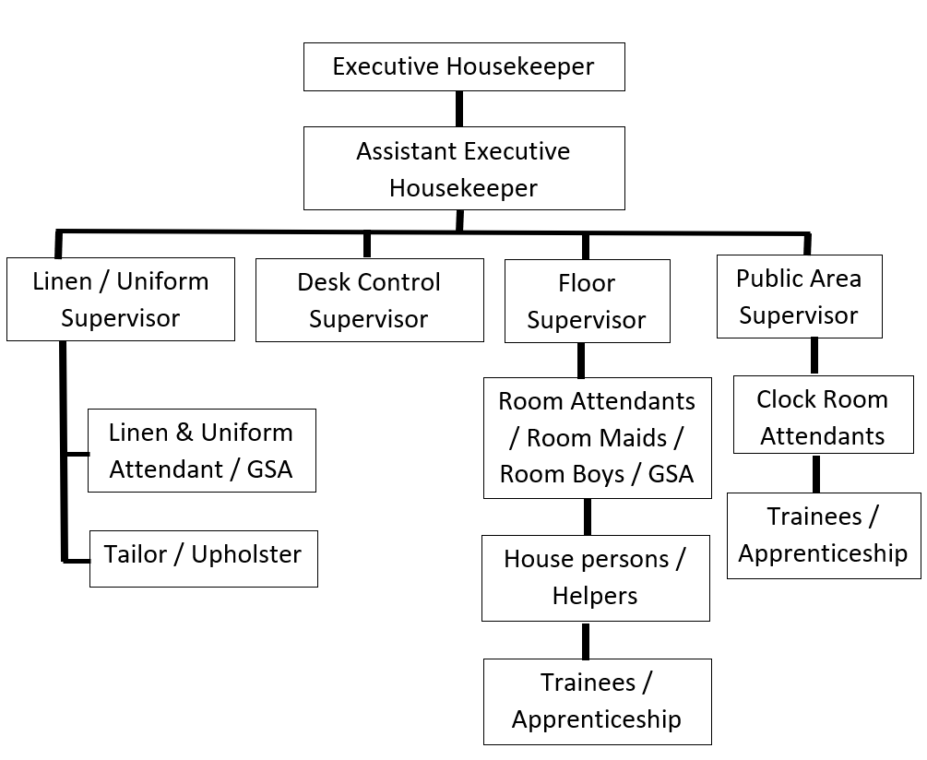
Figure 1: Housekeeping department organizational chart (Andrew, 2013)
The housekeeping training timetable will cover all these areas. New employees will learn cleaning skills, etiquette and interaction skills, presentation and communication skills, use of equipment and product, and finally health safety and fire protocol skills, these are sectioned training periods of 8 weeks as shown in the table below.
A timetable of training activities for the 8 weeks
 | Week 1 | Week 2 | Week 3 | Week 4 | Week 5 | Week 6 | Week 7 | Week 8
Stage1: Knowledge training
Work safety and Health
Property knowledge
Housekeeping cleaning supplies
Customer services
Stage 2: Practical training
Housekeeping daily routine
Guest room cleaning procedure
Time management
Stage 3: Follow-up & Evaluation
Follow up
Evaluation

Trained Employees must carry out these tasks on their own and the post-training evaluation chart as shown in the figure will be adopted. As shown in the chart below, housekeepers' performance will be based on supervisor evaluation (in this case, the housekeeping manager), also based on right attitude assessment, and finally guest feedback on room cleanliness., this is depicted in figure 2.
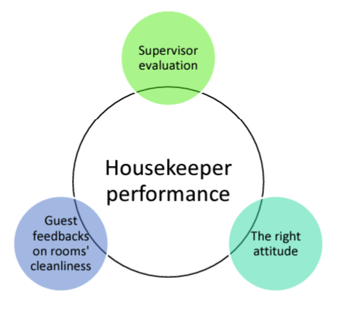
Figure 2: Post-training evaluation of new housekeeper (Tra,2020)
Description of the training activities you will undertake to ensure the new team members can perform all tasks associated with their job role
The activities that would be engaged in during the training of the new employees are categorized into three stages, which include knowledge training, practical training, and follow-up respectively. The knowledge-based training includes work health and safety, property knowledge, housekeeping cleaning supplies, and customer services respectively, this would last for three weeks. The practical training stage involves practicals on housekeeping daily routine shown in figure 3, guest room cleaning procedure, and time management respectively, this would go for the next three weeks. The employees are then allowed to practice what has been taught and follow-up and evaluation will take place in the next two weeks. The training activities will not only be taught but also sectioned into the task, for each individual throughout the training
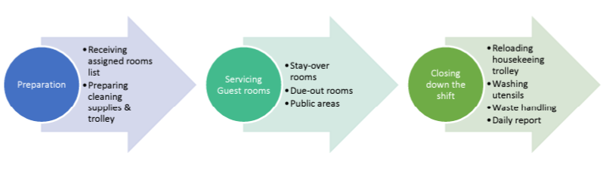
Figure 3: Housekeeping Daily Routine (Tra, 2020)
Some of the knowledge-based activities that would be sectioned into tasks are shown in the table below.
Department Orientation Knowledge for All Employees:  - Quality Guest Service  - Bloodborne Pathogens  - Personal Appearance  - Emergency Situations  - Lost and Found  - Recycling Procedures  - Safe Work Habits  - Manager on Duty  - Your Property's Fact Sheet  - Employee Policies  - The Disabilities Act according to the country.  - The Task List for room attendants | Knowledge for All Housekeeping Employees:  - Working as a Team With Co-Workers and Other Departments.  - Telephone Courtesy.  - Security.  - Housekeeping Keys.  - OSHA (The Occupational Health and Safety Administration) Regulations or Similar as per the local regulation.  - Using Cleaning Supplies Correctly and Safely.  - Maintenance Needs.  - Special Cleaning Requirements.  - Housekeeping Inventories. | Knowledge of Room Attendants:  - What Is a Room Attendant?  - Superior Performance Standards.  - Tip Sharing  - Unusual Guestroom Situations  - Deep-Cleaning Assignments  - Room Status Codes

Safety training such as fire safety, COSHH, health and safety, etc.
COSHH means Control of Substances Hazardous to Health, it is a regulation that controls substances such as Liquids, Solids, Fumes, Dust, Vapours, Fibres, Nano-particles, Mists, Gases, Biological agents such as bacteria and viruses from exposing to sensitive parts of the human body (Lee, 2021). Pesonen (2015) generally identify the major health and safety risk associated with events during housekeeping, they are slips, trips, and falls. If the area at risk is identified, assess, and prevented it can be put under control. Employees are shown the various means of combating fire incidents such as fire extinguishers, use of evacuation passages, etc,
Appropriate branding and logos for Hotel Trinity.
The logo for Hotel trinity, a four-star hotel is shown in the figure below, Yellow is a color associated with the sun. It symbolizes optimism, energy, joy, happiness, and friendship. It might also stand for intellect, the green leaf feature shows the corporate social responsibility and ethical characteristics of the organization


Reference
Andrews S. (2013) Hotel housekeeping: A training manual. New Delhi: McGraw-Hill Education
Setupmyhotel(2022) House Keeping Training Retrieved at: https://setupmyhotel.com/train-my-hotel-staff/hk.html 15 th November, 2022
Lee E. (2021) COSHH Training for Cleaners Retrieved from: https://cpdonline.co.uk/knowledge-base/health-and-safety/coshh-training-for-cleaners/
Miller M. K. (2020) Building A Strong Brand: The Four Steps of Brand Building Retrieved at: https://www.melinakmiller.com/building-a-strong-brand-the-four-steps-of-brand-building/
Pesonen J. (2015) Internal Housekeeping Versus Outsourced Housekeeping. Bachelor of Hospitality Management. Saimaa University of Applied Sciences.
Tra T. (2020) Action plan for training new HouseKeeping Employee: Case Hotel Indigo Helssinki Bachelor of Restaurant Entrepreneurship Laurea University of Applied Sciences

