
Reflective Project Report

Course Code: ACMA5009
Course Title: Group Project
Submitted by:
Ieuan Wyn Morgan
ID: 2014408
Department of Engineering

Submitted to:
Richard Sutton
Submitted on:
11/05/2021

Introduction

In this project I will present to you both my findings and recommendations on how to proceed with the safety concerns surrounding people dropping carousels whilst dismounting them from the MAZAK FJV 250 CNC mills. I will research and develop a method to create a safe working practise for dismounting the MAZAK FJV’s.
This product will be developed for Renishaw PLC. Renishaw PLC is a world known meteorology company specialising in products such as probing systems and 3D printers that print in both titanium and steel. This project will be based on improving a system within the Renishaw machine shop.
Below will be a detailed report that will include a Gantt chart for project planning, the aims I wish to achieve, a description of the methods I use and also a justification for them, detailed research and my findings and recommendations.



Contents Page
Table of Contents
What is the RAMTIC Process? 5
Overview into the project 6
Design Brief 7
Product Design Specification 8
Feasibility Study 13
CAD Drawing 16
Why is CAD greater than manual drafting? 17
Electrical Diagram 18
Material Research 19
Design Evaluation 21
Lewin’s 22
Costs 24
Project Reflection 25
References 26
Appendices 27

What is the RAMTIC Process?

The RAMTIC Process is an automated process designed and developed by Renishaw PLC. The process consists of loading carousels (Fig.1) onto a modified version of a MAZAK FJV 250. The carousel are kitted before production with tools and billets. (Fig.2).The operator will load a carousel onto the machine (Fig.3) and load a program, the machine will load the tooling wings first and measure each tool to ensure they are set correctly.
After, the machine will load a wing full of billets and machine them one at a time. After each of the billets has been machined the program will alert the machine to unload all the tools back into their designated wings and alert the operator that the process has finished. This is an incredibly efficient process and has been at the heart of the Renishaw machine shop since the early ’90s. (Albert, 2020)
Fig.1 Fig.2
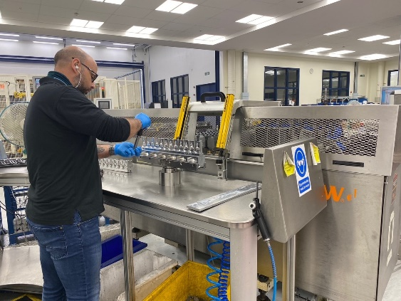
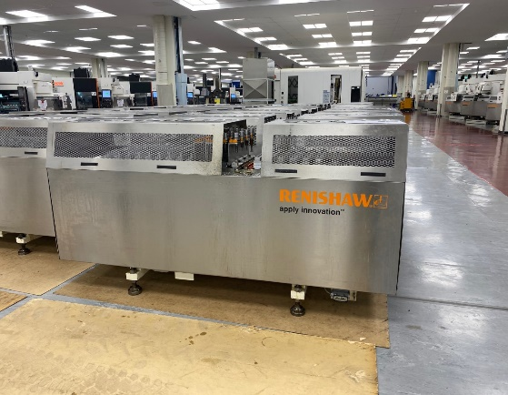

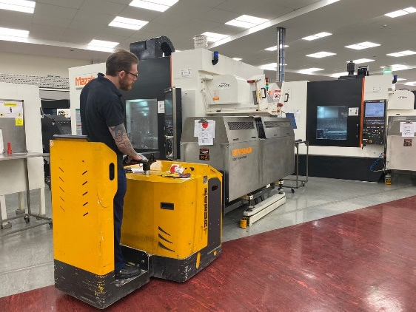

Fig.3

Overview into the project

In this project I will be looking at the safety surrounding loading and unloading the RAMTIC carousel on to the MAZAK FJV’s.
The RAMTIC modification consists of modifying the Gullwing doors (Fig.4) to not open unless the carousel has been disconnected. This is done by utilising a signal from the I/O Card that activates a magnet which will not allow the doors to open. Which will Help to prevent the operator from removing the carousel from the ski’s whilst the carousel is still connected to the FJV.
RAMTIC or Renishaw Automated Milling Turning Inspection Centre, was first developed in the early 90’s and uses a standard tooling platform which has been modified to meet Renishaw’s needs.
This involves a high degree of both automation and closed loop control meaning no manual input is needed. This is all facilitated by using the Renishaw probing system to set tools, in-process monitoring and component validation.
The RAMTIC system continues to be the best system for Renishaw’s standard machining platform i.e. Mazak FJV 250 (Fig.5) with over 50 operations in action. (Albert, 2020)
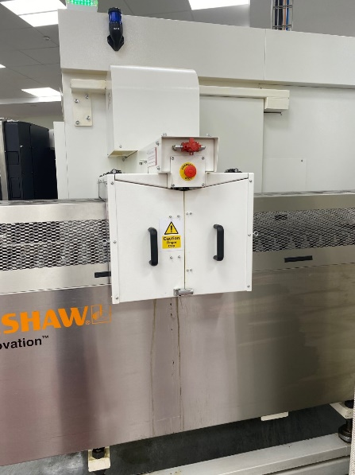
The Gullwing Doors (Fig.4)
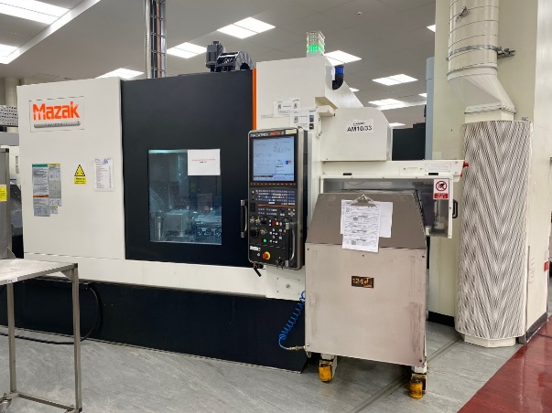

MAZAK FJV 250 (Fig.5)

Design Brief

Problem Statement
The reason we need this modification is down to the risk of the carousel being tipped when removed from the FJV. This can easily be done by not unplugging the hearting plug. Besides the health and safety issues this also causing machine downtime and repair costs.
This can cause the carousel to get stuck whilst one of the operators uses the Doosan to remove it resulting in the carousel tipping over. This is extremely dangerous and is also bad for production.

Design Statement
We will utilize some of the existing RAMTIC system control wirings to make an addition to the gull-wing doors in the form of an electromagnet. The magnet will only be de-energised after the carousel has been unplugged from the machine by the operator/user.
This system is a prevention measure and will significantly reduce risk however the operator/user will still be required to pay attention and ensure the electrical connection and compressed air are disconnected before they attempt to move the carousel.

Target Market
My target market is Renishaw PLC. There is no option to further expand our market due to this being RAMTIC based modification. THE RAMTIC system is only used by Renishaw, meaning the modification will not be compatible with other companies.

Constraints
The only constraint that I have worries about is stopping production, to install the mod each machine will have to be down for several hours meaning that the machine will be missing valuable product

Assumptions
I assume that the modification will lower the risk of having an accident within the Renishaw Miskin machine shop.

Product Design Specification

Performance
1.1 The modification must not exceed the limits presented by the MAZAK FJV 250
1.2 The modification must not be a slow process; it must be instant.
1.3 It must work each time the hearting plug is taken out.
1.4 It must hold the magnets shut until the hearting plug is removed.
1.5 The modification must work with the existing electronics within the MAZAK FJV 250.
1.6 The magnets must withstand at least 280N of force.

Working Environment
2.1 The modification must be able to withstand a shock force without blowing its inner circuit.
2.2 We must keep the modification in a clean environment i.e., an electrical panels.
2.3The magnet and bracket must not corrode from fluids.
2.4 Must be able to withstand at least 100 decibels.
2.5 The modification must withstand vibrations from the machine it is attached, the brackets must come loose neither should the magnet.
2.6 The system must be easy to operate.

Life in service
3.1 The modification must be able to withstand 24/7 production.
3.2 The modification must last the life span of the machine it is attached.
3.3 The technology must still be relevant in 10 years.

4. Maintenance
4.1Maintenance must be accessible and effective.
4.2Maintenance should be a rare occasion.
4.3 Spare parts must be easy to access
  - No special tools will be required.

5.Target Product Cost
  - The modification must cost under £100 per machine, in parts.

6. Competition
6.1 There 5will be no competition from other companies as that this will be a RAMTIC based modification.

7.Shipping and transportation
7.1 The modification will need no shipping or transportation due to the modification not being licensed to any other companies.

8.Packing
  - The modification will not need packaging due to the product not being outsourced.

9.Quantity
9.1 The complete modification will need a minimum of 43 units.
  - There will also be five spare modification packs in stock for breakdowns.

10.Size
10.1 The Brackett size must be no larger than 180mm in length and 60mm in width.
  - The magnet must be no larger than 180 mm in length and 55mm in width.

11.Weight
11.1 My desirable weight for the bracket will be lo larger than one kilo.
  - My desirable weight for the magnet will be no larger than two kilos.

12. Aesthetics, Appearance, and Finish
12.1 I am looking for the bracket and magnet to be in a matte finish.
12.2 The colour will be silver for both the magnet and bracket.
12.3 The magnet and the bracket will both have a textured finish.
12.4 The set-up will appear to look tidy.

13.Materials
13.1 The bracket will be made from stainless steel.
13.2 The magnet will also be made from stainless steel.
13.3 The electrical circuit will be made from industry standard wire.

14.Standards
14.1 The modification will only comply with British standards due to the modification not be outsourced internationally.

15.Ergonomics
15.1 The modification will be able to be used by everyone.
15.2 No training will be required to operate this modification.
  - The only input from an operator will be unplugging a hearting plug.

16.Quality and Reliability
16.1 My product will be made from high-quality materials ensuring a quality product.
16.2 The design will be sound and will work well with the machine in which it’s installed.
16.3 The modification will be reliable by having a good design and being made from quality materials.

17.Shelf life
  - My product will have a shelf life of over 15 years if stored in a dry place.

18.Timescales
18.1 I’m looking to design this modification within 12 weeks.
18.2 I will install a modification to a MAZAK FJV 250 and monitor over six weeks.
18.3 The installation timescale for all 43 machines is two weeks over a five-day working week, 24 hours each day.

19.Testing
19.1 After designing and manufacturing the modification, I will test it on a MAZAK FJV 250 over six weeks, monitoring it every 8 hours.
19.2 I will monitor it by checking for surging power within the machine, checking the magnet stays closed when the hearting plug is still engaged, and testing if the magnet releases after the hearting plug have been removed.
19.3 My results will be updated in a spreadsheet.
19.4 After six weeks, if the testing was successful, the modification will then go into production for the other 43 machines and spares.

20.Safety
20.1 All live wires will be hidden away within an electrical panel.
20.2 All operators will be given a briefing on how the modification works and the trap hazards.
20.3 Large stickers will be placed where operators’ hands can get trapped to warn them of the trapping risk.
20.4 A full risk assessment will be taken out before each modification is installed.

Why is a PDS important?

A Product Design Specification is essential when designing a project; it controls the whole project. It explains what you want from your product. You should always aim to hit every point within the PDS as it sets boundaries for the design.
The PDS is also used to ensure you meet your customers' needs; this is essential to ensure your product is successful and satisfies your customer or yourself.
The PDS was important within my report, and it gave me limits to what I needed. It ensured that I didn’t design something that was not required. The PDS gave me guidance on what I needed for my modification. I based my PDS on my design brief, which I carefully planned out. My PDS covered over 20 different points to ensure everything was covered so my product could be the best.

Feasibility study

Executive Study
Renishaw is a world-renowned company that specialises in metrology equipment. The main headquarters Is based in Wotton-under-edge in Gloucestershire and has several manufacturing sites around the UK and over 80 offices around the world. My site, is the Miskin site, based in Miskin in the Vale of Glamorgan. In this study, I will touch upon the different aspects of my project, these will include, the description of products, technology, organisation and staffing, marketplace and my schedule.

Description of Product
The RAMTIC modification will be designed to benefit the safety of the employee. Until now there is no safety procedure in place to allow the employee to remove a carousel from it’s ski’s safely knowing the hearting plug has been removed. The hearting plug is the lifeline between the CNC and the carousel. If the employee was the remove the carousel from its’s ski’s without unplugging the hearting plug, The carousel would tip, causing both a massive risk to the employee and causing the work to be scrapped. By introducing this modification, it will not allow the carousel to be removed unless the hearting plug has been removed. I will utilise some of the existing RAMTIC system control wiring to make an addition to the gull wing doors in the form of an electro magnet. The magnet will only be de-energised after the carousel has been unplugged from the machine by the operator/user. The specified magnet will withstand 28kg (280N) of force, which should easily be sufficient to hold the gull-wing doors shut.

Technology Consideration
With regards to technology, I believe that Renishaw have the supplies and the resources to implement this modification. No new technology will need to be considered. This modification will be designed using the existing RAMTIC System, meaning that the electro magnet will be wired directly into the wiring panel to meaning no major technology is needed. I believe in creating an easy and simple solution to this, meaning I want to keep the technology at a minimum. This will benefit the maintenance, cost and time aspects of the modification.
By creating this modification with current technology, this will allow for cost to be kept at a low. If I were to contract the design of new technology through an outside company, the cost aspect would be massive. Not only the cost aspect but the time will be greatly increased on this project.

Product/Service Marketplace
Currently the RAMTIC system exists on the MAZAK FJV 250 and is a Renishaw based system, meaning that no other company uses the same system. This means that being able to sell the modification would be impossible as there would be no marketplace for it. The only way a marketplace will be implemented for the modification was if Renishaw were to sell the RAMTIC system to other companies. There’s a marketplace the RAMTIC system as other companies use the MAZAK FJV 250, but, there have been no plans to sell the RAMTIC system to other businesses.

Organisation and Staffing
No additional staff will need to be hired to implement this modification instead I would want one engineer to be trained on all three of the shifts to be able to carry out the installation of the modifcation 24 hours a day. Seeing as we have 43 FJV machines, each engineer should be able to complete two a shift meaning that the whole project should hopefully be complete within two working weeks.

Schedule
I am scheduled to complete this project report at the end of April, meaning that the installation of the modification should be finished within week three and four of May, for the first week I will be looking at conducting a test and installing the first modification and allowing it to be supervised for a week to determine if any problems will arise, if no problems arise I will then install the 42 other modifications..
February 2021 – May 2021 – Compose the project
May week 2 – Ramtic Modification test
May week 3 & 4 – Ramtic Modification install

Findings and Recommendations

In this section I will summarise my findings and recommendations from conducting this feasibility study.

Technology
- No new technology will need to be considered.
- Easy and simple solution
- Low cost, low cost to the company for parts and research
- No outside companies are involved with the design of this modification

Marketing
- No marketing needed as the RAMTIC system only applies to Renishaw.
- Potentially investigate licencing the RAMTIC system to other companies.

Staffing
- The mod will be installed over a three-shift pattern.
- An engineer will be trained on each shift to install the modification.
- No additional staff needed.

CAD Drawing
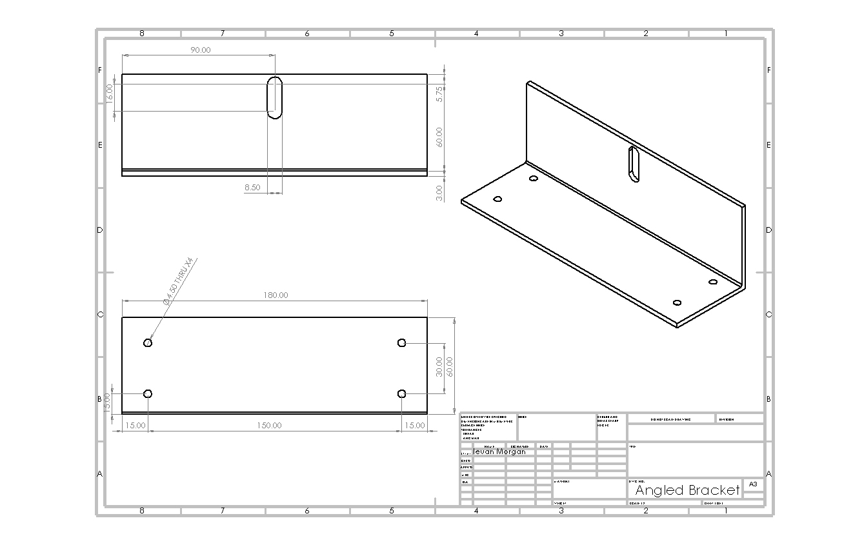
Below is my final design for the angled bracket (Fig.6) that will secure the electro magnet to the gullwing doors.
Fig.6

Design Evaluation

The design is straightforward yet proves effective. The design does everything it's asked to do. The bracket is 180mm in length and 55mm in width. These dimensions are in spec with what I asked for in my product design specification. With these dimensions, the bracket will also weigh under the three-kilogram limit I required. The bracket is a sleek design, and it’ll be made from stainless steel. Aluminium would have been the ideal material due to its lightweight properties, but aluminium is not magnetic, meaning it will prove useless for this bracket.
The bracket will be made solely from recyclable material, meaning that it's environmentally friendly.
The overall design will be robust because it is a solid piece of metal and is not being welded, which means that there will be no weak points to this bracket.
The holes will be pre-drilled to ensure accuracy over each part.
Overall, I believe this is a good design due to meeting several factors in my product design specification.

Why is CAD greater than manual drafting?

Data Storing and Accessibility

Unlike manual drafting, CAD drawings do not need to be stored in filing systems. CAD can easily be saved to a computer’s hard drive within a few clicks of the mouse and can also be accessed anywhere with an internet connection. You are more likely to lose drawings when manual drafting compared to computerized drawings. Also, CAD is more environmentally friendly. (Davi, 2018)

3D views

3D drawings are a great way to show the 3D structure and can easily be demonstrated using AutoCAD software. Creating a 3D view with manual drafting can prove difficult and can take years to master. It is also much easier to make amendments once you know you have made a mistake in CAD. Using AutoCAD allows your drawings to look realistic compared to drawing done on preparation during manual drafting. (Davi, 2018)

Electrical Diagram

As well as designing a mechanical bracket, I must design the electrical circuit that will power the electromagnet, below is my electrical drawings (Fig.7) as well as an explanation into how it works.
(Fig.7)
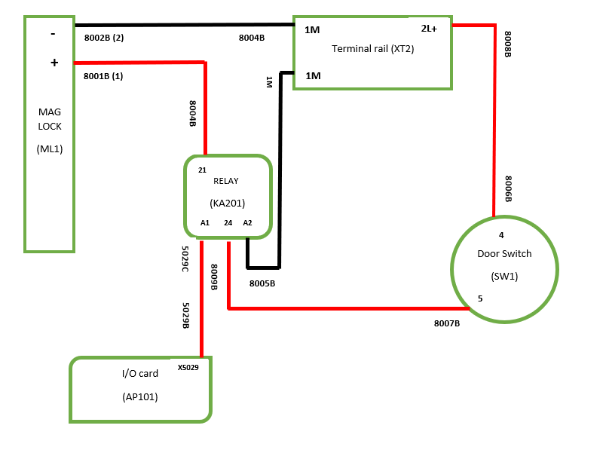

The I/O card is the heart of the machine and supplies power to the whole circuit, power runs along the 5029B wire, powering the relay. By powering the relay A1 will activate A2 by creating a contact and send power along the 8005B line along to 1M in the terminal rail, this will activate 1M and send power along 8004B to the electromagnet. As well as powering 1m the terminal will also power the 2L+- which will send power to the door switch, if the door switch is activated, power will be sent back to the relay and activate 24, this activates the relay which will create a contact between 24 and 21 activating the electro magnet, if the door switch isn’t activated then the relay will not activate and the electromagnet wont magnetize.

Material Research

After creating my design, I will be looking at the properties of stainless steel and aluminium in this section. I will be deciding which material will be the best for my project. I will judge them on strength, corrosion resistance, conductivity, and recyclability.

Strength
Stainless steel has many different grades; the most common are 304 and 316. Each grade comes with different properties. For example, 316 will most commonly be used for a product within either the food or surgical industries. It is also widely used in watches. The 304-grade stainless steel would be the steel that I would use for my project due to its incredible density of 8.06g/cm^3, meaning that this grade of stainless will be perfect for my bracket. (Bell, 2020)

Corrosion Resistance
Stainless steel has high corrosion resistance, hence the name ‘stainless steel.’ The 304-grade steel consists of 18% chromium and 8% nickel. This gives it considerable corrosion resistance. This is ideal for my bracket due to its exposure to the workshop environment. (Bell, 2020)

Conductivity
Stainless steel is conductive. Even tho stainless steel is conductive, it has a much lower conductivity than other steels such as high carbon steels. Stainless 304 has a thermal conductivity of around 15 watts per kelvin per meter and an electrical conductivity of about 1.4 million siemens per meter. This means that Stainless 304 will be a good enough conductor for my bracket. (Bell, 2020)

Is it Magnetic?
Magnets will stick to stainless steel, steel is composed of a lot of iron, iron is a highly magnetic material. Stainless steel that contains a high amount of nickel will not be very magnetic, that why I chose a 304 grade of stainless due to its small amount of nickel. (Bell, 2020)

Recyclability
Stainless steel products are designed to have a long life, this is usually why it is selected in the first place. After the product's life has come to an end, the stainless steel usually has retained a lot of its original alloys such as chromium, nickel, and molybdenum. This makes the high material value to a stainless steel producer, meaning that the majority of steel going into the blast furnaces is recycled. This gives stainless steel a great advantage when it comes to recyclability. (Bell, 2020)

In this section, I will talk about aluminium and compare it to stainless steel.

Strength
Compared to stainless steel, aluminium is a lot weaker. Stainless steel is less likely to warp, deform and bend but compared to aluminium. aluminium is a lot lighter, almost three times as light, which gives it an edge over stainless steel, yet aluminium will be too weak to stand the course of time, providing stainless steel the edge. (Davies, 1999)

Corrosion Resistance
Once aluminium has been exposed to the atmosphere, a thin invisible oxide skin forms, this protects the metal from further oxidation, this gives aluminium high corrosion resistance, aluminium is highly resistant to weathering and other elements. This puts both aluminium and stainless steel on the same level, meaning they both have high corrosion resistance. (Davies, 1999)

Conductivity
Aluminium is a good conductor of electricity, meaning it’s both a famous thermal and electrical conductor. Aluminium is often pulled into wires due to being such a good conductor of electricity, this puts it on top of stainless due to stainless not having excellent electrical conductivity. (Davies, 1999)

Is it Magnetic?
Aluminium is not magnetic, aluminium has 13 electrons which means it has one unpaired electron. Materials with one unpaired electron are known as paramagnetic. This is a massive blow to aluminium as that I need my bracket to be magnetic to meet with the electromagnet to keep the wing doors shut. (Davies, 1999)

Recyclability
Aluminium is considered a sustainable metal, meaning that it can be recycled numerous times without losing any material in the process. It is cheap, fast, and practical to recycle aluminium, meaning that aluminium is popular. (Davies, 1999)

Conclusion
In conclusion, I will choose stainless steel to create my bracket rather than using aluminium for the following reasons. Stainless steel is a lot stronger than aluminium; the bracket will need to hold 280N of force. I need a reliable material that I know will maintain that weight, so I choose stainless steel over aluminium. Also, aluminium is not magnetic, meaning that it will not be able to work with the electromagnetic, this makes it impossible for aluminium to work with my design, meaning that stainless steel comes on top overall.

Design Evaluation

As you can see, the design is straightforward yet proves effective. The design does everything it's asked to do. The bracket is 180mm in length and 55mm in width. These dimensions are in spec with what I asked for in my product design specification. With these dimensions, the bracket will also weigh under the three-kilogram limit I required. The bracket is a sleek design, and it’ll be made from stainless steel. Aluminium would have been the ideal material due to its lightweight properties, but aluminium is not magnetic, meaning it will prove useless for this bracket.
The bracket will be made solely from recyclable material, meaning that it's environmentally friendly.
The overall design will be robust because it is a solid piece of metal and is not being welded, which means that there will be no weak points to this bracket.
The holes will be pre-drilled to ensure accuracy over each part.
Overall, I believe this is a good design due to meeting several factors in my product design specification.

Forces for Change Lewin’s Force Field Resisting Forces
RAMTIC Modification
Aesthetically changes the machine. 2.
Less downtime created by a carousel dropping . 4.
Being able to generate more profit. 5.
Total: 23 Total: 20
Will Void the machine’s warranty.4.
Potential issues with maintenance, due to trail and error installation. 3.
A small cost to the business for parts and labour. 3.
Engineers will need to be trained. 4.
Downtime increase. 4.
Put more money back into the business from the higher profits. 5.
Less near misses recorded . 5.
Further expansion of the RAMTIC system. 4.
Safety of Workers. 5.

Conclusion of Lewin’s force field analysis

After carrying out a Lewin’s force field analysis, I have concluded that the RAMTIC modification will be more beneficial to the company than not. From the research, I can see the top scorer, with a five, is ‘safety of workers’.
All employees fall under the health and safety at work act 1974 and, by law, must be kept safe in the workplace. By implementing this modification, the safety factor within the machine shop will increase. The whole reason for implementing this project is safety.
As well as safety, generating profits is a concern to me, the value of a carousel can range anywhere between £13,500 and £1.5 million. As danger to life, a dropped carousel will be a massive loss to the company due to the machined parts being damaged.
Some of the resisting forces include downtime. Downtime is a huge factor as the machine being worked on can lose thousands of pounds an hour in the installation phase as the machine will need to be isolated. Considering the amount of money the machine will lose in downtime, losing a whole carousel outweighs this significantly.
While a new engineer is being shown the installation process, the machine’s downtime will be longer. Considering the downtime will be longer, the engineer still needs to be fully trained before installing on other machines.
Overall, with a 23 compared to 20, the forces for change outweigh the resisting forces.

Costs

Overall costs
These are the estimated costs below, I based my prices after researching all the parts on RS Components. As well as parts cost, below will be an explanation on how the RAMTIC modification can save Renishaw money.

Modification Parts
- Electro magnet £29.83 (Actual cost)
- Relay & Base £10.00 (Actual cost)
- Wiring, connectors, clips & glands £15.00 (Estimate)
- Mounting brackets – Magnet/pad (To be made in house – Estimated cost) £4.50
- Key switch £5.00 (Actual cost)
This gives us a total of £64.33 per machine in material costs, this complies with my product design specification as the price is below £100.
This gives us a total cost in materials of £2,766.19 ( £64.33 X 43 )

Overall, this cost will outweigh the costs of dropping a carousel. The carousel alone is £3500, then the cost of the products inside, which can be anywhere from £10,000 to £1.5 million. This means even at the lowest a dropped carousel is going to cost £13,500, meaning a one off payment £2,766.19 can save the production department £10,733.81.

Project Reflection

In short, I believe my project has been a success. Mainly due to my time management and detail of each section. Before starting my project, I used Microsoft Excel to plan. I used a Gantt chart to plan each step and its timescale. The Gantt chart was majorly helpful due to being able to spread the workload over the given period, meaning it was manageable. With regards to time management on this project, I believe it went well.
My initial research into the RAMTIC process and the requirement of this project went well. I managed to learn a whole bunch of information regarding the process and how it works. I feel I gave a good explanation and summary due to my good understanding of the in’s and out’s of RAMTIC.
I wish that I expanded more on my design brief. I feel as if my design brief was short and sweet and lacking some critical information. For my next project, I hope to have a fuller, more in-depth design brief.
The PDS covered a whole range of things that relate to my project. The amount I covered, I feel, is sufficient and helped me design the best modification I could. With so many aspects covered, it allowed for my final design to be solid.
My feasibility study was full of helpful research and information relating to my project. I took a lot of different aspects into consideration and answered all questions.
The bracket that I designed on CAD was simple yet effective. It was within spec with my PDS and will be cheap to manufacture. I was happy to make the bracket out of stainless steel after my material research indicated that aluminium would not be the best material for my needs. My electrical diagram is well thought out and effective.
Lewin’s force field analysis indicated that the project is worth doing, with the forces for change being more significant than the resisting forces. Lewin's is a great analytic tool, and I will use it in future projects.
Researching costs, I found that the overall price will be lower than a hundred pounds per machine. The price corresponds with my PDS. For my next project, I will get exact costs instead of estimates.
In conclusion, this project has successfully created a document that will display all aspects of what the RAMTIC project is. In the future, I hope to do more research and go into the design stage of the project with more confidence.

References

J.R.Davies (1999), Corrosion of Aluminum and Aluminum Alloys, 6(2), pp. 1-10.
John Davi (2018), Advantages of manual drafting and CAD drafting, urcadservices (Accessed 26th of April 2021), https://www.urcadservices.com/post/2018/01/04/five-advantages-of-manual-drafting-and-cad-drafting#:~:text=Better%20Quality%20Designs%3A%20The%20CAD,when%20compared%20to%20hand%20drawing.
Mark Albert (2020), RAMTIC system still ticking, Renishaw (Accessed 21st of April 2021), https://www.renishaw.com/en/8985.aspx
Terence Bell (2020), Type 304 and 304L stainless steel, ThoughtCo(Accessed 26th of April 2021), https://www.thoughtco.com/type-304-and-304l-stainless-steel-2340261

Appendices
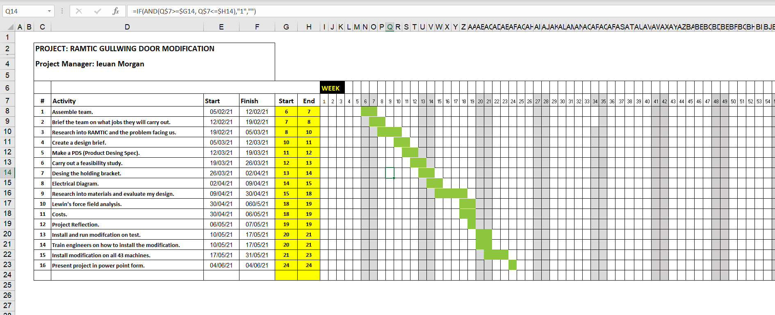
The Gantt chart below is showing the planning process of my project (Fig.8)

(Fig.8)

