Research in Practice
ADAD5004
Holly Morris-Price
2104336
Dissertation Proposal
In this essay I’ll be exploring shadow, light and bleak as my keywords and how they effect images and also how they work as their own style of photography. The style of light & shadow photography is something i work with in my own personal practice and a style I’m very passionate about but i also want to explore bleak imagery and the emotions it can showcase just though a composition or tone of colour. I also think that the style is really under looked and underappreciated within the community.
Shadow, as defined in the Cambridge dictionary is’ ‘an area of darkness, caused by light being blocked by something’. [Cambridge Dictionary, 1995] in this case, to create a Shadow within a photographic piece of work, is to both warp the light with an item that then creates a shadow and to cover an identity, item, or space within said image.
And while Photography allows the perspective of someone or something to be almost warped in a surreal or even an illusionistic way by a shadow, sometimes it can also create something to add onto the image or is can create negative space in the image. A great example of a shadow adding something to the image is David Basanta’s image ‘Fishnet Stockings’.

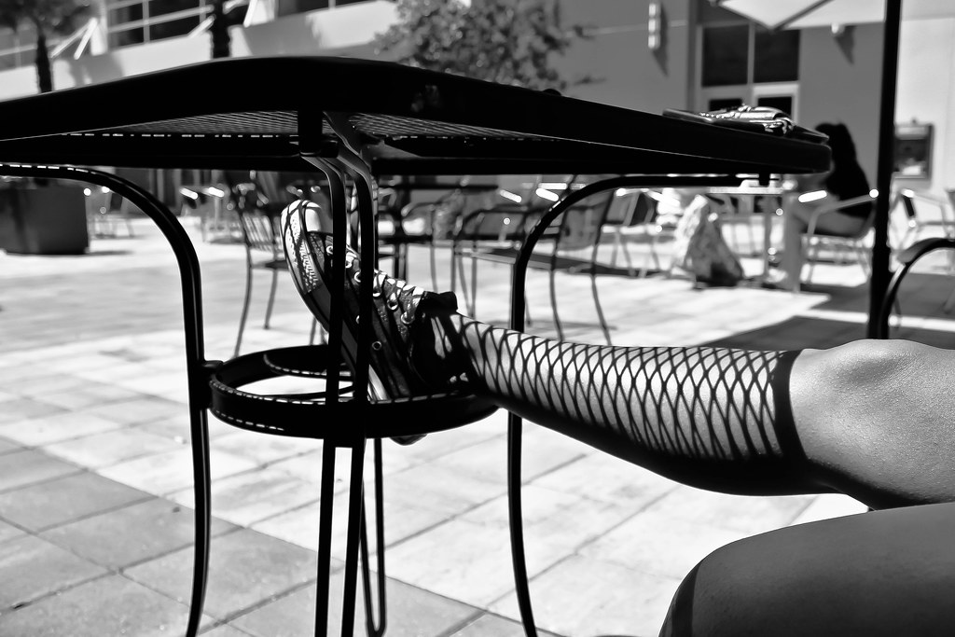
Figure 1, Basanta, M. [2012] Fishnet Stockings
In this image by Basanta he’s used the shadow of a table to create the impression of a pair of fishnet stockings on someone else’s bare leg and while this is such a simple image, it’s really quite interesting to take the concept of using shadows to mimic clothes, or even accessories. I think another great example of shadow photography in the idea of transforming something. As seen in an image taken by Francis Giacobetti.
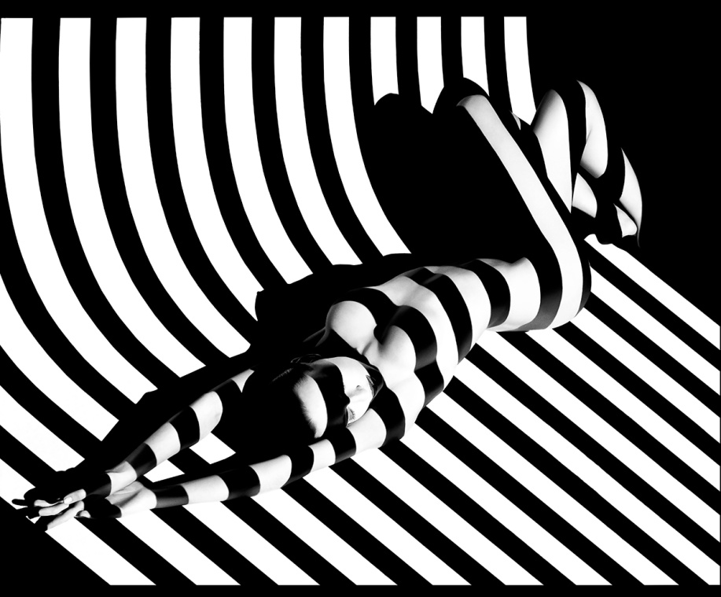

Figure 2. Giacobetti, F [1988] Zebra 17
Giacobetti’s image has a much different aura to it compared to Basanta’s and i think part of this has to do with the contents and auras of both images, and unlike Basanta’s image, the black lines in Giacobetti’s image are more manipulated due to how the model is posed. One photo is much more relaxed and casual and the other is much more posed and has an intimate look to it. However with Giacobetti’s image while it plays on that idea of using shadows to mimic clothes it also distorts the lines that have been created along that area and they are coving not only the chest of the model but it also removes the identity of the model by the shadow being over the eyes. Shadows within photography also play a large role in editing, as you can adjust it to create a darker or lighter shadow to better enhance an image. Sometimes the image won’t need it but sometimes maybe if you’re outside the shadows from the sun aren’t as dark as you wanted. I think shadow photography often gets overlooked and looked at more as a way of enhancing images, much like light does, and while using shadows to mimic clothes is definitely one aspect of shadows i think by playing around with shadows as a way of manipulating images as well, gives a creative outlet that can produce some extremely interesting moods and visuals. For example, with shadow photography you can use the shadows to almost highlight a certain point in the set up or on the model, it allows for so much to be done with it and you work with a relatively small colour/tone palette depending on how you work with shadows, in my personal practice i work heavily in black and white and working with the tones rather than working with a palette since i found that while you have more flexibility with colour my own images tend to build a lot of colour noise on them during the editing process, and also that the content i tend to shoot for my own personal practice brings out more of the aura I’m looking for and also creates that cinematic appearance to the piece which enhances my work even more and also adds an almost candid feel to the work.
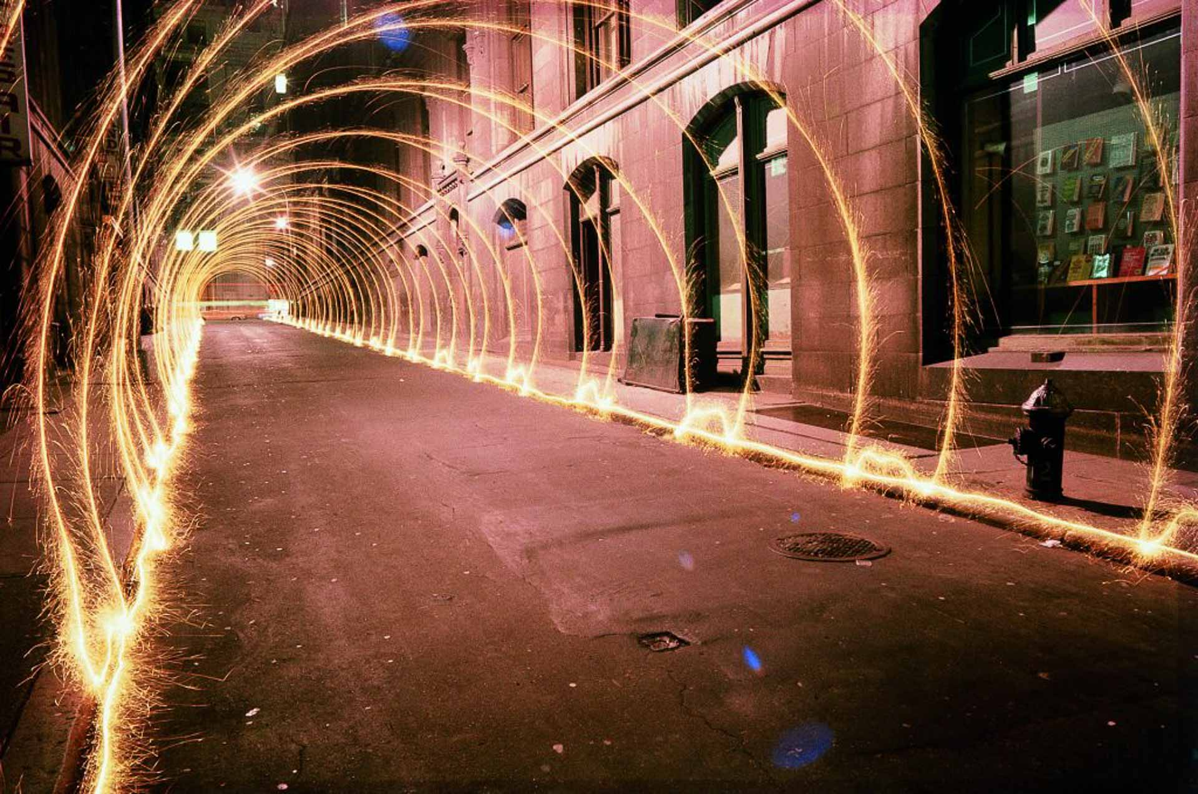
However Shadow’s cannot be achieved without the use of light. Light under the definition of The Cambridge Dictionary means ‘the brightness that comes from the sun, fire, etc. And from electrical devives, and that allows things to be seen’.[The Cambridge Dictionary, 1995] While Light also works in a similar way to Shadow it creates the opposite of shadow due to it being more ‘revealing’ rather than concealing an identity of a model or a subject of interest. Another way light is used is by creating shapes or a silhouette of something, Light photography can also be called Light ‘Painting’ because of how you can use light. When looking into Light Painting, i came across Artist Eric Staller, who works with the light painting and has produced some really interesting pieces of work, something i also discovered he does is, he attaches lights onto cars and then drives around, it gives a really interesting effect due to the use of low shutter speed and some of the images Staller has produced really makes you think about the whole process behind the image, because some of the images on his site are so intricate or so detailed it makes you wonder how it’s all done so cleanly.
Figure 3. Staller, E [1977] Light Tunnel
Light Tunnel by Eric Staller is one image that really intrigues me due to the whole idea of it, it’s so interesting to see this, and in an article by LightPaintingPhotography.com Eric explains both the inspiration and also how he created it. In the online article he says how he attached a sparkler to the end of a broom and then walked down the street creating arches [Lightpaintingphotography.com, 2023] in the same article it mentions some of the other methods that Staller uses for his other Light paintings. Moving on from light painting, and to another way light is used in photography that i previously mentioned, is how it’s used to reveal something rather than conceal. And a great example of this idea of ‘revealing’ something with light is Brian Griffin’s Siouxsie and The Banshees – Dazzle which was taken in 1984.
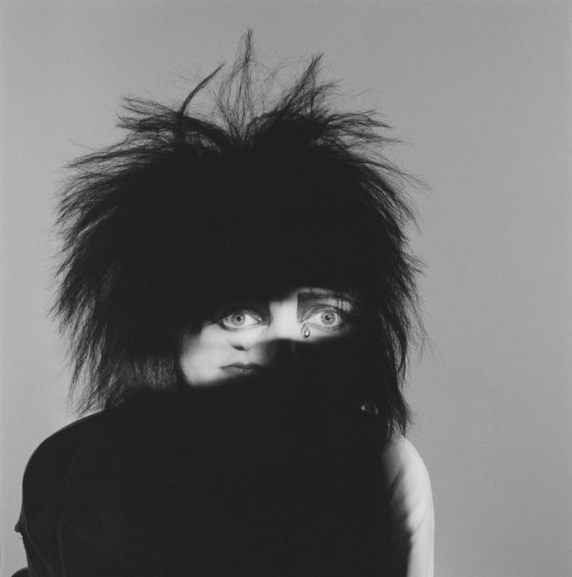

Figure 4 Griffin, B [1984] Siouxsie and The Banshees – Dazzle

Here you can see that using a beam of light has revealed the eyes and if you look closer the bottom half of the image is a wider shout so you can see the mouth, which brings an identity to the image and also brings some mystery to it, so in many ways, it can create the same sort of atmosphere shadows do however because it’s showing you something specific, and the way it’s been done to show both the eyes and mouth has a sense of surrealism to it because it’s such an interesting placement & composition. From a first glance at the image I personally thought it was just the eyes but once you look closer you then see the mouth which I find really interesting.I also think that this use of light photography is really impactful in the black & white scene since you focus more on the lighter areas such as the eyes & mouth, it really pin points the main focus of the image and also creates a really interesting cinematic feel to images, and beside the cinematic lighting and light painting, Light also plays a big part in the editing process, you can make them more vibrant or more dull to enhance an image, but the light when editing can also be considered the whites. I think in photography there isn’t a perfect balance of Shadow and Light, simply because each image has it’s own needs when either editing or even when shooting.

When both shadow and light are used in the same photo it can create many different styles of images, it can make the image cinematic, mysterious, and surreal, it can also make it bleak. While lots of bleak images are very dull in colour and don’t have rich blacks and bright whites, it works well with the subject in the images and they look really ghostly or lonely, but can also make the image feel very melancholic depending on the content of the image you’re looking at, which is something I want to explore in my own practice and how different tones of greyscale, effect a piece of work and it’s appearance and overall emotion as an image, and while under the Cambridge Dictionary Bleak is described as ‘If a place is bleak, it is empty, and not welcoming or attractive’ [Cambridge Dictionary, 1995] I think the melancholic feel to a bleak image in some ways challenges that definition of it being unattractive since when something is melancholic, it’s quite relaxing to look at. However with the photographers I’m going to be looking at, each side of the word bleak is going to be explored from the empty ghostly side to the Calming Melancholy side.

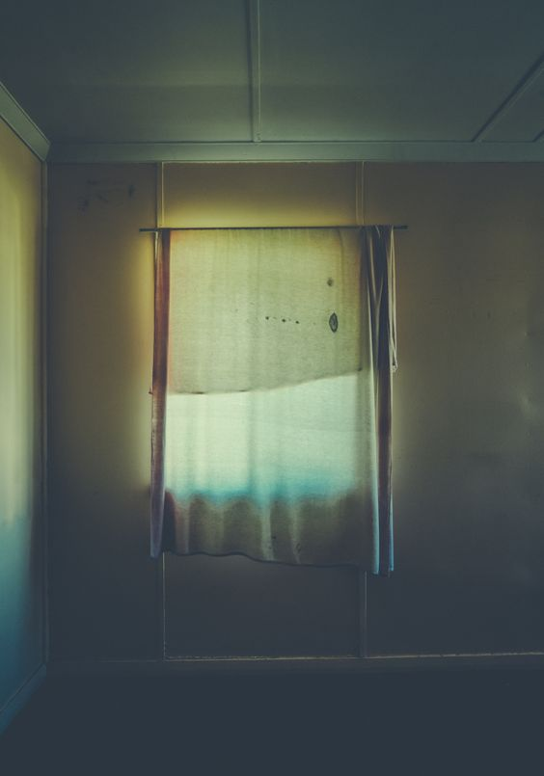
The first photographer I’ve looked at is Jared Fowler, his work is really interesting due to it having that empty appearance and a cinematic feel to it, however it has an aesthetic feel to it due to both the composition of the image and also the colours and tones in the image, working so well together throughout.

Figure 5, Fowler, J [2013] Used House 2
Fowler’s Used House 2 Collection and also the Used House collections altogether are really interesting to go through and look at, the compositing in each image is so simple, but in this specific image i think what creates that lonely and ghostly feel to the image is that there is nothing else in that room besides the one window and worn curtain, and the colours also play a large part in the images expression. If this image were to be in Black & White i don’t think it would hold the same ghostly feel to it due to the the lack of colour present, the muddied and desaturated colours in this image really brings it to life. Another point about this image that draws me in is that fact we know there’s more space in that room, where as on the left side of the image there is a wall the right clearly expands out into the room, and due to the lighting in the image it does seem as though that is the only window within the space, so i’d be curious to see the wider shot of the entire room and how it looks. From here I then went on to explore into more bleak photography to discover the different styles and compositions within the images, I decided to use pinterest for this as i would be able to create a board to put all the images together to then look back at for inspiration later on in my personal practice.
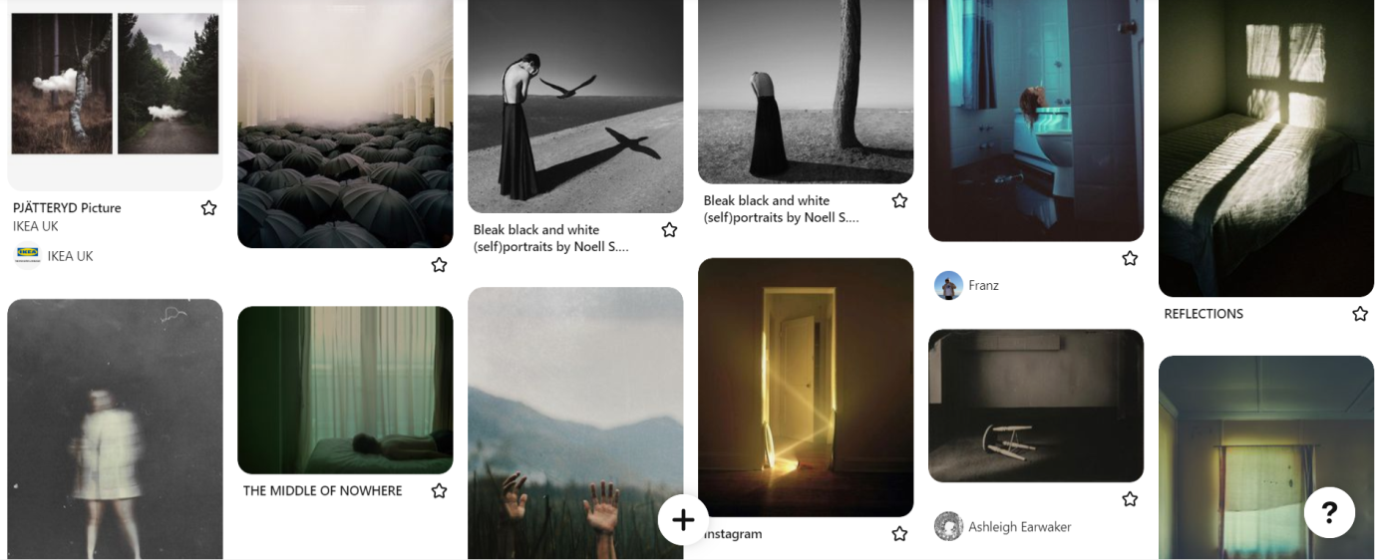
Figure 6, Holly Morris-Price [2023] A Pinterest board showing Bleak photography

When creating the Pinterest board I came across many images while the composition of having the image almost cut in half, and it reminded me very much of Hiroshi Sugimoto’s seascape images due to their bleak and rather calming appearance. Each seascape Sugimoto produced and published had something slightly different about them, so although it felt like you were looking at the same image over and over it never was the same image.
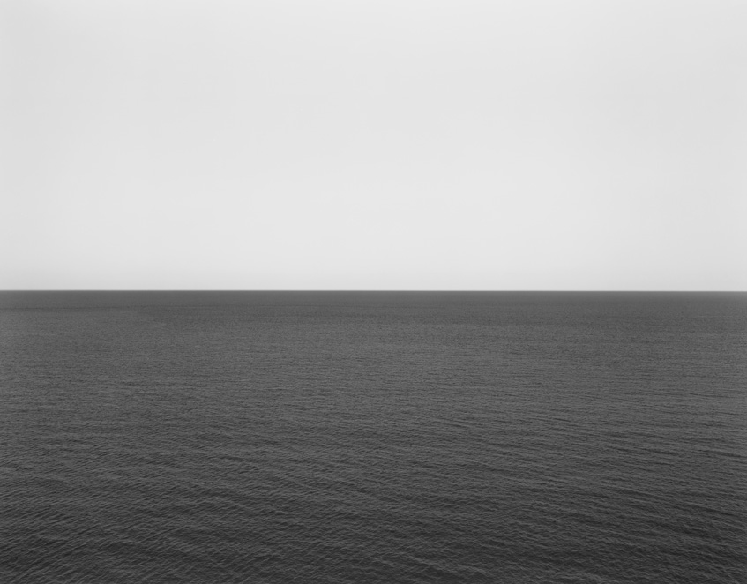
Figure 7 Sugimoto, H [1980] Caribbean Sea, Jamaica
As shown above the image in really simple and has a harsh horizon line, however because of the harshness in that line it almost looks as if the image has been edited this way, and like I previously touched on, many of the seascape photos looked this way with something different to them, whether that be the images exposure, or the images focus, there’s something that’s slightly different each time, and i think that’s what makes these seascapes so interesting to look at. In Figure 7, the bleakness in this image is more like the melancholy bleakness I previously mentioned where it’s more of a peaceful bleakness. The actual image has a dullness to it, however it works because of how sharp the horizon line is, and i think the dullness creates that melancholic feel to it due to it not being so deep in colour unlike the following images.
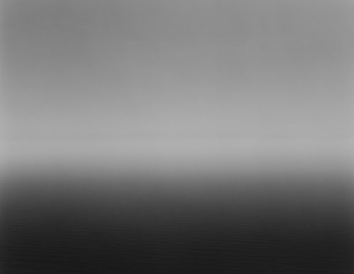
Figure 8 Sugimoto, H [1993] Ligurian Sea, Saviore
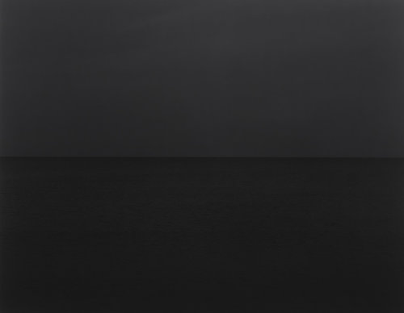

Figure 9 Sugimoto, H [1996] Baltic Sea, Rugen
In both figure 8 and 9 the blacks here are much deeper and give more of an empty impression to it Figure 8 has more of a gradient to its horizon than both Figure 7 and 9 have, and i think that is why it feels bleaker in a ghostly sense rather than melancholic. I think that the differences between both appearances of bleak are within the image itself, and i think this would be a really interesting idea to delve into further.

Overall, each key word I’ve looked into work in relatively similar ways, however each one has parts that divide it from the others. Like how light is meant to be more revealing compared to shadow which conceals something or someone it sets them apart in a rather big way even though you have just done the opposite to which ever you would start with, and then when you add bleak into the mix it is almost like a combination of the previous keywords due to it using both light and shadow to create the bleak images or feeling surrounding an image. I think however when putting one of these keywords with another it creates something quite harmonic due to all the similarities within them, like how shadow can’t exactly exist without light, bleak wouldn’t function the way it does if light and shadow weren’t present in each bleak image produced.

However from here I want to take these keywords on and explore them closer as an area of interest, due to not only some of the artists I’ve covered but also because i want to explore more about how each style with light and shadow differ to using shadows and light in certain areas such as portrait photography and architecture photography and how then using them as a editing tool differs to actually using them as the focus of the work without an item, model, building, or a context co-existing in an image. So from here it raises the questions of how I’m going to look into this difference, and the way i plan to do this is by looking into some different techniques when producing my image and also testing out each focus previously listed to see if these make a difference to just a standalone light & shadow image, the second question that it raises is What is that difference between Light, Shadow and bleak as a style, and as an editing tool, or, for light and shadow to work as a bleak image, does it need a pre-existing context or image subject?

Bibliography:

Figures –
Figure 1 Basanta, M. [2012] Fishnet Stockings [Online] URL: https://www.flickr.com/photos/dbasanta/6890913764/in/photostream/ (accessed: 07/05/2023)
Figure 2. Giacobetti, F [1988] Zebra 17 [Online] URL: https://francisgiacobetti.fr/?page_id=738 (accessed: 07/05/2023)
Figure 3. Staller, E [1977] Light Tunnel [Online] URL: https://ericstaller.com/portfolio/early-works/ (accessed: 08/05/2023)
Figure 4 Griffin, B [1984] Siouxsie and The Banshees – Dazzle [Online] URL: https://www.briangriffin.co.uk/photography/album-covers/siouxsie-and-the-banshees (accessed: 09/05/2023)
Figure 5, Fowler, J [2013] Used House 2 [Online] URL: https://www.bleaq.com/2013/jared-fowler (accessed: 10/05/2023)
Figure 6, Holly Morris-Price [2023] A Pinterest board showing Bleak photography [Online] URL: https://www.pinterest.co.uk/Kiiiiiino/bleak-photography/ (accessed: 10/05/2023)
Figure 7 Sugimoto, H [1980] Caribbean Sea, Jamaica [Online] / Figure 8 Sugimoto, H [1993] Ligurian Sea, Saviore [Online] / Figure 9 Sugimoto, H [1996] Baltic Sea, Rugen [Online] URL: https://www.sugimotohiroshi.com/seascapes-1 (accessed: 10/05/2023)

Online Sources:
Cambridge Dictionary [1995] Light / Shadow / Bleak
Available at:
Light: https://dictionary.cambridge.org/dictionary/english/light
Shadow: https://dictionary.cambridge.org/dictionary/english/shadow?q=Shadow
Bleak: https://dictionary.cambridge.org/dictionary/english/bleak?q=Bleak
(All accessed: 10/05/2023)

Light Painting Photography [2023] How Eric Staller created Light Tunnels. Available at: https://lightpaintingphotography.com/light-painting-artist/featured-artist-2/eric-staller/
(accessed: 10/05/2023)

