LCLM4002_BIRM Digital Skills Task 3
Website Evaluation

Student Number: 2533545
Student Name: Evgenii Denisov
Website Chosen: Cleaners of London
Website Link: https://www.cleanersoflondon.co.uk

Evaluation

Section 1 -- Usability
Question 1a - How quickly and easily does the website load?
The Cleaners of London site opens very quickly, usually within around 1–2 seconds. Its technical performance score is 99/100, while mobile optimisation reaches 100/100. Because the images are optimised, the content appears without noticeable delay. For a B2C business, this matters because visitors can reach the service information straight away instead of leaving the page due to slow loading.
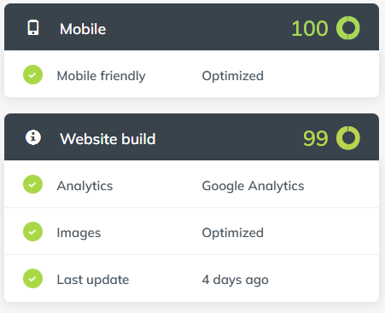
Question 1b - Does the website contain many sub-pages? How does a prospective customer navigate these?
Yes, the site includes a range of sub-pages covering services such as domestic cleaning, carpet cleaning, and end-of-tenancy cleaning. A potential customer can move through them by using the clear sticky menu at the top of the page and the detailed footer links. The 99/100 build score also suggests that the internal structure is organised well, helping users move smoothly between service pages and booking areas.
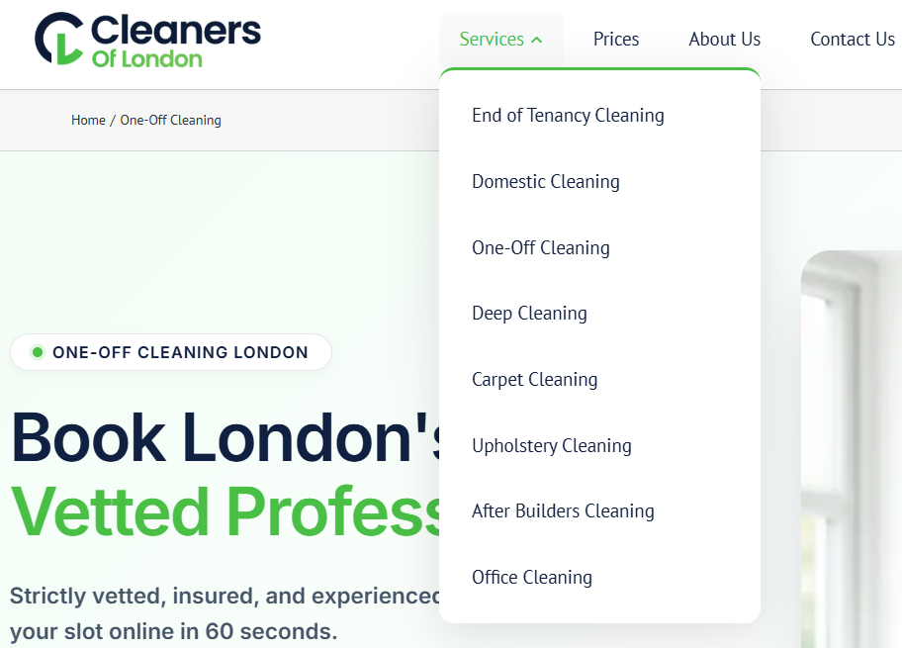
Question 1c - Can a customer make a booking via the webpage?
Yes, the website includes a built-in booking system that allows customers to arrange cleaning services directly online. This reduces the need for manual communication and makes the purchasing process more efficient. From a service-industry perspective, that kind of functionality supports conversions and shows a strong level of digital development, keeping the company accessible and competitive.
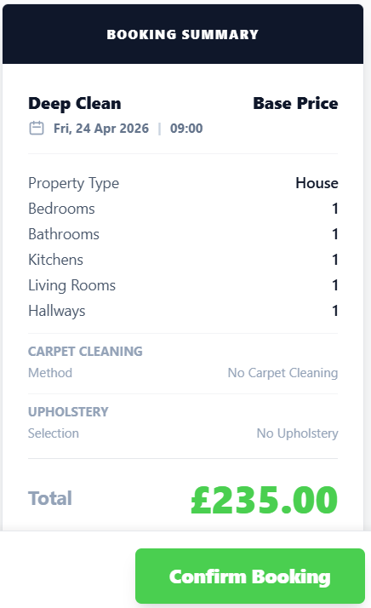
Question 1d - What improvements could be made to the usability of the website?
One important improvement would be to increase accessibility by fixing the missing alt attributes on images. Solving these WCAG A issues would better support users with visual impairments. In addition, stronger and more visible calls to action on the service pages could improve the user journey. These changes would make the site feel more accessible, more professional, and more focused on user needs.
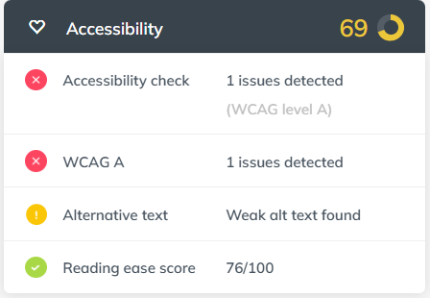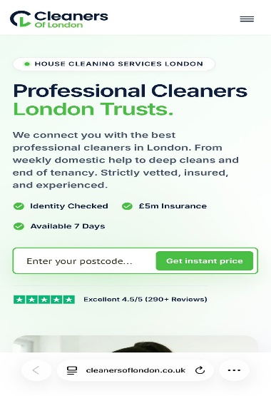

Section 2 -- Pleasure -- Customer Experience
Question 2a -- How pleasant does the webpage look? Are there any differences in appearance on a mobile phone versus a computer?
The website has a professional appearance and adapts effectively across devices. On desktop, users get a wider view of the services, while on mobile the content shifts into a simpler vertical layout designed for touch interaction. With a mobile score of 100/100, the design keeps buttons and menus easy to use on smaller screens, avoiding the common usability issues seen on poorly responsive sites.
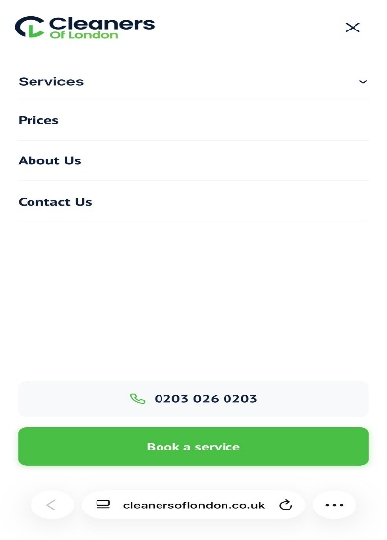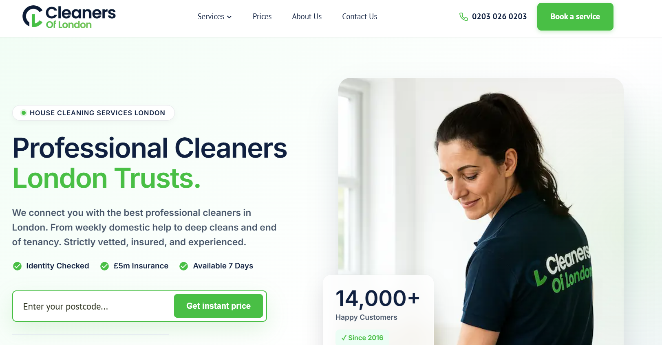
Question 2b - How does the website use imagery, video and colour?
The site uses a green-and-white colour scheme effectively to communicate cleanliness and professionalism. It also includes high-quality images that help create trust, and the technical report confirms that these images are optimised for performance. However, the analysis also points to weak alt text, which means the visual presentation is strong but the supporting accessibility metadata still needs attention. Overall, the balance between appearance and speed supports professional B2C communication.

Question 2c -- Has the website made use of an online chat tool on the website? How effective is this to enquire about the product or service?
The website does not rely on an automated chat feature and instead states a preference for human contact rather than bots. Although there is no live chat box, users are given direct contact options through a visible phone number and email address. This approach places more emphasis on personalised service and can strengthen trust, because enquiries are handled by people rather than automated systems.

Question 2d -- How effective are the social media links on the website?
From a technical point of view, the site performs strongly in this area, receiving a 98/100 score for social media presence in automated testing. Even so, a manual review shows a gap between these strong metrics and the real customer experiences visible on Facebook. That difference suggests automated scores should not be accepted blindly, because good-looking digital indicators do not always reflect dependable service or genuine customer satisfaction.
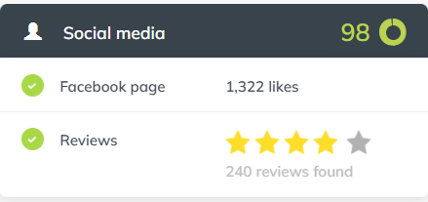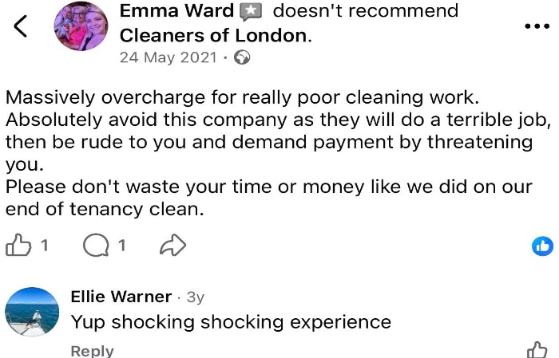

Section 3 -- Perceived Value
Question 3a - How are the services offered by the company made clear to customers?
The services are presented clearly through a structured navigation system that separates the different categories effectively. At the same time, although the tidy layout and “no bots” message imply a direct and personal service model, that polished presentation may give a misleading impression. The site’s organised structure appears heavily focused on conversion, which may hide the operational problems described in external customer feedback.
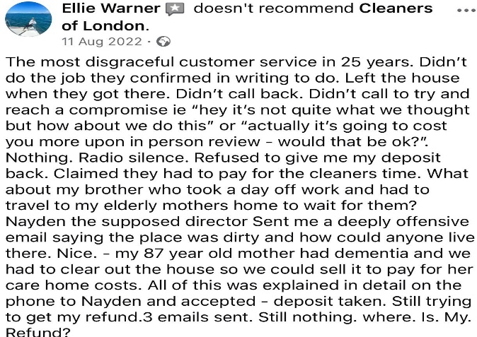
Question 3b - How are customer reviews made available? Are these up to date?
Customer reviews are shown through an integrated review area, but closer checking raises serious concerns. The company presents 236 Google reviews, yet a manual inspection shows no verified physical location on Google Maps. When this lack of location data is combined with outside complaints about overcharging, the positive review profile appears questionable. As a result, the online reputation may function more as a misleading front than as a reliable sign of service quality.
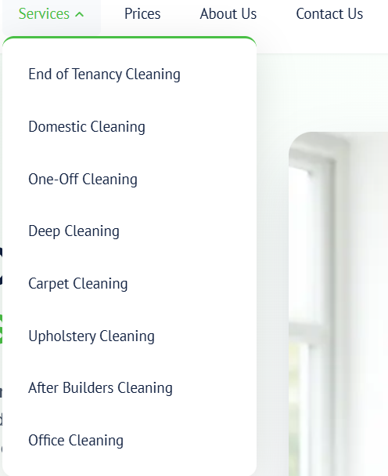
Question 3c -- How is the service presented as high quality? For what reasons would you use the company's service or recommend to a friend or family member?
The service is framed as high quality through a polished layout and a technical score of 99/100. This professional look is clearly intended to build digital trust, which is important for customer engagement. However, the service could not be recommended because of the lack of transparency around its physical address and the doubts surrounding the authenticity of its reviews. Those credibility problems outweigh the professional design and create too much risk.
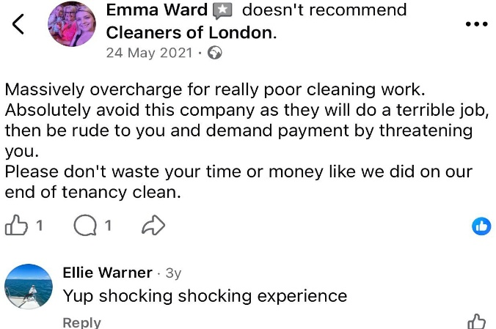
Question 3d - Are prices made clear to customers? If yes, do the prices reflect the quality of service shown? If no, why do you think the company has chosen not to include prices?
No clear prices are displayed on the site. Instead, customers are asked to use a “Request a Quote” system. This kind of approach can be used to collect customer details before revealing actual costs. In this case, the lack of price transparency creates further credibility concerns, especially when external complaints mention overcharging. It seems likely that fixed prices are omitted to hide the real cost until the customer is already deep into the booking process.
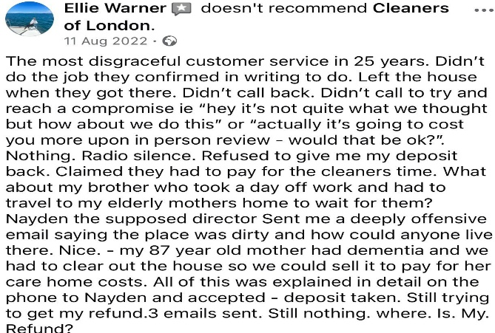

Section 4 -- Searchability
Question 4a - What three words would you type into Google to find this type of service?
1. Cleaning
2. Services
3. London
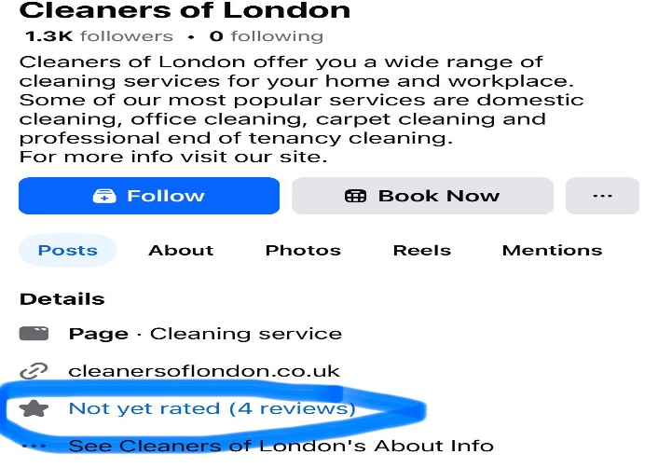
Question 4b - When you type these words into Google, does the company's website appear in the top ten websites?
No, the website does not appear in the top ten organic results for these competitive search terms, despite its strong technical optimisation. The first positions are mainly occupied by major directories and established companies in the sector. This suggests that, although the site is well built internally, limited backlink authority and strong market competition reduce its visibility. Because of that, the business is likely to depend heavily on paid advertising for customer acquisition.
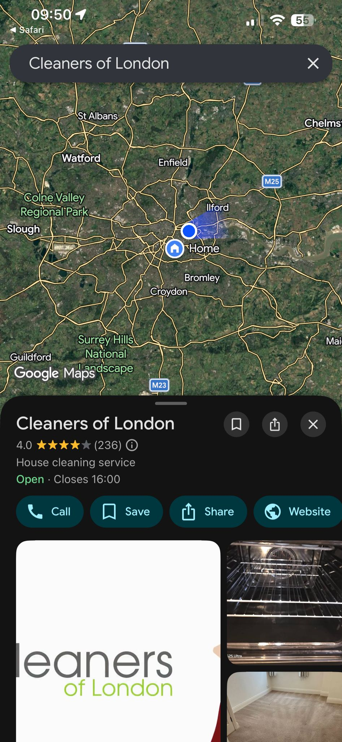

Section 5 -- Reflection and Conclusion
Question 5a - Do you feel that websites still have relevance in modern UK business? Explain your answer.
Yes, websites still matter in modern UK business, especially in service industries, but their real value depends on trust and transparency. In this case, the strong technical scores and mobile performance create an impression of professionalism, yet the concerns about the company’s physical presence and the authenticity of its reviews weaken that purpose. In a competitive UK market, a website that works more as a deceptive front than as a reliable information source becomes a liability. A web presence remains important for tasks like bookings, but it loses value when the digital image conflicts with reality.
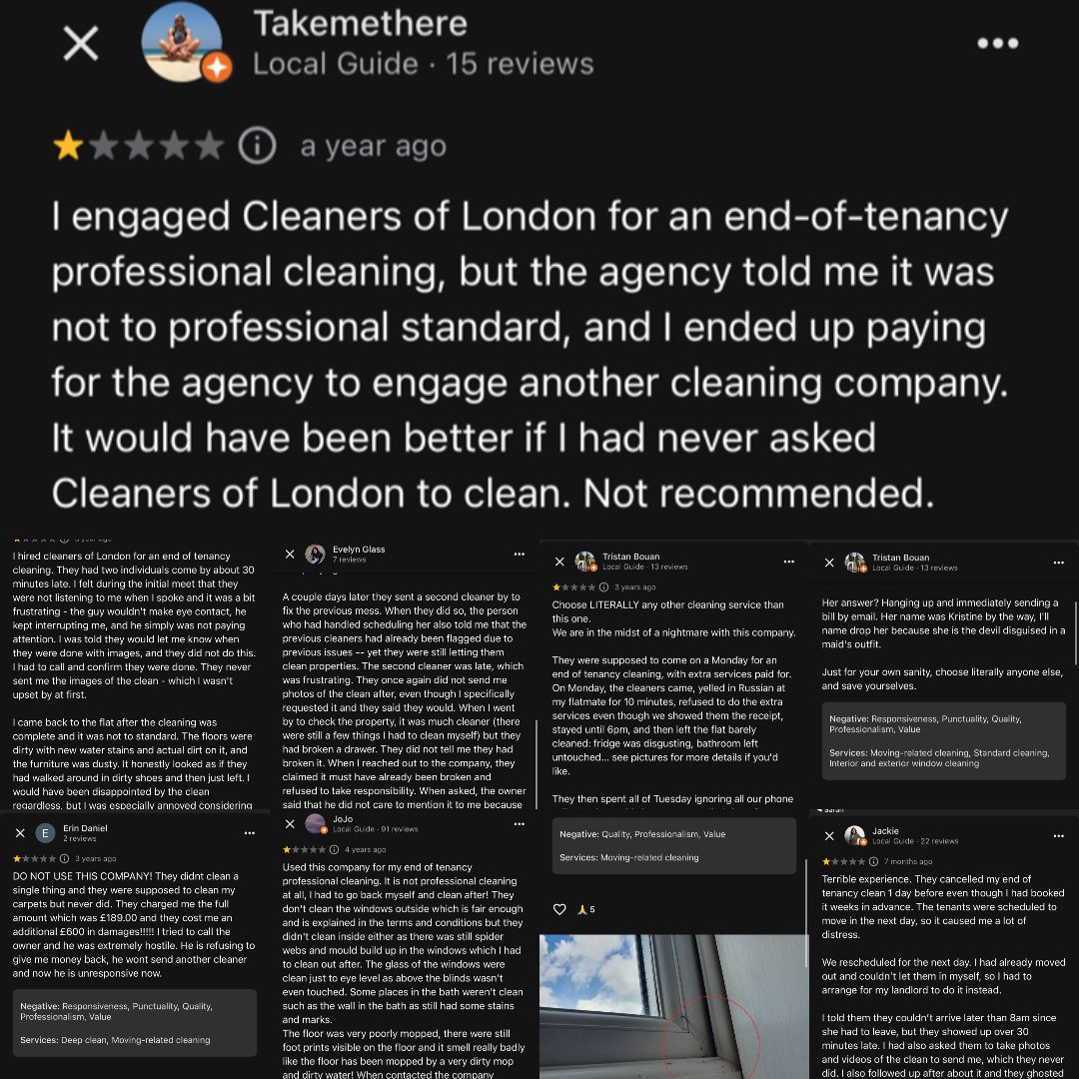
Question 5b - If you were to make one recommendation about how to improve the website of your chosen company, what would it be? Why have you suggested this improvement?
The most important recommendation would be to introduce a verified third-party review system and clearly provide a legitimate physical address. Although the site performs very well technically, the credibility gap created by suspicious reviews damages the entire business model. Transparency is essential for reducing perceived risk in service industries, and the online presentation should match the real-world business. Replacing doubtful signals with authentic social proof would strengthen accountability, improve trust, and support long-term competitiveness in the UK market.
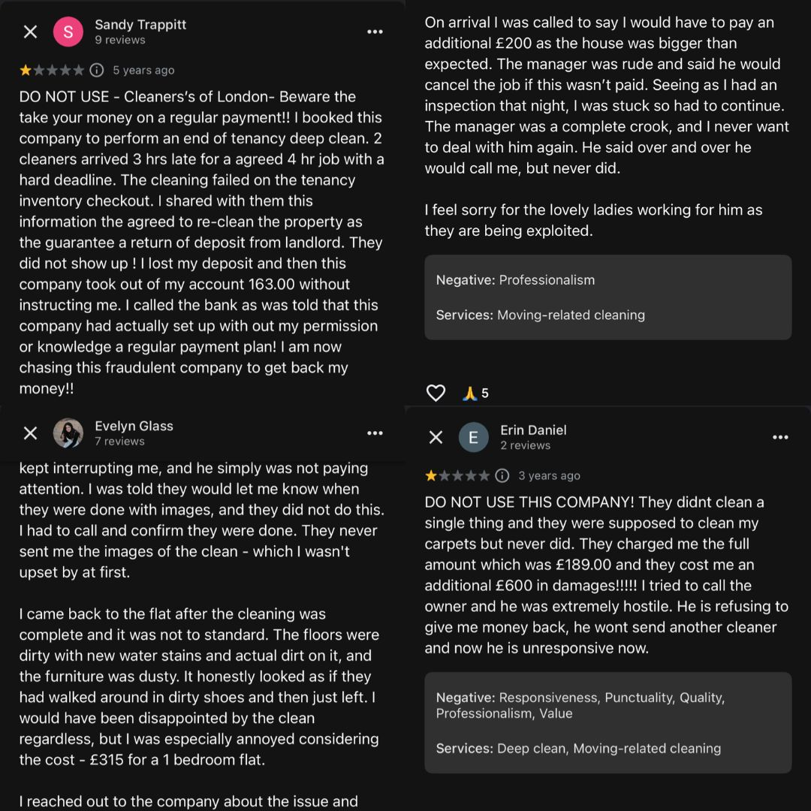

Reference List
1. Botsman, R. (2017) Who Can You Trust? How Technology Brought Us Together and Why It Might Drive Us Apart. London: Penguin Portfolio.
2. Cleaners of London (2026) Cleaners of London Official Website. Available at: https://www.cleanersoflondon.co.uk (Accessed: 26 April 2026).
3. Eggert, A. (2006) Intangibility and Transparency: Critical Success Factors in Service Marketing, Journal of Business Research, 59(12), pp. 123-130.
4. https://websiteassessment.bdc.ca

