Sophie Williams

1701487

What is the effect of fashion in society and an analysis on what can be perceived in the industry such as masculinity and how this has an impact in the fashion world?

Keywords- Masculinity Perception Fashion

Introduction
In this proposal my aim is to discuss my three keywords in depth on how masculinity has been affected over time in the fashion industry on the way individuals perceive different styles over time. To do this I will look at what changes were made for different outfits to be more accepted in society, compared to what was the norm in the past. Firstly, I will be looking at masculinity, how men can be limited to certain stereotypes in fashion for example men wear trousers and women wear skirts. I will also be looking into individual’s perception on different styles and the connection between different looks and what’s seen as masculine fashion and how they combine their ethos to an item of clothing to express different views.

Throughout history there has always been discussion between what a male should wear and what a female should be seen to wear. More recently these changes have been adopted and people are seen to be more accepting of more unisex clothing such as fashion designer Jean Paul Gaultier because his style is very well known to challenge typical views of fashion. “Many of his collections show women adopting masculine attire, or men wearing skirts, corsets, and dresses with trains.” Gaultier was recognised for his controversial pieces where the men and women would be wearing the opposite clothes that people would normally view as the norm in society like taking something like a corset and putting it on a man. Here in this image Gaultier had made a design that gives the percetion of a suit but altered into a dress. This approach to fashion is giving the idea that a mans clothing can be made fashionable onto a woman.
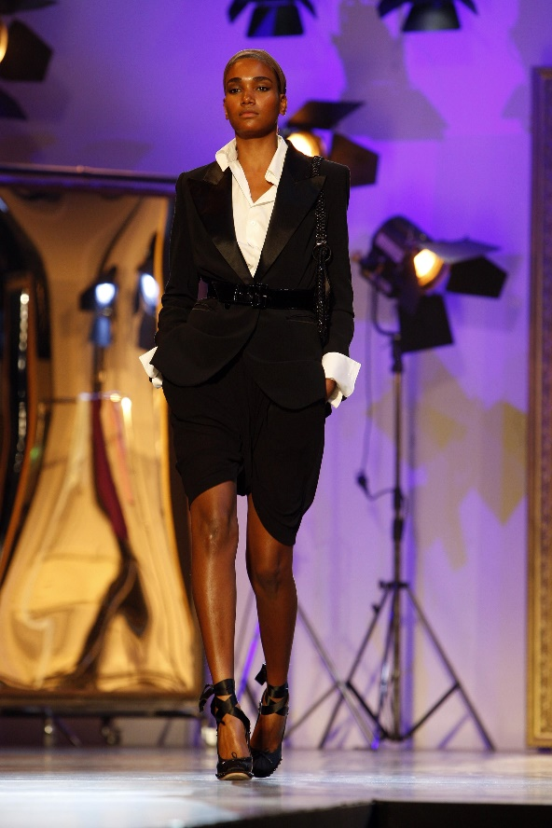

Paris Fashion Week, 2009.

“The term ‘skirt’ is used to refer to any ‘non-bifurcated’ garment, that is to say, any garment that is not divided down the middle below the waist”.
This statement gives the impression that the detail of just a cut and stitch dividing the fabric can have a larger meaning to have an impact of being appropriate to a certain gender. An individual could argue that the movement which made men wearing skirts which is seen today as vastly not acceptable was that it wasn’t the society norm for a man to wear one because it was more restricted for a man when doing more practical work in the past which is often missing in the discussions of skirts on men. Also one of the main reasons is being assosiated with being feminine. Nowadays, boys are usually dressed in pants as soon as they're born but that's a strongly modern development however up until the 19th century, European children were dressed in skirts regardless of their gender. Men's skirts have been acknowledged as a mainstream battle this is frequently based around the idea that the skirt is feminine, a man wearing one is either womanly and therefore portrayed as weak or looking for attention. A piece of clothing that caused a debateable statement through research were jeans by Levi Strauss and Jacob W. Davis. Jeans were seen to be something that both men and women developed to wear as ‘anti fashion’ as said in the men’s reader book because they were made for more working men at the time to have a tougher material to do harder work in. Denim was used by people that needed clothes that would last long.

“Jeans were first adopted as a kind of anti-fashion a conscious, pointed statement that goes against the fashion norm and says ‘I am different, I am different, I am not like you’ by a group of artists in the Santa Fe area in the 1920’s (Brooks 1979: 58). Generally well-educated individuals of both sexes took to wearing jeans as a badge of their own group identity and special status.”
This concludes that wearing skirts or trousers have affected the masculinity of men over the years and that there will always be discussion in the fashion industry about what should be worn. However, society is becoming more accepting and further men are wearing colours like pink which is seen as a feminine colour.

Clothing in terms of culture is to reveal either the historical roots of a person or the roots the group he belongs to. Fashion industry is all about standing out and being different. The manufacturing runs on being edgy as well as having different styles coming in for different seasons. Culture is an important part of it fashion because clothes are a source of non-verbal way of making a statement which can imply to one our interests, beliefs etc. Overall, fashion is a way of expressing ourselves through our clothing and accessories. Culture is made of influences like society, education, values, and norms. Fashion is so largely inclined and controlled by culture therefore high-end brands like Chanel are now being consumed in places like India whereas in the past there wouldn’t be. One statement could make a person believe that men have the dominance to look over women while a woman is made to continue to impress a man by the way she looks by stating “One might simplify this by saying men act and women appear. Men look at women. Women watch themselves being looked at.” However, it also could indicate that women objectify themselves into be a vision of what men would like to see. This could be one of the numerous reasons fashion influences an individual’s looks to create an image of yourself to show other people.
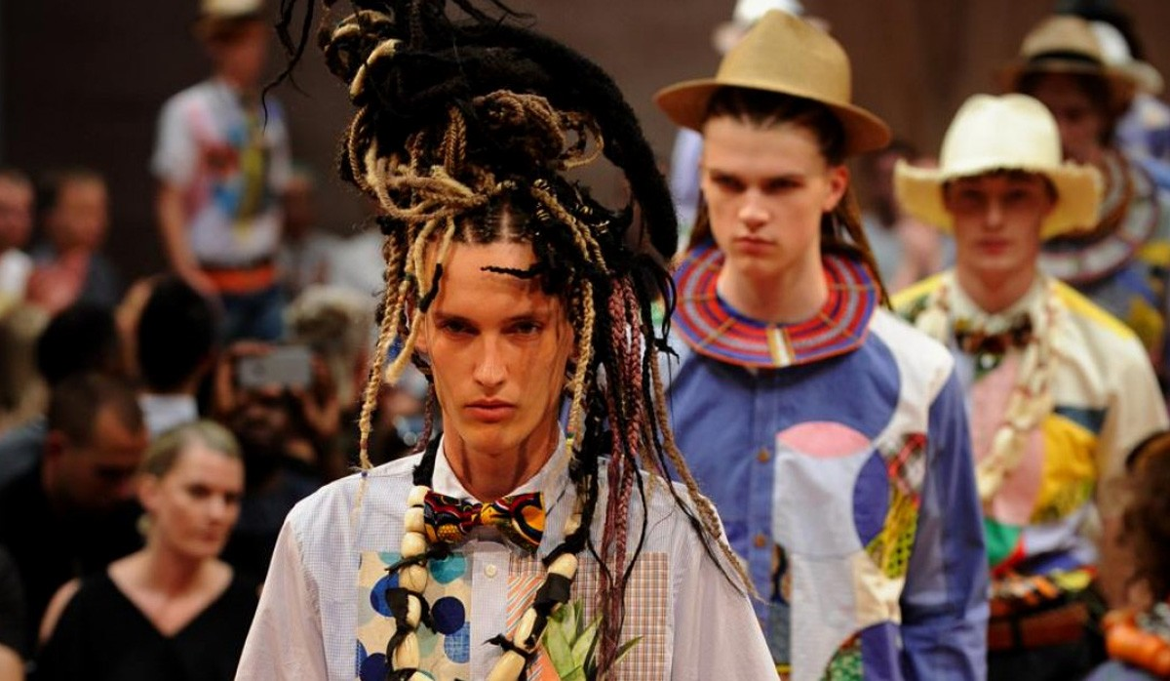
Paris fashion week,2016.

Junya Watanabe’s African themed show caused some controversy in the fashion community because it seemed she wanted to create an African heritage collection. however, the display featured a wide-ranging collection of traditional textiles, while some models wore dreadlock wigs, spears and wooden masks. The pieces had a lot of admiration among many within the fashion community, but some individuals found it “insensitive to the darker side of colonialism” because of her lack of black models and exploited the use of African culture. This was a controversial statement as she could be said to have been trying to achieve the look of black African heritage in fashion but with lack of black models this was an insult to some individuals. However, models such as Winnie Harlow are admired in the fashion industry for being unique which is what one would saying fashion designers try to achieve. The liberation of culture off the borders made the cultural fashion developments increase dramatically. The “freedom of word” has found a place in every single cultural quality nowadays. This means that by wearing something like cowboy boots may not be a symbol of coming from somewhere like Texas, but a sign of preference that has been influenced by the popular culture. People have supplementary awareness of the alteration in fashion and the changes of style as cultural fashion is becoming more popular.
“The growing importance of the ‘popular culture’ as a source for fashion change and the tendency of young designers who attract the public eye to experiment with received ideas of cut, texture and colour, rather than meet the demands of the average consumer”.
This text proposed that fashion is impacting the younger generation because they are not using fashion as a consumer approach but just experimenting with different styles, which one could say is not very good for the economy in the future. However, the fashion industry is growing, and people are looking for a different method to change. Fashion is one of the most powerful means of communication, which sometimes may play a vital role in the life of a person. By stating the importance of the ‘popular culture’ and how we dress reveals more than whether we crave comfort or class and our clothing communicates who we are and how we relate to our culture. This can be represented through art, the media and society around us which are big factors in the fashion business especially for young designer as specified in the writing they have additional ideas to explore clothing in a different mindset to be different and stand out with fresh new ideas.

Clothes have always had a massive impact on the perception of people around and on the perception of the person wearing them. A suit can make a person feel more independent and formal, which could then give the impression of an individual’s observations. The perception of a person can be very predictable in terms of their reaction on a person wearing this or that style of clothing. For instance, if one was to attend a job interview in a suit and the other individual in jeans this could give the impression that the individual in the suit could be more professional. The fondness of people in business wear has always been preferred because of their seriousness in effects. This is one of the primary reasons that even the smallest of businesses make wearing smart clothes one of their requirements for their employees. Therefore, fashion can be a big impact on manipulating the importance of culture, gender, class etc. Fashion is sometimes defined as a constantly changing movement. However, it is essential to say that at current moment fashion has a deeper influence on the life of people through clothing because it has become a vital part of finding oneself. It can be used to as an assurance and to achieve a look that a person would want to attain to portray.

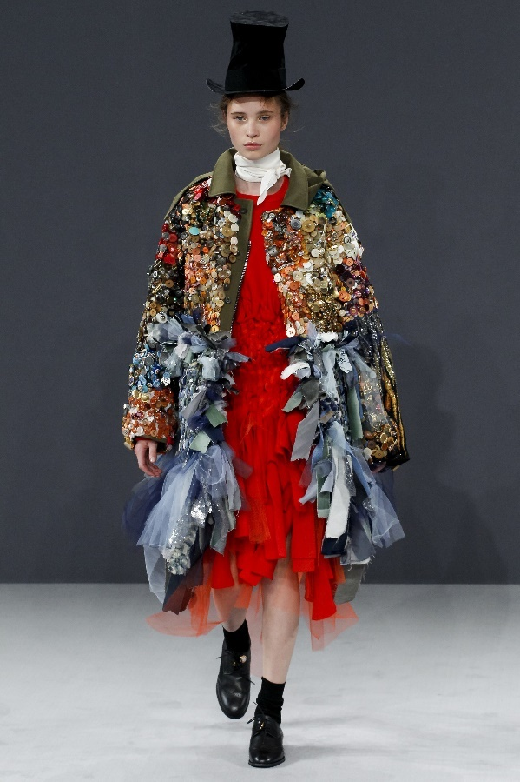

Viktor & Rolf. Fashion week 2016.

In the image above Viktor & Rolf who usually make quite controversial garments as one might say, have taken a female model and created a design that is seen as quite masculine and formal with ruffles. The clothing is created as a surreal exploration of design and showing a way to create, to reveal a different perception of the norm of style. Fashion has always been considered to have more of a women-based orientation. Women over time have become more experimental with clothing such as wearing trainers and suits rather than heels and a skirt.
“certain design companies are keen not to follow trends and instead be seen to be setting the trends. These companies work with their own prediction ideas and in a way operate like fine artists, developing their own ideas and concepts.”
This text relates to Viktor and Rolf because after researching their strategies and designs they have always followed their own style nevertheless still concentrated on the political matters going on to create an outcome attention-grabbing not just for one gender. If a person was to wear a garment to create a strong message to the people outside the response from the designer would be the reaction on the clothes, the person it is wearing. Which could lead to acceptance or a big misunderstanding which is what Viktor and Rolf risk when letting the public perceive their clothing in their own way. From the book ‘Gender’ there is a report that settles that whatever you wear there will always be a judgment even when it is seen as the norm. “On the other hand, men who appear to be too masculine are also a problem since there is always the worry that they might have something to hide”. Referring to masculinity in fashion a man could appear suspicious if too well dressed so by wearing clothing according to trend an individual could feel safe and confident. Men tend to wear more practical clothing; however, fashion is constantly changing according to surroundings as people used to wear clothes in order to indicate their gender, age, social class and occasionally their goals. Fashion is a way through which people can communicate about themselves through what they wear.

These three keywords have led me to question the impact fashion has on individual’s masculinity and how trends can make an individual explore deeper into fashion and see the affect is has on tradition. Fashion and the perception we have on masculinity are all in relation with each other. Fashion and its cultural traits are all leading to the point that fashion can be a manipulation of an individual’s character. The process of a person addressing the issues between what is the norm o wear and what is necessary in society today is seen to be influenced through the media and history. Fashion will always possess a specific meaning and the more diverse the society around us the more fashion-trend will appear and surprise us. People present themselves in different ways and they wear clothing according to certain trends which changes regularly depending on key aspects like the location and the year. For many centuries’ clothes have promoted a message to the viewer in order to maintain cultural traditions.

Bibliography

Bolton, A. (2003). Men in skirts. London: V & A Publications, p.9.

Breward, C, (1995). The culture of fashion. p.235.

Glover, D. and Kaplan, C. (2009). Genders. London. Routledge, p.87.

https://www.highsnobiety.com/2015/12/22/fashion-moments-2015/Amarca, N. Highsnobiety (2019). Accessed 02/05/19.

http://www.ecofashiontalk.com/2016/12/featured-collection-viktor-and-rolf-fall-16/ Brown,S. Eco fashion talk (2016). Accessed 29/04/19.

Jones, A. (2003). The feminism and visual culture reader. p.38.

McNeil, P. and Karaminas, V. (2009). The men's fashion reader. p.331.

Paris Fashion Week, 2009.

Paris Fashion Week, 2016.

https://www.vogue.co.uk/article/jean-paul-gaultier Sowray, B. Vogue (2012). Accessed 29/04/19.

Udale, J. (2014). Textiles and fashion. London, p.144.

