
University of Wales Trinity Saint David
School of Computing
08/12/2020/ACCA6011
Search
By Kieran John Ayres

Table of Contents
Table of Contents
Table of Contents 2
Introduction 3
Task 1 – Code Implementation 4
1.2 User Guide 5
1.3 Testing 5
Test Case 1 – Loading the Map/Grid. 6
Test Case 2 – If Statement for the File Loading 6
Test Case 3 – Search Grid 6
Test Case 4 – Menu 7
Test Case – Stack 7
Task 2 - Hill Climbing 9
Task 3 – 8 Tiles Problem 10
3.1 – Critical Evaluation of the Hill Climbing Algorithm 12
Task 4 – 8 Tiles Problem Using a Different Solution 13
Conclusion 17
References 18
Appendices 19
Program Listing 19

Introduction
The focal point of this assignment is to develop an application using AI methods and to then research and analyse different machine learning algorithms, such as the method of hill climbing. This will be sectioned into tasks, task 1 is so the student can show their attempt at the implementation of the depth first search. It’ll also explain the algorithms and data structures that were used in the code and why, followed by testing and a user guide. Task 2 will be an extensive look at Hill Climbing. Task 3 and 4 focus predominantly on the 8 tiles problem, where the student will solve these with 2 different methods, but evaluating hill climbing algorithm in task 3.

Task 1 – Code Implementation
Task 1 of the assignment was to implement code for an application which can perform a depth first search on a grid. The code for this can be found in the appendices under “Program Listing”. This code is not fully completed as the developer felt a limit in their skill of applying their knowledge to the problem. There will be a test schedule of some of the main functions that were working.
This section will explore the different algorithms and data structures that were used or would have been used in the program, the main algorithm that would have been used in the code is the depth first search algorithm. To show a true understanding of this, the student will provide a pseudocode-based approach to its algorithm with an explanation of the search method. The pseudocode is as follows:
Depth first search, or DFS, is a form of searching algorithm that is part of graph theory. This expands from the starting node and works downwards to the depth of the tree like structure, but can be applied in other ways, such as grids. When it does this, it marks each node as visited, It will do this continuously until the goal node is found. Typically, when in graph mode, it works down the left side of the graph until the nodes do not have any child nodes (nodes that are attached to the bottom of it). In this case, it will then backtrack up the graph to find the nodes that aren’t “visited”. Sometimes, these aren’t found and in some cases the depth first search gets stuck in a loop [1].
BEGIN
DFS ()
Position Current;
Int x;
Initialise Stack();
StartingPosition = k;
Stack.push(k);
While (!stack.empty)
{
x.Stack.Pop()
pushallAdjacentNodes()
}
}
END

The important data structure that was used in the algorithm and would have been integrated within the code is the stack, this has a separate function in the code to show a stack working. Stacks are an integral part of the DFS algorithm. Stacks are a Last in, First Out (LIFO) structure. Which means, that in terms of DFS, it uses this to push nodes into the stack. The two main operations of the stack are “push()” and “pop()”, push would, as it says, push a node onto the stack and pop would pop the top element off the stack. The other operation that is sometimes is used is “peek()”, this is so the developer can peek at the top of the stack without removing it. [2]. In terms of the DFS, it is used to keep track of the current node, as this requires the last in, first out approach which is how the stack is structured.

1.2 User Guide
The user guide for this program is small and simplistic for easier usability
- Load the Program and Build the Solution
- A Switch will then be presented for the user to navigate the program
- This will be present on every function apart from the Stack
- To exit the program, it will need to be manually closed and restarted.

1.3 Testing
As part of task 1, it is required to test the build code to make sure that it succeeds in building and running.

Test Case 1 – Loading the Map/Grid.
Loaded the second map, resulting in a successful test
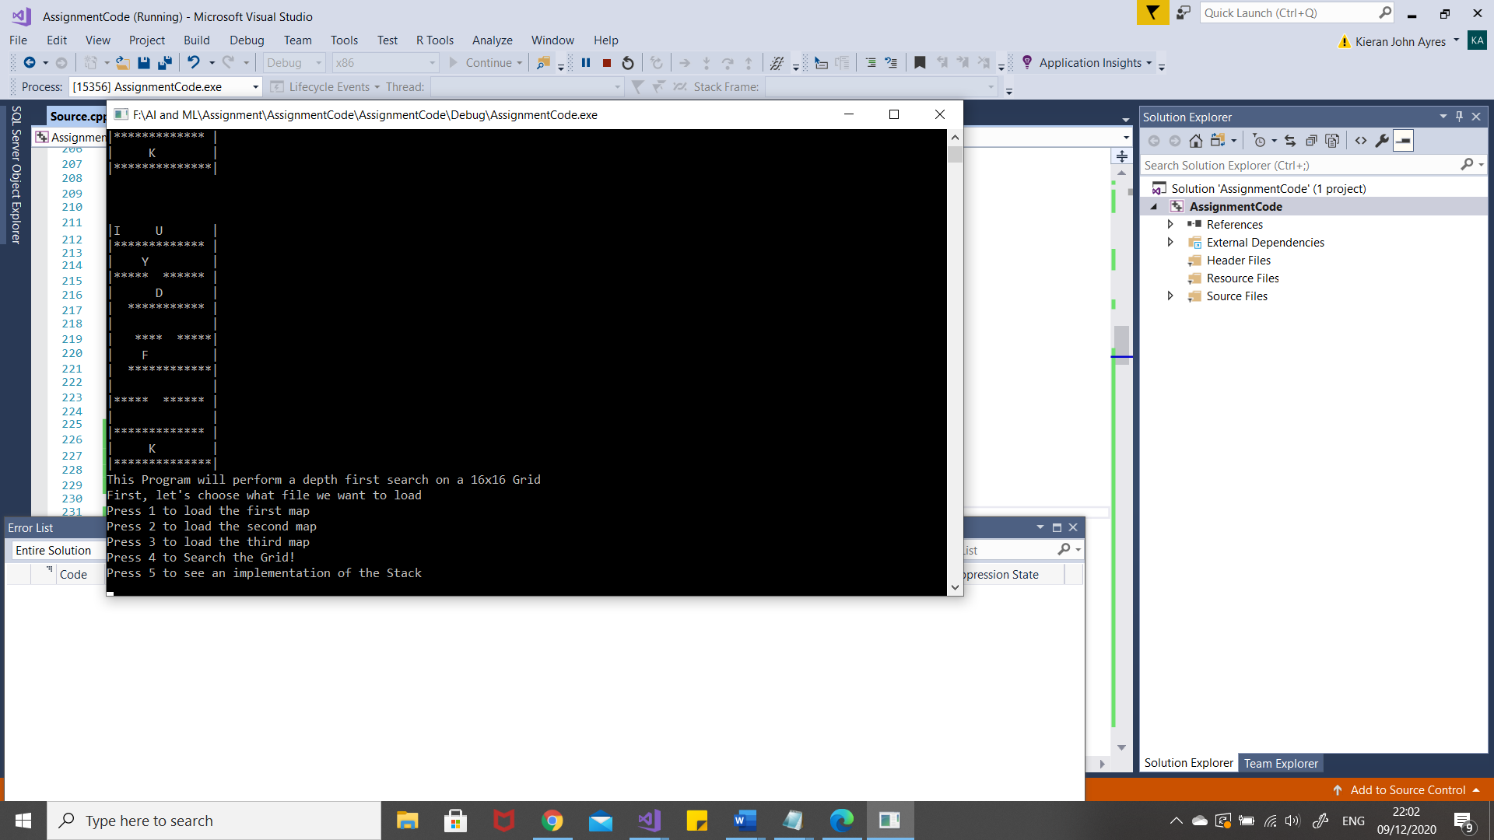

Test Case 2 – If Statement for the File Loading
The test was successful and displayed an error message when file loader wouldn’t load
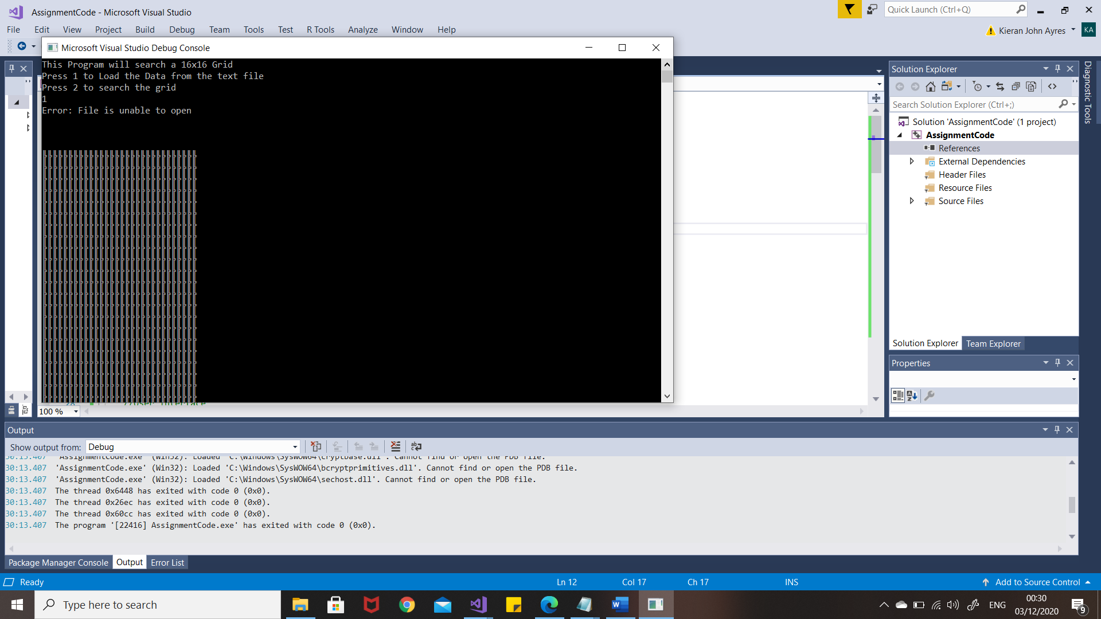

Test Case 3 – Search Grid
Test was successful in simulating the grid searching
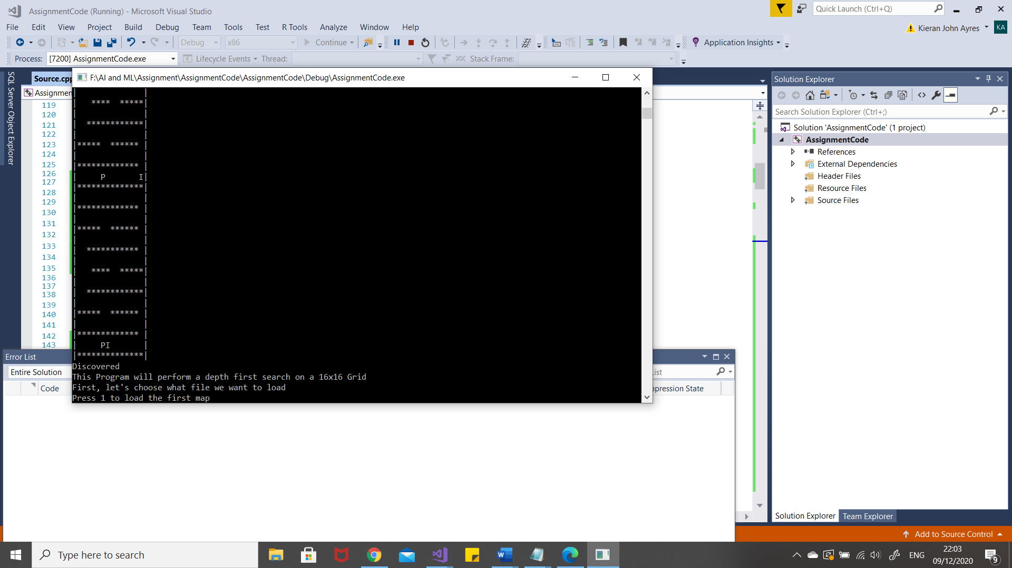

Test Case 4 – Menu
Test was successful and displayed the menu function on every page.
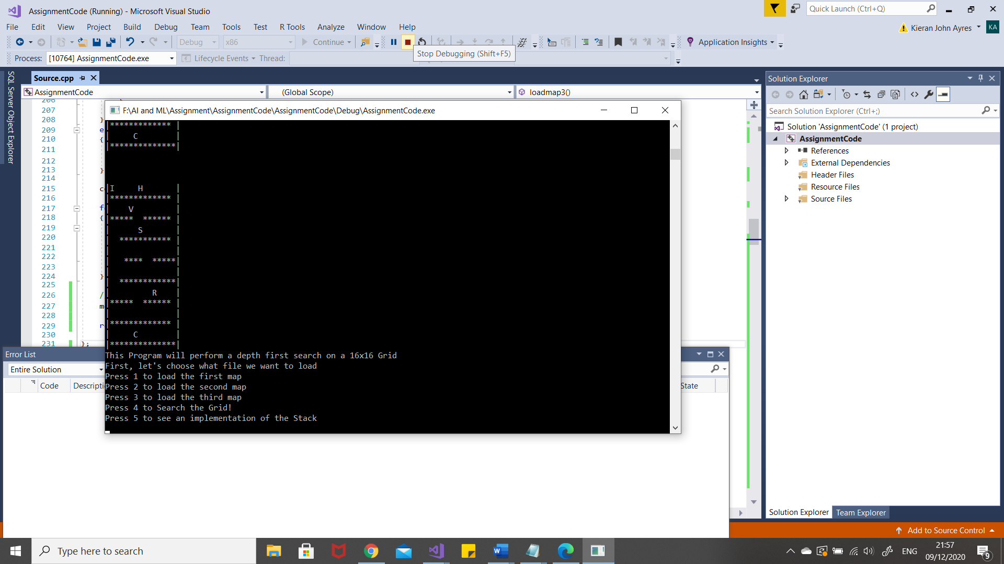

Test Case – Stack
Test Successful as Stack works, however, it doesn’t print the menu like the rest of the application
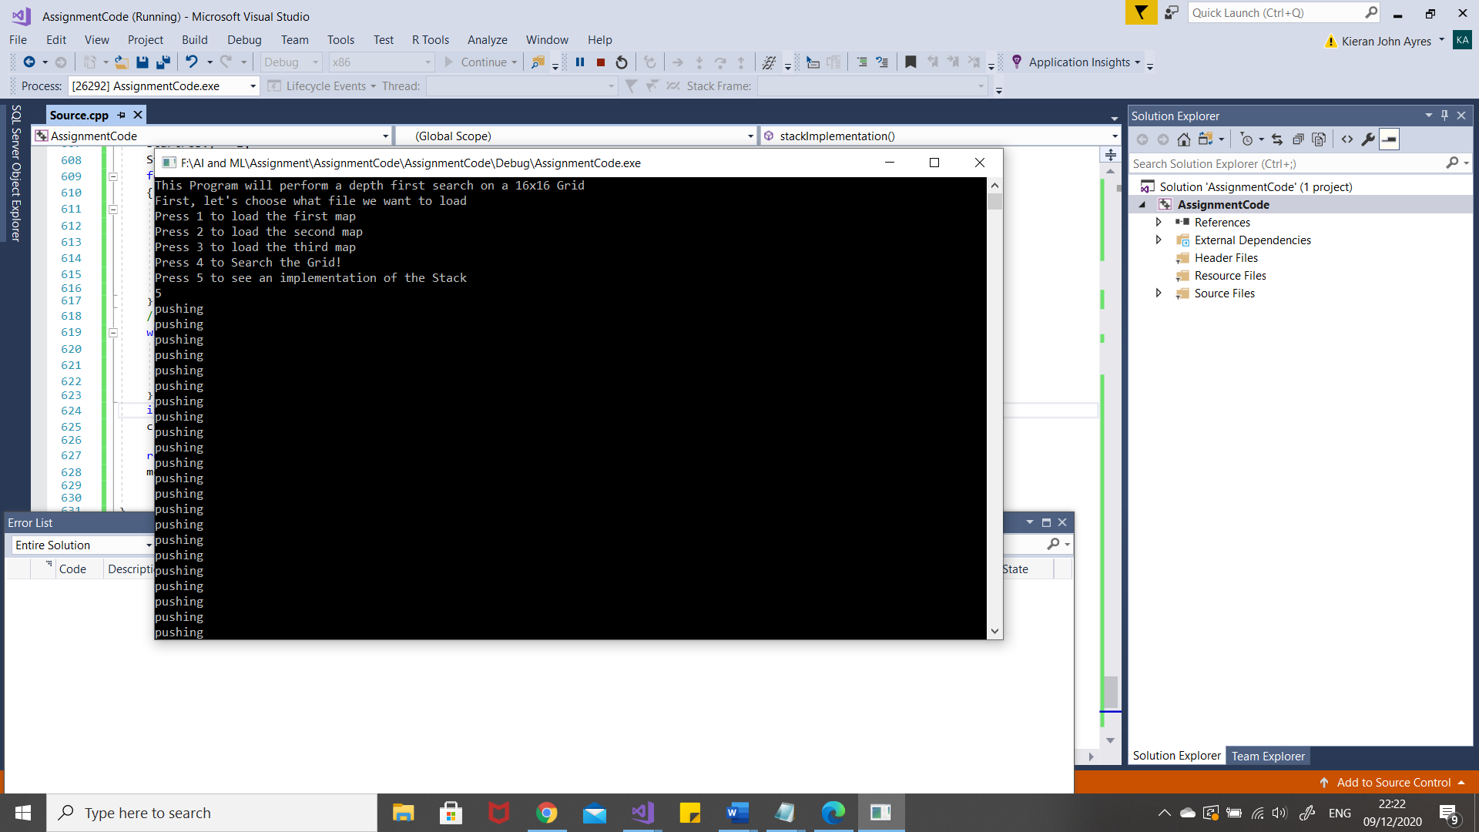

Task 2 - Hill Climbing
Hill climbing is a method that is utilised for optimisation for solving problems that are difficult for a computer to solve, the idea of hill climbing is to apply it when the original state of the problem has the ability or properties to solve it from the information it holds within the state [3]. Hill climbing is also sometimes known as greedy local search. Hill climbing algorithms are known to make fast progress towards their goal states through the use of things such as heuristics. An algorithm to show hill climbing is shown in the text box. The way this hill climbing algorithm was designed was with the implementation idea of looping the algorithm until the goal state can be found, however it would make sure the current state wasn’t the goal state first. There are advantages of this hill climbing algorithm as it is relatively simple it will execute quicker than other types of hill climbing algorithms but isn’t necessarily optimal. There are a lot of disadvantages of hill climbing, one of the most common ones are the local maximum problem, this is where the algorithm forgets the values that are not as good as the current state. Back tracking is then implemented, so the algorithms remembers previous states. This is used in Depth first search where each node is remembered. In some cases of hill climbing algorithms, they can reach a plateau, the algorithm in this text box could have this possible issue as the loop could stop on one state where all next possible states return the same value therefore the agent doesn’t know which one to choose next. This could be overcome by implementing a stochastic process into this algorithm as if all else fails, this would then allow it to move forward by selecting one of the states at random, in that case this wouldn’t be as efficient because that state may not represent the best possible move for the agent to make. There are different types of applications in hill climbing, a popular one is within the field of robotics, this is used to help the robot navigate, as it can decide states on where to move next. [4]
Hill Climbing Algorithm
Begin

Loop (Until solution is found)
Check Initial State
if (goalState == true)
{`
`Report “success”;
}
Else
{
Select State that hasn’t been utilised and implement to find a new state, if success, check if this is goal state
}
Repeat loop to complete
End

Task 3 – 8 Tiles Problem
The task set in this section is for the student to complete their own individual 8 tiles problem. Below the initial state of the puzzle can be seen, followed by the puzzle being completed, step by step. Section 3.1 will then critically evaluate the hill climbing algorithm.
Current:
h=5
h value for potential next positions:
h=6,6,4

1 | 2 | 5
3 | 7 | 4
6 |  | 8

Current:
h=4
h value for potential next positions:
h=5,5,4,3

1 | 2 | 5
3 |  | 4
6 | 7 | 8

Current:
h=3
h value for potential next positions:
h= 4,4,2

1 | 2 | 5
3 | 4
6 | 7 | 8

Current:
h=2
h value for potential next positions:
h= 3,1

1 | 2
3 | 4 | 5
6 | 7 | 8

Current:
h=1
h value for potential next positions:
h=3,2,0
1 |  | 2
3 | 4 | 5
6 | 7 | 8

Current:
h=0
h value for potential next positions:
h=-
 | 1 | 2
3 | 4 | 5
6 | 7 | 8

3.1 – Critical Evaluation of the Hill Climbing Algorithm
The hill climbing method using a heuristic function is an informed search method. This is used when solving the 8 tiles problem. The hill climbing method is really good for the 8 tiles problem. In the case of task 3, the loss function was used, and in the student’s particular puzzle, the puzzle started with only five tiles out of place. This was solved, if you include the initial state, six moves. Which is an efficient number of moves, however the number of moves will always be dictated by the number of tiles out of place and the position of the tiles. For example, if the 8 was positions on the opposite diagonal corner, it would take a while to have the outcome of the goal state of the puzzle. Hill climbing will assess the next potential positions, before choosing the most efficient move. It’s important to note that hill climbing algorithms aren’t optimal, but this is not to say it won’t complete the given problem in a good time, this is why it makes it a good use for the 8 tiles problem. There are moments where hill climbing algorithms can be locked and can’t discover a solution which isn’t good for the user that wants it solved with this method. One of the other problems that the hill climbing algorithm can reach is the local optima, this means that the hill climbing algorithm will choose the best possible next move to position itself as it believes that these minor stages will be the most efficient way to read the goal state but in some cases, a move can sometimes result in that move leading to more moves having to be executed later on in the puzzle. [5] Another way in which this puzzle can be solved is by using an A* search, this can be used in application such as graph traversal. The way it works is looking at the nodes and calculating the cost to get to the next node and the cost to move from the state it is into the goal state that it needs to be in. Russel and Norvig concluded that this is a really good method of search. [6]. The loss function hill climbing method is good, however, the Manhattan distance method is also a good form of hill climbing, these both are similar in efficiency, as the h1 loss function will check all possible moves before choosing the best possible one resulting in the less amount of tiles out of place after the puzzle has made the move. Whereas, with the Manhattan distance, the function will check all possible states of the next move, but by making a sum of all the distances the numbers would need to travel along the y and x axis to return to their goal position before choosing the state with the smallest amount of moves needed to return. To conclude, the student thought both methods worked well in the instance of their puzzle’s starting state, as they both take a level of precaution as both choose the best possible states. However, if they were both to go to the local maximum where they’d forgotten the other moves, they couldn’t go back, to avoid this you could implement a back tracking method within the functions to be able to remember the previous states. In the opinion of the student, they are hard to decide which is better as they both take a similar decision process. The Manhattan distance measure will be completed for task 4 to show the method working. [7] [5]

Task 4 – 8 Tiles Problem Using a Different Solution
As detailed in the previous task, this section will show a different method to solve the eight tiles problem. The method chosen was the Manhattan distance measure. How the puzzle is being moved along by the table next to them, the number being the number that the distance is being calculated and the positions to move being the number of squares it requires to move the number into place.
The 8 tiles code solved with the new method is below:
1 | 2 | 5
3 | 7 | 4
6 |  | 8
The Manhattan Distance (h2) | 0 + 1 + 1 + 0 + 1 + 1 + 0 + 1 + 0 = 5.
Original State

1 | 2 | 5
3 | 7 | 4
 | 6 | 8
1 | 2 | 5
3 | 7 | 4
6 | 8
1 | 2 | 5
3 |  | 4
6 | 7 | 8

The Manhattan Distance (h2) | 1 + 1 + 0 + 1 + 1 + 1 + 1 + 1 + 0 = 6.
The Manhattan Distance (h2) | 1+1+0+  1+1+0+0+0  = 4
The Manhattan Distance (h2) | 1 + 1 + 0 + 1 + 1 + 0 + 1 + 1 + = 6.

 | 1 | 2
3 | 4 | 5
6 | 7 | 8
Goal State

The Manhattan Distance (h2) | 1 + 1 + 0 + 0 + 1 + 0 + 0 + 0 = 3
1 | 2 | 5
3 | 4
6 | 7 | 8
Current State
(Best State Chosen)

1 | 2 | 5
3 |  | 4
6 | 7 | 8
1 | 2
3 | 4 | 5
6 | 7 | 8

1 | 2 | 5
3 | 4 | 8
6 | 7

The Manhattan Distance (h2) | 1+1+0+  1+1+0+0+0  = 4
The Manhattan Distance (h2) | 1 + 1 + 0 + 0 + 0 + 0 + 0 + 0 = 2
The Manhattan Distance (h2) | 1 + 1 + 0 + 0 + 1 + 0 + 0 + 1 = 4

1 | 2
3 | 4 | 5
6 | 7 | 8
The Manhattan Distance (h2) | 1 + 1 + 0 + 0 + 0 + 0 + 0 + 0 = 2
Current State
(Best State Chosen)

1 |  | 2
3 | 4 | 5
6 | 7 | 8

1 | 2 | 5
3 | 4
6 | 7 | 8

The Manhattan Distance (h2) | 1 + 0 + 0 + 0 + 0 + 0 + 0 + 0 = 1

The Manhattan Distance (h2) | 1 + 1 + 0 + 0 + 1 + 0 + 0 + 0 = 3

An example of Back tracking as it remembers the previous state

1 |  | 2
3 | 4 | 5
6 | 7 | 8
The Manhattan Distance (h2) | 1 + 0 + 0 + 0 + 0 + 0 + 0 + 0 = 1
Current State
(Best State Chosen)

1 |  | 2
3 | 4 | 5
6 | 7 | 8

 | 1 | 2
3 | 4 | 5
6 | 7 | 8

The Manhattan Distance (h2) | 1 + 0 + 0 + 0 + 0 + 0 + 0 + 0 = 1

The Manhattan Distance (h2) | 0 + 0 + 0 + 0 + 0 + 0 + 0 + 0 = 0

 | 1 | 2
3 | 4 | 5
6 | 7 | 8
Goal State

Conclusion
In conclusion, the student has attempted to develop an application but encountered issues which would like to be improved in further projects as they were limited by their own skill. The hill climbing algorithm is great for solving problems where the solution exists in the state as it does things step by step but does encounter problems such as the plateau, so it isn’t always a perfect method. They also used the heuristic functions to solve problems, these included the loss function and the Manhattan distance function but noticed that these could also potentially run into issues but concluded that they thought the Manhattan was a better method.

References

[1] | D. G. Navneet Kaur, “Analysis of the Depth First Search Algorithms,” Computer Science and Engineering Department, vol. N.A, no. N.A, p. 7, N.A.
[2] | F. Dedov, “Stack,” in The Bible of Algorithms and Data Structures: A Complex Subject Simply Explained, N/A, Amazon Digital Services, 2020, p. 92.
[3] | P. N. Stuart Russel, Artificial Intelligence : A Modern Approach, New Jersey: Pearson, 1995.
[4] | T. Bahirat, “An Introduction To Hill Climbing Algorithm in AI (Artificial Intelligence),” greatlearningblog, 22nd May 2020. [Online]. Available: https://www.mygreatlearning.com/blog/an-introduction-to-hill-climbing-algorithm/#hillclimbingalgorithm. [Accessed 22nd 12 2020].
[5] | R. Aware, “Solve the Slide Puzzle with Hill Climbing Search Algorithm,” Towards Data Science, 20th March 2017. [Online]. Available: https://towardsdatascience.com/solve-slide-puzzle-with-hill-climbing-search-algorithm-d7fb93321325. [Accessed 8th December 2020].
[6] | “A* search : Minimizing the total estimated solution cost,” in Artificial Intelligence : A Modern Approach, N.A, Pearson, 1995, p. 112.
[7] | S. Renooij, “Artificial Intelligence : Informed Search,” Utrecht University, The Nethetlands, N.A.
[8] | S. C. Shapiro, “Artificial Intelligence,” Artificial Intelligence, vol. N/A, no. N/A, p. 15, N/A.
[9] | U. Source, C++ File Loader, UWTSD/Gordon Dickers.
[10] | U. Source, StackUsageEG, UWTSD/Gordon Dickers.

Appendices

Program Listing
This is to show the code.
//Declare libraries
#include<stack> //to use the stack
#include <stdlib.h> //to exit
#include<stdio.h>
#include<math.h>
#include<iostream>
#include<sstream>
#include<fstream>
#include <string>

//for the grid
#define HEIGHT 16 //define the array size
#define WIDTH 16

using namespace std;

//functions for the program
double loadmap1();
double loadmap2();
double loadmap3();
void menu();
char searchGrid1();
int stackImplementation();
//void searchGrid2();
//void searchGrid3();
//void dfs();
//void pushAdjacentNodes();

typedef struct { //example from moodle of a stack working,
int x;
int y;
} position; //re-usable to position the sya
std::stack<position> Stack;

int main(int argc, char** argv)
{

menu();

};

void menu()
{
int pick;

stringstream stream;
string input = "";

//User interface
cout << "This Program will perform a depth first search on a 16x16 Grid" << endl;
cout << "First, let's choose what file we want to load" << endl;

cout << "Press 1 to load the first map" << endl;
cout << "Press 2 to load the second map" << endl;
cout << "Press 3 to load the third map" << endl;
cout << "Press 4 to Search the Grid!" << endl;
cout << "Press 5 to see an implementation of the Stack" << endl;

//Allows to pick from the switch
getline(cin, input);
stream.str(input);
stream >> pick;
stream.clear();

//This allows the interactive userface so the user can
//follow the operation along, from 1-3
switch (pick)
{
case 1:
//this is used to load the data from the txt file which will load map1.txt'
cout << loadmap1();
break;
case 2:
//this is used to load the data from the txt file which will load map2.txt'
cout << loadmap2();
break;

case 3:
//this is used to load the data from the txt file which will load map3.txt'
cout << loadmap3();
break;
case 4:
cout << searchGrid1();
break;
case 5:
cout << stackImplementation();
break;

}
//answer for yes or no
//cout << "Would you like to do a depth first search on this map?" << endl;
//void dfs();

}

double loadmap1() //function to load the grid //CHANGE NAME to reflect what it does
{

//reading the file
//read in from the text file
//procedurally

char text[WIDTH * HEIGHT];
string line;
ifstream myfile("map1.txt");
if (myfile.is_open()) //if the file is opened
{
int count = 0;
while (getline(myfile, line)) //get a line from the file and put into the line
{
cout << line << endl;
line.copy(&text[WIDTH*count], WIDTH, 0); //holds the map
count++;
//jumping 10 for every element of the array
//when the lines run out, it will stop and close
}
myfile.close(); //close the file once done
}
else
{
cout << "Error: File is unable to open" << endl;
//force close the program //test with different values in the width and height
}

cout << endl << endl << endl;

for (int y = 0; y < HEIGHT; y++)
{
for (int x = 0; x < WIDTH; x++)
{
cout << text[WIDTH * y + x];
}
cout << endl;
}

menu();

return 0;
// int x = 2, y = 2;
// cout << text[WIDTH * y + x] << endl;
//for testing purposes
//given (x,y) is (5,6) OUTPUT the char (1) AND the chars above (0), below it (-), left (3) and right (4) of it
// cout << "current position centered on ( " << x << " , " << y << ")" << "char is: " << text[WIDTH * y + x] << endl;

};

double loadmap2() //load the second map
{
//reading the file
//read in from the text file

char text[WIDTH * HEIGHT];
string line;
ifstream myfile("map2.txt");
if (myfile.is_open()) //if the file is opened
{
int count = 0;
while (getline(myfile, line)) //get a line from the file and put into the line
{
cout << line << endl;
line.copy(&text[WIDTH*count], WIDTH, 0); //holds the map
count++;
//jumping 10 for every element of the array
//when the lines run out, it will stop and close
}
myfile.close(); //close the file once done
}
else
{
cout << "Error: File is unable to open" << endl;
//force close the program //test with different values in the width and height
}

cout << endl << endl << endl;

for (int y = 0; y < HEIGHT; y++)
{
for (int x = 0; x < WIDTH; x++)
{
cout << text[WIDTH * y + x];
}
cout << endl;
}
menu();

return 0;

//void menu();

};

double loadmap3() //load the second map
{
//reading the file
//read in from the text file
//procedurally

char text[WIDTH * HEIGHT];
string line;
ifstream myfile("map3.txt");
if (myfile.is_open()) //if the file is opened
{
int count = 0;
while (getline(myfile, line)) //get a line from the file and put into the line
{
cout << line << endl;
line.copy(&text[WIDTH*count], WIDTH, 0); //holds the map
count++;
//jumping 10 for every element of the array
//when the lines run out, it will stop and close
}
myfile.close(); //close the file once done
}
else
{
cout << "Error: File is unable to open" << endl;
//force close the program //test with different values in the width and height
}

cout << endl << endl << endl;

for (int y = 0; y < HEIGHT; y++)
{
for (int x = 0; x < WIDTH; x++)
{
cout << text[WIDTH * y + x];
}
cout << endl;
}

//switch
menu();

return 0;

};

char searchGrid1()
{

cout << "|I C |" << endl;
cout << "|************* |" << endl;
cout << "| K |" << endl;
cout << "|***** ****** |" << endl;
cout << "| G |" << endl;
cout << "| *********** |" << endl;
cout << "| |" << endl;
cout << "| **** *****|" << endl;
cout << "| W |" << endl;
cout << "| ************|" << endl;
cout << "| |" << endl;
cout << "|***** ****** |" << endl;
cout << "| |" << endl;
cout << "|************* |" << endl;
cout << "| P |" << endl;
cout << "|**************|" << endl;

cout << "| IC |" << endl;
cout << "|************* |" << endl;
cout << "| K |" << endl;
cout << "|***** ****** |" << endl;
cout << "| G |" << endl;
cout << "| *********** |" << endl;
cout << "| |" << endl;
cout << "| **** *****|" << endl;
cout << "| W |" << endl;
cout << "| ************|" << endl;
cout << "| |" << endl;
cout << "|***** ****** |" << endl;
cout << "| |" << endl;
cout << "|************* |" << endl;
cout << "| P |" << endl;
cout << "|**************|" << endl;

cout << "Discovered" << endl;

cout << "| |" << endl;
cout << "|*************I|" << endl;
cout << "| K |" << endl;
cout << "|***** ****** |" << endl;
cout << "| G |" << endl;
cout << "| *********** |" << endl;
cout << "| |" << endl;
cout << "| **** *****|" << endl;
cout << "| W |" << endl;
cout << "| ************|" << endl;
cout << "| |" << endl;
cout << "|***** ****** |" << endl;
cout << "| |" << endl;
cout << "|************* |" << endl;
cout << "| P |" << endl;
cout << "|**************|" << endl;

cout << "| |" << endl;
cout << "|************* |" << endl;
cout << "| K I |" << endl;
cout << "|***** ****** |" << endl;
cout << "| G |" << endl;
cout << "| *********** |" << endl;
cout << "| |" << endl;
cout << "| **** *****|" << endl;
cout << "| W |" << endl;
cout << "| ************|" << endl;
cout << "| |" << endl;
cout << "|***** ****** |" << endl;
cout << "| |" << endl;
cout << "|************* |" << endl;
cout << "| P |" << endl;
cout << "|**************|" << endl;

cout << "| |" << endl;
cout << "|************* |" << endl;
cout << "| KI |" << endl;
cout << "|***** ****** |" << endl;
cout << "| G |" << endl;
cout << "| *********** |" << endl;
cout << "| |" << endl;
cout << "| **** *****|" << endl;
cout << "| W |" << endl;
cout << "| ************|" << endl;
cout << "| |" << endl;
cout << "|***** ****** |" << endl;
cout << "| |" << endl;
cout << "|************* |" << endl;
cout << "| P |" << endl;
cout << "|**************|" << endl;

cout << "K Discovered" << endl;

cout << "| |" << endl;
cout << "|************* |" << endl;
cout << "| |" << endl;
cout << "|***** I****** |" << endl;
cout << "| G |" << endl;
cout << "| *********** |" << endl;
cout << "| |" << endl;
cout << "| **** *****|" << endl;
cout << "| W |" << endl;
cout << "| ************|" << endl;
cout << "| |" << endl;
cout << "|***** ****** |" << endl;
cout << "| |" << endl;
cout << "|************* |" << endl;
cout << "| P |" << endl;
cout << "|**************|" << endl;

cout << "| |" << endl;
cout << "|************* |" << endl;
cout << "| |" << endl;
cout << "|***** ****** |" << endl;
cout << "| IG |" << endl;
cout << "| *********** |" << endl;
cout << "| |" << endl;
cout << "| **** *****|" << endl;
cout << "| W |" << endl;
cout << "| ************|" << endl;
cout << "| |" << endl;
cout << "|***** ****** |" << endl;
cout << "| |" << endl;
cout << "|************* |" << endl;
cout << "| P |" << endl;
cout << "|**************|" << endl;

cout << "Discovered" << endl;

cout << "| |" << endl;
cout << "|************* |" << endl;
cout << "| |" << endl;
cout << "|***** ****** |" << endl;
cout << "|I |" << endl;
cout << "| *********** |" << endl;
cout << "| |" << endl;
cout << "| **** *****|" << endl;
cout << "| W |" << endl;
cout << "| ************|" << endl;
cout << "| |" << endl;
cout << "|***** ****** |" << endl;
cout << "| |" << endl;
cout << "|************* |" << endl;
cout << "| P |" << endl;
cout << "|**************|" << endl;

cout << "| |" << endl;
cout << "|************* |" << endl;
cout << "| |" << endl;
cout << "|***** ****** |" << endl;
cout << "| I|" << endl;
cout << "| *********** |" << endl;
cout << "| |" << endl;
cout << "| **** *****|" << endl;
cout << "| W |" << endl;
cout << "| ************|" << endl;
cout << "| |" << endl;
cout << "|***** ****** |" << endl;
cout << "| |" << endl;
cout << "|************* |" << endl;
cout << "| P |" << endl;
cout << "|**************|" << endl;

cout << "| |" << endl;
cout << "|************* |" << endl;
cout << "| |" << endl;
cout << "|***** ****** |" << endl;
cout << "| |" << endl;
cout << "| *********** |" << endl;
cout << "| I|" << endl;
cout << "| **** *****|" << endl;
cout << "| W |" << endl;
cout << "| ************|" << endl;
cout << "| |" << endl;
cout << "|***** ****** |" << endl;
cout << "| |" << endl;
cout << "|************* |" << endl;
cout << "| P |" << endl;
cout << "|**************|" << endl;

cout << "| |" << endl;
cout << "|************* |" << endl;
cout << "| |" << endl;
cout << "|***** ****** |" << endl;
cout << "| |" << endl;
cout << "| *********** |" << endl;
cout << "| I |" << endl;
cout << "| **** *****|" << endl;
cout << "| W |" << endl;
cout << "| ************|" << endl;
cout << "| |" << endl;
cout << "|***** ****** |" << endl;
cout << "| |" << endl;
cout << "|************* |" << endl;
cout << "| P |" << endl;
cout << "|**************|" << endl;

cout << "| |" << endl;
cout << "|************* |" << endl;
cout << "| |" << endl;
cout << "|***** ****** |" << endl;
cout << "| |" << endl;
cout << "| *********** |" << endl;
cout << "| |" << endl;
cout << "| **** *****|" << endl;
cout << "| W I |" << endl;
cout << "| ************|" << endl;
cout << "| |" << endl;
cout << "|***** ****** |" << endl;
cout << "| |" << endl;
cout << "|************* |" << endl;
cout << "| P |" << endl;
cout << "|**************|" << endl;

cout << "| |" << endl;
cout << "|************* |" << endl;
cout << "| |" << endl;
cout << "|***** ****** |" << endl;
cout << "| |" << endl;
cout << "| *********** |" << endl;
cout << "| |" << endl;
cout << "| **** *****|" << endl;
cout << "| WI |" << endl;
cout << "| ************|" << endl;
cout << "| |" << endl;
cout << "|***** ****** |" << endl;
cout << "| |" << endl;
cout << "|************* |" << endl;
cout << "| P |" << endl;
cout << "|**************|" << endl;

cout << "Discovered" << endl;

cout << "| |" << endl;
cout << "|************* |" << endl;
cout << "| |" << endl;
cout << "|***** ****** |" << endl;
cout << "| |" << endl;
cout << "| *********** |" << endl;
cout << "| |" << endl;
cout << "| **** *****|" << endl;
cout << "|I |" << endl;
cout << "| ************|" << endl;
cout << "| |" << endl;
cout << "|***** ****** |" << endl;
cout << "| |" << endl;
cout << "|************* |" << endl;
cout << "| P |" << endl;
cout << "|**************|" << endl;

cout << "| |" << endl;
cout << "|************* |" << endl;
cout << "| |" << endl;
cout << "|***** ****** |" << endl;
cout << "| |" << endl;
cout << "| *********** |" << endl;
cout << "| |" << endl;
cout << "| **** *****|" << endl;
cout << "| |" << endl;
cout << "| ************|" << endl;
cout << "| I |" << endl;
cout << "|***** ****** |" << endl;
cout << "| |" << endl;
cout << "|************* |" << endl;
cout << "| P |" << endl;
cout << "|**************|" << endl;

cout << "| |" << endl;
cout << "|************* |" << endl;
cout << "| |" << endl;
cout << "|***** ****** |" << endl;
cout << "| |" << endl;
cout << "| *********** |" << endl;
cout << "| |" << endl;
cout << "| **** *****|" << endl;
cout << "| |" << endl;
cout << "| ************|" << endl;
cout << "| I |" << endl;
cout << "|***** ****** |" << endl;
cout << "| |" << endl;
cout << "|************* |" << endl;
cout << "| P |" << endl;
cout << "|**************|" << endl;

cout << "| |" << endl;
cout << "|************* |" << endl;
cout << "| |" << endl;
cout << "|***** ****** |" << endl;
cout << "| |" << endl;
cout << "| *********** |" << endl;
cout << "| |" << endl;
cout << "| **** *****|" << endl;
cout << "| |" << endl;
cout << "| ************|" << endl;
cout << "| |" << endl;
cout << "|***** ****** |" << endl;
cout << "| I |" << endl;
cout << "|************* |" << endl;
cout << "| P |" << endl;
cout << "|**************|" << endl;

cout << "| |" << endl;
cout << "|************* |" << endl;
cout << "| |" << endl;
cout << "|***** ****** |" << endl;
cout << "| |" << endl;
cout << "| *********** |" << endl;
cout << "| |" << endl;
cout << "| **** *****|" << endl;
cout << "| |" << endl;
cout << "| ************|" << endl;
cout << "| |" << endl;
cout << "|***** ****** |" << endl;
cout << "| I|" << endl;
cout << "|************* |" << endl;
cout << "| P |" << endl;
cout << "|**************|" << endl;

cout << "| |" << endl;
cout << "|************* |" << endl;
cout << "| |" << endl;
cout << "|***** ****** |" << endl;
cout << "| |" << endl;
cout << "| *********** |" << endl;
cout << "| |" << endl;
cout << "| **** *****|" << endl;
cout << "| |" << endl;
cout << "| ************|" << endl;
cout << "| |" << endl;
cout << "|***** ****** |" << endl;
cout << "| |" << endl;
cout << "|************* |" << endl;
cout << "| P I|" << endl;
cout << "|**************|" << endl;

cout << "| |" << endl;
cout << "|************* |" << endl;
cout << "| |" << endl;
cout << "|***** ****** |" << endl;
cout << "| |" << endl;
cout << "| *********** |" << endl;
cout << "| |" << endl;
cout << "| **** *****|" << endl;
cout << "| |" << endl;
cout << "| ************|" << endl;
cout << "| |" << endl;
cout << "|***** ****** |" << endl;
cout << "| |" << endl;
cout << "|************* |" << endl;
cout << "| PI |" << endl;
cout << "|**************|" << endl;

cout << "Discovered" << endl;

menu();
return 0;
};

int stackImplementation()
{
position currentpos; //initialise current position
currentpos.x = 0;
currentpos.y = 0;
position startPos; //initialise start position
startPos.x = 1;
startPos.y = 2;
Stack.push(startPos); //dfs initialise stack with start position
for (int i = 0; i < 5; i++) //push a shed load of positions onto rthis stack to test it.
{ // not part of the dfs algorithm!!!!!!!!!!!!!!
for (int j = 0; j < 5; j++) {
currentpos.x = i;
currentpos.y = j;
Stack.push(currentpos);
cout << "pushing" << endl;
}
}
//empties the stack
while (!Stack.empty()) {
currentpos = Stack.top(); //top plus pop equals a stack pop operation
Stack.pop();
cout << "Popping (" << currentpos.x << "," << currentpos.y << ")" << endl;
}
int x = 0;
cin >> x;

return 0;
menu();

}

//void searchGrid2()

//void searchGrid3()
//{char PositionX; //starting position for the dfs algorithm, this will have the stack implementation }

