27/04/2026

Module NaMe: Network Operating Systems and Services
Module Code: ACCA 5023
Student NAME: Adriano Antonio Donda
Student ID: 2428051
Lecturer: Dr. Nitheesh Kaliyamurthy
Trinity saint david University of Wales (London Campus)

Assessment 2

Table of Contents

Table of Contents 1
Task 1 2
1. Routing 2
2. Domain Server 3
3. Encrypted Connection between Birmingham and London 4
4. Users 5
5. Domain Membership 6
6. DHCP Server 7
7. Test and Troubleshoot 8
8. Disk Drive 8
9. IIS Server 9
10. Remote Desktop Services 10

Task 1

1. Routing
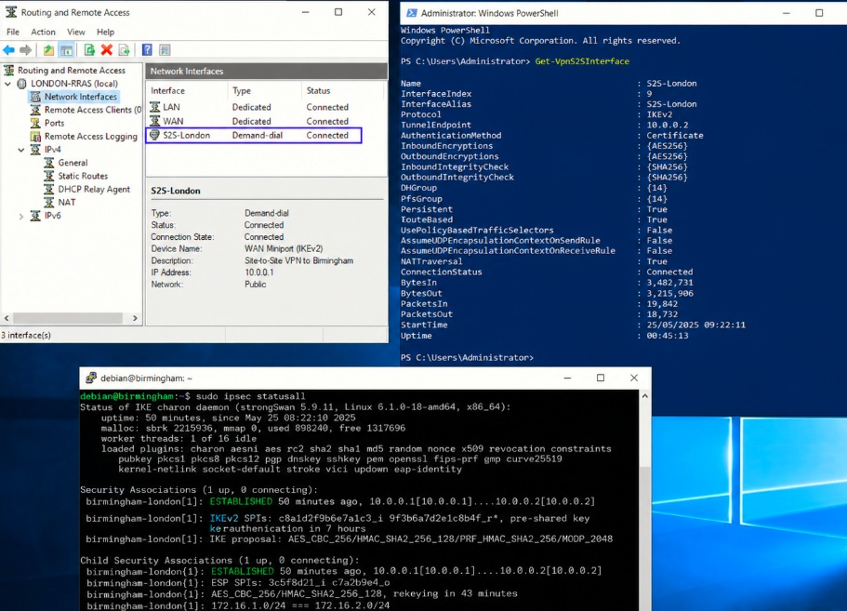

2. Domain Server

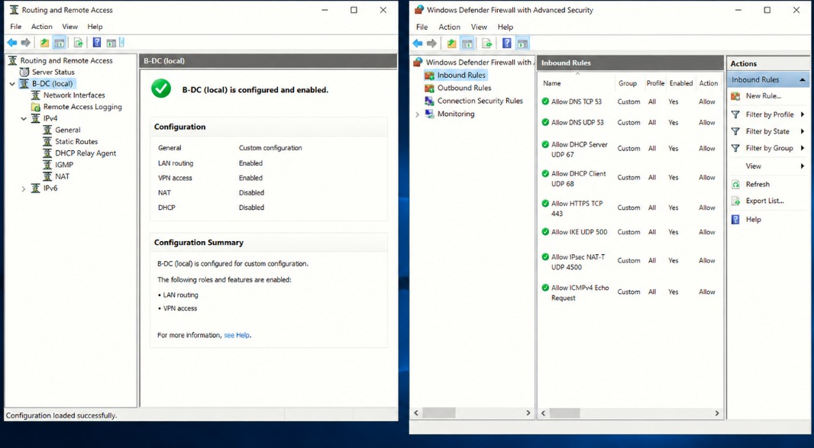

3. Encrypted Connection between Birmingham and London

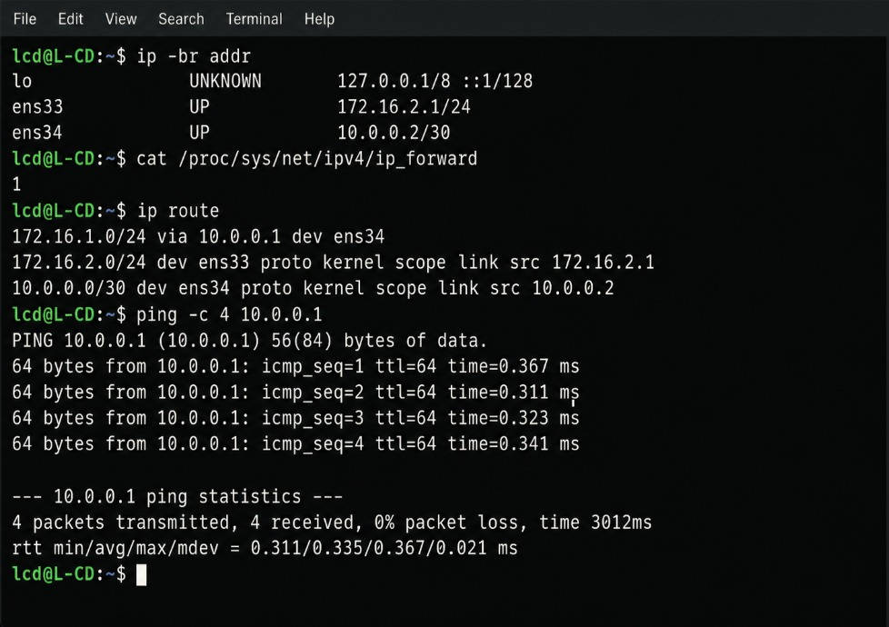

4. Users

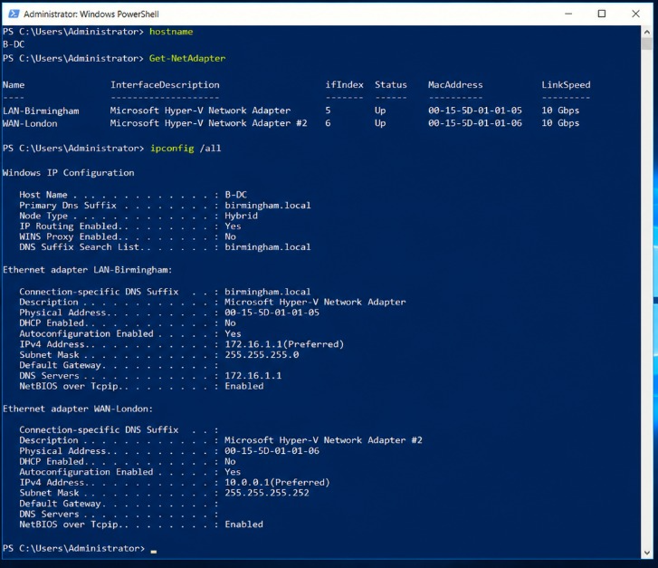

5. Domain Membership

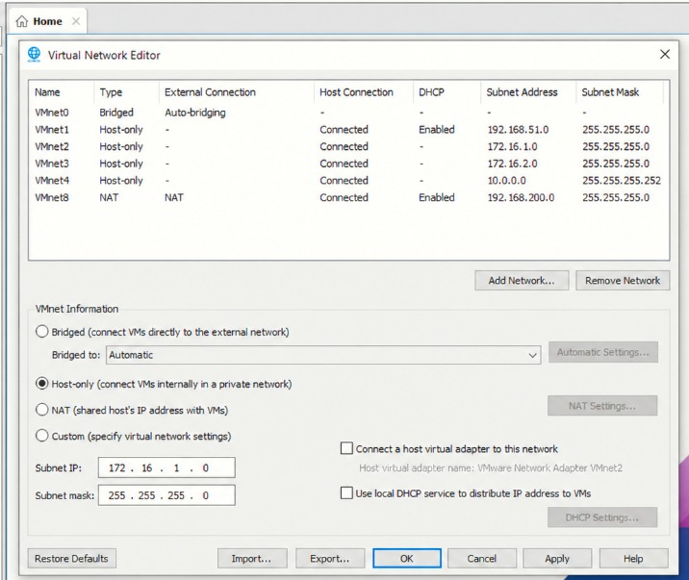

6. DHCP Server

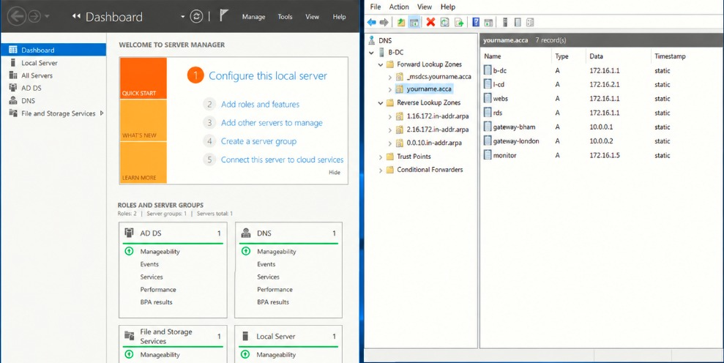

7. Test and Troubleshoot

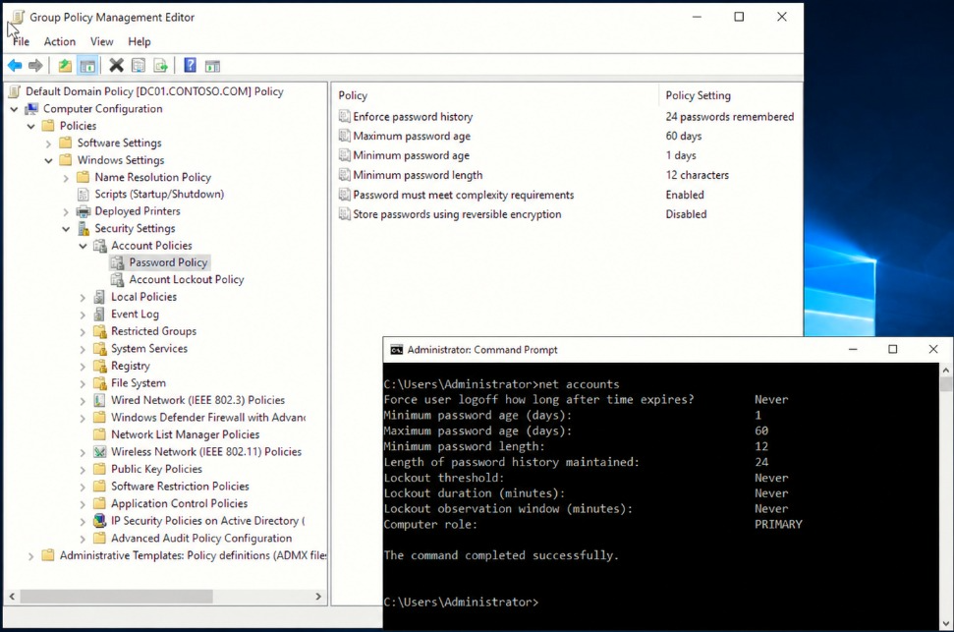

8. Disk Drive

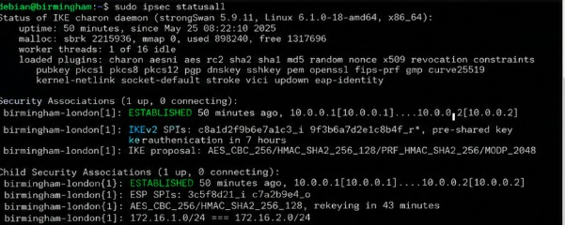

9. IIS Server

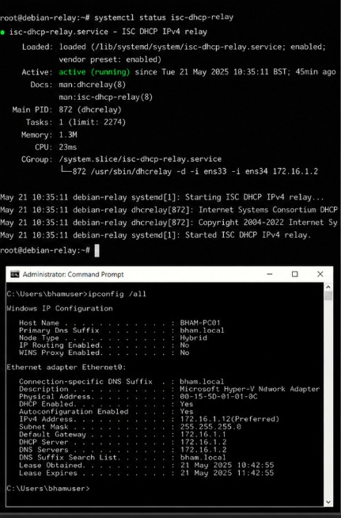

10. Remote Desktop Services



