

L7 - Data Mining & Visualisation
ACCA7015
Exploratory Data Analysis – Report and Demonstration

Student Name: Jure Jurcevic
Student Number: 2212275
Date: 20/11/2025
Contents
Abstract 3
Introduction 4
Literature Review 5
Predictive analytics 5
Decision trees and Random Forests 5
K-Means clustering and segmentation 5
Predictive analytics for Airbnb 6
Dataset Description 7
Methodology 9
Data preparation 9
Feature engineering 9
Data types and normalisation 9
Feature selection 10
Modelling tools and configuration 10
Evaluation strategy 12
Results 13
Exploratory data analysis 13
J48 decision tree classification 13
Random Forest classification 14
K-Means clustering 15
Discussion 19
Business Recommendations 20
Conclusion and Future Work 21
References 22

Abstract
Organisations in the digital economy increasingly rely on predictive analytics to support decisions about pricing, marketing and risk. Predictive models use historical data and machine learning algorithms to discover patterns and to estimate future or unknown outcomes. In the short-term rental market, platforms such as Airbnb generate large volumes of listing data, including location, room type, price and customer reviews. This information can be used to predict price levels and to identify distinct segments of properties.
This project applies classification and clustering techniques to the publicly available AB_NYC_2019 Airbnb dataset, which contains 48,895 listings for New York City. A new categorical target variable, price_category, is created to label each listing as low, medium, high or premium. Two classification models are built in Weka: a J48 decision tree and a Random Forest ensemble. Their task is to predict price_category from features such as neighbourhood group, room type, availability and review activity. In addition, a K-Means clustering model is trained on selected numeric attributes to uncover unsupervised groupings of listings, which are then interpreted using Power BI visualisations.
The Random Forest achieves higher overall accuracy (about 68%) than the decision tree (about 66%), with better performance on the minority premium class. K-Means clustering with $K=3$produces clusters that differ in location, demand and typical price category, highlighting segments such as “prime Manhattan, high-demand listings” and “low-demand outer-borough listings”. The findings show how classification and clustering together can give Airbnb hosts and platform managers insight into price drivers, demand patterns and market structure, supporting more informed pricing and investment decisions.

Introduction
Data driven decision making is now common in many industries. Predictive analytics uses historical data, statistics and machine learning to estimate unknown future events and to support strategic choices [1]. Instead of relying only on intuition, decision makers can use evidence from models trained on past behaviour. Typical examples include churn prediction in telecommunications, credit scoring in banking and demand forecasting in retail.
Two families of techniques are central to predictive analytics. Classification assigns each observation to one of a set of discrete classes using labelled training data. Clustering discovers groups of similar observations when no labels are provided. Both are important: classification focuses on prediction of specific targets, while clustering offers exploratory insight into structure within the data [2].
Short term rental platforms such as Airbnb are fertile ground for predictive analytics. Listing data capture location, property type, price and customer activity across thousands of properties. Prior research has used machine learning models to estimate nightly prices, to predict occupancy rates, and to understand what features make a listing successful [3]. Tree based models such as Random Forest and gradient boosting are often found to perform strongly on such structured tabular data, while still offering some level of interpretability.
This project focuses on the New York City Airbnb Open Data 2019 dataset. The aim is twofold:
- Build and evaluate classification models that predict the price category of each listing from its characteristics.
- Apply K-Means clustering to identify natural segments of listings based on location and demand-related features and explore how these segments relate to price.
The analysis uses Weka for modelling and Power BI for visualisation. Screenshots from both tools are included in the main text as evidence of the experimental process. The report is organised as follows. Section 2 reviews recent literature on predictive analytics, with attention to decision trees, Random Forests and K-Means clustering. Section 3 describes the Airbnb dataset and the engineered variables. Section 4 outlines the methodology for data preparation, modelling and evaluation. Section 5 presents the classification and clustering results, supported by screenshots. Section 6 discusses the findings and limitations, Section 7 proposes business recommendations, and Section 8 concludes and suggests directions for further work.

Literature Review

Predictive analytics
Recent reviews describe predictive analytics as a branch of advanced analytics that uses statistical and machine learning methods to discover patterns in historical data and to estimate future outcomes [4]. The growth of “big data” has driven adoption across finance, healthcare, retail and transport. Modern predictive systems often combine multiple data sources and use automated learning pipelines. Key stages include data preparation, feature engineering, model training, validation and deployment, commonly structured by frameworks such as CRISP-DM [5].
Predictive models can be supervised or unsupervised. Supervised models learn from labelled examples to predict a specific target, for example whether a transaction is fraudulent. Unsupervised models such as clustering discover structure without labels and are often used for segmentation or anomaly detection. In practice, analysts frequently combine both approaches; unsupervised clustering helps to understand the data, while supervised models deliver operational predictions [6].

Decision trees and Random Forests
Decision trees remain popular due to their intuitive structure and transparency. Algorithms such as C4.5, CART and their variants split the feature space into regions using simple if then rules, which are easy for humans to interpret [7]. However, individual trees are prone to overfitting, especially when grown deep on noisy data. Pruning and constraints on tree depth can reduce overfitting but may lower accuracy.
Ensemble methods tackle this variance problem by combining many trees. Random Forest, introduced by Breiman, trains multiple trees on bootstrap samples and random subsets of features, then aggregates their predictions [8]. Studies in the last few years consistently report that Random Forest often outperforms single trees and other traditional algorithms on structured data, while being robust to noisy features and capable of handling nonlinear relationships [7]. For example, comparative work in finance, healthcare and marketing shows Random Forest achieving higher F1 scores and AUC than standalone trees, logistic regression and k-nearest neighbours, although at the cost of lower interpretability [7].
Class imbalance is a common challenge in classification. Recent research highlights that minority classes may be badly predicted if models optimise only overall accuracy. Techniques such as resampling, synthetic minority oversampling (SMOTE) and class weighted loss functions are widely used to improve performance on rare classes [9]. There is also growing interest in explainable AI (XAI) for ensemble models, using tools such as SHAP values and partial dependence plots to understand feature effects [10].

K-Means clustering and segmentation
K-Means is one of the oldest but most widely used clustering algorithms. It partitions data into clusters by iteratively assigning points to the nearest centroid and updating centroid positions. Because of its simplicity and computational efficiency, K-Means is frequently applied in business analytics for customer segmentation and product grouping [5]. Recent works use K-Means or its variants for retail customer segmentation, energy usage profiling and education analytics, often as a first step before more complex models [11].
K-Means has well known limitations. The number of clusters must be chosen in advance, and results can be sensitive to initial centroid positions and to feature scaling. The algorithm assumes roughly spherical clusters of similar size and struggles with elongated or irregular group shapes. Research therefore recommends careful normalisation of features, multiple random restarts and evaluation using internal metrics such as the silhouette coefficient or Davies Bouldin index [5].

Predictive analytics for Airbnb
Several recent studies apply machine learning to Airbnb data. Work using datasets from cities such as New York, London and Barcelona shows that location, room type, number of reviews and availability are strong predictors of nightly price and occupancy [12]. Ensemble tree models, especially Random Forest and XGBoost, often achieve the best predictive performance in price estimation tasks, outperforming linear models and simple trees.
Other research uses clustering to segment Airbnb listings into groups based on location and pricing features. For example, clusters may represent budget listings in outer boroughs, mid-range apartments in emerging neighbourhoods, or luxury properties in central areas [13]. These segments are useful for platform strategy and for hosts wishing to benchmark their properties.
The present project builds on this literature by combining classification and clustering on the NYC 2019 dataset. Decision trees and Random Forests are used to predict price categories, while K-Means is used to reveal underlying listing segments that can later be compared with pricing outcomes.

Dataset Description
The analysis uses the AB_NYC_2019 Airbnb Open Data for New York City. This dataset, derived from the Inside Airbnb project and made available on Kaggle, contains 48,895 listings. Each row represents a single listing with attributes describing location, property type, host activity and review history.
Key attributes include neighbourhood group (borough), neighbourhood, latitude, longitude, room_type (entire home/apt, private room, shared room), price, minimum_nights, number_of_reviews, last_review, reviews_per_month, calculated_host_listings_count and availability_365. The official description notes that the dataset summarises listing activity and metrics for 2019 and can be used to analyse host behaviour, geographic patterns and performance metrics.
For this project, the raw dataset is cleaned and transformed into a modelling dataset. The main predictive focus is on a new categorical variable price_category, engineered from the continuous price attribute. Price is binned into four ordered categories: low, medium, high and premium. Cut off points are chosen based on the empirical distribution of prices so that each category captures a meaningful region of the market, while still retaining enough records. The resulting distribution is imbalanced: the low category contains about 44,7% of listings, medium about 35,2%, high about 17,9% and premium roughly 2,1%. Only a small fraction of listings falls into the most expensive premium group, which reflects the real-world dominance of modestly priced properties.
The dataset also shows strong geographic skew. Manhattan and Brooklyn account for most listings, with Queens, Bronx and Staten Island representing much smaller shares. Entire homes and private rooms dominate the room_type distribution, and shared rooms are rare. These structural properties of the data influence both model behaviour and the interpretation of results.
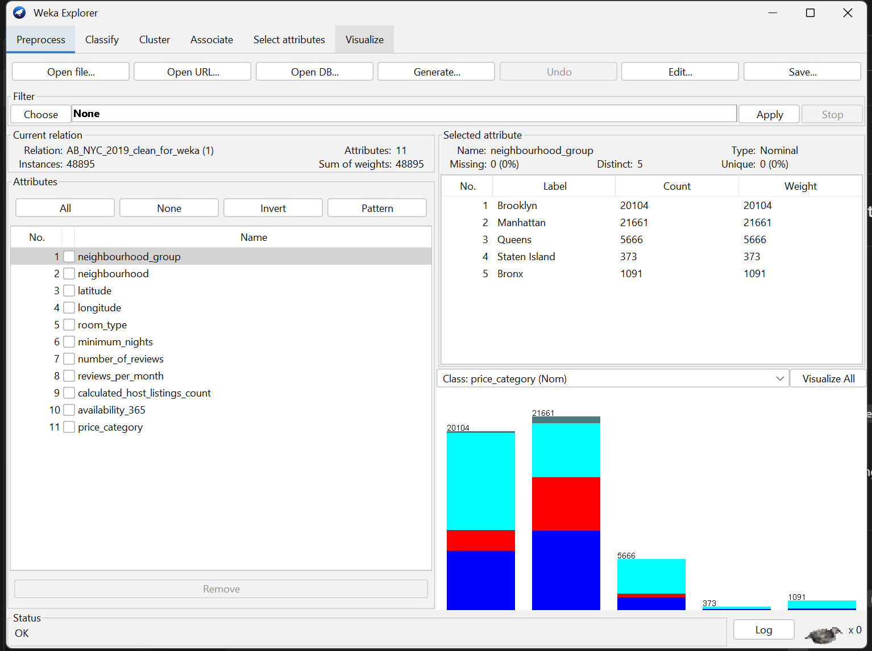
Figure 1 Open and Load Dataset in Weka

Methodology
The project follows the general logic of the CRISP-DM process model, moving from data understanding through preparation, modelling, evaluation and interpretation [14]. All modelling is carried out in Weka 3.8, with additional exploratory analysis and visualisation in Power BI.

Data preparation
Data cleaning focuses on handling missing values, outliers and irrelevant attributes. The variable reviews_per_month contains missing values for listings with no reviews. These cases are interpreted as having zero review activity, so the missing values are replaced with 0. The attribute last_review is a date field that is not required for modelling and is therefore removed. Textual attributes such as listing name and host_name are also dropped to avoid high dimensional sparse inputs that do not generalise well.
Outliers are examined in price, minimum_nights, number_of_reviews and availability_365. A small number of listings show extremely high nightly prices or unrealistic minimum_nights requirements. Because the task is to predict price categories rather than exact prices, these extreme values mainly influence the premium category. Instead of removing them, the analysis keeps them but monitors their impact. Minimum_nights values above a realistic upper bound (for example, more than 365 nights) are capped, since bookings longer than a year do not make sense in the context of nightly rentals.

Feature engineering
The central engineered feature is price_category. Converting continuous price to an ordinal categorical variable turns the task into multi class classification. This framing is easier to explain to business stakeholders (for example, predicting whether a listing belongs to a low or high price tier) and avoids some of the heavy tails of the price distribution. The thresholds for each price band are chosen from the observed percentiles of price, with adjustment to ensure that each class has a non-trivial number of examples.
Several other design choices are made. The variable neighbourhood_group (borough) is retained as a compact representation of location. The fine-grained neighbourhood name, which has more than two hundred levels and many rare categories, is excluded from classification models to reduce sparsity and potential overfitting. Latitude and longitude are kept mainly for clustering, where precise spatial distance matters.
The attributes number_of_reviews, reviews_per_month, calculated_host_listings_count and availability_365 are preserved. They capture demand and host behaviour: heavily reviewed properties might be more attractive or cheaper; hosts with many properties may behave differently from casual hosts; properties with low availability can signal either high demand or manual blocking.

Data types and normalisation
In Weka, neighbourhood_group, room_type and price_category are defined as nominal attributes. Numeric attributes are left as real-valued. Decision trees and Random Forests are invariant to monotonic transformations and can handle different scales, so explicit scaling is not required for classification.
K-Means clustering relies on Euclidean distance in feature space, so feature scaling is critical. A separate clustering dataset is created that excludes the price_category target and other categorical variables. For clustering, the retained numeric attributes are latitude, longitude, minimum_nights, number_of_reviews, reviews_per_month, calculated_host_listings_count and availability_365. These features are normalised using Weka’s Normalize filter to have zero mean and unit variance, ensuring that no single variable dominates distances purely due to scale differences. This approach is consistent with recommendations from recent clustering studies [15].
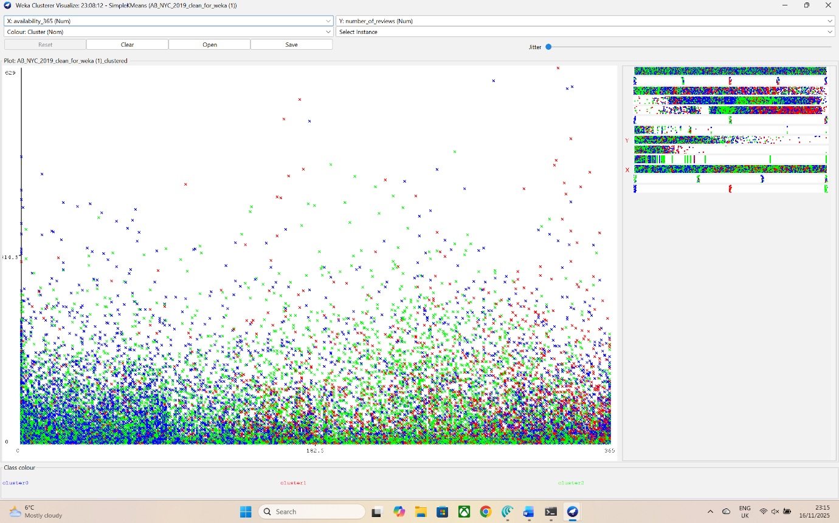
Figure 2 Visualize Cluster

Feature selection
Feature selection combines domain judgement with Weka’s attribute evaluation tools. Borough, room_type, availability_365, number_of_reviews and reviews_per_month are expected to influence price, based on previous Airbnb research [16]. To confirm this, the InfoGainAttributeEval ranking method is run with price_category as the target. The evaluator reports that neighbourhood_group and room_type carry the highest information gain, followed by availability_365 and review-related attributes. Latitude and longitude add some information but less than the categorical location indicator once borough is included.
For clustering, the goal is to let the algorithm discover combinations of location and demand features. Price itself is deliberately omitted from the clustering variables so that clusters are not trivially driven by the outcome of interest. After clustering, the relationship between clusters and price_category can be inspected.

Modelling tools and configuration
All classification models are built using Weka’s J48 and RandomForest implementations. The J48 decision tree uses default pruning parameters: confidence factor 0.25 and minimum of 2 instances per leaf. Random Forest uses 100 trees, each trained on a bootstrap sample with d randomly chosen features at each node, where d is the number of predictors.
K-Means clustering is performed using Weka’s SimpleKMeans algorithm. The number of clusters is set to $K=3$in the final model, after experimentation with other values. The algorithm uses Euclidean distance on the normalised feature set, a maximum of 500 iterations and a fixed random seed for reproducibility. The option to preserve instance order is turned on so that cluster assignments can be exported and joined with the original data for visualisation in Power BI.
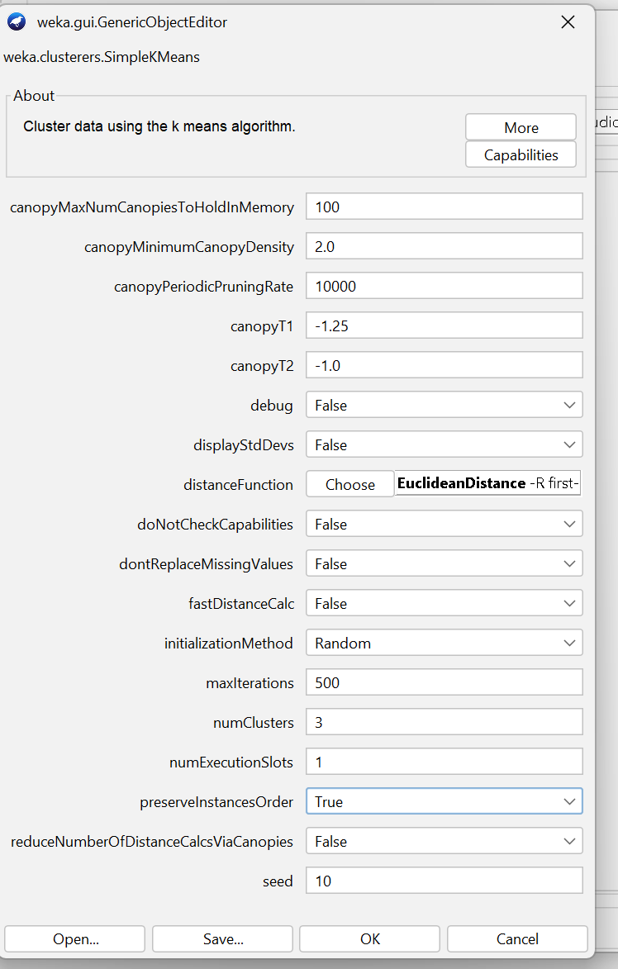
Figure 3 KMeans config
Figure 4 KMeans config

Evaluation strategy
For classification, model performance is assessed using 10-fold cross validation on the full dataset. This approach divides the data into ten equal parts; each fold acts once as validation data while the remaining folds are used for training. The reported metrics are the mean overall accuracy, Kappa statistic, and class-wise precision, recall and F1-score. Cross validation is widely recommended when a separate hold-out test set is not available, as it uses data efficiently while still giving a robust estimate of out of sample performance [17].
Given the imbalanced distribution of price categories, accuracy alone may hide poor performance on minority classes. Therefore, particular attention is paid to precision, recall and F1 for the premium and high classes, as well as to the macro averaged and weighted averaged F1-scores.
For clustering, evaluation is based on internal quality measures and interpretability. The average silhouette coefficient for the chosen K is computed externally in Python, and the Davies Bouldin index is taken from Weka’s output. Lower Davies Bouldin values and higher silhouette values indicate more distinct clusters. However, because internal metrics do not directly include business meaning, the main emphasis is on understanding cluster centroids and visual patterns in Power BI maps and charts [18].

Results

Exploratory data analysis
Initial exploration in Weka confirms the strong dominance of Manhattan and Brooklyn in the dataset. The Visualize tab shows tall bars for these boroughs with a mix of price categories, while Queens, Bronx and Staten Island have far fewer listings. The stacked bar view by price_category indicates that low and medium listings dominate across all boroughs, with premium listings forming only thin segments.
A simple Power BI table created from the exported ARFF data shows that most low-priced listings are private rooms or shared rooms, while high and premium listings are mainly entire homes. Review related columns reveal a long-tail pattern: most listings have relatively few reviews, while a small number have several hundred.

Figure 5 Raw clustered dataset in Power BI Data view

J48 decision tree classification
The J48 decision tree is trained with price_category as the target. Weka’s textual output gives the model accuracy under 10-fold cross validation. The tree correctly classifies 32611 instances out of 48,895, corresponding to an accuracy of 66,69%, and misclassifies 16284 instances. The Kappa statistic is 0,47, indicating moderate agreement beyond chance.
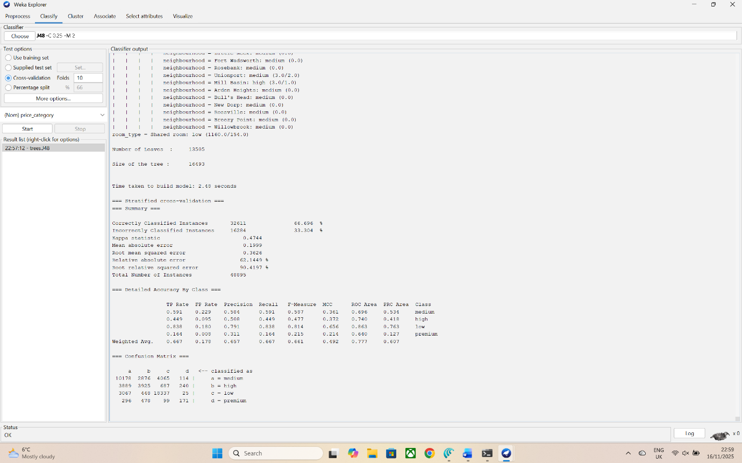
Figure 6 Classification with Decision Tree (J48)”
Inspection of the learned tree shows that room_type appears near the root, splitting entire homes from private and shared rooms. This confirms that property type is a major determinant of price tier. Below this split, neighbourhood_group provides further separation: entire homes in Manhattan are usually classified as high or premium, while entire homes in outer boroughs more often fall into medium.
Branches involving reviews_per_month and availability_365 capture aspects of demand. For example, some paths indicate that entire homes in central locations with low availability (implying many bookings) are classified into higher price categories, while similar properties with high availability are classified as medium or high but not premium. Another part of the tree uses calculated_host_listings_count to distinguish professional hosts with many listings from casual hosts; this appears linked with high priced properties in popular areas.
The Detailed Accuracy by Class section in the Weka output reports precision, recall and F-Measure for each price category. The recall for the majority low class is about 0,838, and precision about 0,791, giving an F-Measure around 0,814. Performance on the medium class is slightly lower but still respectable. For the high class, both precision and recall drop to around 0,5-0,4, suggesting more confusion with neighbouring categories. The premium class, while small, achieves a recall of about 0,164 and a precision of 0,311, with F-Measure around 0,215.
The confusion matrix shows that many true premium listings are predicted as high, and some high listings are mislabelled as medium. However, very few low listings are incorrectly predicted as premium. Overall, the decision tree provides a transparent model with moderate predictive strength.

Random Forest classification
The Random Forest model is trained on the same feature set and evaluated with 10-fold cross-validation. Weka reports 33592 correctly classified instances, giving an accuracy of approximately 68%, an improvement of several percentage points over J48. The Kappa statistic rises to 0,50, indicating stronger agreement between predictions and true labels.
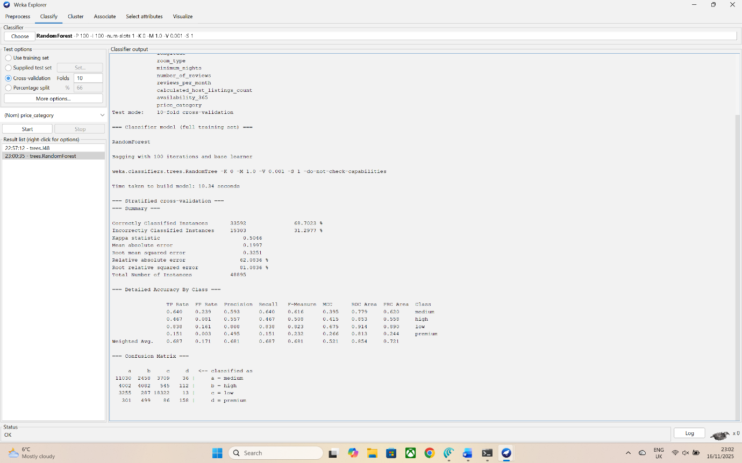
Figure 7 Classification with Random Forest
Random Forest does not produce a single tree structure, but Weka’s attribute importance estimates reveal that room_type and neighbourhood_group are again the most influential features, followed by availability_365 and number_of_reviews. This ranking match both domain intuition and the information gain analysis.
Class-wise metrics show improvements across most categories. Precision and recall for the low and medium classes increase to about 0,8 and 0,6 respectively. The high class sees a noticeable gain in F-Measure, rising to around 0,5. The most important improvement occurs for the premium class. Recall for premium increases from 0,15 under J48 to about 0,16 under Random Forest, and precision improves from 0,311 to about 0,495.
The confusion matrix reveals fewer misclassifications between high and premium, and more premium listings correctly identified. Some confusion remains between medium and high, which is expected given the fuzzy boundary between those price bands. The weighted average F-Measure about 0,681.
These results confirm findings from the literature that ensemble tree methods often outperform single trees on tabular datasets [19]. In practical terms, the Random Forest gives more reliable predictions of price category, especially for the rare premium properties, though at the cost of losing the simple rule structure of J48.

K-Means clustering
K-Means clustering is run on the normalised numeric attributes without the price_category label. After experimentation with several K values, a three cluster solution gives a good balance between interpretability and internal quality measures. Weka reports that cluster 0 contains 21873 instances, cluster 1 5206, and cluster 2 21906, roughly corresponding to 44,6%, 10,6% and 44,8% of the dataset.
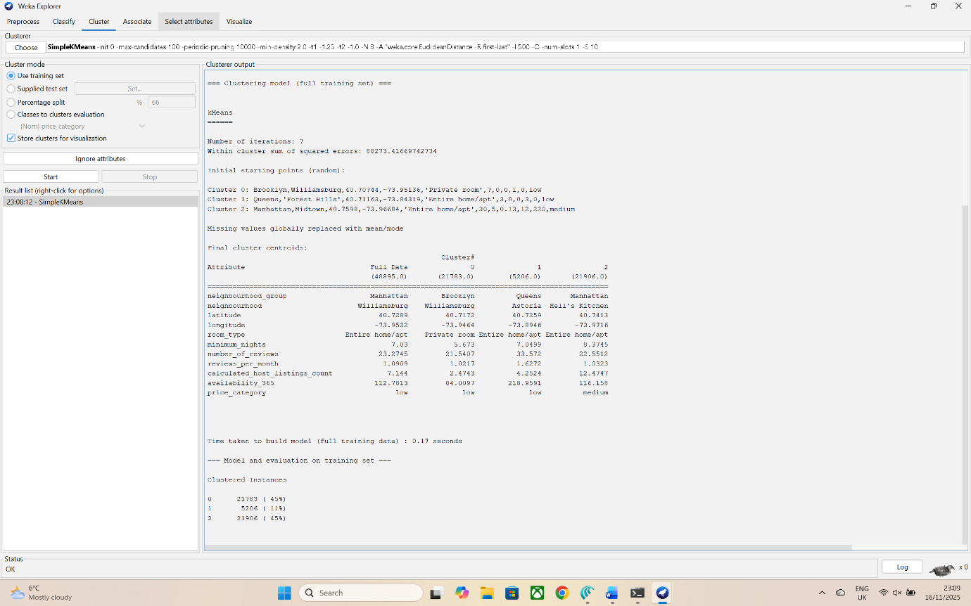
Figure 8 Cluster centroids and Instances per cluster
The centroid table indicates how clusters differ. One cluster has centroids with latitude and longitude values consistent with Manhattan and inner Brooklyn, relatively low availability_365 and higher numbers of reviews. Another cluster has centroids corresponding more to outer boroughs, with very high availability and few reviews, suggesting low demand. A third cluster shows intermediate values.
To make these patterns easier to interpret, cluster assignments are exported from Weka and joined with the main dataset in Power BI. A scatter plot of availability_365 versus number_of_reviews, coloured by cluster, shows distinct clouds of points. One cluster occupies the region of low availability and moderate to high review counts; another occupies high availability and low reviews; the third sits between them.
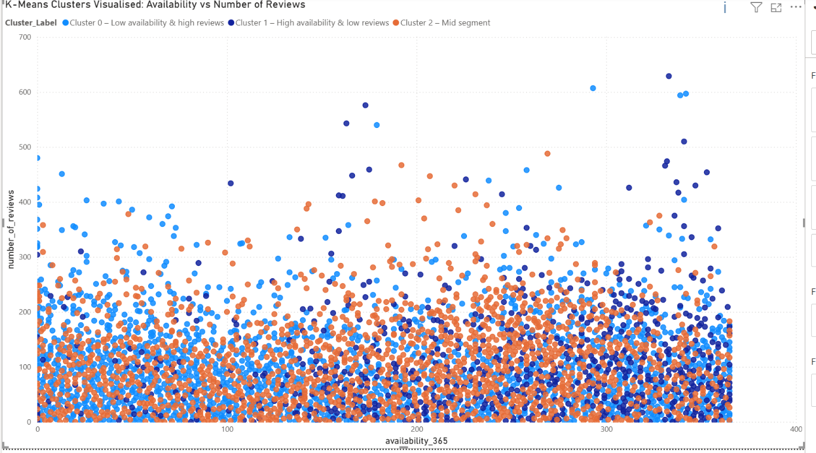
Figure 9 Scatter plot showing Airbnb listings clustered by K-Means using availability and review count
A simple bar chart of cluster label against count of listings illustrates the relative size of each group.
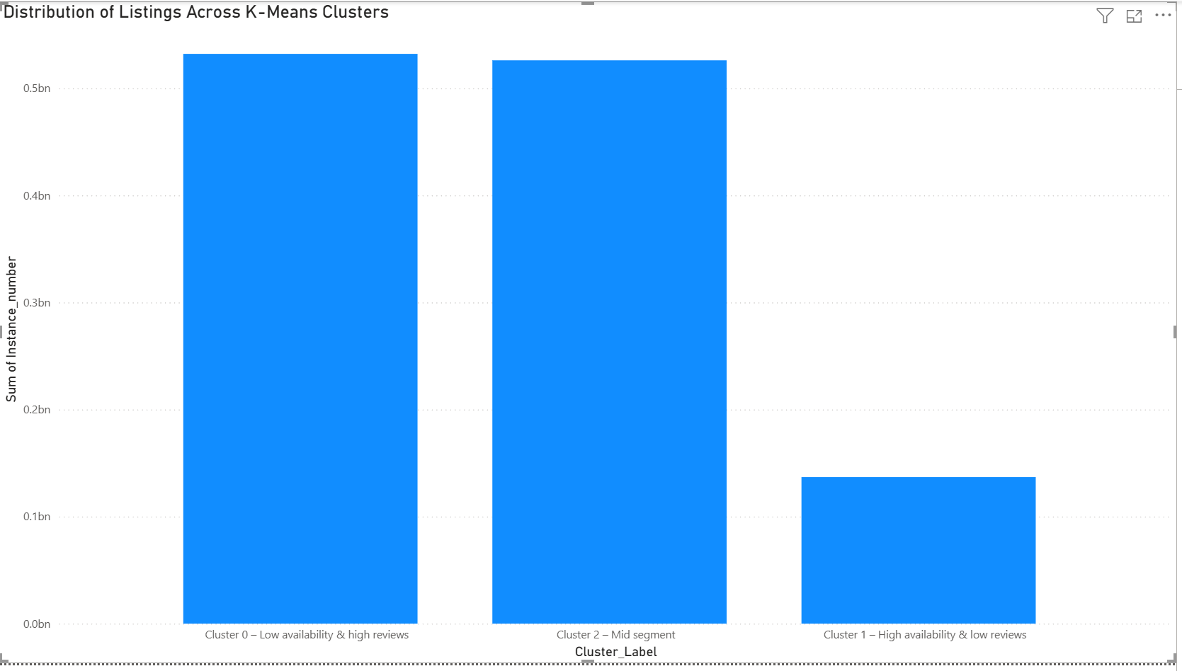
Figure 10 Distribution of Airbnb listings across K-Means clusters
Finally, Weka’s Visualize Cluster window is used to plot availability_365 on the x-axis and number_of_reviews on the y-axis, colouring points by cluster. This visualisation confirms that the algorithm has separated listings primarily by their combination of availability and demand.
Figure 11 Visualize Cluster
When the original price_category is joined to the clustered data in Power BI, a cross tab shows that one cluster contains a high proportion of high and premium listings, another contains mostly low listings, and the third has a mix of low and medium. This suggests that the unsupervised clusters relate closely to both price and demand patterns.

Discussion
The results highlight several important insights about the New York City Airbnb market and about the behaviour of the models.
First, both decision tree and Random Forest emphasise room_type and location as primary drivers of price tier. Entire homes in Manhattan and in popular Brooklyn neighbourhoods are much more likely to fall into the high or premium categories than private rooms in outer boroughs. This is consistent with prior studies that identify property type and location as the strongest predictors of Airbnb price [20].
Second, review related variables and availability also play significant roles. Listings with many reviews and low availability appear to be those with strong demand, which is often associated with higher prices. At the same time, some budget listings with many reviews may exist, especially in Brooklyn and Queens, reflecting large numbers of cost-conscious travellers. The models capture these interactions: for example, some branches in the J48 tree classify private rooms in Manhattan with many reviews as medium rather than low price.
Third, the comparison between J48 and Random Forest illustrates the trade-off between interpretability and accuracy. The decision tree model is easy to interpret and can be communicated to non-technical stakeholders as a set of rules. However, its accuracy is lower, and it struggles with the finer distinction between high and premium categories. Random Forest achieves noticeably higher accuracy and much better recall for premium listings, reflecting its ability to model complex interactions and to reduce variance through bagging. The downside is that it functions as a “black box”, requiring additional tools such as feature importance or partial dependence to explain individual predictions.
Fourth, the clustering results show that K-Means can reveal meaningful segments even without using price as a variable. Clusters differ in geography, availability and review activity. One cluster corresponds to centrally located, high demand listings that are often priced high; another to remote or less attractive properties with high availability and few reviews; and a third to mid-market listings with moderate demand. These segments resemble those identified in other Airbnb segmentation studies [21].
Internal clustering metrics such as the silhouette coefficient and Davies Bouldin index suggest that the three clusters are reasonably separated but not perfect. This is expected in real world data where boundaries between groups are gradual rather than sharp. If more complex clustering algorithms (for example, Gaussian Mixture Models or DBSCAN) were applied, additional structure might be discovered, but K-Means already provides actionable insights in a simple form.
There are, however, several limitations. The dataset represents only a single year (2019) and does not capture seasonal or long-term trends, nor the impact of events such as the COVID-19 pandemic. The price_category thresholds are somewhat arbitrary and may not reflect exact business definitions of low or high price. Class imbalance, especially for the premium category, reduces the amount of information available for the models to learn about very expensive listings. No systematic resampling or cost sensitive learning is applied, so further improvement in minority class performance is possible. Finally, the analysis focuses only on listing level data and does not incorporate host reputation scores, textual reviews or external factors such as distance to tourist attractions, which could enhance predictive power.

Business Recommendations
Despite these limitations, the findings suggest several practical recommendations for Airbnb stakeholders.
For hosts, the models indicate that price category is strongly linked to room type and borough. Hosts considering upgrading from a private room to an entire home can expect a substantial shift in the likely price band, especially in Manhattan and central Brooklyn. At the same time, review activity and availability play roles. Maintaining high occupancy and encouraging guests to leave reviews can support higher prices by signalling popularity and trustworthiness. Listings that appear in the low demand cluster (high availability, few reviews) may need to adjust prices, improve listing photos or descriptions, or adopt promotional strategies to attract bookings.
For platform managers, the Random Forest model provides a tool for automated price band prediction for new listings, based on their initial attributes. Such a model could be used as a decision support system to suggest an appropriate price range or to flag listings that are priced far outside the predicted band, indicating potential overpricing or under-pricing. The clustering results help to understand the structure of the market and to design tailored guidance. For example, different recommendations can be given to hosts in the “prime high-demand” cluster compared with those in the “low-demand outskirts” cluster.
The clusters can also support marketing strategies. Properties in the high demand, high price segment might be promoted as “premium stays” with curated experiences, while those in the mid-market segment could be grouped into themed collections (for example, “family friendly apartments in Brooklyn”). Low demand clusters could receive targeted advice or educational resources on how to improve listing quality.
Likewise, city planners or tourism boards could use similar analysis to monitor the distribution of short term rentals, identifying areas with high density of listings and strong demand. This could inform policy decisions about regulation, taxation or infrastructure support, though such use would need further data and careful ethical consideration.

Conclusion and Future Work
This report has applied predictive analytics techniques to the AB_NYC_2019 Airbnb dataset to explore factors influencing price categories and to identify natural segments of the New York City short term rental market. Two supervised models, a J48 decision tree and a Random Forest, were trained to predict a four-level price_category variable from location, room type, demand and host features. An unsupervised K-Means clustering model was used to group listings based on numeric attributes, and the resulting clusters were examined in Power BI.
The analysis shows that room_type and neighbourhood_group are dominant predictors of price tier, with review activity and availability also contributing. The Random Forest model achieves higher accuracy and better minority class performance than the decision tree, confirming the power of ensemble methods for structured tabular data. K-Means clustering reveals interpretable segments that differ in location, demand and typical price category. Together, these models provide a richer picture of the market than either approach alone.
Future work could improve and extend this analysis in several ways. First, more sophisticated methods for handling class imbalance, such as SMOTE or class weighted loss, could be applied to enhance prediction of premium listings. Second, additional features could be engineered, including distance to major landmarks, host response rate, or sentiment scores extracted from textual reviews using natural language processing. Third, temporal aspects could be considered by analysing multiple years of data and modelling seasonality and trends. Finally, alternative clustering algorithms such as DBSCAN or hierarchical clustering could be compared with K-Means to test whether more nuanced segments emerge.
Overall, the project demonstrates how relatively accessible tools, Weka for modelling and Power BI for visualisation, can be combined to deliver actionable insights from open data. The same workflow could be adapted by students, analysts or small businesses to explore other datasets and decision problems in the growing field of predictive analytics.

References
- R. V. McCarthy, M. M. McCarthy, and W. Ceccucci, Applying Predictive Analytics. Cham: Springer International Publishing, 2022. doi: https://doi.org/10.1007/978-3-030-83070-0.
- K. Swarnalatha, N. Narisetty, G. Rao Kancherla, and B. Bobba, “Analyzing Resampling Techniques for Addressing the Class Imbalance in NIDS using SVM with Random Forest Feature Selection,” International Journal of Experimental Research and Review, vol. 43, pp. 42–55, Sep. 2024, doi: https://doi.org/10.52756/ijerr.2024.v43spl.004.
- N. Murugesan, I. Cho, and C. Tortora, “Benchmarking in Cluster Analysis: A Study on Spectral Clustering, DBSCAN, and K-Means,” Studies in classification, data analysis, and knowledge organization, pp. 175–185, Jan. 2021, doi: https://doi.org/10.1007/978-3-030-60104-1_20.
- Fereshteh Mirzaei, Alireza Amirian-Chakan, Ruhollah Taghizadeh-Mehrjardi, Hamid Reza Matinfar, and R. Kerry, “Soil textural class modeling using digital soil mapping approaches: Effect of resampling strategies on imbalanced dataset predictions,” Geoderma Regional, vol. 38, pp. e00821–e00821, Sep. 2024, doi: https://doi.org/10.1016/j.geodrs.2024.e00821.
- A. M. Ikotun, A. E. Ezugwu, L. Abualigah, B. Abuhaija, and J. Heming, “K-means Clustering Algorithms: a Comprehensive Review, Variants Analysis, and Advances in the Era of Big Data,” Information Sciences, vol. 622, no. 622, Dec. 2022, doi: https://doi.org/10.1016/j.ins.2022.11.139.
- B. I. Nugroho, A. Rafhina, P. S. Ananda, and G. Gunawan, “Customer segmentation in sales transaction data using k-means clustering algorithm,” Journal of Intelligent Decision Support System (IDSS), vol. 7, no. 2, pp. 130–136, Jun. 2024, doi: https://doi.org/10.35335/idss.v7i2.236.
- A. Ashraf, C. A. Rayed, N. A. Awad, and H. M. Sabry, “A Framework for Customer Segmentation to Improve Marketing Strategies Using Machine Learning,” Procedia Computer Science, vol. 260, pp. 616–625, Jan. 2025, doi: https://doi.org/10.1016/j.procs.2025.03.240.
- A. N. S. Kinasih, A. N. Handayani, J. T. Ardiansah, and N. S. Damanhuri, “Comparative analysis of decision tree and random forest classifiers for structured data classification in machine learning,” Science in Information Technology Letters, vol. 5, no. 2, pp. 13–24, Nov. 2024, doi: https://doi.org/10.31763/sitech.v5i2.1746.
- Yohanni Syahra, A. Fadlil, and H. Yuliansyah, “Customer Segmentation Using RFM and K-Means Clustering to Support CRM in Retail Industry,” SinkrOn, vol. 9, no. 3, pp. 1120–1131, Jul. 2025, doi: https://doi.org/10.33395/sinkron.v9i3.14907.
- K. Tabianan, S. Velu, and V. Ravi, “K-Means Clustering Approach for Intelligent Customer Segmentation Using Customer Purchase Behavior Data,” Sustainability, vol. 14, no. 12, p. 7243, Jun. 2022, Available: https://www.mdpi.com/2071-1050/14/12/7243
- J. Schrader et al., “Application of artificial intelligence techniques for the profiling of visitors to tourist destinations,” Frontiers in Artificial Intelligence, vol. 8, Aug. 2025, doi: https://doi.org/10.3389/frai.2025.1632415.
- Y. J. Gao, “Unravelling the What, How, and When of Airbnb Price Prediction : A Case Study of London Based on Machine Learning,” Doria.fi, 2025, doi: https://www.doria.fi/handle/10024/192821.
- R. Deboosere, D. J. Kerrigan, D. Wachsmuth, and A. El-Geneidy, “Location, location and professionalization: a multilevel hedonic analysis of Airbnb listing prices and revenue,” Regional Studies, Regional Science, vol. 6, no. 1, pp. 143–156, Jan. 2019, doi: https://doi.org/10.1080/21681376.2019.1592699.
- Data Science PM, “What Is CRISP DM?,” Data Science Project Management, Dec. 09, 2024. https://www.datascience-pm.com/crisp-dm-2/
- https://www.facebook.com/MachineLearningMastery, “How to Normalize and Standardize Your Machine Learning Data in Weka,” Machine Learning Mastery, Jul. 04, 2016. https://machinelearningmastery.com/normalize-standardize-machine-learning-data-weka/
- L. Schwarzová, “Predicting Airbnb Prices with Neighborhood Characteristics: Machine Learning Approach,” 2020. Available: http://arno.uvt.nl/show.cgi?fid=156281
- S. Yadav and S. Shukla, “Analysis of k-Fold Cross-Validation over Hold-Out Validation on Colossal Datasets for Quality Classification,” 2016 IEEE 6th International Conference on Advanced Computing (IACC), pp. 78–83, Feb. 2016, doi: https://doi.org/10.1109/iacc.2016.25.
- JulCsc, “Get started with Metrics - Power BI,” Microsoft.com, Oct. 02, 2025. https://learn.microsoft.com/en-us/power-bi/create-reports/get-started-metrics (accessed Nov. 20, 2025).
- L. Grinsztajn, E. Oyallon, and G. Varoquaux, “Why do tree-based models still outperform deep learning on tabular data?,” arXiv.org, Jul. 18, 2022. https://arxiv.org/abs/2207.08815
- A. Voltes-Dorta and A. Sánchez-Medina, “Drivers of Airbnb prices according to property/room type, season and location: A regression approach,” Journal of Hospitality and Tourism Management, vol. 45, pp. 266–275, Dec. 2020, doi: https://doi.org/10.1016/j.jhtm.2020.08.015.
- N. Murugesan, I. Cho, and C. Tortora, “Benchmarking in Cluster Analysis: A Study on Spectral Clustering, DBSCAN, and K-Means,” Studies in classification, data analysis, and knowledge organization, pp. 175–185, Jan. 2021, doi: https://doi.org/10.1007/978-3-030-60104-1_20.

