DS 1

My Screenshots/Photos
- Please add 4–6 screenshots or photos of your digital life.
- You can use your phone or laptop.
- For each screenshot, write one or two sentences explaining what it shows.

Screenshot/Photo 1
[Insert Photo/Screenshot below]
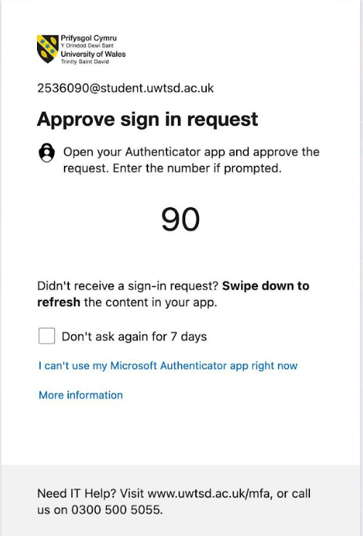
This image represents an effective aspect of my digital life that includes the online security and verification of my identity to log in to my university portal. It has shown a sign-in request with ‘Microsoft Authenticator multi-factor authentication (MFA)’ for the purpose of assessing my account at the university. The MFA can provide an extra layer of security and protection by requiring approval from the mobile device after entering the password for logging in. This process has indicated the need for the following authentication method to maintain security, protection of personal, as well as academic and professional information from the threats of cybercrime. This image has also shared my engagement rate towards the environment of digital learning, where access towards the university account is dependent on the secure system online. It has also represented the convenience and security, which are essential for account management, as well as the protection of sensitive data in the contemporary world of digitalisation.

Screenshot/Photo 2
[Insert Photo/Screenshot below]
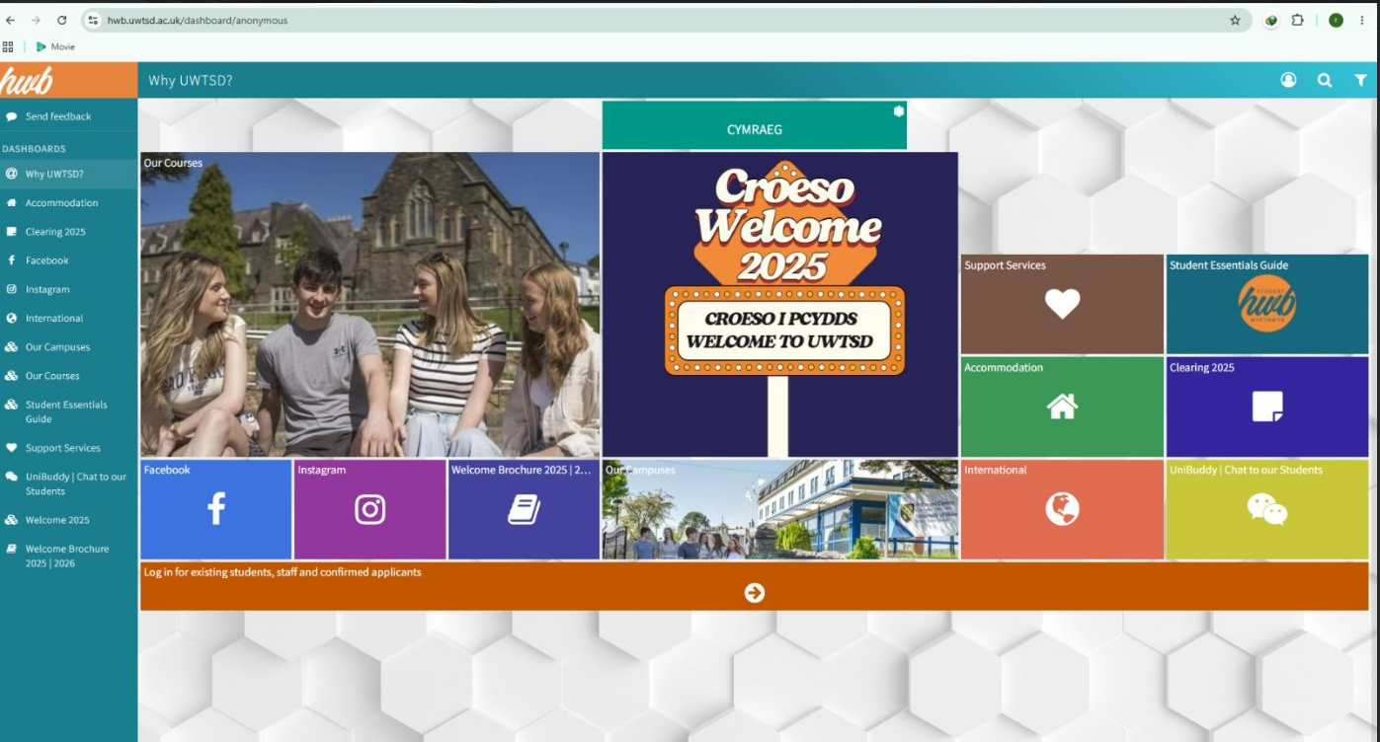
This image has shown an important phase of my digital learning path as a student of this university. As it provides the student online portal of UWTSD, which is significant for me to access the academic resources, as well as information on accommodation, support services, links on social media and communication tools. This platform also helps me to stay connected with the activities of the university and manage my studies in an efficient manner within the digitalised environment. It has highlighted the contribution of technology towards learning, as well as communication and access towards the services, which are essential to engage with the life of the university and find information from anywhere at any time.

Screenshot/Photo 3
[Insert Photo/Screenshot below]
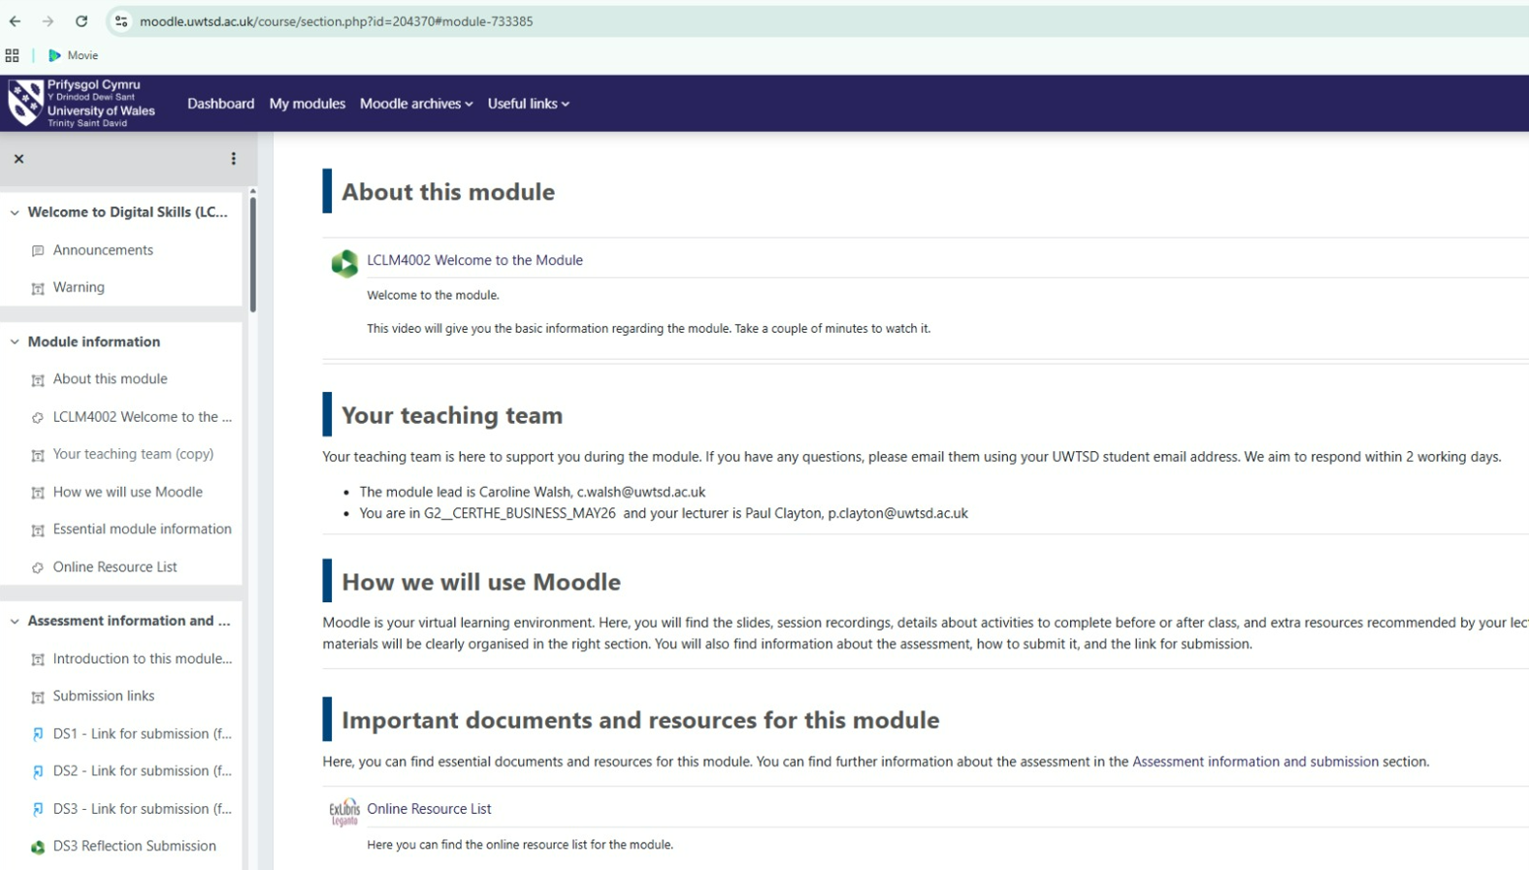This image represents my experience towards digital learning as a student at UWTSD. It has shown the virtual learning environment of the module, where I can access the information related to the module, as well as the learning materials, details of the assessment, along with the links related to submission and lecture communication. In my opinion, Moodle is one of the most important aspects for the students to manage their overall studies through providing an organised access towards the learning resources, and deadlines for submission. It reflects the significance of the digital platform in supporting independent learning, academic progress and communication to study effectively and enhance engagement with the requirements of the course.

Screenshot/Photo 4
[Insert Photo/Screenshot below]
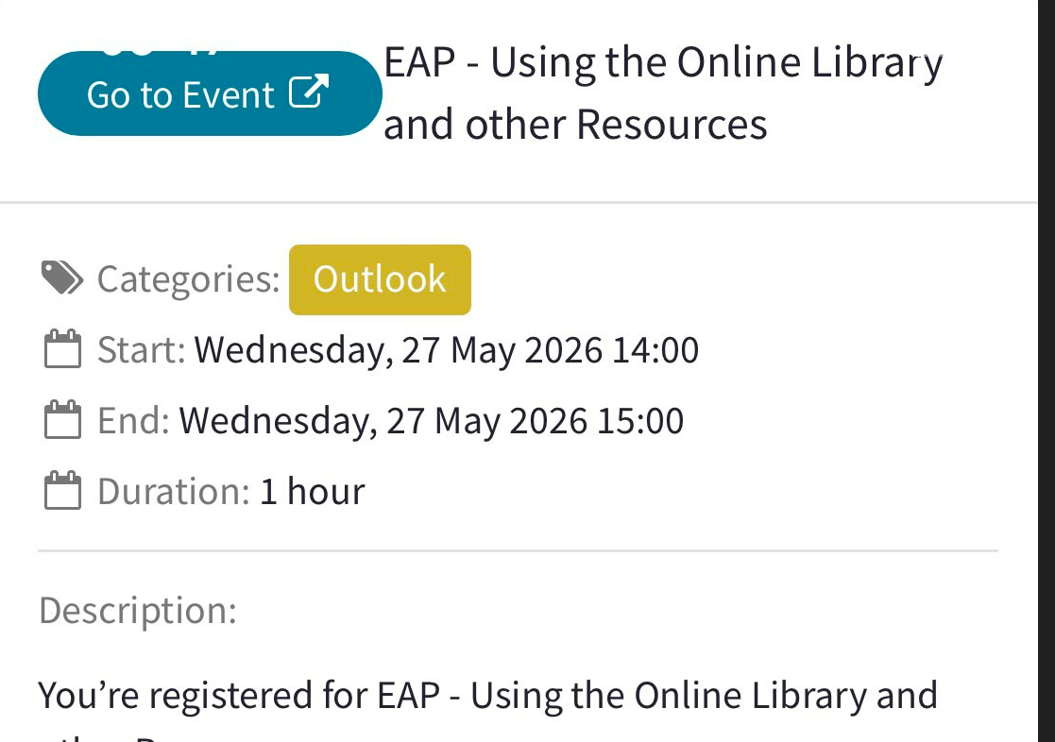
This image reflects my engagement and active participation in the academic development and digital learning system. It has provided the details on my registration towards participating in the online workshop of the university by using the online library and academic resources. The digital platform helps me to access the training session, as well as manage my overall schedule, and develop the research skills, which are essential for me to enhance my professional ability. The event has also given an insight into the importance of technology to support my overall learning, as well as digital literacy to access information and my ability to search for reliable resources to accomplish the assignments.

Screenshot/Photo 5
[Insert Photo/Screenshot below]
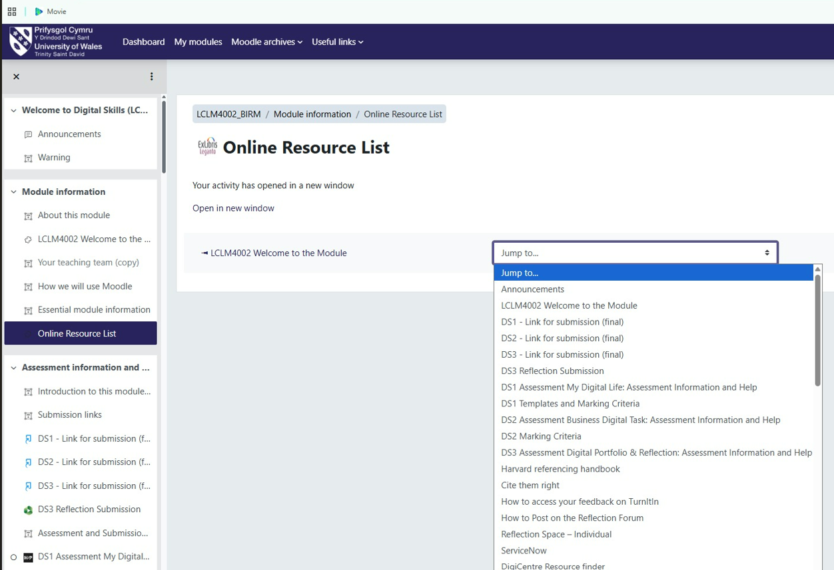
The image represents a significant aspect of my learning ability related to the digitalisation of the online learning platform of the university. In this online learning platform, I can access the resources of the module, assess the information, and get guidance on academic references. The online resource list can provide access towards the learning materials that would help me to accomplish the assessments and improve my research skills. The digital platform can help to organise my overall studies, as well as access the resources for learning at any time while staying updated on the requirements of the course. It has also demonstrated the support of technological features on my independent learning, as well as promoting continuous development in the personal and professional context.

Screenshot/Photo 6
[Insert Photo/Screenshot below]
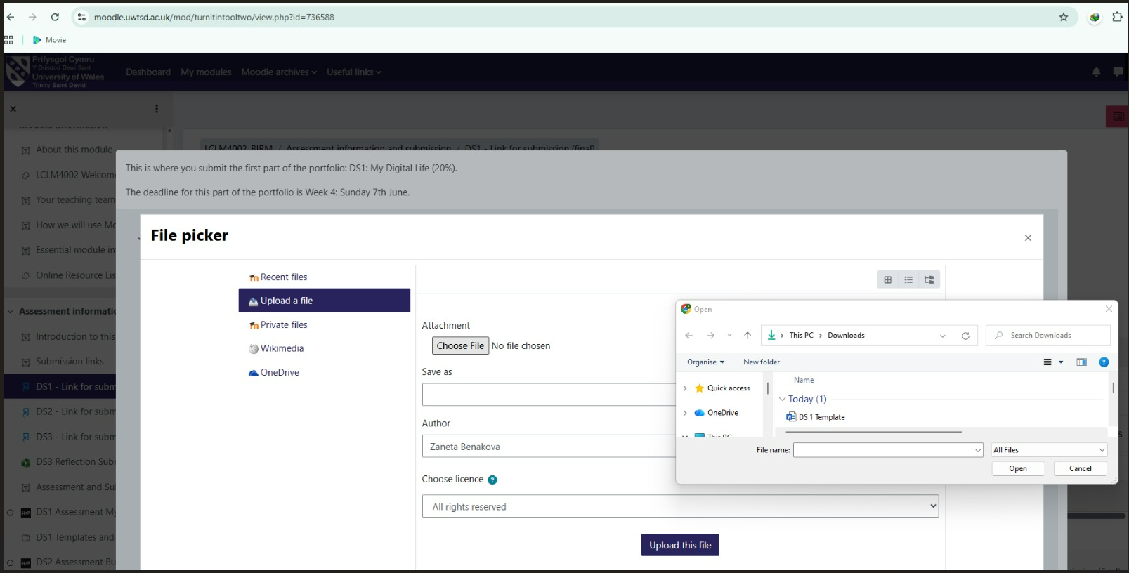 This screen clip has also reflected a significant part of the digital learning through showing the process to upload the assignments by the Moodle of the university and the Turnitin submission system. The digital platforms mainly allow the submission of work in a secure way to meet deadlines, as well as maintain the online academic records. The utilisation of Turnitin can also help to promote academic integrity by checking the originality with a proper referencing process. This highlights the point that technology can support the assessment, as well as feedback, in the management of learning in higher education. The image has also highlighted my individual ability to utilise the digital tools to organise, as well as accomplish and submit the academic assignments, which can be effective for my professional development.

My Short Reflection
- Write 5–8 simple sentences about your digital life.
- You can use the sentence starters below if helpful.
- The digital skills are effective for me because they can help me to accomplish my studies and assignments at the university.
- I utilise Moodle, as well as other online platforms, to access the learning materials and submit my coursework effectively.
- I also use the MFA to maintain the security of my university account and protect my personal data.
- I utilise the online library to identify the learning resources, such as academic articles and books, for delivering a positive outcome on the assignments.
- Digital technologies strengthen my ability to interact with the lecturers, as well as the classmates, to stay engaged and participate in my studies.

Sentence starters
- I use digital tools to …
- I feel confident when I …
- I want to improve …
- I often use these tools: …
- I sometimes feel nervous about …
- I hope this module will help me …
- Digital skills are important for me because …
You can write more if you want.

Submission Checklist
Before you submit, please check:
​​​ ☒ I added 4–6 screenshots
☒ I wrote short sentences for each screenshot
☒ I wrote my short reflection
☒ My work is my own
☒ My file opens correctly
​​☒ My file opens correctly

