Assignment 2
Learning in the Digital Era

UNIVERSITY OF WALES TRINITY SAINT DAVID
LONDON CAMPUS
Module Name: Learning in the Digital Era
Module Code: ACCA 4025

Student Name:THETHE MUSANGU BINYANGA
Student ID:2228216
Group: 3

Lecturer’s Name:
Video Link: https://drive.google.com/file/d/1zeXM_ZYjAtydWfRZqrDWpfps1PrTjogR/view?usp=sharing

Table of Contents
Introduction 2
Presentation 2
Slide 1: Cover Page 2
Slide 2: Introduction and Contents 3
Slide 4: Task 1: Self Evaluation 4
Slide 5: Traits Gained From The Self Evaluation 5
Slide 6: Task 2: Professional Development Plan 6
Reflection & Goals 6
Slide 7: PDP Goals 7
Slide 8: Goal Progress 8
Slide 9: Task 3: Unit 4 Topic Summary 9
Slide 10: Conclusion 10
Slide 11: References 10
Task 4 – Video presentation 11
Conclusion 11
References 12

Introduction
This report provides an overview of my presentation for Assignment 2, focusing on personal development and learning in the digital era. It includes a self-evaluation of my strengths and weaknesses, the development of a Professional Development Plan (PDP) with SMART goals, and the application of Gibbs’ reflective model. The report also highlights key concepts from Unit 4, particularly learning agility and its importance for employability in the IT field.

Presentation
This section introduces the key areas covered in the presentation, including self-evaluation, reflective learning, and personal development planning within the IT field.

Slide 1: Cover Page
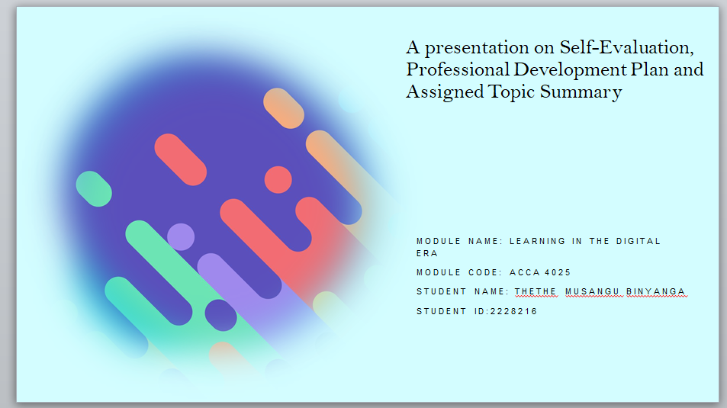

Slide 2: Introduction and Contents
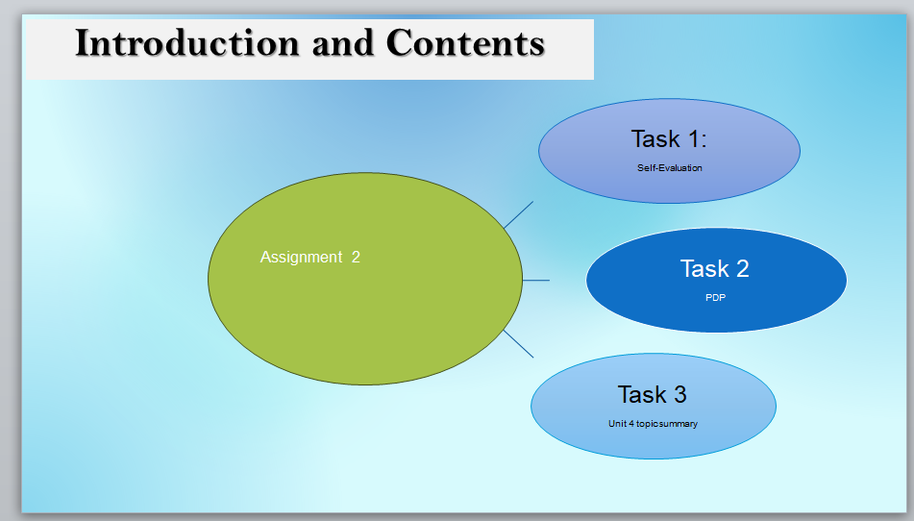
Slide 3: Gibb’s Reflective Model
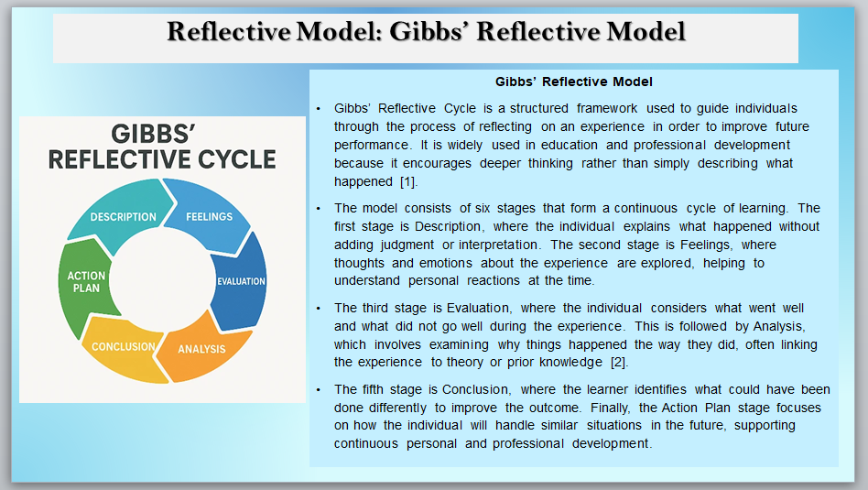
Gibbs’ Reflective Model is a structured framework used to reflect on experiences in a systematic way. It includes six stages: description, feelings, evaluation, analysis, conclusion, and action plan [1]. This model helps individuals learn from past experiences and improve future performance through critical reflection[2]. In this assignment, the model is used to evaluate my personal strengths, weaknesses, and development needs in the field of Information Technology.

Slide 4: Task 1: Self Evaluation
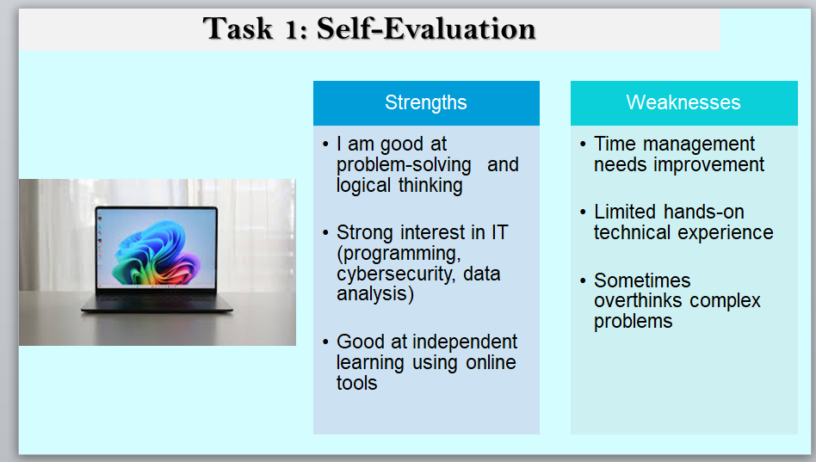
This section presents a self-evaluation of my skills, focusing on strengths and weaknesses in relation to Information Technology. My strengths include problem-solving ability and interest in programming and cybersecurity. However, I also recognise weaknesses such as time management and limited practical experience, which I aim to improve through structured learning and practice.

Slide 5: Traits Gained From The Self Evaluation
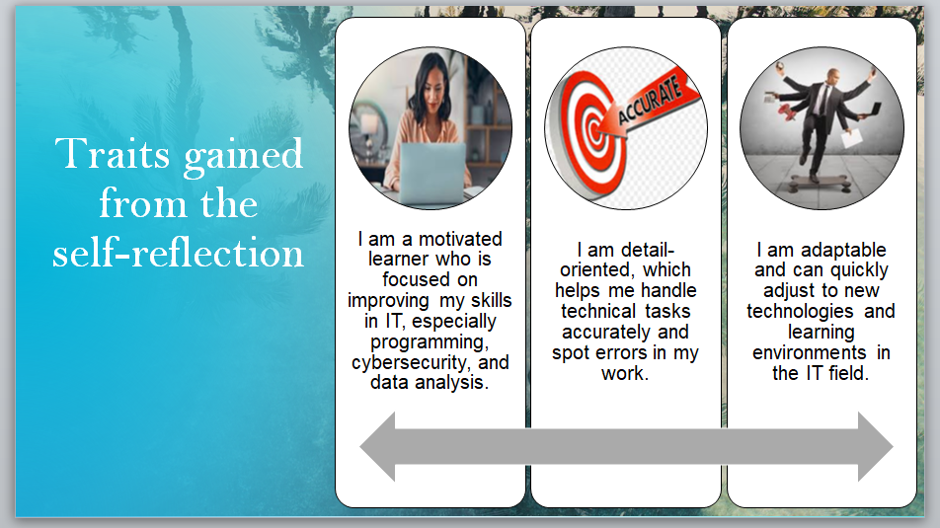
From my self-evaluation, I have identified key personal traits that support my development in IT. I am a motivated learner who is committed to continuous improvement. I am also detail-oriented, which helps in technical tasks such as coding and data analysis. Also, I am adaptable, allowing me to adjust to new technologies and learning environments effectively.

Slide 6: Task 2: Professional Development Plan

Reflection & Goals
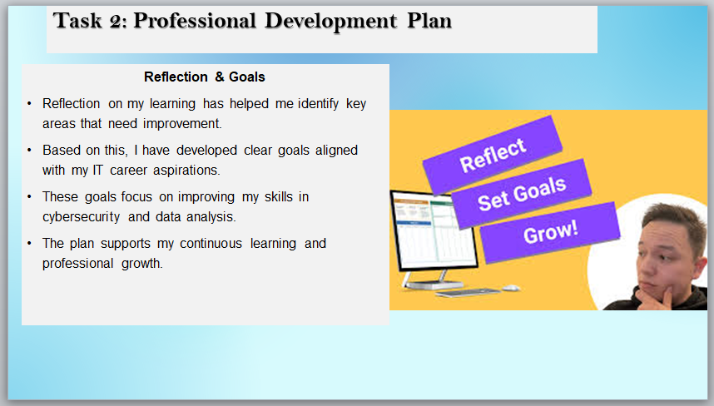
From my reflection, I identified areas that require improvement, particularly in practical IT skills and time management. Using this insight, I developed specific goals to enhance my knowledge in cybersecurity and data analysis. These goals align with my future career aspirations in the IT field and support my continuous professional development.

Slide 7: PDP Goals
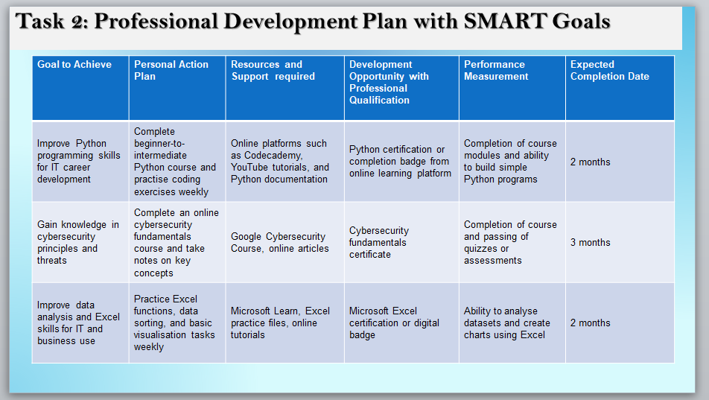
My professional development plan focuses on improving key IT skills such as programming, cybersecurity awareness, and data analysis. These development goals are based on the concept of continuous professional development and the importance of lifelong learning in the digital era. Setting structured and measurable goals is essential for improving employability and adapting to technological changes. Also, using SMART goals supports effective planning and achievement of personal and professional objectives[3].

Slide 8: Goal Progress
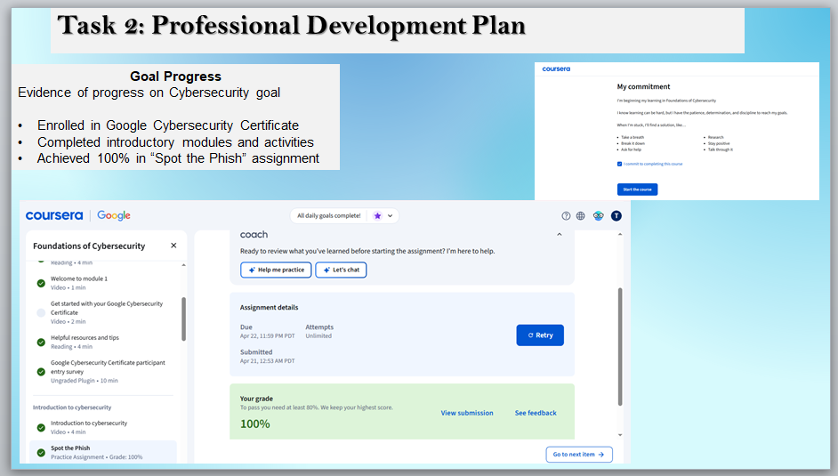
I selected the goal of developing my cybersecurity knowledge by enrolling in the Google Cybersecurity Certificate course. I have completed several introductory modules, including key topics such as the basics of cybersecurity and phishing awareness. I also completed a practice assignment titled “Spot the Phish”, where I achieved a score of 100%. The screenshot provided show my course progress, completed activities, and assessment results. This demonstrates my active engagement with the course and my commitment to developing practical cybersecurity skills. This progress supports my goal of pursuing a career in the IT and cybersecurity field.

Slide 9: Task 3: Unit 4 Topic Summary
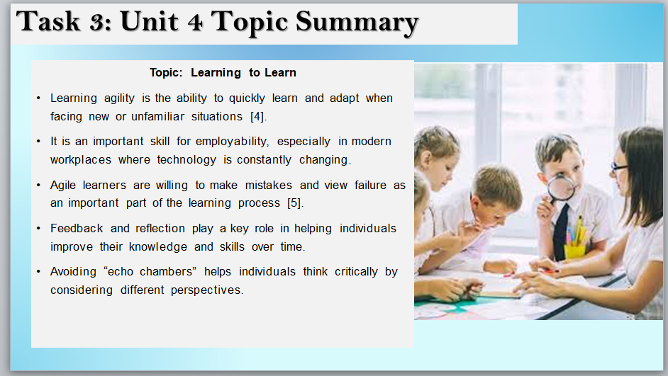
Learning agility refers to the ability to quickly learn and adapt to new situations, which is essential in today’s rapidly changing work environment[4]. In the IT sector, where technology evolves continuously, this skill is critical for maintaining employability. Agile learners are willing to take risks and view failure as part of the learning process, which aligns with experiential learning theory[5]. They also rely on feedback and reflection to improve their performance and develop their skills. Also, avoiding “echo chambers” allows individuals to engage with diverse perspectives and strengthen their critical thinking abilities. Therefore, learning agility is a key factor in lifelong learning and professional development.

Slide 10: Conclusion
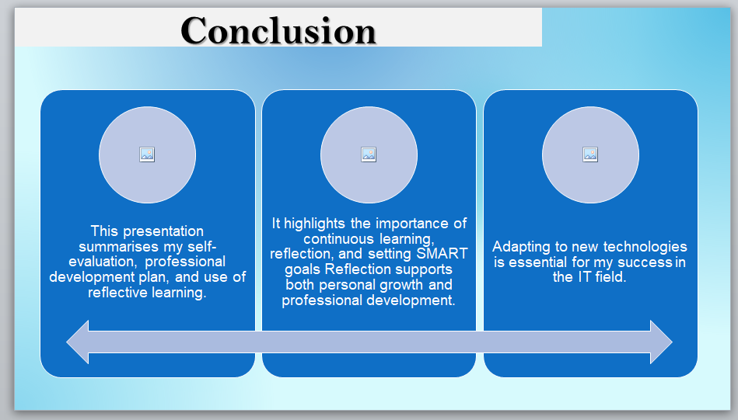

Slide 11: References
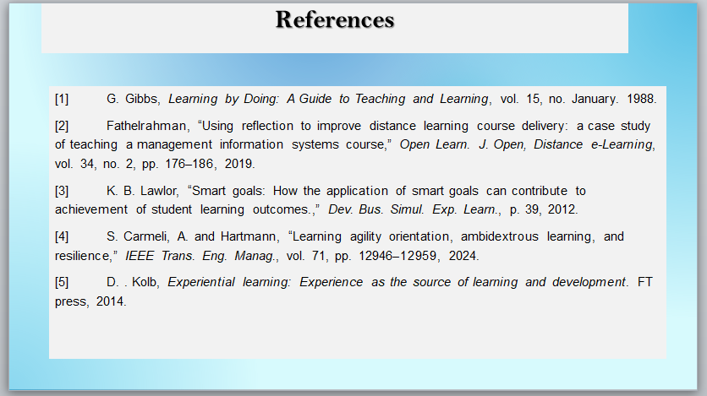

Task 4 – Video presentation
Video Link: https://drive.google.com/file/d/1zeXM_ZYjAtydWfRZqrDWpfps1PrTjogR/view?usp=sharing

Screenshot of the video in a cloud platform
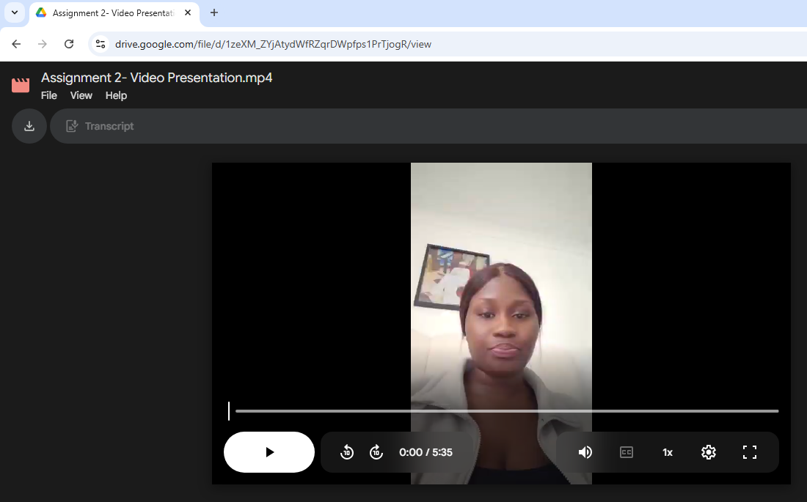
Link to view the PowerPoint presentation: https://docs.google.com/presentation/d/1cz2exNA7ZDb02nySUwBf8CV8r-YZR_br/edit?usp=sharing&ouid=108539750391964325555&rtpof=true&sd=true

Conclusion
In conclusion, this presentation has covered self-evaluation, professional development planning, reflective learning using Gibbs’ model, and the importance of learning agility in the digital era. It highlighted my strengths, weaknesses, and the steps needed to improve my skills in Information Technology, particularly in programming, cybersecurity, and data analysis. From this assignment, I have learned the importance of continuous learning, self-reflection, and setting SMART goals for personal and professional development. The use of Gibbs’ model has helped me understand how to evaluate my experiences and improve future performance. From a personal perspective, I believe that staying adaptable and continuously developing new skills is essential for success in the IT field. Therefore, this assignment has helped me gain a clearer understanding of my career goals and how to achieve them.

References
[1] G. Gibbs, Learning by Doing: A Guide to Teaching and Learning, vol. 15, no. January. 1988.
[2] Fathelrahman, “Using reflection to improve distance learning course delivery: a case study of teaching a management information systems course,” Open Learn. J. Open, Distance e-Learning, vol. 34, no. 2, pp. 176–186, 2019.
[3] K. B. Lawlor, “Smart goals: How the application of smart goals can contribute to achievement of student learning outcomes.,” Dev. Bus. Simul. Exp. Learn., p. 39, 2012.
[4] S. Carmeli, A. and Hartmann, “Learning agility orientation, ambidextrous learning, and resilience,” IEEE Trans. Eng. Manag., vol. 71, pp. 12946–12959, 2024.
[5] D. . Kolb, Experiential learning: Experience as the source of learning and development. FT press, 2014.

