DS 1 Assignment

My Screenshots/Photos
- Please add 4–6 screenshots or photos of your digital life.
- You can use your phone or laptop.
- For each screenshot, write one or two sentences explaining what it shows.

Screenshot/Photo 1
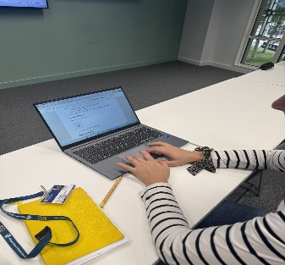
This photo shows me using a laptop during class. I feel confident using laptop and in my everyday life. My typing skills are quite slow, and I would like them to improve. I would like to learn keyboard typing faster and with more confidence, especially during class.

Screenshot/Photo 2
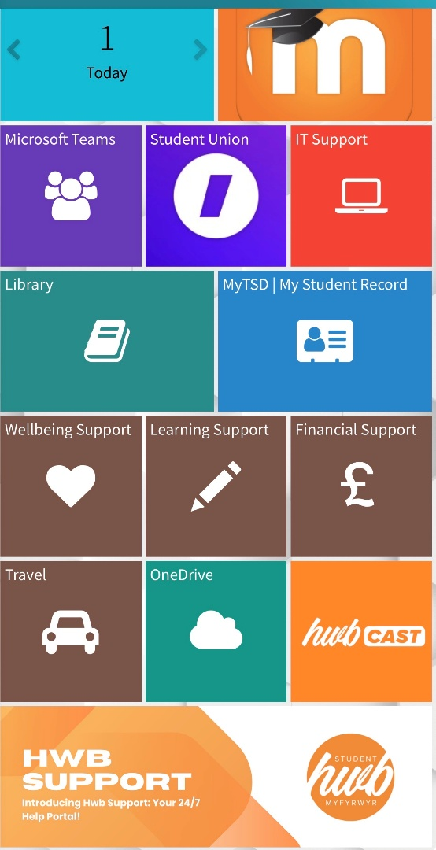
This picture shows screenshot of UWTSD HWB app, I use university HWB to check updates, understand assessment briefs and work on my assignments. I am still learning how to use it.

Screenshot/Photo 3
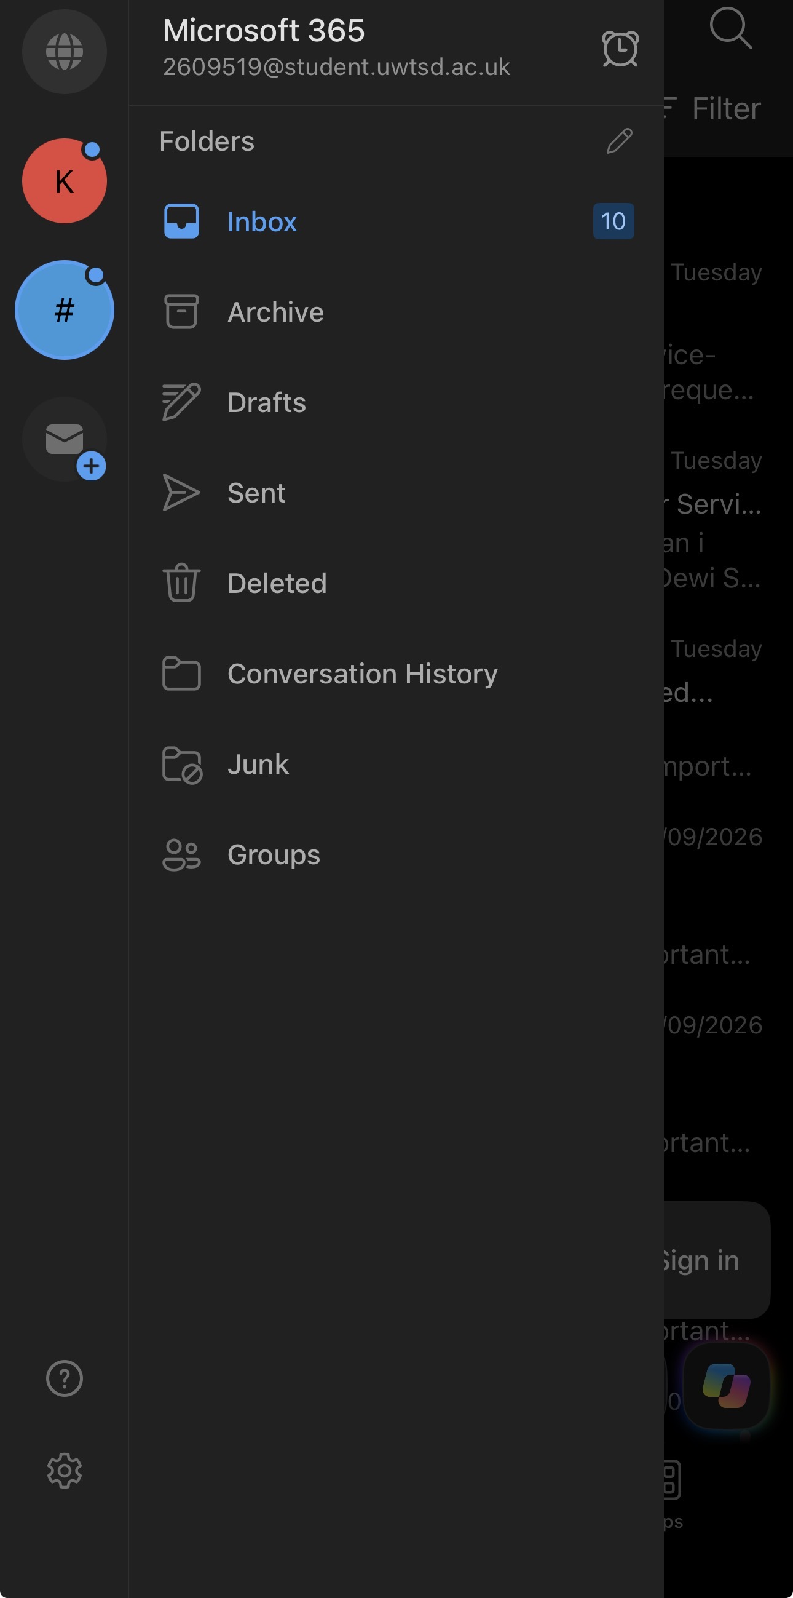
This is my outlook email. By using it, I learnt how to create, sent, receive and reply to emails. I practiced writing polite massages and attaching files. I feel confident using outlook app. In future I will try to organize my inbox more efficiently.

Screenshot/Photo 4
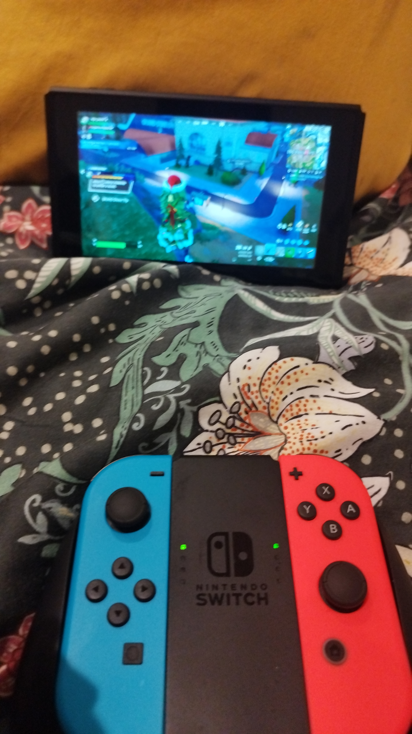
The technology shown is a Nintendo console, I use it with my son in my free time. I am still learning how to use it, and I am not very confident. It helps me to learn something different and develop new digital skills.

Screenshot/Photo 5
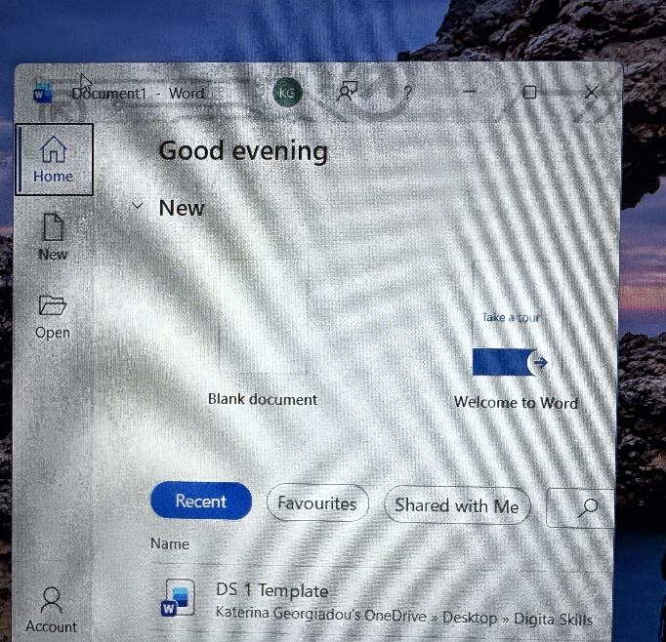
One of my digital skills is Microsoft word. I feel confident using it for my university work and at work. Though this activity, I have learned how to create and edit documents, use basic formatting and save my work correctly. I want to improve my MC Word skills by planning my documents better and learning to use more tools.

Screenshot/Photo 6

My Short Reflection
- Write 5–8 simple sentences about your digital life.
- You can use the sentence starters below if helpful.
Digital technology helps me learn, communicate and work on my university assignments. I often make use Microsoft Word, my laptop, Outlook and the HWB application of the University. I feel confident using these tools for my studies and work. I want to improve my typing skills and learn to type faster. I hope this module will help me improve my digital skills and become more confident. Digital skills have a lot of importance in my life because I use them daily.

Sentence starters
- I use digital tools to …
- I feel confident when I …
- I want to improve …
- I often use these tools: …
- I sometimes feel nervous about …
- I hope this module will help me …
- Digital skills are important for me because …
You can write more if you want.

Submission Checklist
Before you submit, please check:
​​​ ☐ I added 4–6 screenshots
☐ I wrote short sentences for each screenshot
☐ I wrote my short reflection
☐ My work is my own
☐ My file opens correctly
​​☐ My file opens correctly

