Report for the Potential demand for new business hours for The Cwtch Café.
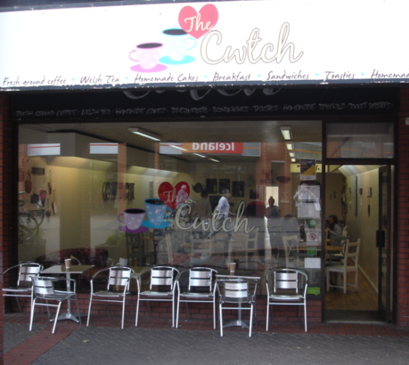

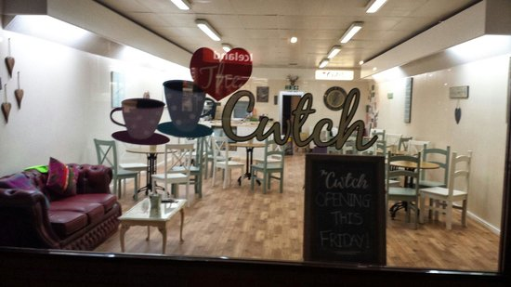
Google.co.uk. (2018).

Tripadvisor.com. (2018).

Business owner: Antonio Facciuto
Email: aw.facciuto@gmail.com
Telephone: 07557100771
Address: 4 St. David’s Square, Swansea. SA1 3LG
(Confidential report)
Contents page
- Terms of reference… 3
- Executive summary… 3
- Introduction… 3
- Aims and objectives… 3, 4
- Research methods… 4
- Research findings… 4, 5
  - The Cwtch café customer satisfaction… 5, 6, 7, 8, 9
  - Consumer research on local café’s… 9, 10, 11, 12
  - Discussion and analysis… 12, 13, 14
- Conclusion… 14, 15
- Recommendations… 15
- Appendix… 15
9.1 Appendix one… 15, 16, 17
9.2 Appendix two… 17, 18
9.3 Appendix three… 18, 19
9.4 Appendix four… 20, 21
- Bibliography… 22

1.Terms of reference
This report is written for The Cwtch café, Swansea and University of Wales Trinity Saint David by two independent consultants- Rosie Hopkins and Laura Rewbridge. The report will assess the feasibility of The Cwtch Café opening on a Sunday.
2.Executive summary
This report analyses who goes to the café. Research undertaken determines the peak times for consumer’s to visit and why they like to go to this particular café. It also determines any recommendations, from existing customers, on how the café could improve. The report also investigates what other café’s visitors to Swansea usually go to and why they go there. It determines what consumers want when visiting a café and any factors that may encourage them to choose to go to The Cwtch Café. The main investigation of this report is to determine if there is a demand for The Cwtch Café to open on a Sunday. A few issues have arisen during this report leading to the consultants concluding that perhaps now is not the correct time for the café to change their opening hours. However, if the café addresses some of the issues produced within this report then there is a potential for them opening the café on a Sunday in the future, or even the possibility of hiring out the venue for private functions.
3.Introduction
In the recent Project Initiation Document it was discussed that the consultants would work with a café in Mumbles. However, due to a lack of communication the consultants have decided to continue the project with a new business – The Cwtch Café in Swansea. This report shows the methodology undertaken to establish if there is a demand for the café to be open on a Sunday. The report produces findings and a discussion established from the research collected.
4.Aims and objectives
The aim of this report is to research if The Cwtch Café should open on a Sunday.
The objectives of this report are:
- To establish why consumers continue to go to The Cwtch Café
- To understand why consumers choose to visit competitor café’s
- To investigate if there is a demand for the café to open on the selected day.
5.Research methods
Research can be defined as “an activity that involves finding out, in a more or less systematic way, things you did not know” (Walliman and Walliman, 2011, p.7).
“Methodology is the philosophical framework within which the research is conducted or the foundation upon which the research is based” (Brown, 2006).
Questionnaires can be classed as both quantitative and qualitative research methodology, this is depending on the nature of the questions being asked. Specifically, the answers being obtained through any close- ended questions with multiple choice answer options are analysed through quantitative methods as they can include bar charts or percentages. However, answers obtained though open-ended questions are analysed using qualitative methods as they involve discussions and any critical analysis without the use of numbers. (Research-Methodology, 2019)
In the Project Initiation Document, it was previously discussed that the chosen research methods were observations and Questionnaires. Due to the consultants changing their initial project there was a limited time scale. This meant that it was not feasible to conduct observations. Due to the fact the consultants wanted to gain consumer opinions rather than observing the target market it was more practical to conduct questionnaires, (See appendix one and two for these.) Questionnaires were produced and conducted by each of the consultants. In the initial Project Initiation Document it was discussed that the questionnaires would be conducted face to face and via social media. However a joint decision was made by the consultants that the most efficient and reliable way to conduct the surveys would be to produce and analyse the results via survey monkey. This decision was made as it is a much quicker way to gather and analyse reliable data, while reaching a large target market.
6.Research findings
6.1 The Cwtch café customer satisfaction
The first finding investigated consumer satisfaction and knowledge about the café.
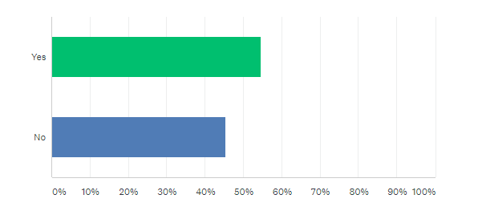
Question 1 – Have you ever been to Café Cwtch?

Looking at these results, 54.69% of respondents have attended The Cwtch Café opposed to 45.31% of respondents who have never attended. This shows that most of the respondents have attended the café and makes their answers for the further questions viable and reliable.

Question 2 – If no, please state your reasons why below. Then proceed to scroll to the bottom of the survey and click the DONE button.

Although most respondents have attended The Cwtch Café it was important for us as consultants to understand why the 45.31% of respondents had never attended the Cwtch Café. Some responses where they do not allow dogs inside, this defers customers with pets to come in as if their pets are not welcome, why would they want to sit and dine here. Other responses were that other establishments like McDonalds was more inviting to them or fitted into their lifestyle more. Others said that the Cwtch Café was in a poor location, some respondents found it difficult to find, or to get too. The biggest response from this question was that most respondents did not have any knowledge on this café, most respondents said they never even knew it existed and this could be down to the poor location or the poor marketing.

Question 3- If you have visited before, please select the day and time you visited.

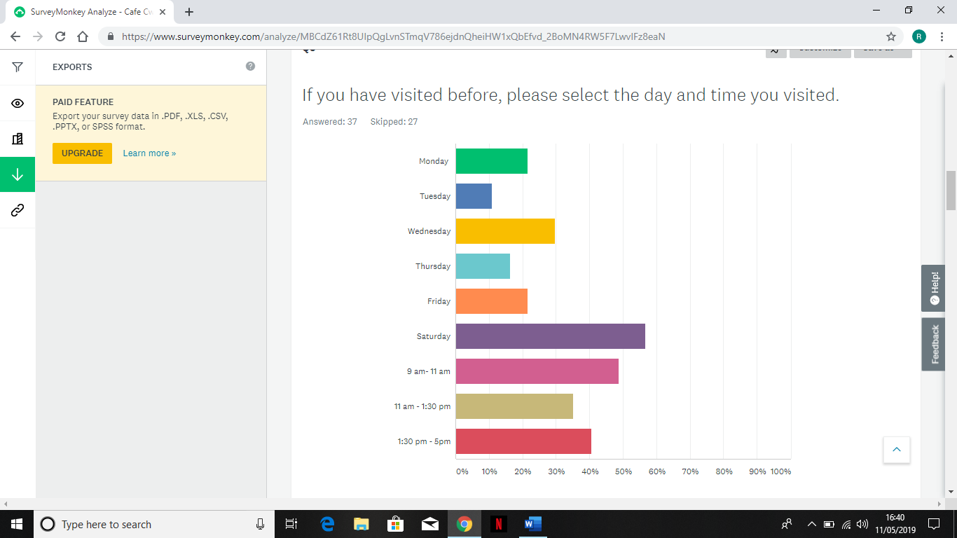

According to this bar chart, the most popular day that respondents visited the Cwtch Café was a Saturday and the most popular time was 9am – 11 am. This was followed by respondents saying the other most popular timing they attend is 1:30 pm – 5pm, followed lastly by the lunch time timings of 11 am – 1:30 pm. The other popularity of days that respondents said they visited were, the second most popular day being Wednesday, followed by, Monday, Friday, Thursday and the least popular day being Tuesday. This shows that respondents visit this café at many varied days and times, not just weekend or weekdays there is a mixture of all.
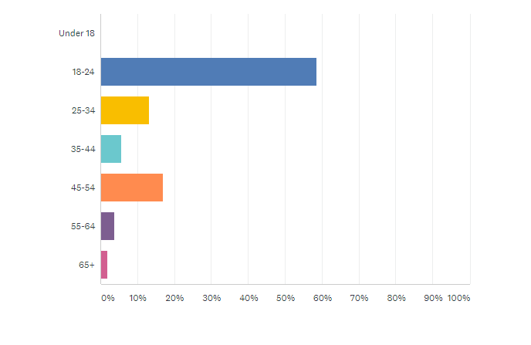
Question 4- How old are you?

This shows that the demographic of respondents was mostly 18- 24-year olds, as 58.49% of respondents were within this age range. This was followed by 45- 54-year olds with a 16.98 %, with 13.21% was 25-34-year olds. 35-44-year olds came in at 5.66%, followed closely by 55-64-year olds with 3.77% and coming in with the smallest percentage was the 65 + with a percentage of 1.89%. This could mean that the Cwtch Café needs to focus on a different demographic or to focus more in on the demographic that they are already attracting and make them interested in visiting on a Sunday.
Question 5- What do you like about this Café?
In response to this answer, respondents were encouraged to be open and honest. Many respondents said that the food was especially delicious with some outstanding service. Others admired the cakes, and the variety. Again, most respondents agreed saying that the coffee was wonderful, especially for a break from shopping on a Saturday. Many also said that the atmosphere and the décor is very welcoming and makes them want to stay longer, especially with the name Cwtch Café, respondents said that the name of the establishment was so inviting and that is what drawn them in. After being there having that homely atmosphere gave the respondents the experience they desired and that is why they like this establishment so much.
Question 6- If it was too open on a Sunday, would you visit?
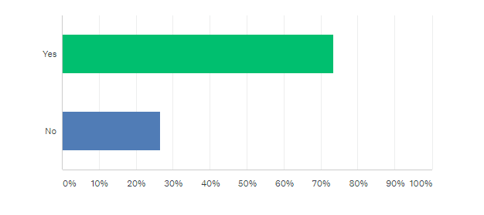

This Question was one of the most important questions, as this whole report is based around whether the Cwtch Café should open on a Sunday. 73.47% of respondents said they would visit if the Cwtch café opened on a Sunday. Opposed to the 26. 53% of respondents who said no. This is a great result as this shows interest in the possibility of the Cwtch Café opening on a Sunday and shows it is a Viable option.
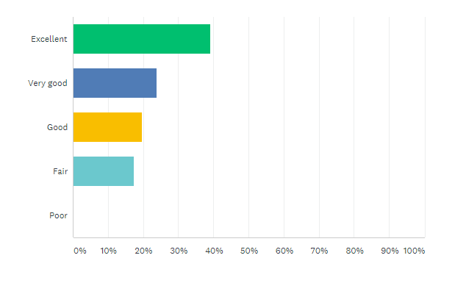
Question 7 – Overall, how would you rate the Cwtch Café?

This graph shows that 39.13% of respondents said that their overall rating of the Cwtch Café would be excellent. Followed by 23.91% of respondents saying they would give it a rating of Very good. 19.57% of respondents said their rating would be good and 17.39% of respondents said their rating would be fair. Not one respondent gave them a rating of poor which is an outstanding result, this shows that the service and overall customer experience is highly rated within the respondents.

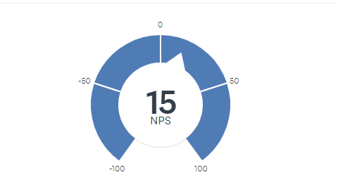
Question 8 - How likely is it that you would recommend Cafe Cwtch to a friend or colleague?

On a scale of 1-10 respondents were asked to state how likely they would recommend the Cwtch café to others. Most respondents said 9 – 10 with that sitting at a percentage of 49%. 17% said they were likely 7 – 8 on the scale to recommend the café. And 34% said they were on the scale 0 -6 to recommendation. This is a mixed result on two opposite ends of the scale, with this mixed response researching the reasons why was essential. Many people said it was purely down to the location and they thought their friends or family would struggle to find the location due to it not being in the middle of the City Centre, or that because it was not well known, that could be a disadvantage.
Question 9 – Do you have any other comments, questions or concerns?
This gave the respondents an opportunity to add their own opinions or ideas. Many respondents left this question unanswered, however a few did give their opinions. One respondent suggested making the Cwtch Café a bigger place, and another said they loved the inspirational quotes on the wall and found them inspiring. A final correspondent said that the Cwtch Café should open on a Sunday to provide ‘the best hangover coffee in Swansea’.
7.2 Consumer research on local café’s
The second findings involved understanding what cafes the respondents go to and why they choose to go there. It also identifies how The Cwtch Café could encourage more people to choose to visit there.
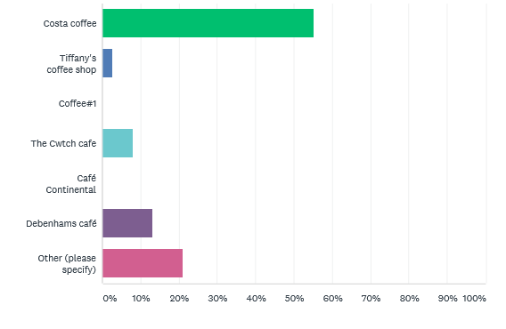
The graph below shows the results of the cafes the respondents visit regularly when in Swansea.

The findings show that the majority of respondents, (55%), choose to go to Costa Coffee when in Swansea compared to other cafes such as The Cwtch Café and other smaller local cafes. The findings did however show that 8% of respondents regularly visit The Cwtch Café. Debenhams café proved popular with 13% of respondents and Tiffany’s Coffee Shop was popular with a small percentage ,3%, of consumers. Some of the other responses listed Starbucks, The Dolphin café and Café Memo as their regular café.
It is important to understand the reason why people choose to go to the café’s they go to. This is to identify any competitive advantage the other café’s/businesses may have.
The findings below show some of the main factors that influence consumers to choose a certain café.
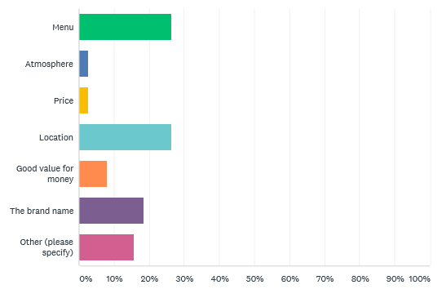

The three main factors that influence consumers to visit a café are the menu, location and brand name. In total 26% of respondents said they visit a café based on their menu and 29% of respondents said they chose that café due to the location. The brand name was another main factor with 18% of respondents saying this was their main influencer. Towards the lower end of the scale was price and atmosphere, with only 3% of respondents selecting these factors. Although 8% of respondents selected that the main factor they visit a café is based on if it is good value for money.
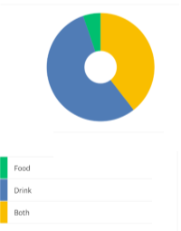
Question three of the survey identifies the purpose of visiting a café- whether it is the food that they go there for or whether it is the drinks they have available. The results are displayed in a pie chart below.

The data shows that the majority of respondents (55%) visit a café to have a selection of hot or cold drinks compared to a much smaller percentage, 5%, of respondents who visit café’s solely for food. Although a total of 39% of respondents voted that they go to café’s for the selection of food and drinks available there.
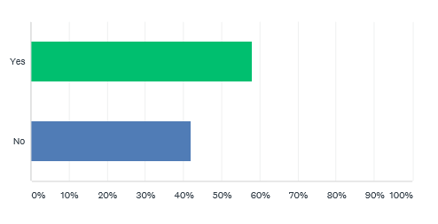
The fourth question was very direct, simply asking respondents if they had previously heard of The Cwtch Café. As shown in the bar graph below 61% responded with yes and 39% said no.

Question five asked respondents if they would consider visiting The Cwtch Café if it was to open on a Sunday. The majority of respondents voted yes. In total 54% of respondents said they would visit The Cwtch Café on a Sunday however, 46% of respondents said they would not. At the end of this question there was an option to comment on why the respondent may or may not visit there if they decided to open on a Sunday. Some of the comments are shown below.
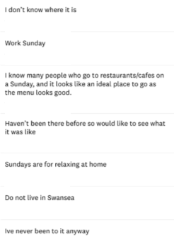

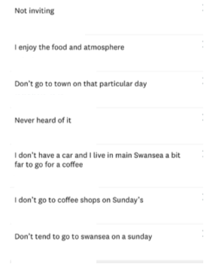

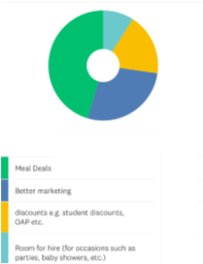
The final question investigated factors that would encourage consumers to visit The Cwtch Café. The results are displayed in the pie chart below.

In total, 39% of respondents said that meal deals would encourage them to visit. While 24% of respondents stated that better marketing would attract them to this café. Discounts would attract 16% of the respondents an 8% of the respondents voted that if they could hire the venue then this would attract them. Some of the respondents left a common stating other reasons they may consider visiting the café. Some stated that they would visit if it was recommended to them while others stated they would go there if they wanted to try somewhere new.
6.3 Discussion and analysis
Overall the research findings from 6.1 show that The Cwtch Café’s busiest times were on a Saturday morning between 9am – 11am. Their most popular age demographic is 18 – 24-year olds, from whoever responded to this survey. The cafes overall rating was excellent, and respondents said they would recommend this café to friends and family. However, many respondents agreed that the location was poor and there was not enough marketing about the café.
The research findings from the consumer research on local café’s shows that out of all the respondents, only 3% choose to regularly go to The Cwtch Café when in Swansea. Although this is relatively low compared to the other listed café’s, the café’s that scored highly were not small and independent businesses.
Two of the main factors that influence consumers when they choose a café are the menu and location. The Cwtch Café has a broad menu offering hot and cold food as well as coffee/tea and a selection of cakes. This makes them a good choice for consumers who choose the café based on their menu. The Cwtch Café is located next to St. David’s car park and therefore may be visited by those using the car park or visiting the shops nearby the café. However due to The Cwtch Café’s location it may be at a disadvantage because it is not located directly in the city centre or around popular shops. The brand name was also an important factor when respondents select a café. Due to The Cwtch Café being a small independent business it is hard to compete with big brand’s such as Starbucks and Costa. Although the majority of respondents did not select a café based on the atmosphere and price, The Cwtch Café excels at both of these factors. It is a small but friendly café that looks very welcoming. It is on par with other small independent café’s when it comes to price, making it appealing to those who consider cost as an important factor when visiting a café.
The results for question three show that there is a great opportunity for The Cwtch Café to appeal to new customers. It is able to provide consumers with both food and drink and is therefore not limited to what it can offer. The Cwtch café offers a variety of food as well as hot and cold drinks as well as sweet treats such as cakes.
Although 61% of respondents answered that they knew The Cwtch Café existed, only 3% of those had actually visited the café. This statistic is relatively low considering such a high level of respondents knew about the café. As the results from previous questions show The Cwtch Café does not have the same appeal as the other café’s listed in question two. One of the main factors is location and as previously discussed this seems to be putting The Cwtch Café at a disadvantage regarding appealing to consumers.
Over half of the respondents said they would choose to visit The Cwtch Café if it did open on a Sunday. Following on from this question there was an option to leave a comment explaining why they may or may not choose to there. However, only a small percentage of respondents completed this section. Some respondents stated that they would not go there due to not being able to and some people stated that they simply did not go into Swansea on a Sunday. These are factors that The Cwtch Café cannot control however, some people stated they would not visit there as they did not know where it was or that it existed. These are factors that the café can have control over. A simple way to overcome this is to market the café better so that consumers know everything they need to know, and they can therefore make an informed decision on whether to visit.
The main incentive for people to visit The Cwtch Café would be if they offered meal deals. This could consist of a cake and a hot drink for a set price or a set lunch menu. If they were to open on a Sunday they could potentially offer a new menu consisting of a Sunday carvery. Although meal deals were a big incentive to the respondents, none of it will be beneficial without better marketing. As discussed some respondents were not aware of the café or its location therefore, in order to consider opening on an extra day, the existence and location of the café needs to be marketed better. Discounts such as student discount and OAP discount would influence some of the respondents to visit. This is something the café could deliver without any additional costs. Some of the respondents would be interested in hiring the venue for a special occasion. This is an easy and innovative way the café could generate revenue on a day that they would usually be closed. Baby showers are an evolving trend, and, with better marketing, The Cwtch Café could be an ideal venue.
7.Conclusion
Overall the results from the Cwtch Café Questionnaire show there is a demand for the Cwtch Café to open on a Sunday. The respondents who answered the questionnaire have shown interest in this establishment opening on a Sunday for many reasons. These including the atmosphere, the menu and a place to go to cure a hangover. After concluding the Cwtch Cafes busiest times, if they were to open on a Sunday, they should have the opening hours between 10 am until 4:30 pm. This will incorporate their busiest times whilst also pushing to increase revenue during a day where they would typically generate zero revenue, due to being closed. As there are not many establishments open on a Sunday this will push a new demographic and encourage new visitors to visit there.
Research shows that a main factor some consumers did not visit The Cwtch Café is due to them either not knowing where it is located or some not even knowing it exists. Although the café does have a facebook page it is not updated regularly. A good way to market is via social media as social media is continuously growing more popular. As previously mentioned some consumers did not know where The Cwtch Café is located. This could be due to the fact that it is located on the edge of the city rather than in the centre between the bustling shops and restaurants. Therefore unless people have already heard about the café or are using the nearby car parks and therefore passing the café, the location could be a disadvantage.
To conclude there is a slight demand for The Cwtch Café to open on a Sunday, however due to some issues addressed within this report, it may be best to postpone this idea until these have been solved.
8.Recommendations
A recommendation would be to market the café better to inform people it exists. A way to do this is to use social media as a platform to market the café.
It could also be recommended that a website is made for the business. This will make it easy for potential customers to gain easy access to information about the café.
A final recommendation would be to allocate signs closer to the city centre to inform people of where the café is located. A good location for these signs would be near to the Quadrant Shopping Centre as this is a busy place with lots of footfall.
9.Appendix
9.1 Appendix one
The Cwtch Café questionnaire
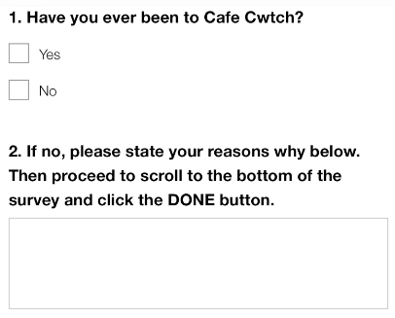

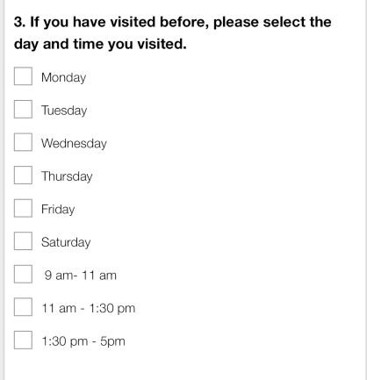

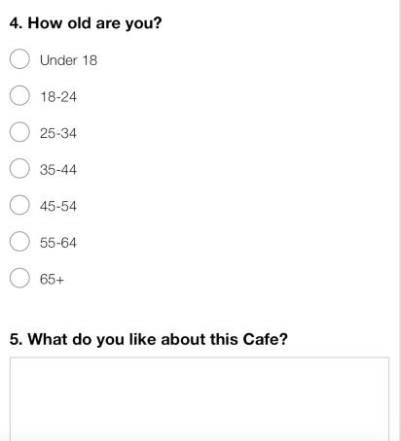

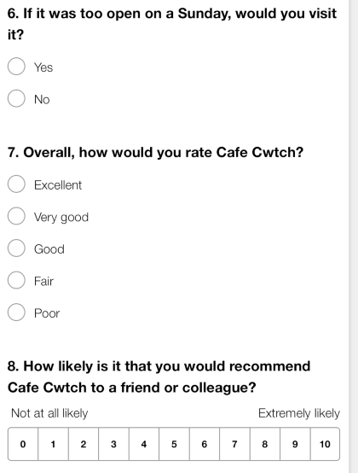

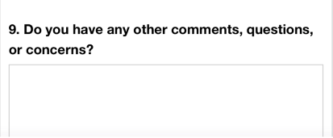

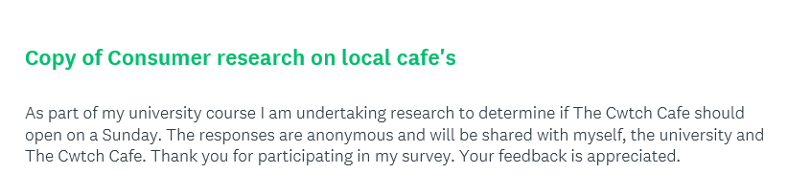
9.2 Appendix two

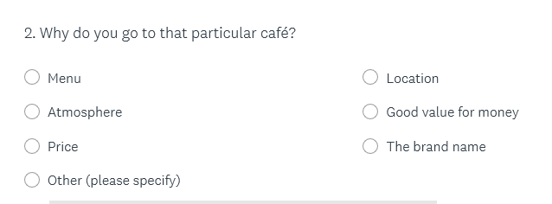
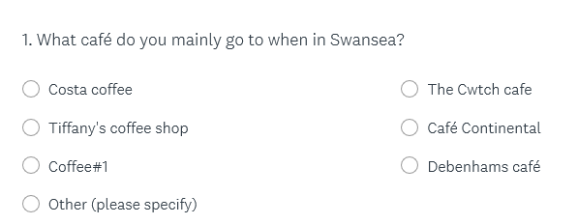
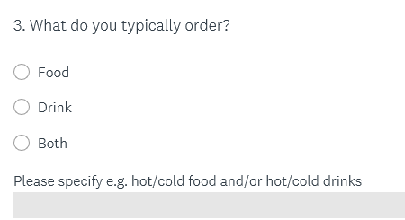
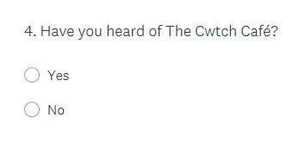

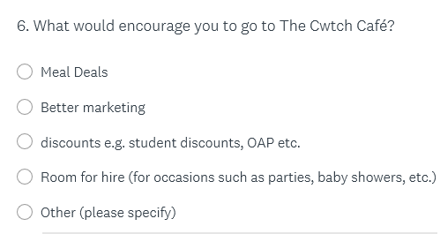
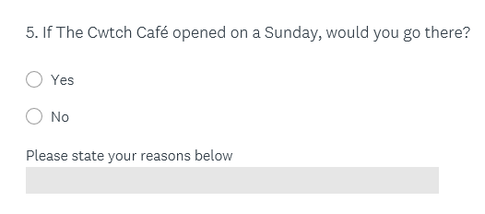

9.3 Appendix three
Minutes of meeting
Date: Monday 1st April
Who attended?
Rosie
Laura

Where was the meeting?
The library
After deciding to work with The Cwtch Café we split up the report. We needed to investigate if the café should open on a Sunday and therefore we split the report into two sections. Rosie will look at the café itself and investigate key factors such as when the café’s peak times are, why people choose to go there and if they would recommend it to other people. Laura will investigate The Cwtch’s competition to analyse why people go to other cafes and what factors may influence people to go to The Cwtch.
Action plan
Rosie will contact Antonio (the business owner) to inform him of our research methods.
We will meet up and discuss our research findings and create a layout for the report.

Date: Wednesday 10th April
Who attended?
Laura
Rosie

Where was the meeting?
University
Rosie updated Antonio with the progress of the report and research.
Laura created the structure of the report and included headings.
Action plan
Complete our individual sections of the plan and meet to put it together.

Date: Friday 10th May
Who attended?
Rosie
Laura

Where was the meeting?
Rosie’s house
In this meeting we combined both of our research findings and produced a final report.
Action plan
Rosie will submit the report on Monday 13th May.

9.4 Appendix four
Correspondence between the consultants and the business.

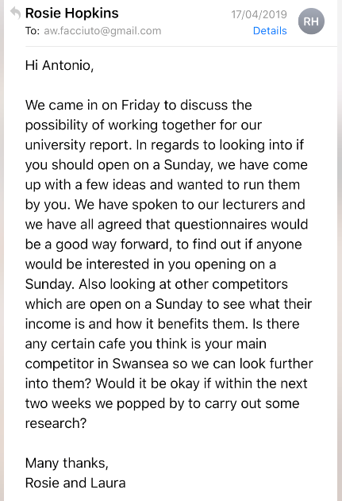

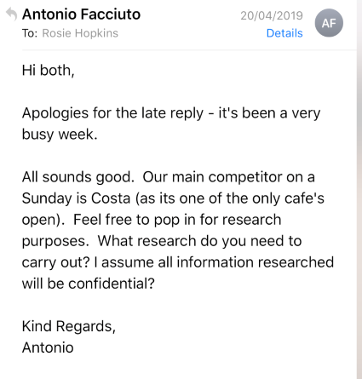

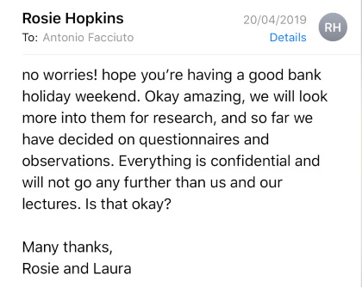

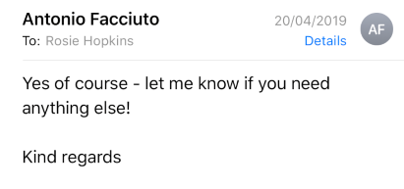

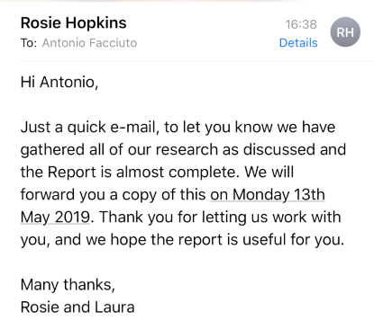

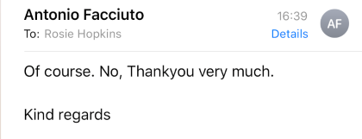

10.Bibliography
Brown RB, 2006, Doing Your Dissertation in Business and Management: The Reality of Research and Writing, Sage Publications
Google.co.uk. (2018). The Cwtch Café Swansea- Google Search. [online] Available at:https://www.google.co.uk/search?q=The+Cwtch+Cafe+Swansea&source=lnms&tbm=isch&sa=X&ved=0ahUKEwi3_qrY6pXiAhXTWxUIHYlBBkIQ_AUIDygC&biw=1518&bih=689#imgrc=ROekRUuwmukw-M:&spf=1557658666737 [Accessed 24 Apr. 2019].
Grbich, C. (2006). Quantitative Data Analysis, Sage Publications Ltd.
Maylor, H. (2010). Project Management, 4th edition, Harlow: Prentice Hall.
Research-Methodology. (2019). methodology - Research -Methodology. [online] Available at: https://research-methodology.net/research-methodology/ [Accessed 13 May 2019].
Research-Methodology. (2019). Questionnaires. [online] Available at: https://research-methodology.net/research-methods/survey-method/questionnaires-2/ [Accessed 13 May 2019].
Tripadvisor.com. (2018). The Cwtch - Picture of The Cwtch, Swansea - TripAdvisor. [online] Available at: https://www.tripadvisor.com/LocationPhotoDirectLink-g186466-d3386164-i109173341-The_Cwtch-Swansea_Swansea_County_South_Wales_Wales.html [Accessed 21 Apr. 2019].
Walliman, N. S. & Walliman N. (2011) “Research methods: the basics” Taylor and Francis

