BENEFITS OF MARKET RESEARCH
Cristina Craciunescu

Course
Digital Skills and Research Methods
Lecturer
Christian Felices
University of Wales Trinity Saint David
23.03.21

BENEFITS OF PRIMARY MARKET RESEARCH
Market research denotes the process used in the determination of product or service viability in a given market (Nunan, 2020). It involves research conducted on potential customers to ascertain their needs. Generally, companies apply the use of market research to obtain insight into their intended market. It also helps them in getting feedback and opinion from their targeted consumers. Start-up companies need to conduct critical market research into their potential market to help them formulating ideal business ideas that translate into business growth. Also, Nunan notes that feedback from the intended customers goes a long way in assisting the start-up in understanding the consumers' changing dimensions (2020, p. 122). The thriving market research presents the business organisation with immense benefits, and some of these benefits include the following.
Business risk reduction
Risk reduction forms an integral component of business productivity. Other organisations go ahead to establish 'business risks' as one of the functional departments. Indeed, all types of business ventures strive to reduce their risks because they adversely affect businesses' profitability. According to Ereaut, one method of reducing risks pertains to the understanding of market information about the targeted customers (2018). This information's availability reduces the risk of wasting resources on market segments that do not form an integral customer base. Appropriate market information enhances the effective and efficient utilisation of resources to acquire new customers while also striving to maintain existing customers. Small organisations and start-ups immensely benefit from market information. These organisations have higher operation risks, coupled with limited resources (Deshpande & Zaltman 2017, p. 28). Therefore, market research information provides vital information to the clients, enhancing their market introduction and subsequent spur towards profitability.
Market Research help in the creation of plans
The results from the market research help generate a marketing plan. Also, Owen believes that the changing dimensions and behaviour of the target market inform decisions leading to business plans. An example entails the marketing plan highlights about the objectives and the path towards its achievement explicitly (2019). Therefore, the plan provides the basis for business in terms of market segment, type of service, leverage for profits and the scope of gaining a better reputation. Therefore, marketing plans help business organisations align their efforts towards specific goals, enabling them to apply efficient, objective realisation performance strategies. Market research stills help them formulate accurate business plans with particular channels of realising business objectives for start-ups.
Research reduces business costs.
According to Owen, small and medium enterprises spend a critical amount of money figuring out the business's particulars (2019). The same information comes typically from low-cost business market research. Sometimes, market research comes freely using available online tools. These online tools provide accurate tools for consumers (Ereaut, 2018). Therefore, market research helps the start-up business in strategizing resource utilisation. It also helps the management with the information needed for adequate resource allocation.
Market research keeps the business relevant.
The onsets of proper business research reveal hidden attributes of the market that entails new demands and trends hidden to the business. The start-up business firms may choose to focus on these trends to capitalise on the existing and new customers. Businesses keeping up with trends of changing social trends, new customers and advances in technology becomes better placed to satisfy their customers (Geanakoplos and Zeldes 2019, p. 59). The above information also helps the start-ups and other existing business firms to respond to the changing dimensions of the business environments reflected by the shifts in consumer preferences.
Market research helps in the identification of threats.
Research helps in uncovering potential threats which may be unnoticed through ordinary market evaluation. Typically, business operation threats exist in substitute products, market competition, and better production methods, amongst others. Business threats have adverse impacts on the wellbeing of business organisations. However, proper identification of these vices results in the development of reliable counter mechanisms and policies that increase survival chances (Narver & Slater 2020, p. 32). Therefore, market research increases the chances for business continuity and success.
Market research helps in measuring business reputation.
Another essential role of market research outcome denotes the realisation of organisational goodwill. The organisation can use the research to determine the thought of consumers regarding their services. Unbiased response from a wide range of clients provides an accurate picture of company perception. Özkan et al. note that positive goodwill presents an opportunity for growth for the business, and it helps in strengthening the factors for realising objectives (2019, p. 388). It follows that businesses that understand their perception employ measures that shape their marketing processes. This process targets the change of factors that contributes to increased efficiency and perception.
Forecasting of revenue.
Businesses significantly rely on the ability to generate an accurate forecast of future profitability or failure. According to Day, conduction of the market survey communicates the attributes of the market. This information helps in understanding market trends compared with previous data (2018, p. 39). Also, a comparison of the two market periods helps in understanding projected market changes. The projected market changes denote the forecasts that help in product planning, resource allocation, and raw materials acquisition.
Market research increases survival chances.
It is the will of every business entity in the market to survive and not fail. Research findings show that six out of ten business organisations fail to stay in their first five years. Failure to survive occurs because many businesses do not understand the market environment's needs and want, reducing marketing strategies. It pays to identify real customers based on their needs, wants, and location. Understanding these complexities translates into accurate targeting and accommodation of growth incentives.
Market research reveals an existing opportunity.
The market has significant opportunities waiting for discovery, and research activities help in locating these opportunities. Some trends are, however, to be recognised. Therefore, businesses partaking in research activities identify these opportunities and take advantage to spur their performance (Day, 2018). Companies and start-ups that fail to consider market research forego the chance arising from market research. Some businesses take advantage of these opportunities through timely investment and allocation of resources to spur their growth.
It helps in understanding market competitors.
The market's operation features a series of competition from different companies that seek to satisfy the same customers. Competition can scuttle the performance of some companies if they fail to enact research findings from the market. Therefore, market research helps organisations monitor the competitors' activities and further suggests incentives for countering these competitors. Competition diminishes market share and turnover. Also, research shows popular events and products with competitors (Narver & Slater 2020, p. 34). After understanding popular products in the market, the business begins to take advantage of the market opportunity. Learning from the mistakes of the competitors' error helps business grow by avoiding the same pitfalls.
Indeed, every business stands to benefit from market research, which calls for systematic business decisions analysis. The result of embarking on market research pertains to the increase in performance. For start-ups, it provides vital insight into the projected business environment (Deshpande & Zaltman, 2017). It helps them understand the market's dimensions, including customer preference, existing threats, opportunities, and emerging business trends. Despite the costs involved, start-ups immensely benefit from conducting marketing research.
Questionnaire analysis
The results obtained from the questionnaire help inform critical decisions about the intended start-up business. The questionnaire's initial response shows that male respondents visit the car wash more often than female. However, the rate of the customer of loyalty remains higher amongst women than men. Therefore, the marketing department should target more men than women. The analysis from the questionnaires reveals an exciting outcome for the citizens. It shows that many respondents prefer to use water for car wash rather than waterless technology. The mobile car wash technology is dry and produces better results, but the clients show resistance to change.
Figure Graph showing Questionnaire analysis
The information from the questionnaire provides essential knowledge for a start-up business. It helps the owners understand the prevailing market attributes like having more male customers than females. Also, it shows higher loyalty amongst female clients than the male ones. Despite knowing the benefits of waterless technology, clients prefer the ordinary car wash that uses water. Therefore, the owner of the business should consider a machine that uses water to clean. More marketing campaigns initiated by the company should also target men because of their low business loyalty rates. The frequency of using waterless technology is much lower than that of water consumption. Therefore, the business organization will immensely benefit from the incorporation of a machine that uses water. Finally, the questionnaire depicting the market environment also reveal essential information about service pricing. The respondents are comfortable when they pay £80. It follows that charging higher than the equilibrium price will harm the service provision.
The web and rationale
The rise in technology has prompted the incorporation of internet tools for interaction and conduction of business transactions. The website provides an ideal extension of the business enterprise beyond geographical confines. The website's establishment for the mobile car service accords prospective clients the opportunity to interact with the proprietors and book the type of the desired service (Miller & Dickson 2018, p. 153). The website features a distinct colour because it is synonymous with the clients. Questionnaire analysis helped in the establishment of a pricing strategy applied to the website. Colour theory forms a vital element in the development of the website. It entails practical guidance that considers colour mixing and visual effects about a specific colour combination with the colour wheel (Night, 2018). The market information arising from the questionnaire advise the inclusion of more male campaigns. Therefore, the website has embodied promotion that targets male customers, including strategies for promotions.

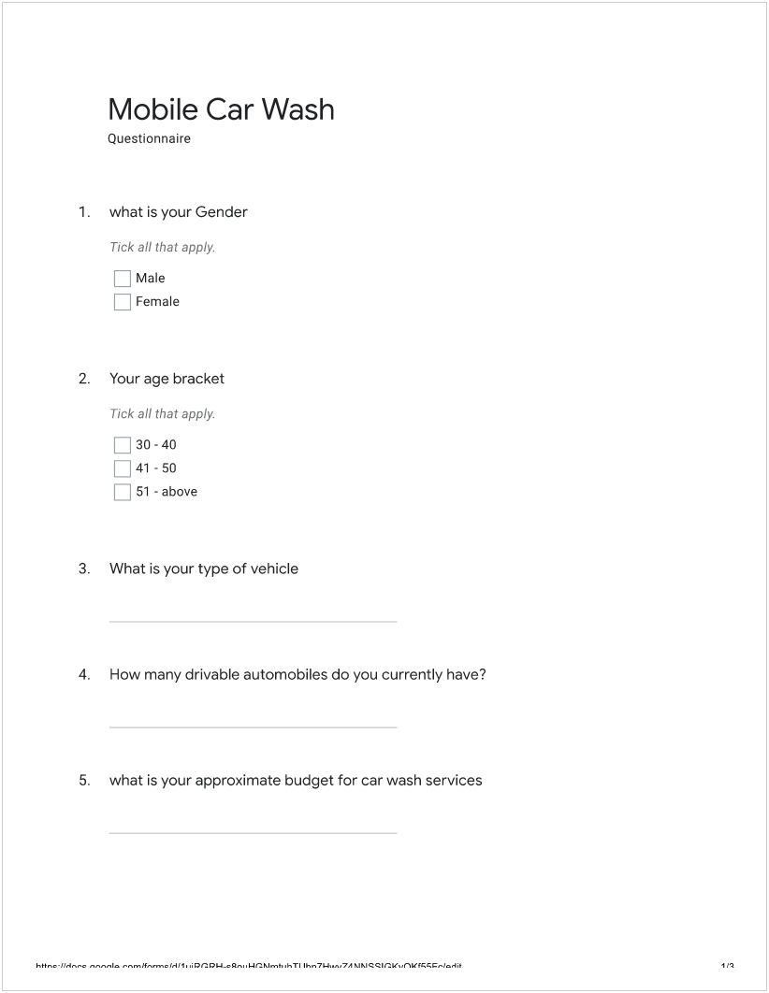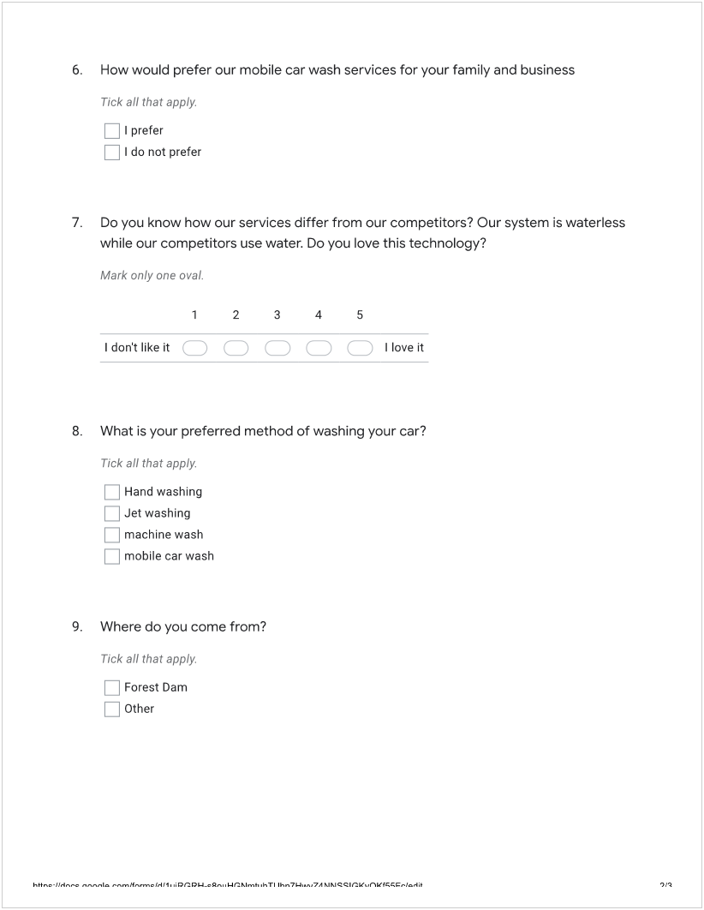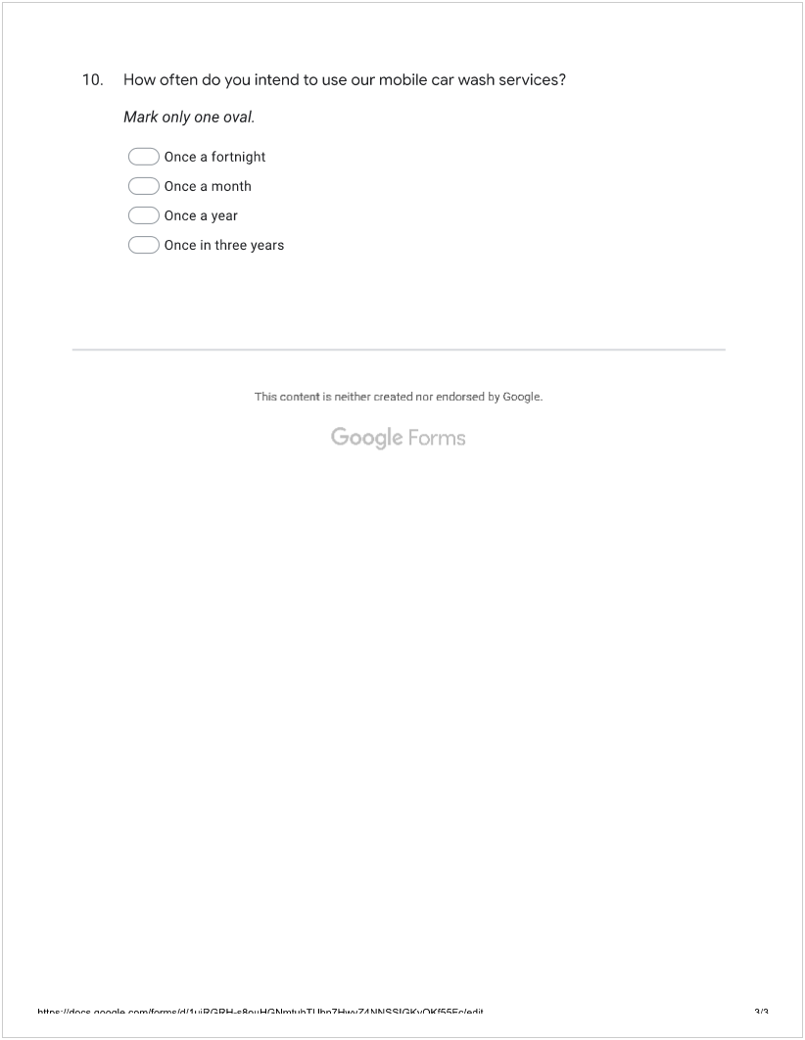

Website login details
Email: c_khitty@hotmail.es
Password: UniversityStudent2021
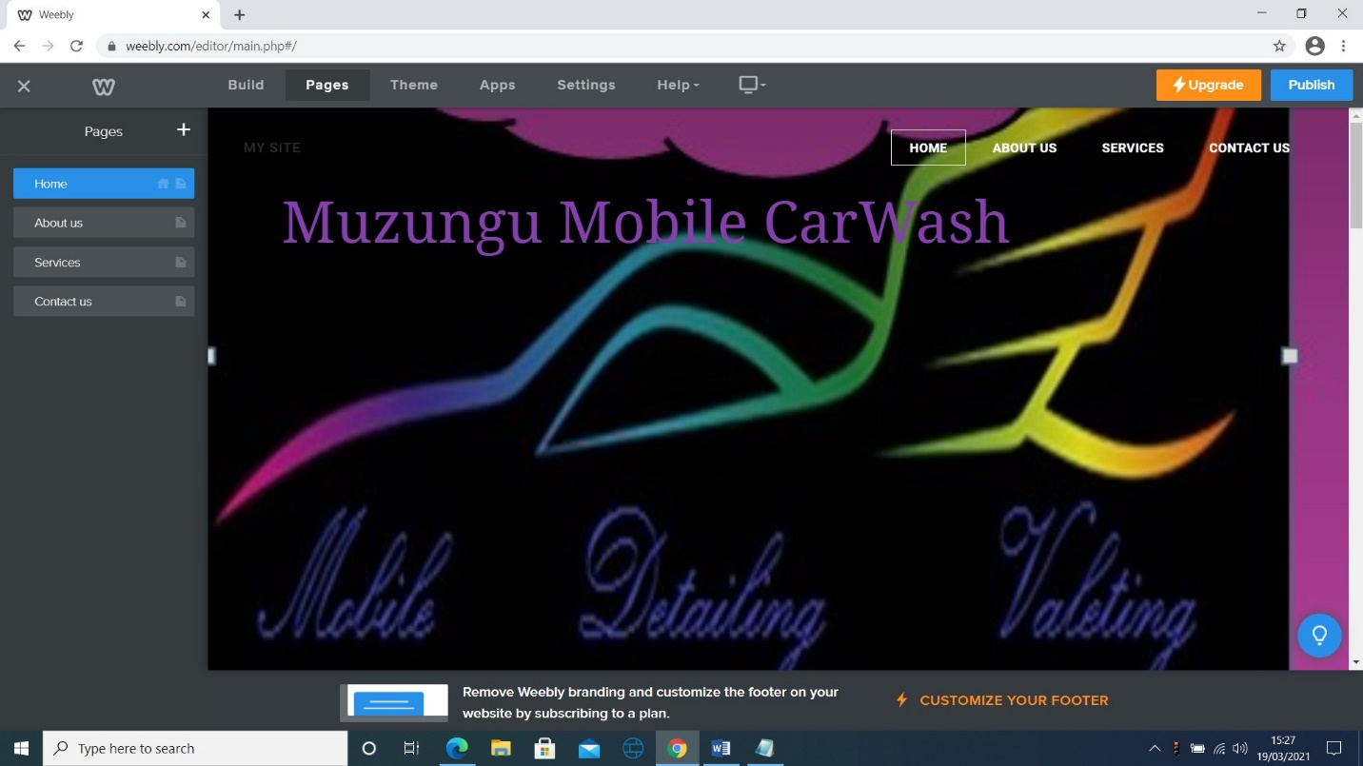

Bibliography
Day, G. (2018). The Capabilities of Market-Driven Organizations. Journal of Marketing, 58(4), pp. 37-52. doi:10.2307/1251915
Deshpande, R., & Zaltman, G. (2017). Factors Affecting the Use of Market Research Information: A Path Analysis. Journal of Marketing Research, 19(1), pp. 14-31. doi:10.2307/3151527
Ereaut, G., 2018. Qualitative Market Research. London: Sage Publications.
Geanakoplos, J. and Zeldes, S., 2019. Market Valuation of Accrued Social Security Benefits. Cambridge, Mass: National Bureau of Economic Research.
Miller, T., & Dickson, P. (2018). On-Line Market Research. International Journal of Electronic Commerce, 5(3), pp.139-167.
Narver, J., & Slater, S. (2020). The Effect of a Market Orientation on Business Profitability. Journal of Marketing, 54(4), pp.20-35. doi:10.2307/1251757
Night, J., 2018. Operation car wash. Chemistry & Industry, 79(3), pp.41-41.
Nunan, D., 2020. Research priorities for data, market research, and insights. International Journal of Market Research, 62(2), pp.121-123.
Owen, M., 2019. Qualitative Market Research. London: Sage Publications.
Özkan, T., Lajunen, T. and Summala, H., 2019. Driver Behaviour Questionnaire: A follow-up study. Accident Analysis & Prevention, 38(2), pp.386-395.

