

Data Mining Report

Programme: BSc Applied Computing

Module: Data Warehousing & Data Mining
Module code: ACCA6026
Student Name: John Gabriel Kak Yomon Meki
Student ID: 2321436
Lecturer: Md Abrar Jahin Almazi Bipon

Submission Date: 31 July 2026

Table of Contents
1. Introduction 2
2. Data Mining in Customer Analytics 3
2.1 Purpose and Practice of Data Mining 3
2.2 Dataset Description and Exploration 3
2.3 Data pre-processing and post-processing 5
2.4 Sample Runs and Analysis Methods 6
3. Business Recommendations 11
4. Reflective Commentary 13
5. Conclusion 13
6. References 15
7. Appendix A Weka Confusion Matrices 17
A.1 ZeroR Confusion Matrix 17
A.2 J48 Decision Tree Confusion Matrix 17
A.3 Logistic Regression Confusion Matrix 18
A.4 Random Forest Confusion Matrix 19
A.5 Naïve Bayes Confusion Matrix 20

1. Introduction
Customer retention remains a major challenge in the telecommunications industry, where customer churn can reduce revenue, profitability, and long-term competitiveness [1], [2]. As competition increases, organisations increasingly rely on data-driven methods to identify customers at risk of leaving and develop targeted retention strategies. Data mining offers a range of techniques for discovering patterns within large datasets and supporting evidence-based decision-making [3], [4]. This report investigates customer churn prediction and customer segmentation using the IBM Telco Customer Churn dataset. Classification and clustering algorithms are implemented and evaluated in Weka to assess their predictive performance and their potential to support customer retention strategies.

2. Data Mining in Customer Analytics

2.1 Purpose and Practice of Data Mining
Data mining is the process of discovering meaningful patterns, relationships, and trends within large datasets to support informed decision-making [2]. It combines statistical analysis, machine learning, and data exploration techniques to transform raw data into useful knowledge. Beyond describing historical events, data mining enables organisations to predict future outcomes and identify opportunities to improve business performance [2], [3].
Across business and retail sectors, data mining supports customer segmentation, sales forecasting, fraud detection, recommendation systems, and customer relationship management (CRM). In customer analytics, historical customer data are analysed to understand behaviour, predict future actions, and improve service delivery [2]. These insights help organisations make evidence-based decisions and use resources more effectively.
Customer churn prediction is a common application of classification techniques, which estimate the likelihood that a customer will discontinue a service. Clustering complements this approach by grouping customers with similar characteristics, enabling organisations to tailor products, services, and retention strategies to different customer segments [2], [3]. However, predictive accuracy alone is insufficient. Effective data mining models should also produce reliable, interpretable, and practical results that support business objectives [4]. Consequently, organisations increasingly combine predictive modelling with customer segmentation to strengthen customer retention and long-term relationships.

2.2 Dataset Description and Exploration
The analysis was conducted using the IBM Telco Customer Churn dataset, a publicly availabledataset widely used for customer analytics and machine learning research [5]. It contains customer demographic information, subscribed services, account details, billing records and a binary target variable indicating whether a customer remained with the telecommunications provider or discontinued the service. The combination of numerical and categorical attributes
makes the dataset suitable for both classification and clustering tasks, allowing customer churn to be predicted while supporting customer segmentation.
The original dataset consisted of 7,043 customer records described by 21 attributes, including the unique customerID field. During the initial inspection, 11 records were found to contain missing values in the TotalCharges attribute. As these represented only a small proportion of the dataset, they were removed rather than imputed to preserve the integrity of the financial information. The customerID attribute was also excluded because it functions solely as a unique identifier and provides no predictive value. Following these adjustments, the analytical dataset contained 7,032 complete customer records and 20 predictive attributes, with Churn retained as the target variable.
The dataset includes four main categories of information. Demographic variables describe customer characteristics such as gender, senior citizen status and partnership. Account-related variables include contract type, tenure, payment method and billing preferences. Service-related attributes record the telecommunications services subscribed to by each customer, while financial variables capture monthly and cumulative charges. Together, these attributes provide a comprehensive representation of customer behaviour and the factors that may influence customer attrition.Exploratory data analysis (EDA) was performed using Microsoft Excel and Tableau before predictive modelling. The purpose of this stage was to verify data quality, understand the distribution of key variables and identify patterns that could influence model performance [6].
The analysis showed that approximately 73.42% of customers remained with the provider, whereas 26.58% had churned. Although this represents a moderate class imbalance, the original distribution was retained because it reflects realistic business conditions.
Further exploration identified several behavioural trends. Customers on month-to-month contracts were considerably more likely to churn than those on longer-term contracts.
Higher churn rates were also observed among customers using fibre optic internet services and electronic cheque payment methods, while shorter customer tenure was associated with a greater likelihood of service cancellation. These observations are consistent with findings reported in previous customer churn studies [7], [8]. Consequently, the exploratory analysis not only improved understanding of the dataset but also identified the variables most likely to influence predictive modelling.

2.3 Data pre-processing and post-processing
Data pre-processing is a critical stage of the data mining process because the quality of the input data directly influences the reliability of predictive models [2]. Real-world datasets often contain missing values, redundant attributes, and inconsistencies that can reduce predictive performance if left unaddressed. The objective of this stage was to prepare a clean, consistent, and representative dataset for analysis.
The dataset was first examined for missing values and data quality issues. Inspection identified 11 incomplete records with missing values in the TotalCharges attribute. As these represented less than 0.2% of the dataset, the records were removed rather than imputed to preserve the integrity of the financial data and avoid potential bias [8], [9]. Following their removal, the dataset contained 7,032 complete customer records.
The customerID attribute was excluded because it serves only as a unique identifier and provides no predictive value. Including identifier fields may increase model complexity without improving classification performance [2]. The remaining variables were verified to ensure that numerical attributes, including tenure, MonthlyCharges, and TotalCharges, were correctly formatted, while categorical attributes such as Contract, InternetService, and PaymentMethod were checked for consistency before importing the dataset into Weka Explorer.
Although the dataset exhibited a moderate class imbalance, with approximately 73% non-churn and 27% churn observations, no balancing technique was applied. Retaining the original class distribution provides a realistic representation of operational business data and enables model performance to be evaluated under practical conditions [9]. Model performance was assessed using multiple evaluation measures, including accuracy, precision, recall, ROC Area, and Cohen's Kappa, to provide a balanced assessment of predictive capability [10], [14].
All classification experiments were performed using 10-fold cross-validation, in which the dataset was divided into ten subsets. Each subset was used once for testing while the remaining subsets were used for training, with the final results obtained by averaging performance across all iterations [10]. Compared with a single train-test split, this approach reduces sampling bias and provides a more reliable estimate of model performance.
Following model development, post-processing activities were undertaken to organise and interpret the results. Performance metrics generated by Weka, including accuracy, precision, recall, ROC Area, and Cohen's Kappa, were summarised in comparative tables to support objective evaluation of the five classifiers. Confusion matrices were also examined to assess each model's ability to distinguish between customers who churned and those who remained. Finally, Tableau was used to produce visualisations of both the exploratory analysis and comparative algorithm performance, converting the experimental results into interpretable findings that informed the comparative analysis presented in the following section.

2.4 Sample Runs and Analysis Methods
The prepared IBM Telco Customer Churn dataset was analysed using Weka Explorer, an open-source platform for implementing and evaluating machine learning algorithms [2], [13]. The overall analytical process followed in this study is illustrated in Figure 1, showing the progression from data preparation to model evaluation.

Data Preparation Workflow Figure
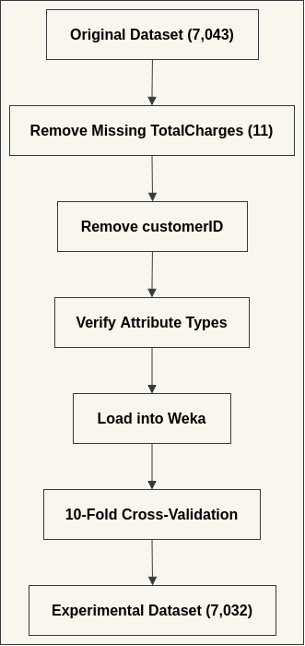
Figure 1: Data Preparation Workflow

The Churn attribute was defined as the target class for all supervised learning experiments.
Each classifier was evaluated using 10-fold cross-validation, in which the dataset was divided into ten subsets, with nine used for training and one for testing in each iteration [12]. This approach provides a reliable estimate of predictive performance while reducing sampling bias.
Five supervised classification algorithms were evaluated. ZeroR served as the baseline
classifier by predicting the majority class [2]. J48 Decision Tree generated interpretable decision rules [14], Logistic Regression estimated the probability of customer churn through statistical modelling [15], Random Forest combined multiple decision trees to improve prediction accuracy [16], and Naïve Bayes applied probabilistic classification based on Bayes' theorem [17].
In addition, SimpleKMeans clustering grouped customers with similar characteristics without predefined class labels, producing three distinct customer segments that support targeted retention strategies (Table 2) [18].
Classifier performance was evaluated using accuracy, precision, recall, ROC Area and Cohen's Kappa, providing a balanced comparison of predictive capability [11]. The overall performance of the classification models is summarised in Table 1, while the corresponding confusion
matrices, which provide a detailed breakdown of correct and incorrect classifications for each algorithm, are presented in Appendix A.
Cluster | Distribution
Cluster 1 | 32%
Cluster 2 | 43%
Cluster 3 | 26%
Table 1: SimpleKMeans Cluster Distribution

The comparative performance of the five classification algorithms is presented in Table 2.
Classification Algorithm | Accuracy (%) | ROC Area | Cohen's Kappa
ZeroR | 73.42 | 0.500 | —
J48 | 78.36 | 0.774 | 0.4098
Logistic Regression | 80.48 | 0.845 | 0.4723
Random Forest | 78.34 | 0.821 | —
Naïve Bayes | 73.36 | 0.818 | —
Table 2: Comparative Performance of Classification Algorithms
The results indicate clear differences between the evaluated models. ZeroR produced the weakest performance because it predicted only the majority class. J48 improved classification while remaining easy to interpret, whereas Random Forest achieved competitive predictive performance through ensemble learning. Naïve Bayes provided acceptable discrimination despite lower overall accuracy. Logistic Regression achieved the strongest overall performance across the selected evaluation metrics, making it the most suitable model for predicting customer churn in this dataset. The Weka results were supported by Tableau visualisations.
Figure 2 shows that 73.42% of customers remained with the provider, while 26.58% had churned, confirming a moderate class imbalance.

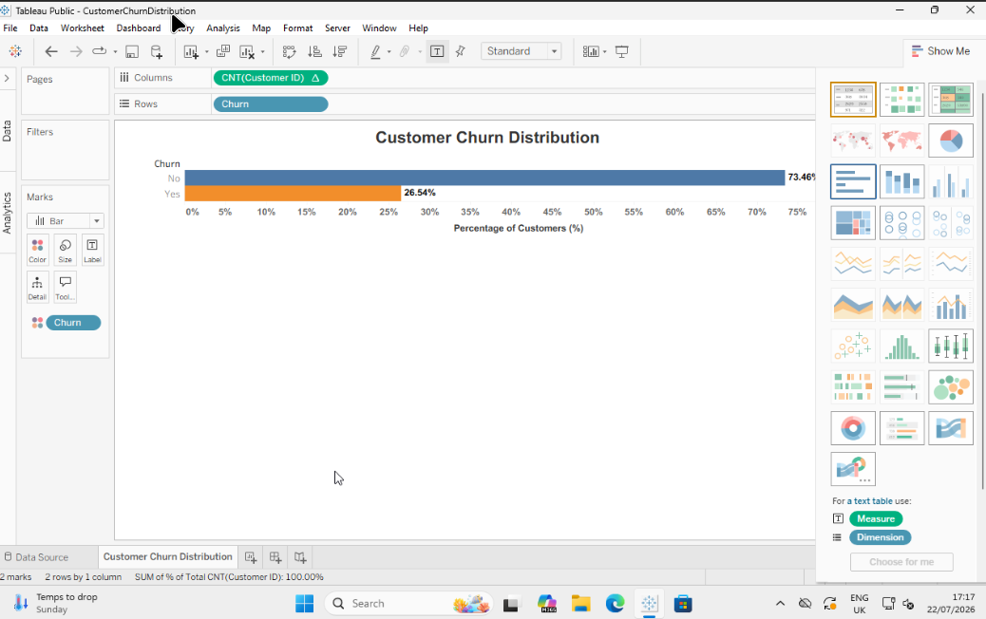
Figure 2: Customer Churn Distribution.

Further visual analysis identified the characteristics most strongly associated with churn.
Customers on month-to-month contracts experienced considerably higher churn rates than
those with longer contracts (Figure 3).
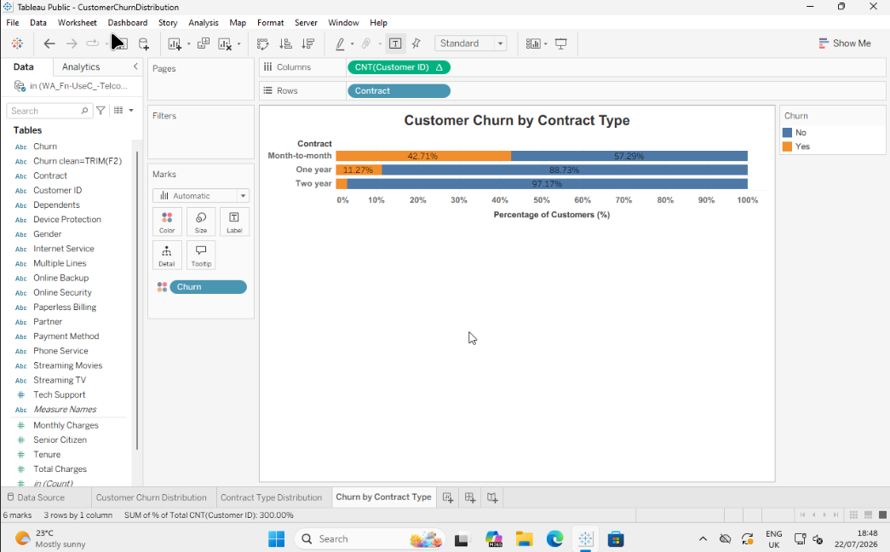
Figure 3. Customer churn by contract type.

Customer churn by internet service type ilustrated in Figure 4.
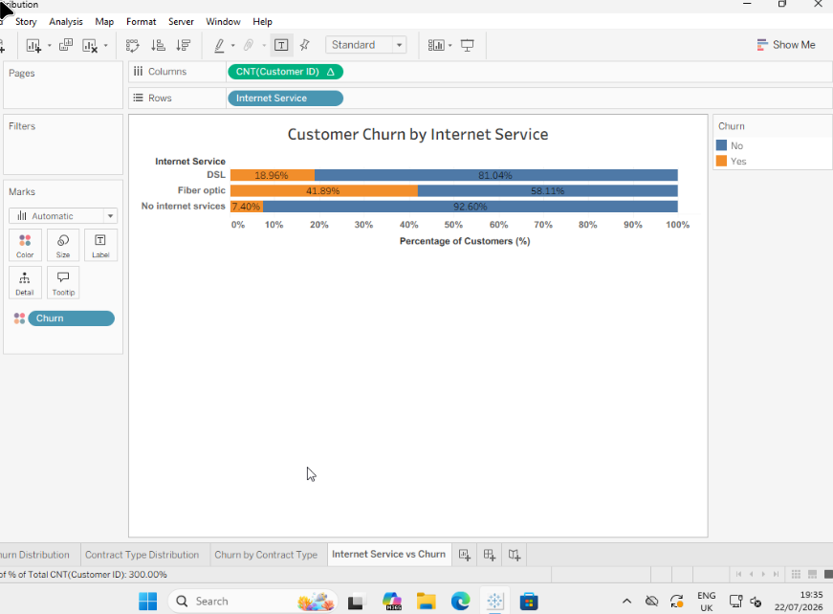
Figure 4: Customer churn by internet service

Customer churn by payment method is shown in Figure 5
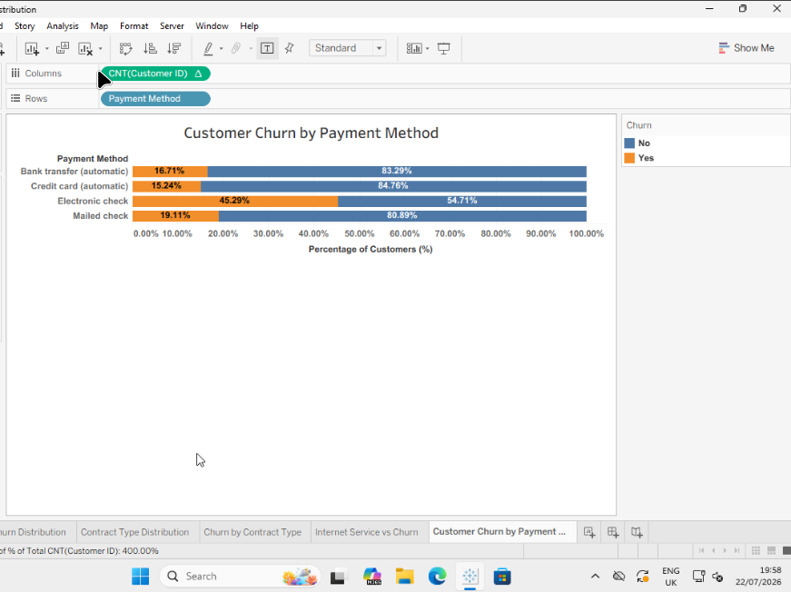
Figure 5: Customer churn by payment method.

Finally, customers with shorter service tenure were more likely to leave the provider than long-term subscribers (Figure 6).
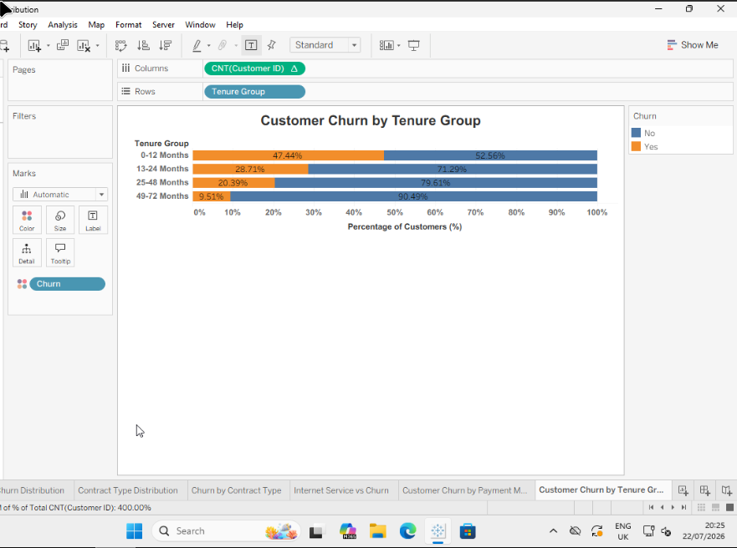
Figure 6: Customer churn by tenure.
These findings are consistent with the Weka classification results, reinforcing that service tenure is a key factor associated with customer churn and supporting the business recommendations presented in the following section.

3. Business Recommendations
The comparative analysis demonstrated that data mining can support customer retention by identifying customers with a high probability of churn before they discontinue a service. Although all classification algorithms outperformed the ZeroR baseline, Logistic Regression achieved the strongest overall balance of predictive accuracy, reliability, and interpretability, making it the most suitable model for this dataset. However, selecting a predictive model should also consider business requirements, including interpretability, computational efficiency, and ease of implementation, rather than relying solely on predictive accuracy [1], [7].
The findings suggest that organisations should prioritise customers identified as high risk for proactive retention initiatives. These may include personalised pricing offers, contract renewal incentives, loyalty rewards, or enhanced customer support before contracts expire. Such targeted interventions enable organisations to allocate retention resources more effectively while reducing the costs associated with acquiring new customers [1]. Focusing on customers who are most likely to leave can improve retention without applying costly incentives across the entire customer base.
The exploratory analysis also identified several characteristics associated with higher churn. Customers on month-to-month contracts, those with shorter service tenure, fibre optic internet services, and electronic cheque payment methods were more likely to discontinue their subscriptions. These patterns provide valuable business intelligence that can support customer relationship management [1], [6]. For example, organisations may encourage customers to move from short-term to longer-term contracts or introduce onboarding programmes that strengthen engagement during the early stages of the customer lifecycle.
The customer segments identified using SimpleKMeans clustering provide additional opportunities for targeted decision-making. Rather than applying a single retention strategy to all customers, organisations can tailor marketing campaigns and service improvements according to the characteristics of each customer segment. This segmented approach is likely to improve customer satisfaction while making more effective use of marketing resources [3].
Predictive models should not be regarded as static solutions because customer behaviour changes in response to market conditions, pricing strategies, and competitor activity. Organisations should therefore retrain and validate predictive models regularly using updated operational data to maintain predictive performance and ensure that business decisions continue to reflect current customer behaviour [2], [12].
Overall, the study demonstrates that combining customer churn prediction with customer segmentation provides organisations with practical, evidence-based insights for improving customer retention and allocating resources more effectively. The findings also highlight the importance of selecting predictive models that balance predictive performance, interpretability, and practical business application [1], [3].

4. Reflective Commentary
This project provided valuable practical experience of applying data mining techniques to a real-world business problem. Before undertaking the analysis, my understanding of customer churn prediction was largely theoretical. Through working with the IBM Telco Customer Churn dataset,
I developed a greater appreciation of the importance of data preparation, model selection and performance evaluation in producing reliable analytical results. The project demonstrated that effective predictive modelling depends not only on choosing appropriate algorithms but also on ensuring that the underlying data are accurate, consistent and suitable for analysis.
Using Weka Explorer allowed me to compare different machine learning algorithms and understand that predictive accuracy alone is not sufficient when selecting a model. The evaluation highlighted the importance of considering additional measures such as precision, recall, ROC Area and Cohen's Kappa, together with model suitability for practical use.
Comparing the strengths and limitations of the classifiers reinforced the idea that different business problems may require different analytical approaches rather than a single best-performing algorithm.
The project also strengthened my ability to interpret technical findings within a business context.
Rather than viewing machine learning as an isolated technical exercise, I recognised how predictive analytics can support customer retention strategies, improve resource allocation and contribute to evidence-based decision-making. This broader perspective increased my understanding of the relationship between data analysis and organisational objectives.
Overall, this assignment enhanced both my technical and analytical skills while reinforcing the importance of combining sound data preparation, appropriate model evaluation and critical interpretation. These experiences have increased my confidence in applying data mining techniques to future business analytics projects and provided a strong foundation for further study in data science and machine learning.

5. Conclusion
This report examined the use of data mining techniques for customer churn prediction and customer segmentation using the IBM Telco Customer Churn dataset. After data preparation and exploratory analysis, five classification algorithms and the SimpleKMeans clustering algorithm were implemented and evaluated using Weka Explorer.
The results showed that all classification models outperformed the baseline ZeroR classifier, with Logistic Regression delivering the best overall balance of predictive accuracy, reliability and interpretability. SimpleKMeans also identified meaningful customer segments, demonstrating how clustering complements predictive modelling by supporting targeted retention and marketing strategies.
The findings emphasise that successful predictive analytics relies not only on selecting appropriate algorithms but also on high-quality data, robust evaluation methods and accurate interpretation of results. Combining classification and clustering enables service providers to identify customers at risk of churn more effectively and develop targeted retention strategies.
Overall, the study demonstrates the practical value of data mining for customer analytics and highlights the importance of aligning analytical techniques with organisational objectives. Future research could investigate advanced ensemble methods, deep learning and explainable artificial intelligence to further improve predictive performance and model transparency.

6. References
[1] V. Kumar and W. Reinartz, Customer Relationship Management: Concept, Strategy, and Tools. Berlin, Germany: Springer, 2018.

[2] I. H. Witten, E. Frank, M. A. Hall, C. J. Pal, and M. Mayo, Data Mining: Practical Machine Learning Tools and Techniques, 5th ed. Cambridge, MA, USA: Morgan Kaufmann, 2025.

[3] J. Han, J. Pei, and H. Tong, Data Mining: Concepts and Techniques, 4th ed. Cambridge, MA, USA: Morgan Kaufmann, 2022.

[4] IBM, "Telco Customer Churn," IBM Community – Base Sample Data Sets, Jul. 11, 2019.

[5] V. Kotu and B. Deshpande, Data Science: Concepts and Practice, 2nd ed. Burlington, MA, USA: Morgan Kaufmann, 2019.

[6] W. Verbeke, D. Martens, C. Mues, and B. Baesens, "Building comprehensible customer churn prediction models with advanced rule induction techniques," Expert Systems with Applications, vol. 38, no. 3, pp. 2354–2364, 2011.

[7] A. Khattak et al., "Customer churn prediction using composite deep learning technique," Scientific Reports, vol. 13, Art. no. 17294, 2023.

[8] S. García, J. Luengo, and F. Herrera, Data Preprocessing in Data Mining. Cham, Switzerland: Springer, 2015.

[9] H. He and E. A. Garcia, "Learning from imbalanced data," IEEE Transactions on Knowledge and Data Engineering, vol. 21, no. 9, pp. 1263–1284, 2009.

[10] S. Bates, T. Hastie, and R. Tibshirani, "Cross-validation: What does it estimate and how well does it do it?," Journal of the American Statistical Association, vol. 119, no. 546, pp. 1434–1445, 2024.

[11] J. R. Quinlan, C4.5: Programs for Machine Learning. San Francisco, CA, USA: Morgan Kaufmann, 1993.

[12] A. Géron, Hands-On Machine Learning with Scikit-Learn, Keras & TensorFlow, 3rd ed. Sebastopol, CA, USA: O'Reilly Media, 2022.

[13] A. K. Jain, "Data clustering: 50 years beyond K-means," Pattern Recognition Letters, vol. 31, no. 8, pp. 651–666, 2010.

[14] D. M. W. Powers, "Evaluation: From Precision, Recall and F-Measure to ROC, Informedness, Markedness and Correlation," Journal of Machine LearningTechnologies, vol. 2, no. 1, pp. 37–63, 2011.

[15] G. W. Cassales, J. J. Liu, A. Bifet, B. Pfahringer, and E. Frank, "Accelerated Weka: GPU Machine Learning with Weka Workbench," Neurocomputing, vol. 646, Art. 130432, 2025.

7. Appendix A Weka Confusion Matrices
This appendix presents the confusion matrices generated by Weka Explorer for each classification algorithm evaluated in the study. These matrices provide detailed classification outcomes by showing the numbers of correctly and incorrectly classified churn and non-churn instances, supporting the comparative performance discussed in Section 1.4.

A.1 ZeroR Confusion Matrix
Presents the baseline classification results, illustrating the performance achieved by predicting only the majority class.

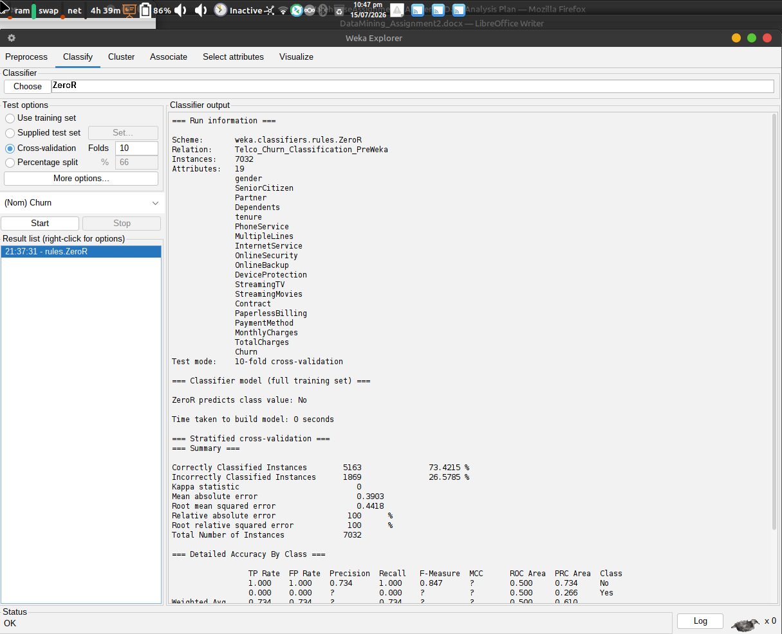
Figure A1: ZeroR Confusion Matrix

A.2 J48 Decision Tree Confusion Matrix
Shows the classification results produced by the J48 decision tree algorithm, including correctly classified instances and prediction errors.
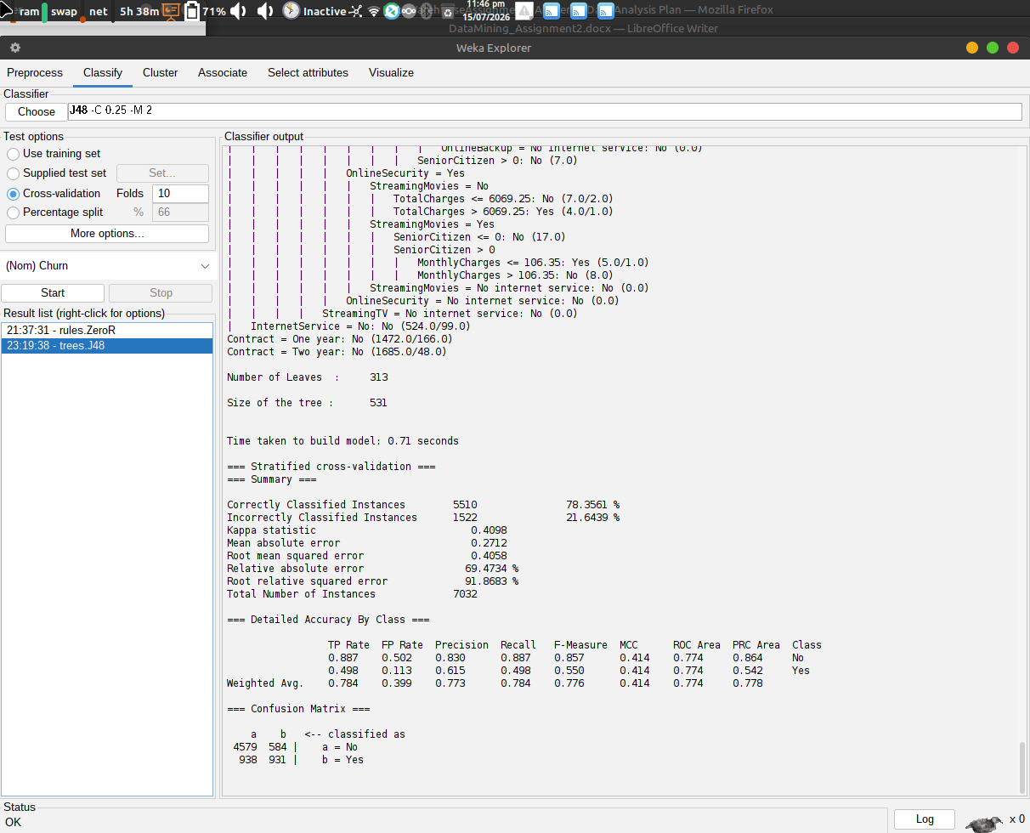
Figure A2: J48 Decision Tree Confusion Matrix

A.3 Logistic Regression Confusion Matrix
Presents the classification outcomes for Logistic Regression, the best-performing model in this study, illustrating its ability to distinguish between churn and non-churn customers.
Figure: Logistic Regression confusion matrix.

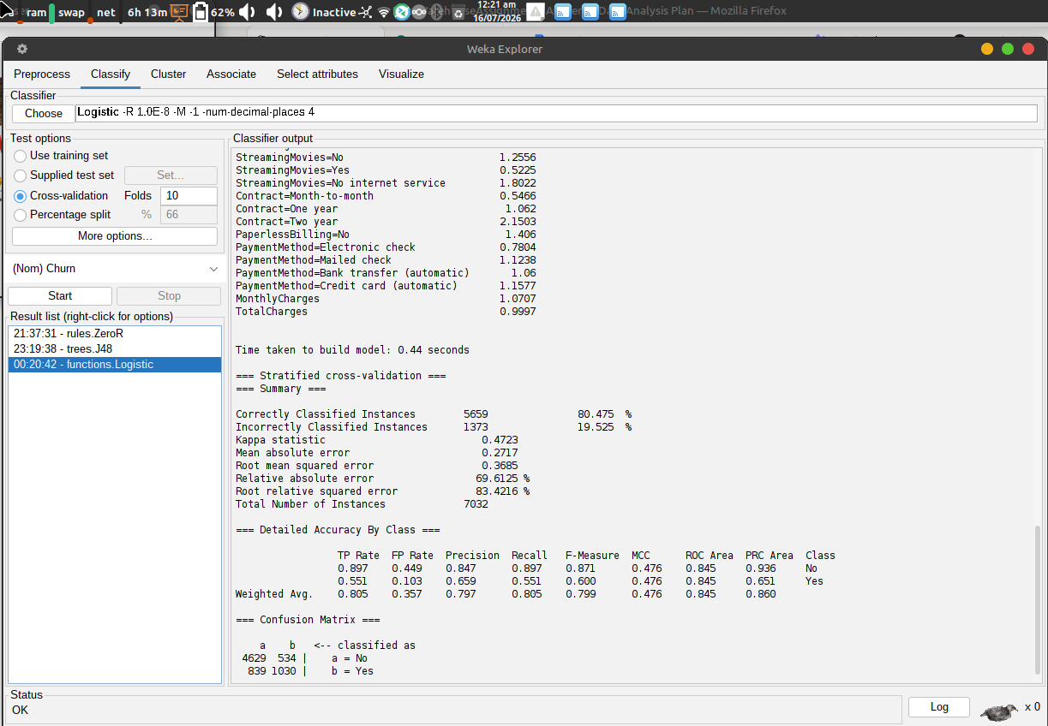
Figure A3: Logistic Regression Confusion Matrix

A.4 Random Forest Confusion Matrix
Shows the classification performance of the Random Forest algorithm, highlighting the distribution of correct and incorrect predictions.
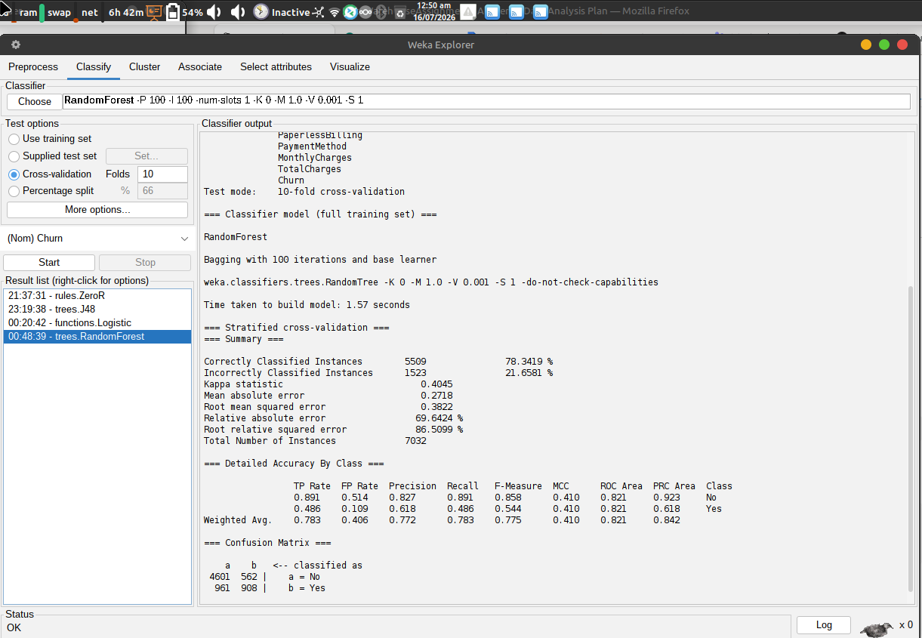
Figure A4: Random Forest Confusion Matrix

A.5 Naïve Bayes Confusion Matrix
Presents the confusion matrix for the Naïve Bayes classifier, illustrating its prediction performance relative to the other evaluated models shown in Figure A5.
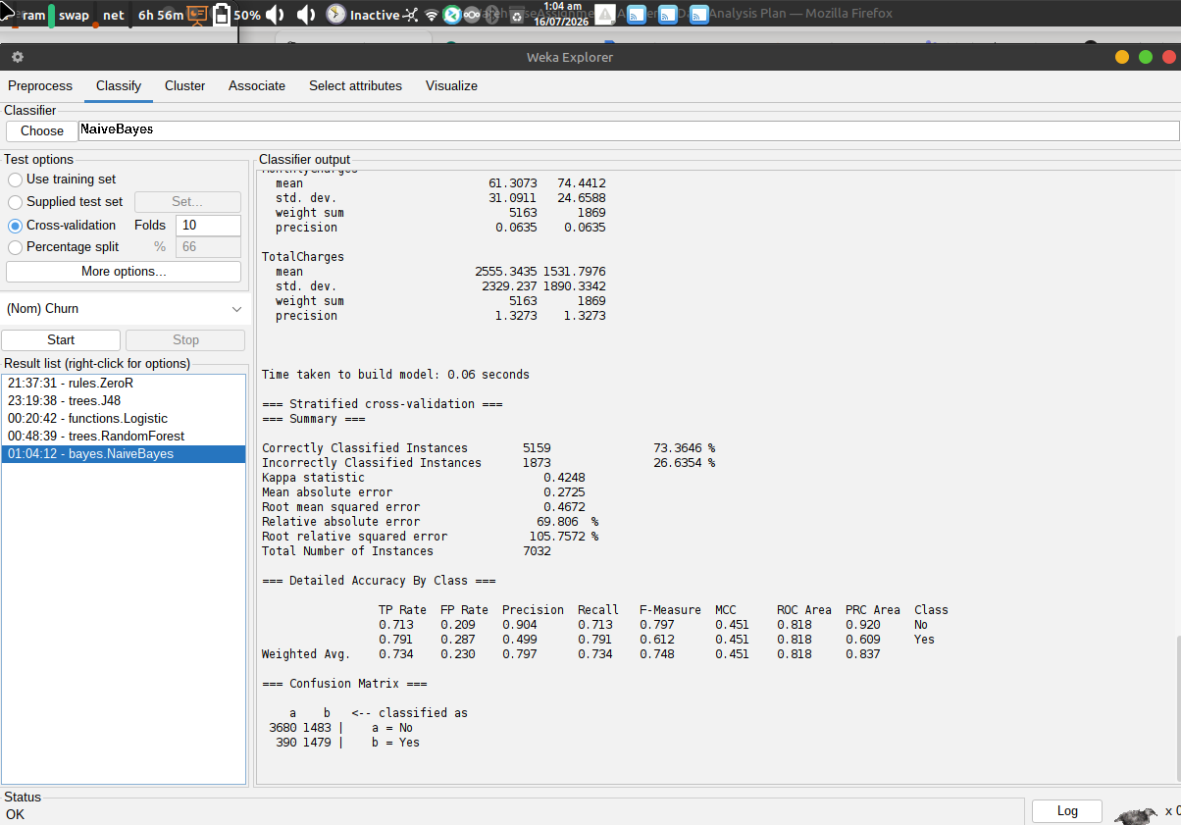
Figure A5: Naïve Bayes Confusion Matrix

