Presenting the diagrams as follow:
1.Context diagram.
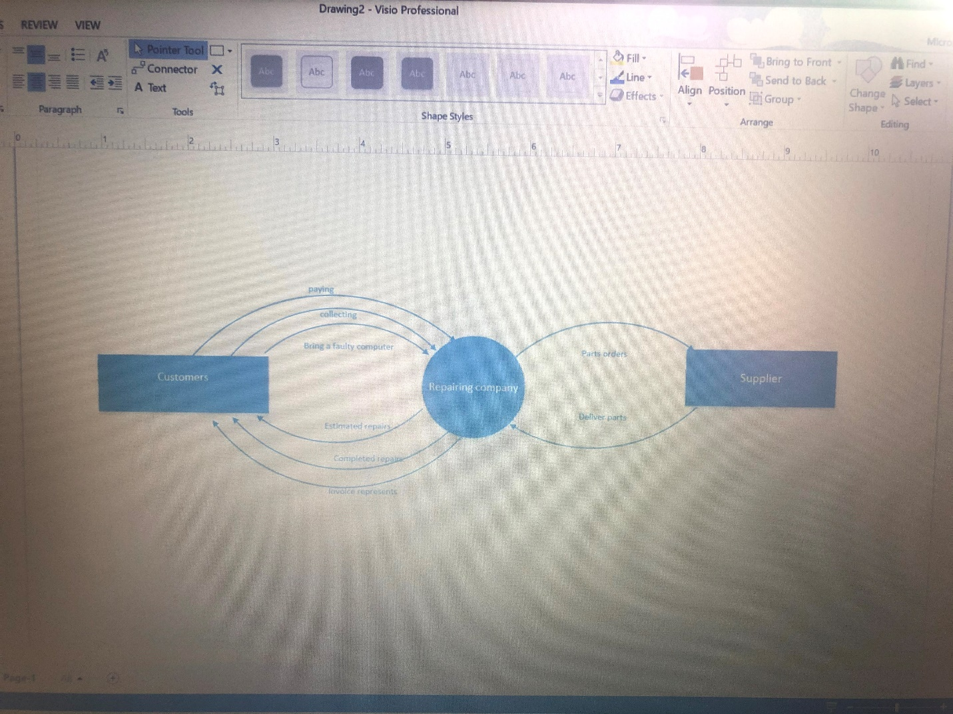

2. DFD level 0 diagram.
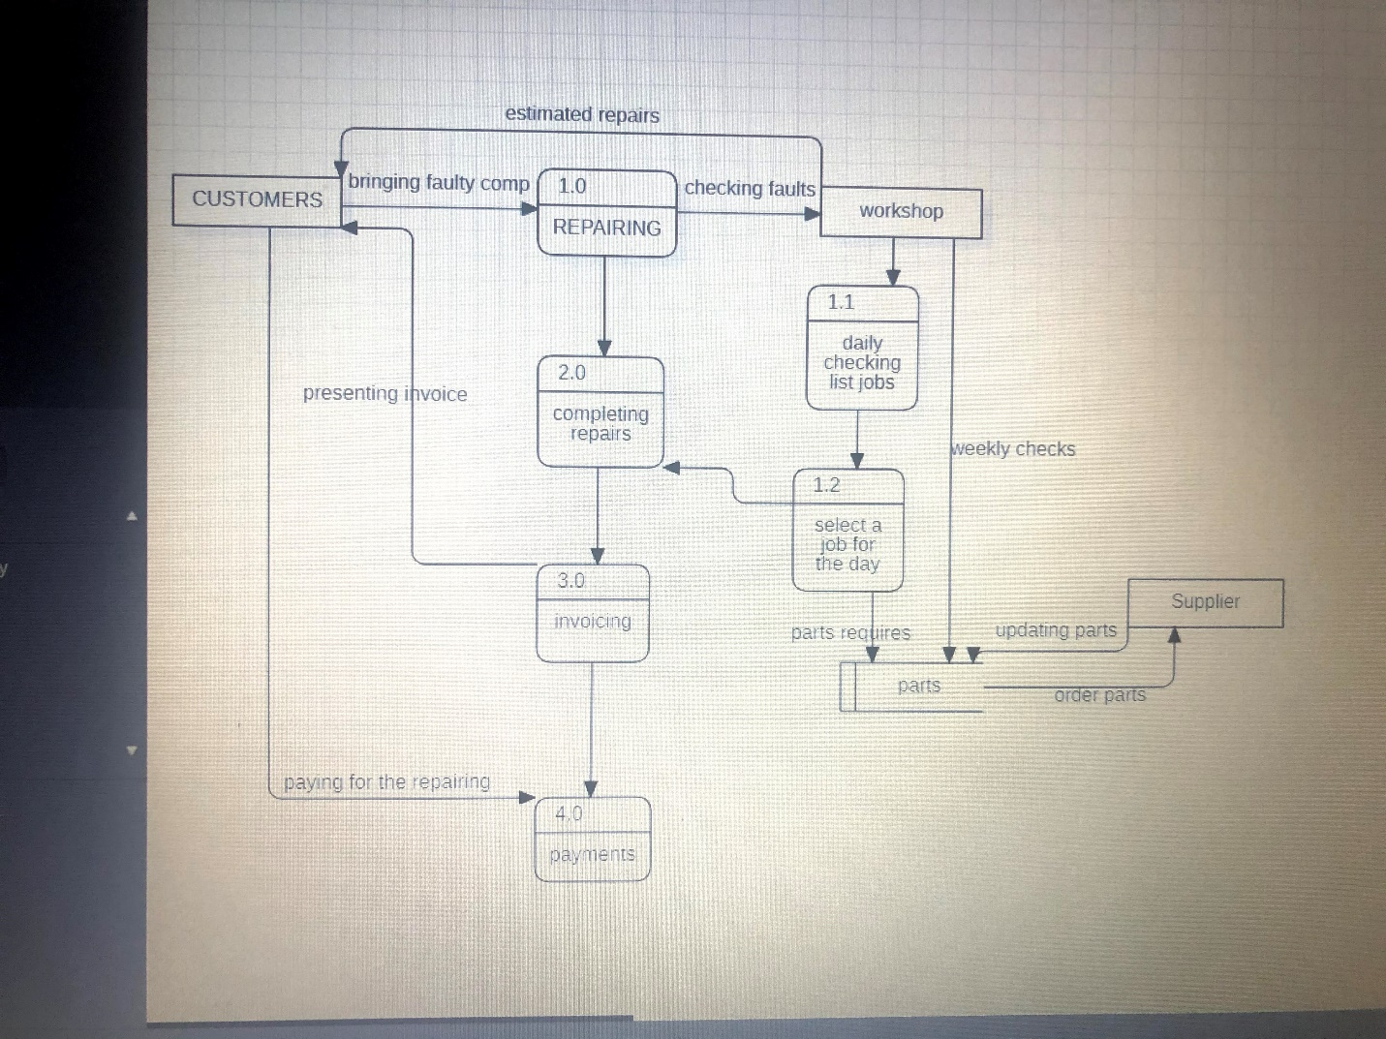
When the customer bring the computer for repairs, in the workshop are checking the faults and then the customer will be let known for the estimated repairs date. When in the workshop mr Lee or someone of the future personal do a daily list checking they can arrange the new dates for those computers which need parts. After the selecting of the job which can be done for the day,workshop complete the repairs and issue invoices to the customers, who are doing the payment for the computer repairs.

3. ER diagram.
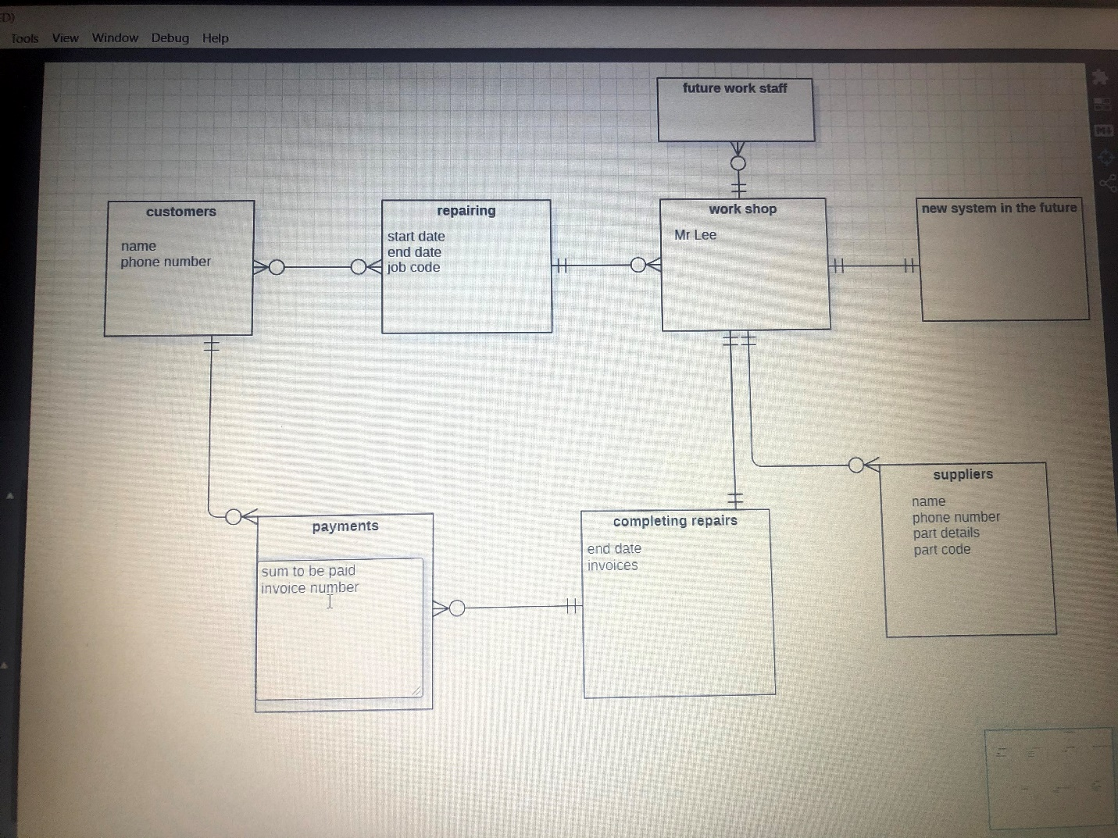

4.Use case diagram.

