

Assessment 1 – Reading Task Template
PART 1: Upload your photo of your A3 in-class notes here:
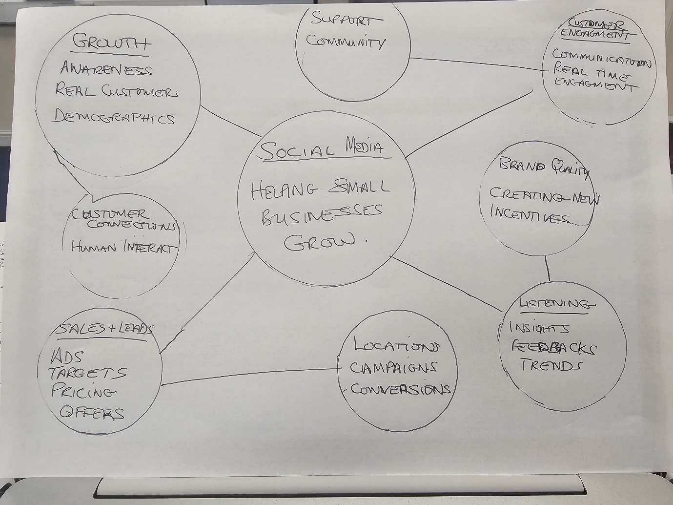

PART 2:
- Answer every question below in 1-3 full sentences.
- Use your own words. Do not use generative AI to answer these questions.
- Include a specific detail from the text when asked.
REMINDER
- The main idea is the overall message of the whole text.
- A key point helps to explain the main idea.
- A specific detail or example from the text shows that the key point is true.

- What is the main idea of the whole text?
The main idea is to show how social media is helping small businesses grow.

- What is one key point that supports the main idea, and which specific example from the text shows this?
The one key point is that social media makes businesses go viral through the internet.

- What is a different key point that supports the main idea, and which specific example from the text shows this?
A different key point is that after customers have used the services of a business the first time they then share their firsthand experience of how was their interaction was with that business on social media .

- Which part of the text do you think is most important, and why?
I think customers hold great importance on the experience of other customers to help them make their own decision on weather to also engage with that business to use their products and services. Like for example of a customer who travelled 3 hours to try out a food place……when other customers read this it has a positive impact for the reader.

Reflection:
- What did you find difficult in this task (including in-class components), and why was it difficult?
I did not find anything difficult in particular.

- What helped you with this difficulty, and how did it help you?
There was not anything difficult for me I felt I understood everything very well .

