Target 1 | Ensure I reference correctly with minor mistakes.
Target 2 | Proofread over work to ensure there are no mistakes.
Target 3 | Make sure work is organised and has structure.
Target 4 | Do not use phrases like ‘in my opinion’, use language like ‘this could suggest that”.
Target 5 | Use relevant sources.

A critical analysis and evaluation of the observation research tool, ‘Leuven Scale’
Introduction
In this assignment I will be completing a critical analysis and evaluation of the observation tool the Leuven scale. To help me complete an effective critical analysis and evaluation of the Leuven scale, I took part in two observation days in a foundation phase classroom. As I was in a foundation phase class (reception), it meant the ages of learners involved in the activity I witnessed were between four and five years old. There were four learners involved in the activity I completed, and the setting was in a classroom provision in the foundation phase. Wales' Foundation Phase is a developmental programme for children ages three to seven (Welsh Government, 2018).
From my observation days I took note that participation and engagement links to an effective learning as the child will not learn if they are not participating. This could suggest that participation and engagement are a big part of an effective learning environment in the foundation phase. This is beneficial for me as the question I based my observation schedule/ Leuven scale on is ‘Do children display high levels of engagement/ involvement when learning in small groups?’.
Literature review
As previously mentioned, the foundation phase is a programme developed in Wales by the Welsh Government for children ages three to seven years old. It motivates children to be creative and make learning enjoyable (Welsh Government, 2015). An important part of the foundation phase is the foundation phase pedagogy. Pedagogy is described a teacher's approach and procedures. It's how they go about their teaching methodology and how they deliver the curriculum to the class (Learning Journals, 2021). The Welsh Government explain that the foundation phase is ‘built on principles of learning through play’ (Welsh government, 2018). Learning through play can help improve children’s language and communication skills as they interact with others around them. It allows them to improve their creative skills and gives them opportunity to form relationships. Play also allows children to develop the seven areas of learning and development set out by the Welsh government. Examples of play that aid this are role play, messy play, creative play, sensory play (Welsh Government, 2015.
As previously in the introduction, I stated that my question was looking at small group learning (‘are children more engaged/ have a higher level of involvement when learning in small groups?’). The educational strategy small group learning emphasises that students learn in smaller groups to aid their learning. A theorist who backs up the group learning technique is Lev Vygotsky. Vygotsky stated that cognitive development is built on by social interactions and the learning process is effective as a result of students engaging with peers that are more knowledgeable (MKO) (Vygotsky, 1978). This relates to mixed ability small group learning.
Small group learning also allows children to improve skills like teamwork, communication and from relationships as the children are working together. Another skill it can massively improve is their problem-solving skills. An Estyn report states that children work well collaboratively, in small groups, supporting each other to resolve problems (Estyn, 2020).
Methodology
The use of the Leuven scale was a big part of my observation in the foundation phase classroom I was in. There are two Leuven scales, one regarding the involvement of children’s learning and one about their emotional well-being. This means childcare professionals, nursery workers, and instructors can assess a child's emotional well-being and engagement using the five-point Leuven scale (learning Journals, 2021). The five points on the scale included, extremely low, low, moderate, high and extremely high. In my observations, I looked at the involvement Leuven scale as I feel it was more suited with my question.
Advantages of using the Leuven scale firstly include, it is purely observation based. This is an advantage as it focuses solely on the child/ children. This means the person observing, if completing the well-being scale can focus on the child and their holistic well-being ensuring it does not count every child as being the same. Another advantage could be it allows a practical way for childcare professionals and parents to measure engagement in learning.
However, on the other hand, disadvantages of the Leuven scale can include it not catering that well for children with disabilities. This is due to the five points in the well-being and involvement scales displaying behaviours that may not be clear in children with SEN (special educational needs) or children with disabilities. This is also prevalent in children who are non-verbal as they may not be able to express their well-being and involvement in activities as much as children who are verbal.
When looking at my observation schedule, I believe I made it easy to fill in with data and read. However, if I was to do this again, I would definitely improve my observation schedule by firstly making it more detailed. Even though it is simplistic and easy to read, I feel like it lacks detail. I think it would benefit me to have more sections looking at the how the children are involved/ engaged by monitoring factors like are they communicating? Are they discussing? Are they supporting others? For examples. This would give me more detailed data to help answer my question. Another improvement I would make to my schedule is smaller time intervals. Due to the age of the children I was observing, I feel like a lot can change in children in five minutes, including their engagement. I would change the timings to two-minute observations to ensure I collect any changes in the children’s behaviour sooner.
Discussions and findings
When conducting my research during my observation days due to being in a school setting, ethics and performing my research process in an ethical manner were a big factor of my research. Ethics are guidelines that help you determine if your acts are morally correct or incorrect. It aids in classifying the discipline, truthfulness, and integrity of our daily actions (Veronica, 2020). Education ethics are crucial for the smooth operation of the system. By establishing the parameters of what is and is not acceptable, the ethics safeguards the interests of both teachers and pupils (Singh, 2020).
When starting my research, consent was given by the teacher as it is their legal responsibility to safeguard the children. I found that all the children (ages four - five years old) were willing to being assessed by me as part of my research. Even though you can argue that they are too young to speak up about taking part, children as young as three were "capable and confident enough to offer or withdraw consent - with some more vocal and inquiring than their parents" according to Flewitt (2005). In addition to this, the British Educational Research Association state that researchers should determine whether there was an active refusal of permission when certain members of a group (such as pupils in a class or their parents/guardians) refused to participate. If there was, researchers should respect this and come up with a workable solution (BERA, 2018). In the classroom setting I was in, if this was the case, a solution would be either not assessing the child, contacting the parent/ guardian, or coming up with a solution with the classroom teacher if the parent/ guardian of the child is not available to contact. BERA (2018) also agrees with this as they later state that in collaboration with gatekeepers, a decision should be made regarding how to proceed for individuals who are unreachable.
I interpreted BERA 2018 guidelines within my practice by looking at them beforehand and ensuring I stay ethical. As stated by the British Educational Research Association (BERA), educational researchers should do their work with respect for all individuals, including themselves, who are a part of or affected by the research they are conducting (BERA, 2018). I believe that I followed this as I had respect for all individuals in the classroom whilst conducting my research.
After collating my data on my observation schedule, I feel like I can answer my research question to an extent. From watching a small group activity, I feel like children are more engaged when there are less people working with them as they are able to communicate and are given the chance to ask and discuss feedback more. However, the reason I feel that I can only answer my question to an extent is due to only being in the classroom environment for two days. I feel like I did not see enough small group activities due to there being other lessons planned for the children and I feel like I would be able to answer my question more if I had seen multiple different ability groups, this being mixed ability group, lower ability groups and higher ability groups. I feel like this would help me answer my question as I could see if small group learning is more engaging for all children, and it would give me more data to go off.
Conclusions and recommendations
To conclude, I found I answered my research question to an extent. I found that small groups when teaching are good to improve children’s involvement in learning as my results showed they were more engaged.
From answering my research question, I found some of the strengths of small group learning were firstly, it allows more opportunities for feedback. As there are less children, not only is there more of a chance for them to ask but they also may feel more comfortable asking due to there being less children learning with them. In addition to this, the children may feel more comfortable with asking for feedback in a more relaxed environment. They also will receive feedback instantly which could result into discussions between the children therefore, benefitting all children involved. Another strength is it can build relationships, social skills and team working skills between the pupils. As there is a small group, it allows pupils to talk with each other comfortably and work together on the tasks they are competing, this then can lead to improvement of social skills.
However, the weaknesses of small group learning were, children may need to go at different speeds. Not all children will be at the same ability and whilst it can be seen as a good thing to have mixed ability groups so the children help each other, it can be challenging also. This is because people may be slower than others and may feel behind, this may knock their confidence. Subsequently, they may also copy higher ability children in their group therefore not actually learning. Another weakness depending on the school may be a lack of staff/ teachers to conduct the small group learning activity. An example of this would be during my observation days. In school X’s foundation phase reception class, there was one teacher and one support staff, in this classroom situation it would be hard for them to do small group learning as both staff were occupied at all the times with the children. This would mean the small group would not receive full attention from the teacher.
My findings will impact my teaching as I now know from my research that small group as can be efficient with certain activities. This is a technique I can use in my practice to ensure involvement of the children I am teaching is high.
To conclude on the Leuven scale, I have found that the scale is a good option when reviewing and recording the behaviour of children’s well-being and involvement. It is an easy way to record data also and is easy to manipulate into your own version. However, I found that it can be hard when being a non-participant observer to record all information at the time of viewing. I think a good option to ensure all data is recorded is to record the observation to re-watch to see if anything is missed. Macrae and Jones also agree that this would be a good option as they state that they suggest the act of filming and reviewing footage in slow-motion (Macrae and jones, 2023, p. 244). Overall, I would use this method again.

References
British Educational Research Association [BERA] (2018) Ethical Guidelines for Educational Research, fourth edition, Lomdon. https://www.bera.ac.uk/researchers-resources/publications/ethical- guidelines-for-educational-research-2018

Christina MacRae & Liz Jones (2023) A philosophical reflection on the “Leuven Scale” and young children’s expressions of involvement, International Journal of Qualitative Studies in Education, 36:2, 234-246, DOI: 10.1080/09518398.2020.1828650

Flewitt, R. (2005). Conducting research with young children: Some ethical considerations. Early Child Development and Care, 175(6), pp. 553–565.

Information for parents and carers How is my child doing in the Foundation Phase? (n.d.). https://www.gov.wales/sites/default/files/publications/2018-06/how-is-my-child-doing-in-the-foundation-phase-a-guide-for-parents-and-carers.pdf.

Learning Journals (2021). What are the different pedagogical approaches to learning? Learning Journals. Available at: https://learningjournals.co.uk/what-are-the-different-pedagogical-approaches-to-learning/.

Learning Journals (2021). What Is the Leuven Scale and How to Use it. Learning Journals. https://learningjournals.co.uk/what-is-the-leuven-scale-and-how-to-use-it/.

Singh, A. (2020). Ethics In Education | Importance Of Ethics In Education. Ecole Globale. Available at: https://www.ecoleglobale.com/blog/ethics-in-education/

Veronica (2020). What are Ethics in Education? | ELN Blog. www.eln.co.uk. Available at: https://www.eln.co.uk/blog/what-is-ethics-in-education.

Vygotsky, L, S. (1978). Mind in society: The development of higher phycological processes. Cambridge, MA: Harvard University Press.

Welsh Government (2015). Foundation Phase Framework Curriculum for Wales. https://hwb.gov.wales/storage/d5d8e39c-b534-40cb-a3f5-7e2e126d8077/foundation-phase-framework.pdf.

www.estyn.gov.wales. (2020.). Children’s interests lead learning activities | Estyn. Available at: https://www.estyn.gov.wales/effective-practice/childrens-interests-lead-learning-activities.
‌
Appendix
Professional reflection

- Describe one observation you carried out. What did you learn from it?

Whilst being in school X, I carried out multiple observations regarding student engagement. One being engagement whilst counting and dancing to a song as a whole group. Even though they were completing a maths activity, their engagement as whole was high. When focusing on four students in particular however, I found one pupil out of the four had a moderate to low involvement in the task. This may be because they do not enjoy singing/ dancing and may prefer sitting down and learning. I learnt from this that every child has different preferences and it is beneficial to look at each child holistically not assume each child enjoys the same tasks.

- What were the challenges and opportunities of being a non-participant observer in the classroom?

A non-participant observer is someone who is observing in the room but is not involved in what they are observing. When I was the non-observer, an opportunity I found was it gave me the chance to properly observe everything to my best ability as I was not involved or occupied with anything else. However, the limitations I found were I felt as though I was isolated from what the children were doing as I was not aiding the learner, simply just watching.

- In your experience, what where the benefits and limitations of the Leuven scale as a research tool?

From my experience of using the Leuven scale, I found the benefits of using the scale as a research tool were firstly it was useful because you can measure non measurable behaviour as it you are observing continuously over set times and see how the results vary. A limitation as previously mentioned in my assignment is being it is hard to record all information at once meaning it is very easy to miss information out.

- What were the main points of learning for you?

A main point of learning for me was looking at ethics and being ethical when it comes to observing in the educational setting. Looking at BERA (2018) really helped with learning to be ethical. Professional dispositions were also a big point of learning for me as it helped me understand the values and ethics that influence behaviour toward the children.

- What would you do differently if you were to conduct this research again?

As mentioned in the main body of my assignment (methodology), I would change and improve my observation schedule inspired by the Leuven scale if I was to conduct this research again. This is due to the scale being quite broad and simplistic. I believe if I designed the scale again with more in-depth, detailed observations, then I would be able to answer my research question more successfully because I would have more data to back it up.

- Discuss any other methods of research you could use in the classroom to improve your practice. What are the positives and negatives?

Another method of research I believe I could use in the classroom to improve my practice could be observing in different settings. Children in mixed ability groups may work differently or better in different settings whether this be outdoors learning or in an area where they feel calm learning for examples. A positive of this would be I feel like this may change the results of my learning and allow children who may not perform as well in the typical classroom setting to excel. However, a negative could be that it could be hard to measure as if the group is mixed ability, one may perform better in another area compared to someone else in the group.

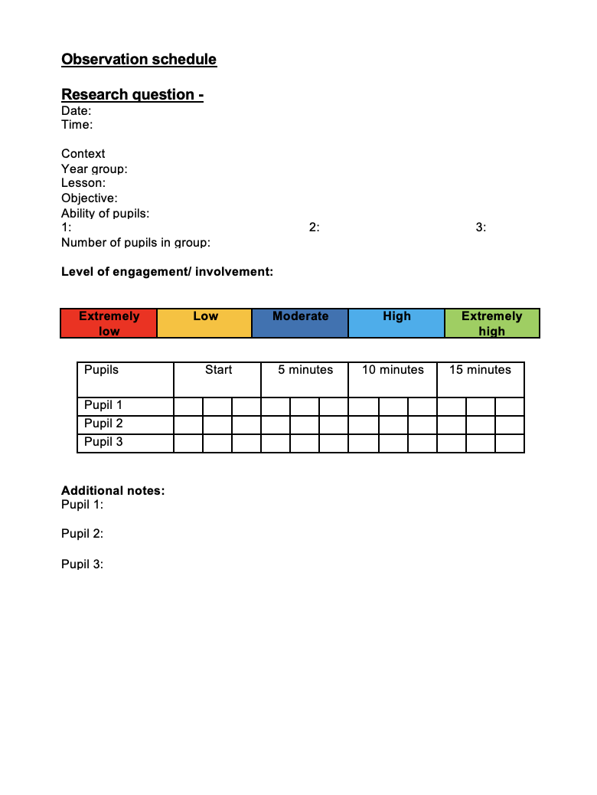

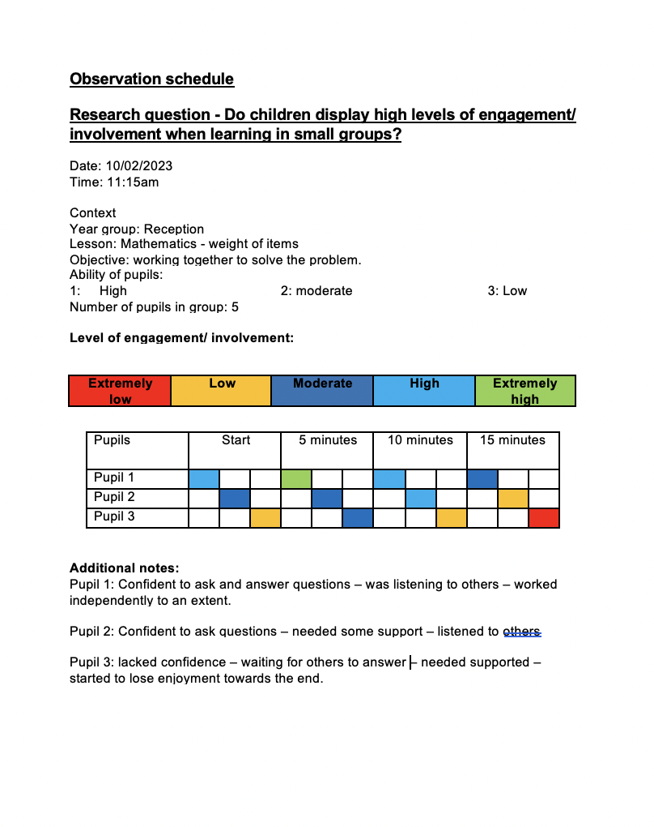
2

