
An investigation focusing on how to get more spectators to attend smaller rugby games within Parc Y Scarlets.


Consultant name: Cerys Jane Jones
P number: P144914
Email: cjones.144914@student.uwtsd.ac.uk
Business: Parc Y Scarlets
Clients name: Mrs Natalie Bunyan
Job title: Customer service manager
Phone number: 07779789424
Email:
Address: Pemberton Park, Llanelli SA14 9UZ
Acknowledgements
There has been a lot of time and effort put into this report in order for it to be completed at the best possible standard. However, it would not have been possible without the continuous help and support from many individuals especially Mrs Natalie Bunyan who is the customer services manager within Parc Y Scarlets on her support throughout the different stages of this report and enabling this report to be done to the best of its ability. Mrs Bunyan was helpful and offered a wide range of advice throughout the completion of this report and her help throughout this report is greatly appreciated.
The consultant would also like to express their gratitude to Mr Robin Cammish, who is the director within Parc Y Scarlets. Mr Cammish found the time to meet with the consultant to discuss the topic of this report and provided excellent advice and help throughout the report. The help and support Mr Cammish offered is greatly appreciated.
The consultant would also like to express their gratitude towards Mr Mike Davies who is the final year tutor for his guidance and constant supervision as well as providing advice and help throughout this report. Mr Davies has been extremely supportive and it is greatly appreciated.
The consultant would then also like to say a final thank you to all their friends and family on the continuous support throughout this report.

Executive summary
This report is focused on how to get more spectators to attend the smaller rugby games within Parc Y Scarlets. There has been a questionnaire sent out to members of the public to get their opinions on the issue, which was found to mainly be the cost to attend the games as a family. There has also been an interview with Mr Robin Cammish carried out in this report, which found that his main issues were with the games being televised which are potentially stopping next season which he hopes will see an increase of fan numbers. The questionnaire findings were also discussed with Mr Cammish and as the main issues raised from the findings of the questionnaire were the pricing to attend as a family the idea of allowing families to bring their own packed lunches along with them or allowing them to purchase a pre-made packed lunch upon arrival were discussed and Mr Cammish agreed that it was a good idea and was something that could be tried out in the future.
During the research for this report it was also highlighted that Parc Y Scarlets do not have anyone working within the stadium that focuses on marketing and is something that Mr Cammish wished was better and something he was disappointed with. Therefore the marketing mix was introduced as one way to help them when considering things to look at when putting together a new marketing strategy and ideas of putting leaflets in local schools and supermarkets was also put across, which again was discussed with Mr Cammish and he approved of the idea.
Overall, it was clear to see that there was a few issues raised with why spectator numbers are so low on smaller games and there were many ideas and a wide range of discussion made to help improve the spectator numbers.

Contents
1. Introduction 4
2. Research methods 4
3. Findings 5
4. Discussion and analysis 11
5. Recommendations 13
6. Conclusion 14
7. Appendices 14
7.1. Questionnaire sample 15
7.2. Minutes with client 16
7.3. GANTT chart 19
8. References 20

- Introduction

This consultancy report will be focusing on how to get more spectators to attend smaller rugby games within Parc Y Scarlets. The reasoning of the chosen topic and business is because the consultant has first-hand experience of how the number of spectators can vary from game to game, some games will have a large number of spectators attending and others will only have a small number of spectators. Scarlets performance as a rugby team is of excellent standard at the moment and being able to use their performance to get more people to attend games is something that needs to be addressed.

The overall aim for this report is to help attract people to attend all games within Parc Y Scarlets and not just the bigger games. By doing this it will help bring in more money to the stadium which will then result in financial benefits for Parc Y Scarlets. The more people Parc Y Scarlets can market and bring into the stadium the better, it will also allow them to then market any other events they have on other than rugby games.
- Research methods

The research methods that have been used to find the best solution to the chosen issue for this report has mainly been primary research, the main programme to gather all primary research has been Survey Monkey. There was a total of 10 questions set out (*refer to appendices 7.1 for the questionnaire sample ) which then went live on social media using, facebook, twitter and snapchat where members of the public were able to voice their opinions related to the questions asked. Primary research was chosen as the main research method as it allowed members of the public who have attended or were familiar with Parc Y Scarlets to share their experiences when attending or visiting the stadium. Primary research using questionnaires was also chosen because the questionnaire is one of the most widely used data collection methods within the survey strategy because each person (respondent) is asked to respond to the same set of questions, it provides an efficient way of collecting responses from a large sample prior to quantitative analysis. (Mark Sunders, 2012) The use of the internet and the wide web has reduced the cost and time requirements for conducting surveys (Klonas, 2011) therefore, by producing a questionnaire which is one of the most popular methods of collecting data among hospitality and tourism researchers, (Paraskevas, 2008) it then helped the consultant produce a large number of responses to the questionnaire at no cost and also helped the consultant gather and analyse quantitative data at the end.

In order to gather all suitable research data for this report and include all research for the business issue, secondary data has also been included within the report. Secondary data tends to be readily available and are often large quantities of data (Klonas, 2011) it also allows you to merge data from various sources in order to provide larger and more usable data sets. (Mick Finn, 2000) By the consultant researching into other people’s opinions written in journals and newspaper articles related to the topic it will allow them to have a better insight into why the issue has occurred and what other researchers recommended to resolved the issue, rather than base the whole report on the primary research.

The final research method that was used to help complete this report was interviews. Mr Robin Cammish who is a member of the board of directors within Parc Y Scarlets, met the consultant where he then expressed his opinion on the issue and why he thought the number of spectators attending the smaller games was so low. The reasoning behind interviewing Mr Cammish, was because the topic was extremely topical to him and Parc Y Scarlets and he was very interested to find out what the consultant had researched.

Before the interviewing process Mr Cammish answered a set of questions set out from the consultant via email, so the interview was arranged as a follow up of the questions to discuss them in further detail, therefore the interview was an unstructured interview which then had the advantage of the interviewer responding in a flexible way to the interviewee and the interviewers role was minimal which allowed the interviewee to express ideas in his own words. (Mick Finn, 2000)
- Findings
- Survey monkey responses

Q2. Have you ever attended a game at Parc Y Scarlets?

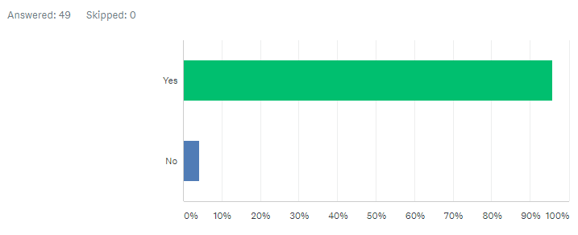

The questionnaire was set out only to target people who have attended a game at Parc Y Scarelts. The reasoning for this was so that all the answers were useful and could be used as part of the primary research for this report. As you can see from the table above the majority of people asked had attended a game within Parc Y Scarlets.

Q3. If so what was your experience like?

The reasoning of asking this question was to see what they found best about the stadium when they attended and what they found could have been better on their visit. As this question was an open question where the respondent could express their experiences within more depth the main negative comments made were the prices of the food and drink and atmosphere being poor due to the number of spectators at the game they attended.

In reference to the food and drink comments one respondent stated that on their experience “It was not that great.. pricing shouldn’t be at the prices they are for what the products and services are” another respondent stated that “the pricing on food and drink it’s too pricey I would rather go for food before or after the game than waste my money on things there as I can get much more for my money elsewhere”. As you can see from the graph above there were more negative than positive comments made on the food and drink on offer within the stadium and most comments made stated that the prices were too high.

In reference to the atmosphere, there was slightly more negative than positive comments when they were commenting on the atmosphere at the game they had attended with a few respondents stating that “The atmosphere could of been better, there is not enough coverage of people attending the games they only like to attend big games such as semi-finals etc” “Atmosphere great when full - but sadly it doesn't happen often!” “Atmosphere is alright but it's the number of fans that turn up that's most disappointing”. One respondent stated that they think the atmosphere is poor due to the stadium arrangement and compared it to Gloucester stadium “There was a small amount of people there compared to other rugby clubs such as Swansea city and Gloucester.. when the Scarlets were in Stradey they always had a large crowd which I think was due to the seating arrangement as they were basically on the pitch with the players, like Gloucester stadium have which is why Gloucester always fill their seats, in my opinion.”

Q4. Did you bring any children along with you to the game? if so, did you find it expensive to attend the game as a family?

Following on from question 3 the consultant wanted to see if people who attended the games brought along family members and if they did how did they find the pricing. The majoring of people came alone or with a friend simply because it was too expensive to attend the event as a family, not in terms of ticket prices for the children but because of the pricing of food and drinks for all the family within the stadium. A few comments made by the respondents were “No and would of been more expensive if I had” “As above. Food/drink prices are very expensive. So it would be hard for a big family to come to a game.” One respondent stated that there was no entertainment for the children before kick-off which meant they ended up getting bored and they stated that “Yes I took my two children, I found it very expensive and there was nothing to entertain them before the game so they got very bored”

Q5. How would you rate the atmosphere at the smaller rugby games within Parc Y Scarlets (1 being poor and 5 being excellent)

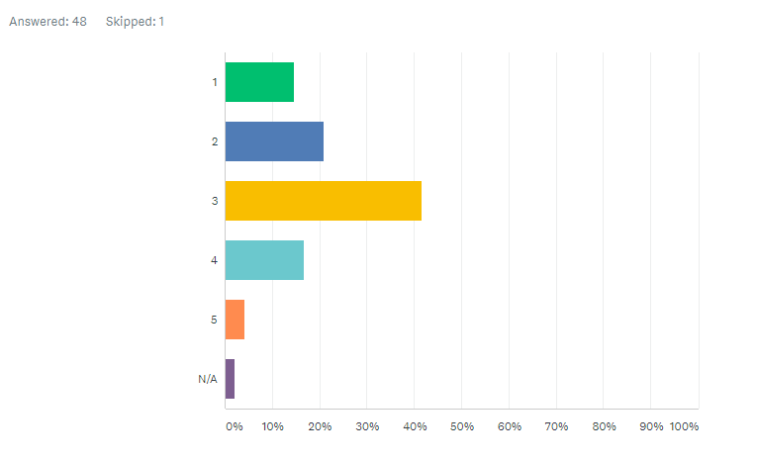

As you can see from the data gathered above, the respondents were asked how they found the atmosphere where they attended a game within Parc Y Scarlets with 1 being poor and 5 being excellent, the majority of respondents answered with a 3, which is not the best result and this shows that the atmosphere could be better and if the atmosphere had of been better their experience would have been more enjoyable.

Q6. In your opinion how would you rate the number of people who attend the smaller rugby games within Parc Y Scarlets (1 being poor and 5 being excellent)

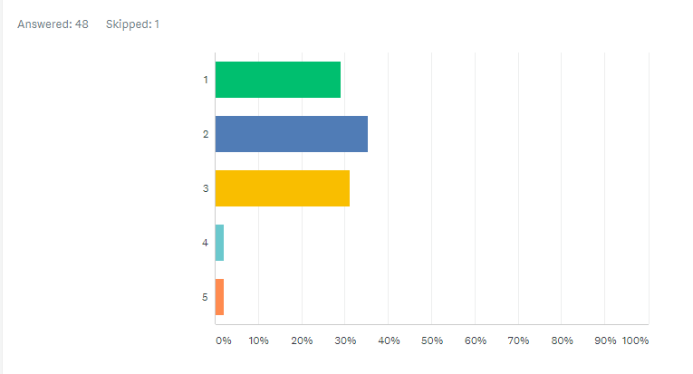

The respondents were then also asked how they would rate the number of people who attend the smaller games within Parc Y Scarlets and the majority of people rated this question with a 2 which is extremely poor and shows that this desperately needs to be improved and by improving the number of people who attend the smaller games this would then help to create more atmosphere and would make spectators experience much more enjoyable.

Q7. If you rated question 6 as poor, why do you think this is?

Following up from question 6, the consultant then wanted to gain more insight into why they rated question 6 as poor and some responses gathered where “It’s poor because not a lot of people attend games, pricing is too high for families to afford to go and enjoy themselves, don’t have good deals” “Because not enough people attend smaller games, they go the pubs to watch them or nearby instead of wasting their money to go there as everything is so expensive. More than half of the seats are usually empty so they are not getting enough people in when they need to.”

One respondent stated that “People can easily watch on TV or prefer to watch it in their local pubs”. Another respondent also stated that they rated the number of spectator attendance poor because “I think more people would attend if prices were lower and there was more going on for the children”.

Q8. In your opinion what would make you attend more rugby games at Parc Y Scarlets?

The reasoning behind this question was to find out what Parc Y Scarlets could do or change to help bring in more people to the stadium and get the public’s opinions on what would make them attend more games within the stadium some responses to this question were “Package deals, more services available, cheaper prices” “Better advertising” “Cheaper food for the children” again another respondent mentioned that having something to engage the children in prior to kick off would make them attend more and stated that “More things going on during the build-up of kick off. When I attended the game there was nothing getting myself and my children excited.”
- Interview with the director within Parc Y Scarlets

In order for the consultant to gain full insight into why spectator numbers are lower on certain game days it was important to collect a wide range of primary research. Although it was important gaining the public’s opinions it was also important to speak to someone within the company who could also share their views on the matter therefore a meeting was arranged with Mr Robin Cammish who is one of the directors within Parc Y Scarlets. The consultant asked Mr Cammish a range of questions the first one being “As we both attend the games regularly we have seen how the number of people watching the games can differ from game to game, so in your opinion do you believe that the number of people who attend the smaller games is an issue? If so, what do you think PYS could do to help bring in more people to the smaller games?” Mr Cammish then responded with a vast amount of issues that affect the number of people who attend the games to which he believes that “Having the smaller games televised has an impact on how many people turn up to the stadium to watch it, even some of the season ticket holders stay at home and watch the smaller games on TV, so if the games were not being televised I think this would have a big impact on the number of people coming along to watch the games, Pro14 cup next year is not actually going to be televised which I think will see more people attend the games at the stadium, however people will be able to sign up for a subscription fee to watch the games where they prefer which actually is going to work out just the same price as a season ticket or even cheaper.” Following up from the questionnaire the consultant send out to the public they decided to offer their own advice and ideas and wanted to see what Mr Cammish thought about them, as most of the respondents felt it was too expensive to attend as a family but would of liked to, the idea of allowing families to bring their own packed lunch to the game or even offering pre-made packed lunch for a small cost was put across to Mr Cammish for his thoughts, to which he agreed that it was a good idea and could potentially see an increase of the number of families coming to attend. Mr Cammish also mentioned that the rugby players go on community visits to help promote Scarlets and go along with freebies and get the children more involved as during half-time they have an under 10s touch rugby game with local schools from the area, who then bring along their families to watch their children play rugby within the stadium which then helps bring in more parents and families, however this has not been very successful recently and Mr Cammish stated that he would like to see more local schools involved, possibly with every game as that would mean each child would bring along their family members and would increase attendance figures and help generate more money and with more people in the stadium it would help create better atmosphere.

When also gathering information for this report the consultant got into contact with Mrs Natalie Bunyan to ask if anyone in marketing were able to help out to which she responded that there was no one within the business who worked for marketing, the consultant then brought this up with Mr Cammish to which he stated that this was a major issue within the business as they do not have the money to employ someone to focus on the marketing side of things which flagged as a concern. Mr Cammish then expressed his own feelings towards the marketing issues and he stated he was “extremely disappointed where marketing is concerned and is planning next year to employ someone who can take control of the marketing which could help improve the amount of people who attend the games but at the moment they simply do not have the money to do so”

- Discussion and analysis

With all the findings from both forms of primary research undergone it is clear to see that there is an issue/s when trying to get people to attend the smaller games within Parc Y Scarlets.

From the findings of the primary research the main issue that kept appearing was the cost of taking the whole family to attend the games and their main issue was the food and beverage prices that were putting them off attending games. The consultant then discussed this issue further with Mr Cammish in the interview and suggested that when families come to attend the rugby games to allow them to either bring their own packed lunch or have a pre-made one they can purchase before entering the stadium if they wish. Mr Cammish approved of that idea and suggested it could be one way to bring in more families to attend the games. Another way to help bring in more families to the games would be to get more local schools involved during half time with the under 10s touch rugby, as discussed above Mr Cammish stated that the turnout of schools could be a lot better so ensuring that they have at least 4 different schools per game would mean that each child that participates, is going to bring along members of their families to watch them play which means more money generated from tickets, food and beverages and helps add to the atmosphere.

As you can see from the research gathered from the questionnaire, the majority of the issues where the pricing and poor atmosphere at the smaller games, however in their recent games this season a crowd of over 14,000 turned out for their final pool stage match against Toulon where a vocal crowd helped push the Welsh region onto victory. (Lewis, 2018) By the Scarlets attracting this many fans to the stadium it helps to create an unforgettable experience in terms of entertainment and atmosphere. Leader of Carmarthenshire County Council, Cllr Emlyn Dole said prior to when the Toulon game took place that “this is an important sell-out match which will create a fantastic atmosphere at Parc Y Scarlets, it is the third time this season to draw crowds of this number. It is providing a big boost to the local economy with hotels and guest houses booked up” (Lewis, 2018) This shows that even though fan numbers have been worse for some games, this season has been one of the best seasons for fan numbers and that is purely down to the fact that the Scarlets squad have been winning games, which was another topic discussed with Mr Cammish in the interview as he stated that “there are many ways to help boost fan numbers, but the only one that truly works is the rugby team’s performance and constant winning of games”.

Mr Cammish also mentioned in the interview that having games televised also has an effect on fan numbers as people then have the choice to watch the games from the comfort of their own homes or in local pubs and he thinks that with the games not being shown on TV that it would potentially help to see an improvement of fan numbers. BBC Wales have lost the rights to air anymore Pro12 games and now fans will need to either pay a subscription fee through ‘Premier Sport’ who will be the only company in the UK showing the games, the subscription charge is still undecided but figures are set to be no more than £9.99. (Thomas, 2018) Mr Cammish stated in the interview that even some season ticket holders do not show up for some of the smaller games and he hopes that by the games not being aired this will persuade the season ticket holders to also attend more games along with more fans coming along to the games.

Another topic that was discussed in the interview with Mr Cammish was the marketing strategy that they have in place, which was something that flagged up to be a big concern with Mr Cammish and something he was disappointed with. Before the consultant carried out any primary research they wanted to speak with someone within the marketing sector in Parc Y Scarlets which as stated above Mrs Natalie Bunyan highlighted that there is no one within Parc Y Scarlets who focuses on marketing which has resulted in marketing for upcoming games being poor and just being a case of word of mouth, unless you are a fan and actually take notice of when upcoming games are you would not really be aware, as the only thing you see that would make you aware of Parc Y Scarlets and upcoming games when visiting Llanelli is one small board about 5 miles from the stadium that shows the next upcoming games. In the interview with Mr Cammish he stated that he would like to have inflatable rugby balls around Llanelli with all information on notice boards to help make fans more aware of upcoming games, the consultant then advised that even by having leaflets or ads in the newspapers would be another way to make people more aware of games or having competitions on social media to get people to share a post around as social media is the best form of notifying people these days, however Mr Cammish stated that they just do not have the funding to do what he would like to do and because of this marketing has been poor. Following on from the rugby players doing community visits, they could take leaflets in when they go on their visits with information on it about the next upcoming games which the children will the take home and persuade their parents to go. One marketing strategy that Parc Y Scarlets could use could be the marketing mix. The term ‘marketing mix’ has been used as a shorthand way of describing the combined tactical activities of the marketing function for more than twenty-five years, the key to successful marketing strategy is not that the individual elements of the marketing mix are ‘right’ or appropriate to market needs on a one-by-one basis, but that they are blended together to create a cohesive and logical approach. (Fifield, 2012) *refer to appendices for marketing mix figure. The marketing mix could be something Parc Y Scarlets could use as a starting point for their new marketing strategy and as long as all they all blend together it should be able to create a logical approach.

When you compare Scarlets modern stadium to the likes of Gloucester’s stadium Kingsholm formally known as ‘The Shed’, the atmosphere that they have at their rugby games is exceptional. Kingsholm Stadium has been ranked as one of the very best grounds to host Rugby World Cup matches this year. The Telegraph said: "The beating heart of rugby union in England is arguably found not in Twickenham, but in Gloucester – at a stadium about the fifth of the size and featuring a stand that looks like a cow shed. (Echo, 2015) This shows that no matter how much you modernise a stadium simply having a rugby pitch/stadium that engages fans more just makes the whole experience much more enjoyable and unforgettable. On question 3 of the questionnaire this was one effect that one of the respondents stated, they stated that the atmosphere was a lot better in Stradey which was down to the seating plan and having the fans seats right next to the lines so that the fans felt as though they were on the pitch with the rugby players which is how the seating arrangement is within Gloucester and that is why they always manage to fill their seats and create a better atmosphere. However, this is something that cannot be changed within Parc Y Scarlets therefore they need to spend more time creating new ways to bring more fans in and trying out new ideas to engage fans more when attending a game at Parc Y Scarlets.
- Recommendations

The recommendations that the consultant have to help maximise spectator numbers when attending the smaller games are, to allow cheaper options for families to attend such as offering them to bring their own packed lunches into the stadium or to allowing them to purchase a pre-made one upon arrival at a small cost as this was one of the main issues raised when carrying out primary research.

Another recommendation would be to ensure that at every game there is always 4 local schools present to play the under 10’s touch rugby at half time, which would also help bring in more families to the stadium which would help create a better atmosphere within the stadium and would help generate more money into the stadium.

As far as the rugby teams performance is concerned Scarlets have been performing exceptionally well and the main reason fans will attend a rugby game is because the rugby team is playing well and by using this to their advantage they have a huge potential next season to bring in more fans, especially with the games potentially not being televised this could then work in their favour and also see an increase in fan numbers, which is something the consultant and Mr Cammish discussed and agreed would be a good idea if it was to go ahead.

Another recommendation for Parc Y Scarlets to consider would be to look at hiring someone to focus solely on marketing as marketing has a huge impact on how many fans attend a game and is something that is important for any business. Although they do not have the funding now they need to find a way to increase their marketing strategies, they have to spend money in order to make it and just by having a few new ways to promote and market their upcoming games they will soon see an increase in fan numbers.
- Conclusion

In conclusion to the research undergone it is clear to see that there are many issues and factors stopping people from attending the rugby games within Parc Y Scarlets some of these being pricing and marketing. However, there are many different ways to help overcome these issues and these have been highlighted throughout this report and if Parc Y Scarlets used a few of the ideas addressed such as allowing families the choice of bringing their own packed lunches, improving marketing strategies or even having 4 local schools playing at every game this would help see an increase in spectator numbers.

However, as stated before this has been one of the best seasons in terms of fan attendance for Scarlets but this has only been for the big games, when the smaller games are on fans prefer to watch from their homes or from their local pubs so with the likelihood of the games no longer being televised this could help with fan numbers and is something to keep an eye on for next season, as well as having a better marketing strategy in place for next season too.

Overall the consultant has made sure that they have looked into all primary research and has done their best to advise and offer solutions that could be addressed in the future to potentially help boost the number of spectators attending smaller games within Parc Y Scarlets.
- Appendices
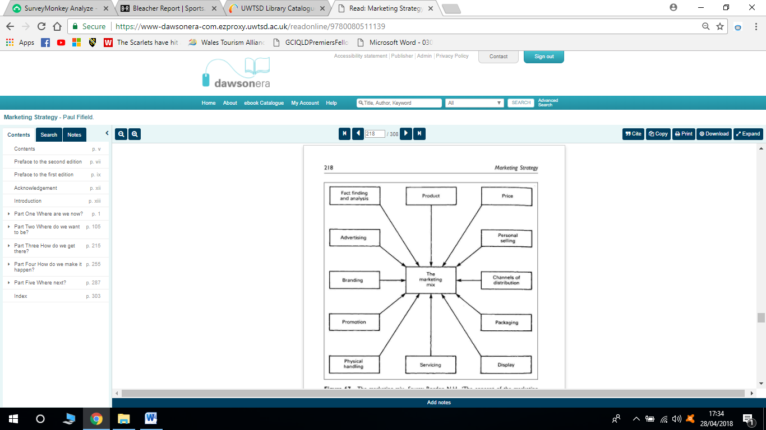 (Fifield, 2012)
  - Questionnaire sample

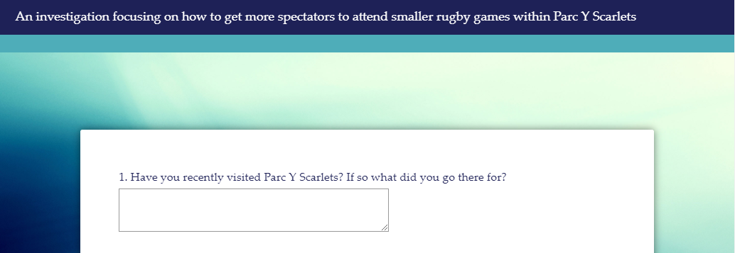

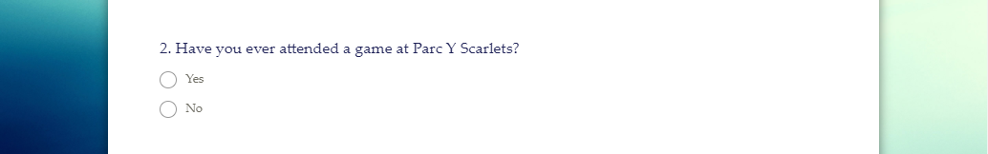

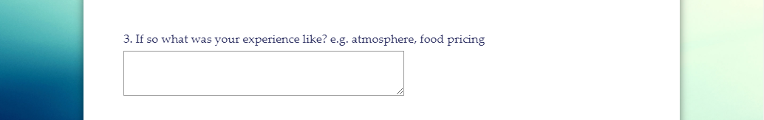

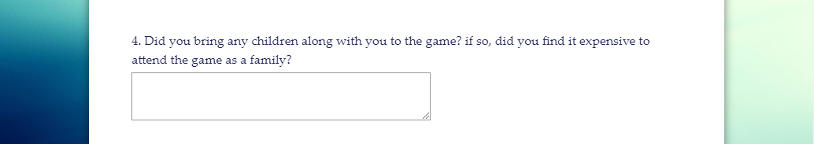

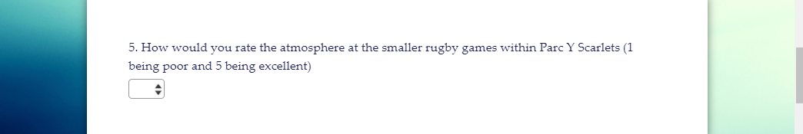

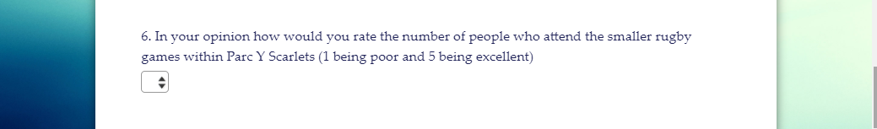

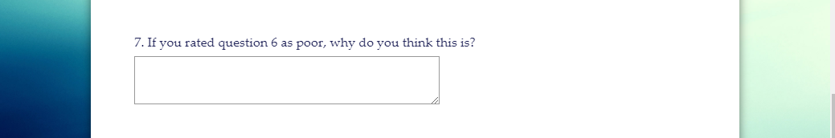

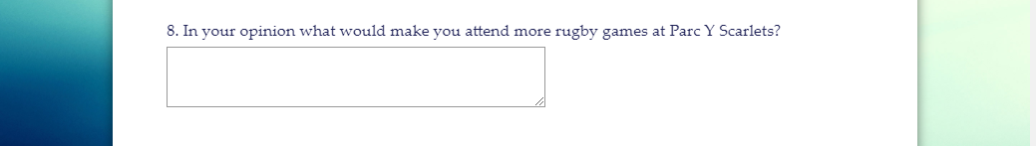

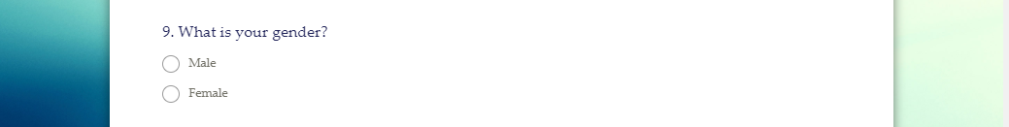

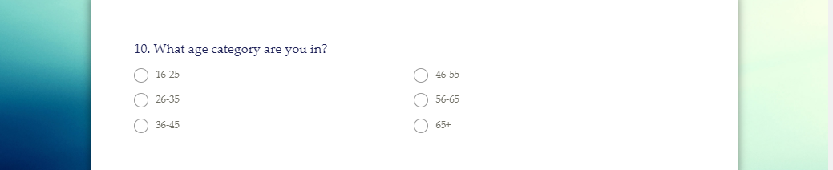
  - Minutes with client

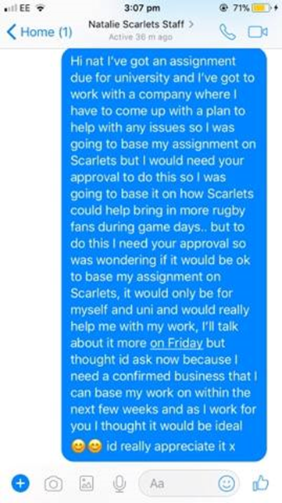

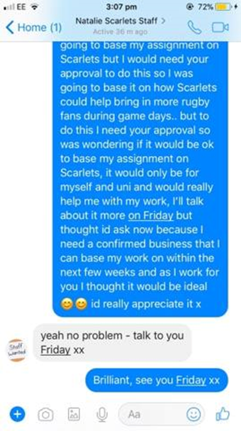

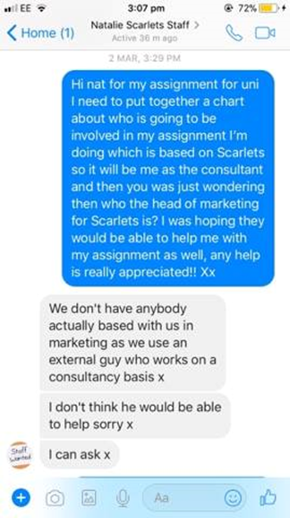

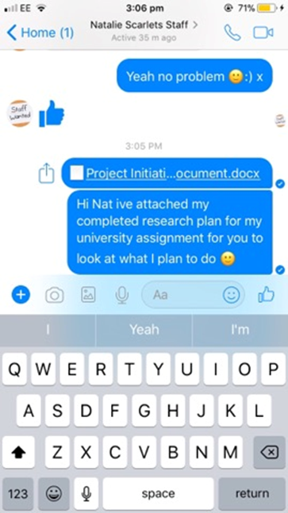

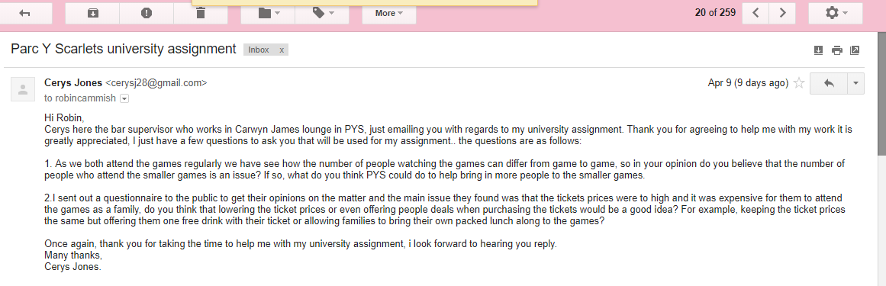

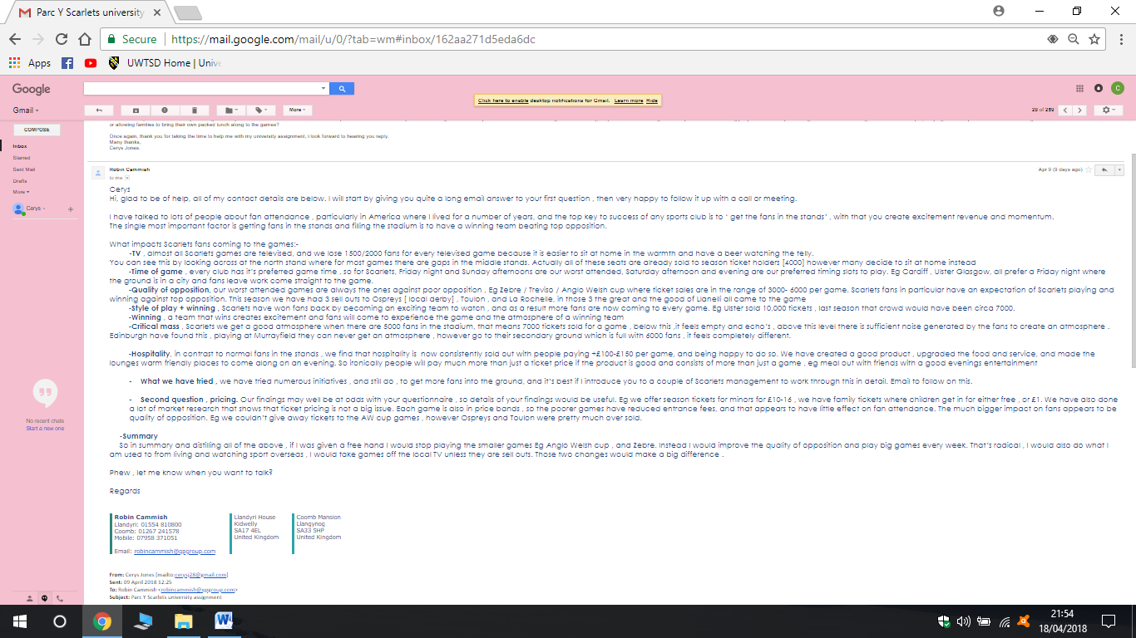

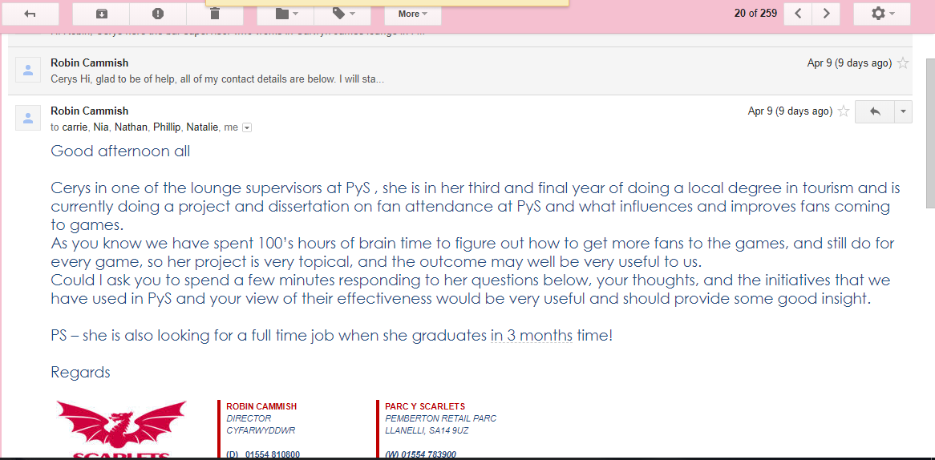

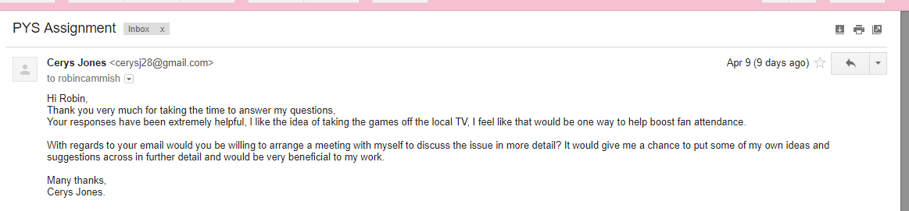

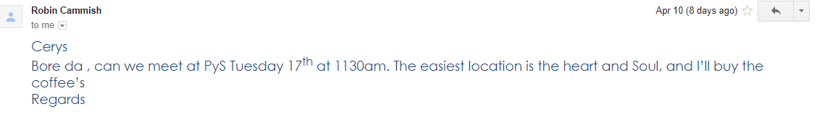
  - GANTT chart

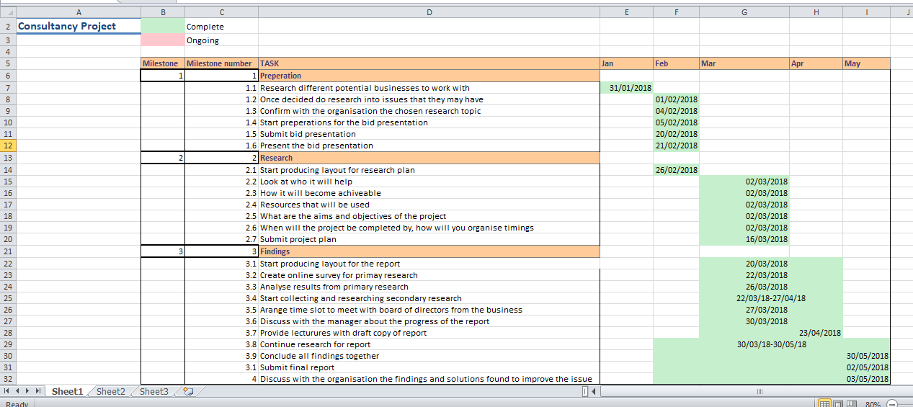

- References

Bibliography
Echo, G. C. (2015, Sep 14th). Kingsholm Stadium in Gloucester ranked among the very best Rugby World Cup 2015 grounds. Retrieved Apr 20, 2018, from southwestbusiness: http://www.southwestbusiness.co.uk/regions/gloucestershire/14092015162536-kingsholm-stadium-in-gloucester-ranked-among-the-very-best-rugby-world-cup-2015-grounds/
Fifield, P. (2012). Marketing Strategy. 2nd ed. Hoboken : Taylor and Francis 2012.
Klonas, R. B. (2011). Quantitative methods in tourism. Bristol: Channel view publications.
Lewis, I. (2018, Mar 28th). Parc Y Scarlets gearing up for it's 'biggest game ever'. Retrieved Apr 19th, 2018, from Llanelli Online: http://llanellionline.news/2018/03/28/parc-y-scarlets-gearing-up-for-its-biggest-ever-game/
Mark Sunders, P. L. (2012). Research methods for business students. Harlow: Pearson.
Mick Finn, M. E.-W. (2000). Tourism and leisure research methods. Harlow: Pearson Education.
Paraskevas, L. A. (2008). Planning research in hospitality and tourism. Oxford: Elsevier Ltd.
Thomas, S. (2018, Mar 6th). The full story behind the BBC losing the rights to show PRO14 matches and what it means for rugby in Wales. Retrieved Apr 25th, 2018, from Wales Online: https://www.walesonline.co.uk/sport/rugby/rugby-news/full-story-behind-bbc-losing-14376276

