

LEVEL/ LEFEL 5
MODULE CODE: ACCC5004
WEB DEVELOPMENT by

Aleksandar Nedelchev
BCs Cloud Computing

Table of Contents

1. Introduction 3
2. Research Literature 3
3. Introduction to application 4
4. Testing of the application 9
5. Evaluation 13
6. Conclusion 13
7. Reference 15
8. Appendix 16

Introduction
PHP applications are effective tools for carrying out functions of software over web platforms. These do not require any independent platform and can be hosted in an existing domain using framework designs. This study focuses on the PHP frameworks that are used by developers for creating web-based applications. An online database along with the web application for student management is explained in the following sections. XAMPP server is used for hosting the database and linked with the web application so that data can be stored and retrieved from the database via this web application of student management.

Research Literature
There are various PHP frameworks that are used by web application developers for the PHP coding process. These frameworks are function libraries and systems for carrying out the coding and programming process. Different types of PHP mainframes provide different sets of execution platforms that generate varied levels of performance indicators in the web applications (Odeh, 2019). This also provides a wide range of functional frameworks that not only improves the web application but also makes the process of PHO coding simple. Few of these PHP frameworks are discussed and analyzed here for better understanding of the process.
Laravel: It is one of the most popular PHP frameworks that provide a wide variety of efficient syntaxes and functions to work with. For the purpose of building a modern web application using PHP, Laravel provides the most critical parts that reduce time consumption. Few of the major activities that are vital for PHP application development like the user authentication and session’s management are already taken care of by this framework (Hostringer, 2020). It not only integrates multiple functions and add-ons but also aligns third party platforms and functional libraries.
One of the third party libraries that Laravel is compatible with is the Amazon Web Services. Few of the key features in this are add-ons for enhancing core functionalities of the PHP application. As stated by Prokofyeva and Boltunova (2017), there are various built in functions as well that makes the developer’s work simpler like caching, routing as well as system user management. In order to better the system performance, tasks in this mainframe are run asynchronously to improve efficiency and speed. This makes Laravel one of the most popular PHP frameworks.
CodeIgniter: This framework is much smaller in size and has concise functionalities but has an effective toolkit that allows developers to carry out various PHP development functions. This tool is favored by PHP developers as it provides a framework for application development using the MVC architecture (Hostringer, 2020). MVC is the architecture that divides a framework in terms of its specific tasks for specific development scenarios. This enables the developers to use the tool for PHP application development in a small footprint.
For new developers, this tool is the best because of its highly descriptive documentation of each library function and internal features. At the same time, its concise set of functionalities makes its lightweight and easier to use. However due to irregular releases, this framework is not the best for security standards. According to Bashir et al. (2016), this makes the framework prone to intrusion and sudden collapse that may not be identified due to its concise functionalities. Still, its MVC architecture is well known and is used by developers for detailed and phase wise PHP application development.
Symfony: It is another popular PHP development framework that uses both selective framework and total framework function for better usability of the project function libraries. This is also a selective function that developers can use to identify and shortlist only those functions that they would need for a project (Hostringer, 2020). There is also a secured built in testing mechanism that runs and tests the components of the application to generate better calibration and configuration settings.
Since there are various options to select functions for a particular PHP application, it is a highly flexible framework that ensures better usability of the system for an application. As opined by Miyaji (2016), it is vital for the developers to use this framework for better selectivity of the functional libraries and components. It is also useful as it has in build testing functions for component testing while the project is currently going on that enables for an error free system in the web application platform.

Introduction to application
The website application is designed using relevant PHP frameworks for better designs and ease of PHP coding process. This application is useful for students to manage their courses and its modules for appearing in the examination (Odeh, 2019). One of the most significant aspects of this application is the fact that it allows students to login and choose the course they want to apply for. The courses that are accessible in the database have defined modules for classroom sessions. Students must clear examinations first to receive the grade cards. There are multiple sections in the application that can be used by the students.
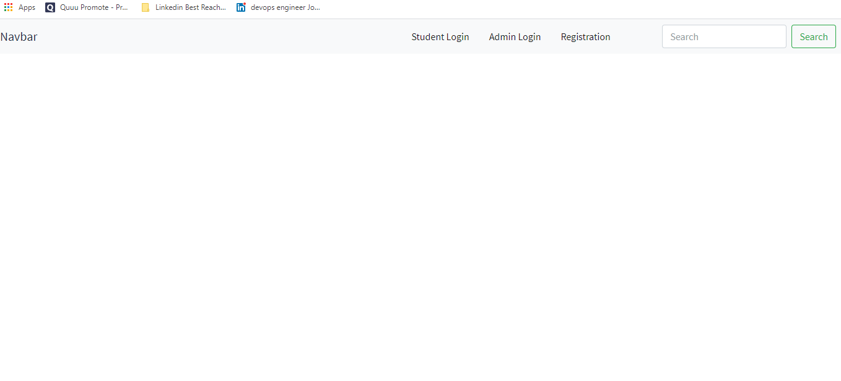
Figure 1: Application dashboard
Source: Created by author

The application dashboard is the first page of the application hosted in the Internet. As observed, it is a super type entity where both students and admin can login to their respective portals in the system. The registration environment is also provided in the image below [Refer to Appendix 1].
Student registration: This is the environment where the students register themselves in the system for generating a password and username. They need this for login in the system as stated in the below section. The areas that students must enter are their names, usernames, email, password for accessing the system and a mobile number [Refer to Appendix 2].

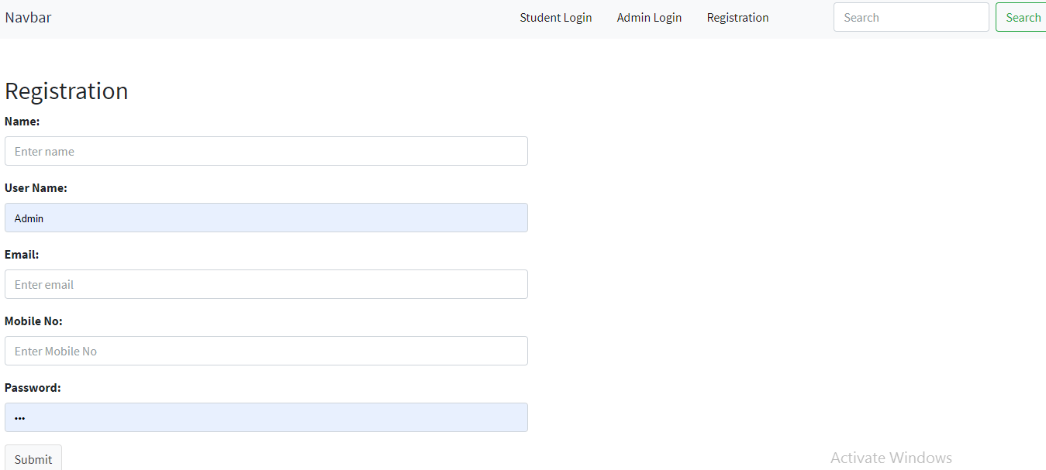
Figure 2: Student registration environment
Source: Created by author
Student login: Once, the student registers in the system, he has access to his username and password that he will use for login in the application. As observed from the login environment, the application has an effective student login process where the students route themselves from the dashboard call to function button of Student Login. As observed in the above image, students need to enter their username and password to access their portals [Refer to Appendix 3].

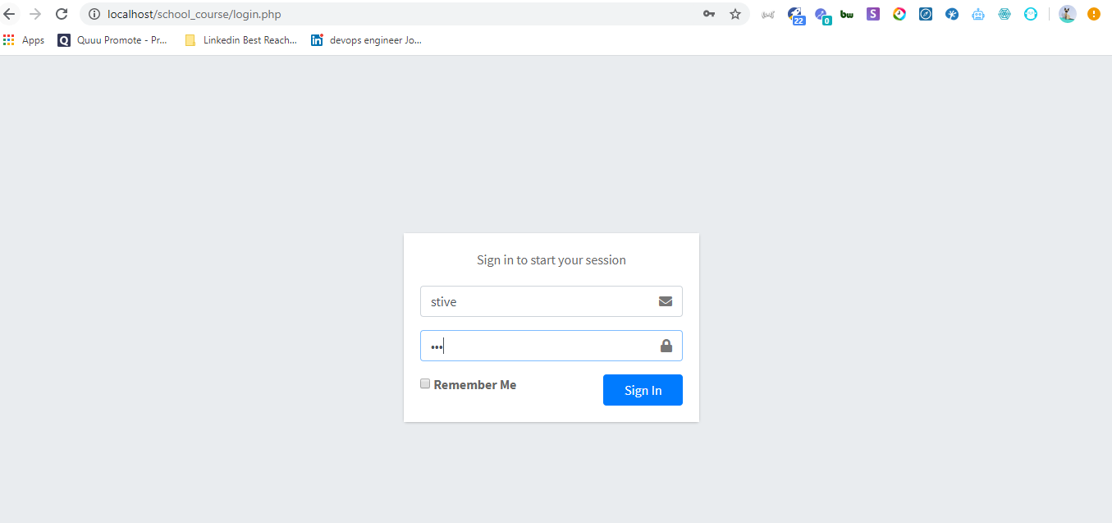
Figure 3: Application login environment
Source: Created by author

Courses addition: This is the section in the application that provides the various courses that a student can enroll for in the process. Every course is added in the system by the admin. The image provided below states the process in the application of adding a course for students to select from. As observed, the course name, its descriptions and supportive modules can be updated and entered to add a new course [Refer to Appendix 4].
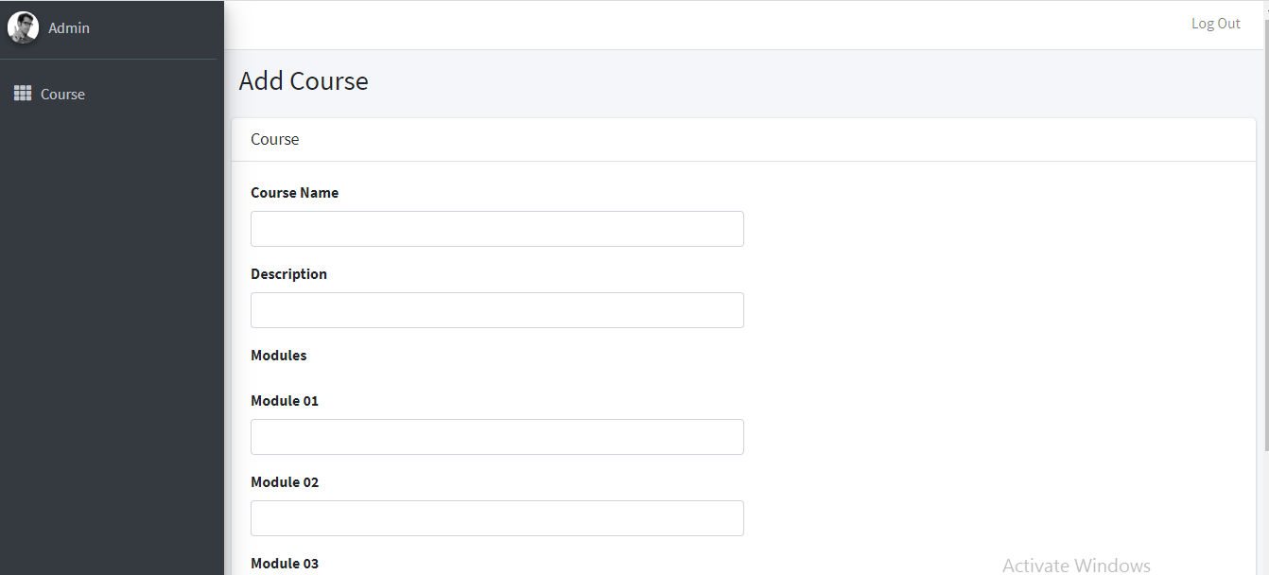
Figure 4: Course addition environment for Admin
Source: Created by author

Course list: The current system that is built using the PHP framework has four distinct courses for students to choose from. Every course is provided a unique Course ID for identification within the database. Few of the courses in the application are the Business Management and Business Management (Top-Up). A view button for each course is provided to see the detailed modules for each course that are described below [Refer to Appendix 5].

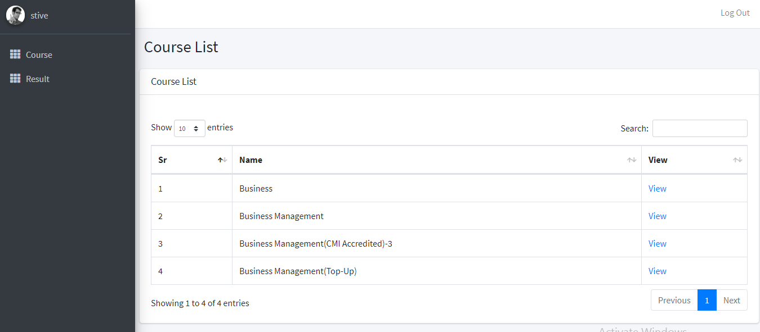
Figure 5: Current course list in the application
Source: Created by author

Course details: This section is provided for all the courses in the applications along with the details of modules that a student needs to choose. The File documentation link connects to the course details and respective modules that can be downloaded by the student upon admission in the course. As discussed, this menu appears after clicking on the view button in the main course dashboard. Respective courses have their own details and modules. The Apply for course button are used by the students to get access to the course application section in the application [Refer to Appendix 6].
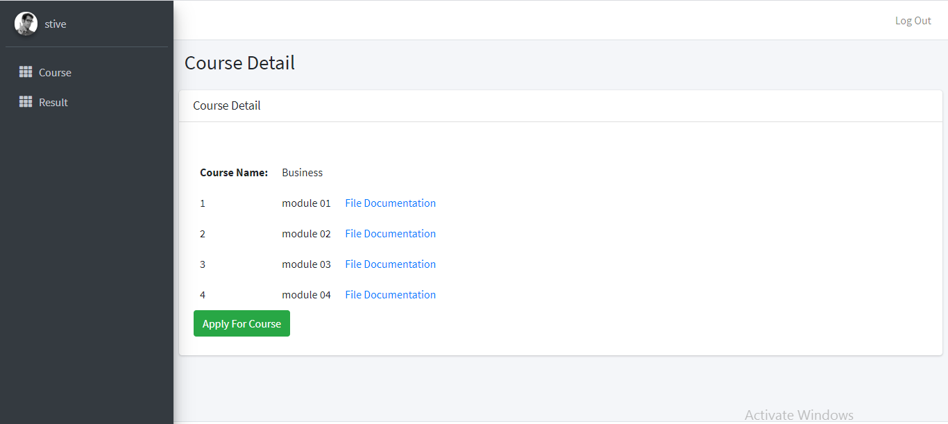
Figure 6: Course details in the application
Source: Created by author

Results: This is the section of the application where students can access their grade and marks of the examinations. As observed from the images, the name of the student is reflected with the list of the results. Each result row provides information like course appeared for, grade, marks, percentage and year of exam. Student can also use the log out button located in the top right corner of this page for logging out of the system after viewing the results [Refer to Appendix 7].

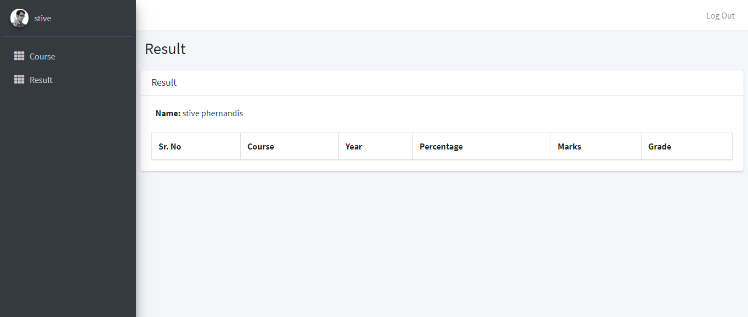
Figure 7: Results in the application
Source: Created by author

Testing of the application
The testing of the application is done at the database level to check the referential integrity of each system and understand the entity relationship between each application section. Hence, each of these units that are discussed earlier is checked for efficiency and stability. These include the login dashboard, user portal, course and module section and the results section. XAMPP server is used for this purpose to test the application backend.
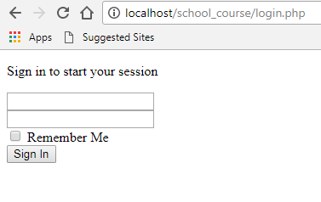
Figure 8: Login section of the application
Source: Created by user
The application is launched in the phpmyadmin localhost server so that both user and admin access is possible in the application. The first test that is done in part of the user access is the login environment where the user must enter login username and password to access the application. Once the access is done, the user must choose from a list of various options (Hostringer, 2020). As tested, a user can access the course, module and results sections of the application. This section provides screenshots of all relevant sections that users and admin have access to in the designed application for better demarcation of the application functionalities [Refer to Appendix 8].
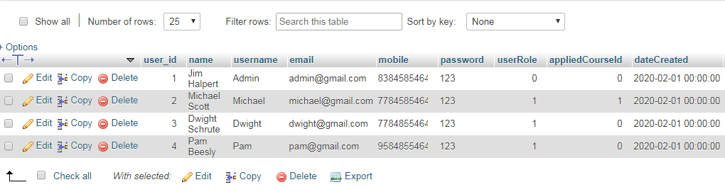
Figure 9: User section of the application
Source: Created by user
The testing for the course section is done as the main segments and features of this page are already discussed here. As observed from the screenshot, the section of Course selection in the database has multiple columns like Course ID, course names and description and creation date. Each of these columns has referential integrity as attributes of this dataset does not match with those of other data sets in the system. This ensures that this section is effective and can be made live for better implementation of the student management system [Refer to Appendix 9].

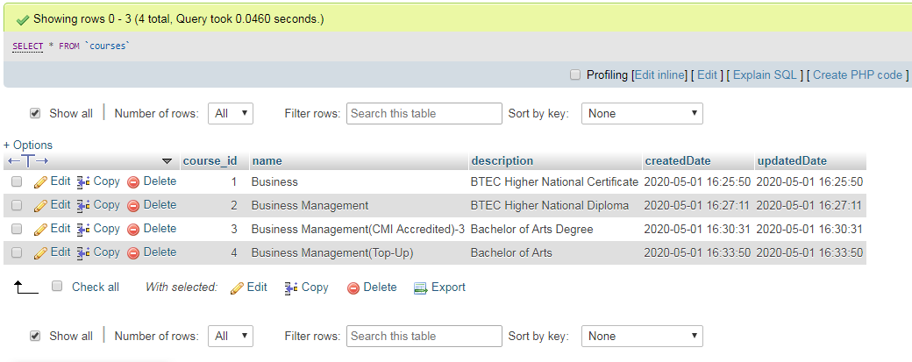
Figure 10: Course section of the application
Source: Created by user
The testing of the modules section is also done by checking the file systems of the uploaded files in the server. For instance, as observed in the screenshot of the module section, there are four defined columns for each data row. For instance, a data row has the course ID and the module ID along with the name of the module and the module files in the pdf format for better accessibility. Thus, as per the tests done on the system, there are no issues with the referential integrity of the system and documents uploaded in the application server are retrievable [Refer to Appendix 10].
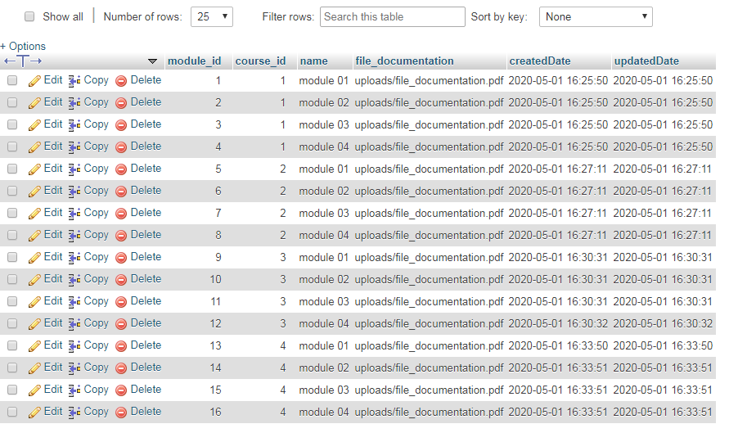
Figure 11: Module section of the application
Source: Created by user

The final application section for users is the result page where the students can check their marks and grade for each course. As observed in the screenshot, the results page hold details relate to the course ID and user ID so that there is no confusion in the results section. This page is also critical as one student can access only one course at a time. Once they pass the course, the student is eligible for applying for a new course. Hence, the set of student IDs for a particular course ID is unique to prevent duplication and coursework [Refer to Appendix 11 and 12].

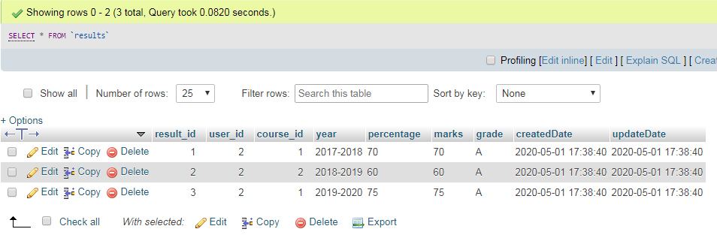
Figure 12: Result section of the application
Source: Created by user

Evaluation
I think that the application is ready to be implemented for real life scenarios. One of the best ways in which application can be used is the module and course management of students. It is the basic need of a student management system to allow both admin and users to access via a same portal into respective access pages (Bashir et al. 2016). Hence, this application helps the admin to add a course in the application and allows a student to select a course from the list. This is effective and useful for student modules and course management.
There are scopes for development in the application especially in the results page. In a way that the admin is uploading course module files for each course, in a similar way they can also upload the result reports in the results page for students to download. Application of the CodeIgniter framework can be useful for this purpose as it will divide the various functionalities of the system in various class functions for the application (Odeh, 2019). This will demarcate the courses and models in the application page and ensure website continuity even when one of the pages collapses in the application.

Conclusion
It can be concluded that online applications that are hosted in web platforms are not only simple but also effective as it renders less space and works with better efficiency. The PHP models of CodeIgniter and Laravel are also effective in this case as these consume lesser memory and perform with greater accuracy of database integration. In this case, the student management system designed and hosted is efficient and renders a great level of course selection service for students. There is efficient demarcation of application access and user privileges that allow both the admin and student to use this tool for course addition and course registration respectively.

Reference
Bashir, G.M.M., Hoque, A.S.M.L. and Nath, B.C.D., 2016. E-learning of PHP based on the solutions of real-life problems. Journal of Computers in Education, 3(1), pp.105-129.
Hostringer, 2020 8 Best PHP Frameworks for Web Developers Available at: https://www.hostinger.com/tutorials/best-php-framework [Accessed on 30 April, 2020]
Miyaji, I., 2016. Comparison of term recognition and awareness in blended classes of JavaScript and PHP programming. Asian Education Studies, 2(1), p.28.
Odeh, A.H., 2019. Analytical and Comparison Study of Main Web Programming Languages‒ASP and PHP. TEM Journal, 8(4), pp.1517-1522.
Prettyman, S., 2016. Learn PHP 7. Apress.
Prokofyeva, N. and Boltunova, V., 2017. Analysis and Practical Application of PHP Frameworks in Development of Web Information Systems. Procedia Computer Science, 104, pp.51-56.

Appendix
Appendix 1
Figure 1: Application dashboard
Source: Created by author

Appendix 2
Figure 2: Student registration environment
Source: Created by author

Appendix 3
Figure 3: Application login environment
Source: Created by author

Appendix 4
Figure 4: Course addition environment for Admin
Source: Created by author

Appendix 5
Figure 5: Current course list in the application
Source: Created by author

Appendix 6
Figure 6: Course details in the application
Source: Created by author

Appendix 7
Figure 7: Results in the application
Source: Created by author

Appendix 8
Figure 8: Login section of the application
Source: Created by user

Appendix 9
Figure 9: User section of the application
Source: Created by user

Appendix 10
Figure 10: Course section of the application
Source: Created by user

Appendix 11
Figure 11: Module section of the application
Source: Created by user

Appendix 12
Figure 12: Result section of the application
Source: Created by user

