
ProblEM-Solving and decision making
Understanding and Solving the complex problem of Staff Absenteeism in Mid Cheshire Hospitals NHS Foundation Trust (MCHT).

April 8, 2022
UNIVERSITY OF WALES TRINITY ST DAVID
BMSW4004
NAME: MAGDALENA SIEMIATKOWSKA
STUDENT NUMBER: 2110059
LECTURER: DR CHIJIOKE UBA

Table of Contents

Introduction 2
Problem’s definition, nature & impact 2
PESTEL Analysis to understand the external factors causing the problem 3
Using the Cause-and-Effect Fishbone Analysis to identify causes and sub causes of the problem 5
Evaluating possible solutions using GRID Analysis 7
GRID Analysis over Staff Absenteeism 9
Plan of implementing chosen decision to solve Staff Absenteeism issue 10
Discussion of success indicators to measure the effectiveness of the implementation of the chosen decision 13
Conclusions 14
References 16

Introduction

The goal of this research is to discuss the problem of staff absenteeism in Mid Cheshire Hospital and to discuss the problem solving and decision-making approach added to come up with a solution to the problem.
To solve this problem, the first step is to identify it clearly, and to understand its nature, scope and impact on the organization and its employees. This first step precedes the second, i.e., to understand the causes of the problem using relevant problem-solving tools and models.
Specifically the PESTEL and Fishbone analytic tools are used.
The PESTLE Analysis is selected instead of SWOT considering the type of problem faced to identify Political, Sociocultural, Economic, Legal, Technological factors (and it’s more detailed form).
The fishbone analysis is employed to discover and highlight the problem's causes and sub-causes, allowing for creative, detailed evaluation (Olson & Fagen, 2007).
Drawing from the PESTLE and Fishbone analysis to identify the main causes, possible solutions that target these causes are identified. The GRID analysis is then employed to analyse the posssible solutions to identify and choose the most appropriate solution that’ll be implemented to solve the problem. The Grid method is applied because it not only considers different aspects but also their quality. It’s a very useful tool for decision-making complexity-staff absenteeism (Kalinchenko, 2021).
These tools will assist in making decisions that are in the best interests of the organisation, staff, and patients.
Finally, the conclusion elaborates on the issue’s assessment and the solution discovered to comprehend the rationale for the judgments made and how they were applied.

Problem’s definition, nature & impact

The Problem Mid Cheshire Hospital Trust is facing staff absenteeism which is characterized as failing to show up for work on time and is assessed by the length of time skipped. It can be classified as unintended/authorized or optional/disapproved (Duclay, et al., 2015).
Due to high absenteeism, the use of temporary personnel increased. The annual average of Mid Cheshire NHS Trust grew from 2007 to 2012. The intention was to decrease staff absenteeism, however, a few inspections revealed that this was not the case.

Scope of the Problem
The issue faced by MID Cheshire Hospitals NHS Trust is a difficult one (Olson & Fagen, 2007). It has internal & external factors. The scope is UK wide problem.
Impact of the Problem
The problem impacts the Mid Cheshire Hospital employees which is seen by high level of staff absenteeism.
The impact on the hospital is seen by each year as the absence was costing the NHS Trust over £1 million in lost revenue.
This issue has got also impacted the clients by long waiting lists appointment due to insufficient number of hospital staff.
Resulting in:
Degrading service quality because of a rise in the use of seasonal/agency workers, stress, workers de-motivation, the overwhelming volume of need with the consequences of increasing demand on medical staff, facilities, poor quality service.

PESTEL Analysis to understand the external factors causing the problem

Pestel has been put in place to understand the external variables causing the problem. This method is designed to examine a program’s Political, Economic, Social, Technological & Legal Implications (Bruin, 2016).
It has been applied here to consider the external environment before commencing a project. It’s an analytical tool for business strategy, good for identifying all potential risks, difficulties; a conceptual approach to assessing the effects of a venture (Rastogi & Trivedi, 2016).
PESTEL analysis is a method for analysing external concerns that can both benefit and harm a company. It's used to spot business opportunities, risks, and aids in determining the level of change that benefits the company and in planning the change's path. It helps prevent future harm to the company, such as approaches/capabilities (Pathak, 2020).
It’s an examination of different answers to complicated issues with the goal of selecting the best answer (Tsanqas, et al., 2019).
A Pestle Analysis revealed 4 main external factors linked to staff absenteeism: Political, Economic, Sociocultural, Technological (Warner & Zaranko, 2021).

POLITICAL FACTORS
• Covid regulations post-Brexit; unknowns about how EU drugs/gear will be transformed to the UK.
• Many medical experts are from EU nations.
• Immigrants have worse living conditions.

ECONOMIC FACTORS
- Because of the financial crisis (2008), the globe faced recession in the economy, with the effect on NHS, which has been struggling financially due to economic & legal purposes, making it hard for NHS to supply adequate patient healthcare to its clients.
- This has been evidenced in serious staffing issues.
- The NHS isn’t an appealing employer for healthcare specialists because of its low pay.
SOCIOCULTURAL FACTORS
- Ageing population- the elderly have more serious health issues (diabetes/various cancers).
- Big patient expectations- client’s standards are increasing now more than before the rise of social media, enhanced education sector,
- Sick people often have a better understanding of the medical options, anticipate government bodies to pay any price on hospitalization,
- NHS is expected to continue providing better healthcare than it has ever been.
- Increase health consciousness from COVID, fear of contracting the virus.
TECHNOLOGICAL FACTORS
Technological improvements in healthcare have substantially enhanced the NHS system's quality.
- The NHS has integrated new technologies to provide good treatment; innovation has increased clinical training.
- This gives more trained staff for the NHS to handle; while the NHS still faces personnel issues, there appears to be hoped that modern health organisations can help alleviate this problem (Coker, 2018).

Using the Cause-and-Effect Fishbone Analysis to identify causes and sub causes of the problem

Kaoru Ishikawa created the Fishbone Diagram (Japan, 1960), which is now recognised as one of the best quality management tools for understanding the cause of the problems. The model assumes the form of a fish, with the head representing the main issue and sub causes- bones (Wong, 2011).
The Cause and Effect Analysis is divided into two parts; it's designed to glimpse for seeing what had happened before, and then to think ahead to plan for the upcoming; it’s one of the most extensively utilized, successful problem-solving techniques.
The Fishbone diagram done for the problem of staff absenteeism is presented below.

Figure 2.
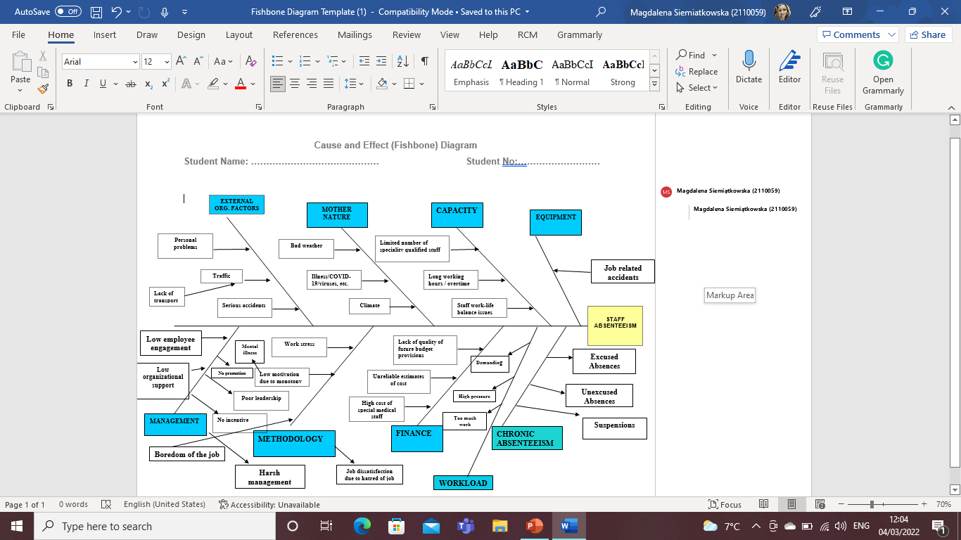
Source: Author.

Using the diagram efficiently requires a few steps: highlighting the main problem, determining the main components, writing them down, then possible sub causes. It's critical to share the problem's potential sources with staff and affected parties to help solve it (East Midlands Improvement Network and Dave Young, 2008).
According to the diagram, the main problems are finance, workload, chronic absenteeism, methodology, management, equipment, capacity, mother nature and organizational external factors followed by sub causes:
- Finance: poor future budget provisions, unreliable cost estimates, high special medical staff costs,
- Workload: high demands, pressure, work overload,
- Chronic absenteeism: excused and unexcused absences, suspensions,
- Methodology: workplace stress, low motivation due to monotony, boredom, dissatisfaction,
- Management: low employee engagement, lack of incentive and promotion cause mental illnesses, poor leadership.
- Equipment: job-related accidents,
- Capacity: lack of specialised staff, long workdays/overtime, and issues with work-life balance,
- Mother nature: bad weather, viruses, climate,
- External organizational factors: personal issues, traffic, transportation, accidents.

In sum, unusual, fundamental origins should be recognized and memorized for an Ishikawa overview to help teams remember details while solving problems (Wong, 2011) and to fix a problem it’s essential to understand its roots (Okes, 2019).
A Fishbone Diagram is relevant for understanding the causes of problems. The Mid Cheshire Hospital Problem was understood and analysed using a Fishbone Diagram (Lewis, 2020).

Evaluating possible solutions using GRID Analysis

Fishbone highlights 4 main chosen causes: Capacity, External organizational factors, Management, Workload and PESTEL highlights factors: Political, Economic, Sociocultural, Technological. Drawing from these, the next step was to identify possible solutions that target the main causes, and to evaluate them such that the most appropriate one can be chosen.
A Grid Analysis was used for the evaluation because it not only considers different aspects and their quality but it’s a useful tool for decision-making complexity (Kalinchenko, 2021).
A well-thought-out nonappearance plan supported by the official's tools can reduce absenteeism. The number of permitted leaves, time frame for requesting leaves, whom to contact, the consequences for non-compliance should be clearly stated.
The possible solutions that were identified and evaluated using the GRID analysis are as follows:
1. Appropriate Compensation-this solution addresses the main cause; Financial issues.
Employees frequently engage inside hustles to make up for low pay. They don't care about work when they're involved in these activities. This will undoubtedly lead to absenteeism. As a result, paying employees adequately keep them within their jobs.
2. Working environment & employee feedback
No solution is possible without appraisals. It's undeniably the most important step before seeking a solution. It helps to know how employees view their workplace.
3. Adaptable schedule
Every sophisticated workplace requires flexibility. These arrangements keep employees engaged and reminds them of their duties. It's well-known that employees who do important, enjoyable work look better than their peers. Companies should take care to ensure the same.
4. Wellness & health programs
The rapid increase in staff responsibilities has made it difficult for them to relax, resulting in several health issues that affect their availability at work. Employee health initiatives may help solve this issue. Wellness programs are designed to work alongside an employee's regular work schedule. Thanks to technological advancements, implementing wellness initiatives has never been easier.

GRID Analysis over Staff Absenteeism

Figure 4.
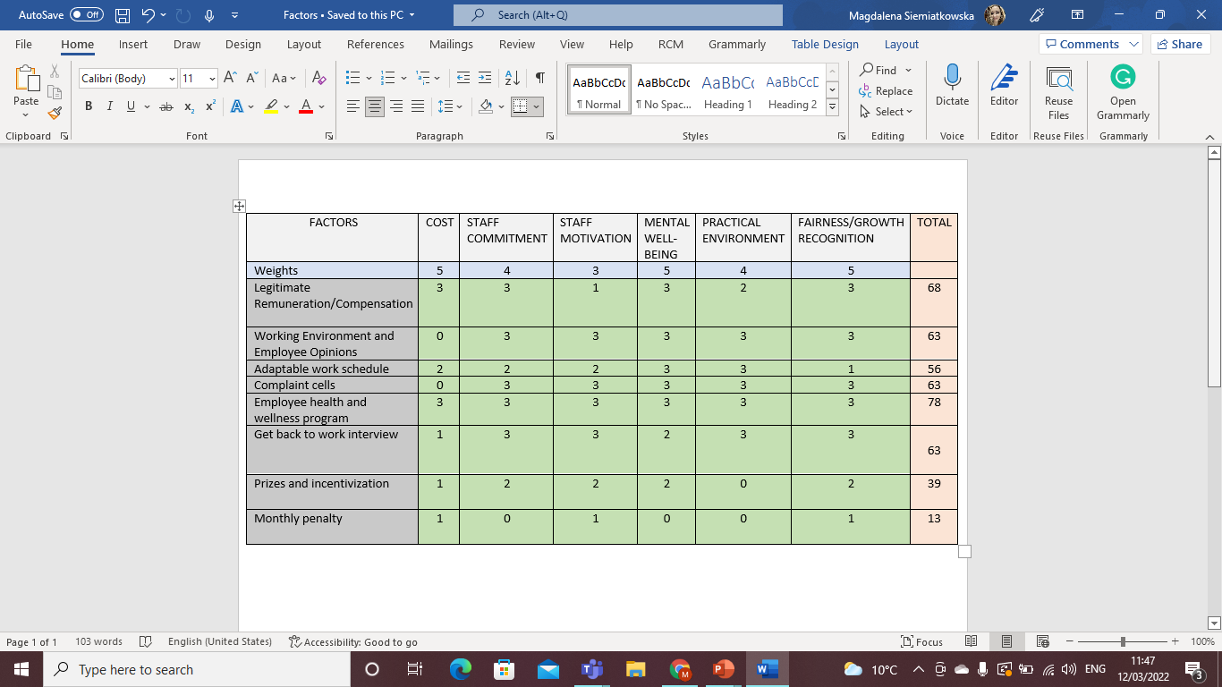
Source: Author.

Based on the conducted GRID analysis for the staff absenteeism problem, the Employee health & wellness program is the best solution with a total score of 78.

Plan of implementing chosen decision to solve Staff Absenteeism issue

The first step to implementing any solution is to come up with relevant plans of action. Specifically, the actions that need to be done before implementation, including what these actions are, when they will be done, and who will be responsible for doing them. This is the action plan before implementation.
This has been done for the Health & Wellness Program to help staff with their absenteeism and is presented in the table below.

Employee Health and Wellness Program Action Plan

Actions | Description | Time frame | Staff responsible
Identify and document health and wellness needs | Speak with the departmental managers to completely identify wellness needs on staff based on staff queries/  Talk directly to the employees to try and identify the problem,  Talk to the wellness expert  Record the training needs | 1st May 2022-8th May 2022 | Line manager
Identify Trainees | Speak with the Departmental Manager to determine who needs the program the most.  Send the list to the Human Resources department. | 9th May 2022-11th May 2022 | Training committee
Find a trainer  Prepare training schedule | The Training Committee would debate and determine whether to hire outside health & wellness trainers or hold internal training sessions.  Finalise arrangement with the internal or external trainer  Prepare a training schedule and share it with departmental supervisors. | 11th May 2022-15th May 2022  15th May 2022-16th May 2022 | Training Committee  Training committee

When the Action Plan before implementation is okay and the solutions are implemented, it’s important to monitor them, to make sure that things are going well. To do this, a plan detailing how the solution will be monitored needs to be developed.
For the chosen solution, the monitoring plan has been developed as in below:
Monitoring
 | Description | Time Frame | Staff responsible
Participation  Engagement | % Of trainees who participated in the staff health & wellness program  Average learner satisfaction rating/other forms of involvement such as comments, questionnaires, surveys, feedback forms, etc. | Daily  Daily | Internal auditor  Training committee
Learning | Average score attained by health and wellness specialists in a well-thought-out evaluation. | Weekly | Training committee

Evaluation
Success Indicator(s) | Data source/information collection method | Time frame | Staff responsible
Employee feedback | Paper questionnaires,  Surveys, Online reviews | Weekly | Management,  Medical Directors

Source: Author

Discussion of success indicators to measure the effectiveness of the implementation of the chosen decision

Understanding a company's key corporate metrics requires basic knowledge in today's modern corporate world (Alles, et al., 2005).
When there is a significant change in the staff structure at Mid Cheshire Hospital, new statistics are required. A few months later, the transformation's outcomes may be seen as distinct, or perhaps identical. Setting realistic goals keeps the company engaged and eager to take on new challenges.
Getting employee feedback via multiple channels is critical to understanding employee reactions to change and staying on track. People need to be heard, so leaders should give workers one-on-one feedback. Surveys can help companies get more responses to relevant questions and determine if more changes are required.
According to GRID, the NHS staff Health and Wellness Program is the best solution. It encompasses all workplace healthcare initiatives. Games, competitions, and exercise are common.
Wellness programs at Mid Cheshire Hospital and the NHS empower staff to make positive lifestyle changes and reduce staff absenteeism by improving personal affairs.

Conclusions

The current paper highlighted a variety of approaches that can be used to solve a problem in a corporation.
The PESTEL analysis was chosen over the SWOT analysis because it’s the most appropriate option based on the nature of the problem; it has proven successful if it’s carried out with the participation of anyone willing to participate in but could also be affected by the effect stated in the preceding report.
The Fishbone diagram was one of the techniques used in this report. It identified the problem’s root cause and created a plan to address it.
It has been demonstrated using the GRID tool that it’s feasible to make appropriate decisions.
Following the creation of a plan, the research shows the importance of constantly monitoring the outcome, as well as regularly reviewing the staff. The final decision must also be communicated to employees via appropriate channels to ensure everyone is aware of the upcoming changes.
This study provided a variety of solutions and decision-making tools to help Cheshire Hospital NHS Trust make the best decision possible.
With an ageing population, Brexit uncertainty and modern technology, the NHS is under pressure. While absenteeism has its benefits, it is a costly issue that management must address. Worker absenteeism has many causes, and each employee's behaviour is unique.
Employees may achieve challenging tasks and feel more connected and accomplished.
As a result, changes were necessary to keep the hospital operating and provide treatment for the patients with the best solution to address for the staff-Health & Wellness Program.

References

Alles, M. G., Brennan, G., Kogan, A. & Vasarhelyi, M. A., 2005. Continuous monitoring of business process controls: A pilot implementation of a continuous auditing system at Siemens. International Journal of Accounting Information Systems, 7(2), pp. 137-161.
Bruin, L. d., 2016. Business to you. [Online]
Available at: https://www.business-to-you.com/scanning-the-environment-pestel-analysis/
[Accessed 9 March 2022].
Coker, J., 2018. EMG-Health. [Online]
Available at: https://www.emg-health.com/omnipresent/challenges-and-solutions-in-the-national-health-service-nhs/
[Accessed 15 March 2022].
Duclay, E., Hardouin, J., Sébille, V. A. E. & Moret, L., 2015. Exploring the impact of staff absenteeism on patient satisfaction using routine databases in a university hospital.. Journal of nursing management, 23(7), pp. 833-841.
East Midlands Improvement Network and Dave Young, 2008. Quality improvement. [Online]
Available at: https://qi.elft.nhs.uk/resource/cause-and-effect-diagram-fish-bone
[Accessed 3 3 2022].
Kalinchenko, D., 2021. Rationalize.io. [Online]
Available at: https://rationalize.io/2021/03/09/using-grid-analysis-for-idea-evaluation/
[Accessed 7 March 2022].
Lewis, S., 2020. Tech Target. [Online]
Available at: https://whatis.techtarget.com/definition/fishbone-diagram
[Accessed 7 March 2022].
Okes, D., 2019. Root Cause Analysis-The Core of Problem and Corrective Action.. 2nd ed. Milwaukee, Wisconsin: American Society for Quality, Quality Press.
Olson, S. & Fagen, A. P., 2007. Understanding inteventions That encourage Minorities to Pursue Research Careers: Summary of a Workshop. 1st ed. Washington: National Academies Press.
Pathak, R., 2020. Analytic steps. [Online]
Available at: https://www.analyticssteps.com/blogs/what-pestle-analysis
[Accessed 4 March 2022].
Rastogi, N. & Trivedi, M. K., 2016. Pestle Technique-A tool to identify external risks in construction projects.. International Research Journal of Engineering and Technology (IRJET), 3(1), pp. 384-388.
Team, F. F., 2017. Full Fact. [Online]
Available at: https://fullfact.org/health/what-is-the-nhs/#:~:text=The%20NHS%20stands%20for%20the,nurse%20at%20a%20doctor's%20surgery
[Accessed 9 March 2022].
Tsanqas, M., Jequirim, M., Limousy, L. & Zorpas, A., 2019. The Application of Analytical Hierarchy Process in Combination with PESTEL-SWOT Analysis to Assess the Hydrocarbons Sector in Cuprus. Energies (Basel), 12(5), p. 791.
Warner, M. & Zaranko, B., 2021. Institute for Fiscal Studies. [Online]
Available at: https://ifs.org.uk/publications/15606?gclid=CjwKCAiAvaGRBhBlEiwAiY-yMHPdxNBTzNb9UZr5acRxJOBbHPmXL4yVxk-x41HPbCHIqjPXD8e5NBoC9EoQAvD_BwE
[Accessed 10 3 2022].
Wong, K. C., 2011. Using an Ishikawa diagram as a tool to assist memory and retrieval of relevant medical cases from the medical literature. Journal of Medical Case Reports, 5(1), pp. 120-120.
Wong, K. C., 2011. Using an Ishikawa diagram as a tool to assist memory and retrieval of relevant medical cases from the medical literature. Journal of Medical Case Reports, 5(1), p. 1.

