BUSINESS PLAN
SMART CHOICE CARS LTD

1. Title Page
Student Name: Vladislavs Suhankins
Student ID: 24303951
Programme: Certificate in Higher Education Business Skills for the Workplace
Module: Enterprise and Entrepreneurship
Module Code: LCLM4006
Assignment Title: Individual Written Business Plan
Lecturer: Dr Charles Obinwa
Submission Date: 24 November 2025

2. Table of Contents
- Overview of the Business Idea
- Environmental Analysis (PESTEL)
- Marketing Management Structure
- Marketing Strategies
- Funding Requirements and Startup Costs
- Conclusion
- Reference List

3. Overview of the Business Idea
SmartChoice Cars Ltd is a business that I am planning to establish in East London, focusing on the sale of dependable used vehicles both online and from a small sales yard. The aim of the company is to provide customers with a simple and trustworthy buying process, offering a more customer-friendly alternative within the second-hand vehicle market.
The idea for this business is based on my professional background.I have spent eight years working as a sales manager at Pegasus Motors Ltd. During this time, I developed strong skills in vehicle sales, communication, customer relationship management and handling the full sales process from first enquiry to final handover. This experience has shown me how important transparency and service quality are for buyers, and it has given me the confidence and knowledge required to start my own company.
I decided to register the business as a private limited company (LTD) because this structure offers protection to the owner. In an LTD, financial responsibility belongs to the company itself, meaning that the director is not personally liable for business debts. This legal format also increases trust with suppliers and financial institutions, which is particularly important in the motor trade.
At the early stage, SmartChoice Cars Ltd will operate with a simple management approach. I will take responsibility for purchasing vehicles, daily operations and financial decisions. To keep expenses low, external services such as accounting, MOT checks and digital marketing will be outsourced instead of employing full-time staff. Choosing East London as the location provides several advantages, including good transport links, a large customer base and access to nearby car auctions.
In the first year, the company will specialise in used cars priced between £3,000 and £10,000, focusing on popular and cost-efficient models like the Ford Fiesta, Toyota Yaris and Vauxhall Astra. The main goal is to build a reputation based on honesty, clear vehicle history and reliable customer support, creating a solid foundation for future development, including the potential introduction of used hybrid and electric vehicles as demand continues to grow.

4. Environmental Analysis (PESTEL)
Political
UK regulations affect all used-car businesses, including requirements from Trading Standards, advertising accuracy and mileage transparency. The Consumer Rights Act protects buyers, meaning vehicles must be sold in roadworthy condition. Brexit-related changes have increased complexity for importing cars; however, SmartChoice Cars Ltd will source vehicles from the domestic market, reducing exposure to political and trade uncertainties.
Economic
High living costs and inflation have influenced consumers to choose used vehicles instead of purchasing new ones. According to Statista (2024), the UK used-car market remains valued at over £45 billion annually, showing strong resilience even during economic instability. Finance options such as instalment plans and hire purchase are increasingly popular among younger buyers, creating opportunities for dealerships that offer flexible payment solutions.
Social
Demand for personal transportation remains high in urban areas, particularly among workers in logistics, healthcare and hospitality sectors who require reliable vehicles. Customers increasingly expect convenient online browsing and transparent information before visiting a dealership. Trust has become a key factor in used-car purchasing decisions, meaning warranties, history checks and customer reviews are essential for building credibility.

Technological
Technology is reshaping car-buying behaviour. Online platforms such as AutoTrader allow customers to compare prices easily. SmartChoice Cars Ltd will invest in a user-friendly website, digital advertising and virtual vehicle tours to reach customers beyond walk-in traffic. Digital tools will also support operational efficiency, including vehicle history checks, online payments and customer data management in line with GDPR requirements.
Environmental
Growing awareness of environmental impact is shifting interest toward low-emission and hybrid vehicles. Although the business will initially focus on petrol and hybrid used cars, future expansion into pre-owned electric vehicles aligns with London’s Ultra Low Emission Zone (ULEZ) policies. Responsible disposal of materials such as tyres, oil and batteries will follow environmental standards to minimise ecological impact.
Legal
Operating as an LTD requires registration with Companies House, appropriate insurance and compliance with data protection laws. VAT registration becomes necessary when turnover exceeds £85,000. The Consumer Rights Act gives customers the right to return faulty vehicles within 30 days, requiring SmartChoice Cars Ltd to maintain high inspection standards. Clear documentation and accurate advertising will reduce legal risks.

5. Marketing Manager Structure
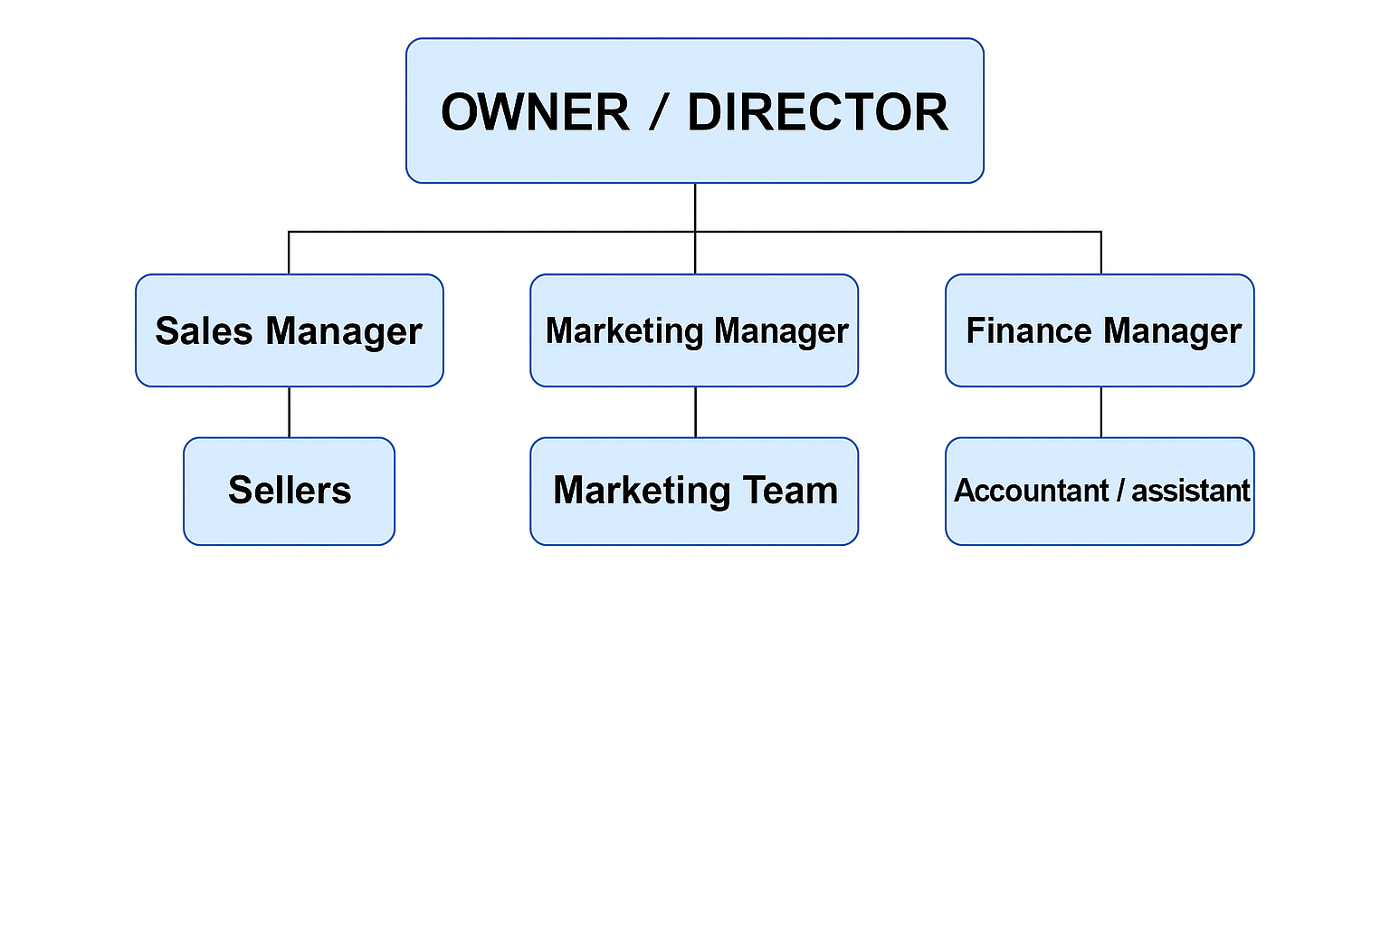
Owner / Director – The person who owns or leads the company. They make important decisions and manage the whole business.

Sales Manager – The person who controls and supports the sales team. They make sure products or services are sold well.

Sellers – People who talk to customers and sell the company products or services.

Marketing Manager – The person who plans how to promote the company. They manage advertising and social media to attract more customers.

Marketing Team – People who help the marketing manager. They create content, ads, and help with campaigns.

Finance Manager – The person who manages company money. They check income, spending, and make sure everything is correct.

Accountant / Assistant – The person who helps with financial records, pays bills, prepares invoices, and supports the finance manager.

6. Marketing Strategies
SmartChoice Cars Ltd will adopt a customer-focused marketing approach using segmentation, positioning and the 4Ps model to reach the target audience effectively.
Target Market Segments
- First-time buyers aged 18–30 seeking affordable cars under £6,000
- Families requiring a second vehicle with low running costs
- International students and new residents in East London
- Gig-economy workers (couriers and private-hire drivers)
Positioning and USP
The company will position itself as a trustworthy and transparent dealership offering:
“Reliable used cars with clear history, competitive pricing and flexible online-to-yard purchasing.”
Product Strategy
Stock will focus on vehicles with:
- full service history
- recent MOT
- low mileage where possible
- professional cleaning and inspection
Optional services will include extended warranties and breakdown cover to increase revenue and customer reassurance.
Price Strategy
Prices will be set using competitive benchmarking and AutoTrader valuation tools. No-negotiation pricing will reduce customer pressure and increase confidence. Promotional offers during quieter months may encourage sales consistency.
Place Strategy
Sales channels will include:
- a secure website with reservation deposits
- AutoTrader listings
- social media platforms
- a small East London yard for viewings and test drives
This hybrid approach reduces overheads while expanding reach.
Promotion Strategy
Promotional activities will include:
- targeted digital advertising in East London postcodes
- TikTok and Instagram video tours
- Google My Business optimisation
- customer referral incentives
- partnerships with local driving schools and mechanics
Customer reviews will support long-term reputation building.

7. Funding Requirements and Startup Costs
SmartChoice Cars Ltd requires initial funding to cover early operational losses and purchase initial stock. The company plans to use a combination of owner investment and external finance.
Funding Sources
- £18,000 owner’s capital
- £11,000 UK Start-Up Loan
- £5,000 overdraft facility for cash-flow protection
The Start-Up Loan is chosen due to low interest rates and mentoring support suitable for new LTD companies.

Startup Expenses – Table 1: Initial Startup Costs for SmartChoice Cars Ltd
Description | Amount
Yard rental deposit | £6000
Website development | £2000
Office equipment | £1500
Signage & Branding | £800
Legal & Registration fees | £700
Total | £11,000

Table 2: Fixed Monthly Costs
Description | Cost Per Month
Yard rent | £2000
Insurance | £800
Utilities | £150
Accounting services | £200
Total | £3,150

Table 3: Estimated Variable Monthly Costs
Description | Estimated Monthly
Fuel & Transport | £350
Car Cleaning & Valeting | £300
Advertising & Marketing | £450
Minor Repairs & Servicing | £500
Total | £1600

Table 4:Cash Flow Forecast For 6 Months
Month | Cars Sold | Net Profit (£) | Opening Balance (£) | Closing Balance (£)
Jan | 1 | -6000 | 22000 | 16000
Feb | 2 | -4000 | 16000 | 12000
Mar | 3 | -2000 | 12000 | 10000
Apr | 4 | 0 | 10000 | 10000
May | 5 | 2000 | 10000 | 12000
Jun | 6 | 4000 | 12000 | 16000

This investment will ensure the business can operate sustainably until profitability is achieved.

Conclusion
SmartChoice Cars Ltd is a business idea that builds on my eight years of experience as a sales manager at Pegasus Motors Ltd. During this time, I learned how important clear communication, transparency and fair pricing are when selling used vehicles. This experience led me to start my own company and offer a more customer-focused service in the East London market. The hybrid sales model, combining online browsing with the option to view cars in person, reflects current buying behaviour and gives customers greater convenience.Choosing an LTD structure provides limited liability and increases trust with suppliers and lenders. Financial projections show that although the business may face early challenges, cashflow should stabilise by the fourth or fifth month. In the future, I plan to expand stock levels and introduce used hybrid and electric vehicles as demand grows.

Reference List
Gov.uk (2024) Consumer Rights Act: Vehicle Sales Guidance. Available at: www.gov.uk (Accessed: 21 November 2025).
Jobber, D. and Ellis-Chadwick, F. (2020) Marketing Management. 10th edn. McGraw-Hill.
Kotler, P. and Armstrong, G. (2022) Principles of Marketing. 18th edn. Pearson.
SMMT (2023) UK Used Car Market Report. Available at: www.smmt.co.uk (Accessed: 18 November 2025).
Statista (2024) Used Car Market Value in the United Kingdom. Available at: www.statista.com (Accessed: 20 November 2025).

