

Applied Programmable Logic Controllers

Factory Control

ACDA6000

Luke Andersen (1603319)

Supervisor: Dr Adel Ismel

Table of Contents
Task 1 1
1.1 Programmable Logic Controller 1
1.1.1 Existing PLCs 1
1.1.2 Fixed PLCs 1
1.1.3 Modular PLCs 4
1.1.4 Conclusion of existing PLCs 7
Task 2 7
2.1 Factory I/O 7
2.1.1 Design 7
2.1.2 Operational Flow Chart 9
Task 3 10
3.1 TIA Siemens 10
3.1.1 Tag Table 10
3.1.2 Networks 12
Task 4 26
4.1 HMI 26
4.1.1 Main Menu 26
4.1.2 Box Control 27
4.1.3 Number of Boxes 28
4.2 Conclusion 30
4.3 Future Recommendations 30
Bibliography 31

Task 1

1.1 Programmable Logic Controller
Programmable Logic Controller which is commonly known as a ‘PLC’ are used as an industrial computer control system. A PLC can continuously monitor the state of input devices and can make decisions based upon a custom programme that can control the state of any output device that is connected to the PLC. [1] An input that is connected to a PLC can be something as simple as a push button or a diffuse sensor, whereas an output could be an LED or a pump. The CPU module of the PLC contains a processor along with its memory part. The processor executes all data that needs processing via the inputs and produces the equivalent outputs. [2] Figure 1. Provides a block diagram of a PLC Module.
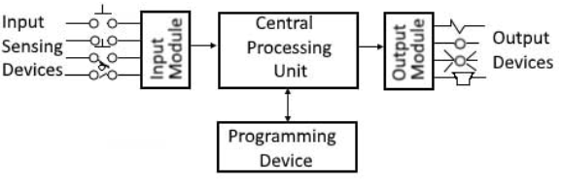
Figure 1. [2]
The programming language that is most commonly used to operate a PLC is Ladder Logic. Ladder Logic is a very visual programming language, which allows easier understanding of the process created. Ladder Logic is made out of rungs of logic, which forms a lookalike ladder, the logic operations are expressed via symbolic notation. [3]
An advantage of using PLCs within industry is that a production line, process or machinery can be greatly improved due to the ability to modify and replicate the operation or process while collecting and communicating vital information. [1] A PLC can increase the reliability, flexibility and also accuracy of any automated system.

1.1.1 Existing PLCs
There are two main types of PLC, fixed and modular. Fixed PLCs have a fixed number of Inputs and Outputs, hence the name that has been given to them. The capabilities of the inputs and outputs are decided by the manufacturer of all Fixed PLCs, whereas Modular PLCs can have inputs and outputs added. [4]

Fixed PLCs
This section will look at Fixed PLCs on today’s market and will compare and contrast each one by referencing the Pros and also the Cons of each PLC.

Schneider Logic Module SR3B261BD
This PLC contains 16 inputs and 10 outputs and operates at 24V. It includes an LCD backlight display for easier accessibility and costs £270. The PLC module weighs just 400 grams and can operate between temperatures of -20°C - 40°C. [5]
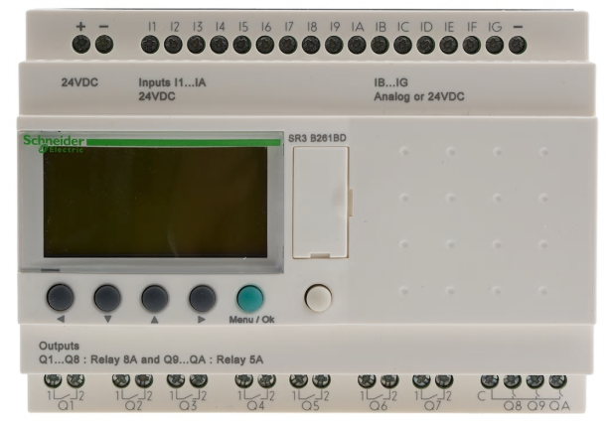
Figure 2. [5]

Siemens 6ED1052-1CC08-0BA1
This Siemens PLC operates at 24V and weighs just 246 grams. It contains an LCD display as shown in Figure 3. and costs just £127.20. The PLC has just 8 inputs and 4 outputs and can operate between temperatures of -20°C - 55°C. [6]
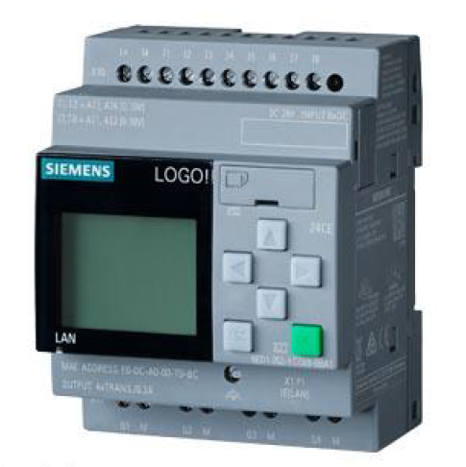
Figure 3. [6]

Crouzet XDP24-E
An expensive PLC costing £330.08 which can operate between temperatures between -20°C - 60°C. The PLC contains an extortionate 24 inputs and 24 outputs, and operates at 24V. It weighs 330 grams and has an LCD display as shown in Figure 4. [7]
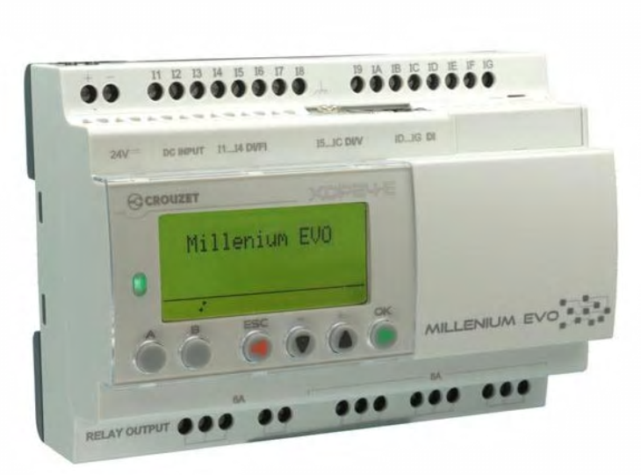
Figure 4. [7]

Table 1. is a comparison of Compact PLCs
Name | Schneider SR3B261BD | Siemens 6ED1052-1CC08-0BA1 | Crouzet XDP24-E
Image
Service Voltage * | 24V | 24V | 24V
Advantages | - Good amount of I/O  - LCD Display  - Low Power consumption  - High cycle life (10 million operations)  - 10 year back up memory | - Small in size  - Cheap  - LCD Display  - Ethernet network  - micro SD card socket | - Bluetooth  - High No. of I/O  - LCD Display  - Lightweight for size  - High cycle life (5 million operations)  - Ethernet network
Disadvantages | - Costly  - Big in size  - No Bluetooth  - No Ethernet | - Limited No. of I/O  - Relatively heavy for size | - Costly  - Big in size
Operating Temperature | -20°C - 40°C | 20°C - 55°C | -20°C - 60°C
Weight | 400g | 246g | 330g
Dimensions | 125mm x 90mm x 59.5mm | 71.5mm x 90mm x 60mm | 124.6mm x 90mm x 62mm
Cost | £270 | £127.20 | £330.08
Table 1. [5] [6] [7] *When I/O are connected, they consume current from the 24V service power

Modular PLCs
This section will look at Modular PLCs on today’s market and will compare and contrast each one by referencing the Pros and the Cons of each PLC in Table 2.

Crouzet Nano EM4B26-ET
This PLC has a base total of 16 inputs and 10 outputs, however with two expansions to the CPU a total of 46 Inputs/Outputs can be used. The operating temperature is -20°C – 60°C and costs £370.19 for the standalone PLC. For the add on modules they cost £152.20 each, with both modules and the standalone PLC, the total cost is £674.59. The weight of the standalone PLC is 345 grams and both modules weigh 260 grams, taking the total weight to 605 grams. It also has an LED screen and a service voltage of 24V.The dimensions for the standalone PLC are 124.6mm x 90mm x 60.6mm. [8] [9]
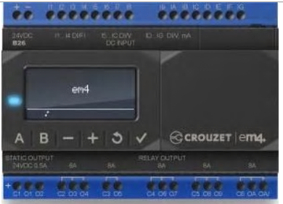
Figure 5. [8]

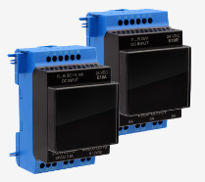
Figure 6. [9]

Schneider Modicon TM221CE16R
The service voltage for this modular PLC is rated 24V and contains 9 inputs and 7 outputs. It weighs just 346 grams and its dimensions are 90mm x 70mm x 95mm. It’s operating temperature is -10°C – 55°C and it costs £205.20. The add on modules are bought separately for outputs and inputs, the output module costs £75.60 and the input module costs £67.20. A further 2 inputs and 2 outputs can be added per module, increasing the total number of inputs to 11 and outputs to 9. [10] [11]
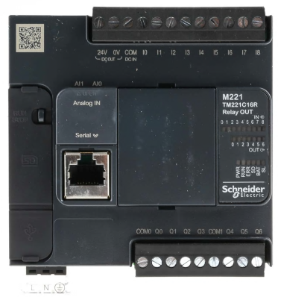
Figure 7. [10]

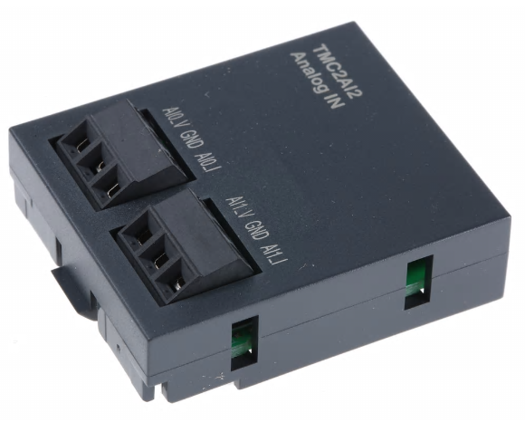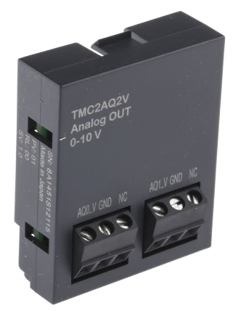
Figure 8. [11]

Mitsubishi FX5U-32MT/ESS
This PLC contains 16 inputs and 16 outputs while operating at 24V and between temperatures of 0°C – 55°C. It weighs a total of 650 grams and costs an extortionate £815.40 for just the standalone PLC. The add on module cost £126.60 but adds a further 7 inputs and 7 outputs, increasing the total inputs and outputs to 23 each. The dimensions for the standalone PLC are 150mm x 90mm x 83mm. [12] [13]
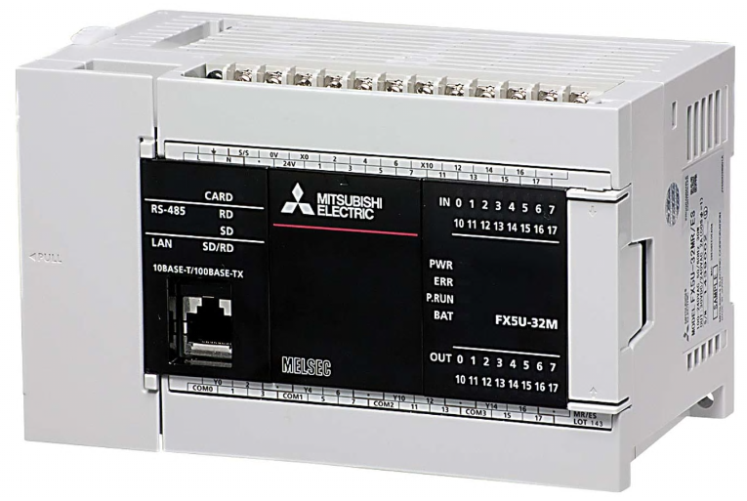
Figure 9. [12]

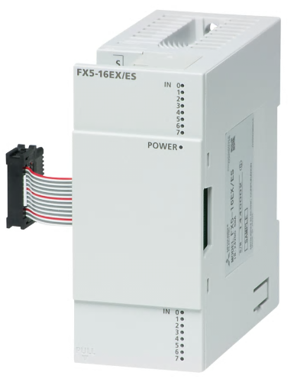
Figure 10. [13]

Table 2. is a comparison of Modular PLCs on today’s market.
Name | Crouzet Nano EM4B26-ET | Schneider Modicon TM221CE16R | Mitsubishi FX5U-32MT/ESS
Image
Service Voltage * | 24V | 24V | 24V
Advantages | - Bluetooth  - Ethernet  - LED Screen  - Lightweight  - High No. Inputs  - RS-485 | - Cheap  - Small in size  - Cheap add on modules  - Lightweight  - Ethernet | - High No. of I/O  - Robust  - Ethernet  - SD card slot  - RS-485  - High No. of I/O on add on module
Disadvantages | - Costly  - Expensive add on modules | - No display screen  - No Bluetooth  - Low No. of I/O | - Extremely expensive  - Heavy  - No Bluetooth  - Large in size
Operating Temperature | -20°C – 60°C | -10°C – 55°C | 0°C – 55°C
Weight (Standalone PLC) | 345g | 346g | 650g
Dimensions | 124.6mm x 90mm x 60.6mm | 90mm x 70mm x 95mm | 150mm x 90mm x 83mm
Cost of standalone PLC | £370.19 | £205.20 | £815.40
Table 2. [8] [10] [12] *When I/O are connected, they consume current from the 24V service power

Conclusion of existing PLCs
After comparing Compact and Modular PLCs I think it is evident that the Modular type of PLC is the more advantageous PLC to use within industry. My reasoning behind this is because the Modular PLC may be the more expensive of the two, but it gives the addition of expanding the inputs and outputs in a simplistic form. If the PLC used in this scenario would be a Compact PLC, another unit would have to be purchased and installed. Whereas, the Modular PLC would simply have an additional module to purchase, which is more than half the price of a Compact PLC.

Task 2

2.1 Factory I/O
Factory I/O is an easy to use 3D simulation which allows the user to build virtual factory processes through the use of several industrial components. By simply dragging and dropping the components, it takes minutes to create a simple factory process. Factory I/O can also be used with the addition of a PLC, this is where ladder logic is used via the programme TIA Siemens. As previously stated in chapter 1.1 ladder logic is one of the most commonly used programming language.

2.1.1 Design
I created a factory system as shown in Figure 11. which is able to sort four different packages based on size and weight. The four different packages were separated by the names of ‘Extra Small, Small, Medium and Large.’ The following components were used in my system:-
- 9 Diffuse Sensors
- 5 Conveyors Belts
- 1 Conveyor Scale
- 2 Pushers
- 1 Wheel Sorter
- 4 Stacks Lights
- 1 Emergency Stop
- 1 Start Button
- 1 Stop Button
- 1 Reset Button
- 4 Counters
- 1 Warning Light
- 1 Siren
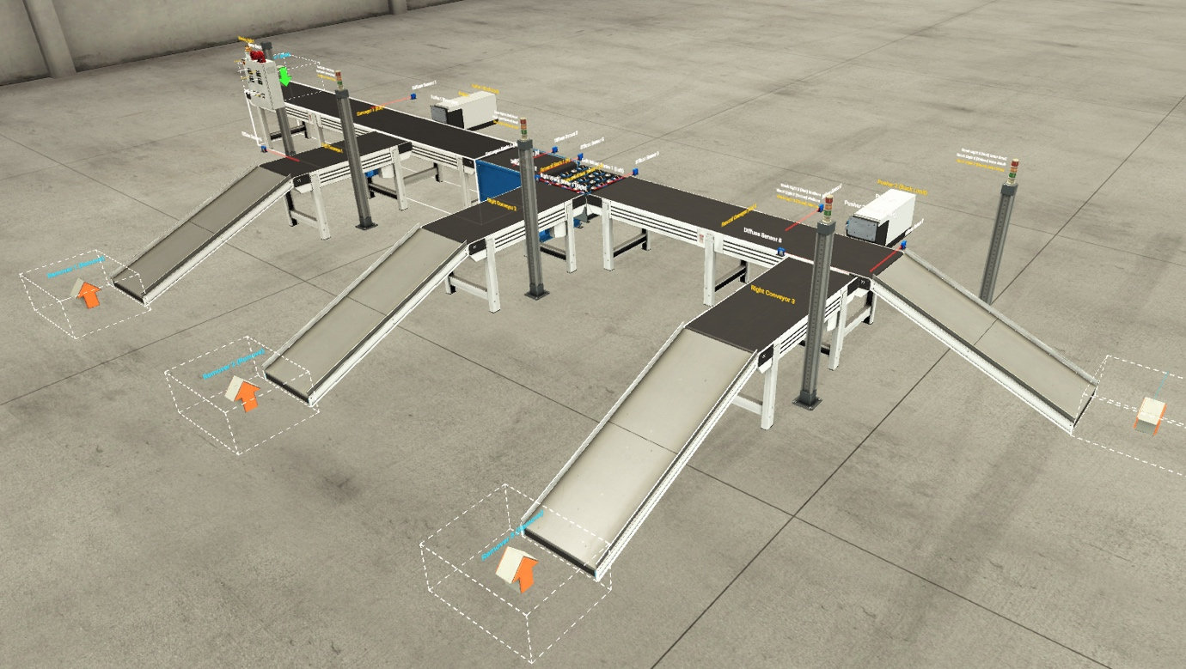
Figure 11.
I ensured that the system was efficient and as simple as possible, which would allow me to create an easy to follow ladder logic control via TIA Siemens. To limit the current draw of the system, each conveyor starts in a sequence but the stop and emergency stop button controls all conveyors and pushers within the system for health and safety reasons.

2.1.2 Operational Flow Chart
Figure 12. is the operational flow chart for my Factory I/O system.

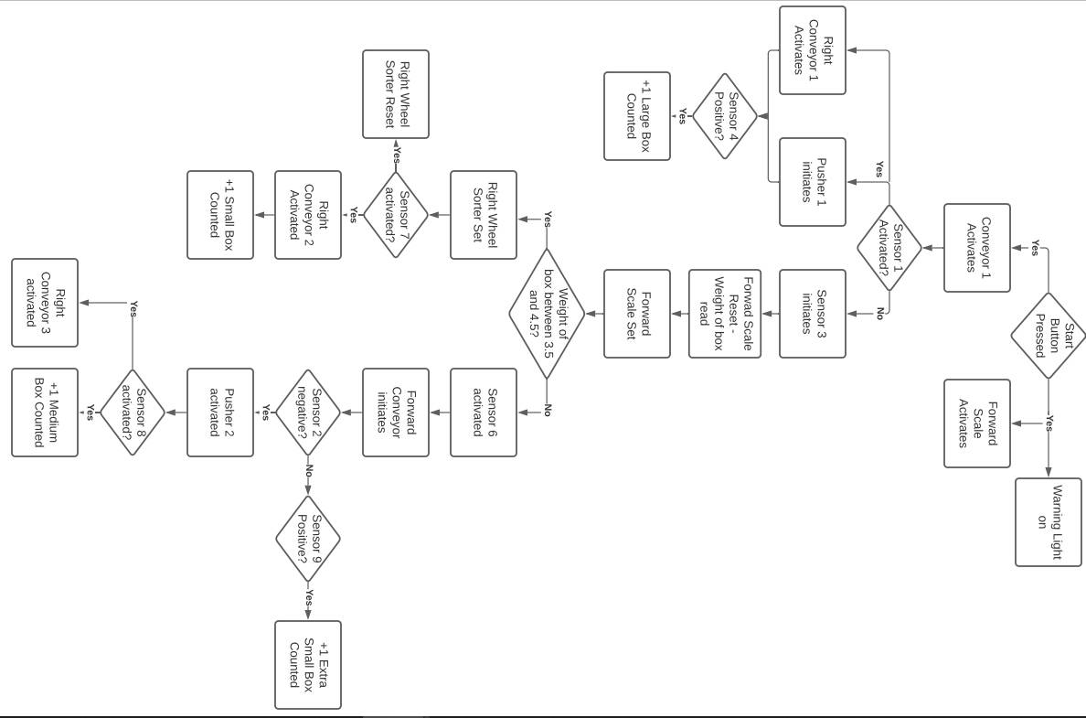
Figure 12.

Task 3

3.1 TIA Siemens
To operate and control my factory process as shown in Figure 11. a ladder logic program was created using TIA Siemens V16. Some of the functions used throughout the Networks are shown in Figure 13.
Figure 13.

3.1.1 Tag Table
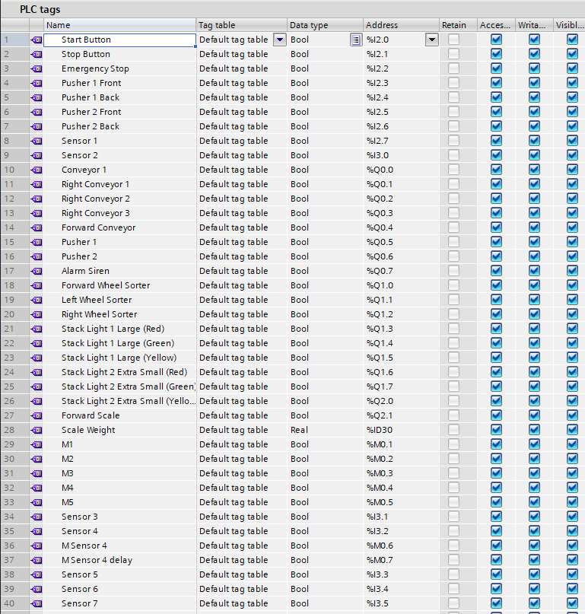
Figure 14. Shows all the tags that are used within the ladder logic program. The address %l is signified as an input, %Q is an output, %QD as a display output and %M is symbolised as a memory. The inputs and outputs used on TIA are also replicated on the PLC that is used on Factory I/O as shown in Figure 15.
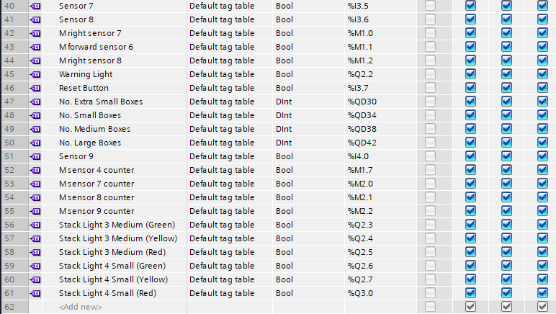
Figure 14.
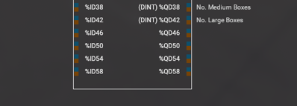
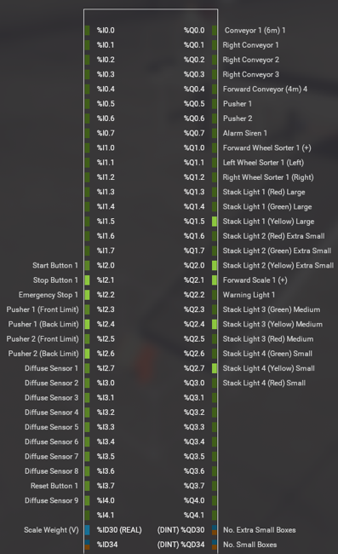
Figure 15.

3.1.2 Networks
The following networks are designed to operate the Factory I/O system as shown in Figure 11. The networks consists of various functions such as timers and counters. The functions will be used alongside inputs and outputs.

Network 2
As previously stated in 3.1.1 all inputs and outputs along with functions have tags, as shown in Figure 14. The inputs within this network consist of the start, stop and emergency stop, along with M1 which, although is not a physical input, is a memory location. The sequence of this network is to set the memory location of M1 for the Start, Stop and Emergency Stop of the system.
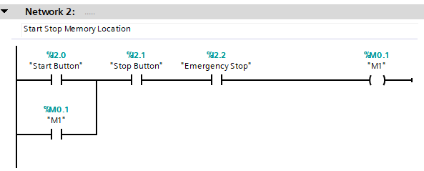
Figure 16.
The state of the inputs and outputs for Network 2 are normally open, this means that the open contact will not flow current in its normal state. Only when the contact is energized, this is done via pressing a push button for Network 1 (start, stop or emergency stop).

Network 3
To enable the following outputs of this network, the start button must be pressed which sets the memory location M1 as shown in Figure 16. M1 is activated. Conveyor 1, the forward scale (of the conveyor scale) and the warning light have are now been initiated, as shown in Figure 17.
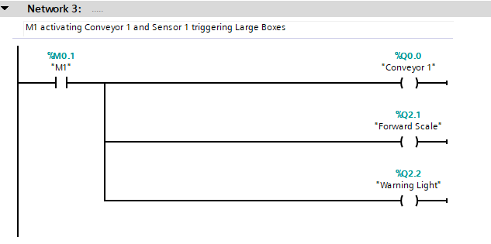
Figure 17.

Figure 18. shows the Factory I/O’s components from Network 3. Conveyor 1, forward scale and the warning light are present.
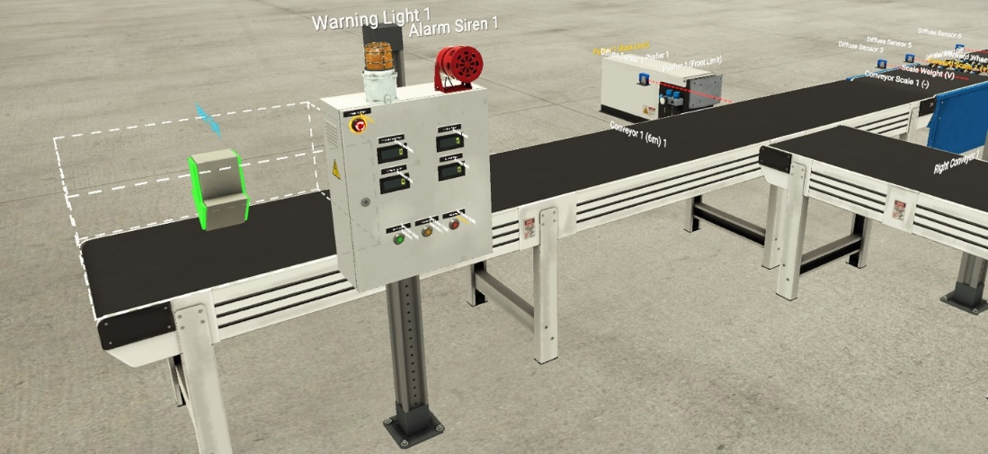
Figure 18.

Network 4
The emergency stop is introduced throughout the systems networks as it is vital that when the system needs to be stopped for any given reason, all components and machinery shut down immediately for health and safety reasons. By pressing the emergency stop button all aspects of the system will shut down and then all boxes will be removed.
Pusher 1 will stop operating on extraction and retraction if the emergency stop button is pressed at any time.
The SR (Set-Reset) function for Pusher 1 enables the pusher to extract and retract. SR is set if the signal state is ‘1’ at the S input and ‘0’ at the R input. Otherwise, if the signal state is ‘0’ at the R input and ‘1’ at the S input, the flip flop is set. This is reflected when the Sensor 1 contact becomes negative due to a box passing through it, it will then activate the pusher. When the pushers front limit is reached it will retract, this how the reset operation functions.
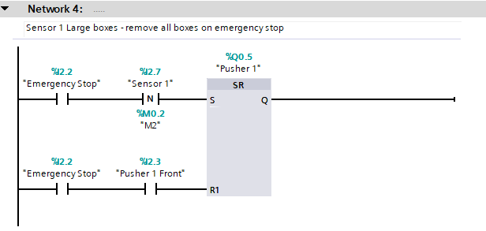
Figure 19.

Sensor 1 has been raised in height to the top of the Pusher as shown in Figure 20. To allow only the Large boxes to trigger the sensor. This means that only the large boxes will be moved onto the Right Conveyor 1 leaving the Medium, Small and Extra Small boxes to sort.
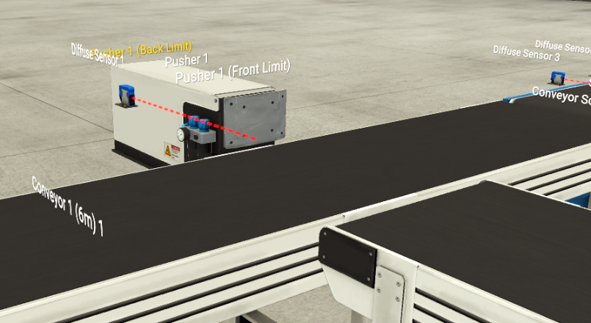
Figure 20.

Network 5
The input of the emergency stop is a normally closed contact. The normally closed contact unlike the normally open one, flows current in its normal state. Energizing the contact and switching it on will cause the contact to open, which stops the current flowing.
Network 5 introduces a TON Timer. This is a simplistic timer where when the emergency stop button has current going through it, a signal will be sent to the timer which will delay the output (Q) for the duration that the pre-set (PT) has been set for, in this instance, that is 4mS. Once 4mS has been reached, the siren will be activated.
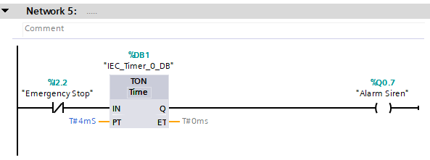
Figure 21.

The siren and emergency stop button in Factory I/O are shown in Figure 22.
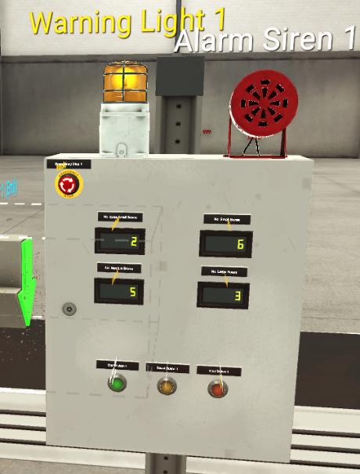
Figure 22.

Network 6
The ladder logic within this network enables the Right Conveyor 1 to initiate and stop. Firstly, when sensor one is activated, the Right Conveyor 1 then initiates. The emergency stop is implemented into the network for health and safety reasons.
Due to the Large Boxes being the only sized box to move along the Right Conveyor 1, I produced a piece of programming for the conveyor to shut off once the Large box leaves the conveyor. This is implemented on the last line of Figure 23. When Sensor 4 is negative, the Right Conveyor 1 resets. If sensor 4 was positive and not negative a delay timer would have to be introduced in order to stop the conveyor. This is because the Large box may not of left the conveyor when it resets and it would be stuck on the conveyor until another Large box reactivates the Right Conveyor 1.
The Right Conveyor 1 and Sensor 4 can be found on Figure 24.
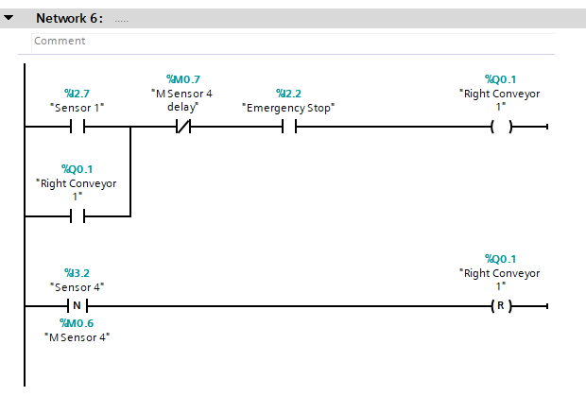
Figure 23.
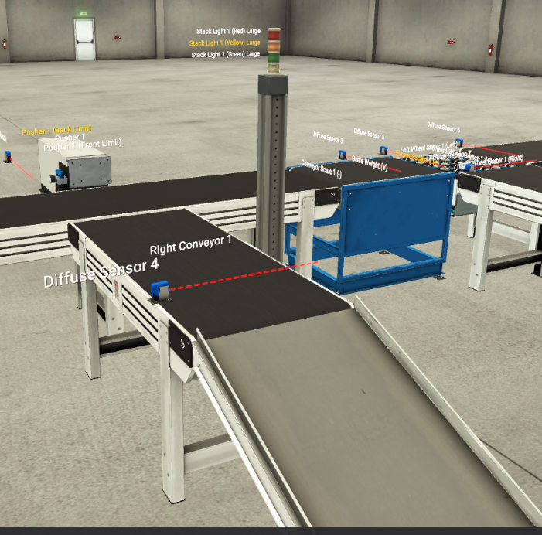
Figure 24.

Network 7
This network sorts the Medium boxes from the Extra Small and Small boxes. When Sensor 3 has been triggered, the forward scale will reset. The forward scale is the forward movement of the conveyor scale. The reason as to why the forward scale is reset is because we had inaccuracy when weighing the boxes on the scale while it moved, so it was important that the weighing of the boxes was accurate. As the conveyor scale only needs to stop briefly a TON Timer delay is introduced so that after the Pre Set Time (PT) of 2 seconds, the conveyor scale will reactivate again. The emergency stops are implemented to stop and reset the conveyor in case of an emergency.
When sensor 3 has been activated and the forward scale has stopped, a TON Timer is then introduced and the Pre Set time of 1 second is set. The output (Q) is activated after the delay of 1 second. The function IN RANGE is a function where if the real value of the scale weight (%ID30) is between the minimum and maximum values, which were set manually, the output (Right Wheel Sorter) would activate. This function is used to ascertain the Medium boxes from the Small and Extra Small.
After several readings and measuring the weight of each box, it was clear that only the medium boxes weighed between 3.5 and 4.5 on the scale. If the box weighs between 3.5 and 4.5 the Right Wheel Sorter would set due to the use of the function IN RANGE. This would allow the Medium sized boxes to move on to the Right Conveyor 2 as shown in Figure 26. Once Sensor 7 has been activated, which meant that the Medium box would now be on the Right Conveyor 2, the Right Wheel Sorter would reset and move back to its original position of facing frontward.
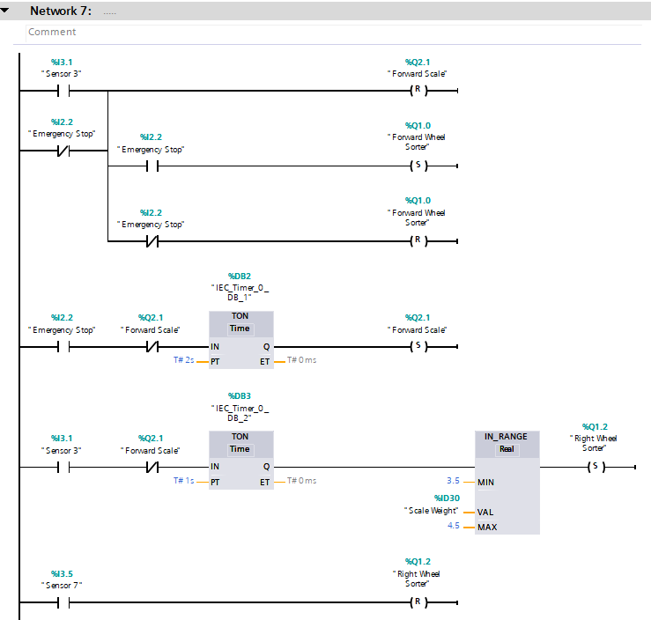
Figure 25.

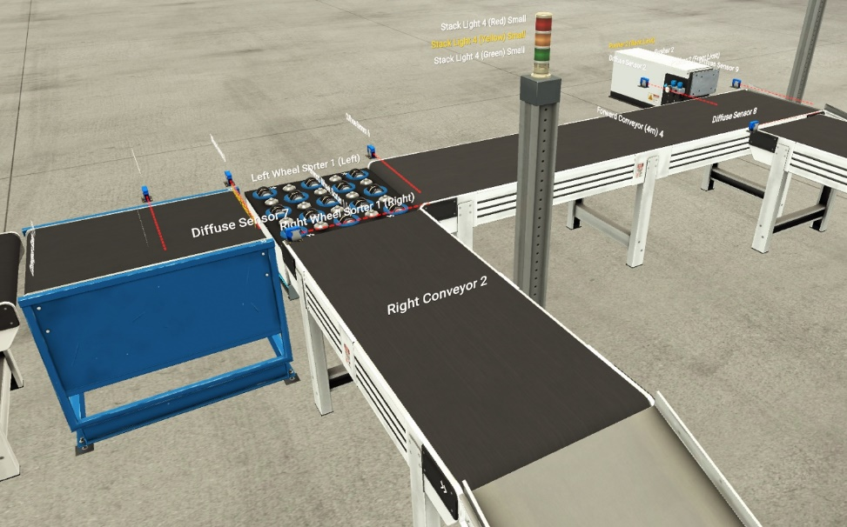
Figure 26.

Network 8
Network 8 consists of the Right Conveyor 2 and Sensor 7 as shown in Figure 27. The right Conveyor 2 is where all Medium boxes will be directed. When Sensor 7 is activated then the Right Conveyor 2 operates.
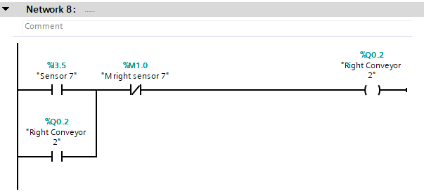
Figure 27.

Network 9
Sensor 6 is located just after the Wheel Sorter as shown in Figure 29. When Sensor 6 is initiated, it activates the Forward Conveyor, this is the conveyor that sorts the last two sets of boxes, Small and Extra Small.
When Sensor 2 becomes negative, Pusher 2 will extract. Once again using the SR function it allows the Pusher to retract (reset) when the front limit becomes positive. Sensor 2 is set at a height which allows to distinguish between the Small and Extra Small sized boxes. It is set at a height where only the Small boxes would trigger the Sensor, therefore the pusher will only remove the Small boxes onto the Right Conveyor 3 which is shown in Figure 30.
When the small box has changed course due to Pusher 2, it will initiate Sensor 8. When Sensor 8 is initiated it activates the Right Conveyor 3.
The Extra Small boxes will continue to run along the Forward and no longer need to be sorted, as they’re the only sized box on that conveyor.
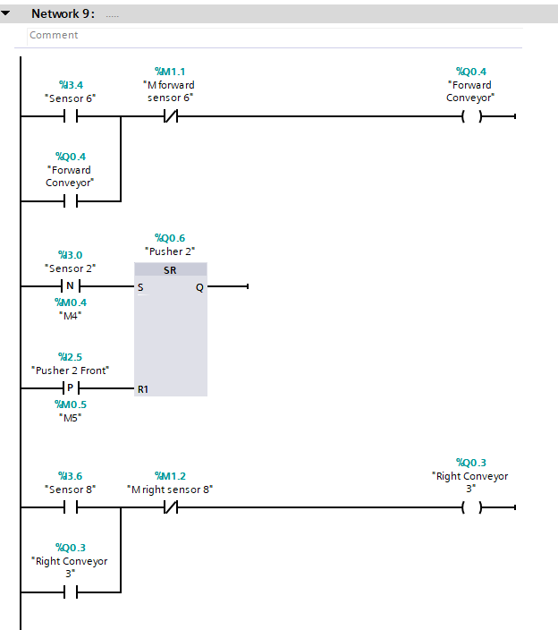
Figure 28.

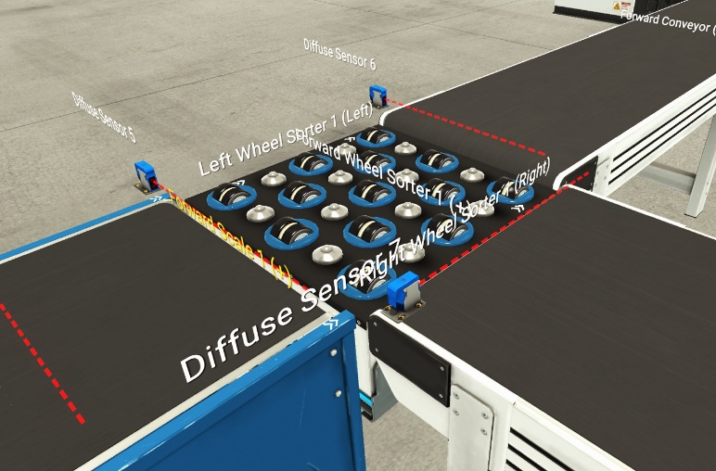
Figure 29.

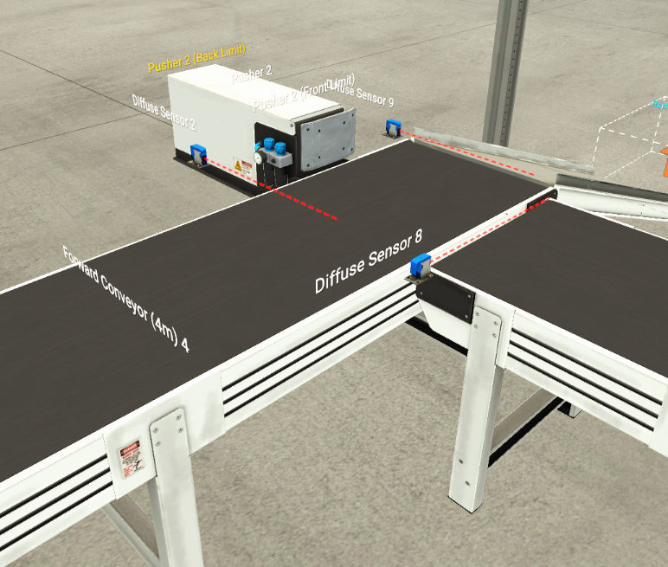
Figure 30.

Network 10
This network introduces the counter function (CTU) to the system as shown in Figure 31. Each time Sensor 4 becomes positive the counter function receives a pulse and the current value (CV) increases by 1. A pre-set value (PV) for the number of boxes can be set. By pressing the reset button the total number of boxes (CV) that have been accounted for through the function of the counter (CTU) can be reset to 0. The output of the current value (CV) is displayed through a digital counter which is shown in Figure 32. CV is the total number of Large boxes that have passed through Sensor 4.
This network has been replicated through to Network 11, Network 12 and Network 13. The only modifications in these networks are the sensors used and the displays used are for the appropriate sized boxes.
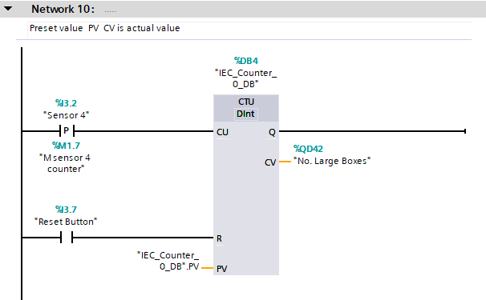
Figure 31.

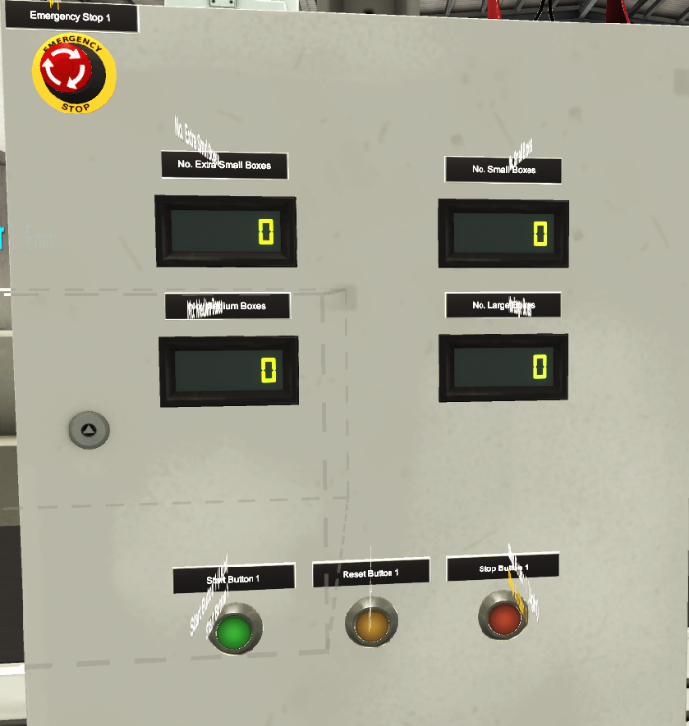
Figure 32.

Network 11
Network 11 where a counter (CTU) is used to calculate the total number of small boxes, follows the same ladder logic procedure as Network 10. This network uses the same type of counter (CTU) which operates when Sensor 7 has been triggered. The reset button will reset all counters when pressed.
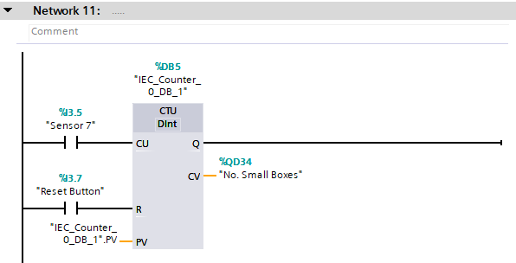
Figure 33.

Network 12
This network follows Network 10 and Network 11, although it uses Sensor 8 as the input. As shown in Figure 34. This network calculates the total number of Medium boxes.
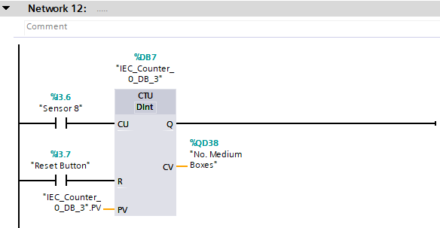
Figure 34.

Network 13
This network also uses the counter function (CTU) to calculate the total number of Extra Small boxes, this time using Sensor 9. When Sensor 9 becomes positive it sends a pulse to the counter. The reset button rests all counters as shown in Figure 35.
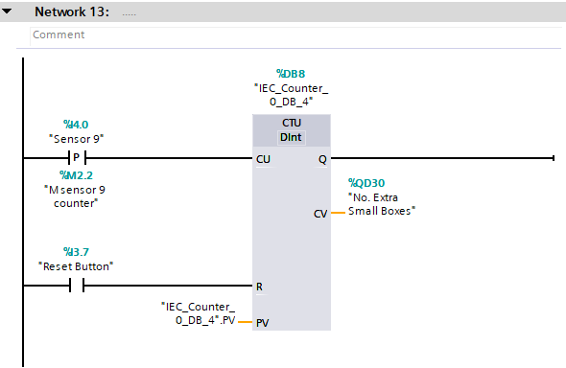
Figure 35.

Network 14
Network 14 introduces Stack Lights. These are used to keep track of the total number of boxes. As shown in Figure 36. Stack Light 1 is used to replicate the number of Large boxes.
The first line of this network is where the calculated number of Large boxes value (CV) is taken from Network 10 (%QD42) along with the pre-set value (PV). The Function labelled < Dint uses the total number of large boxes and if that number is less than the pre-set value, the output of Stack Light 1 Large (Green) is activated.
The second line of this network uses the function == Dint. This function uses the calculated number of large boxes (CV) and if that number is equal to the pre-set value (PV) it will activate Stack Light 1 Large (Yellow).
The final line of this network uses the function > Din, function will activate Stack Light 1 (Red) if the calculated number of Large boxes (CV) is larger than the pre-set value (PV).
Only one of these outputs will work at any one time and the pre-set value (PV) is kept the same throughout, unless changed when the number of boxes has been reset.
The stacks lights can be found in Figure 37.
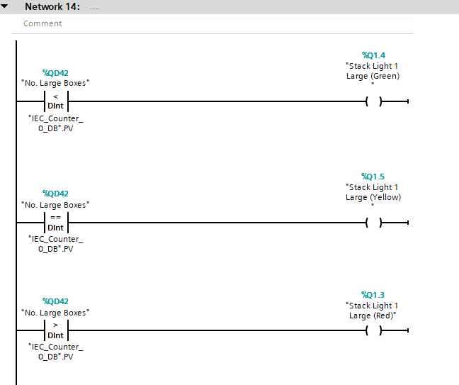
Figure 36.

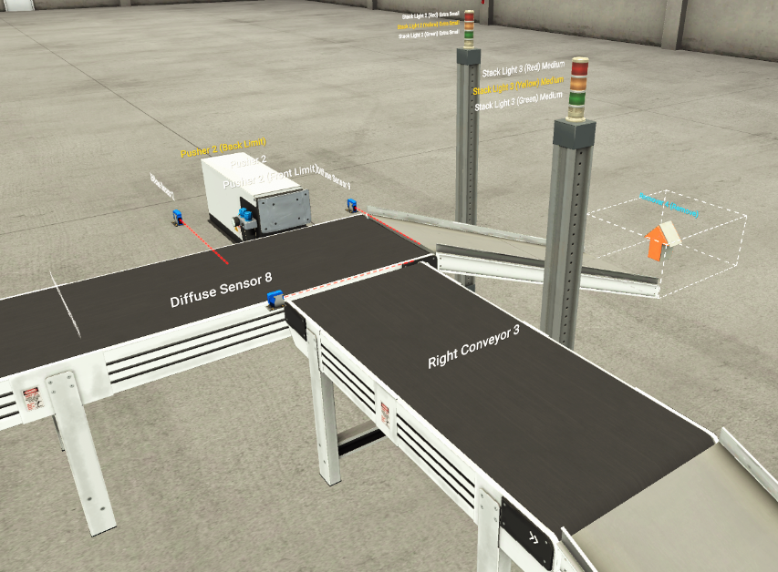
Figure 37.

Network 15
This network follows Network 14, where on the first line the calculated number of Small boxes (CV) is less than the pre-set value (PV), the Stack Light 4 Small (Green) activates.
If the calculated number of Small boxes (CV) is equal to the pre-set value (PV), then the Stack Light 4 Small (Yellow) is initiated.
When the calculated number of Small boxes (CV) is greater than the pre-set value (PV), the Stack Light 4 Small (Red) is activated as shown in Figure 38.
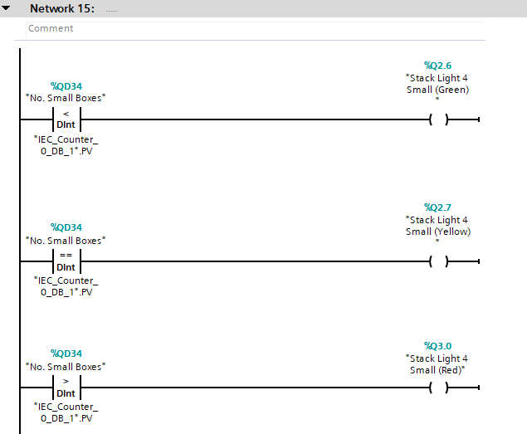
Figure 38.

Network 16
As shown in Figure 39. The same procedure is followed as Network 14 and Network 15, except the calculated number of boxes (CV) and the pre-set value (PV) is for the Medium boxes. Stack Light 3 Medium is used for the outputs.
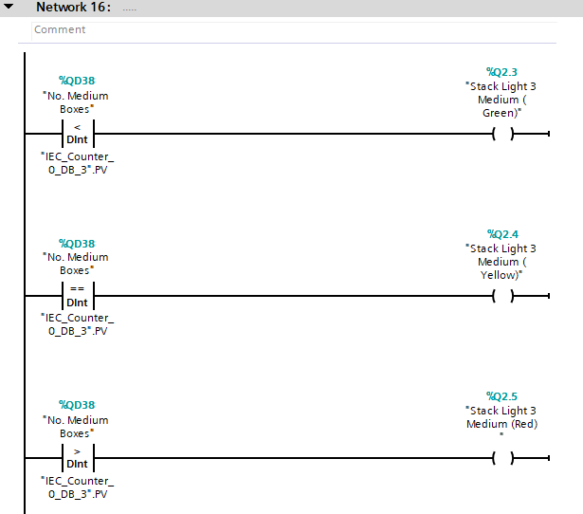
Figure 39.

Network 17
Once again, Network 17 follows the same procedure as Network 14, Network 15 and Network 16. The functions used are the same and the inputs used are the calculated number of Extra Small boxes (CV), the pre-set value (PV) for total number of Extra Small boxes. The outputs used for this network is the Stack Light 2 Extra Small as shown in Figure 40.
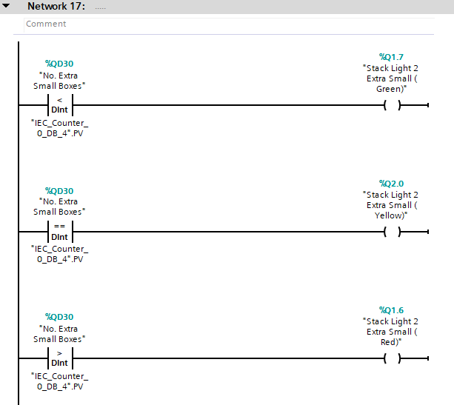
Figure 40.

Task 4

4.1 HMI
A Human-Machine Interface (HMI) is a user interface or dashboard that connects a person to a machine. [14] HMIs are most commonly used to visually display data and monitor machine inputs and outputs. HMIs can come in a variety of shapes and sizes such as a computer monitor, tablets, built in screens on machine.
A HMIs job is to communicate with a PLCs inputs and outputs, and to then display the information for the user to view. The idea of a HMI is to make it clear and minimalistic, the navigation between each screen should be straight forward.

4.1.1 Main Menu
Figure 39. is the main menu of my HMI that was created in TIA Siemens. The HMI was created in order to access and control the inputs and outputs of the factory system via a touch screen panel. The main menu consists of a start and stop button. As shown Figure 41. When the stop button has been activated the circle below both buttons will turn red. When the start button has been activated then the circle will turn green, as shown in Figure 42. An emergency stop button has been introduced into the HMI’s main menu for health and safety.
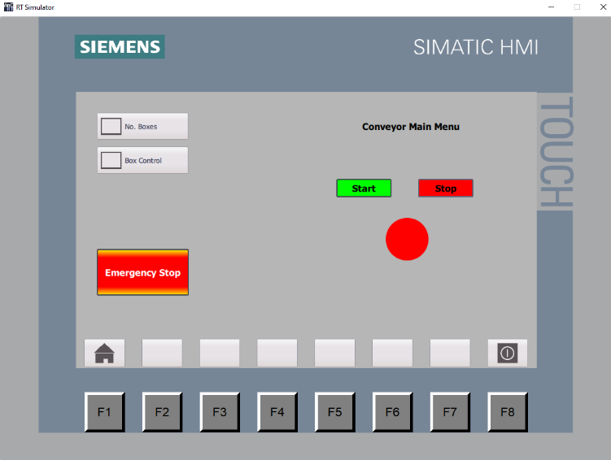
Figure 41.

The left hand side of the main menu consists of two buttons that when pressed will transition to the Number of boxes screen or the Box Control screen.
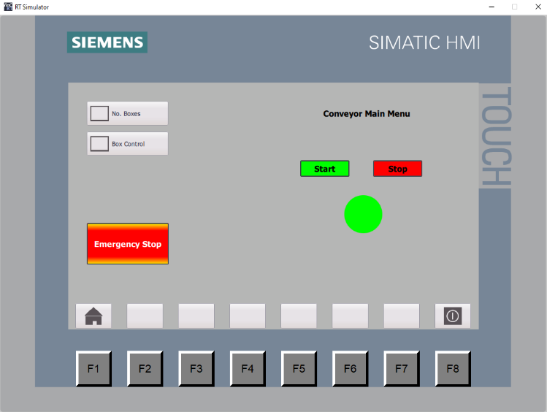
Figure 42.

4.1.2 Box Control
This screen is used to control the pre-set values (PV) for the calculated number of boxes that are used in Networks 14-17. As shown in Figure 43. The pre-set values are 5 and when the boxes are being accounted for the labels on the right hand side per box control say ‘counting.’ The pre-set value can be changed via the HMI.
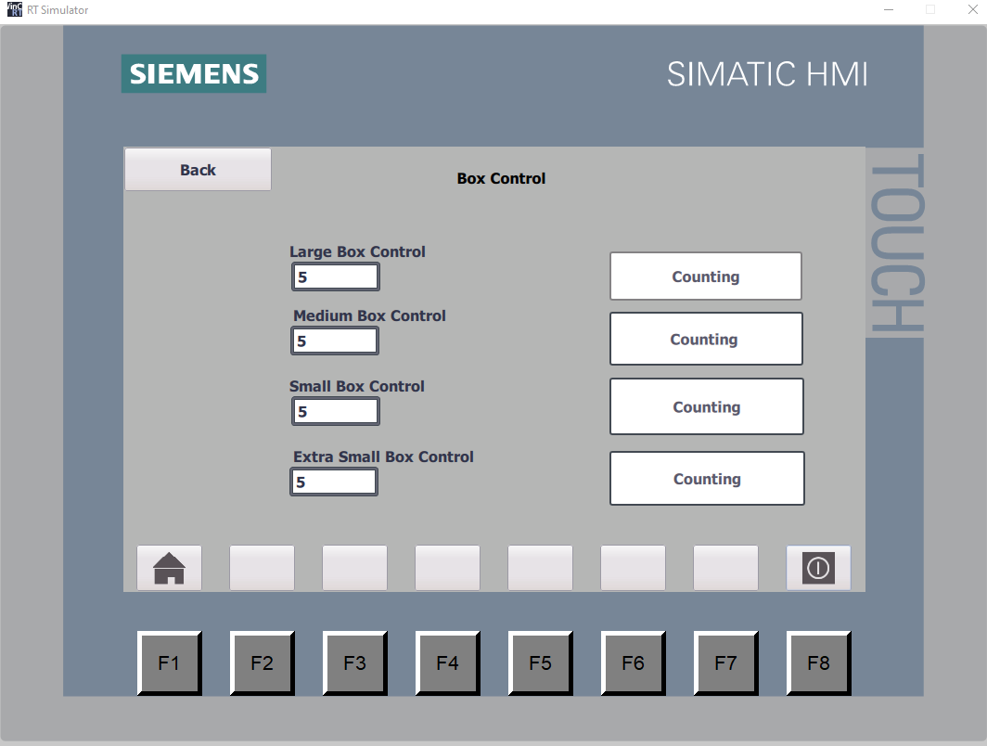
Figure 43.
When the pre-set value of 5, which is shown in Figure 43. Is exceeded. The labels on the right hand side will show the message ‘Count Exceeded.’ Figure 44. Displays the message when the total number of large boxes has exceeded 5.
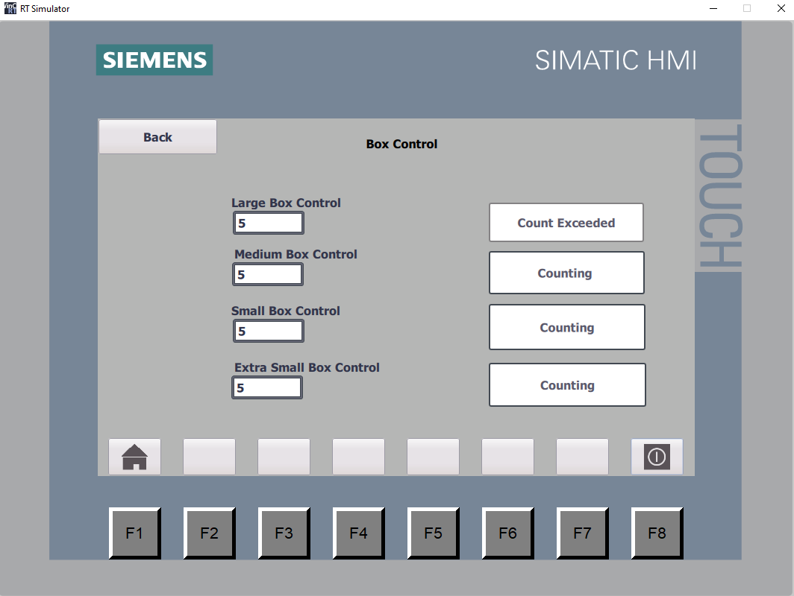
Figure 44.

4.1.3 Number of Boxes
This HMI screen replicates Networks 14-17 in the stack light form as shown in Figure 45. It is evident that the pre-set values (PV) are set at 5 for all four sized boxes. The total number of boxes on the left hand side that have been accounted for have not reached the pre-set value that were set on the HMI in Figure 44. Which is why the circles are green. The circles represent the colours that are showing on the stack lights in the factory system.
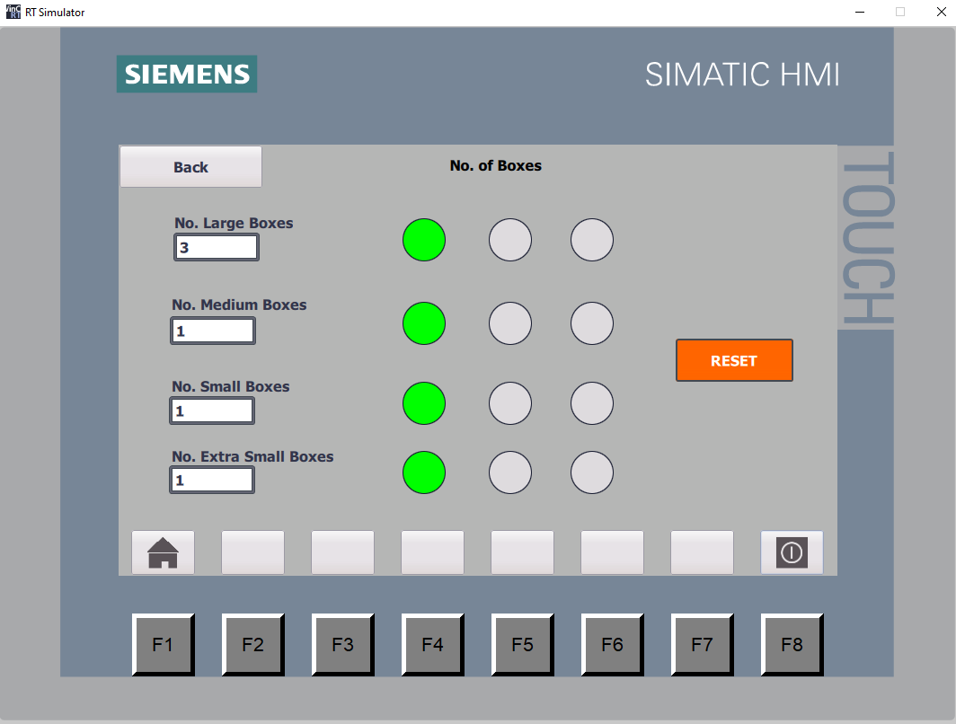
Figure 45.

Once the pre-set value of 5 has been met for the total number of large boxes, an orange warning light appears on the HMI and also to the relevant Stack light for the Large boxes as shown in Figure 46. This is replicated for all size boxes and not just large.
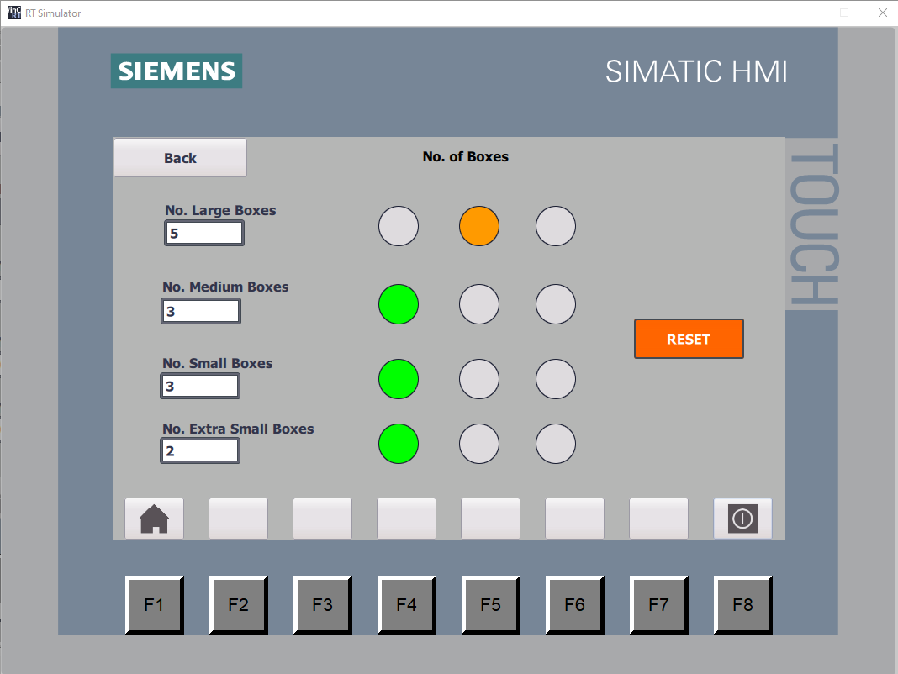
Figure 46.

When the pre-set value of the total number of boxes exceeds 5, a red light will appear on the relevant stack light and also on the HMI as shown in Figure 47.
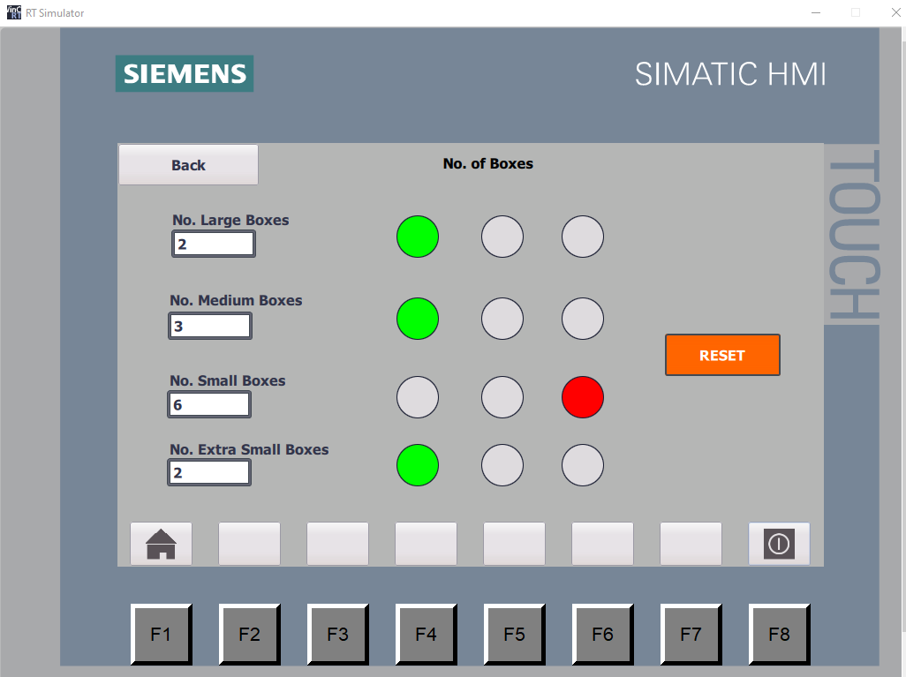
Figure 47.

Figure 48. Illustrates the warning lights when the medium boxes have equalled the pre-set value of 5 and the small boxes have exceeded the pre-set value, totalling at 6. The reset button that is incorporated within this screen on the HMI is to reset the total number of boxes counted. It will reset the calculated value back to 0.
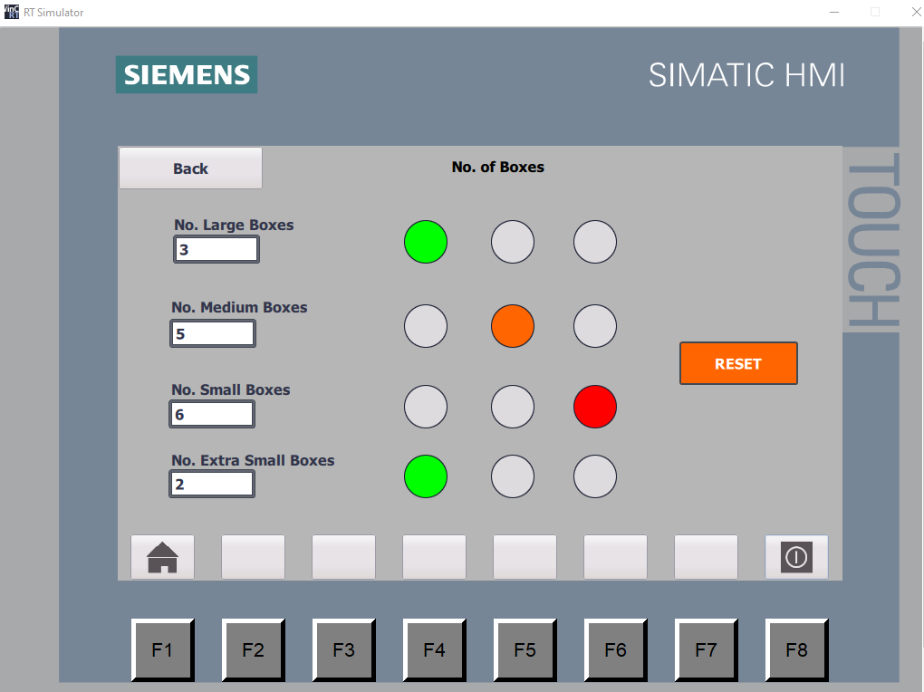
Figure 48.

4.2 Conclusion
The aim of this assignment was to create a simplistic system that would sort four different packages based on size and weight, and to also limit the current draw at start up, each conveyor should be started in sequence. Upon reflection, I have successfully met the aims set from the outset. It is appropriate to give this conclusion, given the programing reinforces that each box of different size or weight was successfully sorted. Each conveyor throughout the system was initiated through a selection of sensors, which limited the current draw at start up. A HMI was introduced for operation interaction and included displays along with controls that managed the factory system.

4.3 Future Recommendations
Upon reflection of this assignment and if I were to start from the beginning again there would be a few minor changes that I would implement. Firstly, I would organise my memory locations more adequately and implement the use of them throughout the system. I would do this by adding a memory location for the emergency stop instead of adding an open contact for each process. Secondly, I would improve the layout of the main menu and include the emergency stop button on the Number of boxes and Box control screen. I think it is important to be able to access the emergency stop button at all times.

Bibliography

[1] | Advanced Micro Controls Inc., “AMCI.com,” Advanced Micro Controls Inc., 8 January 2022. [Online]. Available: https://www.amci.com/industrial-automation-resources/plc-automation-tutorials/what-plc/. [Accessed 8 January 2022].
[2] | Farnell, “Farnell.com,” Farnell, 8 January 2022. [Online]. Available: https://il.farnell.com/industrial-application-plc-design. [Accessed 8 January 2022].
[3] | Peter, “PLC Academy,” 4 September 2017. [Online]. Available: https://www.plcacademy.com/ladder-logic-tutorial/. [Accessed 8 January 2022].
[4] | D. Chaudhari, “DipsLab,” Dips Lab, 15 October 2018. [Online]. Available: https://dipslab.com/difference-between-compact-modular-plc/. [Accessed 8 January 2022].
[5] | RS Components, “RS PLCs,” Schneider, 8 January 2022. [Online]. Available: https://uk.rs-online.com/web/p/plcs-programmable-logic-controllers/4684242. [Accessed 8 January 2022].
[6] | Kempston Controls, “Kempston Controls Siemenes,” Siemens, 8 January 2022. [Online]. Available: https://www.kempstoncontrols.co.uk/6ED1052-1CC08-0BA1/Siemens/sku/1829329. [Accessed 8 January 2022].
[7] | Mouser, “Mouser Controllers,” Crouzet, 8 January 2022. [Online]. Available: https://www.mouser.co.uk/ProductDetail/Crouzet/88975111?qs=55YtniHzbhD%252BWKcGuq64PA%3D%3D&mgh=1&vip=1. [Accessed 8 January 2022].
[8] | Mouser, “Mouser Controllers,” Crouzet, 9 January 2022. [Online]. Available: https://www.mouser.co.uk/ProductDetail/Crouzet/88980171?qs=NPAmerw%2FZTvayEd864f6zQ%3D%3D&mgh=1&vip=1. [Accessed 9 January 2022].
[9] | Crouzet, “Crouzet Products,” Crouzet, 9 January 2022. [Online]. Available: https://soda.crouzet.com/pn/?i=88982213. [Accessed 9 January 2022].
[10] | RS Components, “RS Components PLCs,” Schneider, 9 January 2022. [Online]. Available: https://uk.rs-online.com/web/p/plcs-programmable-logic-controllers/8066840. [Accessed 9 January 2022].
[11] | RS Components, “RS Components PLC Accessories,” Schneider, 9 January 2022. [Online]. Available: https://uk.rs-online.com/web/p/plc-accessories/8066890. [Accessed 9 January 2022].
[12] | RS Components , “RS Components PLCs,” Mitsubishi, 9 January 2022. [Online]. Available: https://uk.rs-online.com/web/p/plcs-programmable-logic-controllers/8755688. [Accessed 2022 January 2022].
[13] | RS Components, “RS Components PLC Accessories,” Mitsubishi, 9 January 2022. [Online]. Available: https://uk.rs-online.com/web/p/plc-accessories/8755694. [Accessed 9 January 2022].
[14] | Inductive Automation, “Inductive Automation,” 16 January 2022. [Online]. Available: https://www.inductiveautomation.com/resources/article/what-is-hmi. [Accessed 16 January 2022].

