

The Effectiveness of Intelligence-Led / Neighbourhood Policing in the UK

School: UWTSD Swansea
Degree: Policing and Criminology
Name: Rhys Neal
Student ID: 2031277
Due Date: 8th APRIL 2024
Word Count: 8,018

Declaration
This work has not previously been accepted in substance for any degree and is not being concurrently submitted in candidature for any degree.
Signed Date: 8th April 2024
STATEMENT 1
This dissertation is being submitted in partial fulfilment of the requirements for the degree of BSc.
Signed Date: 8th April 2024
STATEMENT 2
This dissertation is the result of my own independent work/investigation, except where otherwise stated. Other sources are acknowledged by footnotes giving explicit references. A bibliography is appended.
Signed Date: 8th April 2024
STATEMENT 3
I hereby give consent for my dissertation, if accepted, to be available for photocopying and for interlibrary loan, and for the title and summary to be made available to outside organisations.
Signed Date: 8th April 2024

STATEMENT 4
I hereby give consent for my dissertation, if accepted, to be available on the university’s IT system to those who have consent to use the system.
Signed Date: 8th April 2024

Abstract

The aim of the dissertation was to investigate the overall effectiveness of intelligence led policing by Neighbourhood Policing Teams in the UK. To successfully complete this, the researcher has conducted critical analysis into existing relevant literature on this topic.
To aid the researchers understanding of the topic, an independent survey was conducted. This survey set out to obtain another input on this topic from members of the community within Gwent, South Wales, and serving police officers of Gwent Police.
Results from the survey supported the overall literature that was analysed in the second chapter of the dissertation. From conducting research of different methods, this dissertation achieved its goal of answering whether or not intelligence led neighbourhood policing is effective.

Acknowledgements
I would like to firstly thank my dissertation mentor Lewis Tandy for his ongoing support and time when working through this dissertation. In addition to all members of staff working for UWTSD which have offered support and guidance.
Furthermore, I would like to give a mention to my family for helping me through this process even from the other side of the world. The consistent support I have received from everyone has allowed me to focus and work towards my goal of obtaining a degree.
Finally, I would like to thank my partner for her time in helping me with each stage of the degree. I feel very fortunate to have such a strong support system.

Table of Contents
__________________________________________________________________________________
Chapter 1 - Introduction 8
1.1 Background 8
1.2 Research Rationale 8
1.3 Aims and Objectives 8
1.4 Research Structure 9
1.5 Conclusion 9
__________________________________________________________________________________
Chapter 2 - Literature Review 10
2.0 Introduction 10
2.1 Intelligence Led Policing – Australian Institute of Criminology 10
2.2 Neighbourhood Policing Evidence Review – The College of Policing 10
2.3 Public Perceptions of Policing: A review of research and literature – The Home Office 12
2.4 Neighbourhood Policing: Past, presesnt and future 13
2.5 Conclusion 13
__________________________________________________________________________________
Chapter 3 - Methodology 15
3.0 Introduction 15
3.1 Research Strategy 15
3.2 Data Collection 15
3.3 Limitations and problems 16
3.4 Ethical Considerations 16
3.5 Conclusion 16
__________________________________________________________________________________
Chapter 4 - Data Analysis 18
4.0 Introduction 18
4.1 General Approach of Data Analysis 18
4.2 Data Supported Findings of the Literature Reviewed 18
4.3 Demographics of the Survey 18
4.4 Survey Questionnaire Findings 19
4.4.1 Figure 1 19
4.4.2 Figure 2 19
4.4.3 Figure 3 20
4.4.4 Figure 4 21
4.4.5 Figure 5 21
4.5 Conclusion 22
__________________________________________________________________________________
Chapter 5 - Conclusion and Recommendations 23
5.0 Introduction 23
5.1 Completion and Achievement of Objectives 23
5.2 Main Findings 24
5.3 Recommendations 25
5.4 Limitations 25
5.5 Future Research 25
5.6 Conclusion 26
__________________________________________________________________________________
Bibliography 27
__________________________________________________________________________________
Appendices 30
Appendix 1 – Copy of questionnaire 30
Appendix 2 – Ethics form 34
__________________________________________________________________________________

Chapter 1 – Introduction:

This section of the workbook sets out to display the rationale for choosing this study topic, in addition to outlining what the aims of this study will be with its description and structure.

– Background

Firstly, I believe that it is important to understand the definition of both ‘intelligence’ in a policing context and ‘neighbourhood policing’. Therefore, intelligence as stated by Essex Police is “information which the police receive or collect” (Essex Police, 2023). Neighbourhood policing is described as “being a trusted presence within the community, working closely with people and using a wide range of problem-solving skills to address community issues” (Police, 2024).
Intelligence led policing has become a cornerstone of modern policing practices, especially in the United Kingdom. This strategy focuses on gathering, analysing, and sharing information to enhance the effectiveness of policing efforts. Within this framework, intelligence led neighbourhood policing plays a vital role in proactively addressing criminal activities and improving community safety and security. The United Kingdom has been a pioneer in implementing intelligence led policing initiatives to tackle the evolving challenges presented by crime and security threats.

1.2 – Research Rationale

The decision to explore the effectiveness of intelligence led neighbourhood policing in the UK stems from the significant role and established importance this approach plays, in shaping contemporary policing methodologies. With a heightened emphasis on engaging with communities and collaboratively solving problems. Intelligence led neighbourhood policing provides a comprehensive structure for police forces to address crime trends, pinpoint high risk areas, and allocate resources strategically. By combining intelligence analysis with community policing principles, police forces can enhance their ability to prevent crime, disrupt criminal activity, and cultivate trust within the communities they serve.
Moreover, reviewing the UKs experience with intelligence led policing offers a compelling context for evaluating the outcomes and influence of such strategies on reducing crime and enhancing community welfare. By investigating the effectiveness of intelligence led neighbourhood policing in the UK, this study can offer valuable insights for policymakers, police forces, and researchers aiming to optimise crime prevention strategies and improve public safety outcomes. By examining the reasons behind adopting intelligence led policing in the UK and assessing its implementation at the neighbourhood policing level, this study seeks to contribute to the current literature currently available surrounding this topic.

1.3 – Aims and Objectives

Aim:
The aim of this dissertation is to properly investigate the effectiveness of intelligence led neighbourhood policing in the UK.
Objectives:
To successfully achieve the aim, the following objectives will be met:
Objective 1: To identify and research quality sources of available literature regarding the related topic.
Objective 2: To identify the most suitable research approach to research the effectiveness of intelligence led neighbourhood policing in the UK.
Objective 3: To finally analyse the data collected to understand and conclude the findings on the effectiveness of intelligence led neighbourhood policing in the UK.

1.4 – Research Structure

To successfully achieve each objective for this study, this research will be broken down into five main chapters. These chapters will individually discuss and achieve an aim for this study.
The first chapter of this study is the introduction to the topic. This chapter aims to provide the reader with an understanding of the study and what will be covered throughout.
The second chapter presents the current literature surrounding the research topic. The literature review will help to provide the reader with an understanding of the research on this topic and current findings.
In chapter three, the method and methodology will be presented to identify appropriate primary research techniques for this study. The goal being to address or highlight research gaps and analyse the collected data effectively.
Within the fourth chapter it will show and analyse data that has been collected from research conducted for this study. It will do this by gathering the research results and presenting it in a statistical manner within the chapter.
Chapter five sets out to assess whether all the objectives and aims set in this study have been met. In addition to discussing the main findings and identifying if there are any recommendations and limitations to the research.

1.5 – Conclusion

This chapter has introduced the research and has identified the aims and objectives of this study. In addition, it has set out why this research project is beneficial within the topic of the effectiveness of intelligence led policing within the neighbourhood level. The next chapter will introduce the current literature on this topic to identify if there are any gaps for research to be conducted.

Chapter 2 – Literature Review:

2.0 – Introduction

In this literature review, the aim is to explore and critically analyse four separate academic studies into the effectiveness of intelligence led neighbourhood policing, generally in the UK (or from the UKs experience, in the case of the Australian study). Sources include reputable entities, seen as global leaders in the field, they were the UK’s College of Policing, Home Office, and the Police Federation. By examining these varying scholarly articles, it sets out to identify and examine key themes, gaps, and debates in the discourse on intelligence led neighbourhood policing. It is anticipated that the review will then provide a comprehensive overview of the current state of research, serving as a foundation for this study and highlighting areas where further investigation is warranted. Throughout this exploration, it hopes to contribute to the existing literature and offer valuable insights into intelligence led Neighbourhood Policing in the UK.
This chapter of the dissertation will complete the first objective which is to identify and research quality sources of available literature regarding the related topic.

The literature review uses several sources to carry out this objective, one of which is Google Scholar. Google Scholar is internet-based search engine that focuses specifically on scholarly literature, such as academic papers, theses, conference proceedings, and books. Additionally, to this, use of documents and research provided by the government and the College of Policing have been used to meet this objective. These documents have been created reviewing current policing initiatives, which covers the use of intelligence within community policing. These pieces of research and literature have been chosen and used for their credibility.

2.1 – Intelligence Led Policing – Australian Institute of Criminology

This piece of literature was produced by former British police officer and Professor of Criminal Justice and delves into intelligence led policing within Australia, it heavily relies on established or accepted UK practice as its foundation. Based on this paper it can also be argued that Intelligence led policing is difficult to define, however it has been broken down into several key fields within this paper. These fields include, targeting offenders, the management of crime and disorder hotspots within specific localities, and the orchestrated investigation of linked series of crimes and incidents. It seems reasonable to deduce from the latter, and supported within the National Intelligence Model, it emphasises that crime is not randomly distributed, and the identification of key criminal hotspot areas are key (Jerry H. Ratcliff, 2003).

2.2 – Neighbourhood Policing Evidence Review – The College of Policing

The following literature is provided by the College of Policing and it’s an evidence review of British Neighbourhood Policing which was conducted by ‘Her Majesty’s Inspectorate of Constabulary and Fire & Rescue Service’ (HMICFRS) (2016). This was after the HMICFRS found that there were certain aspects, that were obviously beneficial and other that raised concerns or challenges, around the performance of proactive and preventative policing within communities. Based on this, they consequently presented findings and guidance to best identify and tackle the issues.
This piece of literature is clearly relevant to this paper, as it focuses primarily on the effectiveness of UK Neighbourhood Policing Teams. In addition to this, findings clearly identify the importance in Neighbourhood Policing approaches, to the central use of information and intelligence. The research and findings conducted for this literature did not surpass the year of 2007, meaning that the findings in this document are relatively recent and applicable to policing in the 21st century. Furthermore, the research methodology for this literature was conducted in systematic and detailed manner.
The research was sifted and screened to ensure it met the criteria. This was done to maintain consistency throughout the findings.
It has been transparently documented how many studies were looked at through each stage of research. At the time of reviewing there were 178 studies looked at and to focus on the relevant evidence for this document the studies were limited to literature published in English from, Australia, New Zealand, Europe, and North America between 2007 and 2017 (College of Policing, 2018, 6).
On this occasion Rapid Evidence Assessments (REAs) were used. Two sets of pre-agreed metrics were applied to the accumulated data, REA 1 indicating what was working well and REA 2 for the contrary, what wasn’t working well/issues. The divided data was then given to an appropriate practitioner to analyse and review to enable them to come up with accurate guidelines to follow. From the research conducted the College Guideline Committee set out six guidelines which are “engaging communities, solving problems, targeting activity, promoting the right culture, building analytical capability, and developing officers, staff and volunteers”. (College of Policing, 2018, 5).
Relevant here, is that evidence came from that analysis that effective NP, targeting activity and building analytical capabilities, is reliant on information and intelligence. Also, “Overall evidence on neighbourhood policing”. These studies have highlighted that targeted foot patrolling and community and partner involvement in problem solving as being effective elements of Neighbourhood Policing. (Tuffin et al 2006, Connel et al 2008, Skogan and Steiner 2004). Based on these findings above, information and intelligence play a key role. Targeted foot patrols are based off information and intelligence and the ability to identify an area of concern within a small geographical area. Adding to this, to enable effective problem solving there is need for effective information and intelligence to be able to identify the problem and be able to present a solution.
An issue that was clearly identified during this research was several barriers that still currently face Neighbourhood Policing Teams. One of the key obstacles identified was difficulties in engaging with certain groups and communities. These barriers can include language barriers, worries about immigration status and historical distrust in the police. (Skogan and Steiner 2004, Myhill 2012, Fielding 1995). Academic research has stated the importance of tackling these obstacles, that it is important for community engagement to be inclusive and seek the involvement of individuals from marginalised groups in a comprehensive manner. To address the obstacles that hinder certain individuals from interacting with the police, it may be necessary to identify and take measures (Lister et al 2015). This is where information and intelligence play a key role in supporting this. Such arrangements are in place to ensure that the correct means of approach to such communities is taken. This is where tools such as a Community Impact Assessment (CIA) mitigate the risk of policing efforts to isolating the community from the police and as stated by the College of Policing is used to effectively identify vulnerable members of the community and groups (College of Policing, 2013, 10). After identifying these potential issues, it is then possible to put effective measures in place to combat these barriers.
Another key guideline resulting from this research was problem solving. When looking at evidence suggesting effectiveness of Neighbourhood Policing Teams, it was clearly identified that actual information received from the public was invaluable and played a crucial role for successful neighbourhood policing (Connell et al 2008, Tuffin et al 2006, Quinton and Morris 2008, Skogan and Steiner 2004, Mackenzie, and Henry 2009). This information and engagement from the public allows Neighbourhood Teams to aim and deter high-risk offenders due to targeted enforcement (Braga et al 2008, Braga 2008, Papachristos et al 2007, Corsaro at al 2009).

2.3 – Public perceptions of policing: A review of research and literature – The Home Office

In August 2023 the Home Office published the following review into public perception of policing (Home Office, 2023). This review looked at the effectiveness and ineffectiveness of public perception of the current policing style. In addition to reviewing factors that can influence public perceptions and interventions that may improve public perceptions of police.
The scope of this academic paper is very broad and looks at many different aspects of policing, and Neighbourhood Policing is just one vector of policing approach they researched. They examined 162 sources to obtain an answer to their research objective (what is the public’s perception of policing) and all the research conducted was from within the UK, using several policing bodies and police forces. Despite its breath, the literature still adds value to the discourse underway, the term Neighbourhood Policing appears 46 times, highlighting it as a strategy to enable effective policing.
In this review it looks at socio-demographic and other factors influencing public perception of the police. Furthermore, it expands by providing a list of factors that can influence the public’s perception towards the police, these including sex, age, immigration status and ethnicity (satisfaction, trust, and confidence) (Hu et al., 2020). Furthermore, groups and communities are frequently characterised by their unique socio-culture and socio-economic circumstances. As a result of this, the factors that either support or hinder effective collaboration with the police can vary significantly between different groups. (Brewster et al., 2018) It seems reasonable to deduce from this, that it is important that these groups are not overseen, and strategies developed to strengthen relationships to these diasporas, is taken, due to ensure effective policing and potential of a large amount of valuable information being untapped.
A primary source of data used, was from the Mayor of London’s Office, the Mayor’s Office for Policing and Crime (MOPAC) who undertook a Public Attitude Survey (PAS) that occurred relatively recently, between 2014 and 2017. One researcher, finding that the visibility of the police was a major factor into contributing to its effectiveness (Yesberg et al. 2021). As the review progresses its findings show that police visibility had an association with trust in police fairness and effectiveness. Later stating that when police are more visible in communities there are more positive perceptions around police officer behaviours, leading to more collective efficacies in communities. Additionally, Jackson and Bradford (2010) suggest trust and confidence can foster active citizen engagement in shaping local priorities and participating in the management of local services.
Related research also highlighted that individuals living within local communities would rate their confidence in the police more highly if they saw the police in their area (Merry et al., 2012). Further to this they found that individuals who believed that they could engage and influence the police activities in their areas had higher confidence in the police. In addition to the studies that were carried out on adults, research suggested that indirect police exposure to young people aged 10 to 16 can in part have a positive influence (Sindall et al. 2017). The literature also draws on research conducted by (Tyler et al. 2015) on the US approach to proactive policing and what effect this had on local communities. It defined proactive policing as “police-initiated investigatory contacts with the public or preventative measures aimed at deterring future crimes”. From this research it was clear that this approach to policing communities had a negative effect on the community, stating that this way of policing undermines police legitimacy and reported that individuals feel unfairly treated. Findings showed that proactive policing in the US can undermine the relationship between police and the public due to being the subject of suspicion.

2.4 – Neighbourhood Policing: Past, present, and future

This is a literature review of the history of Neighbourhood Policing which was produced by the UK’s Police Foundation (an independent body/think tank that researches and works to improving policing for the benefit of the public). Within this review it discusses the roots of Neighbourhood Policing explaining that the concept came from the US and to the events that led to the publication of the Scarman Report (Lord Scarman, 1981) at the beginning of the 80’s. From this, the National Reassurance Policing Programme was introduced and aimed to reduce several key issues that had emerged within local communities. These issues consisting of, targeting local communities concerns and priorities, reducing crime and the fear of crime, and engaging with communities.
Within the academic study, 5 models of Neighbourhood Policing are analysed in depth. These being, intensive enforcement, hotspot policing, predictive policing, problem-orientated policing, and collective efficiency. There are a number of these which are impacted by intelligence, and these will be explored.
Problem-orientated policing being major a technique used by Neighbourhood teams to reduce crime in local geographic areas. Problem-orientated policing is an advanced version of hotspot policing that is integrated into the National Intelligence Model. It prioritises addressing the root causes of recurring or interconnected issues, typically identified by the local community. This approach takes a proactive and collaborative approach involving multiple agencies to effectively address these problems.
In 2005 the Neighbourhood Policing Programme was implemented across England and Wales with the form of Neighbourhood Policing Teams. These consisted of several officers of different ranks and roles. Consisting of police sergeants, constables, and police community support officers. ACPO Practice Advice accompanied the NPP to identify ‘critical success factors’ for the effective ‘development, implementation and integration of neighbourhood policing’ (ACPO, 2006). A critical assess factor identified was the use of intelligence for deployment of officers and staff. Further within this review it discusses the role of PCSO’s which were introduced in the NPP in 2005. A key role of theirs include intelligence gathering, interacting with the public and tackling low level disorder and anti-social behaviour (Cooper et al, 2006). Although not everyone agrees with the intelligence led policing style within Neighbourhood Policing, a survey conducted as part of Policing in London in 2002 showed that a quarter of the participants stated police should undertake work in schools to gather local intelligence (Fitzgerald et al, 2002).

2.5 – Conclusion

To conclude this literature review, it clearly identifies that there has been a wide scope of research surrounding intelligence and Neighbourhood Policing, on the surface the review demonstrated that all the studies are linked in some part by reoccurring themes, approaches, and issues. After critically analysing the literature however, there are several different views on the effectiveness of this policing approach. Some research suggests that this approach is looked at as making individuals in the community feeling like there are being policed on suspicion which can lead to a lack of confidence and engagement with the police. This was supported by research conducted by Tyler et al. 2015 surrounding the effect of proactive policing in the US. Others believe that this way of policing is proactive and is required to help tackle local community issues and was supported by research conducted by Fitzgerald et al, 2002. Therefore, the above research has highlighted the general effectiveness of intelligence within Neighbourhood Policing, however, has equally highlighted the areas of ineffectiveness. I believe there is a gap in the research for my research to fill.
The next chapter will identify the appropriate research method and methodology to address issues that have been highlighted within the literature review.

Chapter 3 – Research Methodology:

3.0 – Introduction

The previous passage focussed on analysing the existing literature surrounding the topic of the effectiveness of intelligence led neighbourhood policing in the UK. This was undertaken to construct a contemporary understanding of the topic. To advance the discourse and understanding of the theme, this chapter sets out another important tranche of answering the set question, that is to identify the most suitable research approach to research the effectiveness of intelligence led neighbourhood policing in the UK. Critically, it identifies methods to obtain new information and data, that can provide answers to questions and gaps identified in the current literature. The aspiration being that as a result, the final paper is best able to aid any future research or practices in this field.

3.1 – Research Strategy

Research is the process of conducting “a study in detail, especially in order to discover new information or reach a new understanding” (Cambridge Dictionary, 1995). Based on the previous statement, a survey will be created and sent to several serving police officers and a cross-section of the public of whom, all have had some varying interaction with the police. The questions listed in the survey are tailored to identify and measure the effectiveness of the intelligence led policing operation within Gwent, South Wales. The police officers selected to participate consist of different ranks and roles within Gwent Police, to capture a broader and authentic view on this topic. The participating members of the public, vary from victims of crime, family members of the latter, witnesses, and general members of the communities, within Gwent, that are the focal point and recipients of the policing approach being discussed. Survey’s will be sent to participants via email and will include a link for them to follow to the survey which will be available on a website namely, 'Survey Monkey' as this will allow the participants to complete to survey anonymously. The survey research method has been selected, as it proves useful in gathering large amounts of data and obtaining insights into the participants opinions, attitudes, and behaviours (Babbie, 2016).

3.2 – Data Collection

Firstly, within this dissertation, data collection will be a vital pillar in gathering relevant information and forming insights. To best analyse the findings, the use of quantitative and qualitative methods will be used to inform a more comprehensive understanding of the research topic (J Health Serv Res Policy, 2005). With regards to the quantitative analysis, use of statistical techniques to analyse numerical data collected from surveys will be utilised. This involves the measuring of frequency and distribution of variables, identifying patterns, and conducting statistical tests to examine the relationship between variables. By quantifying the data, this will provide objective and measurable evidence to support or refute the effectiveness of intelligence led neighbourhood policing. Furthermore, qualitative methods will be used to explore in depth perspectives, opinions and experiences of individuals involved in or affected by intelligence led neighbourhood policing. This will involve analysing textual data provided from the survey. The qualitative analysis will identify themes, patterns, and narratives that may not be captured by quantitative data alone. "The SurveyMonkey product produces some graphics of the findings, in the form of graphs. They enable clear understanding to some aspects of the research undertaken” (SurveyMonkey, 2023).

To analyse the findings, a thematic analysis approach will be employed (Nursing and Health Sciences, 2013). This entails identifying recurring themes and patterns within the collected data. By categorising and organising the qualitative data into meaningful themes, a deeper understanding of the effectiveness of intelligence led neighbourhood policing can be gained. This analysis will facilitate the extraction of key insights, identification of strengths, weaknesses, and challenges, and the provision of recommendations for improvement.

In conclusion, by combining quantitative and qualitative methods and employing thematic analysis, a comprehensive and holistic evaluation of the effectiveness of intelligence led neighbourhood policing will be achieved. This research aims to contribute to the existing literature and inform future practices in this field.

3.3 – Limitations and problems

There are several limitations and problems that can occur when conducting this method research. These risks will be discussed in more depth. On certain occasions there can be a lack of participation. This can generally come from the fact that the invited participants do not have an interest in either the use of intelligence led policing or neighbourhood policing as an approach, therefore the survey may be dismissed out of hand. This may lead to officers only in favour of intelligence and neighbourhood policing completing the survey, therefore, will identify an inaccurate result in the data as these results may be predominately in favour. To combat this issue, encouragement will be made in the hope that officers of all views are included so the findings of this research are accurate and accurately portray the views of the officers serving within Gwent Police and the feedback from the communities they serve.

Another limitation that can occur when conducting this research is the time frame. Due to several participants who are actual serving police officers, (20 of the total 40 participants), who are in a variety of ranks and roles, entailing a number of different shift patterns and leave periods. Therefore, there is a risk that certain officers may miss the email, or not have suitable time to complete. This may affect the data findings as officers who wished to complete the survey may be missed. Therefore, a timeframe will be created, ensuring that all the officers that the survey is sent to have adequate time to complete and send back their answers.

3.4 – Ethical Considerations

To conduct research for this dissertation it was at upmost importance to consider ethical considerations. This owing to the fact that participants for this research may have had negative previous dealings with the police therefore may find discussing certain topics distressing. To ensure research was conducted ethically, an ethics form was completed and approved prior to the research being conducted to ensure all lines of enquiries met an ethical requirement.
In addition to this, anonymity was given to every participant of the research to further support the volunteering participants. As well as being research conducted on a voluntary basis, all participants were made aware that at any point they could withdraw or reject participation.

3.5 – Conclusion

To conclude, this chapter has successfully identified the most suitable research approach to research the effectiveness of intelligence led neighbourhood policing in the UK. It has done this by identifying gaps in the literature and identifying how best to approach the research.

Chapter 4 – Data Analysis:

4.0 – Introduction

In this stage of the dissertation, there will be an outline of the context in which data was used in the research, along with its purpose in understanding the effectiveness of intelligence led neighbourhood policing in the UK.
Several different methodologies of acquiring data exist, on this occasion two were used to support this paper. Primarily there was an intent to utilise the available relevant data, already verified as authenticated from the articles covered in the literature review. This review strategy was used by ColoverQuinton2018, when title and abstract searches of the specific online databases (ProQuest, EBSCO, Web of Science and Emerald Insight), was used to obtain related data, that in turn could be applicable to the findings of this paper. Secondly the researcher obtained data via a survey questionnaire, from several policing practitioners and members of the public recently exposed to localised policing. In total 25 people, were involved. The questions asked focussed on their awareness of, and the level of perceived effectiveness, of neighbourhood policing approaches.

4.1 – General Approach of Data Analysis

Data analysis involves the collection and transformation of data to identify patterns. It is beneficial to present visual representations of findings to facilitate comparisons (Bryman and Hardy, 2009). An example of the approach used in one of the literature reviews was from ColoverQuinton2018, they used systematic searches of online literature databases, the National Police Library catalogue, the Global Policing Database, and other relevant websites, to limit the volume of literature to be reviewed and focus on the most relevant for their evidence assessment. The data from the survey was collected and analysed through the SurveyMonkey website. This tool to collect data was used due to it’s easy to use data analysis tool, which allows the author of the survey to access the responses quickly and easily to the survey, in addition to putting the data in an easy-to-read graph format. There were other means to analysing data, one of which was the use of Chi Square. The researcher chose not to use this method to analyse the results of the research due to the non-suitability to low respondent surveys. Additionally, difficulty in interpretating results (McHugh, 2003).

4.2 – Data Supported Findings of the Literature Reviewed

In their findings presented in Neighbourhood policing: impact and implementation / Summary findings from a rapid evidence assessment, the following data focused approach was applied. The Policing College researchers who developed the search strategy (Sarah Colover and Paul Quinton) sifted studies using a series of inclusion and exclusion criteria. The studies were initially read in detail and summarised them using a data extraction framework. Consequently, their findings were appropriately validated by the data extraction method used.

4.3 – Demographics for the Survey

Participants of this research were members of the public and police officers. Participation for this research was completely voluntary and participants were notified of this prior to completing the survey. In addition, all participants were told that they would remain anonymous to encourage their participation. No questions relating to age, gender, or ethnicity were involved in the survey as the researcher was aiming to get a broad overview of the general public’s opinion on the concept of intelligence led neighbourhood policing. The survey, to achieve this broad scoped data collection method was shared on several social media platforms, consisting of snapchat, Facebook, and WhatsApp.

4.4 – Survey Questionnaire Findings

This section of the research will hope to achieve and clarify the gaps in research and understanding surrounding people’s viewpoints on the effectiveness of intelligence led neighbourhood policing. When reflecting upon the qualitative research located within the literature review, it suggested that there were equal arguments for both the positive and negatives surrounding this topic. This research was conducted to establish what the public and police officers thought about this topic. To do this, several questions were sent to participants, including their knowledge of the topic and their views on the topic.

4.4.1 – Figure 1

Respondent’s answers to “How familiar are you with the concept of intelligence led neighbourhood policing?”
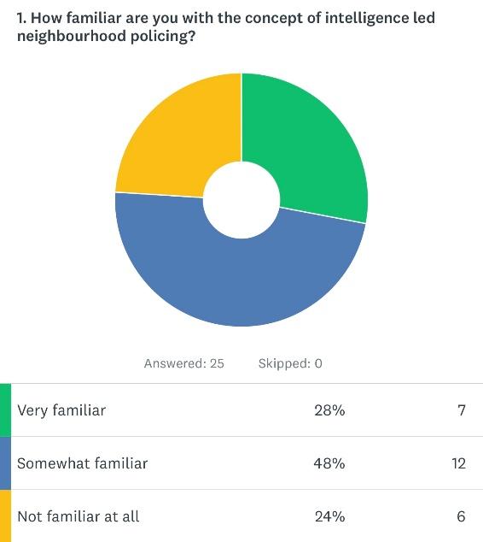

The above graph shows the answers of the participants in the form of a graph. From analysing the result, it shows that most participants are somewhat familiar with the concept of intelligence led neighbourhood policing, this being 48%. The other half of participants are split almost equally between having no knowledge or being very familiar with the concept.

4.4.2 – Figure 2

Respondent’s answers to “How effective is intelligence led neighbourhood policing in reducing crime rates?”

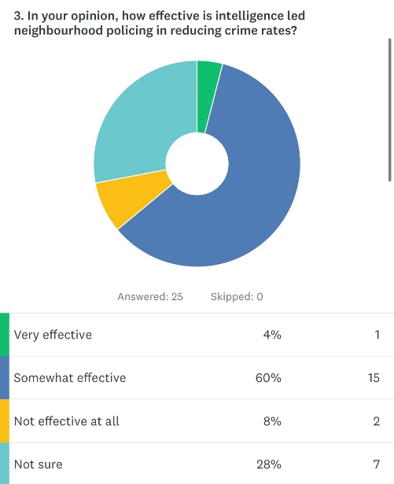

The graph displayed above shows the participants thoughts on the effectiveness of the intelligence led neighbourhood policing when it comes to reducing crime rates. It shows that 60% of participants believe this concept of policing to reduce crime rates is somewhat effective. 4% of persons believed this concept to be very effective in reducing crime rates and 8% stating that it is not effective at all. However, the second largest vote was ‘not sure’ with 28%. This reflects on the answers provided in figure 1 which was that around a quarter of participants were not aware of this concept of policing.

4.4.3 – Figure 3

Respondent’s answers to “Have you observed any positive changes in your neighbourhood as a result of intelligence led policing?”
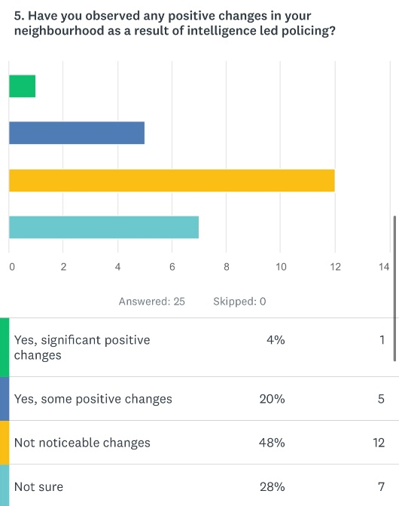

From the answers provided by respondents for this question, 48% deem there to have been no noticeable changes within their communities due to intelligence led neighbourhood policing. Approximately a quarter of participants believe there to be positive changes within their community. Meanwhile, the other quarter do not know whether this has played a part in contributing to positive changes within their community.

4.4.4 – Figure 4

Respondents’ answers to “What improvements, if any, would you suggest for intelligence led neighbourhood policing to be more effective?”
A common theme that was shown within participants results from this question were that there needs to be a greater police presence within the communities. This allowing police officers to communicate with members of the community. This being another common theme, that there is need for more communication between the police and communities with regards to intelligence led policing. Participants highlighted that the reason they do not see changes within the community because of this concept of policing is because they are unaware that it is occurring. In addition to this, another recommendation that was mentioned numerous times was working within schools to gather intelligence. This validates research conducted in London in 2002, whereby it was highlighted that more work needs to be done by Neighbourhood Policing Teams within schools to obtain valuable intelligence (Fitzgerald et al, 2002).

4.4.5 – Figure 5

Respondent’s answers to “Overall, how would you rate the effectiveness of intelligence led neighbourhood policing in the UK?”
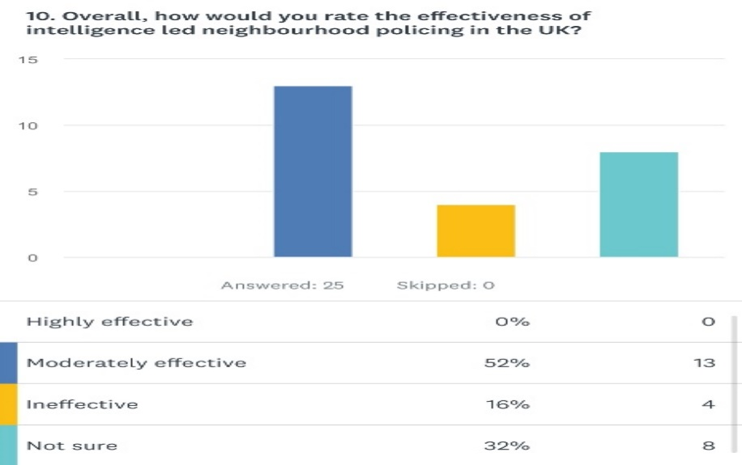

Overall, 52% of participants would say that they believe that intelligence led neighbourhood policing is effective. Furthermore, only 16% of participants would argue that this concept of policing is ineffective. 32% of the participants were unsure whether it is an effective concept or not.

4.5 – Conclusion

This chapter achieved the third objective which was: To analyse the data collected to understand the effectiveness of intelligence led neighbourhood policing in the UK.
To conclude, this study has identified that most police officers and members of the public believe that intelligence led neighbourhood policing is effective, this suggests a general contrast from the research obtained in the literature review. Within that research, overall findings show an equal split between the effectiveness and non-effectiveness of intelligence led neighbourhood policing. Based upon my own research a clear definitive answer has been obtained, as to the overall effectiveness of this concept of policing. The survey I conducted showed 52% of participants identifying that the concept is effective, in comparison to 16% of participants disagreeing. However, a clear theme that has been identified within this research. This theme is that several participants still do not know what this concept is. Therefore, not enabling clarity via data analysis, as to fully deduce if this concept is effective or not, due to 32% of participants selecting that they are unsure.

Chapter 5 – Conclusion and Recommendations:

5.0 – Introduction

Previous chapters of this dissertation have covered the introduction to the topic, research into current literature available, has the set out how researcher would conduct their own research into the topic, and has provided an analysis into the findings conducted within the survey. Those chapters have achieved the objectives they set to achieve. Within this section of the dissertation, it will set out to achieve the final objective which is:
To provide recommendations surrounding the discovered issues of the effectiveness of intelligence led neighbourhood policing within the UK.
To do this, all research that has been collected will be analysed, considered and recommendations will be made accordingly. Also, being looked at within this final section will be limitations to the research I conducted and any recommendations I have made and/or potential avenues for future research surrounding this topic.

5.1 – Completion and Achievement of Objectives

The first objective was:
To investigate and analyse the current available literature on the effectiveness of intelligence led neighbourhood policing in the UK.
This objective was met within chapter two of the dissertation.
The second objective was:
To identify the most suitable research approach to research the effectiveness of intelligence led neighbourhood policing in the UK.
This objective was met within the third chapter of the dissertation. The approach taken to conduct this research was because of analysing findings from chapter two. A quantitative approach was taken on this occasion as the vast majority of chapter two was qualitative therefore added a secondary approach to obtaining research.
The third objective was:
To analyse the data collected to understand the effectiveness of intelligence led neighbourhood policing in the UK.
This objective was achieved within the fourth chapter after analysing research conducted by the researcher using a quantitative approach.
The fourth objective:
To provide recommendations surrounding the discovered issues of the effectiveness of intelligence led neighbourhood policing within the UK.
The fourth and final objective will be achieved within this chapter of the dissertation.

5.2 – Main Findings

As I add the findings of my research, I believe it has established three specific findings in regard to the outlined primary objective, being to establish if Intelligence-Led Neighbourhood Policing in the UK was an effective approach to be taken in policing our country. The first specific finding is a definitive, yes to that question. It will be recalled that I reviewed literature of unarguable and trusted quality, two of the reviews were concerned at looking at the Neighbourhood Policing concept, its use and effectiveness and the other looking a policing more holistically, however all three clearly supported the approach and its importance in delivering effective policing. This was generally the position of those who took part in my Survey Monkey exercise. But note, none of the participants believed that it was highly effective, 52% said it was moderately effective, with 16% of participants saying that it was ineffective.
Furthermore, as per the objective question, set at the outset, we must consider closely the part that quality intelligence plays in any Neighbourhood Policing initiative. My second specific finding relates to the absolute importance of good information and intelligence being key to enabling effective practice. The general research from chapter two deduced that barriers of engagement within certain groups and communities exist within communities and can be an obstacle to effective Neighbourhood Policing. The literature indicated that effective use of information and intelligence can help address these barriers and ensure inclusive community engagement. This point, the lack of effective intelligence and information regarding the community being served by the police, can render the overall concept as potentially ineffective. For this reason, problem orientated policing, is an advanced version of hotspot policing that focuses on addressing the root causes of recurring issues. It involves proactive and collaborative approaches, utilising intelligence to effectively address problems. In the same vein, the College of Policing review of the UK Neighbourhood Policing, found that targeted foot patrol and community involvement in problem solving are effective elements of Neighbourhood Policing and should be adopted. Based on this adoption of these approaches it can also be argued that, as with Tyler et al. 2015 findings into proactive policing within the US, he suggested that this way of policing can lead to members of the community feeling as if they are being policed upon suspicion. Leading to a lack of support and confidence between the community and the police. So to summarise this second point, effective Neighbourhood Policing needs good information about and from the communities being policed, this involves close contact and focussed policing methods, these two actions themselves could be an actual or perceived issue and ironically lead to a lack of ‘good’ information (the driver for the concept) being received by the police.
Finally, my last significant finding. As stated earlier, 32% of participants of the survey I conducted were not sure how to respond to this question. I conclude that this demonstrates a lack of understanding into this form of policing. Also, the independent research conducted within chapter four, has shown that there is a significant lack of understanding from members of the public surrounding the concept of intelligence led neighbourhood policing. Whether by lack of understanding by practitioners or the public, this vacuum of knowledge will hinder successful Neighbourhood Policing and potentially cause friction.

5.3 – Recommendations

I have selected to suggest two recommendations, the first surrounding the need to raise the profile of Neighbourhood Policing amongst the public and rank and file police officers. This is in keeping with the finding’s summary above. My second is more nuanced, mentioned throughout various sections of this paper, it did not make the main findings, but is a cornerstone and enabler of the Neighbourhood concept. That being an advised increase presence in uniformed policing in areas, as part of a Neighbourhood strategy.
The first that the concept of intelligence led neighbourhood policing needs to be shared and explained better to the community. This would help with trust and confidence from the community and would lead to a better overall relationship between police and public. This could lead to the community seeing a more noticeable difference within their communities because of this concept as they are aware of its role. This recommendation comes from the established finding of a lack of understanding towards Neighbourhood Policing, that then undermines successful collection of relevant community related information and an increased risk that communities misconstrue the concept when it is used.
The second recommendation is visibility within communities. When reviewing and analysing results from the survey and literature, it highlighted that participants in the survey would like to see a greater presence of police in their community. This allowing them to communicate with the police and inform them of local issues. The latter positive point was a common finding in the various literature reviews and their findings. Elaborating on this final recommendation, is more visibility and work within schools. This was a common piece of feedback provided from the survey which supports the research of Fitzgerald et al, 2002 within the research conducted in London in 2002.

5.4 – Limitations

This section will discuss some limitations that were faced upon completion of this dissertation. The first limitation faced was the word count. Owing to the fact this research was completed for an undergraduate dissertation, research was limited to a word count which played a role in how much could be explored for this topic.
Another limitation found was the time scale. This aiming towards the time the researcher had to complete independent research into this topic due to deadlines having to be met. Moreover, the survey was limited to the number of participants that could answer due to software that was used. Also, there was a limitation on the geographical area of the research conducted by the researcher for chapter four. This was shared amongst individuals living in the Gwent area of South Wales. Therefore, was not specific for the whole of the UK.

5.5 – Future Research

Intelligence led neighbourhood policing is a large part of current policing within the UK. Due to the timescale for conducting research for this dissertation, several other avenues of research were not explored which could have been used to understand this topic in grater means. Therefore, for future research there are many opportunities and avenues to explore in this field, this including a larger survey covering a wider geographical area within the UK, speaking to current serving neighbourhood officers, and conducting independent research within communities.

5.6 – Conclusion

Summary of findings:
The research undertaken, firstly identified recent and currently relevant literature dealing in different degrees with the discourse on the effectiveness of intelligence led neighbourhood policing in the UK. This enabled the identification of key elements and issues of this policing concept. With these parts of the discussion identified, it enabled questions to be configured, that would form the basis of a survey that would be undertaken in the Gwent area, of South Wales. The survey paired with the academic research offered a more granular view to the key topics. If anything, this dissertation has allowed the reader to see varied insights into the effectiveness of intelligence led neighbourhood policing in the UK. The key findings in general, support the use of the concept as a strategy, but it also identified that failings to secure adequate information/intelligence on the communities could scupper the use of the strategy at any stage and finally found that there appears to be an evidenced blind spot in the general awareness of the use of Neighbourhood Policing concepts. Finally, it has successfully provided arguments for and against this topic whilst highlighting areas for improvement and adding recommendations to support this.

Chapter 6 – Bibliography:

ACPO (2006). Practice Advice on Professionalising the Business of Neighbourhood Policing.
Wyboston: Centrex.

Braga, A. A. (2008) Pulling levers focused deterrence strategies and the prevention of gun homicide. Journal of Criminal Justice, 36(4), pp 332-343.

Braga, A. A., Pierce, G. L., McDevitt, J., Bond, B. J. and Cronin, S. (2008) The strategic prevention of gun violence among gang-involved offenders. Justice Quarterly, 25(1), pp 132-162.

Babbie, E. (2016). The Practice of Social Research. Boston, MA: Cengage Learning.
Brewster, B., Gibson, H. and Gunning, M. (2018) 'Policing the community together: The impact of technology on citizen engagement'. Societal Implications of Community-oriented Policing and Technology, p. 91.
British Journal of Nursing. 2007. Step-by-step guide to critiquing research. Part 1: quantitative research. Available at: BJN_16_11_658_63_Quant.indd (psu.edu)
Bryman, A. and Hardy, M. (2009) Handbook of Data Analysis. London: Sage Publications.
College of Policing. 2018. Neighbourhood Policing: impact and implementation. Available at: np_rea_summary.pdf (college.police.uk)
College of Policing. 2013. Community Impact Assessment. Available at: College of policing - CIA.pdf
Connell, N. M., Miggans, K. and McGloin, J. M. (2008) Can a community policing initiative reduce serious crime? A local evaluation. Police quarterly, 11(2), pp 127-150.

Corsaro, N., Brunson, R. K. and McGarrell, E. F. (2009) Problem-oriented policing and open-air drug markets: Examining the Rockford pulling levers deterrence strategy. Crime and Delinquency, 59(7), pp 1,085-1, 107.

Cooper, C., Anscombe, J., Avenell, J., McLean, F. and Morris, J. (2006) A national evaluation of Community Support Officers, Home Office Research Study 297. London: Home Office.

Cambridge Dictionary. 1995. Meaning of Research in English. Available at: RESEARCH | English meaning - Cambridge Dictionary
Essex Police. 2023. What is Police Intelligence. Available at: What is police intelligence? | Essex Police
Fielding, N. G. (1995) Community policing. Oxford: Oxford University Press.

FitzGerald, M., Hough, M., Joseph, I. and Qureshi, T. (2002) Policing for London. Cullompton: Willan.

FitzGerald, M., Hough, M., Joseph, I. and Qureshi, T. (2002) Policing for London. Cullompton: Willan.

Home Office. 2023. Public perceptions of policing: A review of research and literature. Available at: UK Policing Public Perseptions.pdf
Hu, X., Dai, M., DeValve, M.J. and Lejeune, A. (2020) Understanding public attitudes towards the police: Co-variates of satisfaction, trust, and confidence'. Canadian Journal of Criminology and Criminal Justice, 62(1), pp. 26 to 49.

Jerry H. Ratcliff. 2003. Intelligence-led Policing. Available at: Intelligence-led policing (aic.gov.au)
Jackson, J. and Bradford, B. (2010) 'What is Trust and Confidence in the Police?' Policing: A Journal of Policy and Practice, 4(3), pp. 241 to 248.

J Health Serv Res Policy. 2005. Synthesising qualitative and quantitative evidence: a review of possible methods. Available at: Synthesising-Qualitative-and-Quantitative-Evidence-A-Review-of-Possible-Methods.pdf (researchgate.net)
Lister, S., Adams, B. and Phillips, S. (2015) Evaluation of police-community engagement practices. Swindon: Economic and Social Research Council.

Lord Scarman (1981) The Brixton Disorders. London: HMSO.

Mackenzie, S. and Henry, A. (2009) Community policing: A review of the evidence.
Edinburgh: Scottish Government Social Research.

Merry, S., Power, N., McManus, M. and Alison, L. (2012) 'Drivers of public trust and confidence in police in the UK. International Journal of Police Science and Management, 14(2), pp. 118 to 135.

Myhill, A. (2012) Community engagement in policing: Lessons from the literature. London: Neighbourhood policing: Impact and implementation. Home Office.

McHugh, M. (2013) ‘The chi-square test of independence’, Biochemical Medical, 23(2), pp.143-149.
Nursing and Health Sciences. 2013. Content analysis and thematic analysis: Implications for conducting a qualitative descriptive study. Available at: Content analysis and thematic analysis: Implications for conducting a qualitative descriptive study - Vaismoradi - 2013 - Nursing & Health Sciences - Wiley Online Library
Papachristos, A. V., Meares, T. L. and Fagan, J. (2007) Attention felons: Evaluating project safe neighborhoods in Chicago. Journal of Empirical Legal Studies, 4(2), pp 223-272.

Police. 2024. Neighbourhood Policing. Available at: Neighbourhood policing | Join The Police (joiningthepolice.co.uk)
Quinton, P. and Morris, J. (2008) Neighbourhood policing: the impact of piloting and early national implementation. London: Home Office.

Skogan, W. G. and Steiner, L. (2004) Community policing in Chicago, year ten. Chicago:
Illinois Criminal Justice Information Authority.

Sindall, K., McCarthy, D.J. and Brunton-Smith, I. (2017) Young people and the formation of attitudes towards the police'. European Journal of Criminology, 14(3), pp. 344 to 364.

SurveyMonkey. 2023. Available at: SurveyMonkey: The World’s Most Popular Free Online Survey Tool
Tuffin, R., Morris, J. and Poole, A (2006) An evaluation of the impact of the national reassurance policing programme. London: Home Office.

Tyler, T.R., Jackson, J. and Mentovich, A. (2015) 'The consequences of being an object of suspicion: Potential pitfalls of proactive police contact.
Journal of Empirical Legal Studies, 12(4), pp. 602 to 636.

Yesberg, J., Brunton-Smith, I. and Bradford, B. (2021) 'Police visibility, trust in police fairness, and collective efficacy: A multilevel Structural Equation Model'. European Journal of Criminology, 20(2). Available from: https://gbr01.safelinks.protection.outlook.com/?url=https%3A%2F%2Fdoi.org%2F10.1177%2F14773708211035306&data=05%7C01%7Crhys.neal1%40gwent.police.uk%7Cafe8ab46e6484fc0de8208dbe6d3f439%7Ce46c8472ef5d4b63bc744a60db42c371%7C0%7C0%7C638357570236204744%7CUnknown%7CTWFpbGZsb3d8eyJWIjoiMC4wLjAwMDAiLCJQIjoiV2luMzIiLCJBTiI6Ik1haWwiLCJXVCI6Mn0%3D%7C3000%7C%7C%7C&sdata=7Ydr1XnZMZzOjtVQwxsR3fFlUoMTcQJC%2FsXm8vASTkQ%3D&reserved=0 [accessed 07/08/2023].

Chapter 7 – Appendices

7.1 – Appendix 1 – Copy of Questionnaire
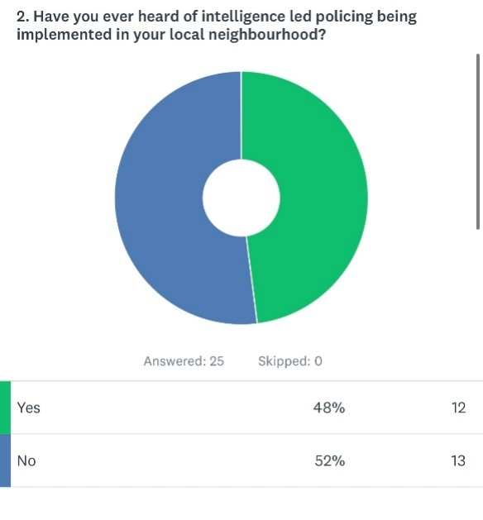
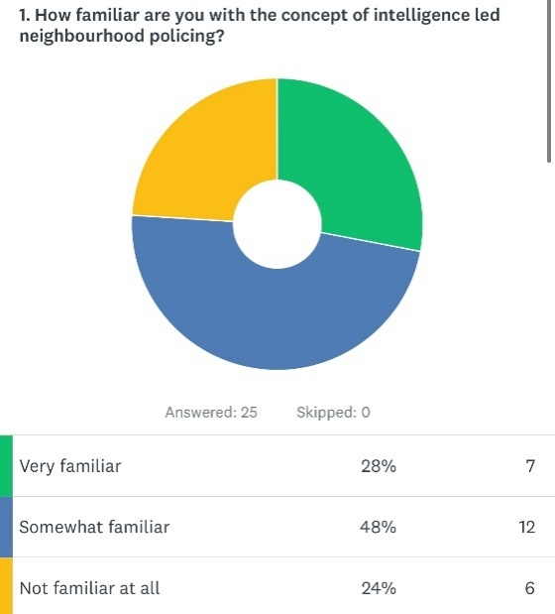

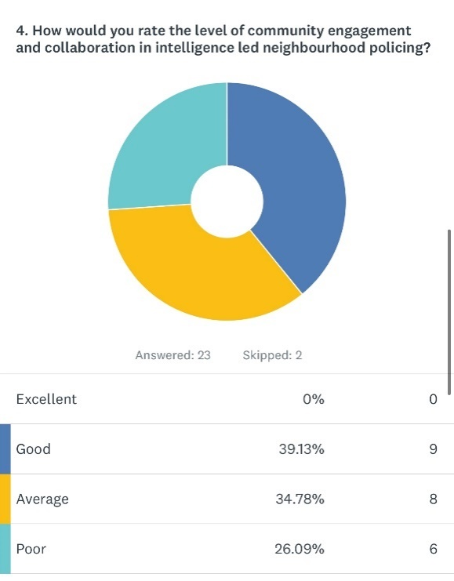
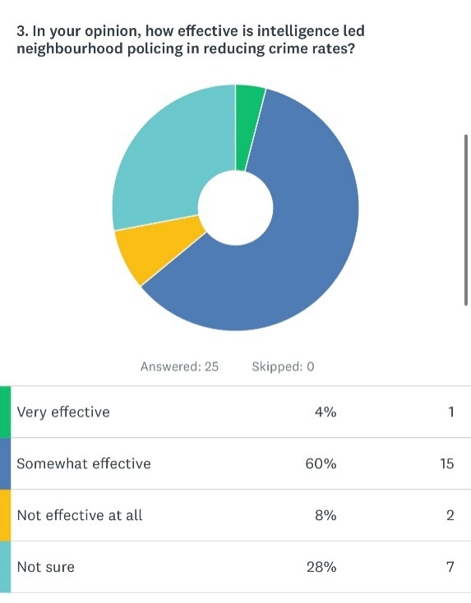

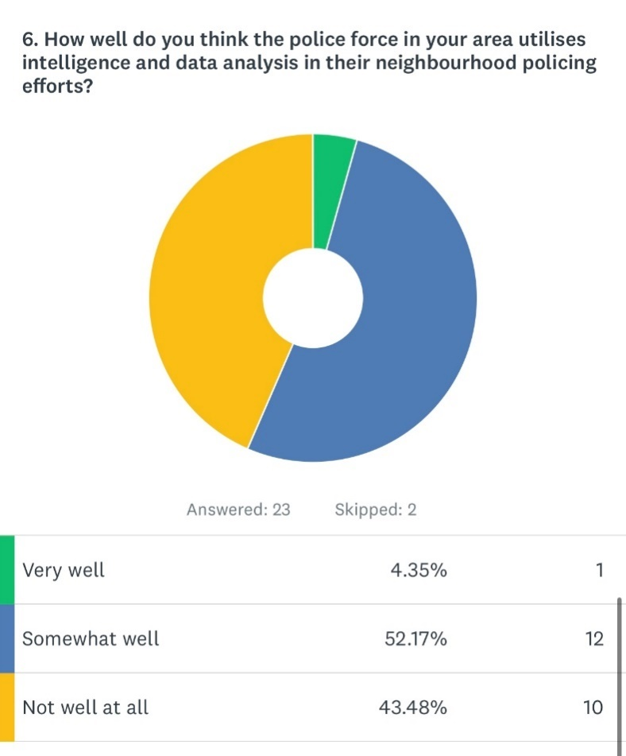
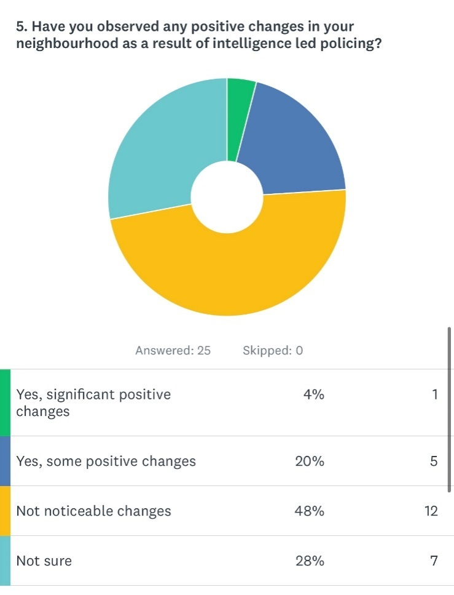

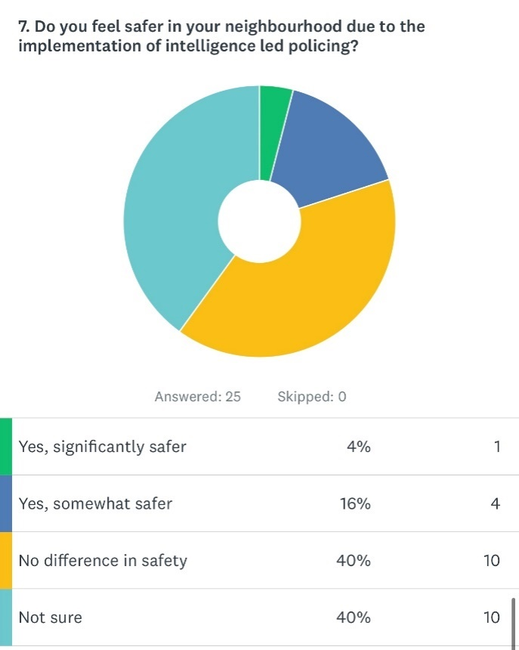

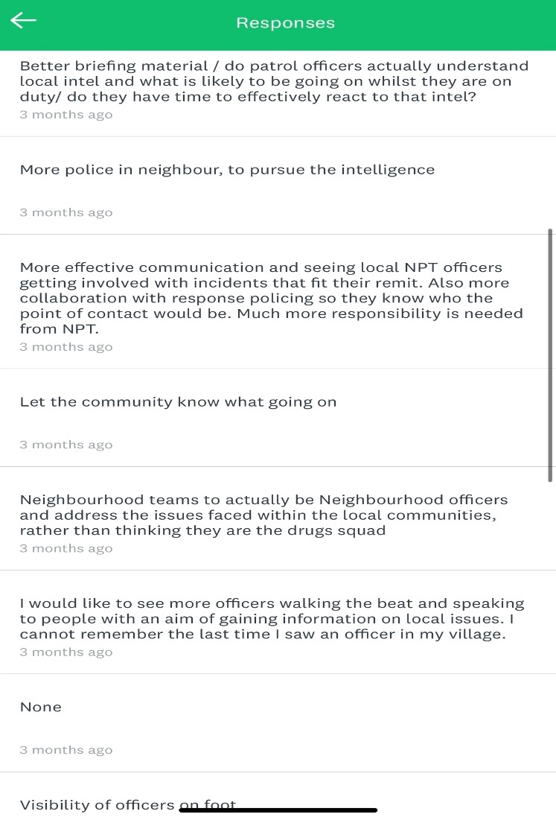
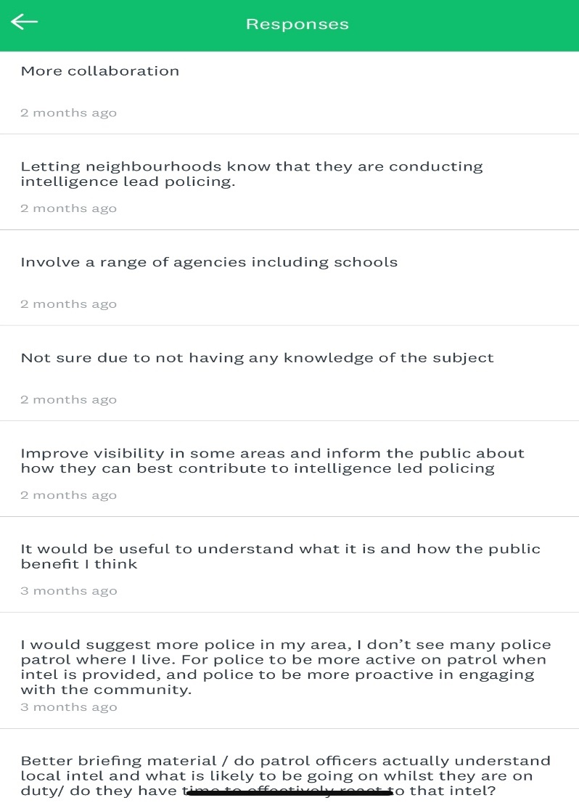
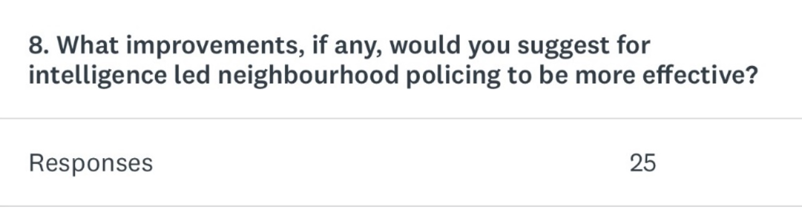
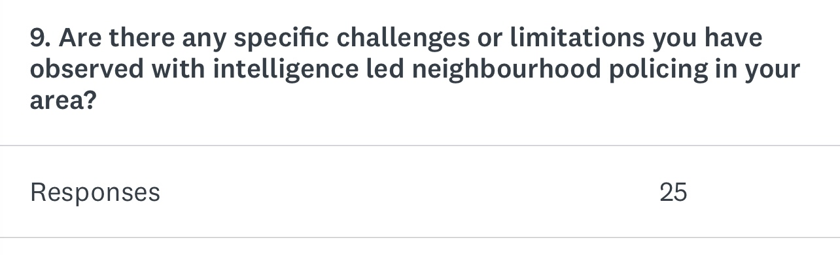
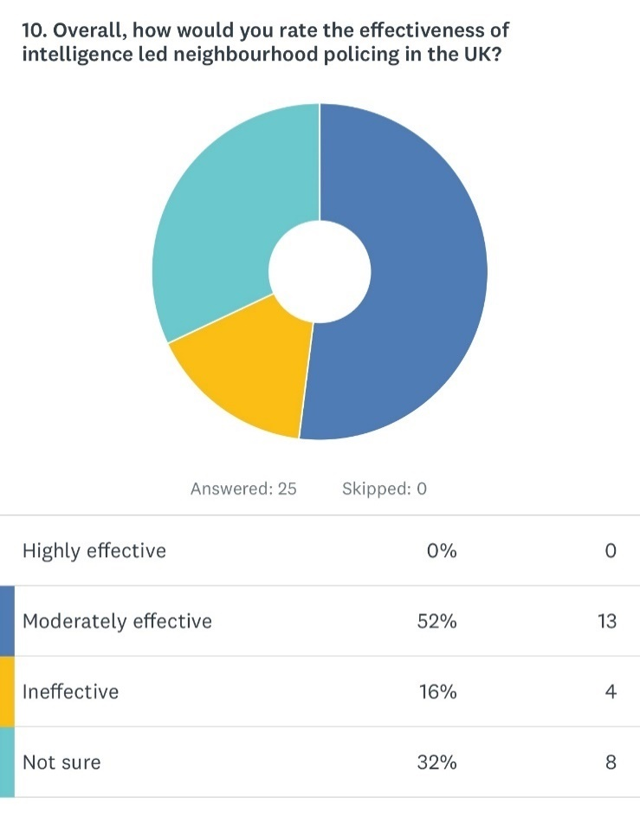
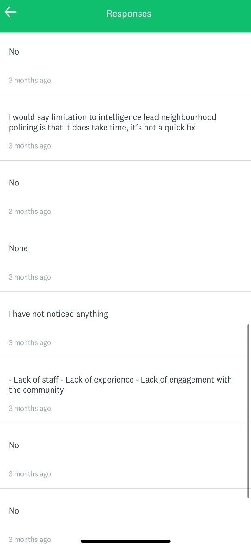
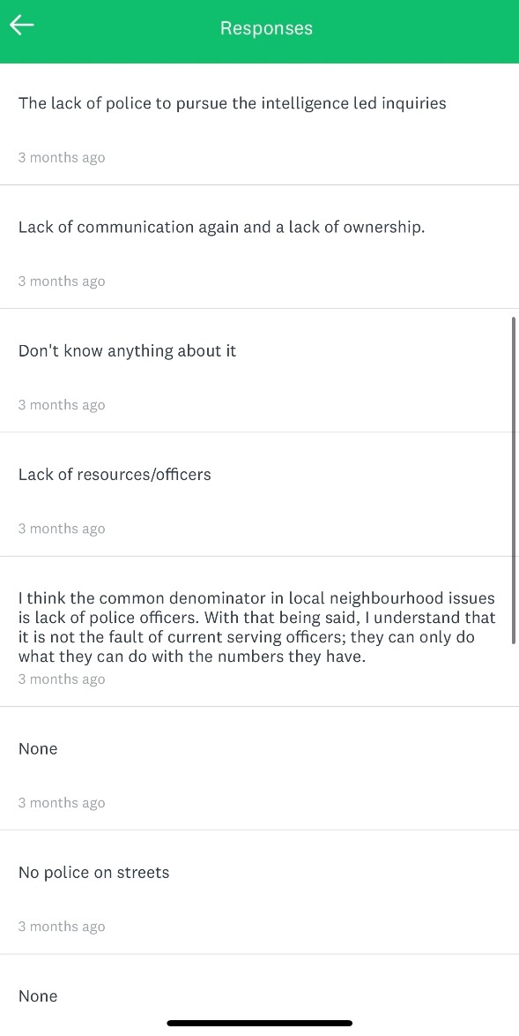
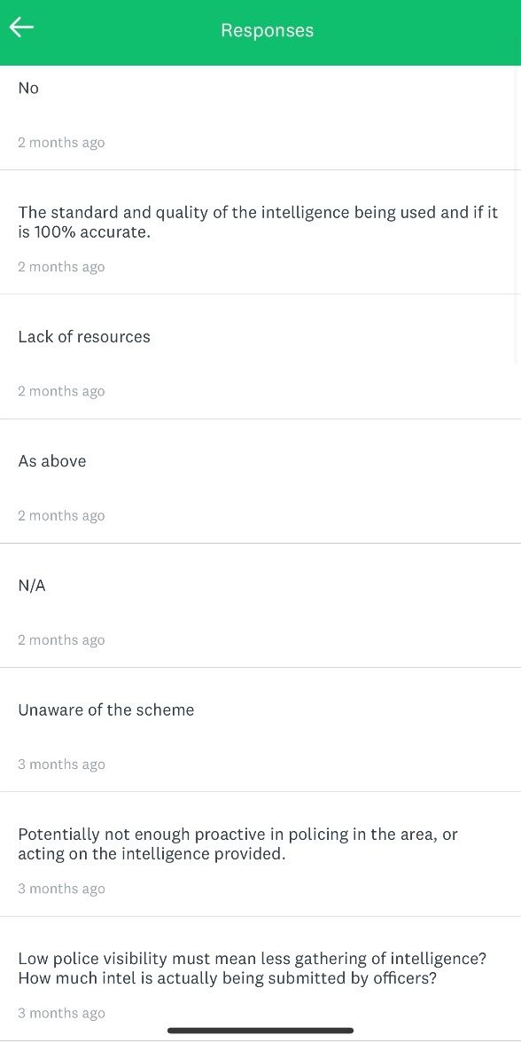

7.2 – Appendix 2 – Ethics form

APPLICATION FOR ETHICAL APPROVAL

RESEARCH STUDENTS
This form is to be completed by the student within SIX months for full-time students and TWELVE months for part time students, after the commencement of the research degree or following progression to Part Two of your course.

Once complete, submit this form via the MyTSD Doctoral College Portal at (https://mytsd.uwtsd.ac.uk).

This document is also available in Welsh.

RESEARCH STAFF ONLY
All communications relating to this application during its processing must be in writing and emailed to pgresearch@uwtsd.ac.uk , with the title ‘Ethical Approval’ followed by your name.

STUDENTS ON UNDERGRADUATE OR TAUGHT MASTERS PROGRAMMES should submit this form (and receive the outcome) via systems explained to you by the supervisor/module leader.

In order for research to result in benefit and minimise risk of harm, it must be conducted ethically. A researcher may not be covered by the University’s insurance if ethical approval has not been obtained prior to commencement.

The University follows the OECD Frascati manual definition of research activity: “creative work undertaken on a systematic basis in order to increase the stock of knowledge, including knowledge of man, culture and society, and the use of this stock of knowledge to devise new applications”. As such this covers activities undertaken by members of staff, postgraduate research students, and both taught postgraduate and undergraduate students working on dissertations/projects.

The individual undertaking the research activity is known as the “principal researcher”.

Ethical approval is not required for routine audits, performance reviews, quality assurance studies, testing within normal educational requirements, and literary or artistic criticism.

Please read the notes for guidance before completing ALL sections of the form.

This form must be completed and approved prior to undertaking any research activity. Please see Checklist for details of process for different categories of application.

SECTION A: About You (Principal Researcher)
1 | Full Name: |  | Rhys Neal
2 | Tick all boxes that apply: |  | Member of staff: | ☐ | Honorary research fellow: | ☐
 | Undergraduate Student | ☒ | Taught Postgraduate Student | ☐ | Postgraduate Research Student | ☐

3 | Institute/Academic Discipline/Centre: | University of Wales Trinity St David
4 | Campus: | Swansea
5 | E-mail address: | 2031277@student.uwtsd.ac.uk
6 | Contact Telephone Number: | 07544158097
 | For students:
7 | Student Number: | 2031277
8 | Programme of Study: | Professional Policing Practice
9 | Director of Studies/Supervisor: | Lewis Tandy

SECTION B: Approval for Research Activity
1 | Has the research activity received approval in principle?  (please check the Guidance Notes as to the appropriate approval process for different levels of research by different categories of individual) |  | YES | ☐ | NO | ☒
 |  |  |  |  | Date
2 | If Yes, please indicate source of approval (and date where known): Approval in principle must be obtained from the relevant source prior to seeking ethical approval | Research Degrees Committee |  | ☐
2 |  | Institute Research Committee |  | ☐
2 |  | Other (write in) |  | ☐

SECTION C: Internal and External Ethical Guidance Materials
 | Please list the core ethical guidance documents that have been referred to during the completion of this form (including any discipline-specific codes of research ethics, location-specific codes of research ethics, and also any specific ethical guidance relating to the proposed methodology). Please tick to confirm that your research proposal adheres to these codes and guidelines. You may add rows to this table if needed.
1 | UWTSD Research Ethics & Integrity Code of Practice | ☒
2 | UWTSD Research Data Management Policy | ☒
3 | [List any other relevant documents here] | ☐

SECTION D: External Collaborative Research Activity
1 | Institution
2 | Contact person name
3 | Contact person e-mail address
4 | Is your research externally funded? |  | YES | ☐ | NO |  | ☐
5 | Are you in receipt of a KESS scholarship? |  | YES | ☐ | NO |  | ☐
6 | Are you specifically employed to undertake this research in either a paid or voluntary capacity? | Voluntary | YES | ☐ | NO | ☐
7 |  | Employed | YES | ☐ | NO | ☐
8 | Is the research being undertaken within an existing UWTSD Athrofa Professional Learning Partnership (APLP)? | If YES then the permission question below does not need to be answered. | YES | ☐ | NO |  | ☐
9 | Has permission to undertake the research has been provided by the partner organisation? | (If YES attach copy)  If NO the application cannot continue | YES | ☐ | NO |  | ☐
If there are external collaborators then you should gain consent from the contact persons to share their personal data with the university. If there are no external collaborators then leave this section blank and continue to section E.

Where research activity is carried out in collaboration with an external organisation
10 | Does this organisation have its own ethics approval system? | YES | ☐ | NO | ☐
 | If Yes, please attach a copy of any final approval (or interim approval) from the organisation (this may be a copy of an email if appropriate).

SECTION E: Details of Research Activity
1 | Indicative title: | The effectiveness of UK neighbourhood policing teams (NPT).
2 | Proposed start date: | 28/08/2023 | Proposed end date: | 08/04/2024
Introduction to the Research (maximum 300 words per section)
Ensure that you write for a Non-Specialist Audience when outlining your response to the points below:
- Purpose of Research Activity
- Proposed Research Question
- Aims of Research Activity
- Objectives of Research Activity
Demonstrate, briefly, how Existing Research has informed the proposed activity and explain
- What the research activity will add to the body of knowledge
- How it addresses an area of importance.
3 | Purpose of Research Activity  The purpose of this research activity is to gain a better understanding of the UK neighbourhood policing teams and how effective they are within local communities. I will be looking at current initiatives currently in pace and will analyse how effective these are.  (this box should expand as you type)
4 | Research Question  - How effective is neighbourhood policing within the communities they serve?  - Does neighbourhood policing enhance the publics perception of safety within their local communities?  - What do the public expect from their local neighbourhood policing teams?  - Does this vary in different areas within police forces, e.g. rural areas and cities?  - How neighbourhood policing teams utilise technology in their role?  (this box should expand as you type)
5 | Aims of Research Activity  - Due to looking at the effectiveness of current initiatives implemented within neighbourhood policing departments in the UK, an aim of mine is to see how effective they are and to scope whether there is a place for clear improvement.  (this box should expand as you type)
6 | Objectives of Research Activity  - Evaluate the effectiveness of community engagement initiatives.  - Analyse the role of neighbourhood policing in enhancing public perceptions of safety.  - Investigate the role of neighbourhood policing in addressing specific local issues.  - Assess the utilisation of technology and innovation in neighbourhood policing.  (this box should expand as you type)
Proposed methods (maximum 600 words)
Provide a brief summary of all the methods that may be used in the research activity, making it clear what specific techniques may be used. If methods other than those listed in this section are deemed appropriate later, additional ethical approval for those methods will be needed. You do not need to justify the methods here, but should instead describe how you intend to collect the data necessary for you to complete your project.
7 | To conduct this research I will be using a mono-method approach. Using different sources of research to try and obtain the most accurate research. These methods will include conducting questionnaires, interviews with relevant persons, different case studies and literature reviews.  Questionnaires will be conducted in an ethical manner. Consent from any participants will be obtained prior to any completion. In addition, participants will be made aware that if at any point they do not wish to finish or complete the questionnaire they are able to stop at any point. Furthermore, these questionnaires will be completely anonymous, and this will be told to the participant prior to starting. This is in the hope that I will obtain more accurate research as the participant are more likely to speak freely knowing their identity is hidden.  With regards to any interviews conducted. Consent again will be obtained from the participants. Again they will have the option to opt out of the research/interview at any point. The participants will be provided with the questions prior to the interview so that they will know what to expect and are not caught off guard.  With regards to the case studies and literature reviews, all of the information used from this aspect of research will be properly referenced in accordance to Harvard referencing. In addition, this will be done in line with the standards set out by plagiarism.  (this box should expand as you type)
Location of research activity
Identify all locations where research activity will take place.
8 | For questionnaires, this will be carried out internally within the police, with local partners and members of the public in order to obtain the best research available.  With regards to the interviews these will be conducted and recorded via face to face online calls. Using applications such as ‘teams’.  Finally, with regards to case studies and literature reviews these will be carried out online and via books or articles.  (this box should expand as you type)
Research activity outside of the UK
If research activity will take place overseas, you are responsible for ensuring that local ethical considerations are complied with and that the relevant permissions are sought. Specify any local guidelines (e.g. from local professional associations/learned societies/universities) that exist and whether these involve any ethical stipulations beyond those usual in the UK (provide details of any licenses or permissions required). Also specify whether there are any specific ethical issues raised by the local context in which the research activity is taking place, for example, particular cultural and/or legal sensitivities or vulnerabilities of participants. If you live in the country where you will do the research then please state this.
9 | At present this is not applicable to my proposed dissertation as I am going to be looking at the effectiveness of UK neighbourhood policing teams.  (this box should expand as you type)

10 | Use of documentation not in the public domain: Are any documents NOT publicly available? | NO | ☒
10 |  | YES | ☐
11 | If Yes, please provide details here of how you will gain access to specific documentation that is not in the public domain and that this is in accordance with the current data protection law of the country in question and that of England and Wales.  (this box should expand as you type)

 | Does your research relate to one or more of the seven aims of the Well-being of Future Generations (Wales) Act 2015? | YES | NO
12 | A prosperous Wales | ☐ | ☐
13 | A resilient Wales | ☐ | ☐
14 | A healthier Wales | ☐ | ☐
15 | A more equal Wales | ☐ | ☐
16 | A Wales of cohesive communities | ☒ | ☐
17 | A Wales of vibrant culture and thriving Welsh language | ☐ | ☐
18 | A globally responsible Wales | ☐ | ☐
19 | If YES to any of the above, please give details:
I have answered yes to No.12 as my research is based on the effectiveness of neighbourhood policing within the UK, this would expand to Wales. One of my primary objectives is to identify whether the role of NPT enhances the public’s perception of safety.

(this box should expand as you type)
 | Will the research activity include: | YES | NO
1 | Use of a questionnaire or similar research instrument? | ☒ | ☐
2 | Use of interviews? | ☒ | ☐
3 | Use of focus groups? | ☐ | ☒
4 | Use of participant diaries? | ☐ | ☒
5 | Use of video or audio recording? | ☒ | ☐
6 | Use of computer-generated log files? | ☒ | ☐
7 | Participant observation with their knowledge? | ☒ | ☐
8 | Participant observation without their knowledge? | ☐ | ☒
9 | Access to personal or confidential information without the participants’ specific consent? | ☐ | ☒
10 | Administration of any questions, test stimuli, presentation that may be experienced as physically, mentally or emotionally harmful / offensive? | ☐ | ☒
11 | Performance of any acts which may cause embarrassment or affect self-esteem? | ☐ | ☒
12 | Investigation of participants involved in illegal activities? | ☒ | ☐
13 | Use of procedures that involve deception? | ☐ | ☒
14 | Administration of any substance, agent or placebo? | ☐ | ☒
15 | Working with live vertebrate animals? | ☐ | ☒
16 | Procedures that may have a negative impact on the environment? | ☐ | ☒
17 | Other primary data collection methods. Please indicate the type of data collection method(s) below. | ☐ | ☐
 | Details of any other primary data collection method:  (this box should expand as you type) | ☐ | ☐

SECTION F: Scope of Research Activity
 | Who are the intended participants: | YES | NO
1 | Students or staff at the University? | ☐ | ☒
2 | Adults (over the age of 18 and competent to give consent)? | ☒ | ☐
3 | Vulnerable adults? | ☐ | ☒
4 | Children and Young People under the age of 18? (Consent from Parent, Carer or Guardian will be required) | ☐ | ☒
5 | Prisoners? | ☐ | ☒
6 | Young offenders? | ☐ | ☒
7 | Those who could be considered to have a particularly dependent relationship with the investigator or a gatekeeper? | ☐ | ☒
8 | People engaged in illegal activities? | ☐ | ☒
9 | Others. Please indicate the participants below, and specifically any group who may be unable to give consent. | ☐ | ☐
 | Details of any other participant groups:  (this box should expand as you type) | ☐ | ☐
If NO to every question, then the research activity is (ethically) low risk and may be exempt from some of the following sections (please refer to Guidance Notes).

If YES to any question, then no research activity should be undertaken until full ethical approval has been obtained.

SECTION G: Intended Participants
If there are no participants then do not complete this section, but go directly to section H.
Participant numbers and source
Provide an estimate of the expected number of participants. How will you identify participants and how will they be recruited?
10 | How many participants are expected? | Interview: 1 to 2 participants  Questionnaires: 20  (this box should expand as you type)
11 | Who will the participants be? | Interview: These serving police officers who work within the neighbourhood policing team  Questionnaires: These will be a mix of police officers in and out of the neighbourhood policing department, members of staff that work in partnership of the police and if possible members of local communities  (this box should expand as you type)
12 | How will you identify the participants? | Interview: I will reach out to a police force and will obtain whether I would be able to conduct the above research  Questionnaires: I will again reach out to a police force and will obtain whether I would be able to conduct the above research. I will reach out to partner agencies to obtain consent to conduct questionnaires with members of staff. I will enquire how to engage with members of the community.  (this box should expand as you type)

 | Information for participants: | YES | NO | N/A
13 | Will you describe the main research procedures to participants in advance, so that they are informed about what to expect? | ☒ | ☐ | ☐
14 | Will you tell participants that their participation is voluntary? | ☒ | ☐ | ☐
15 | Will you obtain written consent for participation? | ☒ | ☐ | ☐
16 | Will you explain to participants that refusal to participate in the research will not affect their treatment or education (if relevant)? | ☒ | ☐ | ☐
17 | If the research is observational, will you ask participants for their consent to being observed? | ☒ | ☐ | ☐
18 | Will you tell participants that they may withdraw from the research at any time and for any reason? | ☒ | ☐ | ☐
19 | With questionnaires, will you give participants the option of omitting questions they do not want to answer? | ☒ | ☐ | ☐
20 | Will you tell participants that their data will be treated with full confidentiality and that, if published, it will not be identifiable as theirs? | ☒ | ☐ | ☐
21 | Will you debrief participants at the end of their participation, in a way appropriate to the type of research undertaken? | ☒ | ☐ | ☐
22 | If NO to any of above questions, please give an explanation
 | (this box should expand as you type)

 | Information for participants: | YES | NO | N/A
24 | Will participants be paid? | ☐ | ☒ | ☐
25 | Is specialist electrical or other equipment to be used with participants? | ☐ | ☒ | ☐
26 | Are there any financial or other interests to the investigator or University arising from this study? | ☐ | ☒ | ☐
27 | Will the research activity involve deliberately misleading participants in any way, or the partial or full concealment of the specific study aims? | ☐ | ☒ | ☐
28 | If YES to any question, please provide full details
 | (this box should expand as you type)

SECTION H: Anticipated Risks

Outline any anticipated risks that may adversely affect any of the participants, the researchers and/or the University, and the steps that will be taken to address them.

If you have completed a full risk assessment (for example as required by a laboratory, or external research collaborator) you may append that to this form.
1 | Full risk assessment completed and appended? |  | Yes | ☒
1 |  |  | No | ☐
2 | Risks to participants  For example: sector-specific health & safety, emotional distress, financial disclosure, physical harm, transfer of personal data, sensitive organisational information
 | Risk to participants:  - Emotional distress – Some people may find talking about their safety in their community upsetting this is why the following action will be taken to ensure safety is prioritised  (this box should expand as you type) | How you will mitigate the risk to participants:  - This will be mitigated by adding a safe number which is completely independent at the bottom of questionnaires, consent form  (this box should expand as you type)
3 | If research activity may include sensitive, embarrassing or upsetting topics (e.g. sexual activity, drug use) or issues likely to disclose information requiring further action (e.g. criminal activity), give details of the procedures to deal with these issues, including any support/advice (e.g. helpline numbers) to be offered to participants. Note that where applicable, consent procedures should make it clear that if something potentially or actually illegal is discovered in the course of a project, it may need to be disclosed to the proper authorities
As mentioned in the above box. Due to issue’s discussed may bring back negative previous experiences, a safe number and website will be posted at the bottom of any form needing to be completed to ensure the participant can receive any support if needed.

(this box should expand as you type)
4 | Risks to the investigator  For example: personal health & safety, physical harm, emotional distress, risk of accusation of harm/impropriety, conflict of interest
 | Risk to the investigator:  Conflict of interest – Due to me (the investigator) being a current serving police officer.  (this box should expand as you type) | How you will mitigate the risk to the investigator:  - To mitigate this risk I will not be participating in any of the research due to this becoming a conflict of interest.  (this box should expand as you type)
5 | University/institutional risks  For example: adverse publicity, financial loss, data protection
 | Risk to the University:  Data protection – Data gathered from relevant research  (this box should expand as you type) | How you will mitigate the risk to the University:  - All data obtained and submitted to the university will be in accordance to the Data Protection Act  (this box should expand as you type)
6 | Environmental risks  For example: accidental spillage of pollutants, damage to local ecosystems
 | Risk to the environment:  N/A  (this box should expand as you type) | How you will mitigate the risk to environment:  (this box should expand as you type)

 | Disclosure and Barring Service
 | If the research activity involves children or vulnerable adults, a Disclosure and Barring Service (DBS) certificate must be obtained before any contact with such participants. | YES | NO | N/A
7 | Does your research require you to hold a current DBS Certificate? | ☐ | ☐ | ☒
8 | If YES, please give the certificate number. If the certificate number is not available please write “Pending”; in this case any ethical approval will be subject to providing the appropriate certificate number.

SECTION I: Feedback, Consent and Confidentiality

1 | Feedback  What de-briefing and feedback will be provided to participants, how will this be done and when?
I participants will be provided with written feedback. This will be thanking them for their participation. Will be again outlining that their identity will remain anonymous if desired. This will be done via email or if not appropriate, handwritten.

(this box should expand as you type)
2 | Informed consent  Describe the arrangements to inform potential participants, before providing consent, of what is involved in participating. Describe the arrangements for participants to provide full consent before data collection begins. If gaining consent in this way is inappropriate, explain how consent will be obtained and recorded in accordance with prevailing data protection legislation.
Participants that are identified for my research will again be sent an email to provide them with background surrounding my research, the topic and what is required. They will then be asked to provide me with written consent prior to engaging with any research.

(this box should expand as you type)
3 | Confidentiality / Anonymity  Set out how anonymity of participants and confidentiality will be ensured in any outputs. If anonymity is not being offered, explain why this is the case.
For the interviews, I will ask whether they wish to remain anonymous. If this is the case, front facing cameras will be turned off therefore the participants identity will be unknown. They will also be referred to by a different name, e.g. person A.

For the forms, there will not be an option to put the name of the participant therefore this will ensure their remain anonymous.

(this box should expand as you type)

SECTION J: Data Protection and Storage

 | Does the research activity involve personal data (as defined by the General Data Protection Regulation 2016 “GDPR” and the Data Protection Act 2018 “DPA”)? | YES | NO
1 | “Personal data” means any information relating to an identified or identifiable natural person (‘data subject’). An identifiable natural person is one who can be identified, directly or indirectly, in particular by reference to an identifier such as a name, an identification number, location data, an online identifier or to one or more factors specific to the physical, physiological, genetic, mental, economic, cultural or social identity of that natural person. Any video or audio recordings of participants is considered to be personal data. | ☐ | ☐
 | If YES, provide a description of the data and explain why this data needs to be collected:
2 | I AM UNABLE TO SELECT THE BOX –  NO  (this box should expand as you type)
 | Does it involve special category data (as defined by the GDPR)? | YES | NO
3 | “Special category data” means sensitive personal data consisting of information as to the data subjects’ –  (a) racial or ethnic origin,  (b) political opinions,  (c ) religious beliefs or other beliefs of a similar nature,  (d) membership of a trade union (within the meaning of the Trade Union and Labour Relations (Consolidation) Act 1992),  (e) physical or mental health or condition,  (f) sexual life,  (g) genetics,  (h) biometric data (as used for ID purposes), | ☐ | ☐
 | If YES, provide a description of the special category data and explain why this data needs to be collected:
4 | NO  (this box should expand as you type)

 | Will data from the research activity (collected data, drafts of the thesis, or materials for publication) be stored in any of the following ways? | YES | NO
5 | Manual files (i.e. in paper form)? | ☐ | ☒
6 | University computers? | ☐ | ☒
7 | Private company computers? | ☒ | ☐
8 | Home or other personal computers? | ☐ | ☒
9 | Laptop computers/ CDs/ Portable disk-drives/ memory sticks? | ☐ | ☒
10 | “Cloud” storage or websites? | ☐ | ☒
11 | Other – specify: | ☐ | ☒
12 | For all stored data, explain the measures in place to ensure the security of the data collected, data confidentiality, including details of backup procedures, password protection, encryption, anonymisation and pseudonymisation:
 | (this box should expand as you type)

 | Data Protection
 | Will the research activity involve any of the following activities: | YES | NO
13 | Electronic transfer of data in any form? | ☐ | ☒
14 | Sharing of data with others at the University outside of the immediate research team? | ☐ | ☒
15 | Sharing of data with other organisations? | ☐ | ☒
16 | Export of data outside the UK or importing of data from outside the UK? | ☐ | ☒
17 | Use of personal addresses, postcodes, faxes, emails or telephone numbers? | ☐ | ☒
18 | Publication of data that might allow identification of individuals? | ☐ | ☒
19 | Use of data management system? | ☐ | ☒
20 | Data archiving? | ☐ | ☒
21 | If YES to any question, please provide full details, explaining how this will be conducted in accordance with the GDPR and Data Protection Act (2018) (and any international equivalents, where appropriate):
 | (this box should expand as you type)
22 | List all who will have access to the data generated by the research activity:
 | (this box should expand as you type)
23 | List who will have control of, and act as custodian(s) for, data generated by the research activity:
 | (this box should expand as you type)
24 | Give details of data storage arrangements, including security measures in place to protect the data, where data will be stored, how long for, and in what form. Will data be archived – if so how and if not why not.
 | (this box should expand as you type)
25 | Please indicate if your data will be stored in the UWTSD Research Data Repository (see https://researchdata.uwtsd.ac.uk/ ). If so please explain. (Most relevant to academic staff)
 | (this box should expand as you type)
26 | Confirm that you have read the UWTSD guidance on data management (see https://www.uwtsd.ac.uk/library/research-data-management/) | YES | ☐
27 | Confirm that you are aware that you need to keep all data until after your research has completed or the end of your funding | YES | ☐

SECTION K: Declaration
The information which I have provided is correct and complete to the best of my knowledge. I have attempted to identify any risks and issues related to the research activity and acknowledge my obligations and the rights of the participants.

In submitting this application I hereby confirm that I undertake to ensure that the above named research activity will meet the University’s Research Ethics and Integrity Code of Practice which is published on the website: https://www.uwtsd.ac.uk/research/research-ethics/
1 | Signature of applicant: | R.NEAL | Date: 01/09/2023

For STUDENT Submissions:
2 | Director of Studies/Supervisor: |  | Date:
3 | Signature: |  | Date:

For STAFF Submissions:
4 | Academic Director/ Assistant Dean: |  | Date:
5 | Signature: |  | Date:

Checklist: Please complete the checklist below to ensure that you have completed the form according to the guidelines and attached any required documentation:
☒ | I have read the guidance notes supplied before completing the form.
☒ | I have completed ALL RELEVANT sections of the form in full.
☐ | I confirm that the research activity has received approval in principle
☐ | I have attached a copy of final/interim approval from external organisation (where appropriate)
☐ | I have attached a full risk assessment (where appropriate) ONLY TICK IF YOU HAVE ATTACHED A FULL RISK ASSESSMENT
☒ | I understand that it is my responsibility to ensure that the above named research activity will meet the University’s Research Ethics and Integrity Code of Practice.
☒ | I understand that before commencing data collection all documents aimed at respondents (including information sheets, consent forms, questionnaires, interview schedules etc.) must be confirmed by the DoS/Supervisor, module tutor or Academic Director.

